2018 Chatham Strait Sablefish Stock Assessment

Authors: Jane Sullivan, Ben Williams, and Andrew Olson

To: Andrew Olson, Karla Bush

Cc: Chris Siddon, Ben Williams, Sarah Power, Katie Palof, and Sara Miller

# Assessment timeline

Presentation to industry: Wednesday, March 7;

Initial Draft: Wednesday, May 2;

Internal ADF&G review: Thursday, May 10;

Final version approved by reviewers & managers: Friday, May 13;

Public announcement of formal quota: TBD

# Summary table

|  |  |  |  |
| --- | --- | --- | --- |
| Quantity | 2017 | 2018 | Percent change (%) |
| Exploited abundance (2017 value from last year) | 1,564,409 | 1,972,463 | 26.1 |
| Exploited abundance | 2,138,742 | 2,188,766 | 2.3 |
| Exploited abundance (adjusted for uncertainty in recruitment) | 1,927,382 | 1,972,463 | 2.3 |
| Exploited biomass (2017 value from last year) | 13,502,591 | 16,716,483 | 23.8 |
| Exploited biomass | 18,049,305 | 18,549,637 | 2.8 |
| Exploited biomass (adjusted for uncertainty in recruitment) | 16,265,597 | 16,716,483 | 2.8 |
| $$F_{ABC}=F_{50}$$ | 0.0683 | 0.0635 | -7.0 |
| $ABC$ (round lbs) | 850,113 | 1,088,298 | 28.0 |
| $ABC_{adj}$ (round lbs) | 850,113 | 980,748 | 15.4 |

# Summary

* The 2018 recommended Allowable Biological Catch ($ABC_{adj}$) for Northern Southeast Inside Waters (NSEI - Chatham Strait) at a full-recruitment fishing mortality level of $F_{50\%}$ = is 980,748 round pounds. This is a 130,635 pound increase (15.4%) from the 2017 ABC of 1,564,409 round pounds;
* The adjustment to the $ABC$ accounts for the high uncertainty in the 2014 year class, which is estimated to be the largest recruitment event for sabelfish since 1977 (Hanselman et al. 2017). If the 2018 $ABC$ is not adjusted and assessment methodology remains constant from previous years, the $ABC$ would be 1,088,298 pounds, a 238,185 pound increase (28.0%) from 2017. Because fish younger than 7 years comprise 15-20% of the forecasted exploited biomass in 2018 and less than 50% of females are mature at this age, this adjustment will help protect future spawning potential for this year class;
* The adjusted population estimate from the 2017 mark-recapture project in Chatham Strait is 1,927,382 individuals. This is a revised estimate and a change from the previous estimate of 1,564,409 individuals from the 2017 mark-recapture project. Had there been a mark survey in 2016, the increase in the population would have been observed a year earlier. The adjusted forecast of abundance for 2018 is 1,972,463 individuals (Figure 1);
* Female sablefish continue to be retained in greater proportion in the commercial fishery. The proportion of females observed in the commercial catch is greater than the proportion of females in the longline survey for all ages (Figure 2 and Figure 3).
* Catch per unit effort (CPUE) in the ADF&G Chatham Strait longline survey increased relative to 2016 from 0.20 to 0.23 numbers per hook (15.0%) (Figure 4). This reflects a 4.1% increase from the ten year average CPUE of 0.22 sablefish per hook.
* Commercial longline fishery CPUE decreased relative to 2016 from 0.91 to 0.82 pounds per hook (10.0%) (Figure 5). This is only a 3.7% decrease from the ten year average CPUE of 0.85 pounds per hook.
* Anomolously strong recruitment from the 2014 (and possibly 2013 and 2015) year classes have been observed in the ADF&G longline survey age composition (Figure 6). The 2014 year class was first observed in the 2017 commercial fishery age-composition data (Figure 7). The federal stock assessment authors are treating this recruitment event with caution by capping the recruitment estimate at the previous maximum recruitment value from 1977 (Hanselman et al. 2017). As described earlier, we also adjusted the estimated abundance and biomass to reflect this uncertaintly;
* The federal stock assessment for sablefish reported a significant increase in abundance and associated quota. The recommended federal ABC for the 2018 commercial longline sablefish fishery is 14,957 metric tons, a 14.3% increase from the 2017 ABC of 13,083 metric tons (Hanselman et al. 2017). The $F_{ABC}$ presented in the summary table above is not directly comparable to the federal harvest rate of $F_{40\%}$, because the methods used to assess abundance and determine $F$ values are different. Moreover, the federal assessment authors have taken additional conservation measures to adjust for whale depradation and dampen the predicted population increase from the strong 2014 year class (Hanselman et al. 2017).

# Changes to the NSEI sablefish assessment for 2018 relative to 2017

1. As discussed in the Summary and Section I of this report, the 2017 estimate of exploited abundance used to determine the $ABC$ was adjusted to account for the high degree of uncertainty in recent recruitment events. We used the 15% percentile from the posterior distribution of abundance as the input to the yield per recruit analysis and calculation of $ABC$ (Figure 8). The relative impacts of adjusting the abundance can be seen in the Summary table at the beginning of this report and in Figure 1.
2. The mark-recapture models used in this analysis are based on analyses by Dr. Franz Mueter (Mueter 2010). We compare population estimates from a simple Chapman estimator with estimates from several extensions of a stratified Peterson estimator that account for changes in capture probability through time, natural and fishing mortality, migration, and seasonal trends in catch rates. These alternative model structures are implemented in the Bayesian open source software JAGS 4.3.0 (Depaoli 2016). Previous methods used arbitrary break points (e.g. 5 or 10 days) to define temporal strata throughout the fishing season (Mueter 2010, Van Kirk et al. 2016). Here we use cumulative catch over time to define temporal strata. We use a combination of convergence criteria, deviance information criterion (DIC; Spiegelhalter et al. 2002), and a visual examination of seasonal trends in abundance to aid in model selection.
3. The NSEI Chatham Strait sablefish assessment was developed into a reproducible research product (de Leeuw 2001). It is publically hosted on the web-based version control service GitHub at <https://github.com/commfish/seak_sablefish>. This effort included a thorough review of all data sources available for the NSEI. It involved detailed conversation with ADF&G programming staff, Scott Johnson and Paul Caldwell, as well as Region I Groundfish Project biologists, Andrew Olsen, Aaron Baldwin, and Mike Vaughn. The outcomes of these discussions are documented in software code, README file, and Issues tab of the seak_sablefish repository. This product is considered conditionally reproducible, indicating that potential users must formally request any confidental data sourced in the code in order to produce the full assessment (Schwab et al. 2000). However, survey and other non-confidential data are made available, and all queries and subsequent transformations to the data are included in the analysis.

# Section I: 2017 Acceptable Biological Catch (ABC)

The 2016 marking survey released 7,096 marked fish. We accounted for tags recovered outside of the NSEI or period of recapture, natural and fishing mortality, and differences in the size of fish captured in the pot survey and the longline fishery (Section II). We explored alternative candidate models that account for movement in and out of Chatham Strait and incorporate fishery CPUE. Finally, because of the large increase in estimated abundance since 2016 coupled with uncertainty in recruitment, we adjusted the point estimate for the 2017 exploited abundance by taking the 15th percentile from the posterior distribution of abundance before conducting the yield per recruit analysis and calculation of $ABC$ (Figure 8). This adjustment serves to stabilize the fishery and is intended to guard against overfishing if the 2014 year class is lower than currently predicted. Moreover, because fish younger than 7 years comprise 15-20% of the forecasted exploited biomass in 2018 and less than 50% of females are mature at this age, this adjustment will help protect future spawning potential for this year class.

The recommended adjusted abundance estimate of 1,927,382 for 2017 was partitioned into sex-specific age classes from 2017 commercial fishery catch-at-age/sex data and projected into 2018 (Section III). This produced an estimated foreceast of exploited abundance of 1,972,463 individuals for 2018. Multiplying by mean commercial fishery weights-at-age produced an estimate of exploited biomass of 16,716,483 round pounds.

# Section II: Mark-recapture analysis

The mark-recapture project forms the foundation for current sablefish management in Chatham Strait and will scale absolute abundance in a future age-structured assessment model. The most commonly used method used for abundance estimation and the model that was used for many years by ADF&G is the Chapman estimator:

$$N=\frac{(K+1)(n+1)}{k+1}-1,$$

where $N$ is the estimated population abundance, $K$ is the total number of individuals marked in the population, $n$ is the number of individuals checked for marks at the time of recapture, and $k$ is the number of marked individuals out of $n$. A description of all model variables is found in Table 1, and a coarse summary of the tag data since 2005 is found in Table 2. Note that ADF&G did not conduct a mark survey in 2011, 2014, or 2016 due to budget restrictions.

There are four primary assumptions integral to the Chapman estimator, which have been discussed in detail in previous iterations of this report (Williams and Van Kirk 2017, Dressel 2009, Mueter 2010). Briefly, these assumptions include a closed population (no movement in or out of the study area), equal probability of recapture, sufficient time between marking and recapture to allow for marked individuals to be randomly distributed throughout the unmarked population, and no tag loss or errors. Violations to these assumptions can be mitigated through study design, treatment of data, and changes to model structure. We utilized a combination of approaches to meet or relax these assumptions including:

1. We accounted for potential changes in the selectivity between the pot survey and longline survey and fishery by (1) estimating growth between May and August using known length recaptured individuals, (2) comparing the cumulative length distributions between tagged and recaptured fish, and (3) adjusting our sample sizes accordingly. Using this approach, we found minimal differences in the cumulative length distributions between marked and recaptured since 2005 (Figure 9). These findings run contrary to those of previous authors, who adjusted the number of marks using fixed selectivity curves instead of data (Williams and Van Kirk 2017, Mueter 2010).
2. We explored mixing in the population between statistical areas since 2005, and determined that the population is sufficiently mixed (Figure 10). These findings are consistent with Mueter (2010) and lend support to current study design of the mark-recapture project.
3. We developed a suite of alternative models that are stratified by time in order to account for natural and fishing mortality, potential changes in the probability of recapture, and tag loss from other fisheries or outside waters $D$. This allows for greater precision in the estimates of abundance, as each time-period compensates for changes in $K$, $n$, and $k$.
4. To account for potential violations of the closed population assumption, two of the alternative models estimate an additional parameter for migration (see Models 2 and 4, Table 3).
5. To further address a potential change in capture probability through time, two of the alternative models incorporate fishery CPUE data to account for seasonal changes in catch rates or fish abundance (see Models 3 and 4, Table 3).

The Chapman estimator serves as our null model (Model 0) and the basis of comparison to other models (Table 3). We developed Models 1-4 in a Bayesian framework using JAGS 4.3.0 (Depaoli 2016). Breakpoints for temporal strata were defined by dividing cumulative catch evenly over time.

## Model 1: Time-stratified Petersen estimator

We assumed the abundance of sablefish in Chatham Straight in a given time period $N_{i}$ followed a normal distribution with an uninformative prior centered on past assessments’ forecast of abundance.

For any given time period $i$:

$$K_{i}=\left\{\begin{matrix}(K_{0}-D_{0})*exp(-M*t_{i}) & i=1 \\ (K_{i-1}-k_{i-1}-D_{i-1})*exp(-M*t_{i}) & i>1\end{matrix}\right.$$

.

$$N_{i}=\left\{\begin{matrix}(N_{i}*exp(-M*t_{i}) & i=1 \\ (N_{i-1}-C_{i-1})*exp(-M*t_{i}) & i>1\end{matrix}\right.$$

The probability that a sablefish caught in a given time period is marked, $p_{i}$, is informed by the ratio of marks in population to the total population at that time $K_{i}/N_{i}$. We assume each $p_{i}$ follows a beta prior distribution $p_{i}=beta(α,β)$, where $α=(K_{i}/N_{i})*x$, $β=(1-K_{1}/N_{i})/x$, and the magnitude of $x$ indicates our relative confidence in $K_{i}/N_{i}$. Because we had already assigned a vague prior for $N_{i}$, we assumed $x$ was equal to 10,000.

In a given time period, the likelihood of recapturing $k$ marked sablefish given $n$ sampled individuals follows a binomial distribution, where

$$Pr(k|n,p)=\left({n \atop k}\right)p^{k}(1-p)^{n-k}.$$

The final estimate and credible interval reported for $N$ is the average $N$ across all time periods.

## Model 2: Accounting for movement

Following Mueter (2010), we extended the time-stratified Peterson estimator by estimating a parameter for net migration $r$. If $r$ is positive, it indicates that there was net positive movement of sablefish into Chatham Strait during the fishery. Conversely, a negative $r$ would suggest net movement out of Chatham during the fishery. Following Mueter (2010), we assigned $r$ a vague normal prior distribution, centered at +5,000 individuals. This parameter is incorporated into the model with the addition of $r$ into the abundance equation from Model 1:

$$N_{i}=(N_{i-1}-C_{i-1})*exp(-M*t_{i})+r*t_{i}.$$

## Models 3 and 4: Including fishery CPUE data

As an extension to the above models and to account for seasonal trends in abundance and fishing effort, we included fishery CPUE data in the model. An examination of fishery CPUE annually since 2005 (omited for brevity), shows slight increasing or decreasing linear trends in fishery CPUE. This suggests a change in fish abundance or density throughout the fishing season and that the direction of this change is variable between years. Fishery CPUE in a given time period (defined as number of sablefish per 1000 hooks) was back-calculated using mean fish weight in the fishery and weight of the landing from fish tickets.

Following Mueter (2010), we constructed versions of Model 1 and 2 that included the fishery CPUE data (Table 3). We assumed that fishery CPUE was proportional to total sablefish abundance in each time period

$$CPUE_{i}=q*N_{i},$$

where catchability $q$ is the constant of proportionality. The models including fishery CPUE data were fit to both the mark-recapture and fishery CPUE data by maximizing the combined likelihood (consisting of a binomial likelihood component for the mark-recapture data and a normal likelihood for the fishery CPUE data). Both likelihood components received equal weights in the combined likelihood, thus fishery CPUE and mark-recapture data contribute equally to the parameter estimation.

## Results and model selection

A total of 32 models were fit for each mark survey year from 2005 to 2017 (10 distinct years). We visually examined trace plots and used the Gelman and Rubin’s convergence diagnstic to test the convergence of MCMC chains (Gelman and Rubin 1992). All models were well mixed, except for versions of Models 3 and 4 with fewer than 4 time periods. Models 3 and 4 used fishery CPUE data to estimate $q$, so these models require more observations of CPUE (ie. more time periods) to converge. These models were omitted from further consideration.

We used a combination of DIC and a visual examination of trends in abundance estimates to aid in the remaining model selection. There is a tradeoff between the number of time periods $P$ and accurately describing seasonal trends. A visual comparison of Models 1-4 across a range of time periods $P$ shows that the final estimate of $N$ does not change after $P≥6$ for most years (Figure 11. Because capturing this temporal trend was a motivating factor in the development of these models, we chose to eliminate models with $P<6$ and compared remaining candidates using DIC.

The models with the most support in all years were Models 1 and 2 by DIC ($ΔDIC≤2$) (Burnham and Anderson 2003). The point estimate and credible interval for $N$ for the top candidate models for 2017 are found in Table 4. Models 1-4 have much lower estimates of abundance than the simple Chapman estimator, likely because the Chapman estimator does not account for natural or fishing mortality or changes in abundance throughout the season. Although Model 2 had statistical support, the credible intervals for net migration ($r$) were wide for all years, and the direction of net migration (positive or negative) was inconsistent across years (Figure 12). It provides an interesting contrast to the other models, but more research is needed before bringing this type of model forward for management. Models 3 and 4, though having a lower DIC weighting, had reasonable abundance estimates and fit the CPUE data well in most years (2017 was a notable expection; Figure 13). These models have potential for future development.

Ultimately we selected Model 1 with $P=6$ to bring forward for the 2018 forecast and calculation of the 2018 ABC, because it had the lowest DIC and was most similar to models used for recent assessments. A retrospective analysis shows that Model 1 abundance estimates follow a similar trend and general magnitude as past model estimates (Figure 1). As discussed in Section I, we used the 15th percentile from the posterior distribution as the adjusted abundance estimate for subsequent analyses (Figure 8).

# Section III: Determining Allowable Biological Catch

Using the adjusted abundance estimate, we calculated vulnerable abundance-at-age for ages 2+ by partitioning the estimated exploited abundance into cohorts using commercial fishery catch-at-age proportions and incrementing by annually:

$${\overset{^}{N}}_{t,a}=\sum_{k=1}^{2}{[}\frac{γ_{k}{\overset{^}{N}}_{y-1,a-1}ϕ_{y-1,a-1}}{s_{k,a-1}}s_{k,a}]^{(-s_{k,a-1}F_{t-1}+M)}$$

for which ${\overset{^}{N}}_{y,a}$ = the estimated exploitable abundance-at-age $a$ in year $y$, $ϕ_{k}({\overset{^}{N}}_{y-1,a-1})$ = the fishery catch-at-age proportion at age $a-1$ in year $y-1$, $s_{k,a}$ = the commercial fishery selectivity-at-age for age $a$ and sex $k$ (Hanselman et al. 2017), $F_{y-1}$ = the full recruitment fishing mortality implemented in year $y-1$, $γ_{k}$ is the proportion of the commercial longline catch by sex $k$, and

Natural mortality $M$ is assumed constant over time and age, and is set to 0.1 (Johnson and Quinn, 1998).

Vulnerable abundance for age-4, the youngest age-class considered in the commercial fishery, is calculated as

$$\overset{^}{N_{y,4}}=\sum_{k=1}^{2}{\frac{γ_{k}({\overset{^}{N}}_{y-1,4}ϕ_{t-1,a-1})}{s_{k,4}}}s_{k,a}$$

.

Application of the Baranov catch equation for which full-recruitment fishing mortality $F=F_{50\%}$, obtained from yield-per-recruit tables in conjunction with mean fishery weight-at-age $w_{a}$, is used to calculate the $ABC$:

$$ABC=\sum_{k=1}^{2}{\sum_{a=4}^{max(a)}{\frac{Fs_{a}}{Z_{a}}}}N_{a}(1-e^{-Z_{a}})*w_{a}$$

,

where $Z_{a}$ is the sum of natural mortality $M$ and $F$.

# Future work and recommendations

1. It is a priority for the Region I Groundfish Project and biometric team to develop and implement an integrated age-structured assessment for this stock. Due to changes in staff, no progress was made on the age-structured assessment in 2017. It is our goal to present this assessment in spring of 2019.
2. Data from mark-recapture projects prior to 2005 are currently not available and portions of the modern data are not entered in the ADF&G database. The authors recommend that these data are rehabilitated and entered into a database.

# References

Burnham, K.P. and Anderson, D.R. 2003. Model selection and multimodel inference: a practical information-theoretic approach. Springer Science & Business Media.

Depaoli, S., James P. Clifton, and Patrice R. Cobb. 2016. Just Another Gibbs Sampler (JAGS) Flexible Software for MCMC Implementation. Journal of Educational and Behavioral Statistics 41.6: 628-649.

Dressel, S.C. 2009. 2006 Northern Southeast Inside sablefish stock assessment and 2007 forecast and quota. Alaska Department of Fish and Game, Fishery Data Series No. 09-50, Anchorage.

de Leeuw, J., Reproducible Research. The Bottom Line, Department of Statistics, UCLA, Department of Statistics Papers, Paper 2001031101, March 2001. Available online at <https://escholarship.org/uc/item/9050x4r4>

Gelman, A and Rubin, DB (1992) Inference from iterative simulation using multiple sequences, Statistical Science, 7, 457-511.

Hanselman, D. H., C. J. Rodgveller, C. R. Lunsford, and K. H Fenske. 2017. Chapter 3: Assessment of the sablefish stock in Alaska. *In:* Stock assessment and fishery evaluation report for the groundfish resources of the GOA and BS/AI as projected for 2018. North Pacific Fishery Management Council, 605 W 4th Ave, Suite 306 Anchorage, AK 99501.

Johnson, S. L., and T. J. Quinn II. 1988. Catch-Age Analysis with Auxiliary Information of sablefish in the Gulf of Alaska. Contract report to National Marine Fisheries Service, Auke Bay, Alaska. 79 pp. Center for Fisheries and Ocean Sciences, University of Alaska, Juneau, Alaska.

Mueter, F. 2010. Evaluation of stock assessment and modeling options to assess sablefish population levels and status in the Northern Southeast Inside (NSEI) management area. Alaska Department of Fish and Game, Special Publication No. 10-01, Anchorage.

Schwab M., M. Karrenbach, and J. Claerbout, Making scientific computations reproducible, Computing in Science & Engineering, vol. 2, no. 6, pp. 61–67, Nov. 2000. Available online at <http://sepwww.stanford.edu/doku.php?id=sep:research:reproducible:cip>.

Williams, B, Van Kirk. 2017. 2017 NSEI Sablefish Assessment. State of Alaska, Department of Fish and Game, Division of Commercial Fisheries Memorandum. March 16, 2017.

# Tables

Table 1. Notation for models used in the 2017 stock assessment.

|  |  |
| --- | --- |
| Variable | Definition |
| $$N_{0}$$ | Number of sablefish in Chatham Strait at time of marking during the ADF&G pot survey |
| $$K_{0}$$ | Number of marks released in the ADF&G pot survey |
| $$D_{0}$$ | Number of marks that are not available to either the ADF&G longline survey or to the fishery (tags recovered in halibut fishery or outside of Chatham Strait) |
| $$i$$ | Subscript for each time period, which may refer to the ADF&G longline survey ( $i$ = 1) or to one of the fishery time periods based on time of landing |
| $$N_{i}$$ | Number of sablefish in Chatham Strait at the beginning of time period $i$ |
| $$D_{i}$$ | Number of tags lost in time period $i$ that should be decremented from the next time period |
| $$C_{i}$$ | Total catch (number of sablefish removed) during time period $i$ |
| $$K_{i}$$ | Number of marked sablefish in Chatham Straight at the beginning of time period $i$ |
| $$t_{i}$$ | Number of days in time period $i$ |
| $$n_{i}$$ | Observed catch during period $i$ (number of marked and unmarked sablefish that were checked for clips or tags in the ADF&G longline survey) |
| $$k_{i}$$ | Number of marked fish recovered in period $i$ (tags in the ADF&G longline survey) |
| $$p_{i}$$ | Probability of recapture in time period $i$ |
| $$M$$ | Natural mortality decremented daily and fixed at 0.1 following Johnson and Quinn (1988) |
| $$r$$ | Net number of unmarked individuals entering or leaving Chatham Strait (migration parameter) |
| $$q$$ | Catchability coefficient for the fishery relating fishery CPUE in period $i$ to sablefish abundance $CPUE_{i}=q*N_{i}$ |
| $$P$$ | Total number of time periods |

Table 3. A description of the mark-recapture models compared in 2017.

|  |  |  |
| --- | --- | --- |
| Model | Description | Parameters |
| Model 0 | Chapman estimator | $$N$$ |
| Model 1 | Time-stratified Peterson estimator with natural mortality | $N$, $p$ |
| Model 2 | Model 1 with migration | $N$, $p$, $r$ |
| Model 3 | Model 1 with fishery CPUE data | $N$, $p$, $q$ |
| Model 4 | Model 1 with migration and fishery CPUE data | $N$, $p$, $r$, $q$ |

Table 2. A summary of data inputs to the mark-recapture models, including marked individuals ($K_{0}$), recaptured individuals ($k$), sampled individuals ($n$), tags recaptured before the longline survey ($D_{0}$), and during the survey or the fishery ($D$) for years with a mark survey from 2005 to 2017.

|  |  |  |  |  |  |
| --- | --- | --- | --- | --- | --- |
| Year | $$K_{0}$$ | $$k$$ | $$n$$ | $$D_{0}$$ | $$D$$ |
| 2005 | 7,118 | 60 | 17,495 | 9 | 44 |
| 2006 | 5,325 | 26 | 14,481 | 3 | 20 |
| 2007 | 6,157 | 33 | 15,253 | 2 | 10 |
| 2008 | 5,450 | 42 | 15,483 | 4 | 12 |
| 2009 | 7,071 | 42 | 14,946 | 7 | 9 |
| 2010 | 7,443 | 54 | 14,764 | 4 | 6 |
| 2012 | 7,582 | 66 | 18,047 | 23 | 4 |
| 2013 | 7,961 | 86 | 13,570 | 24 | 3 |
| 2015 | 6,862 | 63 | 12,274 | 1 | 10 |
| 2017 | 7,096 | 39 | 14,200 | 3 | 3 |

Table 4. Results from candidate models in 2017, including abundance estimate (median) and 95% credibility intervals, deviance, parameter penalty, and delta DIC (DIC = 0 is the model with the most support).

|  |  |  |  |  |  |  |
| --- | --- | --- | --- | --- | --- | --- |
| Model | Estimate | Upper CI | Lower CI | Deviance | Parameter penalty | delta DIC |
| Model0 | 2,517,481 | NA | NA | NA | NA | NA |
| Model1 | 2,122,673 | 2,585,530 | 1,778,852 | 38.11 | 3.66 | 0.00 |
| Model2 | 2,145,708 | 2,665,681 | 1,774,421 | 38.54 | 4.05 | 0.82 |
| Model3 | 2,107,460 | 2,566,178 | 1,755,491 | 87.01 | 7.49 | 52.73 |
| Model4 | 2,202,930 | 2,765,639 | 1,806,800 | 86.23 | 9.32 | 53.78 |

# Figures

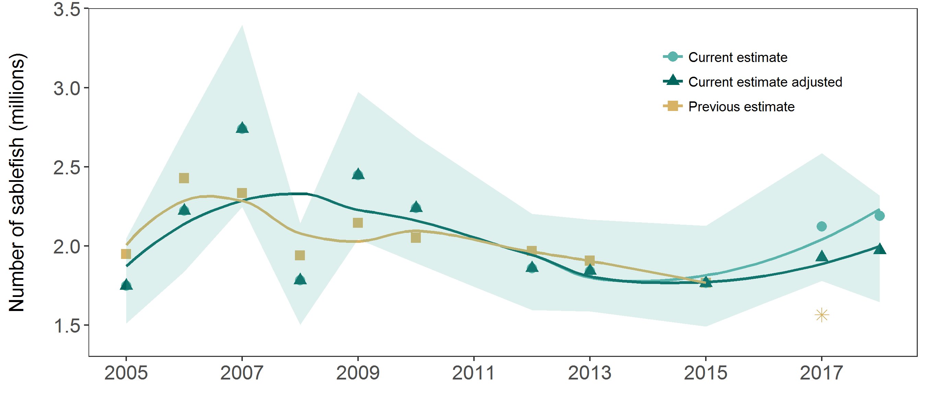

Figure 1. Abundance estimates from the current model (light green), adjusted current model (dark green), and previous against previous estimates of abundance (gold) from 2005 - 2017. Shaded areas indicate 95% credibility intervals from the posterior distribution. The gold asterix shows the past forecast of abundance in 2017, which was poorly estimated due to a lack of a mark survey in 2016.

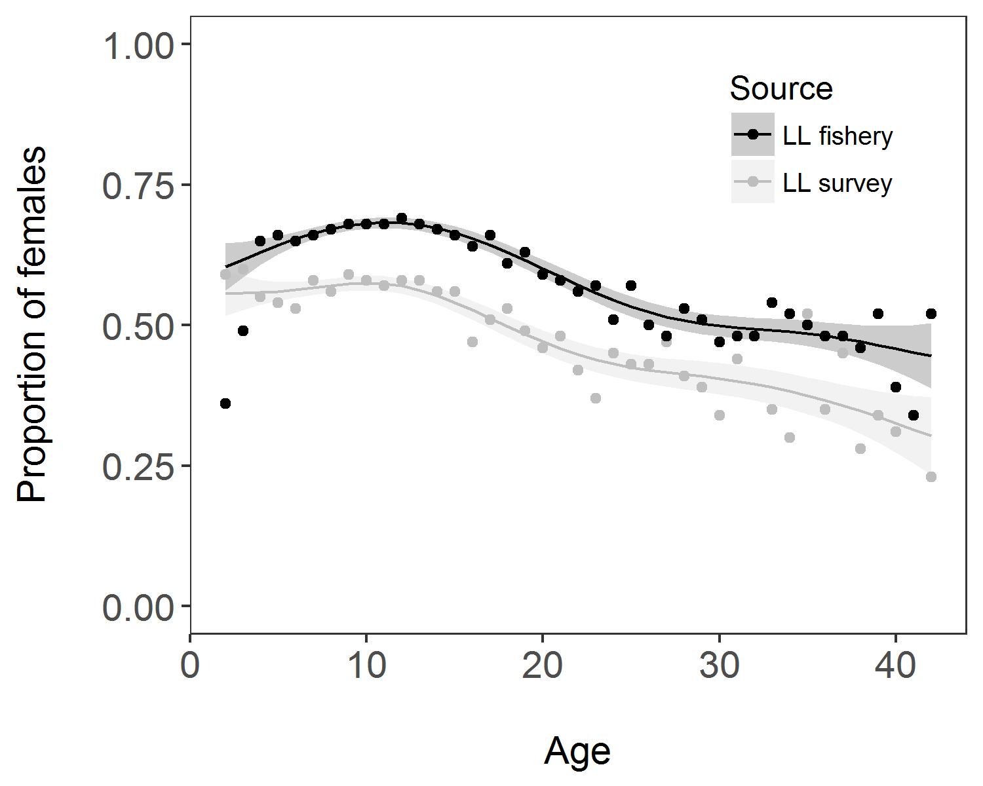

Figure 2. Proportion of females at age in the commercial longline fishery (black) and longline survey (grey). Shaded areas and smoothed curves are the predicted values and standard errors from a generalized additive model.

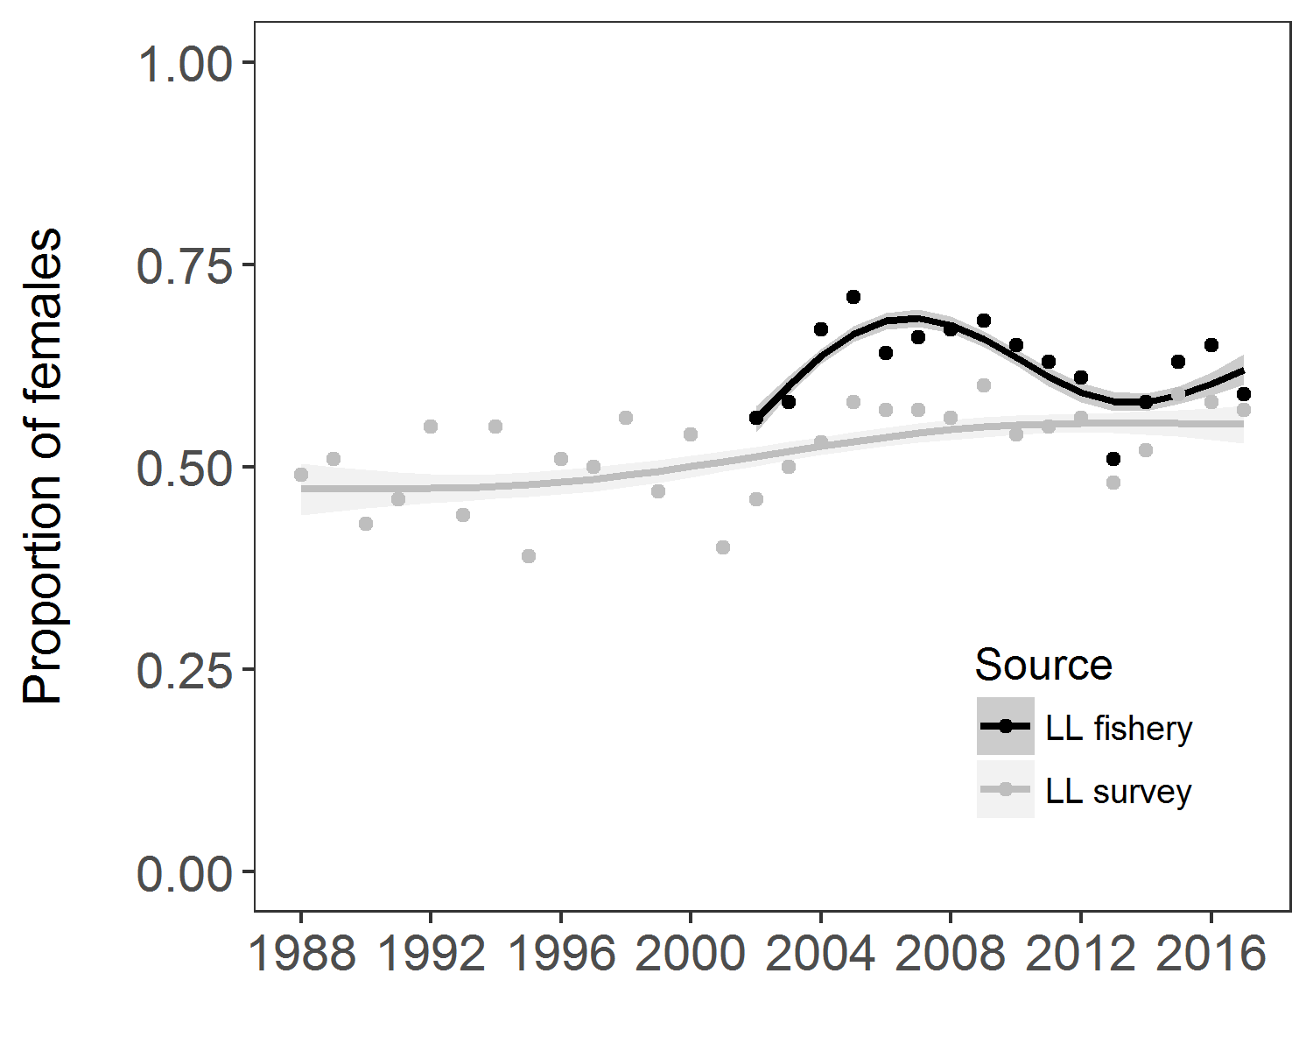

Figure 3. Proportion of females in the commercial longline fishery (black) from 2002 to 2017 and longline survey (grey) from 1988 to 2017. Shaded areas and smoothed curves are the predicted values and standard errors from a generalized additive model.

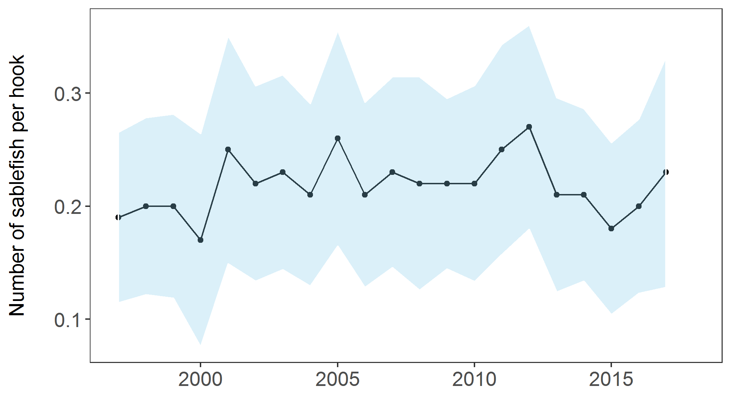

Figure 4. Longline survey CPUE in sablefish per hook (+/- 1 standard deviation), 1997 - 2017.

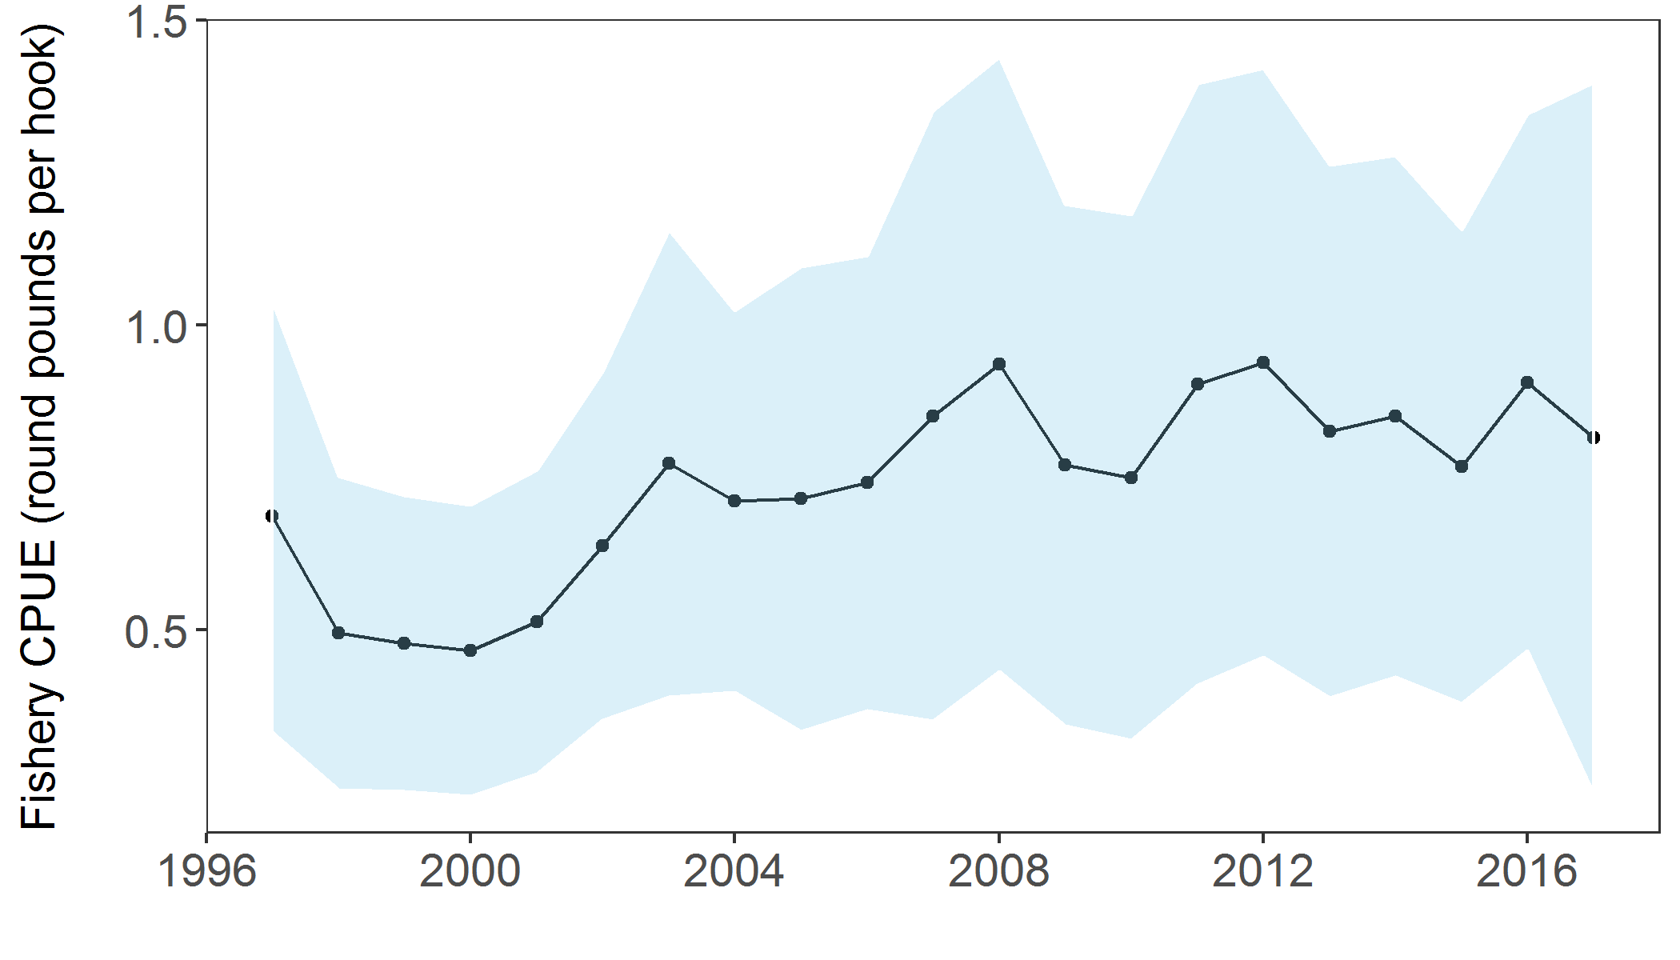

Figure 5. Commercial longline fishery CPUE in round pounds per hook (+/- 1 standard deviation), 1997 - 2017.

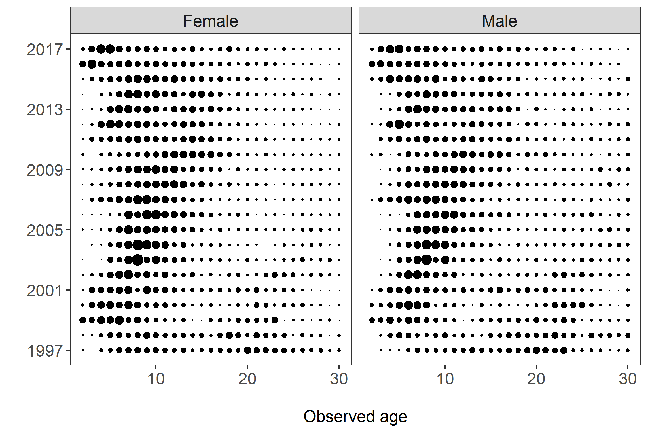

Figure 6. Proportions-at-age for males and females in the ADF&G longline survey, 1997 - 2017.

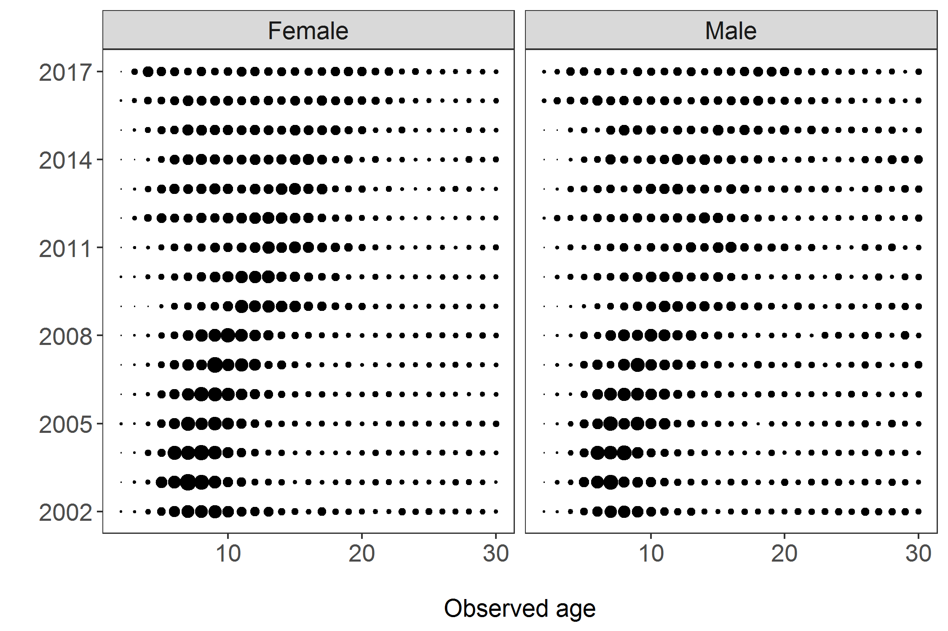

Figure 7. Proportions-at-age for males and females in the longline fishery, 2002 - 2017.

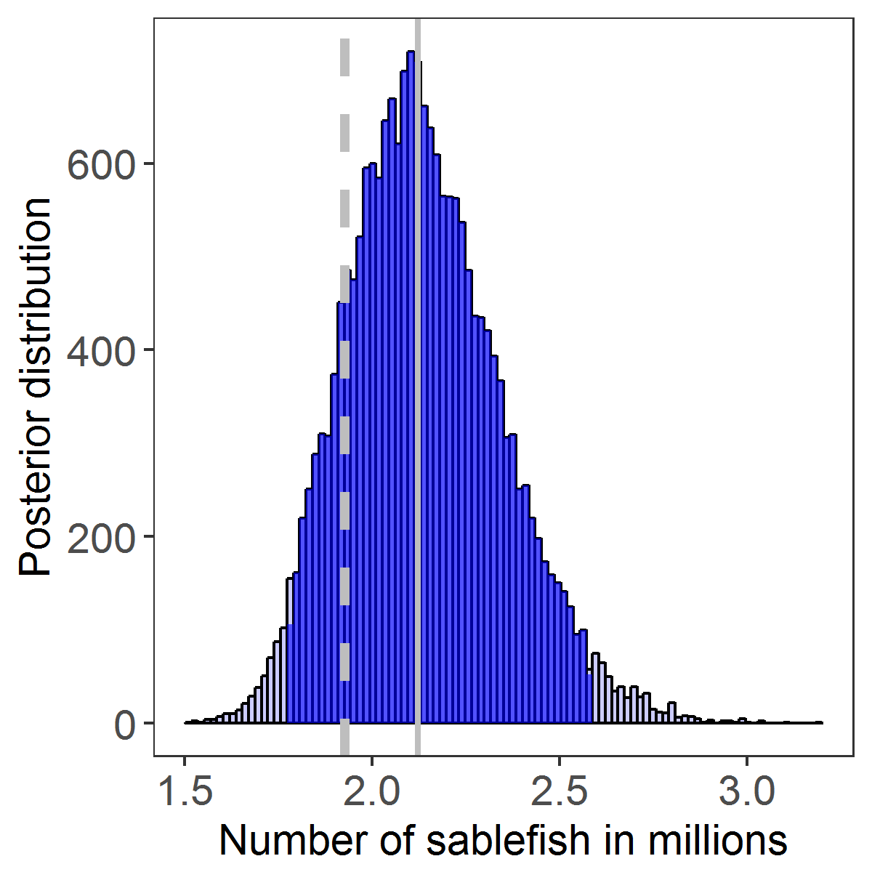

Figure 8. The posterior distribution of abundance (sablefish in millions) in 2017. The dark shaded area represents the 95% credibility interval, the solid grey line is the median abundance estimate, and the dashed grey line is the adjusted abundance estimate (15th percentile) recommended for the2018 forecast.

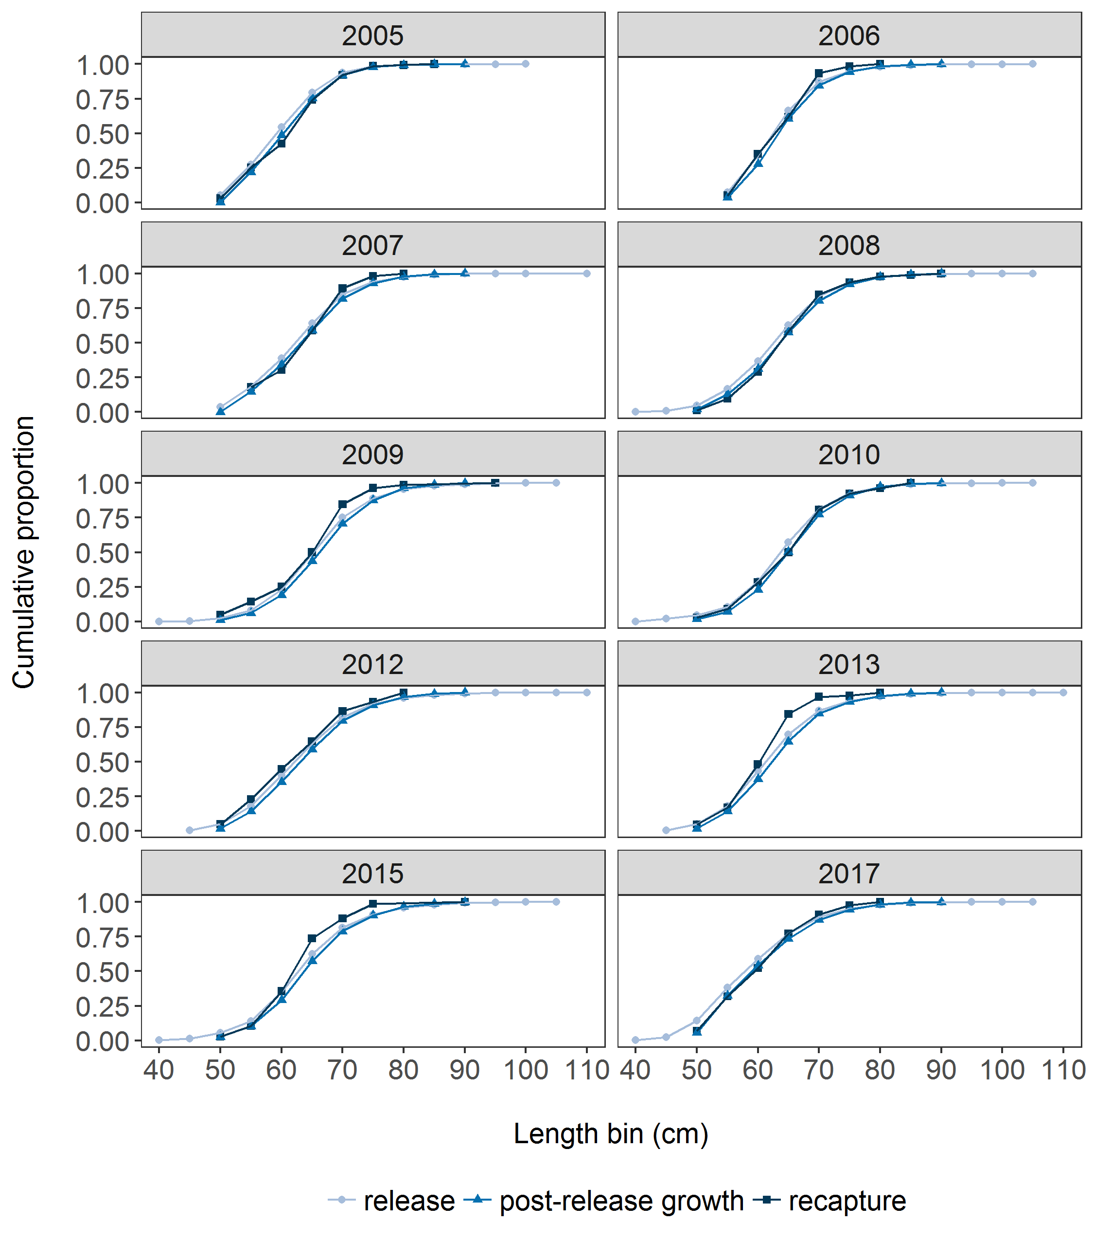

Figure 9. The proportion at length released, predicted growth after release, and recaptured in Chatham Strait by 5-cm length bins, 2005 - 2017. Statistical areas are arranged roughly north to south along each axis.

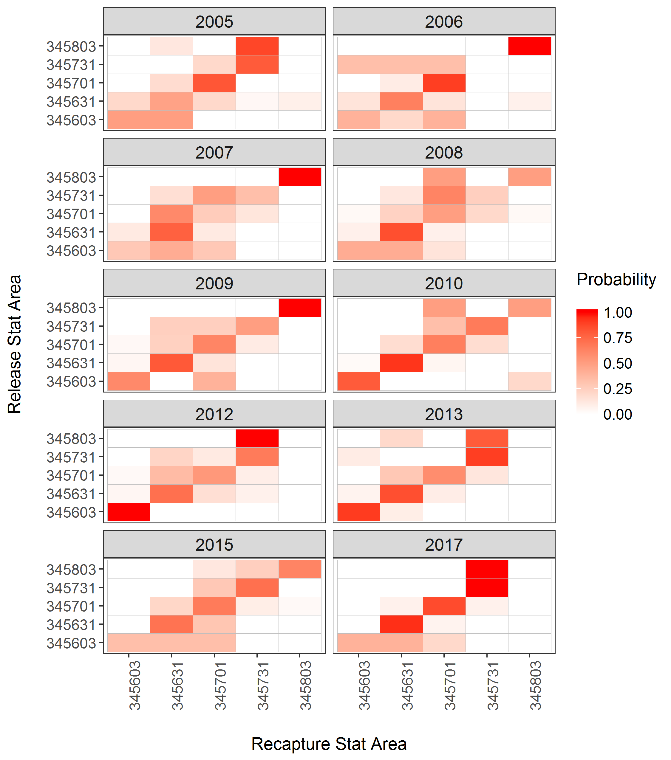

Figure 10. The probability of being recaptured in a statistical area given release area, 2005 - 2017. Statistical areas are arranged roughly north to south along each axis.

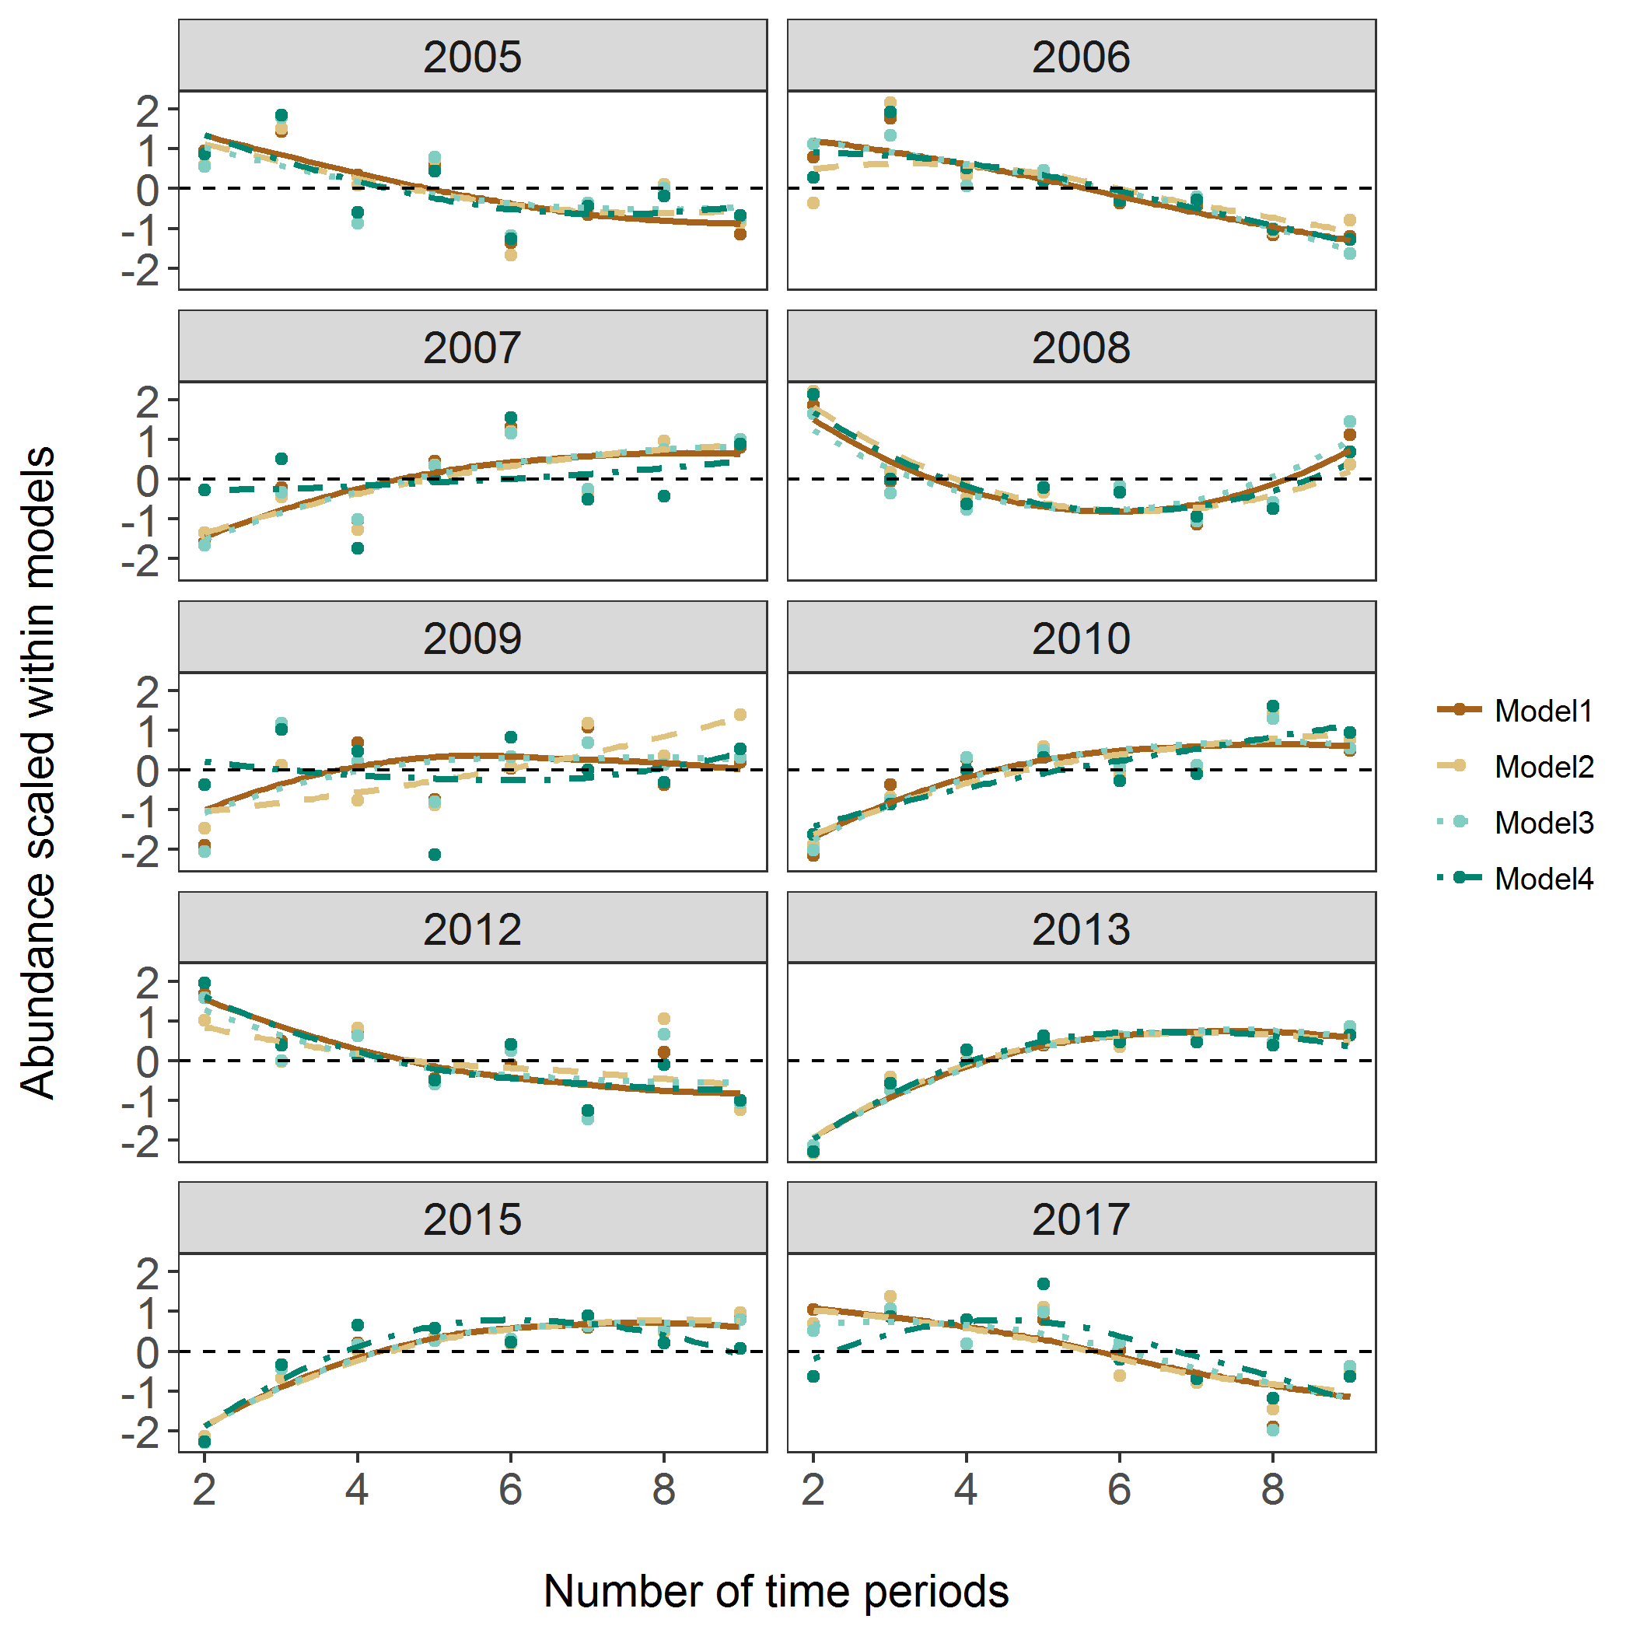

Figure 11. Centered and scaled abundance estimates from four mark-recapture models over a range of different numbers of time periods for years with a mark survey, 2005 - 2017.

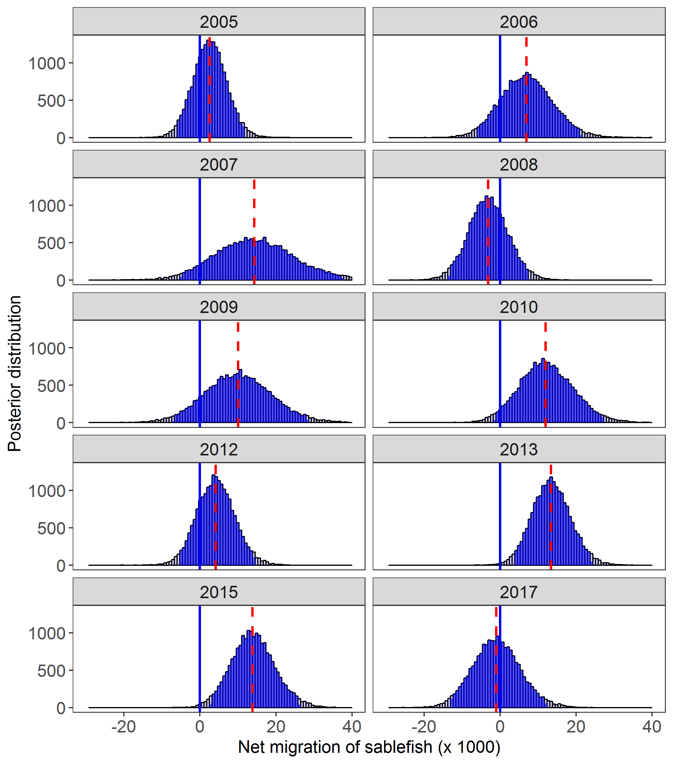

Figure 12. Posterior distribution of net migration into Chatham Strait with 95% credibility intervals shaded (Model 2, P=6). The median point estimate is denoted in the red dashed line. The solid blue line at net 0 migration aids in visualization of results across years with a mark survey, 2005 - 2017.

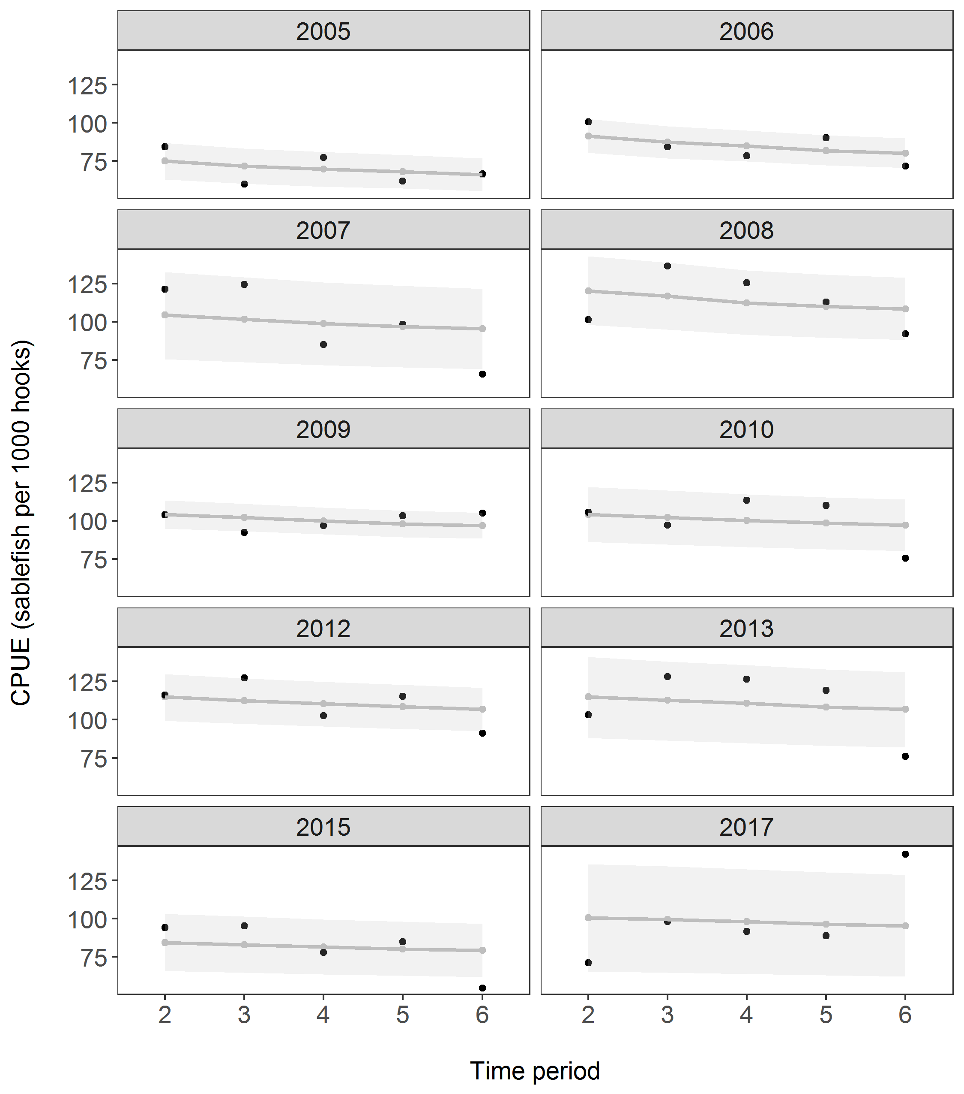

Figure 13. Observed (black) versus fitted (grey) CPUE (sablefish per 1000 hooks) in the longline fishery (Model 3, P=6) for years with a mark survey, 2005 - 2017. Grey shaded areas indicate 95% credibility intervals from the posterior distribution.