COVID19

J. Wall

2020-03-30

We will use this assignment to look at COVID-19 data

# First we will look at data in the US by county

The first portion of this work is thanks to Max Kuhn of RStudio.

theme_set(theme_bw())  
  
dat <-  
 read_csv("https://raw.githubusercontent.com/nytimes/covid-19-data/master/us-counties.csv")  
  
deaths_by_state <- dat %>%  
 group_by(state) %>%  
 summarize(total_deaths = max(deaths)) %>%  
 arrange(desc(total_deaths))  
  
deaths_by_state

## # A tibble: 55 x 2  
## state total_deaths  
## <chr> <dbl>  
## 1 New York 776  
## 2 Washington 146  
## 3 Louisiana 73  
## 4 Michigan 56  
## 5 Illinois 40  
## 6 California 37  
## 7 New Jersey 35  
## 8 Georgia 23  
## 9 Connecticut 21  
## 10 Nevada 14  
## # ... with 45 more rows

# total deaths   
sum(deaths_by_state$total_deaths)

## [1] 1378

# Latest data from:  
max(dat$date)

## [1] "2020-03-29"

* **Exercise 1:** produce a tibble that has both deaths and total cases per state, arranged by the total number of cases in descending order

## # A tibble: 55 x 3  
## state total_deaths total_cases  
## <chr> <dbl> <dbl>  
## 1 New York 776 33768  
## 2 Illinois 40 3445  
## 3 New Jersey 35 3020  
## 4 Michigan 56 2704  
## 5 Washington 146 2163  
## 6 California 37 2136  
## 7 Florida 11 1471  
## 8 Louisiana 73 1350  
## 9 Connecticut 21 1245  
## 10 Massachusetts 9 981  
## # ... with 45 more rows

## [1] "total deaths = 1378"

## [1] "total cases = 62263"

## [1] "latest data from: 2020-03-29"

Now we will choose just a few states to look at

dat_small <-  
 dat %>%  
 filter(state %in% c("South Carolina", "Connecticut")) %>%  
 mutate(county = factor(county))  
  
dat_small %>%  
 filter(state == "Connecticut") %>%  
 ggplot(aes(x = date, y = cases, group = county, col = county)) +  
 geom_line() +  
 geom_point() +  
 facet_wrap(~ state) +  
 scale_y_log10() +  
 scale_color_brewer(palette = "Set1")

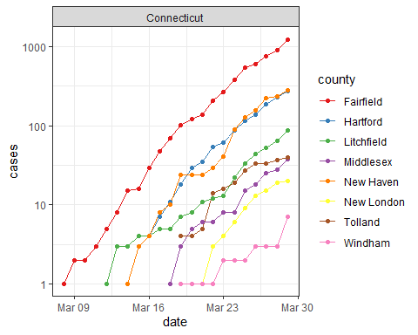

* **Exercise2:** (1 1/2 points) Do the analysis like above for the DMV area (DC, MD and VA) for both deaths and total cases. Use <http://www.theusgenweb.org/dcgenweb/geography/counties.shtml> for the counties in the DMV area. Be sure you get them all (hint: look at spelling in the dataset versus spelling you are entering)

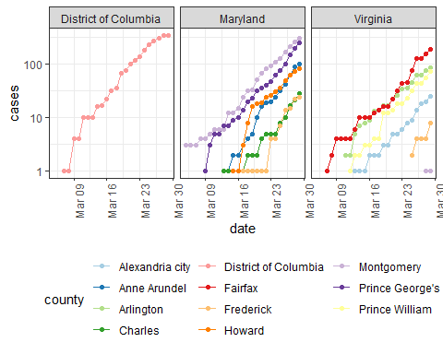

* **Exercise 3:** (1 1/2 points) Graph the total number of cases by date in the DMV area and the total deaths by date.

## [1] "total deaths = 13"

## [1] "total cases = 1499"

## [1] "latest data from: 2020-03-29"

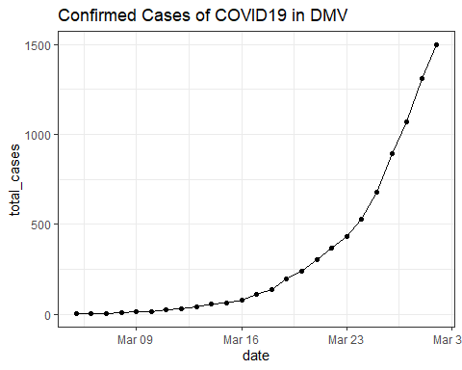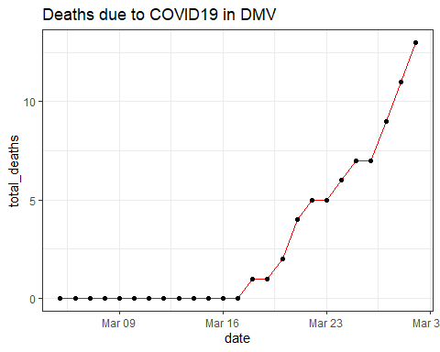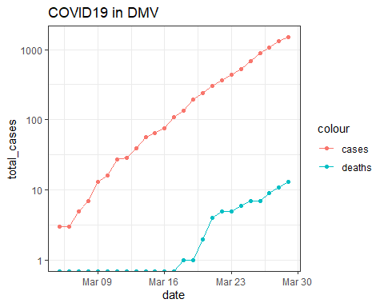

# Get and clean worldwide Data

* **Exercise 4:** Get data from (<https://raw.githubusercontent.com/CSSEGISandData/COVID-19/master/archived_data/archived_time_series/time_series_19-covid-Confirmed_archived_0325.csv>). After you have read in the dataset, create a new variable calles Country/State that combines the country with the province/state and tidy the dataset.

## # A tibble: 6 x 7  
## `Country/State` `Province/State` `Country/Region` Lat Long Date   
## <chr> <chr> <chr> <dbl> <dbl> <date>   
## 1 Thailand <NA> Thailand 15 101 2020-01-22  
## 2 Thailand <NA> Thailand 15 101 2020-01-23  
## 3 Thailand <NA> Thailand 15 101 2020-01-24  
## 4 Thailand <NA> Thailand 15 101 2020-01-25  
## 5 Thailand <NA> Thailand 15 101 2020-01-26  
## 6 Thailand <NA> Thailand 15 101 2020-01-27  
## # ... with 1 more variable: Confirmed_Cases <dbl>

* **Exercise 5:** Find the 25 Country/State’s with the most Confirmed Cases (Hint: use group_by, summarize and ungroup?)

## # A tibble: 25 x 3  
## `Country/State` `Country/Region` ttl  
## <chr> <chr> <dbl>  
## 1 China_Hubei China 2894885  
## 2 Italy Italy 497959  
## 3 Iran Iran 252770  
## 4 Spain Spain 186200  
## 5 Korea, South Korea, South 181699  
## 6 Germany Germany 160974  
## 7 France_France France 117724  
## 8 China_Guangdong China 67015  
## 9 US_New York US 64538  
## 10 China_Henan China 61811  
## 11 China_Zhejiang China 61207  
## 12 China_Hunan China 50256  
## 13 China_Anhui China 47647  
## 14 Switzerland Switzerland 46413  
## 15 China_Jiangxi China 45181  
## 16 United Kingdom_United Kingdom United Kingdom 35081  
## 17 China_Shandong China 33603  
## 18 China_Jiangsu China 30272  
## 19 China_Chongqing China 28659  
## 20 Netherlands_Netherlands Netherlands 28030  
## 21 Cruise Ship_Diamond Princess Cruise Ship 26228  
## 22 China_Sichuan China 25719  
## 23 China_Heilongjiang China 21991  
## 24 Belgium Belgium 21324  
## 25 China_Beijing China 20967

* **Exercise 6:** (2 points) Plot the number of cases over time for the top 25 country/states. Use appropriate scales for the axes.

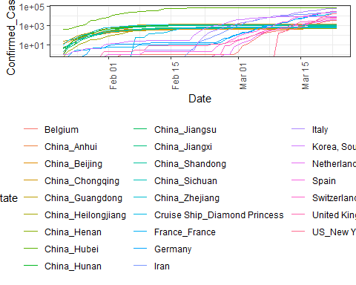

* **Exercise 7:** (2 points) Get the data for the state of NY from this csse dataset and compare the growth of cases from this dataset to the growth shown in the nytimes dataset used for exercises 1-3. Does the data match? If not, how is it different?

## # A tibble: 29 x 3  
## Date Confirmed_Cases n  
## <date> <dbl> <dbl>  
## 1 2020-03-01 NA 1  
## 2 2020-03-02 NA 1  
## 3 2020-03-03 NA 2  
## 4 2020-03-04 NA 11  
## 5 2020-03-05 NA 22  
## 6 2020-03-06 NA 44  
## 7 2020-03-07 NA 89  
## 8 2020-03-08 NA 106  
## 9 2020-03-09 NA 142  
## 10 2020-03-10 173 173  
## 11 2020-03-11 220 217  
## 12 2020-03-12 328 326  
## 13 2020-03-13 421 421  
## 14 2020-03-14 525 610  
## 15 2020-03-15 732 732  
## 16 2020-03-16 967 950  
## 17 2020-03-17 1706 1374  
## 18 2020-03-18 2495 2382  
## 19 2020-03-19 5365 4152  
## 20 2020-03-20 8310 7102  
## 21 2020-03-21 11710 10356  
## 22 2020-03-22 15793 15168  
## 23 2020-03-23 15793 20875  
## 24 2020-03-24 NA 25666  
## 25 2020-03-25 NA 33067  
## 26 2020-03-26 NA 38988  
## 27 2020-03-27 NA 44636  
## 28 2020-03-28 NA 53364  
## 29 2020-03-29 NA 59568

