A co-expression network analysis on European and American maize

**Author:** Jan Izquierdo i Ramos  
**Supervisor:** Dr. Georg Haberer

Bachelor’s Degree in Bioinformatics - UPF, UPC, UB, UAB

Plant Genome and Systems Biology - Helmholtz Munich

# Introduction

Gene expression serves as a fundamental indicator of gene function, it provides critical insights into the biological activity of an organism. The transcription of a gene into RNA is a crucial step in gene activity, therefore, it is highly regulated. This regulation is both temporal and spatial, ensuring that genes are expressed in specific tissues at concrete developmental stages and is essential for orchestrating complex biological processes. Because of its importance this regulation has been studied extensively, comprehensive gene expression atlases have been established to capture these patterns in many model organisms.

This specificity of expression allows for the detection of the function of a gene in a specific time and tissue. Beyond detection in development, dynamic changes in gene expression serve as clues to identify environmental stimuli or other external stressors because they can serve as a response to these.

By the analysis of expression patterns, researchers can infer gene functions, regulatory networks are discovered and better understandings of organism adaptability are reached.

To analyze gene expression it has to be measured, there are several techniques that can be used, early methods included qPCR and Northern blots, which only allowed tracking of the expression of one gene, nowadays RNA-seq is the preferred, and widely used, technique as it allows for genome-wide expression profiling. RNA-seq bases the gene expression in the number of sequencing reads that align to a given gene. These are a direct measurement of transcript abundance and require distinct statistics and methods to ensure compatibility in comparisons. To account for differences in sequencing depth and gene length different approaches exist:

* Transcripts per million (TPM): Takes into account gene length and total sequencing depth, ensuring that expression values sum to one million across a sample.
* Counts per million (CPM): Adjusts for sequencing depth by scaling counts per million mapped reads.
* Reads per kilobase per million mapped reads (RPKM): Normalizes by both, individual gene length and sequencing depth.

The primary objective of normalization is to detect differentially expressed genes (DEG), genes in which significant expression differences can be observed between tissues, developmental stages or environmental conditions. Traditional expression analyses are generally being phased out because they focus on comparing the expression of individual genes, however, genes rarely function in isolation, they rather operate within a biological context, forming coordinated units named functional modules. To map and understand these complex module relationships, approaches that extend beyond single-gene analysis are used, gene co-expression networks.

## Gene co-expression

Gene co-expression refers to the coordinated expression of genes across tissues, developmental stages or environmental conditions. The typical co-expression analysis employs pairwise comparisons of gene expression levels, identifying genes that show similar expression patterns across samples. These patterns provide information on possible relationships between genes, which give insights into functional associations, as genes that exhibit correlated expression patterns are often involved in the same biological processes or pathways.

This principle is the basis of the guilt-by-association rule, which dictates that unknown functions of genes can be inferred based on the co-expression of genes with known functions.

Co-expression is quantified using statistical correlation measures, including Pearson and Spearman correlations. Pearson correlation measures linear relationships between two gene expression profiles and sets the relation in a -1 to 1 scale, from perfect inverse correlation, to perfect correlation. Spearman’s correlation captures monotonic relationships between two variables by ranking their values and computing Pearson correlation on the ranks. Spearman presents no distributional assumptions while Pearson assumes normally distributed data, this makes Spearman more robust in settings that present heterogeneous samples or nonlinear regulatory mechanisms, which is not the case of this study.

|  |  |
| --- | --- |
| 12§display§r_{xy} = \frac{\sum\limits_{i=1}^{n} (x_i - \overline{x})(y_i - \overline{y})}{\sqrt{\sum\limits_{i=1}^{n} (x_i - \overline{x})^2} \sqrt{\sum\limits_{i=1}^{n} (y_i - \overline{y})^2}}§svg§600§FALSE§p |  |

Figure 1: Pearson correlation and Spearman rank correlation formulas.

Highly co-expressed gene pairs show nearly identical expression profiles across samples, while lowly co-expressed gene pairs would display no correlation pattern. The number of samples heavily influences the reliability of correlation estimates, datasets with fewer samples are more susceptible to senseless correlations. Normalization has a strong effect on correlation as raw counts introduce biases due to library size differences. Measures such as RPKM or CPM provide more accurate estimates by standardizing expression values across samples.

## Co-expression networks

Co-expression networks are the next step to pairwise gene co-expression analysis, while pairwise comparisons provide insights between individual genes, network-based approaches allow for a comprehensive understanding of the interaction between any set of genes; they can even extend the comparisons to cover entire transcriptomes. These networks are essential in the identification of functional gene modules, regulatory pathways and key genes in biological processes.

Graphs are the ideal data structure for the representation of gene interactions in co-expression networks, genes are modelled as nodes while edges represent significant co-expression relationships, the significance is determined by statistical metrics such as Pearson or Spearman correlation coefficients.

A thresholding step is required to determine the inclusion and exclusion of co-expression between genes, it is applied to retain only statistically significant correlations, otherwise, random noise would prevail over biologically meaningful associations.

The ability to identify gene modules is one of the key advantages of co-expression networks, gene modules are clusters of tightly related genes which are likely to share common biological functions. Various clustering algorithms and graph-based methods are available for the detection of these modules:

* Hierarchical clustering groups genes based on similarity in expression patterns.
* Clique-based approaches identify groups of genes that form highly interconnected sub-networks
* Community detection algorithms such as Markov clustering or Louvain modularity, which divide networks into biologically relevant groups.

By the “guilt-by-association” principle and gene modules researchers can infer gene functions of unknown genes that cluster with well-characterized genes, as they are probably involved in similar processes.

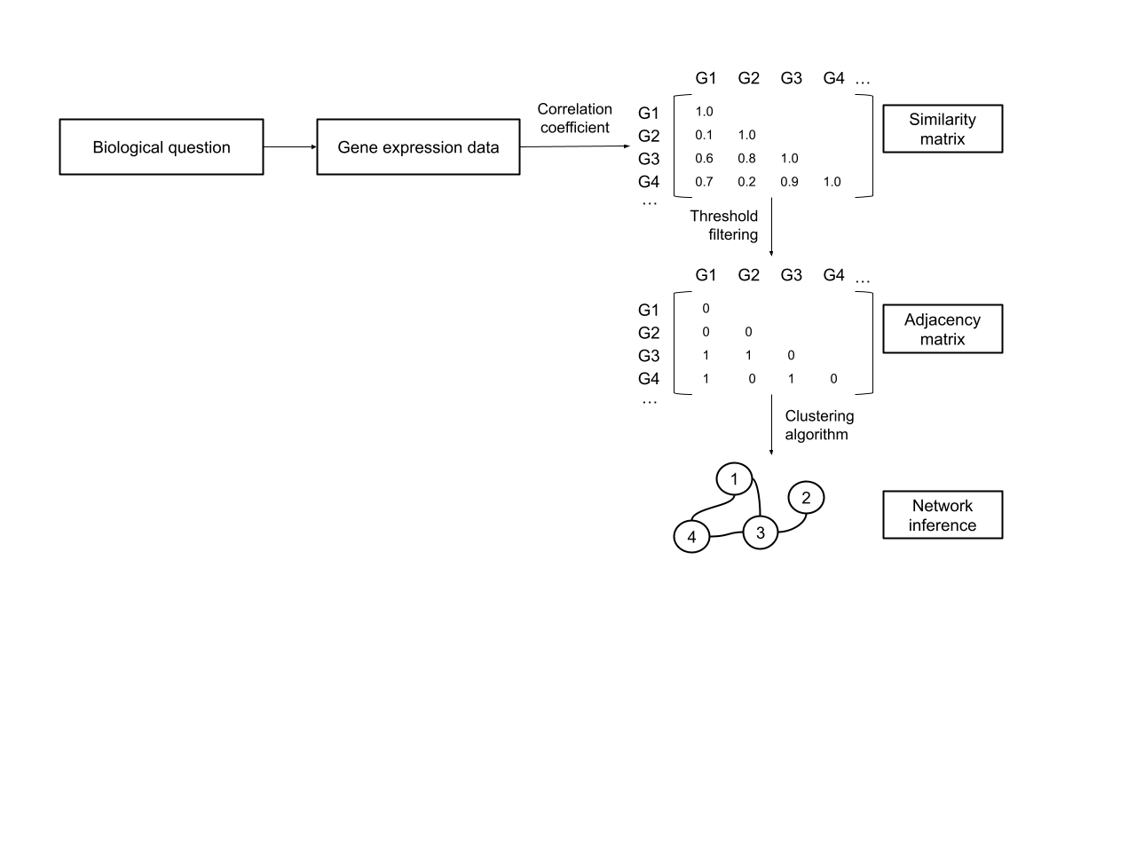

Figure 2: Simplified representation of the process for network building. [(Serin et al., 2016, p. 4)](https://www.zotero.org/google-docs/?SXDo3b)

## WGCNA

To construct and analyze co-expression networks the most widely used method is Weighted Gene Co-Expression Network Analysis (WGCNA). It is an approach designed to identify gene modules and explore their relation with phenotypic traits. Simple correlation-based networks use strict thresholds to determine edges, while WGCNA constructs a weighted network, where edges are assigned continuous values to reflect the strength of the co-expression relationship. [(Langfelder & Horvath, 2008)](https://www.zotero.org/google-docs/?bFGtUv)

WGCNA follows a series of steps to construct and analyze networks, the process begins by using Pearson or Spearman correlations to compute the pairwise correlation coefficients between gene expression profiles, with those correlations an adjacency matrix is constructed. The matrix quantifies the strength of the co-expression relationship between genes.

Next, a soft thresholding power is applied to the matrix to transform it into a weighted network. This highlights strong correlations and diminishes the influence of weaker associations, ensuring a better reflection of underlying gene interactions and therefore an enhancement in biologically important connections.

The network structure is further refined through the calculation of a Topological Overlap Matrix (TOM), which takes into consideration relationships between pairs of genes and the shared interactions that happen with the whole network. This additional layer of connectivity collaborates in the identification of biologically relevant clusters and improves the robustness of the network.

Following the refinement of the co-expression network the genes are grouped into similarly expressed modules, these modules are determined by using hierarchical clustering and dynamic tree-cut algorithms and represent sets of genes with highly similar expression patterns, which suggests potential functional relationships.

Finally, the identified modules are correlated with external traits to assess their biological significance and relations. Links can be established using co-expression patterns and specific biological processes by integrating variables such as tissues, developmental stages, environmental conditions or phenotypic traits.

This also allows for the analysis of specific relations between modules, and therefore genes, in detailed conditions or tissues, and also how a concrete environmental condition might affect the whole transcriptome.

## Maize lines and transcriptional variation

Maize is a widely produced crop, one of the 3 most important plants worldwide, it surpasses the global production of wheat and rice and has become a staple food around the world, it has uses as human and animal aliment, as a resource in industrial products and as a model organism in genetics. The widespread cultivation of this crop is because it presents a high yield potential, extensive genetic diversity and is extremely adaptable. The mentioned genetic diversity is manifested in the existence of multiple maize germplasms like Flour maize, Sweet maize, Dent maize and Flint maize. Also the use of this diversity has been extensively exploited in breeding programs to increase agronomic efficiency, the most common method is inter-group hybridization, which exploits heterosis for better yields.

This genetic diversity of maize has been well documented, pan-genome studies present clear evidence of the multiple aspects that this crop presents [(Haberer et al., 2020)](https://www.zotero.org/google-docs/?OrTqm6). However, the effect of this high genomic variability on the transcriptional variation of different maize lines presents a lot of research opportunities. Understanding the transcriptional diversity and differences present in these lines is necessary for uncovering how genetic differences have affected the regulation and functional pathways causing the phenotypic variations into multiple maize lines. By analysing gene co-expression networks that include multiple lines, relationships can be found between gene expression, phenotypic traits and differences in genome structure and organization.

To explore this, the present study focuses on five maize lines: B73, DK150, EP1, F7 and PE75. B73 belongs to the U.S. Dent maize group is a widely used reference genotype, for example, it serves as a benchmark for comparative analysis. DK150, EP1 and F7 are all European Flint lines, originating from southern Germany, northern Spain and southern France. And PE75 is a derivation from a German landrace, the Petkuser Ferdinand Rot population, a doubled-haploid line to represent a more genetically diverse background.

A comprehensive transcriptome atlas was generated to capture expression profiles across 30 tissues in the 5 maize lines, with multiple samples per tissue for a better representation of the data. Tissues from different zones of the plant and through multiple developmental stages were chosen, like *crown root*, *cob*, *leaf*, *root* and *seed*.

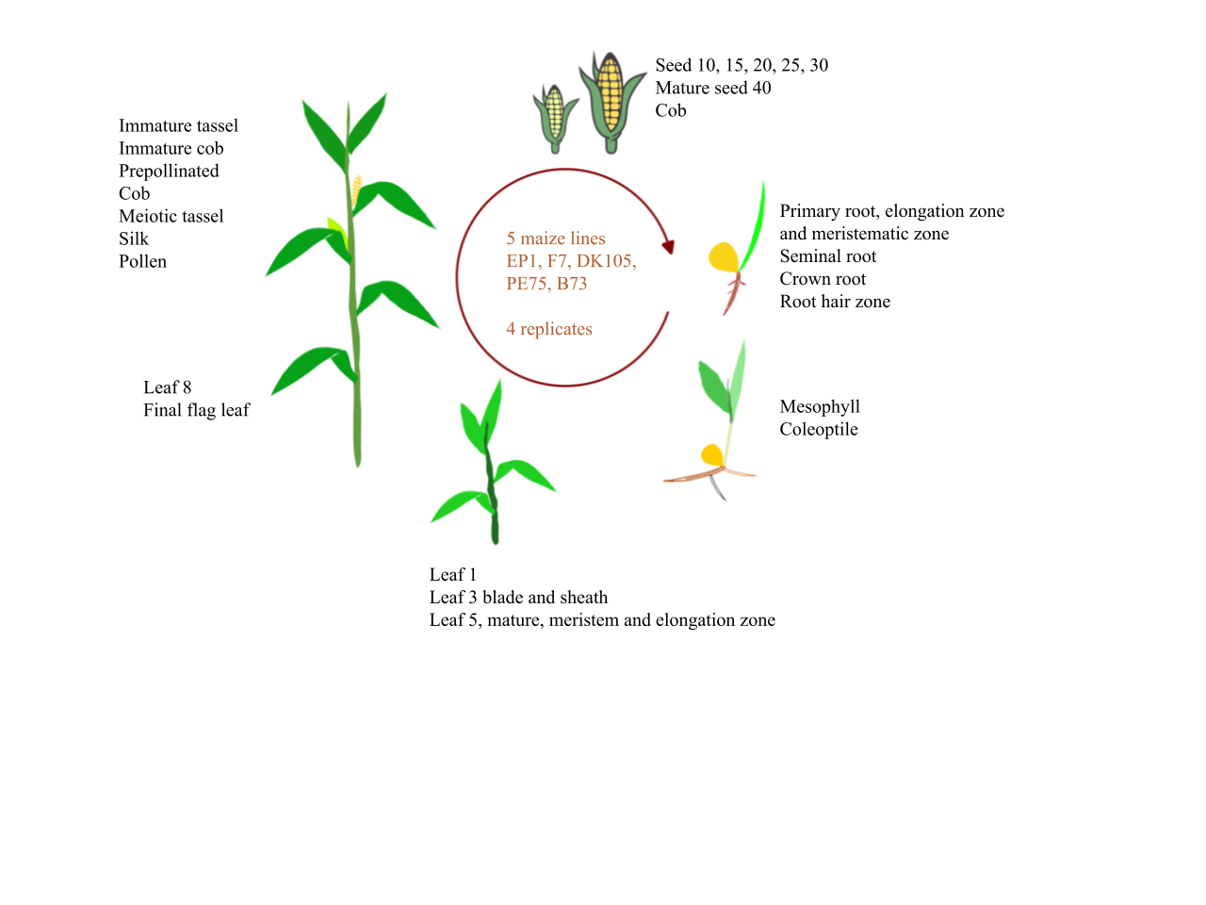

Figure 3: Representation of the stages and tissues where data from the 5 maize lines was gathered. (Image provided by Dr. Georg Haberer)

This dataset contains the data for constructing genotype-specific gene co-expression networks, enabling the creation of networks for comparative analysis of transcriptional organization across different genetic backgrounds. Using WGCNA, gene modules specific to each genotype are separately examined for biological relevance. Using these co-expression networks, the study intends to measure and determine the amount of co-expression variance between genotypes, whether specific functional modules are unique to certain genetic backgrounds, the effects location may have had in the expression and therefore phenotype development of these lines and how these differences reflect the underlying regulatory mechanisms.

By integrating genotype-specific expression data in the co-expression analysis, this research aims to contribute to a deeper understanding of transcriptional regulation in maize and its relationship to genetic diversity.

# Objectives

This study intends to understand the relationship between the gene expression patterns in 5 different maize lines and the phenotypic differences they present by the employment of gene co-expression networks.

An essential part of the study is to determine whether common gene modules are present across the maize lines, how they relate to phenotypic similarities, which modules are most common to be conserved and to which phenotypic traits they relate. Complementary to this objective, the study also aims to examine the diverging modules across lines and uniqueness of modules, the transcriptional variations that stem from these and their contribution to phenotypic divergence.

The ultimate goal of this research is to contribute to a broader understanding of the maize transcriptome by offering insights into the effect that gene expression has on genetic diversity. The finality that it leads to is to provide a basis for further research on maize breeding, genetic adaptation, and crop improvement.

# Methods

## Data filtering

The produced data and metadata contains errors and low quality samples, it will need to be processed for cleaning. This process begins with an evaluation of the metadata, where the quality of the samples is assessed. Specifically, a quality score of 0 indicates high-quality samples, while scores of 1, 2, or 3 denote progressively lower quality, with 3 representing the poorest-quality samples. After careful observation a discrepancy was identified between the number of samples in the data and metadata, this can be tracked to samples belonging to the pollen tissue, which are present in metadata but they have no expression data. The lack of pollen samples in data is due to the challenges associated with sequencing pollen tissue, from which not enough genetic material could be extracted for successful sequencing.

To ensure consistency between gene expression data and metadata an R script that removed any samples that were not present in both datasets was used.

Subsequently, the renaming of a metadata column containing coded tissue identifiers was executed using a python script, the objective was to rewrite arbitrary numerical and alphanumeric codes with formalized tissue abbreviations, for a better readability of the data. This transformation was done by observing the data and creating a reference dictionary, and systematically substituting each code by an abbreviation.

Then the final step in the data preprocessing is to partition the data into the different lines, as the intended analysis is a co-expression analysis of traits within the individual species. The R script merges the metadata with the gene expression data and subsequently divides the dataset into separate tables for each species. After this, they are split again into CSV and TXT files containing the expression data and metadata for each maize line.

## Replicates in the data

For all subsequent analyses, the data was processed separately for each maize line. The first step involved removing outlier genes using WGCNA module functions in R. This was done to remove data points which would heavily skew our data while contributing minimal biological relevance.

Following this, the replicate samples for all tissues were merged to address potential imbalances in the dataset. This was done to avoid bias in the analysis caused by discrepancies in replicate numbers, as if there were to be 4 replicates belonging to tissue *silk* and only 1 belonging to tissue *crown root*, that would skew the results. To solve this imbalance the expression values for each gene across all replicates of a given tissue were summed and then averaged by dividing by the number of replicates, ensuring an equal contribution from all replicates to the final dataset.

## Normalization

To be able to extract conclusions from a counts table, normalization is needed. The goal of normalization is to ensure that read counts represent differences in true gene expression. This enables meaningful comparisons across samples while reducing noise in the data, thereby facilitating pattern recognition.

Normalization is crucial because raw gene expression values are not inherently comparable between samples, the total number of reads can vary across samples and so a large difference in a gene’s read count between different conditions may simply be the result of differential coverage.

Raw gene expression comparisons are also affected by random variability in the alignment to a given gene within a specific sample. Additionally, normalization is needed because it also accounts for variations in the total RNA content across samples, ensuring their compatibility for comparison.

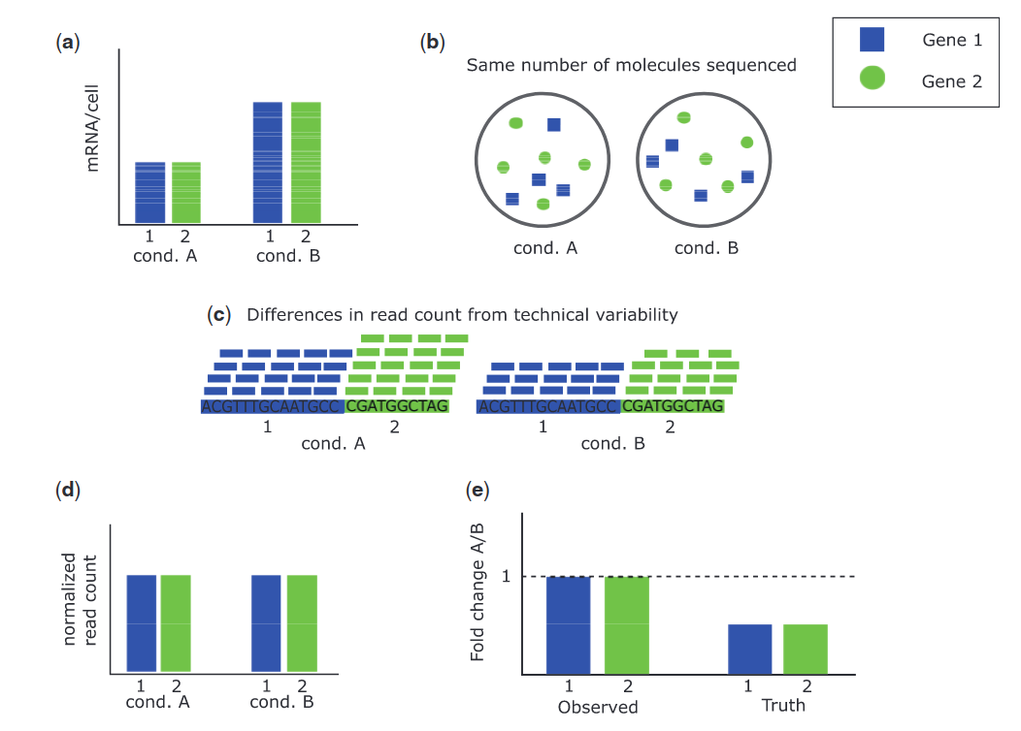

Figure 4: Two genes, and an experiment to compare expression between condition A and condition B. **(A)** Global up-regulation under condition B for both genes, the same amount of mRNA/cell is produced. **(B)** Same number of molecules sequenced under the 2 conditions, and the two genes produce the same amount of mRNA, as gene 2 is four-fifths the length of gene 1, so it must produce five-fourths the number of molecules that gene 1 does. **(C)** Sequenced reads are aligned to the reference genome and mapped to each gene. The distribution of reads is the same in each sample, but by chance the sample for condition A happens to have more reads in total. **(D)** A normalization process is executed, it removes the differences in read count from technical variability, which stabilizes the counts for the genes in both conditions. **(E)** In (D) the normalized read counts are the same, the observed fold change for each gene is 1, indicating no differential expression. However, the genes are twice as expressed under condition B, so we should observe half the expression when comparing A to B. [(Evans et al., 2017, p. 4)](https://www.zotero.org/google-docs/?SXStAJ)

There are multiple approaches to data normalization: by library size, by control genes and distribution-based methods. Each of these approaches relies on a specific parameter such as gene length or a gene group as reference. Moreover, different assumptions are made for each approach, therefore choosing the right approach is key, as wrong assumptions can lead to erroneous results as shown in Figure 1.3. In this study, normalization was performed by library size, more concretely using these 2 methods: Reads Per Kilobase per Million mapped reads (RPKM) and Counts Per Million (CPM), which were both used and subsequently compared against each other to determine the most suitable approach..

The RPKM method accounts for gene length and sequencing depth but may be biased by RNA composition differences. Additionally, it is not ideal for cross-sample comparisons. And CPM is a method that adjusts only for sequencing depth and performs well when comparing samples with similar composition. However, in CPM normalization longer genes may appear more highly expressed.

To select the appropriate method, the dataset was processed using both methods and the results were evaluated. The program hinges on the edgeR R package to provide the normalization and it uses the same process to apply a logarithmic transformation to the data. The distribution of normalized values was then visualized graphically for each method to assess its effectiveness.

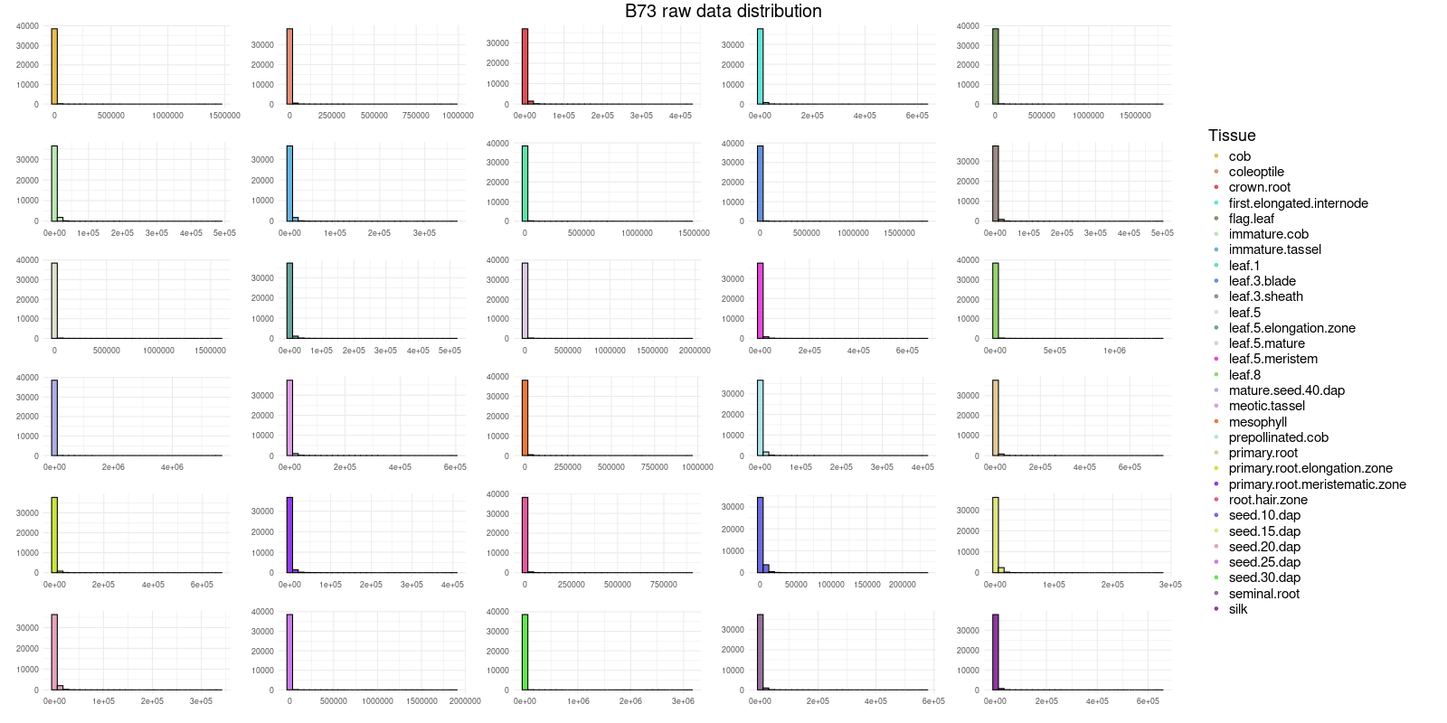Figure 5: Plot of the distribution of the gene expression data for all tissues of maize line B73 with no normalization.

Figure 5 is raw data distribution, it can be seen that most genes present the expression at similar, very low, levels, if the data is normalized the visualization will be better.

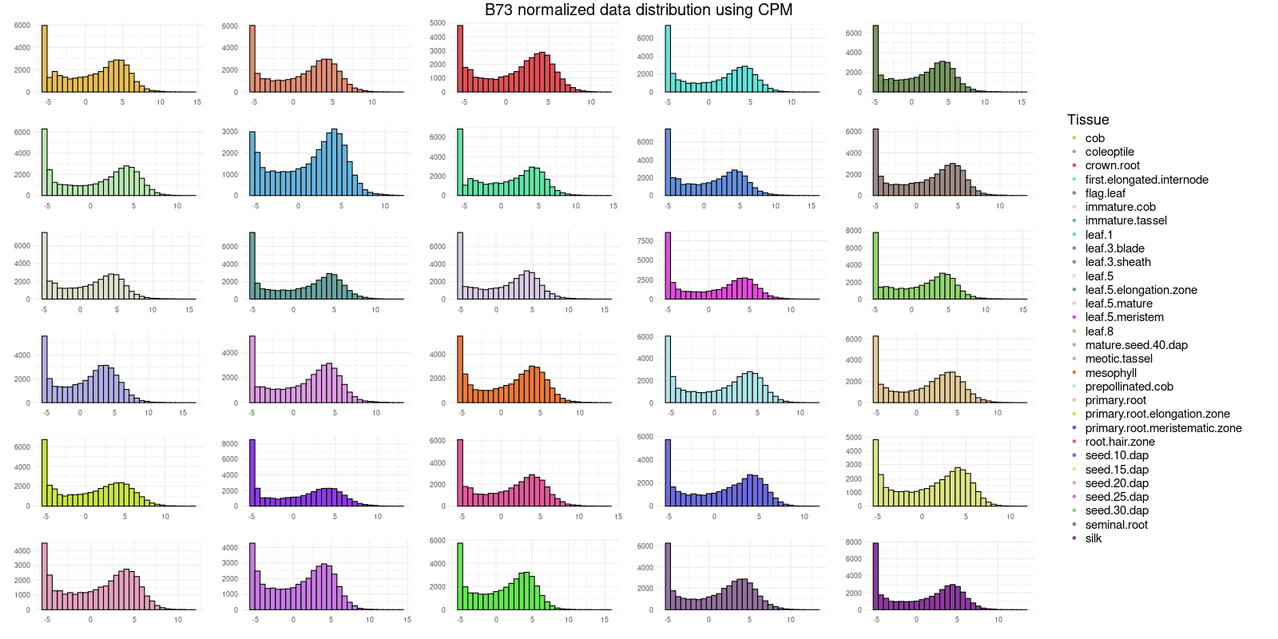*Figure* 6.1*:* Plot of the distribution of the gene expression data for all tissues of maize line B73 where CPM normalization was performed using edgeR.

In Figure 6.1 the data has been normalized using CPM, however, an anomaly can be observed in the distribution, an extreme increase in low expression representation which means that the data is not correctly normalized. The resulting distribution appears to be a bimodal distribution, with an irregular peak present in the region of low expressed genes.

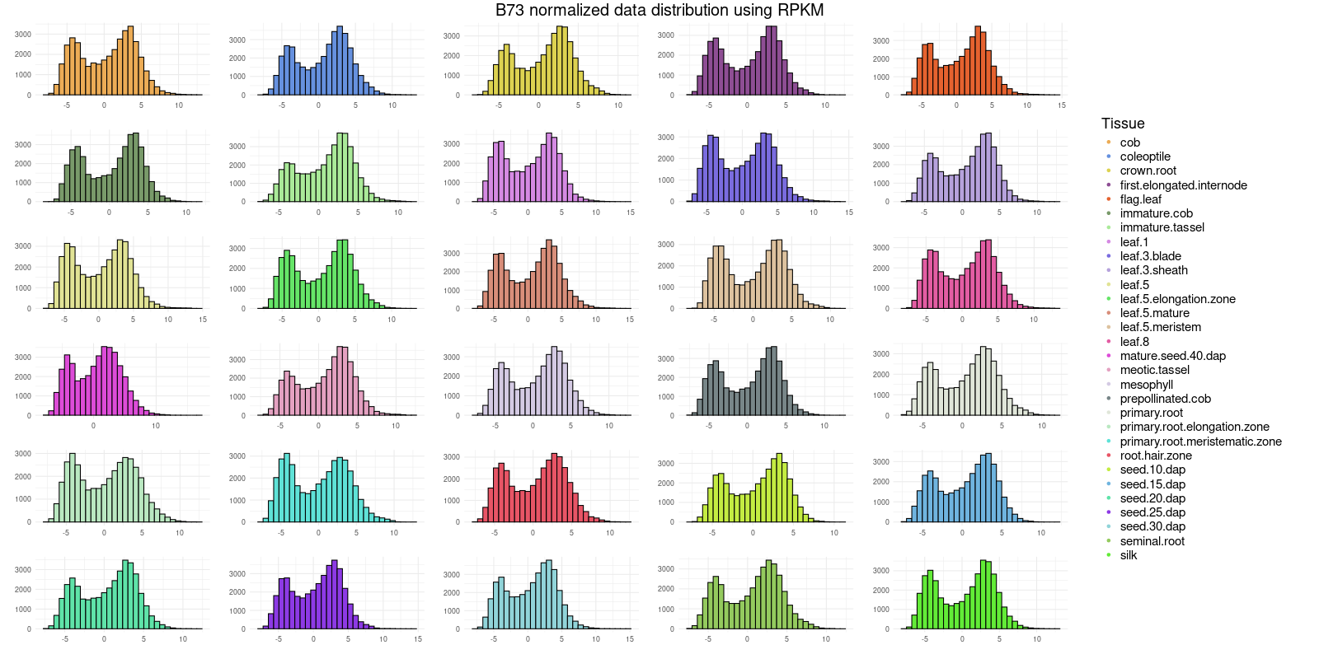Figure 6.2: Plot of the distribution of the gene expression data for all tissues of maize line B73 where RPKM normalization was performed using edgeR.

The Figure 6.2 graph represents RPKM-normalized data, which should ideally follow a normal distribution in the shape of a bell curve. However, it can be observed that this is not the case. Instead the plots exhibit a bimodal distribution, with an irregular peak corresponding to the low expressed genes.

In both normalized data graphs anomalies can be observed due to overrepresentation of lowly expressed genes. To achieve a completely normalized data, the lowly expressed genes must be removed. Removing the lowly expressed genes is done through gene expression filtering.

## Filtering of lowly expressed genes

Filtering by gene expression is an essential step in the workflow as it eliminates background noise caused by lowly expressed genes. The removal of lowly expressed genes is a useful procedure because it enhances Differentially Expressed Gene (DEG) detection sensitivity, improving later analysis. The initial stage of the workflow is evaluating the impact of expression filtering in the 2 normalization processes and comparing the number of genes retained in each case.

A consistent filtering strategy is applied across both methods, wherein the total counts of each gene whose individual count is higher than a predefined threshold (*x)* are summed, and only those with a total count equal to or greater than a predefined threshold (*y*) are retained. These threshold values (*x* and *y*) differ depending on the normalization method to allow for an optimal normalization. The values and retained genes while maintaining a normal distribution are:

|  |  |  |  |
| --- | --- | --- | --- |
|  | ***x*** | ***y*** | **genes kept/total genes** |
| **CPM** | 1 | 12 | 22205/38708 |
| **RPKM** | 0 | 10 | 24537/38708 |

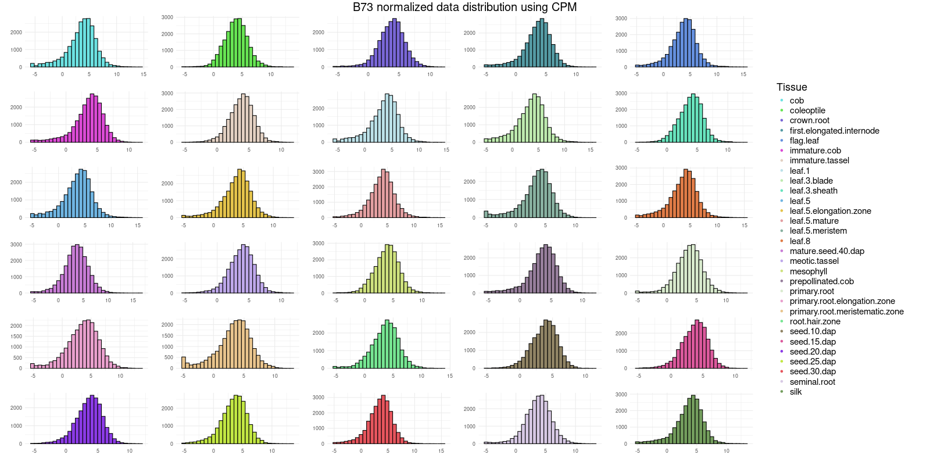Figure 7.1: Plot of the distribution of the gene expression data for all tissues of maize line B73 where CPM normalization and gene filtering through total counts have been performed.

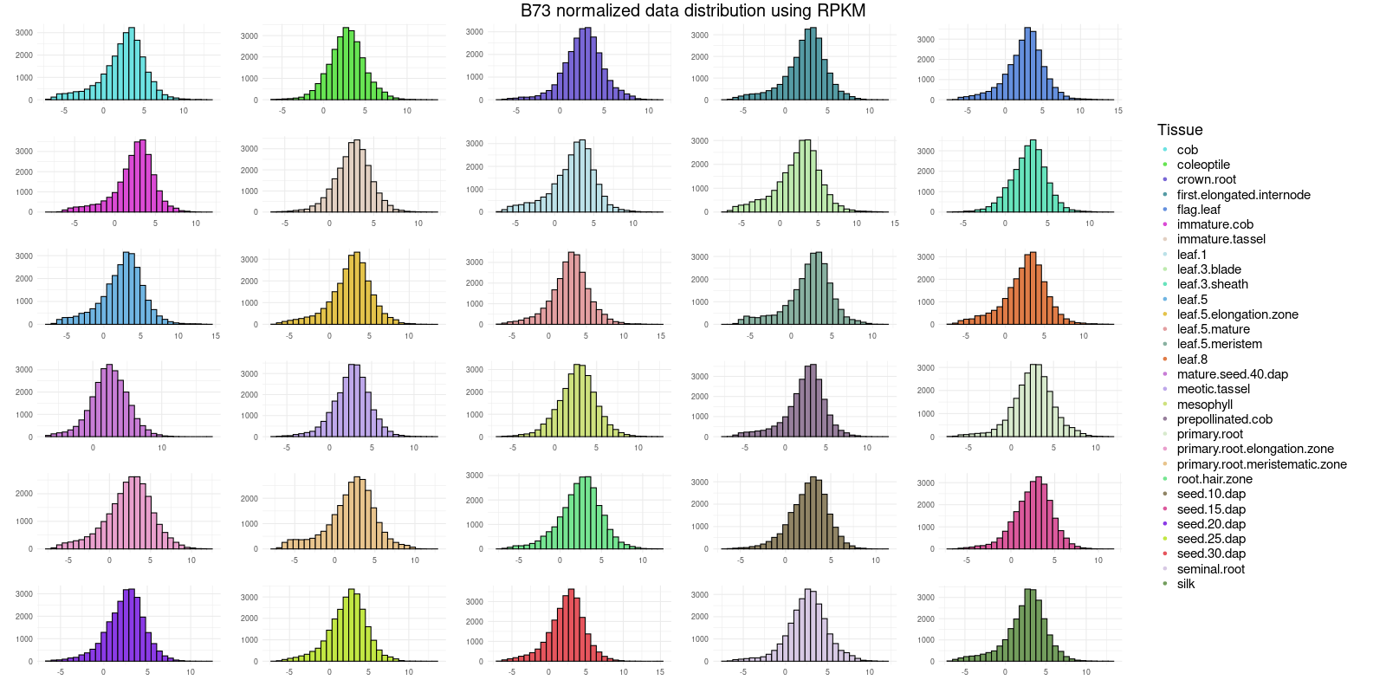

Figure 7.2: Plot of the distribution of the gene expression data for all tissues of maize line B73 where RPKM normalization and gene filtering through total counts have been performed.

In the plots represented in Figure 7 it is evident that the data distribution is almost identical to that of a normal distribution in both methods, even though some slight variations are present in particular cases of both CPM and RPKM. For all subsequent analysis it must be assumed that RPKM will be used, as it produces similar results than CPM while retaining a much larger content of genes.

After evaluating the filtering based on total gene count an alternative method was proposed. Filtering only by total count may overlook cases where a gene is highly represented in a single sample, potentially missing important correlations. To address this issue, the new approach combines filtering by total gene count, as in the previous method, with an additional criterion: retaining genes that exhibit at least a value greater than a predetermined threshold *t*, even if the total of the gene is not greater than the predefined threshold.

To assess the effectiveness of this method, both the fitness of the data distribution and the number of retained genes are considered. The thresholds *x*, *y* and *t* vary depending on the methods used to allow for the most optimal normalization, considering that the distributions are similar in both cases, this figure illustrates the differences they produce on the amount of retained genes.

|  |  |  |  |  |
| --- | --- | --- | --- | --- |
|  | ***x*** | ***y*** | ***t*** | **genes kept/total genes** |
| **CPM** | 1 | 12 | 8 | 22654/38708 |
| **RPKM** | 0 | 10 | 6 | 25296/38708 |

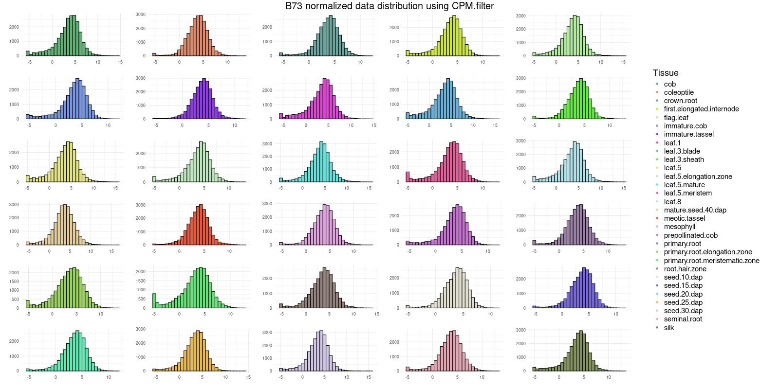

Figure 8.1: Plot of the distribution of the gene expression data for all tissues of maize line B73 where CPM normalization and gene filtering through sample counts have been performed.

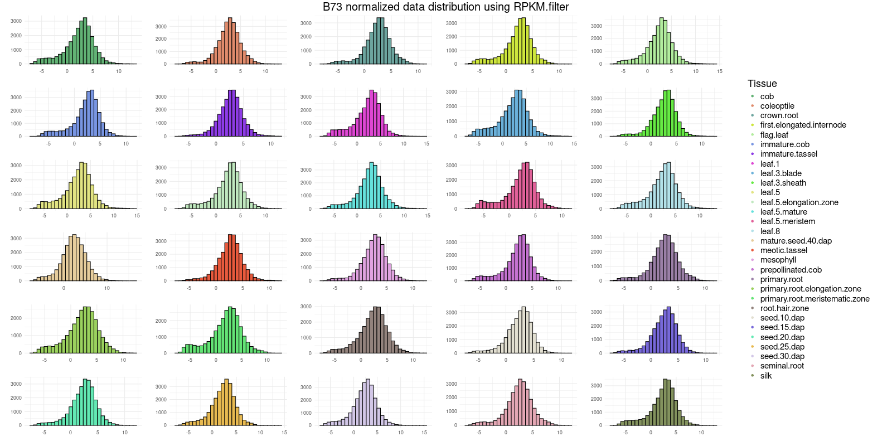Figure 8.2: Plot of the distribution of the gene expression data for all tissues of maize line B73 where RPKM normalization and gene filtering through sample counts have been performed.

The graphs represented in Figure 8 demonstrate that both CPM and RPKM exhibit similar distributions. However, RPKM aligns more closely with a normal distribution and retains a greater set of genes. This finding is consistent with the conclusions drawn from the filtering by total counts method. As a result, all subsequent analysis will be conducted using the RPKM data, filtered by this second method as it retains a larger amount of genes.

## Network construction and gene clustering

Following the filtration process, the next step in constructing the gene co-expression network involves clustering genes while maintaining an appropriate soft-thresholding power, which will vary for each data set. To determine the appropriate power for each case, the program considers the signed R2 and the mean connectivity, selecting the optimal value from a range of 1 to 17 and odd numbers between 17 and 49. If the value exceeds 30 it is capped, as that is the maximum soft power allowed for clustering.

The gene clustering process is performed with the WGCNA function "blockwiseModules". This function requires the specification of a block size, which is set to a value greater than the genes, provided that the system memory permits it. This approach allows for processing as a single block, thereby enhancing the clustering quality, ensuring a more comprehensive network representation. The procedure employs a high deep split parameter and signed TOM type, coupled with a low mergeCutHeight for a highly sensitive module detection with substantial, though not extreme, granularity. The resulting gene clusters vary in number across the different maize lines, reflecting distinct expression pattern associations.

Genes that do not fit into any specific cluster are assigned to the grey module, a category for unclassified genes. For the quantity of genes in our samples, the module is ideally maintained at a 1000 genes maximum. Key parameters that influence the regulation of this module’s size include the initial normalization and filtering methods, which ensure high-quality input data and sufficient gene retention for optimal clustering, the blockwiseModules parameters, which enhance granularity and classification accuracy, and finally, the soft-thresholding power selection, as it impacts the overall network structure.

An adjacency table is generated from the replicate data. This table in conjunction with the gene expression dataset is the object utilized to calculate the correlations between the gene modules and replicates, and enables the downstream analysis of module-trait relationships.

# Preliminary results

The final product of the co-expression analysis is the correlation of an adjacency table which contains the gene expression grouped by modules and the traits that are to be analyzed. For the visualization of these relations a correlation plot that includes the significance of the cases is processed for each line.

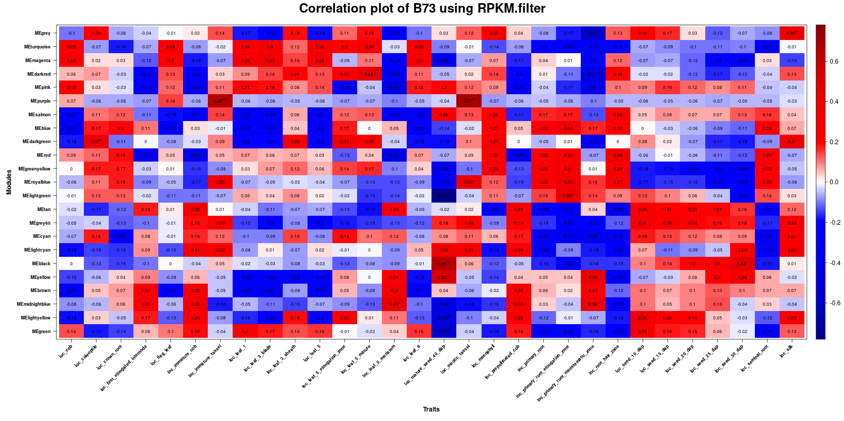

Figure 9.1: Figure 9.3: Representation of module-trait relationships in the B73 maize line.

On Figure 9.1 clear functional groups of gene modules can be identified, at a first glance the observation can be made that MEsalmon, MEblue, MEred, MEgreenyellow, MEroyalblue and ME lightgreen are all involved in up-regulation on root tissues, while ME turquoise, MEtan, MEgrey60, MEcyan, MElightcyan and MEblack are involved in root tissues as well, but in suppressed expression.

There are 4 modules which appear to be heavily involved in the early stages of the leaf growth process.

Most seed traits share MEgreenyellow, MEroyalblue as down-regulated modules, while 5 modules appear up-regulated, MEblack is predominant in later seed stages and MElightyellow and MEgreen are heavily involved in early stages. Most modules that appear in seed development genes appear differentially expressed in root regulatory genes as well, but appear in opposite regulatory patterns.

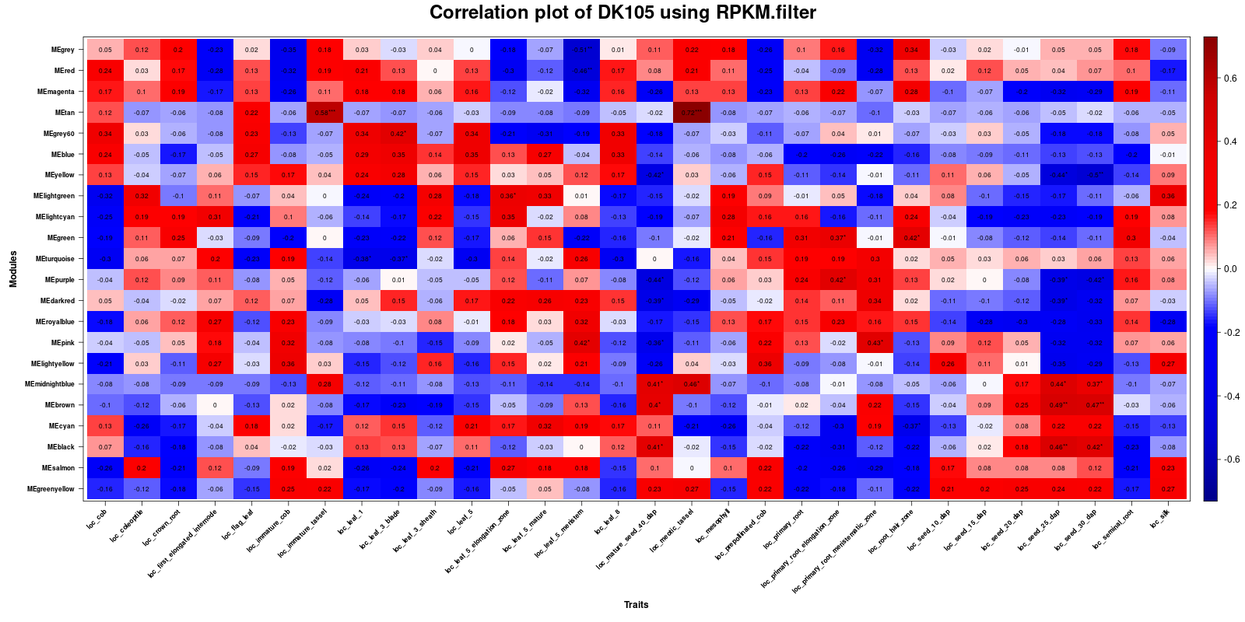

Figure 9.3: Representation of module-trait relationships in the DK105 maize line.

In the correlation plot of DK105, which can be observed in Figure 9.2, a clear gene module to trait relation is between 13 gene modules and the late stages of seed development, where a majority appear as down-regulated modules. Out of these 13 gene modules MEcyan, MEsalmon and MEgreenyellow are also relevant in the early stages of seed development.

There are also strong co-expression patterns that identify the clear involvement of 8 modules in primary root development, of these modules the suppressed ones are also over expressed in late-stage seed development, presenting a possible relation between the traits.

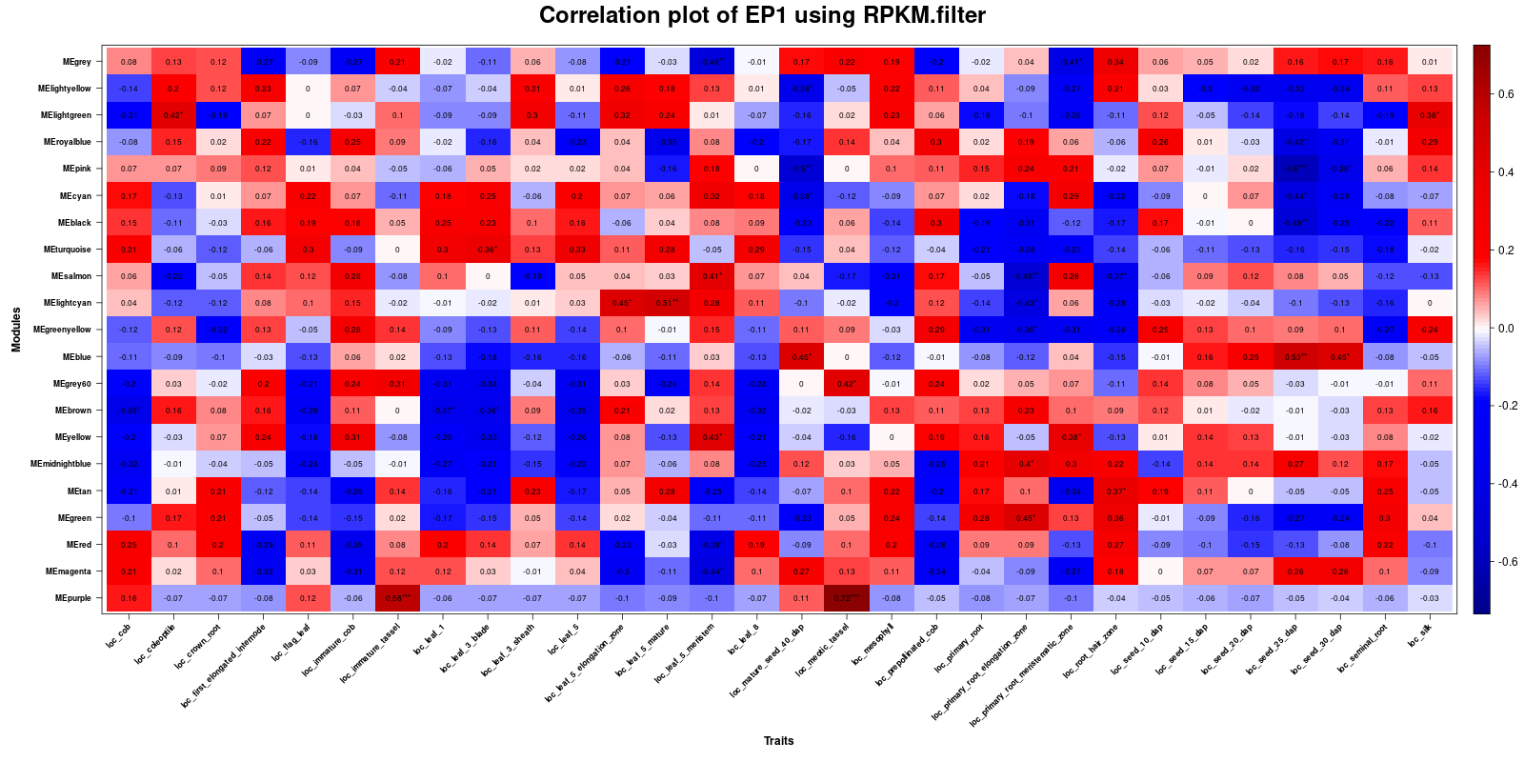

Figure 9.3: Representation of module-trait relationships in the EP1 maize line.

In Figure 9.3 which corresponds to the correlation plot of EP1 genotype it can be observed that usual expression patterns can not be observed, most other maize lines show clear up-regulation patterns in seed development traits, while in EP1, only 3 significantly up-regulated modules are present, while 8 appear suppressed mainly in late stage development modules. There is a clear differential expression in leaf traits, specifically in the earliest and latest stages of development, where 10 modules tend to be significantly expressed, 7 of them suppressed while MEcyan, MEblack and MEturquoise are overexpressed. In root development, 12 modules seem to be differentially expressed, most appear as down-regulated, however, the patterns that can be observed in other lines between seed and root development are missing.

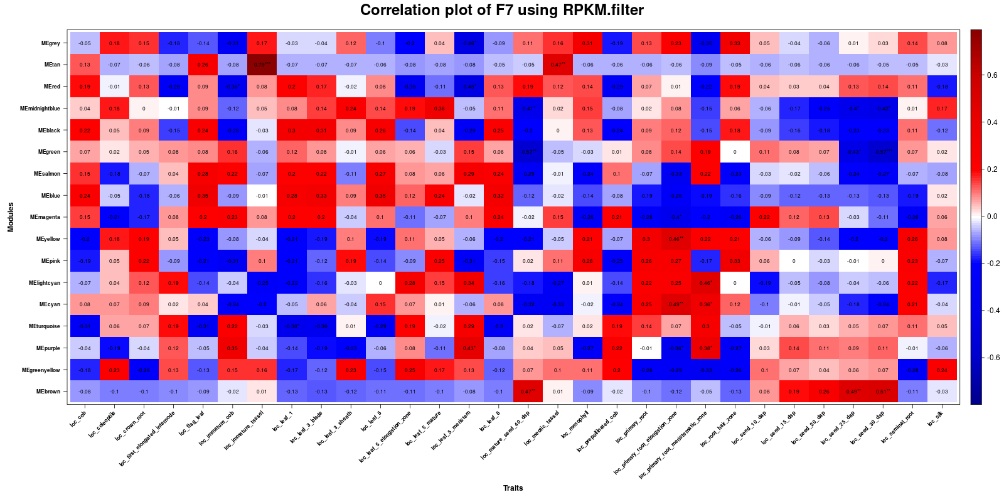

Figure 9.4: Representation of module-trait relationships in the F7 maize line.

According to Figure 9.4 expression patterns in the F7 genotype are very similar to those present in EP1, it presents a lack of up-regulated seed trait modules, as well as strong differential expression on the root and leaf traits. The differences are that in leaf traits more genes are overexpressed than in the EP1 genotype and in the root traits there is a stronger differential expression as well as more representation of up-regulated modules. Also, in this maize line the expression patterns present in most lines between root and seed are missing as well.

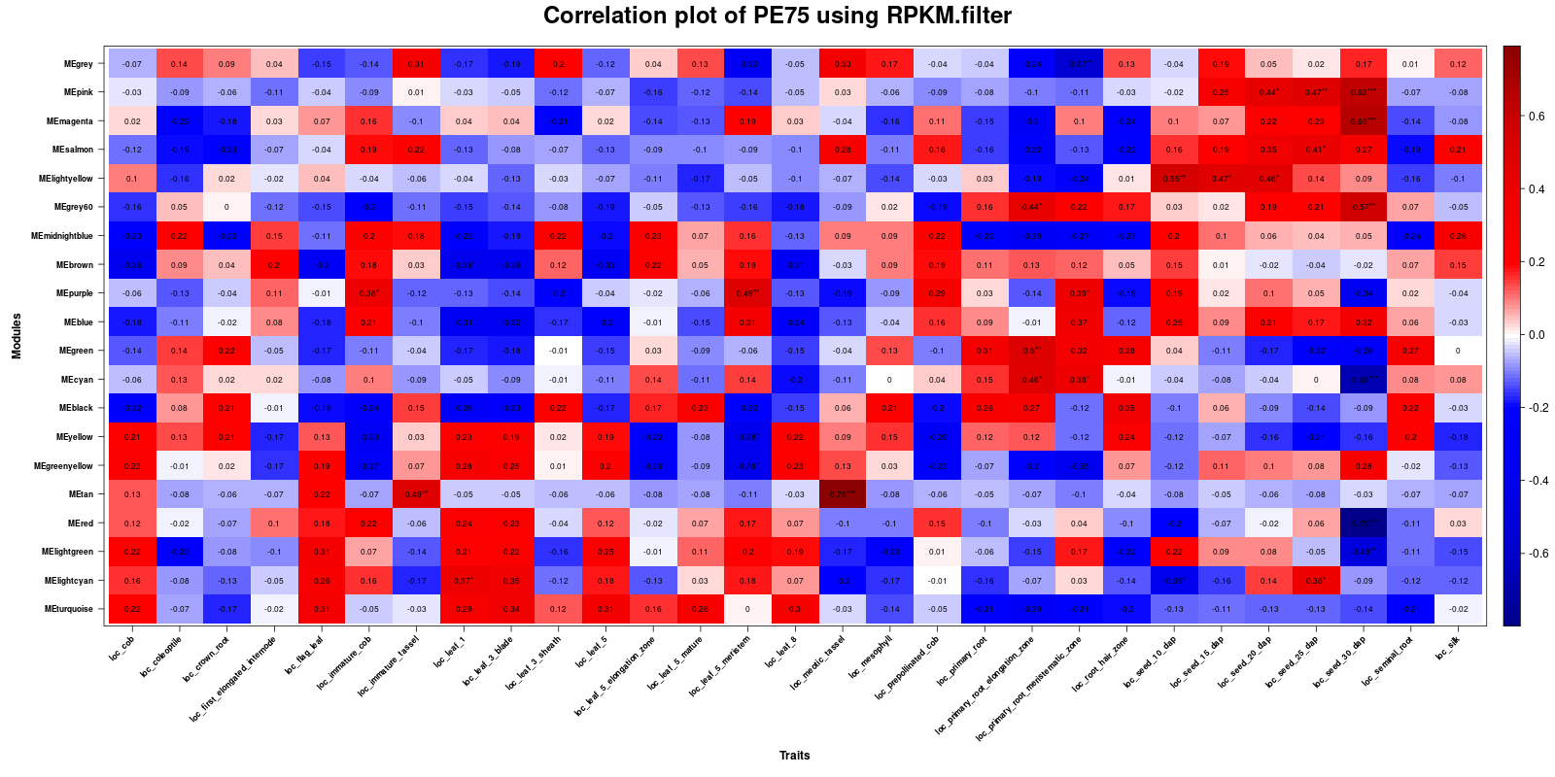

Figure 9.5: Representation of module-trait relationships in the PE75 maize line.

Observing Figure 9.5 PE75 presents co-expression relations between 11 modules from leaf development traits, most are up-regulated modules and present in the early stages of leaf development, although some are present on the later stages as well. A slight pattern of mostly overexpressed modules is also present in root development traits, however down-regulated modules are also present. Finally, seed related traits have mostly up-regulated gene modules associated, and they mostly fit the pattern of an opposite expression with seed related traits.

Although the module-trait relationships for each line can be analyzed separately, more progress is needed to be able to execute a side by side comparison of all lines simultaneously and extract conclusions of the effect of modules across traits of all genotypes. This relation can not be analyzed yet as the genes represented by the modules differ across the multiple maize lines.

# Future directions

This project is a stepping stone into a pantranscriptome co-expression analysis comparing the maize lines traits and expression side by side to find similarities among the tissues and reach a better understanding of these european genotypes. Before that the analysis has to be refined, specifically the reduction of the unclassified clustering modules, this will improve the gene classification and have a big impact on the final correlation tables, this will change the results of the analysis and the conclusions reached from it.

# Bibliography

AbuQamar, S. F., El-Tarabily, K. A., & Sham, A. (2021). Co-expression Networks in Predicting Transcriptional Gene Regulation. *Methods in Molecular Biology (Clifton, N.J.)*, *2328*, 1–11.<https://doi.org/10.1007/978-1-0716-1534-8_1>

Chang, Y.-M., Lin, H.-H., Liu, W.-Y., Yu, C.-P., Chen, H.-J., Wartini, P. P., Kao, Y.-Y., Wu, Y.-H., Lin, J.-J., Lu, M.-Y. J., Tu, S.-L., Wu, S.-H., Shiu, S.-H., Ku, M. S. B., & Li, W.-H. (2019). Comparative transcriptomics method to infer gene coexpression networks and its applications to maize and rice leaf transcriptomes. *Proceedings of the National Academy of Sciences*, *116*(8), 3091–3099.<https://doi.org/10.1073/pnas.1817621116>

Evans, C., Hardin, J., & Stoebel, D. M. (2017). Selecting between-sample RNA-Seq normalization methods from the perspective of their assumptions. *Briefings in Bioinformatics*, *19*(5), 776–792.<https://doi.org/10.1093/bib/bbx008>

Guo, W., Schreiber, M., Marosi, V. B., Bagnaresi, P., Jørgensen, M. E., Braune, K. B., Chalmers, K., Chapman, B., Dang, V., Dockter, C., Fiebig, A., Fincher, G. B., Fricano, A., Fuller, J., Haaning, A., Haberer, G., Himmelbach, A., Jayakodi, M., Jia, Y., … Waugh, R. (2025). A barley pan-transcriptome reveals layers of genotype-dependent transcriptional complexity. *Nature Genetics*, *57*(2), 441–450.<https://doi.org/10.1038/s41588-024-02069-y>

Haberer, G., Kamal, N., Bauer, E., Gundlach, H., Fischer, I., Seidel, M. A., Spannagl, M., Marcon, C., Ruban, A., Urbany, C., Nemri, A., Hochholdinger, F., Ouzunova, M., Houben, A., Schön, C.-C., & Mayer, K. F. X. (2020). European maize genomes highlight intraspecies variation in repeat and gene content. *Nature Genetics*, *52*(9), 950–957.<https://doi.org/10.1038/s41588-020-0671-9>

Huang, J., Vendramin, S., Shi, L., & McGinnis, K. M. (2017). Construction and Optimization of a Large Gene Coexpression Network in Maize Using RNA-Seq Data. *Plant Physiology*, *175*(1), 568–583.<https://doi.org/10.1104/pp.17.00825>

Langfelder, P., & Horvath, S. (2008). WGCNA: An R package for weighted correlation network analysis. *BMC Bioinformatics*, *9*(1), 559.<https://doi.org/10.1186/1471-2105-9-559>

Lu, Y., Yan, J., Guimarães, C. T., Taba, S., Hao, Z., Gao, S., Chen, S., Li, J., Zhang, S., Vivek, B. S., Magorokosho, C., Mugo, S., Makumbi, D., Parentoni, S. N., Shah, T., Rong, T., Crouch, J. H., & Xu, Y. (2009). Molecular characterization of global maize breeding germplasm based on genome-wide single nucleotide polymorphisms. *Theoretical and Applied Genetics*, *120*(1), 93–115.<https://doi.org/10.1007/s00122-009-1162-7>

Mayer, M., Hölker, A. C., Presterl, T., Ouzunova, M., Melchinger, A. E., & Schön, C.-C. (2022). Genetic diversity of European maize landraces: Dataset on the molecular and phenotypic variation of derived doubled-haploid populations. *Data in Brief*, *42*, 108164.<https://doi.org/10.1016/j.dib.2022.108164>

Sarmah, T., & Bhattacharyya, D. K. (2021). A study of tools for differential co-expression analysis for RNA-Seq data. *Informatics in Medicine Unlocked*, *26*, 100740.<https://doi.org/10.1016/j.imu.2021.100740>

Serin, E. A. R., Nijveen, H., Hilhorst, H. W. M., & Ligterink, W. (2016). Learning from Co-expression Networks: Possibilities and Challenges. *Frontiers in Plant Science*, *7*.<https://doi.org/10.3389/fpls.2016.00444>

Sha, Y., Phan, J. H., & Wang, M. D. (2015). Effect of low-expression gene filtering on detection of differentially expressed genes in RNA-seq data. *Annual International Conference of the IEEE Engineering in Medicine and Biology Society. IEEE Engineering in Medicine and Biology Society. Annual International Conference*, *2015*, 6461–6464.<https://doi.org/10.1109/EMBC.2015.7319872>

Zhao, S., Ye, Z., & Stanton, R. (2020). Misuse of RPKM or TPM normalization when comparing across samples and sequencing protocols. *RNA (New York, N.Y.)*, *26*(8), 903–909.<https://doi.org/10.1261/rna.074922.120>