Employing co-expression networks to identify transcriptome diversification in maize lines

**Author:** Jan Izquierdo i Ramos  
**Scientific director:** Dr. Georg Haberer

Plant Genome and Systems Biology, Environmental Health Center, Helmholtz Munich.

Address: Ingolstädter Landstraße 1, 85764 Neuherberg, Munich

Supplementary material and code available at GitHub: <https://github.com/Janek21/BDBI_TFG_MaizeCoexpression>

# Abstract

The genetic diversity of maize has been extensively utilized in breeding programs to enhance agronomic performance and while this variability has been well documented, its impact on transcriptional variation and gene regulation across different lines remains mainly unexplored.

This study uses transcriptomic data from five maize lines-B73, DK150, EP1, F7, and PE75-across 30 tissues, to provide a comprehensive expression atlas for comparative analysis. The objective is to create multi-line co-expression networks for examining gene co-expression relationships simultaneously across different genotypes and tissues. Through this approach, conserved and lineage-specific gene modules are identified, offering insights into the transcriptional basis of phenotypic similarities and differences among the maize lines studied. Furthermore, the study uses these co-expression patterns to infer functions for previously uncharacterized genes using the guilt-by-association principle.

This study demonstrates that gene co-expression relationships exhibit greater strength across distinct genetic lines compared to those observed between different tissues within the same line, which highlights potential regulatory relationships and divergent evolutionary points. By mapping these tissue-line interactions, this study sets up a foundation for deeper investigations into the regulatory mechanisms that drive maize diversity and environmental adaptation as well as advancing the understanding on maize transcript relations.

# Introduction

Maize is a widely produced crop, one of the 3 most important plants worldwide, it surpasses the global production of wheat and rice and has become a staple food around the world, it has uses as human and animal aliment, as a resource in industrial products and as a model organism in genetics. The widespread cultivation of this crop is because it presents a high yield potential, extensive genetic diversity and is extremely adaptable. The mentioned genetic diversity is manifested in the existence of multiple maize germplasms like Flour maize, Sweet maize, Dent maize and Flint maize. Also the use of this diversity has been extensively exploited in breeding programs to increase agronomic efficiency, the most common method is inter-group hybridization, which exploits heterosis for better yields [(Labroo et al., 2021)](https://www.zotero.org/google-docs/?OivtWz).

This genetic diversity of maize has been well documented, pan-genome studies present clear evidence of the multiple aspects that this crop presents [(Haberer et al., 2020)](https://www.zotero.org/google-docs/?OrTqm6). However, the effect of this high genomic variability on the transcriptional variation of different maize lines presents a lot of research opportunities. Understanding the transcriptional diversity and differences present in these lines is necessary for uncovering how genetic differences have affected the regulation and functional pathways causing the phenotypic variations into multiple maize lines. By analysing gene co-expression networks that include multiple lines, relationships can be found between gene expression, phenotypic traits and differences in genome structure and organization.

To explore this, the present study focuses on five maize lines: B73, DK150, EP1, F7 and PE75. B73 belongs to the U.S. Dent maize group and is a widely used reference genotype, for example, it serves as a benchmark for comparative analysis. DK150, EP1 and F7 are all European Flint lines, originating from southern Germany, northern Spain and southern France. And PE75 is a derivation from a German landrace, the Petkuser Ferdinand Rot population, a doubled-haploid line to represent a more genetically diverse background.

A comprehensive transcriptome atlas was generated to capture expression profiles across 30 tissues in the 5 maize lines, with multiple samples per tissue for a better representation of the data. This dataset will be used for constructing a multi-genome co-expression network, enabling the simultaneous comparison of the different tissues that belong to different genotypes.

## Gene co-expression

Gene co-expression typically employs pairwise comparisons of gene expression levels, identifying genes that show similar expression patterns across samples. As genes that exhibit correlated expression patterns are often involved in the same biological processes, unknown gene functions can be inferred based on the co-expression of genes with known functions, this is known as the “guilt-by-association” principle.[(Wolfe et al., 2005)](https://www.zotero.org/google-docs/?nsHJcD)

To quantify co-expression correlation measures are used, among these measures Pearson and Spearman correlations stand out as the most common, Spearman presents no distributional assumptions while Pearson assumes normally distributed data, this makes Spearman more robust in settings that present heterogeneous samples or nonlinear regulatory mechanisms, which is not the case of this study.

Gene co-expression is a first step in developing co-expression networks(Figure 1), which provide understanding among whole sets of genes and allow for much more confidence in the identification of functional gene modules, regulatory pathways and key genes in biological processes. This is because of the capacity to identify clusters of tightly related genes which are likely to share common biological functions, this causes that the functions of unknown genes in a cluster can be inferred by the “guilt-by-association” principle when in the same cluster as well-characterized genes.

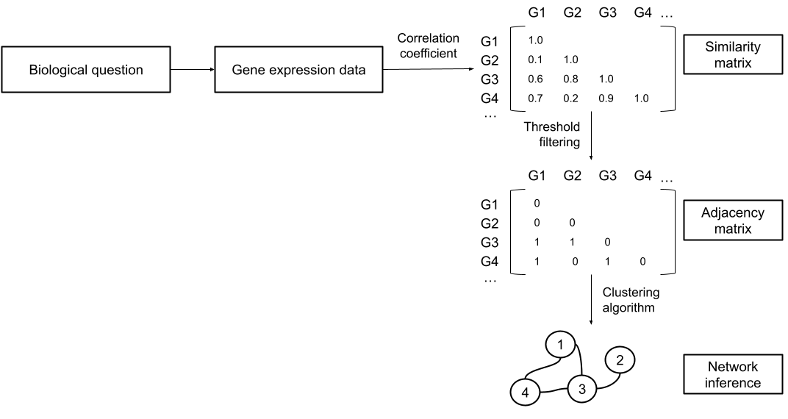Figure 1: Simplified representation of the process for network building.(Serin et al., 2016, p. 4)

By constructing co-expression networks across five distinct maize lines and 30 different tissues this study seeks to improve our understanding of how gene co-expression reflects underlying genomic differences, ultimately providing new insights into the regulatory features that drive maize diversity and adaptation.

# Objectives

This study intends to understand the relationship between the gene expression patterns in 5 different maize lines and the phenotypic differences they present by the employment of gene co-expression networks.

An essential part of the study is to determine whether common gene modules are present across the maize lines, how they relate to phenotypic similarities, which functions tend to be present in the modules and the relation between the presence of these functions and the traits to which these modules relate to. Complementary to this objective, the study also aims to examine the diverging modules across lines, the contribution of the possible transcriptional variations to phenotypic divergence and to discover functional annotation of unknown genes.

The ultimate goal of this research is to contribute to a broader understanding of the maize transcriptome by offering insights into the effect that gene expression has on genetic diversity. The finality that it leads to is to provide a basis for further research on maize breeding, genetic adaptation, and crop improvement.

# Methodology

The following explanation provides an overview of the processes involved in the preparation of the data, creation of the network and function analysis.

## Data filtering

The data is cleaned from errors and low quality samples are filtered out. The high quality samples are identified by belonging to the quality 0 group in the metadata, also, discrepancies between the number of data and metadata samples were found and corrected by eliminating pollen tissue samples, which are present as metadata but present no expression data, as not enough genetic material could be extracted for successful sequencing.

## Replicates in the data

The first step involved detecting and removing outlier genes, data points which would heavily skew the data while contributing minimally to biological relevance. The metadata was expanded to include the tissue and line data on the same instance, which was needed for merging the tissue data of each genotype to address potential imbalances and a high dimensionality. This merging process equalizes the discrepancies caused by differences in replicate numbers, which also skew results, and it is done through calculating the mean of the replicates for that genotype and tissue.

## Normalization

The goal of normalization is to ensure that read counts represent differences in true gene expression, enabling meaningful comparisons across samples and reducing noise in the data.

In this study, normalization was performed by library size, more concretely using the Reads Per Kilobase per Million mapped reads (RPKM), although Counts Per Million (CPM) is also a valid alternative, it was not used due to a better resolution after filtering when using RPKM. The program hinges on the edgeR R package to provide the normalization and it uses the same process to apply a logarithmic transformation to the data. After normalization the data presented an overrepresentation of lowly expressed genes, so to improve the quality of the normalized data, the lowly expressed genes were removed through gene expression filtering, which enhances Differentially Expressed Genes (DEG) detection.(Figure 2)

The applied filtering strategy preserves genes if they present at least one value greater or equal than 0 (at least 1 count for the gene across all replicates), this is to keep the maximum number of possibly correlated patterns as possible, while disregarding the genes that present the least expression.

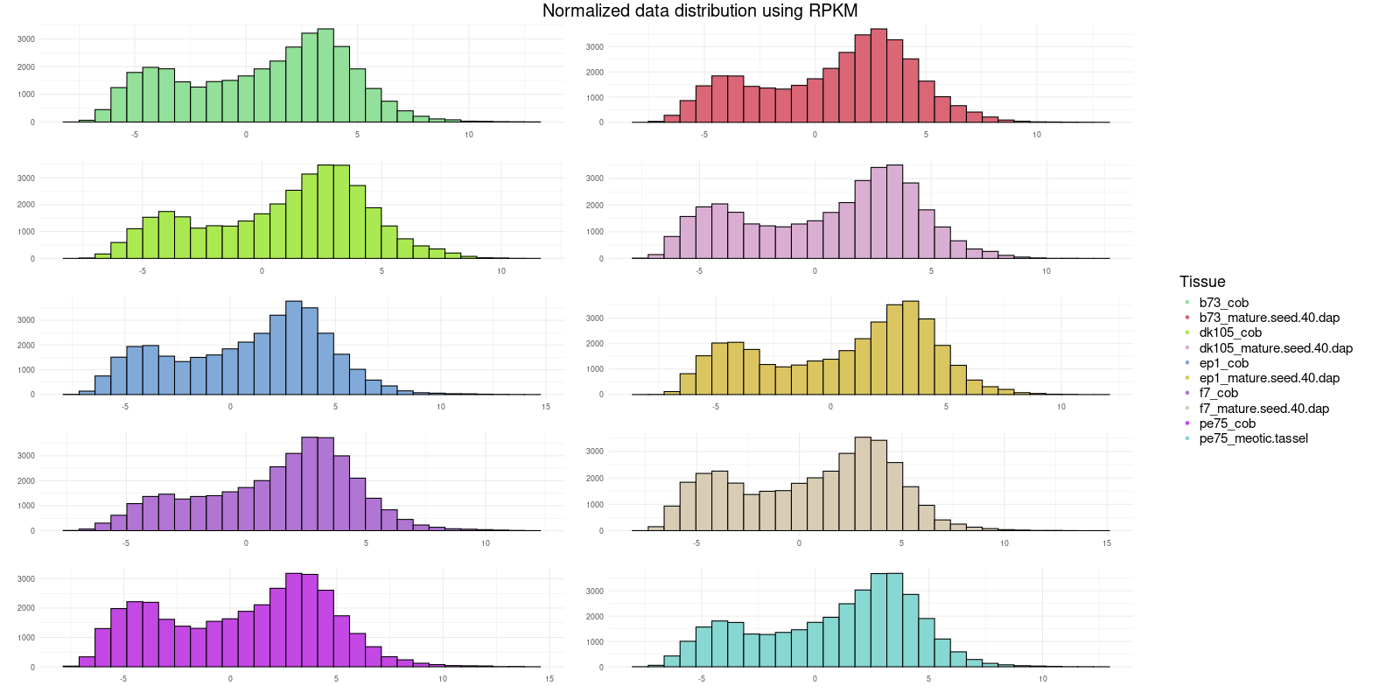Figure 2: RPKM normalized distribution filtered by expression for 2 tissues of each line. The data fits a bimodal distribution for all of the analyzed tissues, so it can be safely assumed that the bimodal distribution is applicable to all tissues. PE75 presents no samples for mature seed 40, so meiotic tassel is used in the display.

## Expression data analysis

For a better comprehension of the data and to grasp at possible correlations within the data, PCA and UMAP analysis were performed. These allow for the visualization of expression patterns in the data and to glimpse into underlying correlations between lines and tissues.

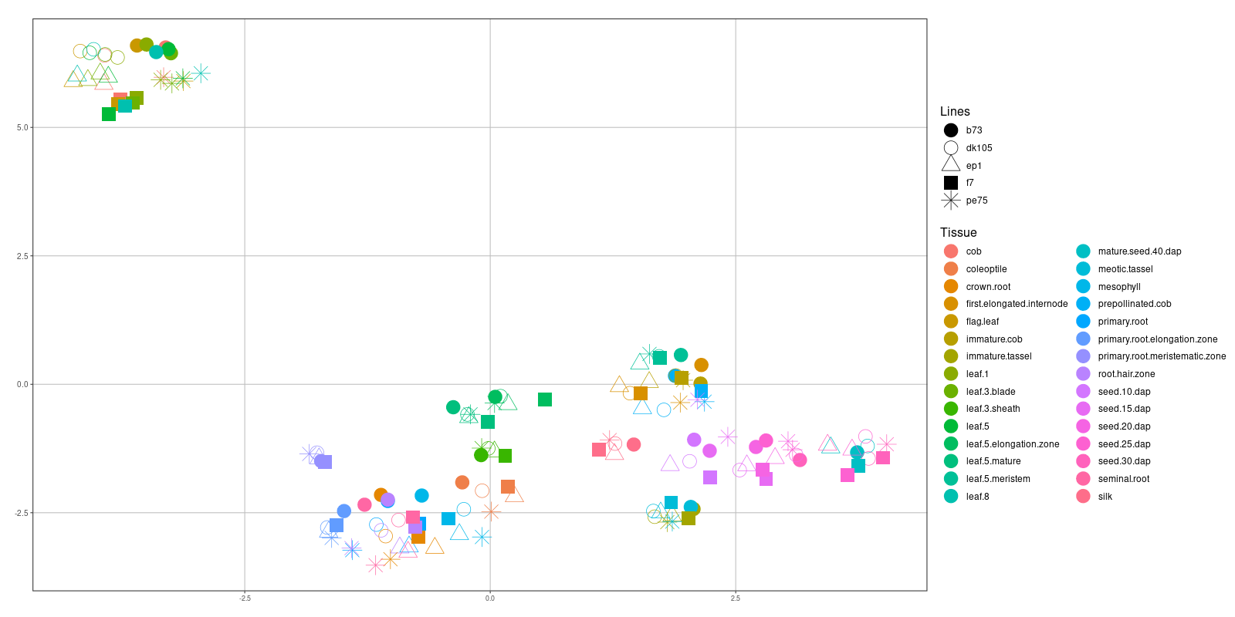Figure 3: Representations of gene expression with features according to tissues and lines. The representation is a UMAP where clusters by expression similarity can be observed.

In Figure 3 it can be observed that co expression relations tend to be stronger for tissue than for line, as an example, leaf blades of multiple tissues cluster together rather than clustering with leaf sheaths or leaf meristems of the same line, therefore it can be assumed that in the creation of the network the tissues will present strong correlation within a module. More examples can be observed, as is the case of the seed groups.

These exploratory data analysis allows for a better knowledge of patterns to search for later in the analysis.

## Network construction and gene clustering

The next step in constructing the gene co-expression network involves clustering genes while maintaining an appropriate soft-thresholding power. To determine the appropriate power for each case, the program considers the signed R2 and the mean connectivity, selecting the optimal value from a range of 1 to 17 and odd numbers between 17 and 49. The value is limited to 30, as that is the maximum soft power allowed for clustering.

The gene clustering process is performed by a WGCNA[(Langfelder & Horvath, 2008)](https://www.zotero.org/google-docs/?m07Mvc) function that has its parameters set to allow for a single-block approach and which uses hierarchical clustering methods. The factors that have the most influence on this clustering are the initial normalization and filtering methods, the function parameters and the soft-thresholding power selection, as it impacts the overall network structure. The effects can be seen in the amount of modules in which genes are classified into, and consequently, the amount of genes present in each module. In the case of our study 39 modules were revealed, with sizes between 28(*plum1)* and 4926*(turquoise*) and a mean size of 914 genes. The *grey* module, which generally contains the worst clustered genes, contained only 11.2% of the total, indicating a successful module separation, even though it could be refined further.

From the creation of this network, the principal components of each module's expression matrices are collected together in an adjacency table with a binary matrix of replicate relationships. This adjacency table is the object utilized to calculate the correlations between the gene modules and replicates, and enables the downstream analysis of module-trait relationships, so that cross-genotype and cross-tissue modules may be identified.

## Function significance in modules

The data from the tables presents multiple expression groupings by lines and tissues, to analyze the biological significance of each module, the functions of the genes that form each of these blocks has to be analyzed. For this analysis a table showing the genes associated with each module is written from the previous computation.

For obtaining the functional gene annotations of the genes in the maize lines mercator4 was used with the Zea Mays B73 data as a base, this generated a file containing the functional annotation for the gene as well as the swissprot, prot-scriber and mercator protein annotations.

To be able to classify these functionally annotated genes to their corresponding modules, a python program counts all the repetitions of each function in all modules and in each individual module and uses this data to perform a Fisher test and prove significance of the different functions in each module.

The program has to filter out all unannotated entries and all entries that belong to Enzyme functions, as those are molecular functions and the focus of the analysis lies on biological functions, therefore they are of no interest and are removed from the universe of the statistical test.

The enriched modules presented different significance levels for distinct biological functions, as can be seen in Table 1, which is a summary table that lists the most significant functions of all modules.

|  |  |  |
| --- | --- | --- |
| *Function* | *Pvalue* | *Module* |
| Cell division | 0 | lightcyan |
| Chromatin organisation | 2.2E-108 | red |
| Protein biosynthesis | 0 | yellow |
| Cell wall organisation | 1E-48 | yellow |
| Cell division | 0 | blue |
| Protein biosynthesis | 1.2E-249 | blue |
| Vesicle trafficking | 0 | salmon |
| Photosynthesis | 0 | turquoise |
| Cellular respiration | 0 | paleturquoise |
| Protein biosynthesis | 4E-42 | grey |

Table 1: 10 most significant functions across all modules

## Gene function analysis

After looking into the composition of the modules and the functions that each of them performed, a deeper analysis was in order to comprehend the modules at gene level. The goal of this analysis was to search for gene functions on a smaller level than modules and to uncover functions of unknown genes, as a gene by gene inspection provides the ability to target more concrete groups and individual genes for more specific analysis of relations and functions.

This process was done at module level, isolating the genes belonging to a particular module from the RNA-seq data and holding them to the same processes used previously on the whole data, meaning that they were joined by tissue and RPKM normalized. A correlation table was computed using this data and the genes were clustered according to the co-expression computations. The first algorithm by which the genes were processed was the K-means clustering, as it is a flexible, efficient and easy to implement method. The algorithm uses a number of centroids optimized by sum of squares, but this clustering method was abandoned as the clustering was of a too coarse grain, not offering enough distinction and biological significance. The alternative method that was chosen for computing the gene clustering was a Louvain community clustering, which allows for an improved resolution and biological significance(Figure 4) as communities work on building clusters based on closely correlated nodes instead of closeness to a centroid as K-means does. For this type of clustering a threshold has to be chosen, this threshold represents the cutoff point of correlation between the genes and it determines the amount of genes and the number of communities, the threshold optimization for each module was done manually.

From the communities the GO functions for each gene are obtained, which allows to unveil unannotated genes and to use the “guilt-by-association” rule to assign functions based on the ones present in closely related genes. To do this the process was to take the genes in the Louvain communities, and obtain the GO terms related to these genes and the functions corresponding to the GO terms, the unknown genes were determined by being the ones that presented no GO term associations. Then the functions of all highly correlated genes(to the unknown genes) were obtained, and filtered by significance, keeping only the 10 most significant functions. By using the “guilt-by-association” rule it is possible to determine that the unannotated genes will present these functions.

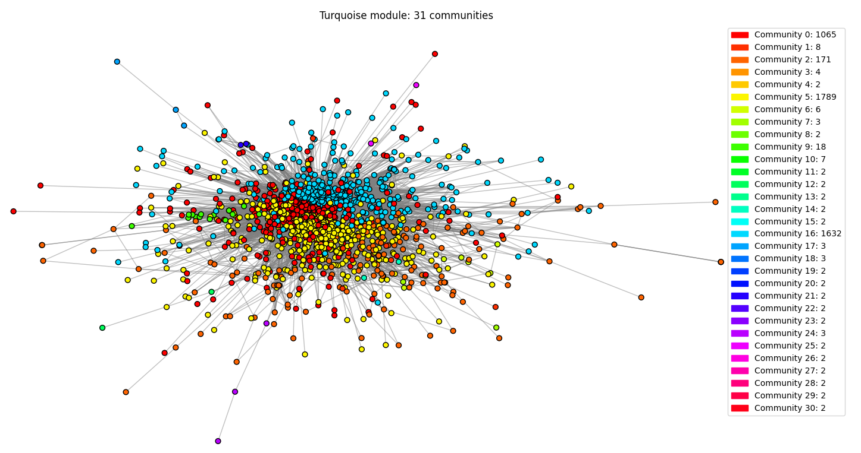Figure 4: Representation of Louvain communities in the central node of correlations for the turquoise module when using a 0.6 threshold.

# Results and discussion

## Correlations

The co-expression analysis produces a correlation table which contains the gene expression grouped by modules and the traits from all lines that are to be analyzed.

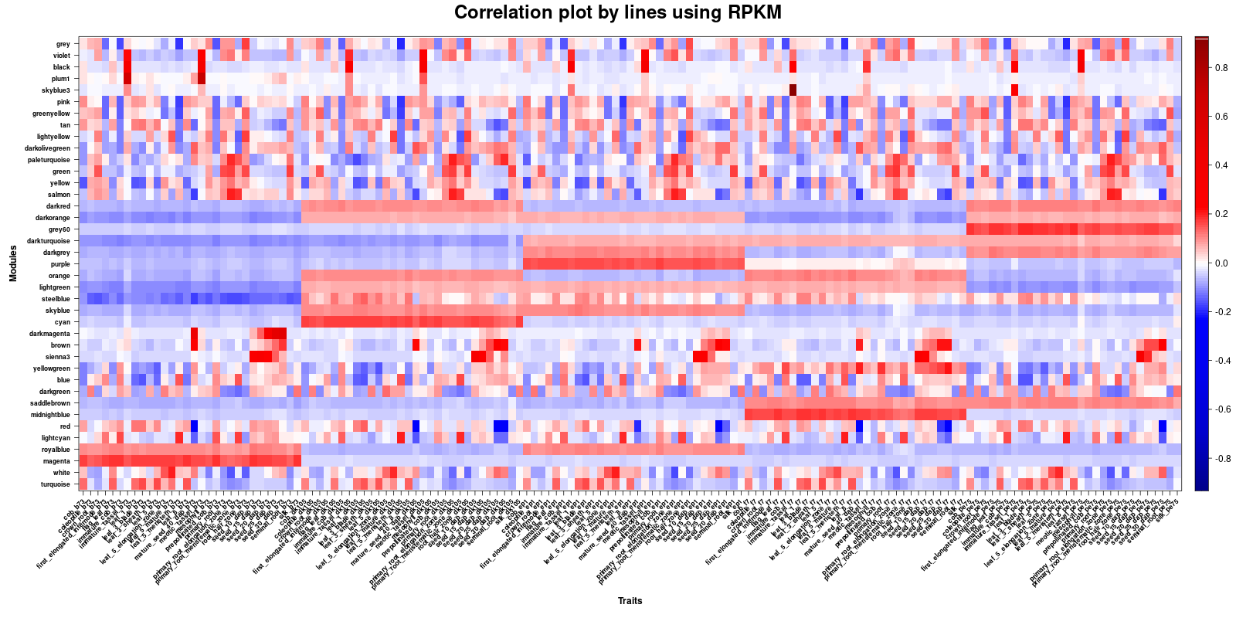Figure 5: Correlation plot with the x axis sorted by lines, groupings by correlation according to the line which the tissue belongs to can be observed, representing feature similarities between the lines. The y axis represents groupings of genes by expression pattern similarity.

In Figure 5, it can be observed that there are gene modules that manifest in blocks by lines, some are expressed in multiple lines while some are expressed only in one, for example, module *darkturquoise* is overexpressed in EP1, F7 and PE75 while *magenta* is only is expressed in B73. These clusters of expression for each module represent similar expression patterns, which means the lines are closely related. When lines are expressed exclusively in a module, then it can also be deduced that the module performs functions that identify these lines from the rest.

These differences present biological significance, for example, most modules present in B73 are not present in any of the other lines, this is because of a germplasm and location difference, B73 is a U.S. dent line while the other lines belong to European flint.

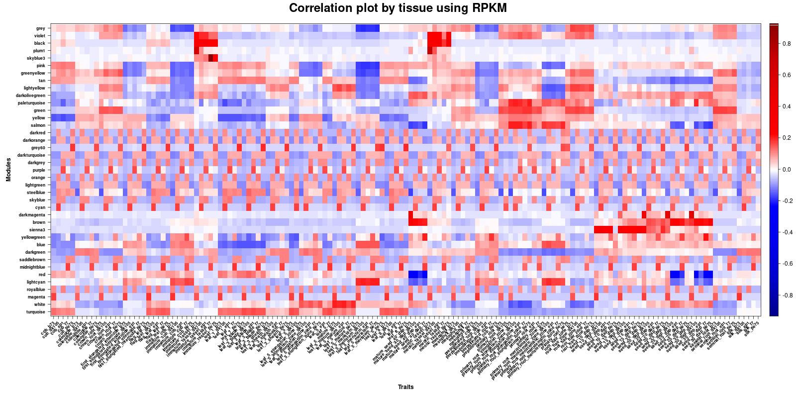Figure 6: Correlation plot with the x axis sorted according to tissues, strong correlation among tissues of different lines can be spotted, representing similar gene functions in certain tissues. The y axis represents groupings of genes by expression pattern similarity.

Apart from the modules clustered by genotype, there are more modules that appear scattered, to observe if they formed patterns by tissue, the correlation graph was ordered accordingly. The resulting plot can be observed in Figure 6 in which groups, different than in the ones present in Figure 5, can also be identified, these groups form patterns around different tissues, and the patterns repeat around one or more modules, creating clusters of expression for various modules and tissues. For example, the *violet* and *black* modules present strong correlations for all immature and meiotic tassels and the *turquoise* module strongly correlates leaf tissues, both of these cases, the tissue groupings follow the earlier observations (Figure 3), it is the case with most tissues, and can be used to corroborate the results.

These clusters by tissue indicate expression similarities across genotypes, where the function of the tissue is more impactful in expression than the line to which it belongs.

## Module functions

All functional modules are groups of genes, therefore by analyzing the composition of the modules their main functions can be identified. Hypotheses can be made for module functions based on the tissues in which there is a strong correlation, as an example, the *turquoise* module is mainly represented in leaf tissues, so the main functions it will present are probably related to photosynthesis, the *black* and *violet* modules present strong correlations with immature and meiotic tassels, which develop male flower structure and form pollen, so the main functions it will present are most likely related to the creation of new structures and plant reproduction and the *yellowgreen*, *blue* and *darkgreen* modules can be observed with strong correlations in immature cob, prepollinated cob and seeds, which means that the genes in this modules are mainly in charge of synthesis and cell division.

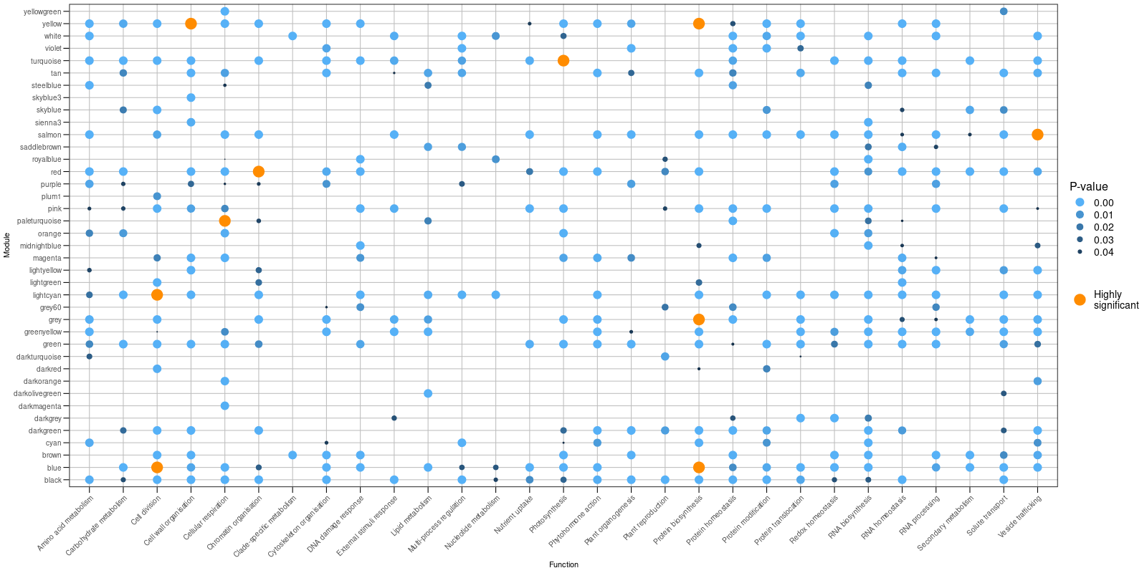Figure 7: Visualization of significant functions per module, it allows for a clear association in the functions performed by each module and therefore by the tissues associated to that module as well.

In Figure 7 the significant functions in each module can be observed, and the functions of highest significance are highlighted, which can be used for corroborating hypotheses like the previous one. It can be observed that the photosynthesis function is of strong significance in the *turquoise* module and that reproductive functions, like plant reproduction and cell division, as well as structural functions, like protein synthesis and cell wall organization, are significant in the *black* and *violet* modules. It can also be observed that the *yellowgreen*, *blue* and *darkgreen* modules not only present high significance for cell division, protein synthesis and RNA synthesis but also for other functions like solute transport and photosynthesis.

The inspections into the functions of individual modules can also be used to discover more about differences of function execution in lines, that being in exclusivity to a line or execution similarities between 2 or more lines. In the correlation plots (Figure 5) it can be observed that there are modules which present exclusive co-expression relations within a line, like module *magenta*, which is only expressed in B73 and presents strong significance for functions like DNA damage response or protein and RNA homeostasis, indicating that this line performs the functions via a different genes than other lines.

## Individual gene analysis

After the analysis of the modules, a deeper analysis was in order, as from the module functions a general functional knowledge is obtained, but an individual gene analysis allows for specification and targeting in the inspections, even when the modules present unknown genes, as the functions of these can be identified using co-expression methods.

The functions for the communities should be closely related to the module functions, but distilled to a finer grain. Hypotheses can be made as to the functions present in the communities, as an example, in the *turquoise* module which presents photosynthetic functions, the gene functions in the communities will mainly be metabolic processes, like calvin cycle regulation and other synthesization functions. Communities present unknown genes, which can be associated with the functions present in the community using the “guilt-by-association” rule; these associations provide a better understanding of the communities as a whole as well as the ability to be used in the case of a need for more detail in an unknown gene.

For concrete function identification in the unknown genes a table similar to the one seen in Table 2 can be consulted, it provides a better insight into the functions by association assigned to each of the unknown genes. This table is key in understanding functions in fine grain on each module, as it allows the search for functions at community and gene level.

|  |  |  |  |
| --- | --- | --- | --- |
| *Community* | *Unknown* | *Annotated* | *Function* |
| C16 | Zm00001eb016410 | Zm00001eb410470  Zm00001eb147980  Zm00001eb131350  Zm00001eb383680 |  |
| C16 | Zm00001eb257940 | Zm00001eb143310  Zm00001eb149430  Zm00001eb296680  Zm00001eb362480  Zm00001eb359580  Zm00001eb086410  Zm00001eb169010 | biological_process  membrane-bounded organelle  intracellular organelle  organelle  molecular_function  binding  primary metabolic process |
| C16 | Zm00001eb213570 | Known | unsaturated fatty acid biosynthetic process  Unknown  secondary metabolic process  pentose-phosphate shunt  glucose catabolic process  isopentenyl diphosphate biosynthetic process, methylerythritol 4-phosphate  regulation of hydrogen peroxide metabolic process |
| C16 | Zm00001eb225990 | Zm00001eb013130 |  |
| C16 | Zm00001eb404360 | Known | megasporogenesis  primary metabolic process  ligase activity  regulation of biological process  nucleus  Unknown  transferase activity  M phase  membrane |
| C16 | Zm00001eb347030 | Zm00001eb347020  Zm00001eb131900  Zm00001eb427640  Zm00001eb270090 | NADP binding  hydro-lyase activity |

Table 2: Representation of a sample of genes belonging to community 16 in the turquoise module, genes can be observed presenting no associated functions, this is mainly due to a lack of significance for any functions the closely correlated genes present

# Discussion

This study has examined multiple maize transcriptomes with the aim of uncovering patterns for a deeper understanding of the diversification across maize lines, which would contribute to an overall deeper understanding of maize genetics. While no single conclusion was sought the analysis has provided insights into important aspects of maize gene expression and its workings across various lines.

In this study, several sections in the transcriptomes have been identified as being closely correlated across the lines, which indicates points of similarity; these points of similarity are tissues where the genes present in these lines perform very similar functions. These findings highlight potential regulatory relationships and divergent evolutionary points, which motivates further investigation through functional validation and targeted studies to confirm and improve these findings.

The study also provides a more detailed analysis of the functions shared across the lines and tissues, allowing to determine that genes often present higher correlation in particular tissues across different lines than with other tissues within their own line. This points to these genes executing specialized functions in the particular tissues, like reproductive functions for tassel tissue or photosynthetic functions for leaf tissue, hypotheses which are proved to be true by analyzing groups of genes, the tissues in which they are mainly expressed and the functions which they perform.

Even though these analyses provide large amounts of data for further research the specification of the data can yet be taken a step further. By an analysis of particular genes and the functions they perform, very specialized and concrete evaluations can be made. The issue arises as many of these genes present unknown functional annotations, but to circumvent this, the steps have been taken to associate functions to genes according to the “guilt-by-association” rule, producing a frame of reference where the concrete, specialized analysis can truly be sought for any particular gene of interest.

Overall the study has produced a broad range of results, however the analysis only contemplates the surface potential of the data. Further studies on the produced information could reach a higher understanding of the steps of diversification in maize and of the effect of shared features and relations between lines.

# Bibliography

Beiki, H., Nejati-Javaremi, A., Pakdel, A., Masoudi-Nejad, A., Hu, Z.-L., & Reecy, J. M. (2016). Large-scale gene co-expression network as a source of functional annotation for cattle genes. BMC Genomics, 17(1), 846. <https://doi.org/10.1186/s12864-016-3176-2>

Chang, Y.-M., Lin, H.-H., Liu, W.-Y., Yu, C.-P., Chen, H.-J., Wartini, P. P., Kao, Y.-Y., Wu, Y.-H., Lin, J.-J., Lu, M.-Y. J., Tu, S.-L., Wu, S.-H., Shiu, S.-H., Ku, M. S. B., & Li, W.-H. (2019). Comparative transcriptomics method to infer gene coexpression networks and its applications to maize and rice leaf transcriptomes. Proceedings of the National Academy of Sciences, 116(8), 3091–3099. <https://doi.org/10.1073/pnas.1817621116>

Childs, K. L., Davidson, R. M., & Buell, C. R. (2011). Gene Coexpression Network Analysis as a Source of Functional Annotation for Rice Genes. PLOS ONE, 6(7), e22196. <https://doi.org/10.1371/journal.pone.0022196>

de Silva, K. K., Dunwell, J. M., & Wickramasuriya, A. M. (2022). Weighted Gene Correlation Network Analysis (WGCNA) of Arabidopsis Somatic Embryogenesis (SE) and Identification of Key Gene Modules to Uncover SE-Associated Hub Genes. International Journal of Genomics, 2022(1), 7471063. <https://doi.org/10.1155/2022/7471063>

Downs, G. S., Bi, Y.-M., Colasanti, J., Wu, W., Chen, X., Zhu, T., Rothstein, S. J., & Lukens, L. N. (2013). A developmental transcriptional network for maize defines coexpression modules. Plant Physiology, 161(4), 1830–1843. <https://doi.org/10.1104/pp.112.213231>

Evans, C., Hardin, J., & Stoebel, D. M. (2017). Selecting between-sample RNA-Seq normalization methods from the perspective of their assumptions. Briefings in Bioinformatics, 19(5), 776–792. <https://doi.org/10.1093/bib/bbx008>

Grote, U., Fasse, A., Nguyen, T. T., & Erenstein, O. (2021). Food Security and the Dynamics of Wheat and Maize Value Chains in Africa and Asia. Frontiers in Sustainable Food Systems, 4. <https://doi.org/10.3389/fsufs.2020.617009>

Guo, W., Schreiber, M., Marosi, V. B., Bagnaresi, P., Jørgensen, M. E., Braune, K. B., Chalmers, K., Chapman, B., Dang, V., Dockter, C., Fiebig, A., Fincher, G. B., Fricano, A., Fuller, J., Haaning, A., Haberer, G., Himmelbach, A., Jayakodi, M., Jia, Y., … Waugh, R. (2025). A barley pan-transcriptome reveals layers of genotype-dependent transcriptional complexity. Nature Genetics, 57(2), 441–450. <https://doi.org/10.1038/s41588-024-02069-y>

Haberer, G., Kamal, N., Bauer, E., Gundlach, H., Fischer, I., Seidel, M. A., Spannagl, M., Marcon, C., Ruban, A., Urbany, C., Nemri, A., Hochholdinger, F., Ouzunova, M., Houben, A., Schön, C.-C., & Mayer, K. F. X. (2020). European maize genomes highlight intraspecies variation in repeat and gene content. Nature Genetics, 52(9), 950–957. <https://doi.org/10.1038/s41588-020-0671-9>

Han, L., Zhong, W., Qian, J., Jin, M., Tian, P., Zhu, W., Zhang, H., Sun, Y., Feng, J.-W., Liu, X., Chen, G., Farid, B., Li, R., Xiong, Z., Tian, Z., Li, J., Luo, Z., Du, D., Chen, S., … Li, L. (2023). A multi-omics integrative network map of maize. Nature Genetics, 55(1), 144–153. <https://doi.org/10.1038/s41588-022-01262-1>

Huang, J., Vendramin, S., Shi, L., & McGinnis, K. M. (2017). Construction and Optimization of a Large Gene Coexpression Network in Maize Using RNA-Seq Data. Plant Physiology, 175(1), 568–583. <https://doi.org/10.1104/pp.17.00825>

Kitano, H. (2004). Biological robustness. Nature Reviews Genetics, 5(11), 826–837. <https://doi.org/10.1038/nrg1471>

Labroo, M. R., Studer, A. J., & Rutkoski, J. E. (2021). Heterosis and Hybrid Crop Breeding: A Multidisciplinary Review. Frontiers in Genetics, 12, 643761. <https://doi.org/10.3389/fgene.2021.643761>

Langfelder, P., & Horvath, S. (2008). WGCNA: An R package for weighted correlation network analysis. BMC Bioinformatics, 9(1), 559. <https://doi.org/10.1186/1471-2105-9-559>

Mayer, M., Hölker, A. C., Presterl, T., Ouzunova, M., Melchinger, A. E., & Schön, C.-C. (2022). Genetic diversity of European maize landraces: Dataset on the molecular and phenotypic variation of derived doubled-haploid populations. Data in Brief, 42, 108164. <https://doi.org/10.1016/j.dib.2022.108164>

Ranum, P., Peña-Rosas, J. P., & Garcia-Casal, M. N. (2014). Global maize production, utilization, and consumption. Annals of the New York Academy of Sciences, 1312(1), 105–112. <https://doi.org/10.1111/nyas.12396>

Serin, E. A. R., Nijveen, H., Hilhorst, H. W. M., & Ligterink, W. (2016). Learning from Co-expression Networks: Possibilities and Challenges. Frontiers in Plant Science, 7. <https://doi.org/10.3389/fpls.2016.00444>

Sha, Y., Phan, J. H., & Wang, M. D. (2015). Effect of low-expression gene filtering on detection of differentially expressed genes in RNA-seq data. Annual International Conference of the IEEE Engineering in Medicine and Biology Society. IEEE Engineering in Medicine and Biology Society. Annual International Conference, 2015, 6461–6464. <https://doi.org/10.1109/EMBC.2015.7319872>

Stuart, J. M., Segal, E., Koller, D., & Kim, S. K. (2003). A Gene-Coexpression Network for Global Discovery of Conserved Genetic Modules. Science, 302(5643), 249–255. <https://doi.org/10.1126/science.1087447>

Wolfe, C. J., Kohane, I. S., & Butte, A. J. (2005). Systematic survey reveals general applicability of “guilt-by-association” within gene coexpression networks. BMC Bioinformatics, 6(1), 227. <https://doi.org/10.1186/1471-2105-6-227>