Alzheimer

The association scores on the image below are based on a variety of data sources, including genetic studies, clinical data, and biological data. The higher the association score, the more likely the gene is to play a role in Alzheimer's disease. In this image we can see that the protein B-amiloyde is the most present in this disease.

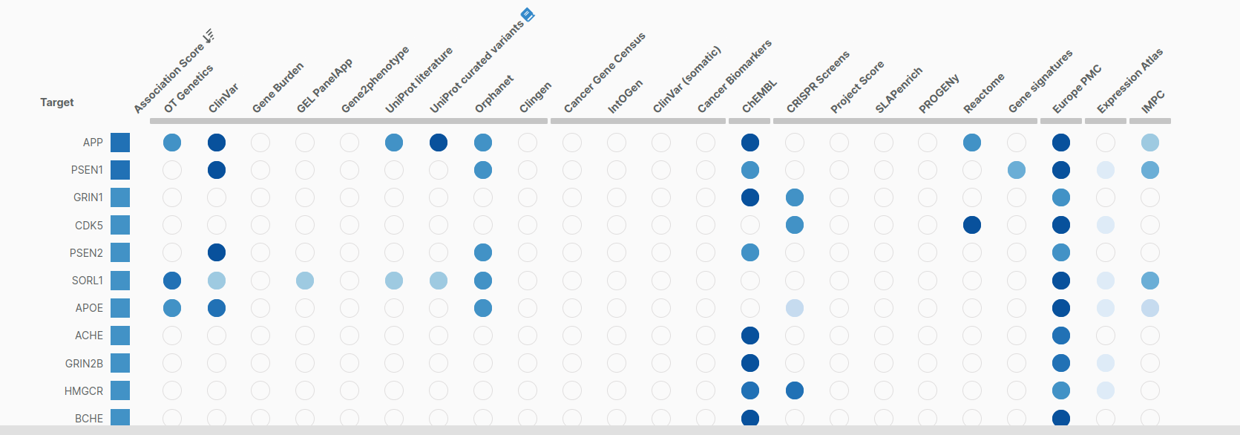

The gene associated with Alzheimer's disease in the image is the amyloid beta precursor protein (APP) gene. APP is a protein that is found in all cells of the body. It is involved in a variety of functions, including cell growth and development, and cell signaling.
Mutations in the APP gene can cause Alzheimer's disease. These mutations can cause the APP gene to produce more amyloid beta protein, or to produce a different form of amyloid beta protein. Amyloid beta protein is a protein that is also found in the brains of people with Alzheimer's disease. It is thought that amyloid beta protein plays a role in the formation of amyloid plaques, which are one of the hallmarks of Alzheimer's disease.
The image below shows the results of a study that looked at the association between the APP gene and Alzheimer's disease. The study found that people who have certain variations in the APP gene are more likely to develop Alzheimer's disease.

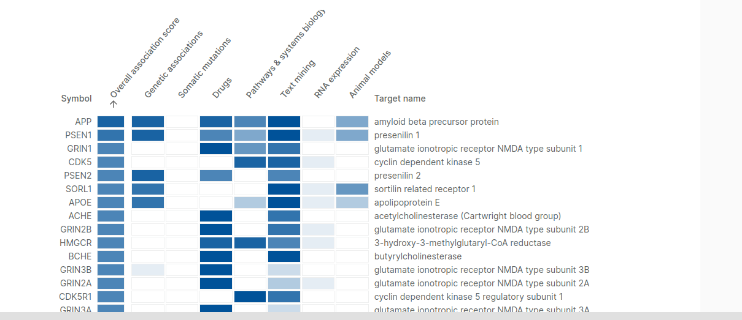

The study also found that the APP gene is associated with the age of onset of Alzheimer's disease. People who have certain variations in the APP gene are more likely to develop early-onset Alzheimer's disease, which is a form of Alzheimer's disease that develops before the age of 65.

The findings of this study suggest that the APP gene is a promising drug target for Alzheimer's disease. Drugs that target the APP gene could potentially be used to prevent or treat Alzheimer's disease.

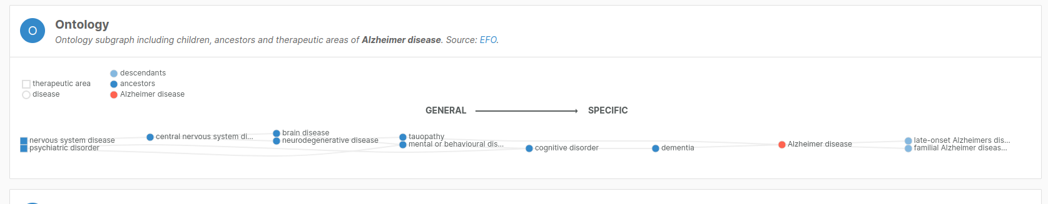

The Ontology is telling us that this disease is a nervous system disease and a psychiatric disorder, which, first it afects to the central nervous system then it generates brain disease and neurodegenerative disease, when the Alzheimer it progresses, it develops cognitve disorder, dementia, and at the end we can tell that the person is afectet for this disease.

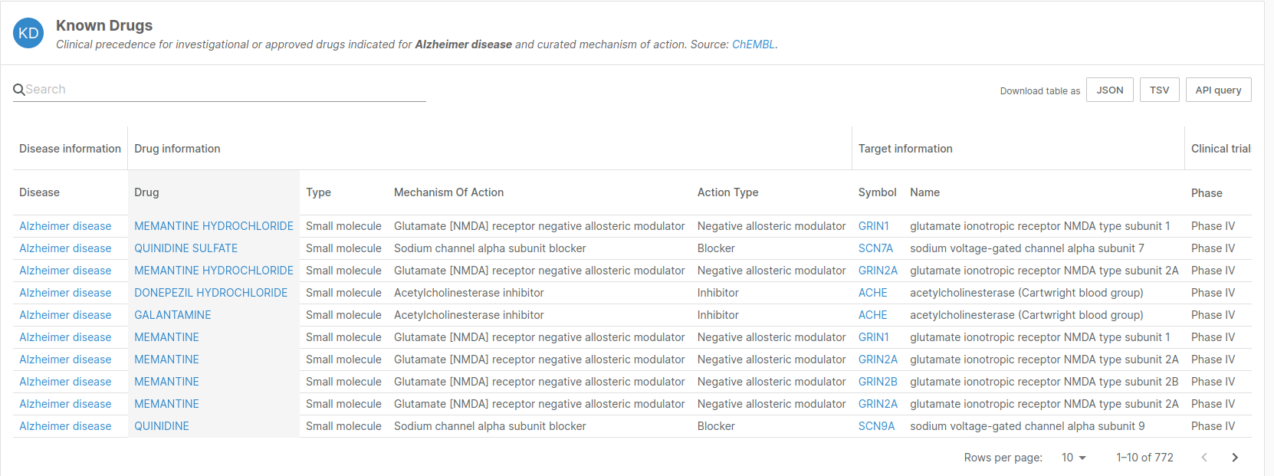

In the profile we have a description of the disease. A progressive, neurodegenerative disease characterized by loss of function and death of nerve cells in several areas of the brain leading to loss of cognitive function such as memory and language.

In the profile of the disease we can look for the drugs that are implement for studys of the disease, in the part we can see the information of the drug, the type, the mechanism of action, the action type and more things like the target information.

