Finally, it is time that you apply all what you have learned on this practical to take a closer look on your own at the ARL6 gene. Use the database Expression Atlas to describe the basal expression of this gene and to list under which conditions this gene is expressed differentially. Include the conditions where the gene shows the highest up and down regulation (as per Log2-FC).
Summarize and discuss your findings individually. You can include both text and images/screenshots.
Submit a document here (PDF; 2-3 pages max)

The basal expression of ARL6 in different species is
Within the human dataset, there are a total of 65 recorded experiments, indicating the presence of the gene in numerous anatomical or organism parts.

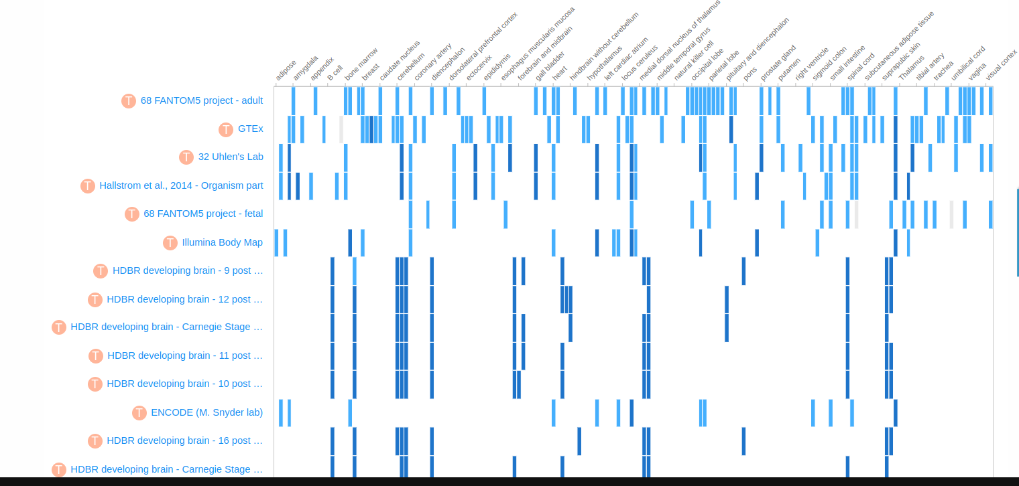

In contrast, when examining other organisms like Anolis carolinensis, only one experiment has been conducted, and the expression of ARL6 is limited to either the brain or kidneys.

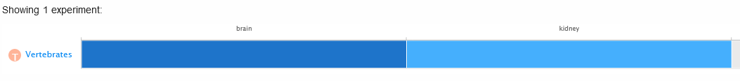
In mice, there are 52 experiments recorded in the database, and we can see that ARL6 is manifested in a lot of organism parts as well

This gene exhibits varying expression patterns and displays substantial up and downregulation values when subjected to different experimental variables, including disease, stimulus, phenotype, block, organism part, treatment, and sampling time point.

The cases with the highest up and down regulation are
In the context of a multidimensional blood stimulation assay, a decrease in expression by 4.5 units was observed. This downregulation occurred within the scope of the experiment, which involved the experimental variables of disease and stimulus.

The next highest is an upregulation of 3.7 in drosophila melanogaster in an experiment consisting of transcription profiling by array of Drosophila embryonic chordotonal neurons. The experimental variable is the phenotype

