Common ancestor, but copies of DNA start to have mutations and differentiate. Once you have in two organisms copies and they try to recombine if it couldn’t make and offspring we can say that they different species.

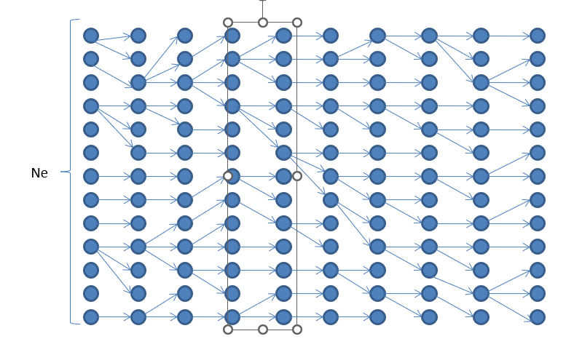

We can see the variability of chromosomes among time, so we start and end with the same number but there has been changes.

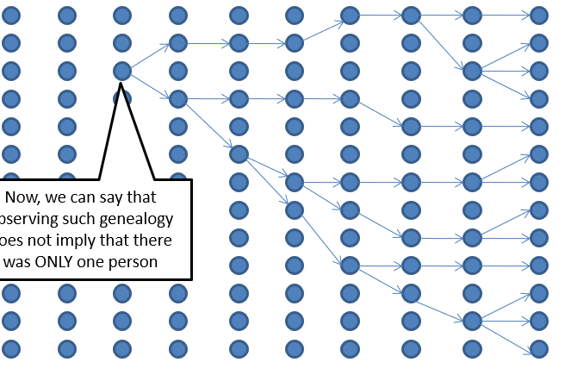

And if we do the process backwards we can see how we will end up finding a common ancestor.

If the mutation rate is high this will be bad (in general having functional mutation is bad)

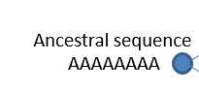 Mutation can’t be very high but why is not 0

From an evolutionary point of view why a molecule (it’s main goal is to make copies) would decide to not reproduce, because “altruism” most cells decide to support only a particular subset of cells to reproduce.

From a molecular point of view, they want to make copies but there are mechanisms to restring all molecules to make copies, when those mechanisms fail and cellules reproduce without control what we have is **cancer**.

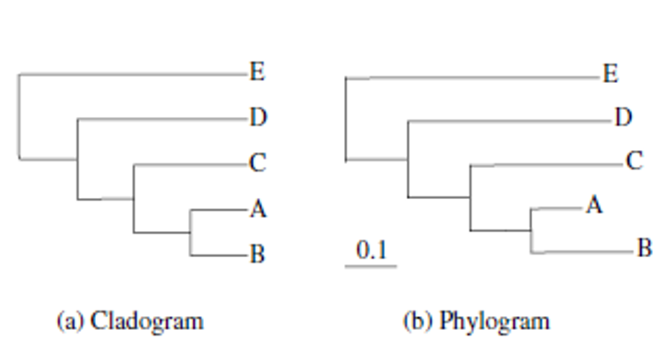

As we can see the difference is the distance of leaves can variate, so in phylogram we could say that B has more mutations.

Usually, the one that makes common sense is A as is a nonsense to say that a specie has more mutations that others, what can happen in order to have a phylogram is that the reproduction rate or mutation rate of the species is very different.

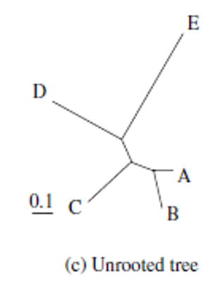 This is different type of tree because you don’t know the root (common ancestor).

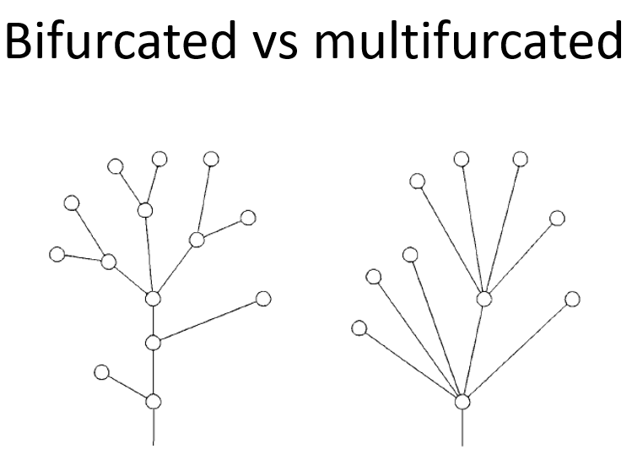We will work with bifurcated ones as are easier.

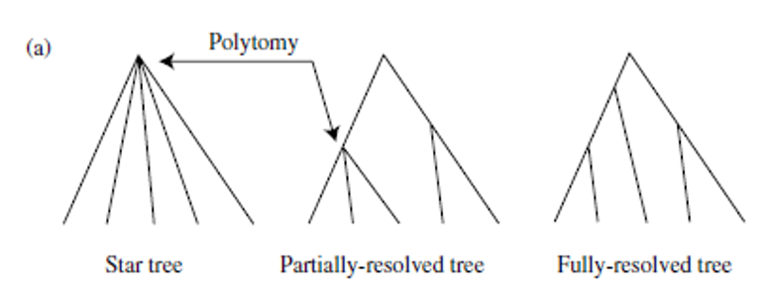We may start with a start tree and we would like to end up with a fully resolve one but we may end up with a partial one.

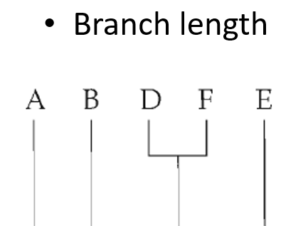 As we see in this type of tree we see pair of species that diverge more than another.

**Newick format**

Each internal node is defined by the connections (,)

Length between noes is defined by (:)

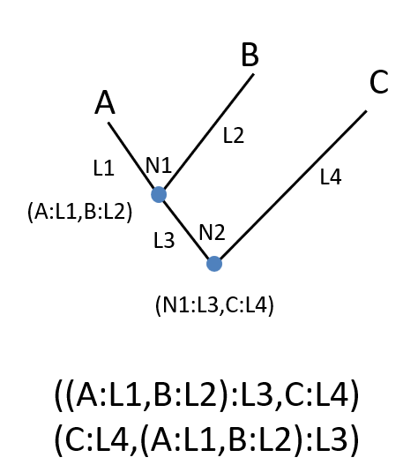

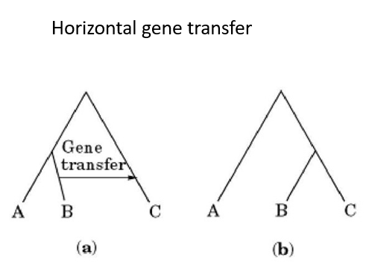Some type of bacteria have the trees in horizontal way.

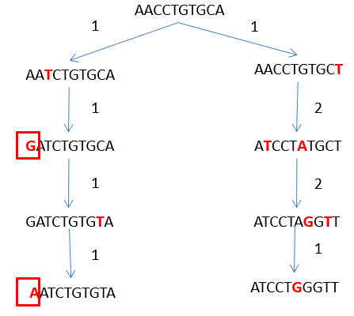 Time divergence …

P $\left(n|t;μ\right)=\frac{{μt}^{n}e^{-μt}}{n!}$ Poisson distribution formula for the mutations.

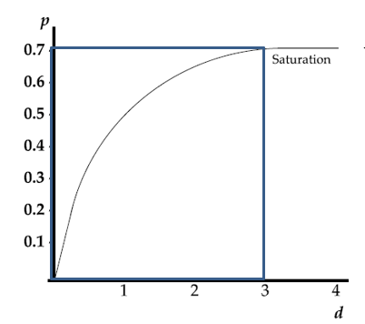 There is a point where we will reach a maximum then species evolve and accumulate genetic changes, the genetic distance between them increases until saturation.

$P\left(t\right)=e^{Qt}=\sum_{n=0}^{∞}{Q^{n}\frac{t^{n}}{n!}}$ Formula of Markov chains in order to how will change a nucleotide to another in a transition matrix.

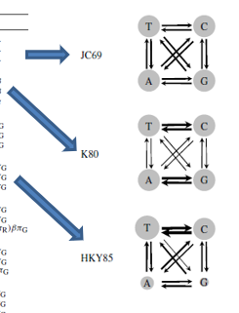 We already have some models done. The goal with this is to correct the saturation time of two species in order to see that we could find an elder ancestor common.

If there are recurrent mutations comparing two species, there could be hide mutation if this happen your tree wouldn’t be correct as some mutation would not appear.