The exam submission will consist in one compressed directory. In this compressed directory you will include two directories: one named results and another named scratch. In the results directory you will include all the files I ask you during the different questions and a text file where you will answer the questions. The scratch directory will be the directory where you have done the exam, and it will contain all the files you have generated.

Each question accounts for 1 point. Try to keep answers simple and direct. You can use your notes and materials of the classes if you want, you can also check biological databases.

In this exercise we are working with a protein for which we have its sequence in a separate file (target.fa) and its structure in a separate pdb file (target.pdb). Answer the following questions about the protein we are studying:

a) What function do you think it may have?

$blastp -query target.fa -db ~/Documents/databases/pdb_seq -out target_pdb.out
Hemoglobin alpha chain → Hemoglobin
1z8u_D

b) Does it belongs to some family of PFAM?. If so, obtain the HMM profile from PFAM and name it p28b.hmm

$hmmscan ~/Documents/databases/Pfam-A.hmm target.fa > scan_target_PFAM.out
get 1z8u in scan output→ → Globin
$hmmfetch ~/Documents/databases/Pfam-A.hmm Globin > p28b.hmm

c) the structure of this protein belongs to some fold in SCOP?, which one?

Search for ID(1z8u) in SCOP, you can look up similar entries only

d) Obtain at least three more sequences with known structure and align them with the sequence of the PROBLEM using the HMM profile. Name the alignment p28d.aln

$hmmsearch p28b.hmm ~/Documents/databases/uniprot_sprot.fasta > MSA_p28b.out
get first 3 sequences(P28316, P26914, P10059) and download from uniprot and get them in 1 file
$cat P10059.fasta P26914.fasta P28316.fasta >> sequences.fasta
align
$hmmalign p28b.hmm sequences.fasta> MSA_2aln.sto
Sto→aln
$perl ~/Documents/databases/perl_scripts/aconvertMod2.pl -in h -out c <MSA_2aln.sto > p28d.aln

e) Obtain the secondary structure with DSSP and name it p28e.dssp

--Given in directory dssp_output

f) Do you think the prediction of secondary structure agrees with the actual secondary structure from DSSP?. Obtain an alignment as proof and name it p28f.aln. Is this prediction reliable?

Split target.pdb using PDB to splitchain to get fasta(tout.fa), align with target.fa using hmm (or clustalw), and obtain seq.aln, then use perl (aconvertMod2.pl) to get .pir to use in modeller.
Load ..0001.pdb and target.pdb to pymol, align with super
super tout.B99990001, target, object=aln1
RMSD=0
Save the alignment
save p28f.aln, aln1
The prdiction is reliable as RMSD=0 and in the alignment the structure matches

g) Do you think the structure is correct? Can you prove it? show an image of the energies that prove it and name it p28g.png

we use prosa, the zscore is of -5.06

h) Find if there is some structural problem and show the location with an image (name it p28h.png). What's the sequence fragment with this problem?

Search for hang-down peaks in the prosa graph and take a photo

i)Do you think the protein PROBLEM can work as a tetramer? show an image that can prove it (name it p28i.png)

problem=1z8u
>fetch 1z8u
load target.pdb (or modeller output? As 2target)
>remove resn hoh
activate sequece display(chains) and rename the selections to hemo<chain>
>super 2target, hemoA
>save iAtg.pdb, 2target
>super 2target, hemoB
>save iBtg.pdb, 2target
>super 2target, hemoC
>save iCtg.pdb, 2target
>super 2target, hemoD
>save iDtg.pdb, 2target
open all the generated files in a new pymol session to see a tetramer of the modeller output (leghemoglobin)

j) Even if it was a monomer, do you think it will work with the function you selected in answer "a"? Use a sequence alignment (ie. you can reuse p28d.aln) to show the conservation/non-conservation of functional residues. Mark the functionally important amino-acids (conserved or non-conserved) in the alignment with the symbol # at the bottom.
#no se
It would work, as the conserved region in the alignment is more or less a quarter of the size of the whole alignment, which could mean that the alignment is made out of 4 sections and each section is a monomer, thus the conserved region could be a monomer
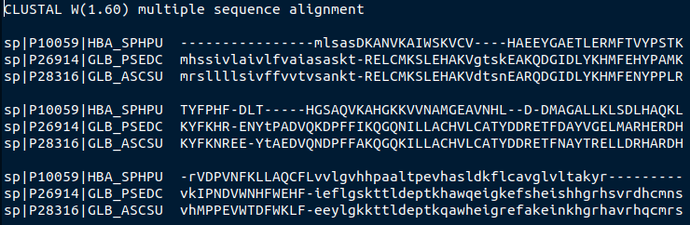
This is the conserved region

k) To further proof your answer in "j": Show an image of the structure of the active site with the relevant aminoacids that preserve (or don't preserve) the function in its active form (i.e. if it requires a cofactor, such as ATP, Ca, etc. include it in the active site interacting with the corresponding residues of the PROBLEM). Name it p28k.png
#falta j

l) If the structure of the PROBLEM was incorrect (answer in g), try to fix it. Name the new monomer model as p28l.pdb
#com fem fixin sense prosa?

