The exam submission will consist in one compressed directory. In this compressed directory you will include two directories: one named results and another named scratch. In the results directory you will include all the files I ask you during the different questions and a text file where you will answer the questions. The scratch directory will be the directory where you have done the exam, and it will contain all the files you have generated.

Each question accounts for 1 point, except for questions e and f that count for 2. Try to keep answers simple and direct. You can use your notes and materials of the classes if you want, you can also check biological databases.

In this exercise we will work with two protein structures called SH2.pdb and SH3.pdb. Answer the following questions about these proteins:

a) Obtain the amino acid sequences corresponding with the two structures. Name them SH2.fa and SH3.fa.

$perl ~/Documents/databases/perl_scripts/PDBtoSplitChain.pl -i SH2.pdb -o SH2
$perl ~/Documents/databases/perl_scripts/PDBtoSplitChain.pl -i SH3.pdb -o SH3

b) Are there HMMs from PFAM for each of these structures? If they are, get them and name them SH2.hmm and SH3.hmm.

$hmmscan ~/Documents/databases/Pfam-A.hmm SH2B.fa > scan_SH2_PFAM.out
$hmmscan ~/Documents/databases/Pfam-A.hmm SH3A.fa > scan_SH3_PFAM.out

Search in .out for SH2 and SH3
SH2: SH2
SH3: SH3_1

$hmmfetch ~/Documents/databases/Pfam-A.hmm SH2 > SH2.hmm
$hmmfetch ~/Documents/databases/Pfam-A.hmm SH3_1 > SH3.hmm

c) Find 4 homologous sequence for SH2. Put them into a single multifasta file. Name the file homologs.fa.

$hmmsearch SH2.hmm ~/Documents/databases/uniprot_sprot.fasta > SH2_homologs.out
Get the first 4 proteins (P29349, P41499, P35235, Q06124), download their fasta
$cat P29349.fasta P41499.fasta P35235.fasta Q06124.fasta > homologs.fa

d) Make a multiple sequence alignment of the 4 sequences you obtained previously using the corresponding HMM you obtained in question c. Then, change the format of the alignment to clustalw format. Name the alignment as MSA.aln.

$hmmalign SH2.hmm homologs.fa> SH2_aln.sto
Sto→aln
$perl ~/Documents/databases/perl_scripts/aconvertMod2.pl -in h -out c <SH2_aln.sto> MSA.aln

e) We want to study the L253R mutation in SH2. Model the structure of SH2 containing this mutation. Be aware that the structure that you have is not complete, therefore the first amino acid corresponds with position 232. Name your model as mutant_model.pdb.

Get the mutated sequence:
Search L in pos 253 in SH2.pdb, look for surrounding amino acids, and search in SH2B.fa, then change L to R and save it as SH2_mutated.fa, change the name of the sequence to SH2BM.
$cat SH2B.fa SH2_mutated.fa > SH2_5aln.fa

$hmmalign SH2.hmm SH2_5aln.fa > SH2_5MSA.sto
$perl ~/Documents/databases/perl_scripts/aconvertMod2.pl -in h -out c <SH2_5MSA.sto>SH25align.aln
$perl ~/Documents/databases/perl_scripts/aconvertMod2.pl -in c -out p <SH25align.aln>SH2aln.pir

Use modeling.py:
alnfile = 'SH2aln.pir',
knowns = ('SH2B'),
sequence = 'SH2BM')

$mv SH2BM.B99990001.pdb mutant_model.pdb

f) Analyze the mutant model you generated previously with ProSa and compare it with a reference structure. Can you tell what is the effect of the mutation in the overall stability of the protein? What reference structure are you using? Take an image of the comparison of the two ProSa profiles and save it as prosa_analysis.png.

Zscore mutant= -6.27

Zscore template= -6.47

The mutation affect the protein, as the Z-score changes

g) Search for a structure containing two proteins interacting, one being homolog to SH2 and the other to SH3. Name this file as template.pdb.

Paste the sequences of SH2 and SH3 together in SH.fa and blast em
$cat SH3A.fa > SH.fa
rename SH3A to SH and paste the sequence in SH2B.fa below the existing sequence
ORDER IS IMPORTANT (first A, then B)

$blastp -query SH.fa -db ~/Documents/databases/pdb_seq -out SH_out.out

We search the first that have A and B together:
PDB ID is 1g83_B and 1g83_A

download 1g83 pdb from rcsb, rename it template.pdb

otherwise
Search for SH2(domain) on 3did and click on bond with SH3_1, choose one of the pdb options

h) Use the template you found in the previous question to build a model of the interaction between SH2 and SH3. Name this model interaction_model.pdb.

Load 1g83(template.pdb) to pymol
>sidebar>A>find>polar contacts>between chains
Color the residues around the polar contacts and create a new selection named sl1
>sb1>A>extract object (>create ob1, sb1)
Group the polar contacts, he new object and the protein in a new group named group01
Extract the group
>save interaction_model.pdb, all
Pymol session h_question.pse

i) Do you think that the interaction that you modeled in the previous question could happen in nature? Select some amino acids from SH2 that you think are important for the interaction between the two proteins. Show images of these amino acids to proof your answers. Name them aa_picture1.png, aa_picture2.png, and so on.
Select the residues around the polar bonds, these are the important residues for the interaction between the proteins. The interaction could happen in nature, as the model protein is an existing protein where the interaction happens.
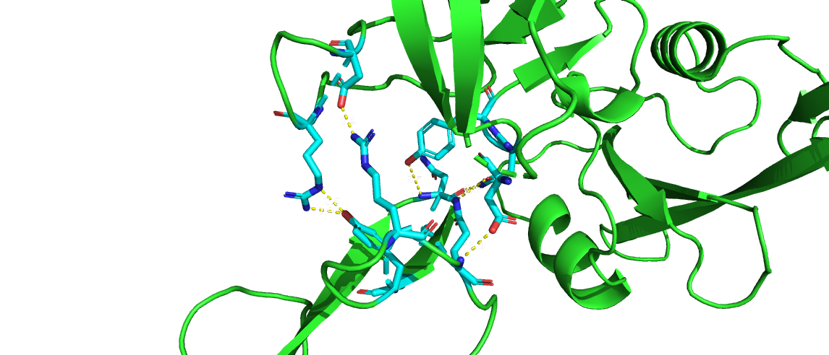

j) Search for the amino acids that you selected in the previous question in the MSA you created in question d. Are these amino acids conserved? Discuss the degree of conservation of these amino acids and why do you think this is happening.
The important amino acids are Chain A:(ASN:210, TYR:214, ARG:218, GLN:220) and Chain B: (ARG:96, ASP:100, ASP:118, ASN:136, TYR:137).
Find them on MSA.aln, etc...

