Лабораторная работа №3 вариант 13

**Задание 1**

1. Заполнение таблиц
2. Вставка записи в таблицу командой INSER

INSERT INTO Type_of_tools (ID_Type,Producer_country,Year,Mark) values ((1,'USA',2008,'Mark1'),

(2,'Canada',2008,'Mark2'),

(3,'USA',2008,'Mark3'),

(4,'Canada',2010,'Mark4'),

(5,'USA',2010,'Mark5'),

(6,'Canada',2010,'Mark6'),

(7,'USA',2012,'Mark7'),

(8,'Japan',2013,'Mark8'),

(9,'USA',2013,'Mark9'),

(10,'USA',2013,'Mark10'));

1. Файлы приложены к отчету
2. Через графический интерфейс

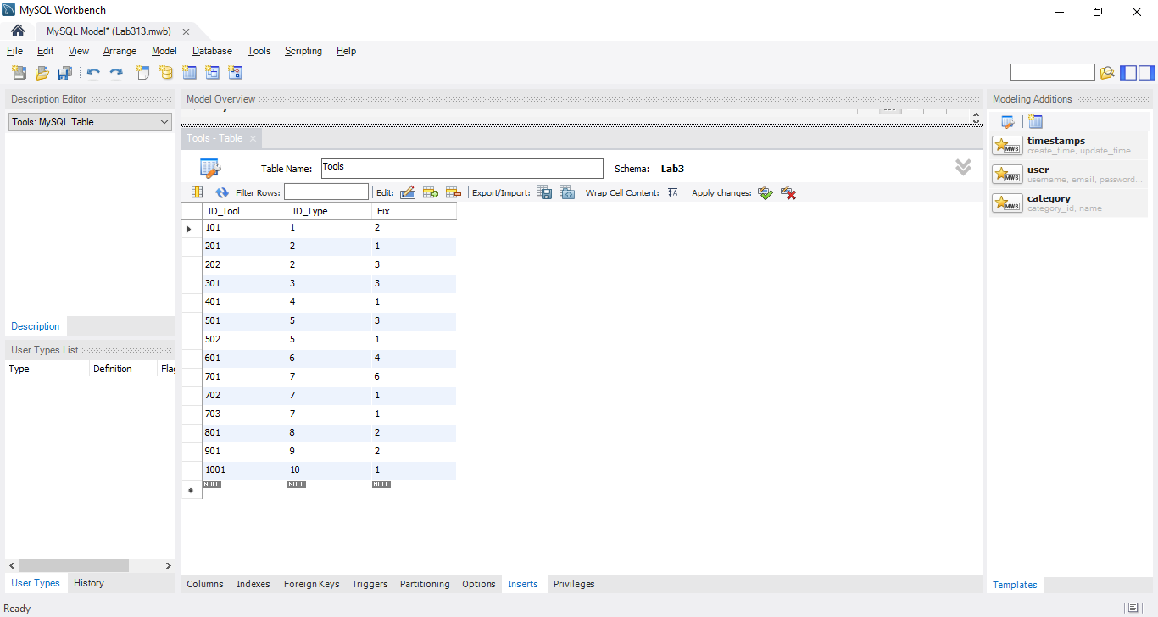

1. Изменение записи в таблице (UPDATE)

UPDATE Type_of_tools SET Producer_country = 'USA'

UPDATE Type_of_tools SET Mark = 'Warmachine' WHERE ID_Type = 2;

UPDATE Kind_of_works SET Duration='06:05:00' WHERE Cost>740;

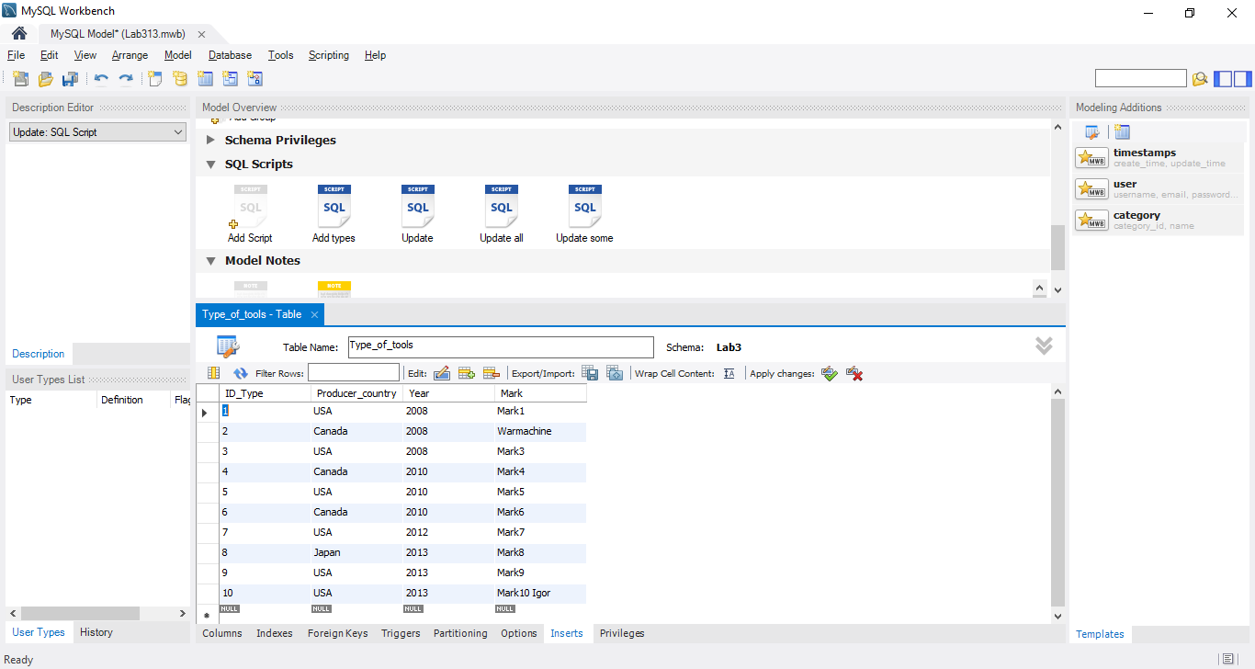

1. Изменение записи в таблице (REPLACE)

UPDATE Type_of_tools SET Mark = REPLACE(Mark, 'Mark', 'IM-Mark');

1. Удаление записи

DELETE FROM Tools WHERE ID_Tool=703;

DELETE FROM Kind_of_works WHERE Cost>800;

DELETE FROM Orders;

TRUNCATE TABLE Tools;

**Задание 2**

SELECT Name, (Cost+0.01) AS 'Rounding off' FROM Kind_of_works WHERE Cost>30 AND Cost<750;

SELECT Name, Duration, Cost

FROM Kind_of_works

Where Cost<500;

SELECT Name, Duration, Cost

FROM Kind_of_works

Where Cost<750

LIMIT 4;

SELECT * FROM Orders

GROUP BY Start_date;

SELECT Work, Count(Work) AS 'Number of works'

FROM Orders

GROUP BY Work

HAVING Count(Work)>1;

SELECT Name AS 'Name' FROM Kind_of_works

UNION

SELECT Mark AS 'Name' FROM Type_of_tools;