Running MSG (Multiplexed Shotgun Genotyping) on the Cloud

Introduction

MSG is an exciting and innovative Bioinformatics pipeline to assign ancestry to genomic segments using next-gen sequence data. However it requires high levels of computing resources for some of the most interesting problems.

Amazon Elastic Computer Cloud (EC2) and other Amazon web services are a good solution by providing these computing resources on demand. Galaxy Cloudman (http://www.biomedcentral.com/1471-2105/11/S12/S4) is a cluster management framework that sets up an Oracle Grid Engine on Amazon EC2 and automates many of the steps of setting up and managing a cluster.

This documents provides detailed instructions on how to run MSG utilizing Galaxy CloudMan running on Amazon EC2.

Dire Warnings

These instructions reference using Amazon cloud web services to run MSG. You are responsible for all charges from Amazon in the running of MSG. Amazon does not have any built-in protections against using large amounts of resources so you could potentially be charged significant amounts of money. We are not responsible for any charges you incur.

Be very careful to monitor the resources you use in the Amazon AWS console (https://console.aws.amazon.com). Make sure all instances have terminated when you are finished with a run, and monitor your disk space usage.

About this document

This document assumes the user already has knowledge of the purpose and general operation of the MSG software. It is only intended to explain how to run MSG on the Amazon Elastic Compute Cloud (EC2) via Galaxy CloudMan.

For general information about MSG and its usage please visit these links:

Source Code: https://github.com/JaneliaSciComp/msg

About MSG: http://genomics.princeton.edu/AndolfattoLab/MSG.html

Instructions

Step 1 – Sign up for Amazon web services

Create an Amazon Web Services (AWS) account and sign up for Elastic Compute Cloud (EC2) and Simple Storage Service (S3) services.

Step 2 – Launch a Galaxy CloudMan Cluster

Open an Internet browser and go to:
https://biocloudcentral.herokuapp.com/launch

A page similar to this will come up:

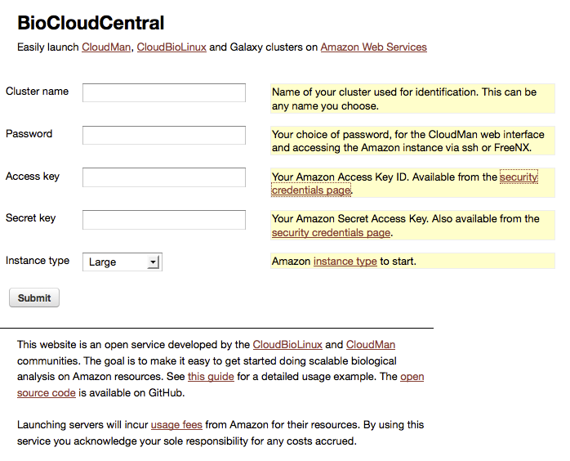
Fill in the fields on this page:

- Cluster Name: This can be anything you would like. (Write down this name as you can come back to it later.) Only use letters in the name. Do not use spaces or special characters.
- Password: You will use this password to access a web console, and for SSH access. Only use letters and do not use any spaces or special characters.
- Cloud: Choose “Amazon (AWS EC2).
- Access Key: Follow the link on the webpage to the right of this field to learn where to find this.
- Secret Key: Follow the link on the webpage to the right of this field to learn where to find this.
- Instance type: Select Large for a good default, but you may want higher memory instances for very large datasets.

Click the button at the bottom of the page to start an instance.

Now a page like this will come up with information about your running cluster:
(Wait 1-5 minutes for this page to update with information about your instance.)

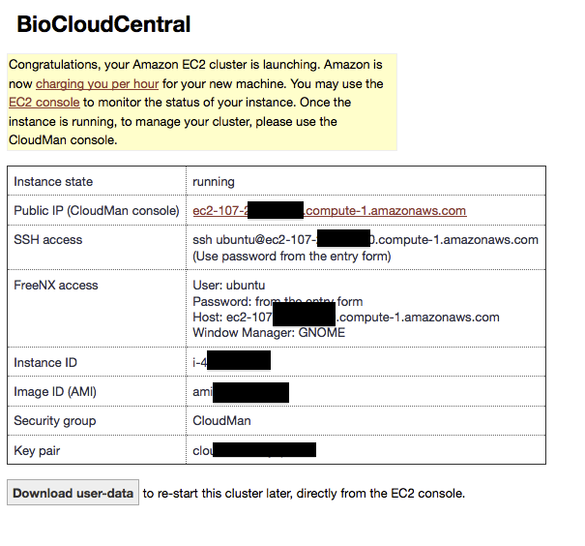

Note the SSH access command. You'll need that for later.

Click on the hyperlink in the row of the table for "Public IP (CloudMan console)". If this link doesn’t appear you may need to wait 5+ minutes as CloudMan starts up.

After clicking on the CloudMan console link a new page will open. On the new page a dialog will pop up asking for a user name and password. Enter your password (but leave the top field blank).

Now you should see a window like this:
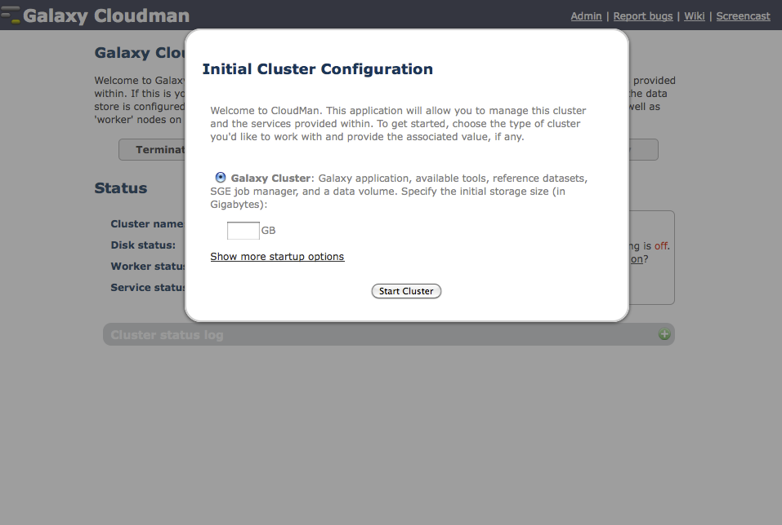

Click "Show more startup options"
Click the "Share-an-Instance Cluster" radio button and enter the share string into the text box. (see “getting the share string” below.)
Getting the Share String:
Go to this URL in a new window. Copy all of the text on this page. This is the share string.
https://raw.github.com/JaneliaSciComp/msg/master/instructions/galaxy_cloudman_share_string.txt

Then click the "Start Cluster" button.

The screen should now look something like the image below. Wait to proceed until the “Disk Status” section shows disk size information (e.g., 696M / 5.0G (14%)) and the status lights are green. (see arrows in image below.)
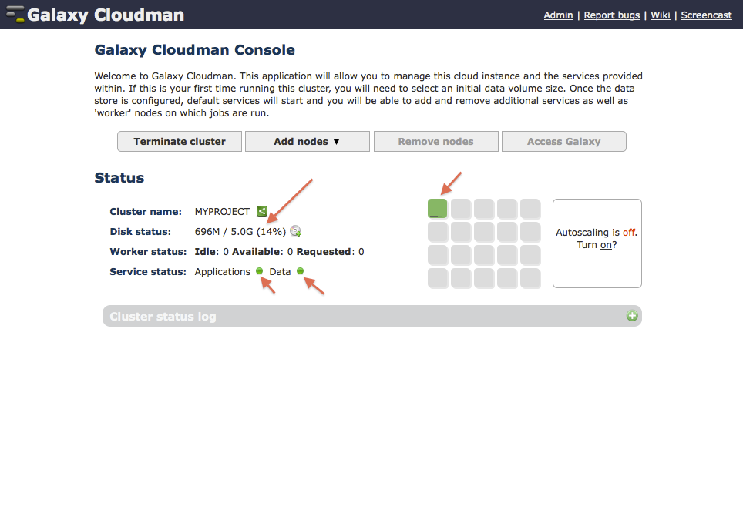

Step 3 – Resize the Disk

It is important to make sure there will be enough disk space to contain both the input files to be used, and the output files generated by MSG.

- First determine the total size of all of your input files.
- Then multiply this number by 10 (or use 11 to be extra safe). This is the total disk space you will need.
- If this number is greater than 4GB, click the CD with a plus sign button to the right of Disk Status to expand the disk size.
- Enter the amount you calculated (in gigabytes).
- Wait to proceed until the resize is complete and the dialog has gone away.
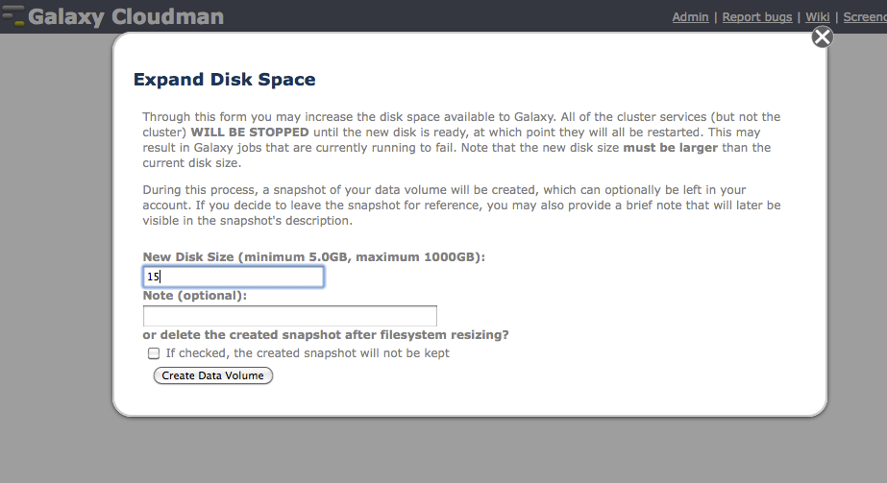

Step 4 – Add Cluster Nodes

Click the “Add nodes” menu button and select the number of cluster nodes you would like to run.
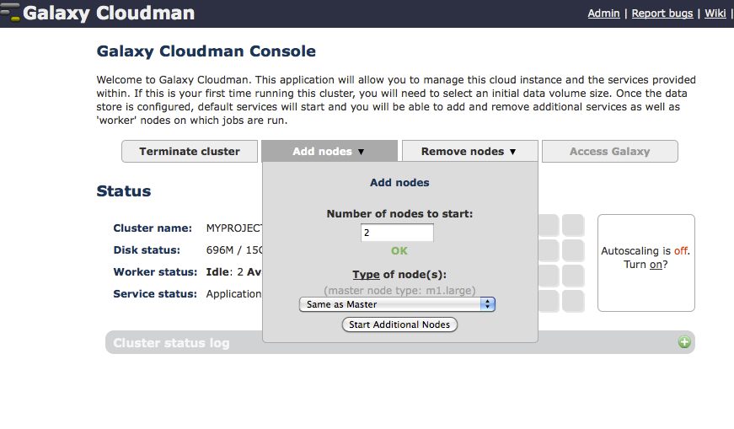
Click the start additional nodes button.
Wait until the nodes turn green as shown in the image below.
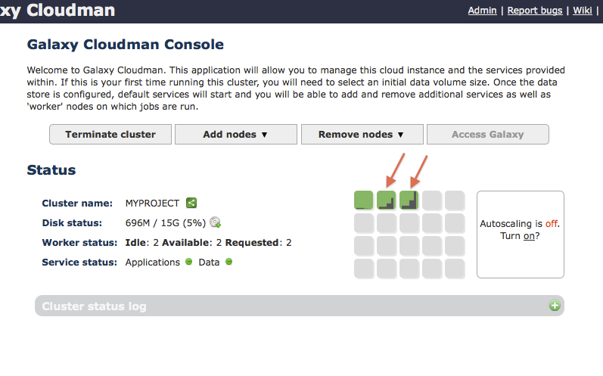

Step 5 – Bring in Input Files

Now you'll want to copy your input files to the cluster master instance.
Open up a terminal window and cd into the local directory with your input files.
Example:

$ cd ~/msg_work/MSG_toy
$ scp reads.fq ubuntu@ec2-107-88-22-109.compute-1.amazonaws.com:/mnt/galaxyData/custom/MY_MSG_RUN

(Replace ubuntu@ec2-107-88-22-109.compute-1.amazonaws.com with the equivalent SSH information from the launch page. The SSH password is the password you entered on the launch page.)

Perform this same process to copy over all of the input files you will need, making sure everything goes into the MY_MSG_RUN directory on the master cluster instance.

Step 6 – Configure and Run MSG

Now ssh into your master instance.
On the page that launched the cluster instance there will be an SSH connection command to run:
example:
ssh ubuntu@ec2-107-88-22-109.compute-1.amazonaws.com
(Replace ubuntu@ec2-107-88-22-109.compute-1.amazonaws.com with the equivalent SSH information from the launch page)

Once you have connected, change directory to your pre-configured MSG working directory:
$ cd /mnt/galaxyData/custom/MY_MSG_RUN
$ ls
You should see all of the files you copied over.

Edit the file msg.cfg to reference the input files you copied over. You may also with to change some of the other settings.

Next, run this command to update your paths:
$ source msg/SOURCEME.GALAXY

Run MSG:
$ perl msg/msgCluster.pl

MSG will now be running, you can watch your working directory to see files as they are created as well as review log files.
You can also run the command "qstat" to see the statuses of the jobs that MSG is running.

Step 7 – Shutting Down

When you are finished running follow these steps:

Exit your ssh session:
$ exit

Next, terminate your cluster instance:
Head back over to the CloudMan web console.
Click the "Terminate Cluster" button.

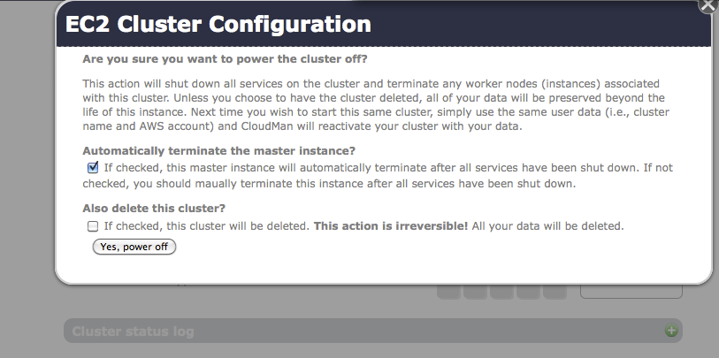

If you are completely done and don't need to save any data, check the "Also delete this cluster" option.
Otherwise you can re-launch later by using the same cluster name and Amazon security credentials.
Click the “Yes, power off” button.

Wait for 5+ minutes to give everything a chance to shut down.

Finally log into the Amazon EC2 console and make sure everything has shut down cleanly.
https://console.aws.amazon.com/ec2

