Table of Contents
1. Repository Information
1.1. Description
2. Images
3. Usage Instructions
4. Build Instructions
5. Hardware
5.1. power_switch_controller_3x2
5.1.1. Repository Information
5.1.2. Images
5.1.3. Schematic
5.1.4. Gerbers
5.1.5. Bill of Materials
5.1.6. Supplemental Documentation
5.2. power_switch_controller_5x3
5.2.1. Repository Information
6. Firmware
6.1. PowerSwitchController
6.1.1. Library Information
6.1.2. API NAMES
6.1.3. API GENERAL
6.1.4. Ancestors
6.1.5. Clients
6.1.6. Devices
6.1.7. More Detailed Modular Device Information
6.1.8. Installation Instructions

Repository Information
Name
power_switch_controller
Version
1.0
License
BSD, Open-Source Hardware
URL
https://github.com/janelia-modular-devices/power_switch_controller.git
Author
Peter Polidoro
Email
peterpolidoro@gmail.com

Description
This device controls low-side power switches for turning on and off solenoids, relays, and resistive loads.

Images

Usage Instructions
- Connect a power supply to the power switch controller board.
- Connect devices to be switched to the shrouded header connectors on the board with either ribbon cables and IDC connectors or individual 2-pin connectors.
- Connect USB cable to from device to host machine and control over a serial port.

Build Instructions
- This controller is made from a single 5x3 or 3x2 form factor modular device.
- This device consists of two pcbs, either the (modular_device_base_5x3) and the (power_switch_controller_5x3), or the (modular_device_base_3x2) and the (power_switch_controller_3x2).
- In addition to the two pcbs, there is one acrylic mounting plate (modular_device_enclosure 5x3 enclosure_bottom) or (modular_device_enclosure 3x2 enclosure_bottom).
- Send the zip files containing the gerbers for each of the two pcbs to your favorite pcb manufacturer for fabrication.
- Using the bill of materials and vendor parts lists order the parts necessary for construction for the two pcbs and the mounting plate.
- Assemble each of the pcbs using the assembly instructions provided for each.
- Use the dxf file for the enclosure_bottom to cut the mounting plate from the acrylic sheet using a laser cutter or send the dxf to a laser cutting service for fabrication.

Hardware

power_switch_controller_3x2

Repository Information
Name
power_switch_controller_3x2
Version
1.1
License
Open-Source Hardware
URL
https://github.com/janelia-kicad/power_switch_controller_3x2
Author
Peter Polidoro
Email
peterpolidoro@gmail.com
- Description
This board controls up to 8 low-side power switches for turning on and off solenoids, relays, and resistive loads.

Images
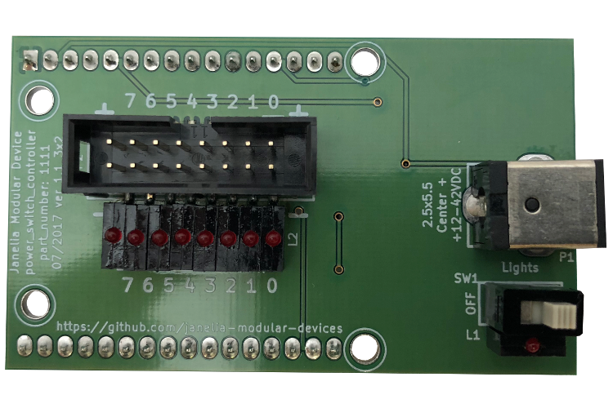
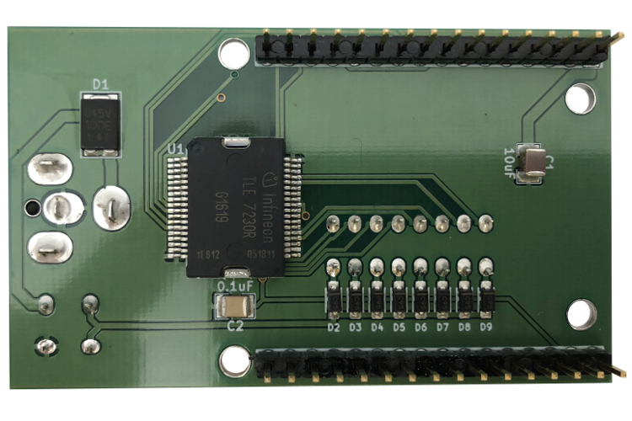

Schematic
./hardware/power_switch_controller_3x2/schematic/power_switch_controller_3x2.pdf
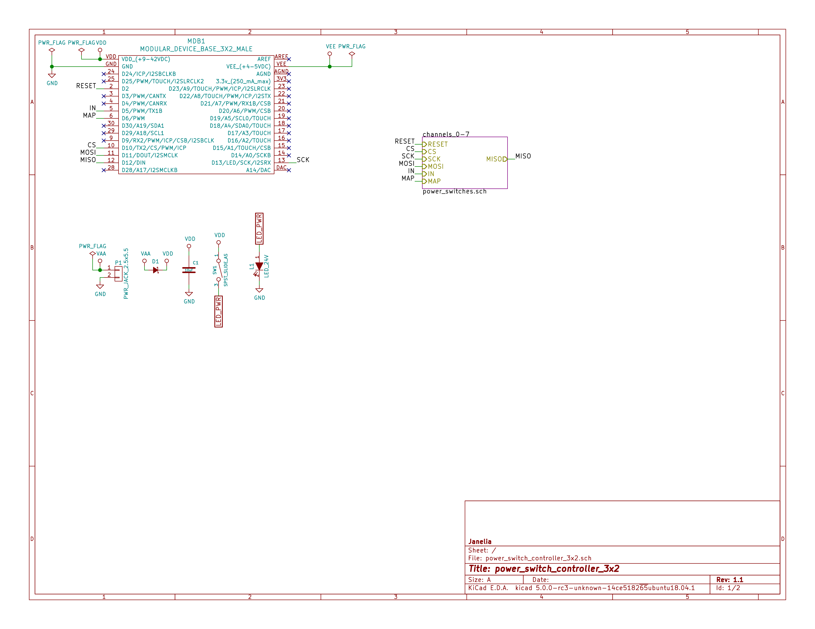
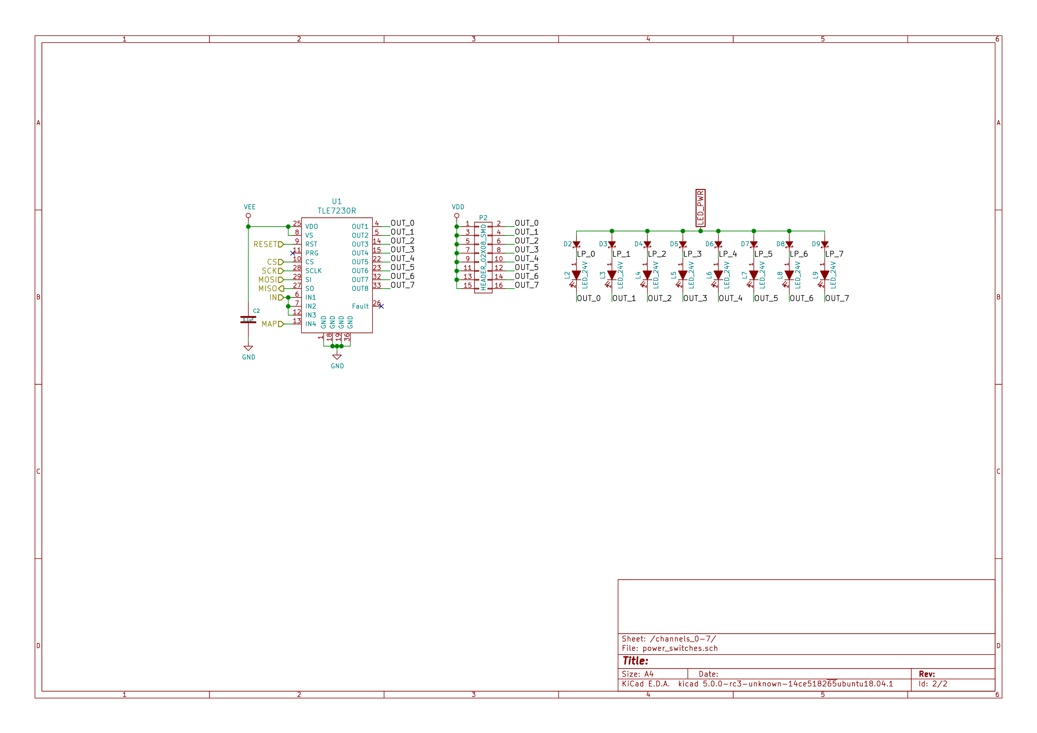

Gerbers
Send gerbers zip file to your favorite PCB manufacturer for fabrication.
./hardware/power_switch_controller_3x2/gerbers/power_switch_controller_5x3_v1.1.zip
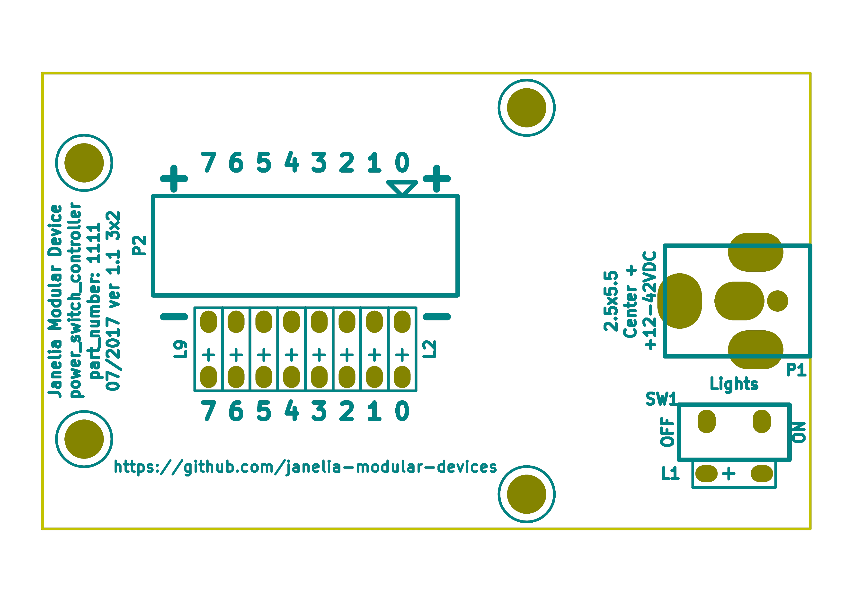
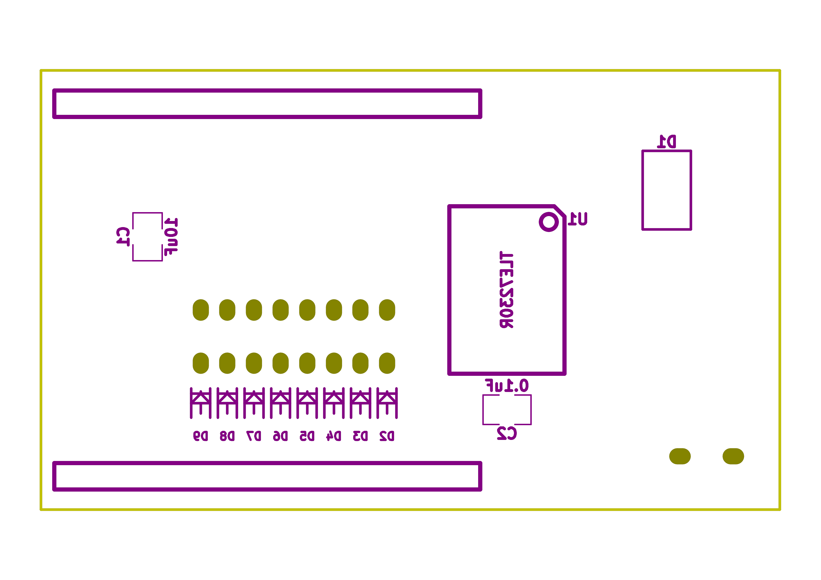

Bill of Materials
- PCB Parts
Item | Reference(s) | Quantity | PartNumber | Vendor | Description
1 | C1 | 1 | 445-4536-1-ND | digikey | CAP CER 10UF 50V 10% X7S 1210
2 | C2 | 1 | 399-13229-1-ND | digikey | CAP CER 0.1UF 100V X7R 1210
3 | D1 | 1 | 568-11697-1-ND | digikey | DIODE SCHOTTKY 45V 10A CFP15
4 | D2 D3 D4 D5 D6 D7 D8 D9 | 8 | CMHD3595 CT-ND | digikey | DIODE GEN PURP 150V 150MA SOD123
5 | L1 L2 L3 L4 L5 L6 L7 L8 L9 | 9 | 350-1723-ND | digikey | LED 2MM 24V VERTICAL RED PC MNT
6 | MDB1 | 2 | S1011E-16-ND | digikey | 16 Position Header Through Hole Male Pins
7 | P1 | 1 | CP-063BH-ND | digikey | CONN PWR JACK DC 2.5X5.5 8A T/H
8 | P2 | 1 | S9187-ND | digikey | CONN HEADR 2.54MM 16POS GOLD SMD
9 | SW1 | 1 | 360-2610-ND | digikey | SWITCH SLIDE SPST 0.4VA 28V
10 | U1 | 1 | TLE7230RCT-ND | digikey | IC SW SMART OCTAL LOWSIDE PDSO36
- Supplemental Parts
Item | Quantity | PartNumber | Vendor | Description
1 | 32 | WM2800-ND | digikey | CONN HOUSING 2POS .100 SINGLE
2 | 64 | WM2512-ND | digikey | CONN TERM FEMALE 22-24AWG GOLD
3 | 64 | WM2513-ND | digikey | CONN TERM FEMALE 24-30AWG GOLD
4 | 4 | AKC16H-ND | digikey | CONN IDC SKT 16POS W/POL 15 GOLD
5 | 1 | MC16M-300-ND | digikey | CBL RIBN 16COND 0.050 MULTI 300ft
6 | 4 | APK16B-ND | digikey | CONN IDC PIN 16POS 30AU NO LATCH
7 | 32 | WM2900-ND | digikey | CONN HOUSING 2POS .100 W/LATCH
8 | 64 | WM2570-ND | digikey | CONN TERM FEMALE 22-24AWG GOLD
9 | 64 | WM2572-ND | digikey | CONN SOCKET 24-30AWG CRIMP 30AU
10 | 32 | WM2533-ND | digikey | CONN HOUSING MALE 2POS .100
11 | 64 | WM2566-ND | digikey | CONN PIN 24-30AWG CRIMP 30GOLD
12 | 64 | WM2567-ND | digikey | CONN TERM MALE 22-24AWG GOLD
- Vendor Parts Lists
./hardware/power_switch_controller_3x2/bom/digikey_parts.csv
./hardware/power_switch_controller_3x2/bom/supplemental_digikey_parts.csv

Supplemental Documentation
- Assembly Instructions
  - Solder header pins into the driver board, making note of TOP label. Insert header pins on bottom of board so that the long unsoldered header pins point down when the TOP label faces up.
  - Solder surface mount and through hole components onto the pcb.

power_switch_controller_5x3

Repository Information
Author
Peter Polidoro
License
Open-Source Hardware

Firmware

PowerSwitchController

Library Information
Name
PowerSwitchController
Version
2.1.3
License
BSD
URL
https://github.com/janelia-arduino/PowerSwitchController
Author
Peter Polidoro
Email
peterpolidoro@gmail.com
- Description
Modular device power switch controller library.

API NAMES
{
"id": "getApi",
"result": {
"firmware": [
"PowerSwitchController"
],
"verbosity": "NAMES",
"functions": [
"setChannelOn",
"setChannelOff",
"setChannelsOn",
"setChannelsOff",
"toggleChannel",
"toggleChannels",
"toggleAllChannels",
"setAllChannelsOn",
"setAllChannelsOff",
"setChannelOnAllOthersOff",
"setChannelOffAllOthersOn",
"setChannelsOnAllOthersOff",
"setChannelsOffAllOthersOn",
"getChannelsOn",
"getChannelsOff",
"getChannelCount",
"saveState",
"recallState",
"addPwm",
"startPwm",
"stopPwm",
"stopAllPwm",
"setPower",
"getPowers"
],
"parameters": [
"channel",
"channels",
"state",
"delay",
"period",
"on_duration",
"count",
"pwm_index",
"channel_group",
"power"
],
"properties": [
"states"
]
}
}

API GENERAL
./firmware/PowerSwitchController/api/

Ancestors
https://github.com/janelia-arduino/ModularServer
https://github.com/janelia-arduino/ModularDeviceBase

Clients

Devices
https://github.com/janelia-modular-devices/modular_device_base.git
https://github.com/janelia-modular-devices/power_switch_controller.git

More Detailed Modular Device Information
https://github.com/janelia-modular-devices/modular-devices

Installation Instructions
https://github.com/janelia-arduino/arduino-libraries

