BAN 502 - Predictive Analytics

McCleave, Janelle

Simple Linear Regression and Correlation
Needed Libraries
library(tidyverse)
##
## v ggplot2 3.1.0 v purrr 0.2.5
## v tibble 1.4.2 v dplyr 0.7.7
## v tidyr 0.8.2 v stringr 1.3.1
## v readr 1.1.1 v forcats 0.3.0
##
## x dplyr::filter() masks stats::filter()
## x dplyr::lag() masks stats::lag()
#install.packages("GGally")
library(GGally)
## Warning: package 'GGally' was built under R version 3.5.2
##
## Attaching package: 'GGally'
## The following object is masked from 'package:dplyr':
##
## nasa
Task 1
Read in airquality dataset
air=airquality
str(air)
## 'data.frame': 153 obs. of 6 variables:
## $ Ozone : int 41 36 12 18 NA 28 23 19 8 NA ...
## $ Solar.R: int 190 118 149 313 NA NA 299 99 19 194 ...
## $ Wind : num 7.4 8 12.6 11.5 14.3 14.9 8.6 13.8 20.1 8.6 ...
## $ Temp : int 67 72 74 62 56 66 65 59 61 69 ...
## $ Month : int 5 5 5 5 5 5 5 5 5 5 ...
## $ Day : int 1 2 3 4 5 6 7 8 9 10 ...
- Describe this dataset.
This data set consists of daily air quality measurements in New York, May to September 1973.
- How many variables and observations are there?
There are 6 variables and a total of 153 obsrevations.
- Is there any missing data?
Yes there is missing data.
- Which variable is likely to be the response (Y) variable?
Ozone is likely to be the response variable since this most relates to of the data.
Task 2
Deletion of Rows with missing data
air2 = air %>% filter(!is.na(Ozone)) %>% filter(!is.na(Solar.R)) #deleting rows with no data
str(air2) #checking structure
## 'data.frame': 111 obs. of 6 variables:
## $ Ozone : int 41 36 12 18 23 19 8 16 11 14 ...
## $ Solar.R: int 190 118 149 313 299 99 19 256 290 274 ...
## $ Wind : num 7.4 8 12.6 11.5 8.6 13.8 20.1 9.7 9.2 10.9 ...
## $ Temp : int 67 72 74 62 65 59 61 69 66 68 ...
## $ Month : int 5 5 5 5 5 5 5 5 5 5 ...
## $ Day : int 1 2 3 4 7 8 9 12 13 14 ...
How many rows and columns remain in this new (air2) data frame?
6 columns still exist and there are now 111 rows.
Task 3
Finding correlation and developing a visualization
#ggcorr
ggcorr(air2, label = TRUE) #feed the data frame directly to the function
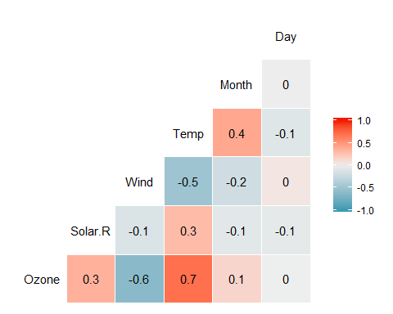
#Note: ggcorr automatically ignores non-numeric data
- Which variable is most strongly correlated with the “Ozone” variable?
Temperature is most strongly correlated.
- Which variable is least strongly correlated with the “Ozone” variable?
Day is least strongly correlated.
Task 4
Scatterplot of Temperature and Ozone
ggplot(air2, aes(x=Temp, y=Ozone)) + geom_point() #scatterplot
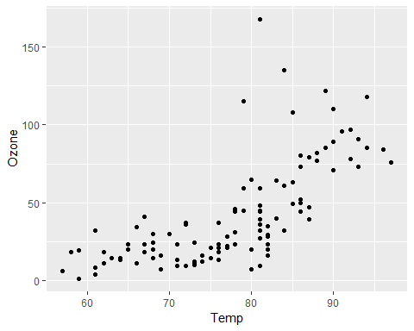
Describe the relationship between “Temp” and “Ozone”.
The relatioship appears to be positively influenced and somewhat linear (although some curvature) that shows that as temperature increases ozone measures increases.
Task 5
Create a linear regression model (called in model1) using “Temp” to predict “Ozone”.
model1 = lm(Ozone ~ Temp, air2) #create linear regression model (y~x)
summary(model1) #examine the model
##
## Call:
## lm(formula = Ozone ~ Temp, data = air2)
##
## Residuals:
## Min 1Q Median 3Q Max
## -40.922 -17.459 -0.874 10.444 118.078
##
## Coefficients:
## Estimate Std. Error t value Pr(>|t|)
## (Intercept) -147.6461 18.7553 -7.872 2.76e-12 ***
## Temp 2.4391 0.2393 10.192 < 2e-16 ***
## ---
## Signif. codes: 0 '***' 0.001 '**' 0.01 '*' 0.05 '.' 0.1 ' ' 1
##
## Residual standard error: 23.92 on 109 degrees of freedom
## Multiple R-squared: 0.488, Adjusted R-squared: 0.4833
## F-statistic: 103.9 on 1 and 109 DF, p-value: < 2.2e-16
confint(model1)
## 2.5 % 97.5 %
## (Intercept) -184.818372 -110.473773
## Temp 1.964787 2.913433
- Discuss the quality of this model (mention the R square value and significance of the predictor variable).
In the model data above we see that the pvalue is less than alpha=.o5 so the predictor variable (Temp) is significant. The R squared is .488 so it is decent and shows some kind of relationship going on. Overall the quality of the data is decent.
- Use the code “confint(model1)” to generate 95% confidence intervals for the coefficients. In what range does the slope coefficient likely fall?
The slope coefficient likely falls within 1.97 and 2.91.
Task 6
Including the regression line in task 4 scatterplot
ggplot(air2, aes(x=Temp, y=Ozone)) + geom_point() + geom_smooth(method="lm", se = FALSE) #regression line with scatterplot
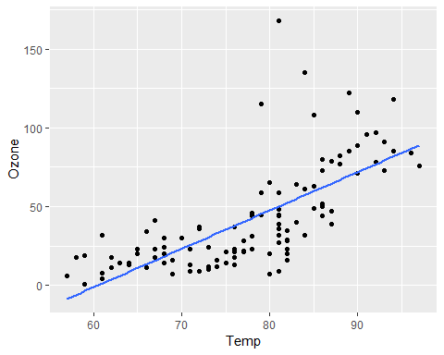
Task 7 Develop a prediction for “Ozone” when “Temp” is 80.
testdata = data.frame(Temp = c(80)) #X=Temp
predict(model1, newdata = testdata, interval = "predict") #Prediction interval
## fit lwr upr
## 1 47.48272 -0.1510188 95.11646
Task 8
Plot “Day” (x axis) versus “Ozone” (y axis) using the “ggplot” function.
ggplot(air2, aes(x=Day, y=Ozone)) + geom_point() #scatterplot
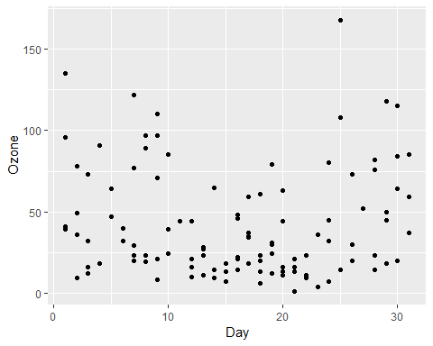
Describe the relationship between “Day” and “Ozone”.
There doesn’t appear to be correlation existing between Day and Ozone.
Task 9
Create a linear regression model (called in model2) using “Day” to predict “Ozone”.
model2 = lm(Ozone ~ Day, air2) #create linear regression model (y~x)
summary(model2) #examine the model
##
## Call:
## lm(formula = Ozone ~ Day, data = air2)
##
## Residuals:
## Min 1Q Median 3Q Max
## -41.00 -24.23 -11.04 19.96 126.08
##
## Coefficients:
## Estimate Std. Error t value Pr(>|t|)
## (Intercept) 42.41536 6.64353 6.384 4.32e-09 ***
## Day -0.01983 0.36604 -0.054 0.957
## ---
## Signif. codes: 0 '***' 0.001 '**' 0.01 '*' 0.05 '.' 0.1 ' ' 1
##
## Residual standard error: 33.43 on 109 degrees of freedom
## Multiple R-squared: 2.693e-05, Adjusted R-squared: -0.009147
## F-statistic: 0.002936 on 1 and 109 DF, p-value: 0.9569
confint(model2)
## 2.5 % 97.5 %
## (Intercept) 29.248109 55.5826192
## Day -0.745321 0.7056539
- Discuss the quality of this model (mention the R square value and significance of the predictor variable).
This is not a great model as the pvalue for predictor variable Day is 0.957 which is well over 0.5 causing there not to be signicant relationship. The R squared is basically very very very close to 0 shoing this as well.
- Use the code “confint(model2)” to generate 95% confidence intervals for the coefficients. In what range does the slope coefficient likely fall? The slope coefficient likely falls within -0.75 and 0.71.
Task 10
Including the regression line in task 8 scatterplot
ggplot(air2, aes(x=Day, y=Ozone)) + geom_point() + geom_smooth(method="lm", se = FALSE) #regression line with scatterplot
