BAN 502 - Predictive Analytics

McCleave, Janelle

R and RStudio Refresher Assignment
Task 1 - Tidyverse installed from previous course already so loading the package
#install.packages("tidyverse")
library(tidyverse)
## -- Attaching packages --------------------------------------------------------------------------------- tidyverse 1.2.1 --
## v ggplot2 3.1.0 v purrr 0.2.5
## v tibble 1.4.2 v dplyr 0.7.7
## v tidyr 0.8.2 v stringr 1.3.1
## v readr 1.1.1 v forcats 0.3.0
## -- Conflicts ------------------------------------------------------------------------------------ tidyverse_conflicts() --
## x dplyr::filter() masks stats::filter()
## x dplyr::lag() masks stats::lag()
Task 2 - Reading in the data
diamonddata = diamonds
nrow(diamonddata) #shows the number of rows in the dataset
## [1] 53940
ncol(diamonddata) #shows number of columns in the dataset
## [1] 10
Task 3 - Creating a scatter plot using ggplot
ggplot(diamonddata, aes(x=carat, y=price)) + geom_point()
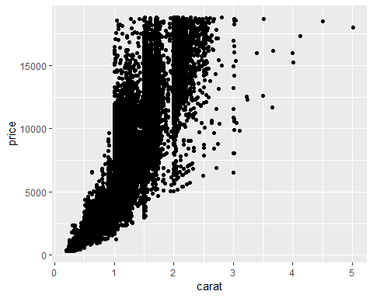 Based on the scatter plot above there seems to be a positive relationship showing that as price increases, carat size of diamond increases or the bigger the diamond the more money you pay.
Task 4 - Color the scatter points by “cut” (adding a third variable)
ggplot(diamonddata, aes(x=carat, y=price, color=(cut))) + geom_point()
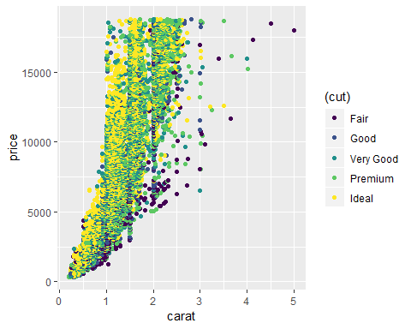 There are three variables displayed above - price, carat, and cut. Here we see that on the x and y-axis as carat size increases, price increases. When we add in the additonal variable of “cut” this now shows us that within each carat size there is a range of cut and price increases based on the better cut within that carat.
Task 5 - Using the plot above we now facet by color showing four variables - carat, price, cut, color)
ggplot(diamonddata, aes(x=carat, y=price, color=(color))) + geom_point()
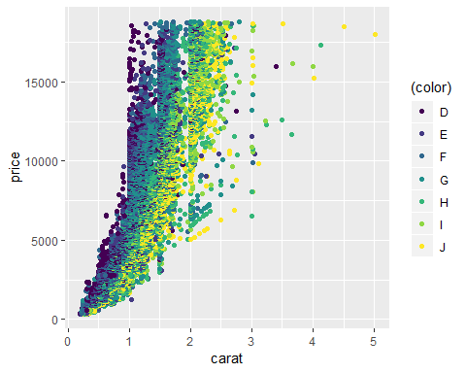
For the scatter plot above, we see that when adding in the color variable, there is a similar idea as it was in Task 4. Price increases based on the carat size first but then there are different levels within each carat which determines cost over another same size carat. As each variable increases in carat size, better cut and etter color, price increases.
Task 6 - Reading in file using readr package
library(readr)
InventoryData <- read_csv("InventoryData.csv")
## Parsed with column specification:
## cols(
## `Item SKU` = col_character(),
## Store = col_character(),
## Supplier = col_character(),
## `Cost per Unit ($)` = col_double(),
## `On Hand` = col_integer(),
## `Annual Demand` = col_integer()
## )
View(InventoryData)
The inventory data pulled in above shows 6 variables (Item SKU, Store, Supplier, Cost per unit, On hand and Annual deman) relating to inventory data for I am assuming a certain company that has multiple stores. This data is collected for each item at a certain store in inventory.
Task 7 - Creating a new dataframe for only items related to supplier A
inventoryA = InventoryData %>% filter(Supplier == 'A')
str(inventoryA)
## Classes 'tbl_df', 'tbl' and 'data.frame': 3695 obs. of 6 variables:
## $ Item SKU : chr "0100" "011" "0113" "0113" ...
## $ Store : chr "003480" "020109" "031779" "080212" ...
## $ Supplier : chr "A" "A" "A" "A" ...
## $ Cost per Unit ($): num 125.3 12.3 208.2 186.5 68.5 ...
## $ On Hand : int 159 173 166 157 34 77 133 28 103 29 ...
## $ Annual Demand : int 1693 1695 1496 1654 290 680 1239 277 962 297 ...
## - attr(*, "spec")=List of 2
## ..$ cols :List of 6
## .. ..$ Item SKU : list()
## .. .. ..- attr(*, "class")= chr "collector_character" "collector"
## .. ..$ Store : list()
## .. .. ..- attr(*, "class")= chr "collector_character" "collector"
## .. ..$ Supplier : list()
## .. .. ..- attr(*, "class")= chr "collector_character" "collector"
## .. ..$ Cost per Unit ($): list()
## .. .. ..- attr(*, "class")= chr "collector_double" "collector"
## .. ..$ On Hand : list()
## .. .. ..- attr(*, "class")= chr "collector_integer" "collector"
## .. ..$ Annual Demand : list()
## .. .. ..- attr(*, "class")= chr "collector_integer" "collector"
## ..$ default: list()
## .. ..- attr(*, "class")= chr "collector_guess" "collector"
## ..- attr(*, "class")= chr "col_spec"
nrow(inventoryA) #shows number of rows
## [1] 3695
Based on the data pulled in with observations representing rows as wellas the nrow function, there are 369 rows in the above dataset.
Task 8 - What does the line of code shown below do? Note the use of the backtick character (on the tilde key on your computer’s keyboard) to delineate the variable names with spaces in them. inventoryA = mutate(inventoryA, OnHandRatio = On Hand / Annual Demand)
inventoryA = mutate(inventoryA, OnHandRatio = `On Hand` / `Annual Demand`)
The above data creates a new variable called OnHandRatio that is added to the dataset inventoryA. There were 6 variables before the creation of the new variable and now there is 7.
Task 9 - Using the groupby and summarize functions to show SKUAvgCost per item SKU
avg_cost = inventoryA %>% group_by(`Item SKU`) %>% summarise(SKUAvgCost = mean(`Cost per Unit ($)`))
avg_cost
## # A tibble: 1,720 x 2
## `Item SKU` SKUAvgCost
## <chr> <dbl>
## 1 0100 125.
## 2 011 12.3
## 3 0113 197.
## 4 0122 81.7
## 5 013 14.3
## 6 0133 203.
## 7 0137 165.
## 8 014 9.22
## 9 0151 75.7
## 10 0152 212.
## # ... with 1,710 more rows
Task 10 - Given your previous course experience with R/RStudio, what topics/concepts did you find to be most challenging? To be honest I was able to grasp all of the topics presented, however I want to do better at remembering structure without having to look it up. This will make writing code faster. I understand this happens with more practice. Nevertheless, having the cheat sheets is helpful and I am sure I could be missing something that we did learn that maybe I did struggle with at first.

