**Assignment 3**

**COMP 482**

**Athabasca University**

**Janelle Montgomery**

**AU ID: 3148028**

***Please Note: I have emailed the Project Implementation and Read Me to Alan Sweeney. The file size was too large to upload to Moodle. Thank You!***

**Heuristic Evaluation**

**Background**

I will begin this heuristic evaluation by giving a brief recap on what the scope of the project and the purpose for the design. I was approached by Ezra Macdonald who is the Vice President of a company called Reptile Explorers. Ezra wanted a way to motivate people who go on his one month long trips to log the information they discover about the reptiles they are studying. These trips take place in Australia, New Guinea, and Vancouver (British Columbia). The kinds of users that were to be expected would be seasoned herpetologists to students. This means the kind of users were expected to be in different age ranges and technical skills. Ezra wanted to make sure users could register and log in to this web application before they could add a new reptile finding. Also having a print of sheet of the guidelines for logging a reptile was important as some locations will not have internet access and this will also accommodate users who do not feel comfortable quickly accessing the web application. From these tasks I have marked up some low- fidelity prototypes and then evaluated them. Following this I began to build a more high functionality prototype of the web application.

**Evaluation**

In this section I will provide screenshots from my design. I will also run through an evaluation using a number of usability heuristics for each screenshot. The screenshots I have chosen are meant to represent one of the core tasks that this web application requires.

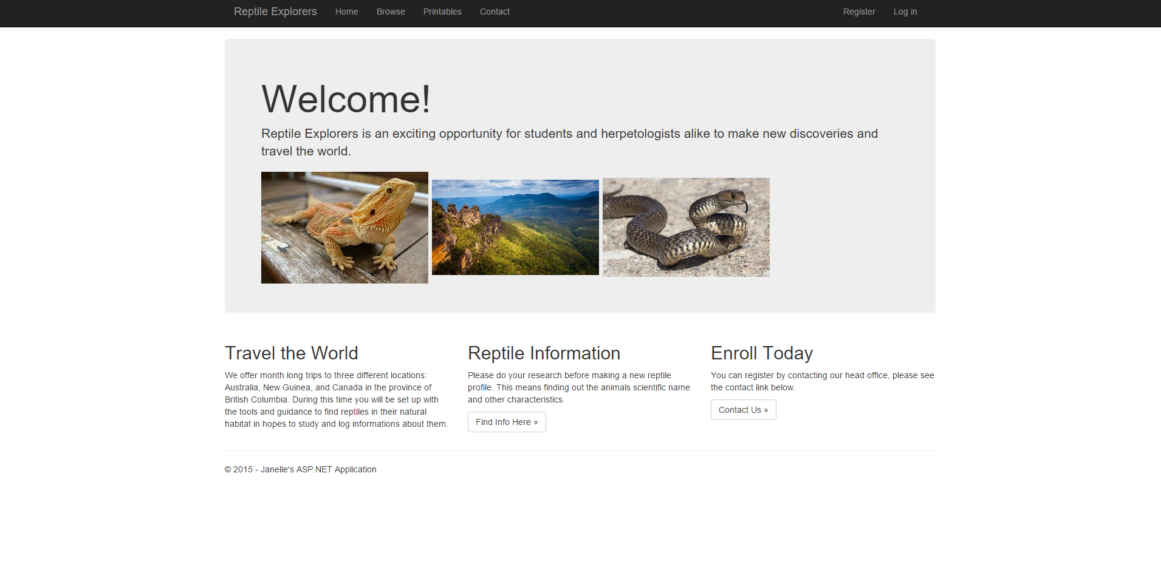

This is the home page of the Reptile Explorers web application. The home page definitely sets the tone for a web application so it is important that you provide a simple and natural dialogue on the page so that users may easily find what they are looking for. I think that this is achieved in this home page. Having the “Register/ Log in” link on the top right hand corner is familiar. So users who have used web applications before will feel comfortable with this format, this in turn minimizes the users memory load. The page is also meant to draw in new users. So ensuring that information about contacting the company and signing up be readily available is important. Having a navigation bar at the top is also a simple way to guide users to where they need to go on the website.

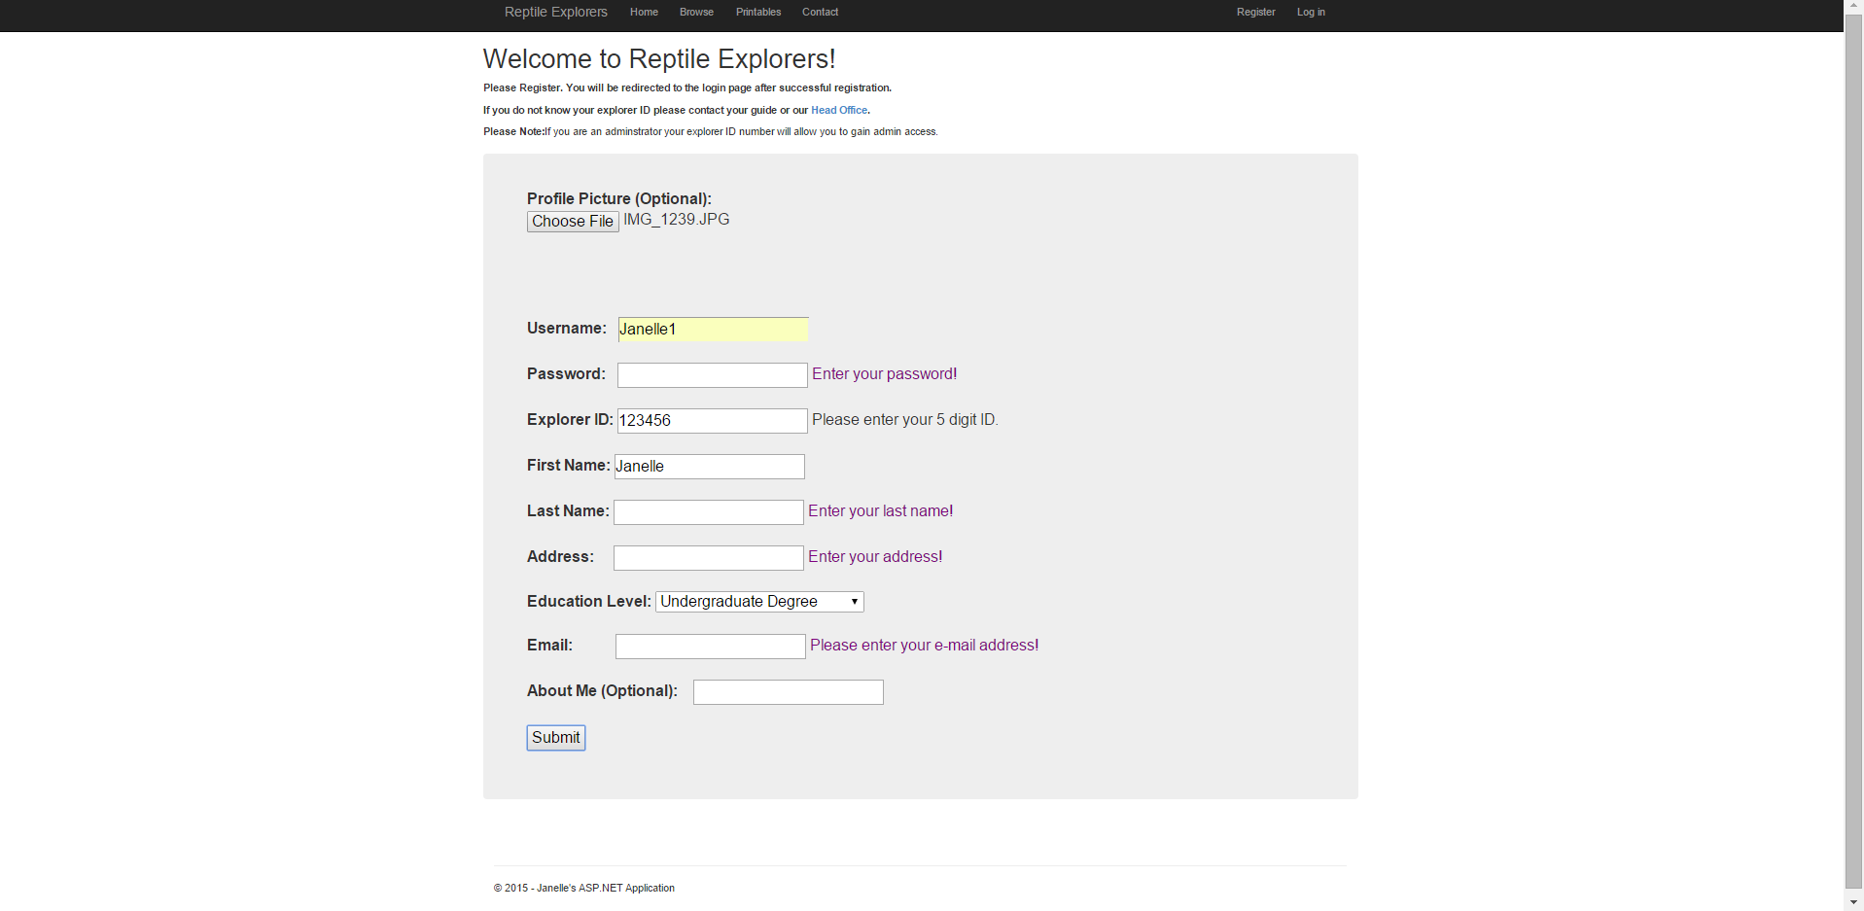

Following looking at the home page it would be logical for a user to click the “Register” link and make their user profile. As you can see the exact same navigation bar can be seen on this page. Keeping the page consistent is vital. This means the user can learn your application once and then know what to expect from other pages in the application. Again this layout is rather simple and uses natural dialogue. I wanted to show in the screen shot what would happen should the user not fill out all required information and try to submit the page. Should this occur, text will appear by the box directing the user to fill it out. Also for the Explorer ID# if the number you enter is greater or less than 5 digits, the user will be informed that all ID’s are 5 digits. This can help to guide the user in fixing their mistakes. So I think this page does well at providing feedback and error messages to the user. I have added a drop down box for Education Level, this prevents errors. However there is not much else on the page for error prevention. There is a blurb at the top notifying the user that once they register successfully they will be redirected to the log in page. It would be nice to send an email to users to confirm their registration. This could be implemented in the future. Also at the top it states that if you are requiring administration access to the application you will be directed to the administration page via your Explorer ID #.

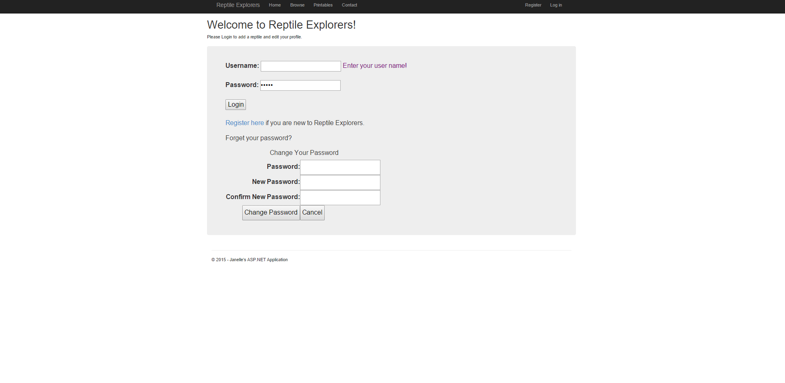

After registering the user will be expected to log in. Also if the user is returning to the application they will be expected to login. Again this format is consistent, provides error feedback and is simple and natural in presentation. I provided a means to change your password on this page should you forget it. I also provided a link to register in case a user has not. Having these provides more information to the user and can make them feel more comfortable. One thing I did not put is the link for technical support should a user have persistent problems logging in. This is a good messages to have and would definitely be implemented in a future design.



Once logged in the user will be directed to their home page. This page has the consistent top navigation bar as well as new one. The new one includes the options: New Reptile, My Profile, and Logout. This is a simple layout and a user should not have too much trouble navigating it. However putting the logout option on this page could be confusing. In the future I would just replace the Log in link with Log out. Just to keep things more clean and consistent. This page does not require a lot for error prevention it is really just hub for the new links once you log in.

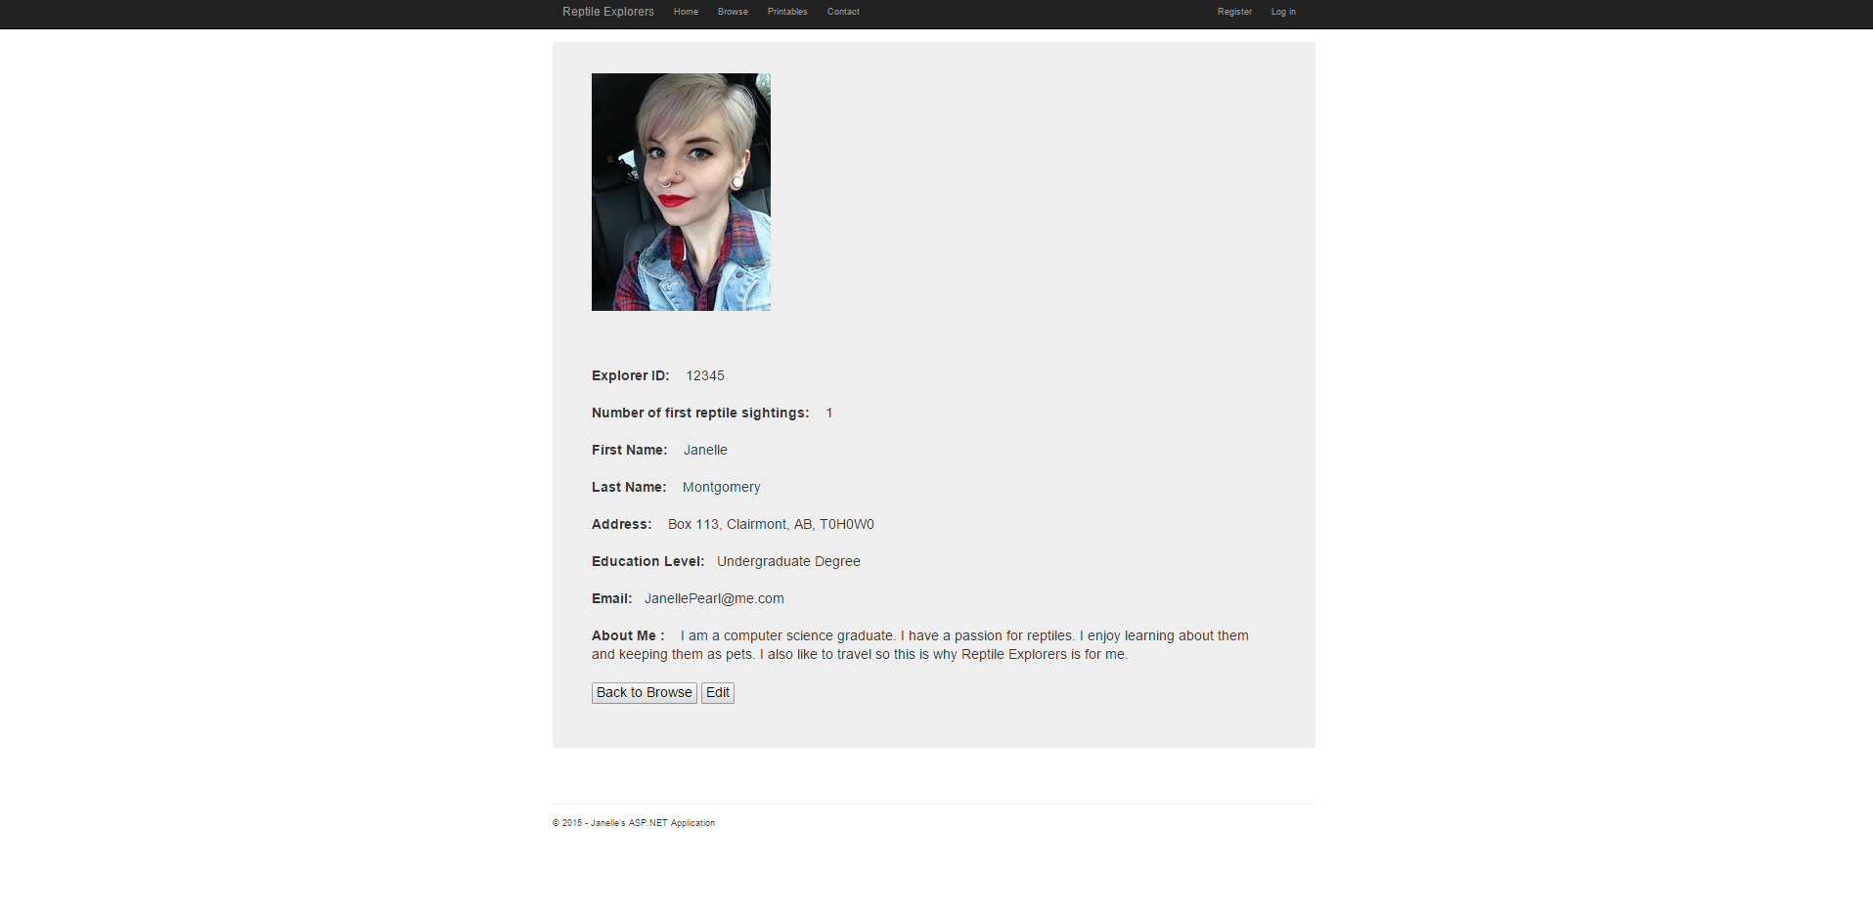

This is what a user profile will look like. This can be found by hitting “My Profile” found in the blue navigational bar. This is a consistent design. It does have a button that states edit. So a user will be able to edit the information on their profile. I definitely don’t think there is enough guidance on this page about the editing feature. In a more advanced design I would possibly include a blurb about editing. Also have an email sent to the user stating their profile has been edited, just for conformation and security reasons. There is also a “back to browse” button that will take a user to the browse section that will be discussed a bit later. All in all this page looks good but is lacking feedback.

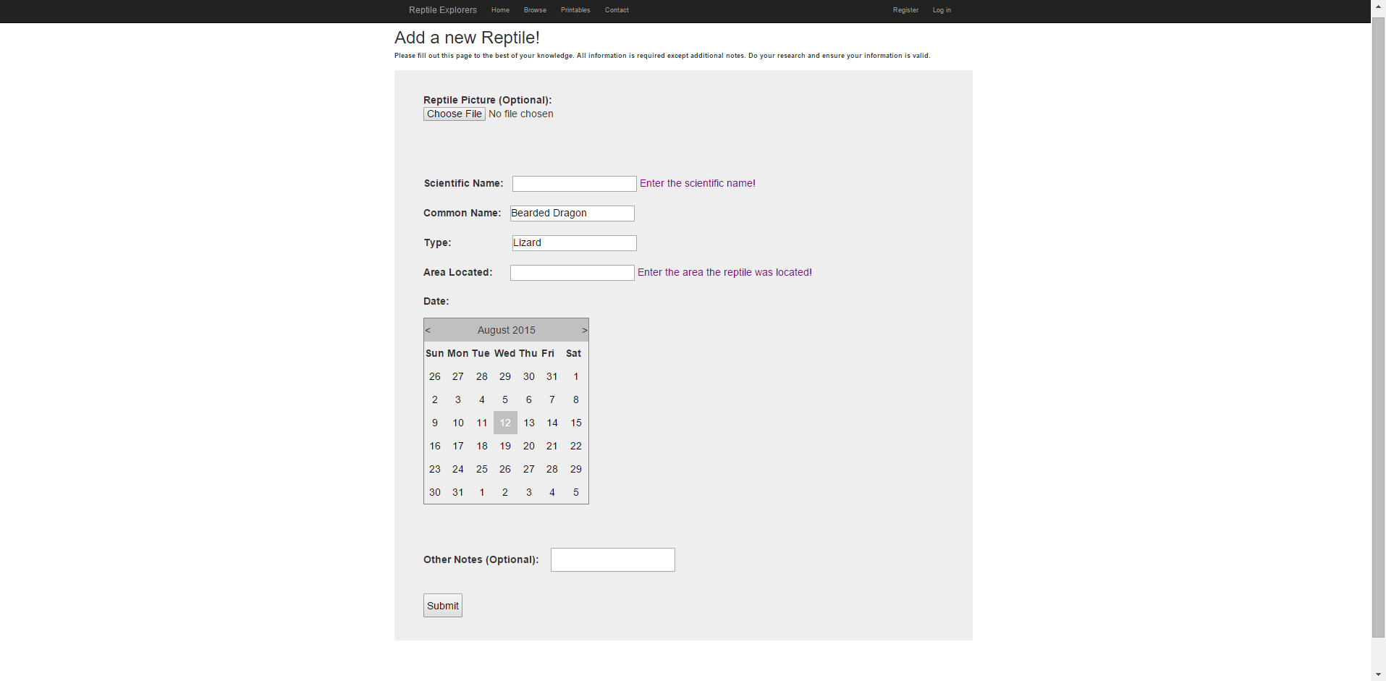

This is the “New Reptile” page. This page is super important as it is the main task for this entire application. I wanted to keep the format consistent with the Registration page. This page follows a similar error feedback and prevention method as well. If a user leaves a non-optional box empty they will be alerted with text beside the box. In an ideal situation there would be reptile names logged into the database and based on the letters the user is typing suggestions would pop up. This could just save the user time in researching the animal and it would also make the profiles more accurate. We don’t want users to get frustrated by having to memorize so many different names and then log them on to the application. This page is fairly simple in design. Once all information is filled out the user may submit. The feedback after this page is submitted is lacking. There is no indication of what to expect. In the prototype now you would just be directed to the page that you created. However in a fully functional design it would not be posted without administration approval. So having some feedback possibly via email saying your submission has been successful and is pending approval would definitely be beneficial.

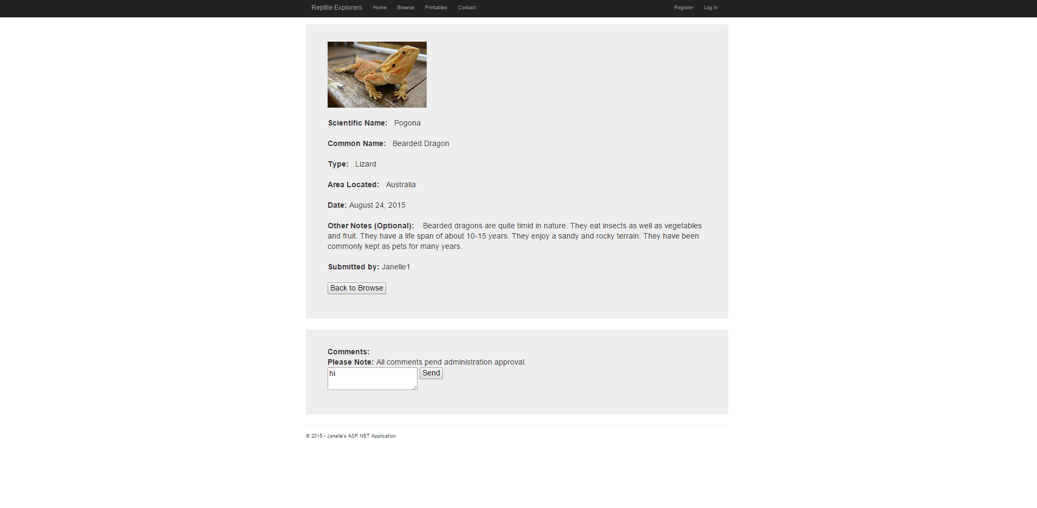

This is what a reptile profile would look like. You can find them by searching or browsing reptile profiles. I think this design is consistent and clean. There is a comments box underneath that explains all comments will need to be approved. There is also a “Back to Browse” button. So the user may exit the page that way. This page does not require much feedback or error prevention.

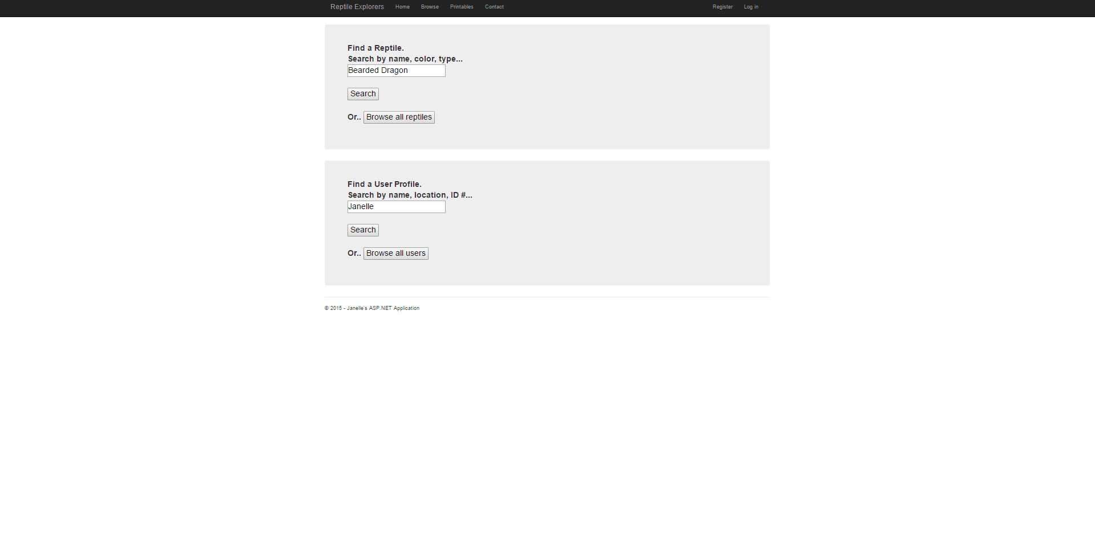

This screen may be found by selecting the “Browse” link from the top navigational bar. So you may search for either User or a Reptile profile. I feel this page is not that natural. Usually a browse page would be dedicated to just one topic. So possibly splitting these up would be a good idea in a future design. Also I would like to see suggested search options. Meaning if a user is searching for a word the word can be matched and picked from the database to guide the user in their search. This will take the memory load off the user and make searching more time efficient. Other than that I do think this page is fairly clear with feedback. The user should understand where each button will take them.

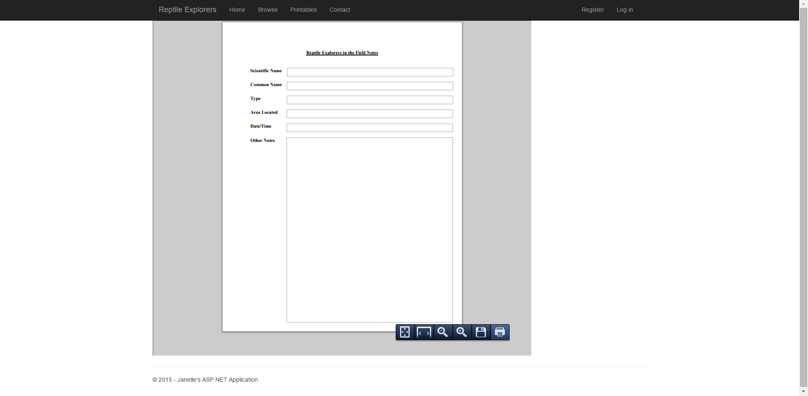

This is the page that can be found when the user clicks “Printables”. This page was necessary for explorers who were not used to web applications and wanted guidance to what they would be expected to write. Also for users who would not have access to the internet while they were in the field. This is just a simple PDF page that a user may print out. The directions appear when you hover over the page. So it is pretty clear on how to go about printing the page. This page does not require much for error prevention or feedback. The feedback provided would be from the printing device that the user chooses. Again this page keeps with the same navigation bar, ensuring the look and feel remain consistent.

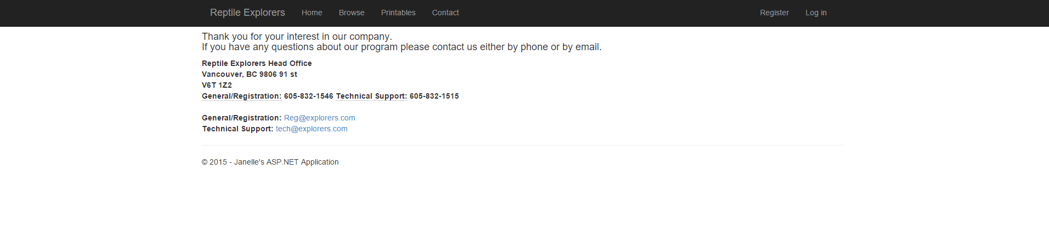

This screenshot illustrates the “Contact” page found at the top navigational bar. It provides an address as well as some contact information. It was important that users could contact someone about general questions as well as registration. Also having a technical support number and email to aid explorers with their profiles or using the web application was important as well. I feel this page follows a fairly familiar format to most contact pages. It has a simple and natural dialogue. This page does not need anything in the means of feedback or error prevention.

**Final design rationale and discussion of the state of the design**

This design definitely has its strengths and its weaknesses. To begin, I think overall the application has a good look and feel to it. It is clean, simple and easy to navigate. That is something I have always liked about it. The home page has some colorful pictures and it is inviting. I think that the tasks that require a user to input information have good error prevention and feedback. I feel that a user with any level of internet savvy would be able to read and understand the mistakes that they had made. I think that the layout for the User and the Reptile profiles looks good. They are clean and simple and easy to read. The contact and printables page are simple and easy to understand as well. These are all things that I think work really well with the application. Now to move on to things that will need some improvement in future design. When the user is registering, logging in, making a new reptile profile there is no mention for the technical support information. I think it could be useful to have a link to the technical support number and email in these areas. That way a user does not have to take as many steps to answer their question or resolve their problem. When a user logs in to the application they are directed to their user home page that has a new navigational bar including: new reptile, my profile and log out. As I mentioned above I would like to move the log out to the top navigational bar to replace the log in option. This is just more natural. Having the log in option remain even after the user has logged in can just be confusing for some users. Also I noticed one major functionality flaw with this page. That is once you leave the page there is not really a way to get back to it besides clicking back on your browser or logging back in. That is just bad design. There should be an option that appears at the top navigational bar that will direct you back to your user home page. That page includes the new reptile button and that is one of the most important tasks of the entire application. So in future development I would definitely add that. I would also like to beef up the browse area as I mentioned above. Possibly adding a drop down to guide users to either reptiles or user profiles for example.

Now do I think that this system would work well for all of the identified tasks and users? I definitely do. The application itself is not perfect yet but it has a solid layout to work with. I feel after applying the changes above it will be a solid application. This is a great example of why doing evaluations incrementally throughout the design process is so important. I have yet to hook this up to a database yet and honestly I am thankful I have not yet. I would have spent a decent amount of time hooking the database up to the existing code, only to have to change it after tweaking the layout. I think that the established users would find this application to be useful and learnable. I look forward to the potential this application has for Reptile Explorers.

**Link to Video:** [**https://www.youtube.com/watch?v=Iud9S8Ax7pE**](https://www.youtube.com/watch?v=Iud9S8Ax7pE)