GARCH Model EUR And CAD

Jane

01/05/2021

# Forcasting Exchange Rate Using GARCH Model for EUR And CAD

## Reading EUR and CAD Currency into r

library(readr)  
library(dplyr)

##   
## Attaching package: 'dplyr'

## The following objects are masked from 'package:stats':  
##   
## filter, lag

## The following objects are masked from 'package:base':  
##   
## intersect, setdiff, setequal, union

EURCADGARCH<- read.csv ("EURCAD_Candlestick_1_D_BID_01.01.2000-31.12.2020.csv")%>%  
 select('GMT.TIME', CLOSE)%>%  
 rename(Date = ('GMT.TIME'), RateEURCAD = ("CLOSE"))  
  
   
tail(EURCADGARCH)

## Date RateEURCAD  
## 6323 2020-12-25 1.56688  
## 6324 2020-12-27 1.56702  
## 6325 2020-12-28 1.56931  
## 6326 2020-12-29 1.57065  
## 6327 2020-12-30 1.56820  
## 6328 2020-12-31 1.55384

## Conversion of Gmt time to date format

library(dplyr)  
library(lubridate)

##   
## Attaching package: 'lubridate'

## The following objects are masked from 'package:base':  
##   
## date, intersect, setdiff, union

EURCADGARCH$Date <- lubridate::ymd(EURCADGARCH$Date)  
head(EURCADGARCH)

## Date RateEURCAD  
## 1 2000-01-03 1.4817  
## 2 2000-01-04 1.4969  
## 3 2000-01-05 1.4963  
## 4 2000-01-06 1.5064  
## 5 2000-01-07 1.4992  
## 6 2000-01-10 1.4928

##Checking for obvious errors or missingg value

#Checking for obvious errors  
which(is.na(EURCADGARCH))

## integer(0)

##Converting the data set into time series object

#Converting the data set into time series object  
EURCADGARCHTS<- ts(as.vector(EURCADGARCH$Rate), frequency = 317, start= c(2000,01,03))  
plot.ts(EURCADGARCHTS)  
title("Time Series plot of EURCADTimeseries ", sub = "(2000-2020)",  
 cex.main = 1.5, font.main= 4, col.main= "blue",  
 cex.sub = 0.75, font.sub = 3, col.sub = "red")

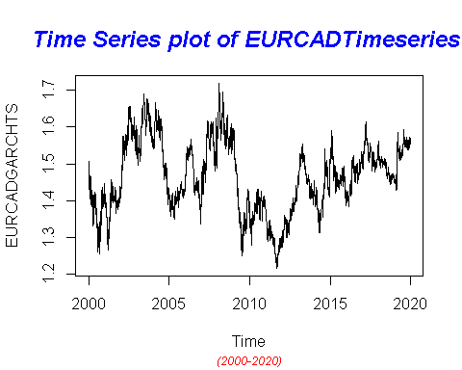

##Dealing with Conditional Heteroscedaticity:

DifflogEURCADGarch= diff(log(EURCADGARCHTS))*100  
plot(DifflogEURCADGarch)  
title("Plot of returns of EURCAD", sub = "(2000-2020)",  
 cex.main = 1.5, font.main= 4, col.main= "blue",  
 cex.sub = 0.75, font.sub = 3, col.sub = "red")

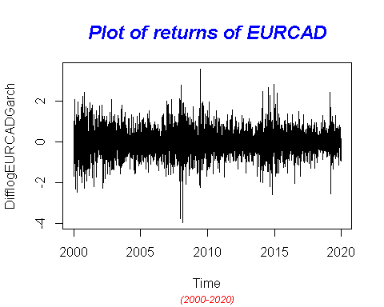

##nature as almost at all lags the p-values fall below the significance levels.

library(TSA)

## Warning: package 'TSA' was built under R version 4.0.5

##   
## Attaching package: 'TSA'

## The following object is masked from 'package:readr':  
##   
## spec

## The following objects are masked from 'package:stats':  
##   
## acf, arima

## The following object is masked from 'package:utils':  
##   
## tar

McLeod.Li.test(y= DifflogEURCADGarch,main="McLeod-Li test statistics for Daily return series")

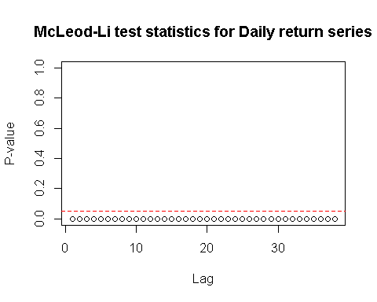

## In order to get an order of GARCH , we further transform the return series into absolute values and squared return values.

abs = abs(DifflogEURCADGarch)  
sqr = DifflogEURCADGarch^2

# GARCH Model specification:

par(mfrow=c(1,2))  
acf(abs, ci.type="ma",main=" ACF for abs. returns")  
pacf(abs, main=" PACF plot for abs.returns")

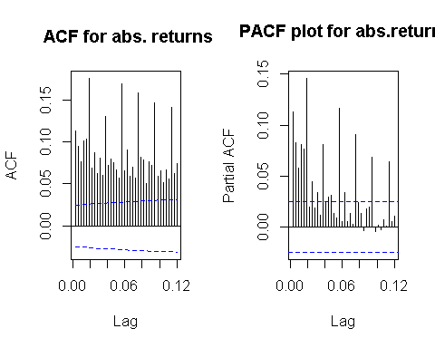

##From ACF and PACF we see many lags are significant. Hence, we plot EACF to get the candidate models

eacf(abs)

## AR/MA  
## 0 1 2 3 4 5 6 7 8 9 10 11 12 13  
## 0 x x x x x x x x x x x x x x   
## 1 x o o o o x x x o o o x x o   
## 2 x x x o o x x x o o o x x o   
## 3 x x x o o x x x o o o x o o   
## 4 x x x x o x x x o o o x o o   
## 5 x x x x x x o x o x o x o o   
## 6 x x x x x x x o o o o x o o   
## 7 x x x x o x x o o o o x o o

##Squared returns ACF and PACF plot

par(mfrow=c(1,2))  
acf(sqr, ci.type="ma",main="ACF for sqr. return")  
pacf(sqr, main="PACF for sqr. return")

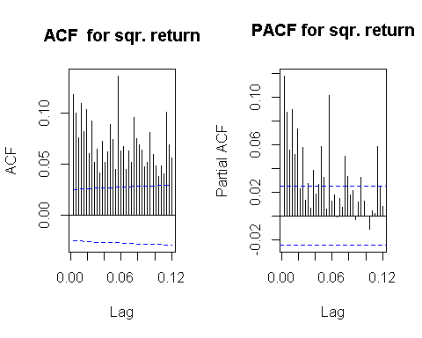

## 

eacf(sqr)

## AR/MA  
## 0 1 2 3 4 5 6 7 8 9 10 11 12 13  
## 0 x x x x x x x x x x x x x x   
## 1 x o o x o x x x x o o x o o   
## 2 x x x o o o o o o o o o o o   
## 3 x x x o o o o o o o o o o o   
## 4 x x x x o o o o o o o o o o   
## 5 x x x x x o o o o o o o o o   
## 6 x x x x x o o o o o o o o o   
## 7 x x x x x x x o o o o o o o

### With reference to the Dickey-Fuller Test, p-value is less than the 0.02 and we can reject the null hypothesis stating the non-stationarity. Hence , we can proceed further for model selection .

#MODEL ESTIMATION: ##GARCH (2,1): for GBP and USD Curruency Pair

# GARCH(2,1)  
library(tseries)

## Registered S3 method overwritten by 'quantmod':  
## method from  
## as.zoo.data.frame zoo

EURCADGARCHFit.21 = garch(DifflogEURCADGarch,order=c(2,1),trace =FALSE)  
summary(EURCADGARCHFit.21)

##   
## Call:  
## garch(x = DifflogEURCADGarch, order = c(2, 1), trace = FALSE)  
##   
## Model:  
## GARCH(2,1)  
##   
## Residuals:  
## Min 1Q Median 3Q Max   
## -4.97662 -0.57416 0.01536 0.55113 5.46322   
##   
## Coefficient(s):  
## Estimate Std. Error t value Pr(>|t|)   
## a0 0.0023600 0.0004289 5.502 3.74e-08 ***  
## a1 0.0475672 0.0054530 8.723 < 2e-16 ***  
## b1 0.4829249 0.1611500 2.997 0.00273 **   
## b2 0.4621471 0.1559044 2.964 0.00303 **   
## ---  
## Signif. codes: 0 '***' 0.001 '**' 0.01 '*' 0.05 '.' 0.1 ' ' 1  
##   
## Diagnostic Tests:  
## Jarque Bera Test  
##   
## data: Residuals  
## X-squared = 570.24, df = 2, p-value < 2.2e-16  
##   
##   
## Box-Ljung test  
##   
## data: Squared.Residuals  
## X-squared = 2.0369, df = 1, p-value = 0.1535

## GARCH (2,2):

##This model can be interpreted as an overfit model of GARCH(2,1) and p values from residual tests confirms that residuals are highly correlated. Thus this model is not consider to be a good fit.

EURCADGARCHFit.22 = garch(DifflogEURCADGarch, order =c(2,2),trace =FALSE)

## Warning in garch(DifflogEURCADGarch, order = c(2, 2), trace = FALSE): singular  
## information

summary(EURCADGARCHFit.22)

##   
## Call:  
## garch(x = DifflogEURCADGarch, order = c(2, 2), trace = FALSE)  
##   
## Model:  
## GARCH(2,2)  
##   
## Residuals:  
## Min 1Q Median 3Q Max   
## -4.9379 -0.5738 0.0154 0.5512 5.4316   
##   
## Coefficient(s):  
## Estimate Std. Error t value Pr(>|t|)  
## a0 1.631e-03 NA NA NA  
## a1 3.418e-02 NA NA NA  
## a2 2.248e-15 NA NA NA  
## b1 9.489e-01 NA NA NA  
## b2 1.203e-02 NA NA NA  
##   
## Diagnostic Tests:  
## Jarque Bera Test  
##   
## data: Residuals  
## X-squared = 579.46, df = 2, p-value < 2.2e-16  
##   
##   
## Box-Ljung test  
##   
## data: Squared.Residuals  
## X-squared = 5.3913, df = 1, p-value = 0.02024

##GARCH (3,1): ##This model can be interpreted as an overfit model of GARCH(2,1) and GARCH (2,2). This model may not be consider to be a good fit.

EURCADGARCHFit.31 = garch(DifflogEURCADGarch,order=c(3,1),trace =FALSE)  
summary(EURCADGARCHFit.31)

##   
## Call:  
## garch(x = DifflogEURCADGarch, order = c(3, 1), trace = FALSE)  
##   
## Model:  
## GARCH(3,1)  
##   
## Residuals:  
## Min 1Q Median 3Q Max   
## -4.99054 -0.57284 0.01518 0.54605 5.38866   
##   
## Coefficient(s):  
## Estimate Std. Error t value Pr(>|t|)   
## a0 0.0030661 0.0005502 5.573 2.51e-08 ***  
## a1 0.0618519 0.0071282 8.677 < 2e-16 ***  
## b1 0.3219028 0.1280592 2.514 0.0119 *   
## b2 0.2877271 0.1552235 1.854 0.0638 .   
## b3 0.3189208 0.1437480 2.219 0.0265 *   
## ---  
## Signif. codes: 0 '***' 0.001 '**' 0.01 '*' 0.05 '.' 0.1 ' ' 1  
##   
## Diagnostic Tests:  
## Jarque Bera Test  
##   
## data: Residuals  
## X-squared = 556.14, df = 2, p-value < 2.2e-16  
##   
##   
## Box-Ljung test  
##   
## data: Squared.Residuals  
## X-squared = 0.34049, df = 1, p-value = 0.5595

##GARCH (3,2): ##This model can be interpreted as an overfitting model and p values from residual tests confirms that residuals are highly correlated. Thus this model is not consider to be a good fit.

# GARCH(3,2)

EURCADGARCHFit.32 = garch(DifflogEURCADGarch,order=c(3,2),trace =FALSE)  
summary(EURCADGARCHFit.32)

##   
## Call:  
## garch(x = DifflogEURCADGarch, order = c(3, 2), trace = FALSE)  
##   
## Model:  
## GARCH(3,2)  
##   
## Residuals:  
## Min 1Q Median 3Q Max   
## -5.01481 -0.57328 0.01523 0.54579 5.41575   
##   
## Coefficient(s):  
## Estimate Std. Error t value Pr(>|t|)   
## a0 3.123e-03 1.139e-03 2.742 0.0061 **   
## a1 6.320e-02 8.625e-03 7.327 2.35e-13 ***  
## a2 5.579e-07 2.538e-02 0.000 1.0000   
## b1 2.614e-01 4.010e-01 0.652 0.5145   
## b2 3.477e-01 2.109e-01 1.649 0.0992 .   
## b3 3.180e-01 2.464e-01 1.290 0.1969   
## ---  
## Signif. codes: 0 '***' 0.001 '**' 0.01 '*' 0.05 '.' 0.1 ' ' 1  
##   
## Diagnostic Tests:  
## Jarque Bera Test  
##   
## data: Residuals  
## X-squared = 559.45, df = 2, p-value < 2.2e-16  
##   
##   
## Box-Ljung test  
##   
## data: Squared.Residuals  
## X-squared = 0.26127, df = 1, p-value = 0.6092

## GARCH (3,3):

This model can be interpreted as an overfitting model and p values from residual tests confirms that residuals are highly correlated. Thus, this model is not consider to be a good fit.

# GARCH(3,3)

EURCADGARCHFit.33 = garch(DifflogEURCADGarch,order=c(3,3),trace =FALSE)  
summary(EURCADGARCHFit.33)

##   
## Call:  
## garch(x = DifflogEURCADGarch, order = c(3, 3), trace = FALSE)  
##   
## Model:  
## GARCH(3,3)  
##   
## Residuals:  
## Min 1Q Median 3Q Max   
## -5.07302 -0.56549 0.01616 0.53947 6.35562   
##   
## Coefficient(s):  
## Estimate Std. Error t value Pr(>|t|)   
## a0 1.066e-02 1.955e-03 5.453 4.95e-08 ***  
## a1 1.262e-01 1.307e-02 9.656 < 2e-16 ***  
## a2 2.911e-02 3.109e-02 0.936 0.34922   
## a3 5.021e-16 2.295e-02 0.000 1.00000   
## b1 1.210e-01 2.104e-01 0.575 0.56539   
## b2 2.558e-01 2.049e-01 1.249 0.21180   
## b3 4.436e-01 1.218e-01 3.642 0.00027 ***  
## ---  
## Signif. codes: 0 '***' 0.001 '**' 0.01 '*' 0.05 '.' 0.1 ' ' 1  
##   
## Diagnostic Tests:  
## Jarque Bera Test  
##   
## data: Residuals  
## X-squared = 611.7, df = 2, p-value < 2.2e-16  
##   
##   
## Box-Ljung test  
##   
## data: Squared.Residuals  
## X-squared = 4.1306, df = 1, p-value = 0.04211

##GARCH (4,2): ##This model can be interpreted as an overfitting model and p values from residual tests confirms that residuals are highly correlated. Thus, this model is not considered to be a good fit.

EURCADGARCHFit.42 = garch(DifflogEURCADGarch,order=c(4,2),trace =FALSE)  
summary(EURCADGARCHFit.42)

##   
## Call:  
## garch(x = DifflogEURCADGarch, order = c(4, 2), trace = FALSE)  
##   
## Model:  
## GARCH(4,2)  
##   
## Residuals:  
## Min 1Q Median 3Q Max   
## -4.95834 -0.57058 0.01532 0.54579 5.29551   
##   
## Coefficient(s):  
## Estimate Std. Error t value Pr(>|t|)   
## a0 3.724e-03 1.583e-03 2.353 0.0186 *   
## a1 7.411e-02 9.563e-03 7.750 9.1e-15 ***  
## a2 5.170e-05 3.519e-02 0.001 0.9988   
## b1 3.704e-01 4.682e-01 0.791 0.4289   
## b2 1.467e-14 2.454e-01 0.000 1.0000   
## b3 2.776e-01 1.255e-01 2.212 0.0270 *   
## b4 2.662e-01 2.512e-01 1.060 0.2893   
## ---  
## Signif. codes: 0 '***' 0.001 '**' 0.01 '*' 0.05 '.' 0.1 ' ' 1  
##   
## Diagnostic Tests:  
## Jarque Bera Test  
##   
## data: Residuals  
## X-squared = 549.19, df = 2, p-value < 2.2e-16  
##   
##   
## Box-Ljung test  
##   
## data: Squared.Residuals  
## X-squared = 0.0091194, df = 1, p-value = 0.9239

## This p-value for this model is highly correlated not a good fit

EURCADGARCHFit.41 = garch(DifflogEURCADGarch,order=c(4,1),trace =FALSE)  
summary(EURCADGARCHFit.41)

##   
## Call:  
## garch(x = DifflogEURCADGarch, order = c(4, 1), trace = FALSE)  
##   
## Model:  
## GARCH(4,1)  
##   
## Residuals:  
## Min 1Q Median 3Q Max   
## -4.9638 -0.5705 0.0153 0.5461 5.3224   
##   
## Coefficient(s):  
## Estimate Std. Error t value Pr(>|t|)   
## a0 3.755e-03 6.444e-04 5.827 5.64e-09 ***  
## a1 7.471e-02 7.177e-03 10.409 < 2e-16 ***  
## b1 3.711e-01 1.187e-01 3.126 0.00177 **   
## b2 3.297e-06 1.273e-01 0.000 0.99998   
## b3 2.466e-01 1.201e-01 2.054 0.04001 *   
## b4 2.958e-01 9.554e-02 3.097 0.00196 **   
## ---  
## Signif. codes: 0 '***' 0.001 '**' 0.01 '*' 0.05 '.' 0.1 ' ' 1  
##   
## Diagnostic Tests:  
## Jarque Bera Test  
##   
## data: Residuals  
## X-squared = 552.36, df = 2, p-value < 2.2e-16  
##   
##   
## Box-Ljung test  
##   
## data: Squared.Residuals  
## X-squared = 0.014786, df = 1, p-value = 0.9032

# Model Selection:

##Best possible model is selected by AIC scores of the models. From the below sort function, GARCH(1,1) would be the best model for the return series. From the p-value, 1.1 also has the lowest correlation

library(dLagM)

## Warning: package 'dLagM' was built under R version 4.0.5

## Loading required package: nardl

## Warning: package 'nardl' was built under R version 4.0.5

## Loading required package: dynlm

## Loading required package: zoo

##   
## Attaching package: 'zoo'

## The following objects are masked from 'package:base':  
##   
## as.Date, as.Date.numeric

GARCHModelSelectionEURCAD = AIC(EURCADGARCHFit.21,EURCADGARCHFit.22 ,EURCADGARCHFit.31,EURCADGARCHFit.32,EURCADGARCHFit.33, EURCADGARCHFit.42, EURCADGARCHFit.41)  
sortScore(GARCHModelSelectionEURCAD, score ="aic")

## df AIC  
## EURCADGARCHFit.41 6 9933.954  
## EURCADGARCHFit.42 7 9936.089  
## EURCADGARCHFit.31 5 9937.328  
## EURCADGARCHFit.32 6 9939.461  
## EURCADGARCHFit.21 4 9942.407  
## EURCADGARCHFit.22 5 9950.468  
## EURCADGARCHFit.33 7 10008.500

# Model Fitting:

library(rugarch)

## Warning: package 'rugarch' was built under R version 4.0.5

## Loading required package: parallel

##   
## Attaching package: 'rugarch'

## The following object is masked from 'package:stats':  
##   
## sigma

EURCADmodel1.1<-ugarchspec(variance.model = list(model = "sGARCH", garchOrder = c(1,1)),   
 mean.model = list(armaOrder = c(5,8), include.mean = TRUE),   
 distribution.model = "norm")  
   
EURCADgarchMODEL1.1<-ugarchfit(spec=EURCADmodel1.1,data=DifflogEURCADGarch, out.sample = 100)  
plot(EURCADgarchMODEL1.1,which="all")

##   
## please wait...calculating quantiles...

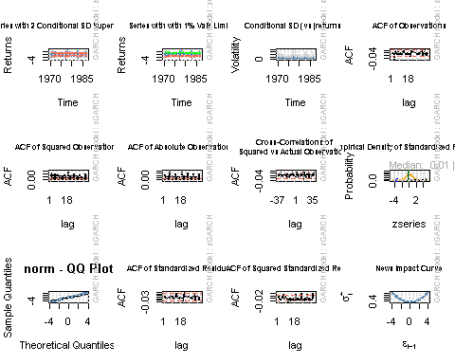

##Model Diagnostics

EURCADgarchMODEL1.1

##   
## *---------------------------------*  
## * GARCH Model Fit *  
## *---------------------------------*  
##   
## Conditional Variance Dynamics   
## -----------------------------------  
## GARCH Model : sGARCH(1,1)  
## Mean Model : ARFIMA(5,0,8)  
## Distribution : norm   
##   
## Optimal Parameters  
## ------------------------------------  
## Estimate Std. Error t value Pr(>|t|)  
## mu -0.002493 0.000171 -14.5728 0  
## ar1 -0.313691 0.000693 -452.7201 0  
## ar2 -0.051617 0.000400 -129.0228 0  
## ar3 0.974087 0.000241 4035.1765 0  
## ar4 0.356473 0.001896 187.9860 0  
## ar5 0.024439 0.001433 17.0500 0  
## ma1 0.323198 0.000018 18010.7636 0  
## ma2 0.062909 0.000015 4232.6570 0  
## ma3 -1.014511 0.000024 -41440.5362 0  
## ma4 -0.358286 0.000019 -18940.2266 0  
## ma5 -0.042152 0.000015 -2850.1371 0  
## ma6 0.030860 0.000012 2582.7244 0  
## ma7 -0.006968 0.000068 -101.8727 0  
## ma8 0.001014 0.000174 5.8324 0  
## omega 0.001702 0.000317 5.3755 0  
## alpha1 0.033697 0.001633 20.6306 0  
## beta1 0.961230 0.000968 993.3566 0  
##   
## Robust Standard Errors:  
## Estimate Std. Error t value Pr(>|t|)  
## mu -0.002493 0.000327 -7.6249 0.0e+00  
## ar1 -0.313691 0.001365 -229.8412 0.0e+00  
## ar2 -0.051617 0.001800 -28.6826 0.0e+00  
## ar3 0.974087 0.001507 646.4663 0.0e+00  
## ar4 0.356473 0.001292 275.8123 0.0e+00  
## ar5 0.024439 0.002042 11.9696 0.0e+00  
## ma1 0.323198 0.000013 24979.4165 0.0e+00  
## ma2 0.062909 0.000011 5796.1944 0.0e+00  
## ma3 -1.014511 0.000055 -18463.3692 0.0e+00  
## ma4 -0.358286 0.000014 -26307.6699 0.0e+00  
## ma5 -0.042152 0.000006 -7543.8939 0.0e+00  
## ma6 0.030860 0.000005 6031.6492 0.0e+00  
## ma7 -0.006968 0.000055 -125.7647 0.0e+00  
## ma8 0.001014 0.000205 4.9389 1.0e-06  
## omega 0.001702 0.000484 3.5146 4.4e-04  
## alpha1 0.033697 0.002106 16.0033 0.0e+00  
## beta1 0.961230 0.000577 1664.6837 0.0e+00  
##   
## LogLikelihood : -4910.659   
##   
## Information Criteria  
## ------------------------------------  
##   
## Akaike 1.5827  
## Bayes 1.6011  
## Shibata 1.5827  
## Hannan-Quinn 1.5891  
##   
## Weighted Ljung-Box Test on Standardized Residuals  
## ------------------------------------  
## statistic p-value  
## Lag[1] 0.03025 8.619e-01  
## Lag[2*(p+q)+(p+q)-1][38] 22.63324 1.662e-07  
## Lag[4*(p+q)+(p+q)-1][64] 40.03132 4.348e-02  
## d.o.f=13  
## H0 : No serial correlation  
##   
## Weighted Ljung-Box Test on Standardized Squared Residuals  
## ------------------------------------  
## statistic p-value  
## Lag[1] 5.855 0.015530  
## Lag[2*(p+q)+(p+q)-1][5] 7.876 0.031632  
## Lag[4*(p+q)+(p+q)-1][9] 13.423 0.008503  
## d.o.f=2  
##   
## Weighted ARCH LM Tests  
## ------------------------------------  
## Statistic Shape Scale P-Value  
## ARCH Lag[3] 2.358 0.500 2.000 0.1246  
## ARCH Lag[5] 3.732 1.440 1.667 0.1998  
## ARCH Lag[7] 8.517 2.315 1.543 0.0402  
##   
## Nyblom stability test  
## ------------------------------------  
## Joint Statistic: 5.8248  
## Individual Statistics:   
## mu 0.02601  
## ar1 0.02334  
## ar2 0.02410  
## ar3 0.01741  
## ar4 0.03120  
## ar5 0.03063  
## ma1 0.02365  
## ma2 0.02473  
## ma3 0.02460  
## ma4 0.02363  
## ma5 0.02447  
## ma6 0.02460  
## ma7 0.02344  
## ma8 0.02443  
## omega 0.34077  
## alpha1 0.21604  
## beta1 0.34174  
##   
## Asymptotic Critical Values (10% 5% 1%)  
## Joint Statistic: 3.64 3.95 4.51  
## Individual Statistic: 0.35 0.47 0.75  
##   
## Sign Bias Test  
## ------------------------------------  
## t-value prob sig  
## Sign Bias 0.01951 0.98443   
## Negative Sign Bias 0.61400 0.53923   
## Positive Sign Bias 2.30589 0.02115 **  
## Joint Effect 7.23195 0.06486 *  
##   
##   
## Adjusted Pearson Goodness-of-Fit Test:  
## ------------------------------------  
## group statistic p-value(g-1)  
## 1 20 238.1 7.826e-40  
## 2 30 254.9 5.645e-38  
## 3 40 271.3 1.430e-36  
## 4 50 313.3 3.231e-40  
##   
##   
## Elapsed time : 2.812176

## Forecasting

forcgarchEURCAD= ugarchforecast(EURCADgarchMODEL1.1, data = DifflogEURCADGarch, n.ahead = 100, n.roll = 10)  
print(forcgarchEURCAD)

##   
## *------------------------------------*  
## * GARCH Model Forecast *  
## *------------------------------------*  
## Model: sGARCH  
## Horizon: 100  
## Roll Steps: 10  
## Out of Sample: 100  
##   
## 0-roll forecast [T0=1987-01-19 02:00:00]:  
## Series Sigma  
## T+1 -0.1114388 0.4332  
## T+2 0.0454404 0.4341  
## T+3 -0.0337630 0.4349  
## T+4 -0.0575720 0.4358  
## T+5 -0.0012146 0.4366  
## T+6 -0.0089261 0.4375  
## T+7 -0.0652772 0.4383  
## T+8 -0.0015482 0.4391  
## T+9 -0.0067055 0.4399  
## T+10 -0.0646396 0.4408  
## T+11 -0.0043985 0.4416  
## T+12 -0.0039884 0.4424  
## T+13 -0.0639403 0.4432  
## T+14 -0.0072530 0.4440  
## T+15 -0.0014828 0.4448  
## T+16 -0.0629988 0.4456  
## T+17 -0.0101425 0.4463  
## T+18 0.0008152 0.4471  
## T+19 -0.0618300 0.4479  
## T+20 -0.0130455 0.4486  
## T+21 0.0028969 0.4494  
## T+22 -0.0604461 0.4502  
## T+23 -0.0159420 0.4509  
## T+24 0.0047556 0.4516  
## T+25 -0.0588605 0.4524  
## T+26 -0.0188127 0.4531  
## T+27 0.0063861 0.4538  
## T+28 -0.0570875 0.4546  
## T+29 -0.0216386 0.4553  
## T+30 0.0077847 0.4560  
## T+31 -0.0551423 0.4567  
## T+32 -0.0244018 0.4574  
## T+33 0.0089494 0.4581  
## T+34 -0.0530407 0.4588  
## T+35 -0.0270852 0.4595  
## T+36 0.0098798 0.4602  
## T+37 -0.0507992 0.4609  
## T+38 -0.0296726 0.4615  
## T+39 0.0105767 0.4622  
## T+40 -0.0484348 0.4629  
## T+41 -0.0321488 0.4635  
## T+42 0.0110428 0.4642  
## T+43 -0.0459649 0.4649  
## T+44 -0.0344998 0.4655  
## T+45 0.0112820 0.4662  
## T+46 -0.0434070 0.4668  
## T+47 -0.0367128 0.4674  
## T+48 0.0112993 0.4681  
## T+49 -0.0407788 0.4687  
## T+50 -0.0387761 0.4693  
## T+51 0.0111015 0.4700  
## T+52 -0.0380981 0.4706  
## T+53 -0.0406794 0.4712  
## T+54 0.0106961 0.4718  
## T+55 -0.0353824 0.4724  
## T+56 -0.0424136 0.4730  
## T+57 0.0100921 0.4736  
## T+58 -0.0326490 0.4742  
## T+59 -0.0439708 0.4748  
## T+60 0.0092994 0.4754  
## T+61 -0.0299152 0.4760  
## T+62 -0.0453448 0.4765  
## T+63 0.0083288 0.4771  
## T+64 -0.0271974 0.4777  
## T+65 -0.0465305 0.4783  
## T+66 0.0071920 0.4788  
## T+67 -0.0245119 0.4794  
## T+68 -0.0475241 0.4800  
## T+69 0.0059015 0.4805  
## T+70 -0.0218740 0.4811  
## T+71 -0.0483233 0.4816  
## T+72 0.0044705 0.4822  
## T+73 -0.0192987 0.4827  
## T+74 -0.0489269 0.4832  
## T+75 0.0029125 0.4838  
## T+76 -0.0167998 0.4843  
## T+77 -0.0493353 0.4848  
## T+78 0.0012418 0.4854  
## T+79 -0.0143907 0.4859  
## T+80 -0.0495500 0.4864  
## T+81 -0.0005272 0.4869  
## T+82 -0.0120836 0.4874  
## T+83 -0.0495735 0.4879  
## T+84 -0.0023797 0.4884  
## T+85 -0.0098897 0.4889  
## T+86 -0.0494098 0.4894  
## T+87 -0.0043007 0.4899  
## T+88 -0.0078195 0.4904  
## T+89 -0.0490638 0.4909  
## T+90 -0.0062754 0.4914  
## T+91 -0.0058822 0.4919  
## T+92 -0.0485415 0.4924  
## T+93 -0.0082889 0.4929  
## T+94 -0.0040858 0.4933  
## T+95 -0.0478500 0.4938  
## T+96 -0.0103262 0.4943  
## T+97 -0.0024376 0.4948  
## T+98 -0.0469971 0.4952  
## T+99 -0.0123730 0.4957  
## T+100 -0.0009434 0.4961

## plotting

plot(forcgarchEURCAD, which= "all")

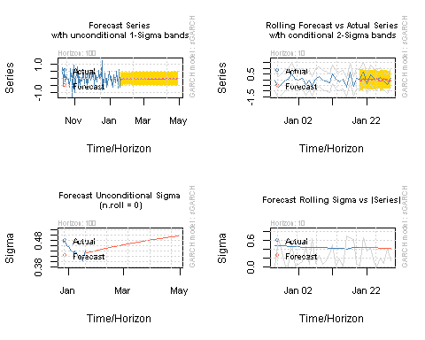

## Forecasting the rate

p.t_1 = 1.55384  
 R_t <- c( -0.1114388, 0.0454404, -0.0337630, -0.0575720, -0.0012146, -0.0089261, -0.0652772, -0.0015482, -0.0067055, -0.0646396, -0.0043985, -0.0039884, -0.0639403, -0.0072530, -0.0014828, -0.0629988, -0.0101425, 0.0008152, -0.0618300, -0.0130455, 0.0028969, -0.0604461, -0.0159420, 0.0047556, -0.0588605, -0.0188127, 0.0063861, -0.0570875, -0.0216386,   
0.0077847, -0.0551423, -0.0244018, 0.0089494, -0.0530407, -0.0270852, 0.0098798, -0.0507992, -0.0296726, 0.0105767,   
-0.0484348, -0.0321488, 0.0110428, -0.0459649, -0.0344998, 0.0112820, -0.0434070, -0.0367128, 0.0112993, -0.0407788,   
-0.0387761, 0.0111015, -0.0380981, -0.0406794, 0.0106961, -0.0353824, -0.0424136, 0.0100921, -0.0326490, -0.0439708,   
0.0092994, -0.0299152, -0.0453448, 0.0083288, -0.0271974, -0.0465305, 0.0071920, -0.0245119, -0.0475241, 0.0059015,   
-0.0218740, -0.0483233, 0.0044705, -0.0192987, -0.0489269, 0.0029125, -0.0167998, -0.0493353, 0.0012418, -0.0143907, -0.0495500, -0.0005272, -0.0120836, -0.0495735, -0.0023797, -0.0098897, -0.0494098, -0.0043007, -0.0078195, -0.0490638, -0.0062754, -0.0058822, -0.0485415, -0.0082889, -0.0040858, -0.0478500, -0.0103262, -0.0024376, -0.0469971, -0.0123730, -0.0009434  
  
  
  
  
  
)  
 p_t= 0  
 for (i in 1:100){  
 p_t = p.t_1 *((2.71828)^(R_t[i]/100))  
 print(p_t)  
 p.t_1=p_t  
 }

## [1] 1.552109  
## [1] 1.552815  
## [1] 1.552291  
## [1] 1.551397  
## [1] 1.551378  
## [1] 1.55124  
## [1] 1.550228  
## [1] 1.550204  
## [1] 1.5501  
## [1] 1.549098  
## [1] 1.54903  
## [1] 1.548968  
## [1] 1.547978  
## [1] 1.547866  
## [1] 1.547843  
## [1] 1.546868  
## [1] 1.546711  
## [1] 1.546724  
## [1] 1.545768  
## [1] 1.545566  
## [1] 1.545611  
## [1] 1.544677  
## [1] 1.544431  
## [1] 1.544504  
## [1] 1.543595  
## [1] 1.543305  
## [1] 1.543403  
## [1] 1.542523  
## [1] 1.542189  
## [1] 1.542309  
## [1] 1.541459  
## [1] 1.541083  
## [1] 1.54122  
## [1] 1.540403  
## [1] 1.539986  
## [1] 1.540138  
## [1] 1.539356  
## [1] 1.538899  
## [1] 1.539062  
## [1] 1.538317  
## [1] 1.537822  
## [1] 1.537992  
## [1] 1.537285  
## [1] 1.536755  
## [1] 1.536929  
## [1] 1.536262  
## [1] 1.535698  
## [1] 1.535871  
## [1] 1.535245  
## [1] 1.53465  
## [1] 1.53482  
## [1] 1.534236  
## [1] 1.533612  
## [1] 1.533776  
## [1] 1.533233  
## [1] 1.532583  
## [1] 1.532738  
## [1] 1.532237  
## [1] 1.531564  
## [1] 1.531706  
## [1] 1.531248  
## [1] 1.530554  
## [1] 1.530681  
## [1] 1.530265  
## [1] 1.529553  
## [1] 1.529663  
## [1] 1.529288  
## [1] 1.528562  
## [1] 1.528652  
## [1] 1.528317  
## [1] 1.527579  
## [1] 1.527647  
## [1] 1.527353  
## [1] 1.526605  
## [1] 1.52665  
## [1] 1.526393  
## [1] 1.525641  
## [1] 1.52566  
## [1] 1.52544  
## [1] 1.524684  
## [1] 1.524676  
## [1] 1.524492  
## [1] 1.523737  
## [1] 1.5237  
## [1] 1.52355  
## [1] 1.522797  
## [1] 1.522732  
## [1] 1.522612  
## [1] 1.521866  
## [1] 1.52177  
## [1] 1.521681  
## [1] 1.520942  
## [1] 1.520816  
## [1] 1.520754  
## [1] 1.520026  
## [1] 1.519869  
## [1] 1.519832  
## [1] 1.519118  
## [1] 1.51893  
## [1] 1.518916