GARCH Model EUR And GBP

Jane

29/04/2021

# Forcasting Exchange Rate Using GARCH Model for EUR And GBP

## Reading EUR and GBP Currency into r

library(readr)  
library(dplyr)

##   
## Attaching package: 'dplyr'

## The following objects are masked from 'package:stats':  
##   
## filter, lag

## The following objects are masked from 'package:base':  
##   
## intersect, setdiff, setequal, union

EURGBPGARCH<- read.csv ("EURGBP_Candlestick_1_D_BID_01.01.2000-31.12.2020.csv")%>%  
 select('GMT.TIME', CLOSE)%>%  
 rename(Date = ('GMT.TIME'), RateEURGBP = ("CLOSE"))  
  
   
head(EURGBPGARCH)

## Date RateEURGBP  
## 1 2000-01-03 0.6261  
## 2 2000-01-04 0.6293  
## 3 2000-01-05 0.6281  
## 4 2000-01-06 0.6263  
## 5 2000-01-07 0.6277  
## 6 2000-01-10 0.6264

## Conversion of Gmt time to date format

library(dplyr)  
library(lubridate)

##   
## Attaching package: 'lubridate'

## The following objects are masked from 'package:base':  
##   
## date, intersect, setdiff, union

EURGBPGARCH$Date <- lubridate::ymd(EURGBPGARCH$Date)  
head(EURGBPGARCH)

## Date RateEURGBP  
## 1 2000-01-03 0.6261  
## 2 2000-01-04 0.6293  
## 3 2000-01-05 0.6281  
## 4 2000-01-06 0.6263  
## 5 2000-01-07 0.6277  
## 6 2000-01-10 0.6264

##Checking for obvious errors or missingg value

#Checking for obvious errors  
which(is.na(EURGBPGARCH))

## integer(0)

##Converting the data set into time series object

#Converting the data set into time series object  
EURGBPGARCHTS<- ts(as.vector(EURGBPGARCH$Rate), frequency = 322, start= c(2000,01,03))  
plot.ts(EURGBPGARCHTS)  
title("Time Series plot of EURGBPTimeseries ", sub = "(2000-2020)",  
 cex.main = 1.5, font.main= 4, col.main= "blue",  
 cex.sub = 0.75, font.sub = 3, col.sub = "red")

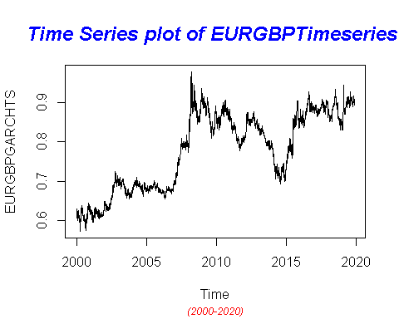

##Dealing with Conditional Heteroscedaticity:

DifflogEURGBPGarch= diff(log(EURGBPGARCHTS))*100  
plot(DifflogEURGBPGarch)  
title("Plot of returns of EURGBP", sub = "(2000-2020)",  
 cex.main = 1.5, font.main= 4, col.main= "blue",  
 cex.sub = 0.75, font.sub = 3, col.sub = "red")

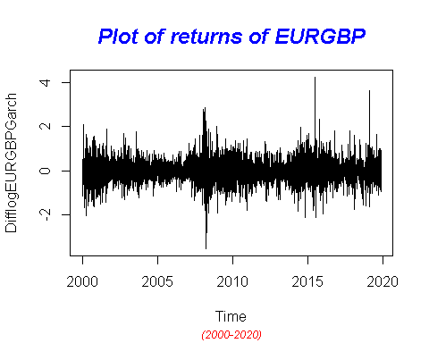

##nature as almost at all lags the p-values fall below the significance levels.

library(TSA)

## Warning: package 'TSA' was built under R version 4.0.5

##   
## Attaching package: 'TSA'

## The following object is masked from 'package:readr':  
##   
## spec

## The following objects are masked from 'package:stats':  
##   
## acf, arima

## The following object is masked from 'package:utils':  
##   
## tar

McLeod.Li.test(y= DifflogEURGBPGarch,main="McLeod-Li test statistics for Daily return series")

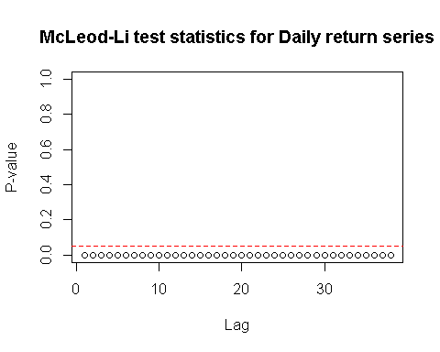

## In order to get an order of GARCH , we further transform the return series into absolute values and squared return values.

abs = abs(DifflogEURGBPGarch)  
sqr = DifflogEURGBPGarch^2

# GARCH Model specification:

par(mfrow=c(1,2))  
acf(abs, ci.type="ma",main=" ACF for abs. returns")  
pacf(abs, main=" PACF plot for abs.returns")

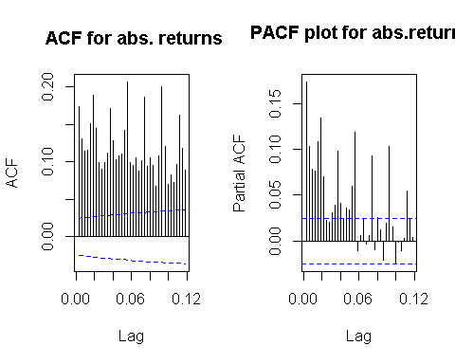

##From ACF and PACF we see many lags are significant. Hence, we plot EACF to get the candidate models

eacf(abs)

## AR/MA  
## 0 1 2 3 4 5 6 7 8 9 10 11 12 13  
## 0 x x x x x x x x x x x x x x   
## 1 x o o o o x o o o o o x o o   
## 2 x x o o o x x o o o o x o o   
## 3 x x x o o x o o o o o x o x   
## 4 x x x x o x o o o o o x o o   
## 5 x x x x x x o o o o x x o o   
## 6 x x x x x x o o o o x o o o   
## 7 x x x x o x x o o o o o o o

##From the squared returns ACF and PACF plot

par(mfrow=c(1,2))  
acf(sqr, ci.type="ma",main="ACF for sqr. return")  
pacf(sqr, main="PACF for sqr. return")

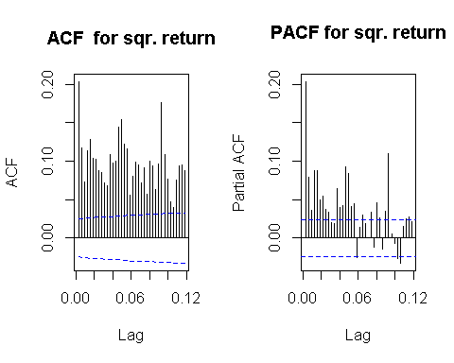

## 

eacf(sqr)

## AR/MA  
## 0 1 2 3 4 5 6 7 8 9 10 11 12 13  
## 0 x x x x x x x x x x x x x x   
## 1 x o x o x o o o o o o x o o   
## 2 x o x o x o o o o o o x o o   
## 3 x x x o x o o o o o o o o o   
## 4 x x x x x o o o o o o o o o   
## 5 x x x o x o o o o o o o o o   
## 6 x x x o x o o o o o o o o o   
## 7 x x x x o o x o o o o o o o

### With reference to the Dickey-Fuller Test, p-value is less than the 0.02 and we can reject the null hypothesis stating the non-stationarity. Hence , we can proceed further for model selection .

#MODEL ESTIMATION: ##GARCH (1,1): for GBP and USD Curruency Pair

# GARCH(2,1)  
library(tseries)

## Registered S3 method overwritten by 'quantmod':  
## method from  
## as.zoo.data.frame zoo

EURGBPGARCHFit.11= garch(DifflogEURGBPGarch,order=c(1,1),trace =FALSE)  
summary(EURGBPGARCHFit.11)

##   
## Call:  
## garch(x = DifflogEURGBPGarch, order = c(1, 1), trace = FALSE)  
##   
## Model:  
## GARCH(1,1)  
##   
## Residuals:  
## Min 1Q Median 3Q Max   
## -4.399589 -0.555232 0.007329 0.568430 6.243267   
##   
## Coefficient(s):  
## Estimate Std. Error t value Pr(>|t|)   
## a0 0.0014781 0.0002521 5.864 4.51e-09 ***  
## a1 0.0456535 0.0029534 15.458 < 2e-16 ***  
## b1 0.9485907 0.0034932 271.550 < 2e-16 ***  
## ---  
## Signif. codes: 0 '***' 0.001 '**' 0.01 '*' 0.05 '.' 0.1 ' ' 1  
##   
## Diagnostic Tests:  
## Jarque Bera Test  
##   
## data: Residuals  
## X-squared = 765.47, df = 2, p-value < 2.2e-16  
##   
##   
## Box-Ljung test  
##   
## data: Squared.Residuals  
## X-squared = 7.9406, df = 1, p-value = 0.004834

## GARCH (2,2):

##This model can be interpreted as an overfit model of GARCH(1,1) and p values from residual tests confirms that residuals has low correlated. Thus this model is not consider to be a good fit.

EURGBPGARCHFit.22 = garch(DifflogEURGBPGarch, order =c(2,2),trace =FALSE)  
summary(EURGBPGARCHFit.22)

##   
## Call:  
## garch(x = DifflogEURGBPGarch, order = c(2, 2), trace = FALSE)  
##   
## Model:  
## GARCH(2,2)  
##   
## Residuals:  
## Min 1Q Median 3Q Max   
## -4.425124 -0.553644 0.007464 0.566711 5.943074   
##   
## Coefficient(s):  
## Estimate Std. Error t value Pr(>|t|)   
## a0 2.086e-03 6.056e-04 3.444 0.000573 ***  
## a1 6.562e-02 7.899e-03 8.307 < 2e-16 ***  
## a2 2.912e-15 2.071e-02 0.000 1.000000   
## b1 4.558e-01 3.164e-01 1.441 0.149675   
## b2 4.705e-01 2.990e-01 1.574 0.115516   
## ---  
## Signif. codes: 0 '***' 0.001 '**' 0.01 '*' 0.05 '.' 0.1 ' ' 1  
##   
## Diagnostic Tests:  
## Jarque Bera Test  
##   
## data: Residuals  
## X-squared = 767.63, df = 2, p-value < 2.2e-16  
##   
##   
## Box-Ljung test  
##   
## data: Squared.Residuals  
## X-squared = 2.2484, df = 1, p-value = 0.1338

##GARCH (3,1): ##This model can be interpreted as an overfit model of GARCH(2,1) and GARCH (2,2). This model may not be consider to be a good fit.

EURGBPGARCHFit.31 = garch(DifflogEURGBPGarch,order=c(3,1),trace =FALSE)  
summary(EURGBPGARCHFit.31)

##   
## Call:  
## garch(x = DifflogEURGBPGarch, order = c(3, 1), trace = FALSE)  
##   
## Model:  
## GARCH(3,1)  
##   
## Residuals:  
## Min 1Q Median 3Q Max   
## -4.418602 -0.551795 0.007475 0.563893 5.676349   
##   
## Coefficient(s):  
## Estimate Std. Error t value Pr(>|t|)   
## a0 2.302e-03 4.466e-04 5.154 2.55e-07 ***  
## a1 8.375e-02 6.903e-03 12.133 < 2e-16 ***  
## b1 5.316e-01 1.045e-01 5.087 3.65e-07 ***  
## b2 1.005e-15 1.454e-01 0.000 1.000000   
## b3 3.773e-01 1.018e-01 3.706 0.000211 ***  
## ---  
## Signif. codes: 0 '***' 0.001 '**' 0.01 '*' 0.05 '.' 0.1 ' ' 1  
##   
## Diagnostic Tests:  
## Jarque Bera Test  
##   
## data: Residuals  
## X-squared = 702.52, df = 2, p-value < 2.2e-16  
##   
##   
## Box-Ljung test  
##   
## data: Squared.Residuals  
## X-squared = 0.22046, df = 1, p-value = 0.6387

##GARCH (3,2): ##This model can be interpreted as an overfitting model and p values from residual tests confirms that residuals are highly correlated. Thus this model is not consider to be a good fit.

# GARCH(3,2)

EURGBPGARCHFit.32 = garch(DifflogEURGBPGarch,order=c(3,2),trace =FALSE)  
summary(EURGBPGARCHFit.32)

##   
## Call:  
## garch(x = DifflogEURGBPGarch, order = c(3, 2), trace = FALSE)  
##   
## Model:  
## GARCH(3,2)  
##   
## Residuals:  
## Min 1Q Median 3Q Max   
## -4.381323 -0.551725 0.007592 0.565241 5.867779   
##   
## Coefficient(s):  
## Estimate Std. Error t value Pr(>|t|)   
## a0 2.905e-03 6.395e-04 4.542 5.56e-06 ***  
## a1 7.159e-02 7.530e-03 9.507 < 2e-16 ***  
## a2 1.882e-02 1.650e-02 1.140 0.2541   
## b1 3.859e-01 1.931e-01 1.998 0.0457 *   
## b2 2.195e-06 1.553e-01 0.000 1.0000   
## b3 5.122e-01 1.099e-01 4.660 3.16e-06 ***  
## ---  
## Signif. codes: 0 '***' 0.001 '**' 0.01 '*' 0.05 '.' 0.1 ' ' 1  
##   
## Diagnostic Tests:  
## Jarque Bera Test  
##   
## data: Residuals  
## X-squared = 697.29, df = 2, p-value < 2.2e-16  
##   
##   
## Box-Ljung test  
##   
## data: Squared.Residuals  
## X-squared = 1.2862, df = 1, p-value = 0.2568

## GARCH (3,3):

## This model can be interpreted as an overfitting model and p values from residual tests confirms that residuals are highly correlated. Thus, this model is not consider to be a good fit.

# GARCH(3,3)

EURGBPGARCHFit.33 = garch(DifflogEURGBPGarch,order=c(3,3),trace =FALSE)  
summary(EURGBPGARCHFit.33)

##   
## Call:  
## garch(x = DifflogEURGBPGarch, order = c(3, 3), trace = FALSE)  
##   
## Model:  
## GARCH(3,3)  
##   
## Residuals:  
## Min 1Q Median 3Q Max   
## -4.418160 -0.553909 0.007512 0.566955 5.837280   
##   
## Coefficient(s):  
## Estimate Std. Error t value Pr(>|t|)   
## a0 2.450e-03 1.085e-03 2.257 0.024 *   
## a1 7.110e-02 8.529e-03 8.337 <2e-16 ***  
## a2 1.997e-02 5.385e-02 0.371 0.711   
## a3 1.223e-14 2.888e-02 0.000 1.000   
## b1 2.787e-01 7.455e-01 0.374 0.709   
## b2 3.121e-01 7.491e-01 0.417 0.677   
## b3 3.101e-01 2.826e-01 1.097 0.273   
## ---  
## Signif. codes: 0 '***' 0.001 '**' 0.01 '*' 0.05 '.' 0.1 ' ' 1  
##   
## Diagnostic Tests:  
## Jarque Bera Test  
##   
## data: Residuals  
## X-squared = 730.26, df = 2, p-value < 2.2e-16  
##   
##   
## Box-Ljung test  
##   
## data: Squared.Residuals  
## X-squared = 1.3356, df = 1, p-value = 0.2478

##GARCH (4,2): ##This model can be interpreted as an overfitting model and p values from residual tests confirms that residuals are highly correlated. Thus, this model is not considered to be a good fit.

EURGBPGARCHFit.42 = garch(DifflogEURGBPGarch,order=c(4,2),trace =FALSE)  
summary(EURGBPGARCHFit.42)

##   
## Call:  
## garch(x = DifflogEURGBPGarch, order = c(4, 2), trace = FALSE)  
##   
## Model:  
## GARCH(4,2)  
##   
## Residuals:  
## Min 1Q Median 3Q Max   
## -4.38463 -0.55559 0.00748 0.57100 5.99505   
##   
## Coefficient(s):  
## Estimate Std. Error t value Pr(>|t|)   
## a0 3.167e-03 1.865e-03 1.698 0.0895 .   
## a1 6.933e-02 7.677e-03 9.031 <2e-16 ***  
## a2 3.466e-02 6.236e-02 0.556 0.5783   
## b1 3.951e-01 9.032e-01 0.437 0.6618   
## b2 4.719e-15 8.972e-01 0.000 1.0000   
## b3 8.563e-02 5.597e-01 0.153 0.8784   
## b4 4.030e-01 4.961e-01 0.812 0.4166   
## ---  
## Signif. codes: 0 '***' 0.001 '**' 0.01 '*' 0.05 '.' 0.1 ' ' 1  
##   
## Diagnostic Tests:  
## Jarque Bera Test  
##   
## data: Residuals  
## X-squared = 742.33, df = 2, p-value < 2.2e-16  
##   
##   
## Box-Ljung test  
##   
## data: Squared.Residuals  
## X-squared = 1.5132, df = 1, p-value = 0.2186

##

EURGBPGARCHFit.41 = garch(DifflogEURGBPGarch,order=c(4,1),trace =FALSE)  
summary(EURGBPGARCHFit.41)

##   
## Call:  
## garch(x = DifflogEURGBPGarch, order = c(4, 1), trace = FALSE)  
##   
## Model:  
## GARCH(4,1)  
##   
## Residuals:  
## Min 1Q Median 3Q Max   
## -4.376240 -0.555976 0.007487 0.569502 5.959987   
##   
## Coefficient(s):  
## Estimate Std. Error t value Pr(>|t|)   
## a0 2.407e-03 4.625e-04 5.204 1.95e-07 ***  
## a1 7.913e-02 7.302e-03 10.837 < 2e-16 ***  
## b1 5.945e-01 1.130e-01 5.262 1.43e-07 ***  
## b2 1.705e-14 1.807e-01 0.000 1.000000   
## b3 2.943e-02 1.589e-01 0.185 0.853098   
## b4 2.873e-01 7.975e-02 3.602 0.000315 ***  
## ---  
## Signif. codes: 0 '***' 0.001 '**' 0.01 '*' 0.05 '.' 0.1 ' ' 1  
##   
## Diagnostic Tests:  
## Jarque Bera Test  
##   
## data: Residuals  
## X-squared = 745.05, df = 2, p-value < 2.2e-16  
##   
##   
## Box-Ljung test  
##   
## data: Squared.Residuals  
## X-squared = 0.49716, df = 1, p-value = 0.4807

# Model Selection:

##Best possible model is selected by AIC scores of the models. From the below sort function, GARCH(3,1) would be the best model for the return series. From the p-value, 3.1 also has the lowest correlation

library(dLagM)

## Warning: package 'dLagM' was built under R version 4.0.5

## Loading required package: nardl

## Warning: package 'nardl' was built under R version 4.0.5

## Loading required package: dynlm

## Loading required package: zoo

##   
## Attaching package: 'zoo'

## The following objects are masked from 'package:base':  
##   
## as.Date, as.Date.numeric

GARCHModelSelectionEURGBP = AIC(EURGBPGARCHFit.11,EURGBPGARCHFit.22 ,EURGBPGARCHFit.31,EURGBPGARCHFit.32,EURGBPGARCHFit.33, EURGBPGARCHFit.42, EURGBPGARCHFit.41)  
sortScore(GARCHModelSelectionEURGBP, score ="aic")

## df AIC  
## EURGBPGARCHFit.41 6 7729.134  
## EURGBPGARCHFit.42 7 7733.284  
## EURGBPGARCHFit.31 5 7733.784  
## EURGBPGARCHFit.32 6 7735.384  
## EURGBPGARCHFit.33 7 7741.609  
## EURGBPGARCHFit.22 5 7743.652  
## EURGBPGARCHFit.11 3 7744.918

# Model Fitting:

library(rugarch)

## Warning: package 'rugarch' was built under R version 4.0.5

## Loading required package: parallel

##   
## Attaching package: 'rugarch'

## The following object is masked from 'package:stats':  
##   
## sigma

EURGBPmodel1.1<-ugarchspec(variance.model = list(model = "sGARCH", garchOrder = c(1,1)),   
 mean.model = list(armaOrder = c(6,4), include.mean = TRUE),   
 distribution.model = "norm")  
   
EURGBPgarchMODEL1.1<-ugarchfit(spec=EURGBPmodel1.1,data=DifflogEURGBPGarch, out.sample = 100)

## Warning in arima(data, order = c(modelinc[2], 0, modelinc[3]), include.mean =  
## modelinc[1], : possible convergence problem: optim gave code = 1

plot(EURGBPgarchMODEL1.1,which="all")

##   
## please wait...calculating quantiles...

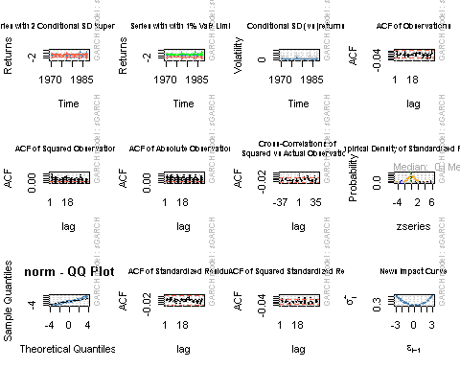

##Model Diagnostics

EURGBPgarchMODEL1.1

##   
## *---------------------------------*  
## * GARCH Model Fit *  
## *---------------------------------*  
##   
## Conditional Variance Dynamics   
## -----------------------------------  
## GARCH Model : sGARCH(1,1)  
## Mean Model : ARFIMA(6,0,4)  
## Distribution : norm   
##   
## Optimal Parameters  
## ------------------------------------  
## Estimate Std. Error t value Pr(>|t|)  
## mu 0.001487 0.004125 3.6051e-01 0.71847  
## ar1 -1.154485 0.000137 -8.4498e+03 0.00000  
## ar2 0.742124 0.000084 8.8325e+03 0.00000  
## ar3 0.949172 0.000120 7.8883e+03 0.00000  
## ar4 0.042950 0.000591 7.2649e+01 0.00000  
## ar5 0.037733 0.000524 7.1969e+01 0.00000  
## ar6 0.036772 0.000649 5.6700e+01 0.00000  
## ma1 1.167477 0.000004 2.6047e+05 0.00000  
## ma2 -0.748188 0.000005 -1.6084e+05 0.00000  
## ma3 -1.031766 0.000005 -1.9859e+05 0.00000  
## ma4 -0.105493 0.000003 -4.1834e+04 0.00000  
## omega 0.001484 0.000247 6.0111e+00 0.00000  
## alpha1 0.046446 0.001913 2.4284e+01 0.00000  
## beta1 0.947616 0.000916 1.0350e+03 0.00000  
##   
## Robust Standard Errors:  
## Estimate Std. Error t value Pr(>|t|)  
## mu 0.001487 0.004313 3.4478e-01 0.730263  
## ar1 -1.154485 0.000131 -8.8115e+03 0.000000  
## ar2 0.742124 0.000086 8.6066e+03 0.000000  
## ar3 0.949172 0.000088 1.0763e+04 0.000000  
## ar4 0.042950 0.000527 8.1556e+01 0.000000  
## ar5 0.037733 0.000680 5.5491e+01 0.000000  
## ar6 0.036772 0.000657 5.5950e+01 0.000000  
## ma1 1.167477 0.000001 9.9153e+05 0.000000  
## ma2 -0.748188 0.000013 -5.6012e+04 0.000000  
## ma3 -1.031766 0.000002 -6.4826e+05 0.000000  
## ma4 -0.105493 0.000003 -3.1421e+04 0.000000  
## omega 0.001484 0.000318 4.6654e+00 0.000003  
## alpha1 0.046446 0.002553 1.8195e+01 0.000000  
## beta1 0.947616 0.000483 1.9620e+03 0.000000  
##   
## LogLikelihood : -3778.303   
##   
## Information Criteria  
## ------------------------------------  
##   
## Akaike 1.2041  
## Bayes 1.2191  
## Shibata 1.2041  
## Hannan-Quinn 1.2093  
##   
## Weighted Ljung-Box Test on Standardized Residuals  
## ------------------------------------  
## statistic p-value  
## Lag[1] 1.082 0.2983  
## Lag[2*(p+q)+(p+q)-1][29] 9.416 1.0000  
## Lag[4*(p+q)+(p+q)-1][49] 16.290 0.9960  
## d.o.f=10  
## H0 : No serial correlation  
##   
## Weighted Ljung-Box Test on Standardized Squared Residuals  
## ------------------------------------  
## statistic p-value  
## Lag[1] 7.446 0.006359  
## Lag[2*(p+q)+(p+q)-1][5] 8.782 0.018782  
## Lag[4*(p+q)+(p+q)-1][9] 12.001 0.018132  
## d.o.f=2  
##   
## Weighted ARCH LM Tests  
## ------------------------------------  
## Statistic Shape Scale P-Value  
## ARCH Lag[3] 1.801 0.500 2.000 0.1796  
## ARCH Lag[5] 2.108 1.440 1.667 0.4479  
## ARCH Lag[7] 4.147 2.315 1.543 0.3258  
##   
## Nyblom stability test  
## ------------------------------------  
## Joint Statistic: 2.0183  
## Individual Statistics:   
## mu 0.11451  
## ar1 0.08477  
## ar2 0.08474  
## ar3 0.08401  
## ar4 0.08431  
## ar5 0.08276  
## ar6 0.08172  
## ma1 0.12766  
## ma2 0.13226  
## ma3 0.13476  
## ma4 0.13751  
## omega 0.38543  
## alpha1 0.13937  
## beta1 0.14311  
##   
## Asymptotic Critical Values (10% 5% 1%)  
## Joint Statistic: 3.08 3.34 3.9  
## Individual Statistic: 0.35 0.47 0.75  
##   
## Sign Bias Test  
## ------------------------------------  
## t-value prob sig  
## Sign Bias 0.6833 0.49443   
## Negative Sign Bias 1.0993 0.27166   
## Positive Sign Bias 1.8553 0.06360 *  
## Joint Effect 6.8366 0.07729 *  
##   
##   
## Adjusted Pearson Goodness-of-Fit Test:  
## ------------------------------------  
## group statistic p-value(g-1)  
## 1 20 228.8 5.867e-38  
## 2 30 244.9 4.994e-36  
## 3 40 262.0 7.860e-35  
## 4 50 283.9 7.890e-35  
##   
##   
## Elapsed time : 2.445754

## Forecasting

forcgarchEURGBP= ugarchforecast(EURGBPgarchMODEL1.1, data = DifflogEURGBPGarch, n.ahead = 100, n.roll = 10)  
print(forcgarchEURGBP)

##   
## *------------------------------------*  
## * GARCH Model Forecast *  
## *------------------------------------*  
## Model: sGARCH  
## Horizon: 100  
## Roll Steps: 10  
## Out of Sample: 100  
##   
## 0-roll forecast [T0=1987-04-01 03:00:00]:  
## Series Sigma  
## T+1 -0.0175020 0.3549  
## T+2 0.0238688 0.3559  
## T+3 -0.0096144 0.3569  
## T+4 0.0164705 0.3579  
## T+5 -0.0011654 0.3589  
## T+6 0.0137289 0.3599  
## T+7 -0.0007232 0.3609  
## T+8 0.0116537 0.3619  
## T+9 -0.0002277 0.3629  
## T+10 0.0098904 0.3639  
## T+11 0.0004323 0.3648  
## T+12 0.0081169 0.3658  
## T+13 0.0012552 0.3667  
## T+14 0.0063438 0.3676  
## T+15 0.0022094 0.3686  
## T+16 0.0045913 0.3695  
## T+17 0.0032507 0.3704  
## T+18 0.0028840 0.3713  
## T+19 0.0043354 0.3722  
## T+20 0.0012485 0.3731  
## T+21 0.0054215 0.3740  
## T+22 -0.0002880 0.3748  
## T+23 0.0064697 0.3757  
## T+24 -0.0016996 0.3766  
## T+25 0.0074436 0.3774  
## T+26 -0.0029618 0.3782  
## T+27 0.0083107 0.3791  
## T+28 -0.0040527 0.3799  
## T+29 0.0090426 0.3807  
## T+30 -0.0049536 0.3816  
## T+31 0.0096160 0.3824  
## T+32 -0.0056500 0.3832  
## T+33 0.0100124 0.3840  
## T+34 -0.0061315 0.3848  
## T+35 0.0102191 0.3855  
## T+36 -0.0063924 0.3863  
## T+37 0.0102285 0.3871  
## T+38 -0.0064322 0.3879  
## T+39 0.0100390 0.3886  
## T+40 -0.0062551 0.3894  
## T+41 0.0096543 0.3901  
## T+42 -0.0058704 0.3909  
## T+43 0.0090835 0.3916  
## T+44 -0.0052920 0.3923  
## T+45 0.0083405 0.3931  
## T+46 -0.0045383 0.3938  
## T+47 0.0074438 0.3945  
## T+48 -0.0036315 0.3952  
## T+49 0.0064158 0.3959  
## T+50 -0.0025972 0.3966  
## T+51 0.0052821 0.3973  
## T+52 -0.0014637 0.3980  
## T+53 0.0040710 0.3987  
## T+54 -0.0002614 0.3993  
## T+55 0.0028126 0.4000  
## T+56 0.0009780 0.4007  
## T+57 0.0015380 0.4013  
## T+58 0.0022224 0.4020  
## T+59 0.0002787 0.4026  
## T+60 0.0034401 0.4033  
## T+61 -0.0009348 0.4039  
## T+62 0.0046002 0.4046  
## T+63 -0.0020729 0.4052  
## T+64 0.0056739 0.4058  
## T+65 -0.0031084 0.4065  
## T+66 0.0066347 0.4071  
## T+67 -0.0040166 0.4077  
## T+68 0.0074593 0.4083  
## T+69 -0.0047765 0.4089  
## T+70 0.0081281 0.4095  
## T+71 -0.0053708 0.4101  
## T+72 0.0086257 0.4107  
## T+73 -0.0057864 0.4113  
## T+74 0.0089411 0.4119  
## T+75 -0.0060148 0.4124  
## T+76 0.0090679 0.4130  
## T+77 -0.0060524 0.4136  
## T+78 0.0090048 0.4141  
## T+79 -0.0059001 0.4147  
## T+80 0.0087549 0.4153  
## T+81 -0.0055638 0.4158  
## T+82 0.0083263 0.4164  
## T+83 -0.0050538 0.4169  
## T+84 0.0077313 0.4174  
## T+85 -0.0043847 0.4180  
## T+86 0.0069864 0.4185  
## T+87 -0.0035747 0.4190  
## T+88 0.0061115 0.4196  
## T+89 -0.0026455 0.4201  
## T+90 0.0051298 0.4206  
## T+91 -0.0016218 0.4211  
## T+92 0.0040668 0.4216  
## T+93 -0.0005299 0.4221  
## T+94 0.0029499 0.4226  
## T+95 0.0006020 0.4231  
## T+96 0.0018074 0.4236  
## T+97 0.0017452 0.4241  
## T+98 0.0006683 0.4246  
## T+99 0.0028710 0.4251  
## T+100 -0.0004391 0.4256

## plotting

plot(forcgarchEURGBP, which= "all")

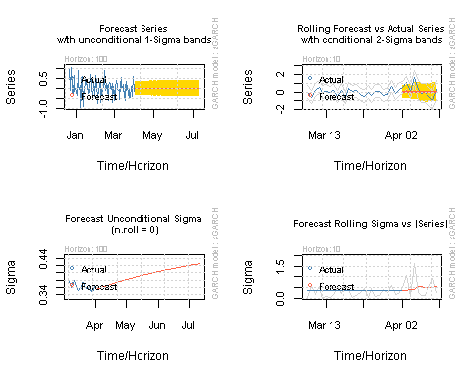

## Forecasting the rate

p.t_1 = 0.89365  
 R_t <- c(-0.0175020, 0.0238688, -0.0096144, 0.0164705, -0.0011654, 0.0137289, -0.0007232, 0.0116537, -0.0002277, 0.0098904, 0.0004323, 0.0081169, 0.0012552, 0.0063438, 0.0022094, 0.0045913, 0.0032507, 0.0028840, 0.0043354, 0.0012485, 0.0054215, -0.0002880, 0.0064697, -0.0016996, 0.0074436, -0.0029618, 0.0083107, -0.0040527, 0.0090426, -0.0049536, 0.0096160, -0.0056500, 0.0100124, -0.0061315, 0.0102191, -0.0063924, 0.0102285, -0.0064322, 0.0100390 , -0.0062551, 0.0096543, -0.0058704, 0.0090835 , -0.0052920, 0.0083405, -0.0045383, 0.0074438, -0.0036315, 0.0064158 , -0.0025972, 0.0052821, -0.0014637, 0.0040710, -0.0002614, 0.0028126, 0.0009780, 0.0015380, 0.0022224, 0.0002787 , 0.0034401, -0.0009348, 0.0046002, -0.0020729, 0.0056739, -0.0031084 , 0.0066347, -0.0040166, 0.0074593, -0.0047765 , 0.0081281, -0.0053708, 0.0086257, -0.0057864, 0.0089411, -0.0060148, 0.0090679, -0.0060524, 0.0090048, -0.0059001 ,  
0.0087549, -0.0055638, 0.0083263, -0.0050538, 0.0077313, -0.0043847, 0.0069864, -0.0035747, 0.0061115, -0.0026455,   
0.0051298, -0.0016218, 0.0040668, -0.0005299, 0.0029499, 0.0006020, 0.0018074, 0.0017452, 0.0006683, 0.0028710 ,   
-0.0004391  
  
  
  
  
  
  
)  
 p_t= 0  
 for (i in 1:100){  
 p_t = p.t_1 *((2.71828)^(R_t[i]/100))  
 print(p_t)  
 p.t_1=p_t  
 }

## [1] 0.8934936  
## [1] 0.8937069  
## [1] 0.893621  
## [1] 0.8937682  
## [1] 0.8937578  
## [1] 0.8938805  
## [1] 0.893874  
## [1] 0.8939782  
## [1] 0.8939761  
## [1] 0.8940646  
## [1] 0.8940684  
## [1] 0.894141  
## [1] 0.8941522  
## [1] 0.894209  
## [1] 0.8942287  
## [1] 0.8942698  
## [1] 0.8942988  
## [1] 0.8943246  
## [1] 0.8943634  
## [1] 0.8943746  
## [1] 0.8944231  
## [1] 0.8944205  
## [1] 0.8944784  
## [1] 0.8944632  
## [1] 0.8945297  
## [1] 0.8945032  
## [1] 0.8945776  
## [1] 0.8945413  
## [1] 0.8946222  
## [1] 0.8945779  
## [1] 0.8946639  
## [1] 0.8946134  
## [1] 0.894703  
## [1] 0.8946481  
## [1] 0.8947395  
## [1] 0.8946823  
## [1] 0.8947739  
## [1] 0.8947163  
## [1] 0.8948061  
## [1] 0.8947502  
## [1] 0.8948365  
## [1] 0.894784  
## [1] 0.8948653  
## [1] 0.8948179  
## [1] 0.8948926  
## [1] 0.894852  
## [1] 0.8949186  
## [1] 0.8948861  
## [1] 0.8949435  
## [1] 0.8949203  
## [1] 0.8949675  
## [1] 0.8949544  
## [1] 0.8949909  
## [1] 0.8949885  
## [1] 0.8950137  
## [1] 0.8950225  
## [1] 0.8950362  
## [1] 0.8950561  
## [1] 0.8950586  
## [1] 0.8950894  
## [1] 0.895081  
## [1] 0.8951222  
## [1] 0.8951036  
## [1] 0.8951544  
## [1] 0.8951266  
## [1] 0.895186  
## [1] 0.89515  
## [1] 0.8952168  
## [1] 0.8951741  
## [1] 0.8952468  
## [1] 0.8951987  
## [1] 0.895276  
## [1] 0.8952242  
## [1] 0.8953042  
## [1] 0.8952504  
## [1] 0.8953315  
## [1] 0.8952774  
## [1] 0.895358  
## [1] 0.8953052  
## [1] 0.8953835  
## [1] 0.8953337  
## [1] 0.8954083  
## [1] 0.895363  
## [1] 0.8954323  
## [1] 0.895393  
## [1] 0.8954555  
## [1] 0.8954235  
## [1] 0.8954783  
## [1] 0.8954546  
## [1] 0.8955005  
## [1] 0.895486  
## [1] 0.8955224  
## [1] 0.8955177  
## [1] 0.8955441  
## [1] 0.8955495  
## [1] 0.8955657  
## [1] 0.8955813  
## [1] 0.8955873  
## [1] 0.895613  
## [1] 0.895609