GARCH Model EUR And USD

Jane

28/04/2021

# Forcasting Exchange Rate Using GARCH Model for EUR And USD

## Reading EUR and USD Currency into r

library(readr)  
library(dplyr)

##   
## Attaching package: 'dplyr'

## The following objects are masked from 'package:stats':  
##   
## filter, lag

## The following objects are masked from 'package:base':  
##   
## intersect, setdiff, setequal, union

EURUSDGARCH<- read.csv ("EURUSD_Candlestick_1_D_BID_01.01.2000-31.12.2020.csv")%>%  
 select('GMT.TIME', CLOSE)%>%  
 rename(Date = ('GMT.TIME'), RateEURUSD = ("CLOSE"))  
  
   
head(EURUSDGARCH)

## Date RateEURUSD  
## 1 2000-01-03 1.0243  
## 2 2000-01-04 1.0295  
## 3 2000-01-05 1.0321  
## 4 2000-01-06 1.0324  
## 5 2000-01-07 1.0296  
## 6 2000-01-10 1.0253

## Conversion of Gmt time to date format

library(dplyr)  
library(lubridate)

##   
## Attaching package: 'lubridate'

## The following objects are masked from 'package:base':  
##   
## date, intersect, setdiff, union

EURUSDGARCH$Date <- lubridate::ymd(EURUSDGARCH$Date)  
head(EURUSDGARCH)

## Date RateEURUSD  
## 1 2000-01-03 1.0243  
## 2 2000-01-04 1.0295  
## 3 2000-01-05 1.0321  
## 4 2000-01-06 1.0324  
## 5 2000-01-07 1.0296  
## 6 2000-01-10 1.0253

##Checking for obvious errors or missingg value

#Checking for obvious errors  
which(is.na(EURUSDGARCH))

## integer(0)

##Converting the data set into time series object

#Converting the data set into time series object  
EURUSDGARCHTS<- ts(as.vector(EURUSDGARCH$Rate), frequency = 322, start= c(2000,01,03))  
plot.ts(EURUSDGARCHTS)  
title("Time Series plot of EURUSDTimeseries ", sub = "(2000-2020)",  
 cex.main = 1.5, font.main= 4, col.main= "blue",  
 cex.sub = 0.75, font.sub = 3, col.sub = "red")

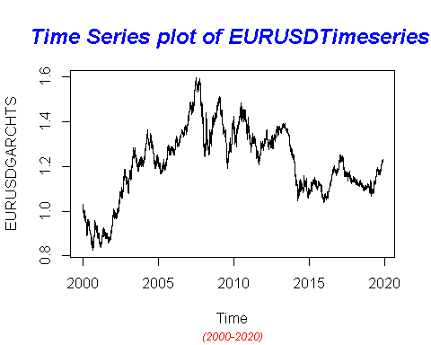

##Dealing with Conditional Heteroscedaticity:

DifflogEURUSDGarch= diff(log(EURUSDGARCHTS))*100  
plot(DifflogEURUSDGarch)  
title("Plot of returns of EURUSD", sub = "(2000-2020)",  
 cex.main = 1.5, font.main= 4, col.main= "blue",  
 cex.sub = 0.75, font.sub = 3, col.sub = "red")

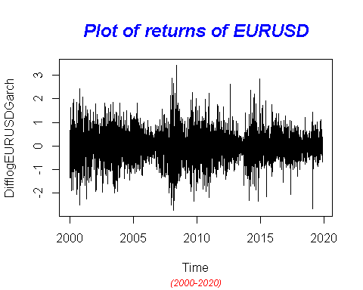

##nature as almost at all lags the p-values fall below the significance levels.

library(TSA)

## Warning: package 'TSA' was built under R version 4.0.5

##   
## Attaching package: 'TSA'

## The following object is masked from 'package:readr':  
##   
## spec

## The following objects are masked from 'package:stats':  
##   
## acf, arima

## The following object is masked from 'package:utils':  
##   
## tar

McLeod.Li.test(y= DifflogEURUSDGarch,main="McLeod-Li test statistics for Daily return series")

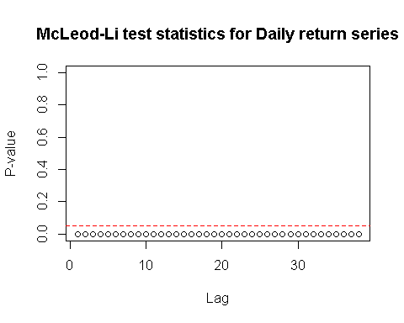

## In order to get an order of GARCH , we further transform the return series into absolute values and squared return values.

abs = abs(DifflogEURUSDGarch)  
sqr = DifflogEURUSDGarch^2

# GARCH Model specification:

par(mfrow=c(1,2))  
acf(abs, ci.type="ma",main=" ACF for abs. returns")  
pacf(abs, main=" PACF plot for abs.returns")

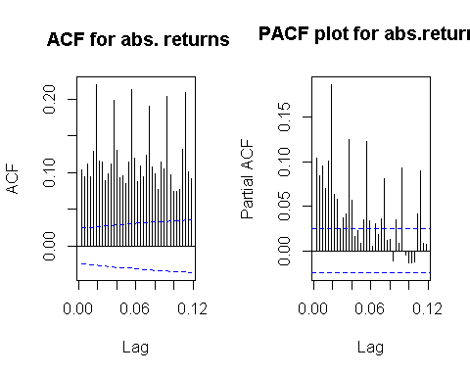

##From ACF and PACF we see many lags are significant. Hence, we plot EACF to get the candidate models

eacf(abs)

## AR/MA  
## 0 1 2 3 4 5 6 7 8 9 10 11 12 13  
## 0 x x x x x x x x x x x x x x   
## 1 x o o o o x x o o o o x o o   
## 2 x x o o o x x x o o o x o x   
## 3 x x x o o x x o o o o x o x   
## 4 x x x x o x x o o o o x o o   
## 5 x x x o x x x o o x x x x o   
## 6 x x o x x x o x x o o o o o   
## 7 x x x x o x x o o o o o o o

##From the squared returns ACF and PACF plot

par(mfrow=c(1,2))  
acf(sqr, ci.type="ma",main="ACF for sqr. return")  
pacf(sqr, main="PACF for sqr. return")

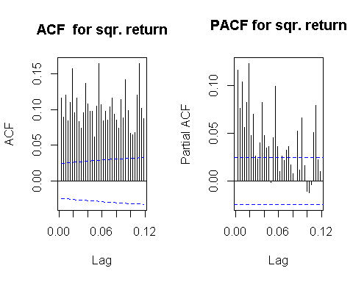

## 

eacf(sqr)

## AR/MA  
## 0 1 2 3 4 5 6 7 8 9 10 11 12 13  
## 0 x x x x x x x x x x x x x x   
## 1 x x x x o x x x o o o x o o   
## 2 x x o x o x o o o o o x o o   
## 3 x x x o o x o o o o o x o o   
## 4 x o x x o x x o o x o x x o   
## 5 x o x x x x o o o x o x o o   
## 6 x x o x x x o x x o o o o o   
## 7 x x x x x x x o o o o o o o

### With reference to the Dickey-Fuller Test, p-value is less than the 0.02 and we can reject the null hypothesis stating the non-stationarity. Hence , we can proceed further for model selection .

#MODEL ESTIMATION: ##GARCH (2,1): for GBP and USD Curruency Pair

# GARCH(2,1)  
library(tseries)

## Registered S3 method overwritten by 'quantmod':  
## method from  
## as.zoo.data.frame zoo

EURUSDGARCHFit.21 = garch(DifflogEURUSDGarch,order=c(2,1),trace =FALSE)  
summary(EURUSDGARCHFit.21)

##   
## Call:  
## garch(x = DifflogEURUSDGarch, order = c(2, 1), trace = FALSE)  
##   
## Model:  
## GARCH(2,1)  
##   
## Residuals:  
## Min 1Q Median 3Q Max   
## -6.630575 -0.538018 0.005751 0.567917 5.473891   
##   
## Coefficient(s):  
## Estimate Std. Error t value Pr(>|t|)   
## a0 7.595e-04 2.935e-04 2.588 0.00966 **  
## a1 2.838e-02 1.006e-02 2.822 0.00478 **  
## b1 9.694e-01 3.735e-01 2.595 0.00946 **  
## b2 1.402e-15 3.628e-01 0.000 1.00000   
## ---  
## Signif. codes: 0 '***' 0.001 '**' 0.01 '*' 0.05 '.' 0.1 ' ' 1  
##   
## Diagnostic Tests:  
## Jarque Bera Test  
##   
## data: Residuals  
## X-squared = 762.31, df = 2, p-value < 2.2e-16  
##   
##   
## Box-Ljung test  
##   
## data: Squared.Residuals  
## X-squared = 0.74626, df = 1, p-value = 0.3877

## GARCH (2,2):

##This model can be interpreted as an overfit model of GARCH(2,1) and p values from residual tests confirms that residuals ahas a low correlated. Thus this model is may consider to be a good fit.

EURUSDGARCHFit.22 = garch(DifflogEURUSDGarch, order =c(2,2),trace =FALSE)

## Warning in garch(DifflogEURUSDGarch, order = c(2, 2), trace = FALSE): singular  
## information

summary(EURUSDGARCHFit.22)

##   
## Call:  
## garch(x = DifflogEURUSDGarch, order = c(2, 2), trace = FALSE)  
##   
## Model:  
## GARCH(2,2)  
##   
## Residuals:  
## Min 1Q Median 3Q Max   
## -6.609518 -0.537467 0.005758 0.567738 5.518265   
##   
## Coefficient(s):  
## Estimate Std. Error t value Pr(>|t|)  
## a0 7.897e-04 NA NA NA  
## a1 1.160e-02 NA NA NA  
## a2 1.778e-02 NA NA NA  
## b1 9.683e-01 NA NA NA  
## b2 4.602e-14 NA NA NA  
##   
## Diagnostic Tests:  
## Jarque Bera Test  
##   
## data: Residuals  
## X-squared = 764.36, df = 2, p-value < 2.2e-16  
##   
##   
## Box-Ljung test  
##   
## data: Squared.Residuals  
## X-squared = 0.017615, df = 1, p-value = 0.8944

##GARCH (3,1): ##This model can be interpreted as an overfit model of GARCH(2,1) and GARCH (2,2). This model may not be consider to be a good fit.

EURUSDGARCHFit.31 = garch(DifflogEURUSDGarch,order=c(3,1),trace =FALSE)  
summary(EURUSDGARCHFit.31)

##   
## Call:  
## garch(x = DifflogEURUSDGarch, order = c(3, 1), trace = FALSE)  
##   
## Model:  
## GARCH(3,1)  
##   
## Residuals:  
## Min 1Q Median 3Q Max   
## -6.580383 -0.536264 0.005715 0.567671 5.527041   
##   
## Coefficient(s):  
## Estimate Std. Error t value Pr(>|t|)   
## a0 1.294e-03 3.622e-04 3.572 0.000355 ***  
## a1 4.631e-02 1.099e-02 4.214 2.51e-05 ***  
## b1 4.464e-01 1.901e-01 2.348 0.018876 *   
## b2 5.037e-01 2.207e-01 2.283 0.022457 *   
## b3 1.316e-05 2.383e-01 0.000 0.999956   
## ---  
## Signif. codes: 0 '***' 0.001 '**' 0.01 '*' 0.05 '.' 0.1 ' ' 1  
##   
## Diagnostic Tests:  
## Jarque Bera Test  
##   
## data: Residuals  
## X-squared = 763.98, df = 2, p-value < 2.2e-16  
##   
##   
## Box-Ljung test  
##   
## data: Squared.Residuals  
## X-squared = 3.3141, df = 1, p-value = 0.06869

##GARCH (1,1): ##This model can be interpreted as an overfitting model and p values from residual tests confirms that residuals are lowly correlated. Thus this model is may consider to be a good fit.

# GARCH(1,1)

EURUSDGARCHFit.11 = garch(DifflogEURUSDGarch,order=c(1,1),trace =FALSE)  
summary(EURUSDGARCHFit.11)

##   
## Call:  
## garch(x = DifflogEURUSDGarch, order = c(1, 1), trace = FALSE)  
##   
## Model:  
## GARCH(1,1)  
##   
## Residuals:  
## Min 1Q Median 3Q Max   
## -6.608767 -0.537781 0.005831 0.567735 5.472496   
##   
## Coefficient(s):  
## Estimate Std. Error t value Pr(>|t|)   
## a0 0.0007904 0.0001138 6.947 3.72e-12 ***  
## a1 0.0287754 0.0019710 14.599 < 2e-16 ***  
## b1 0.9688757 0.0019889 487.151 < 2e-16 ***  
## ---  
## Signif. codes: 0 '***' 0.001 '**' 0.01 '*' 0.05 '.' 0.1 ' ' 1  
##   
## Diagnostic Tests:  
## Jarque Bera Test  
##   
## data: Residuals  
## X-squared = 759.26, df = 2, p-value < 2.2e-16  
##   
##   
## Box-Ljung test  
##   
## data: Squared.Residuals  
## X-squared = 0.79616, df = 1, p-value = 0.3722

## GARCH (3,3):

This model can be interpreted as an overfitting model and p values from residual tests confirms that residuals are lowly correlated. Thus, this model is may consider to be a good fit.

# GARCH(3,3)

EURUSDGARCHFit.33 = garch(DifflogEURUSDGarch,order=c(3,3),trace =FALSE)  
summary(EURUSDGARCHFit.33)

##   
## Call:  
## garch(x = DifflogEURUSDGarch, order = c(3, 3), trace = FALSE)  
##   
## Model:  
## GARCH(3,3)  
##   
## Residuals:  
## Min 1Q Median 3Q Max   
## -6.743809 -0.544253 0.005759 0.568081 5.668121   
##   
## Coefficient(s):  
## Estimate Std. Error t value Pr(>|t|)   
## a0 2.674e-03 3.595e-04 7.437 1.03e-13 ***  
## a1 3.142e-02 7.069e-03 4.445 8.80e-06 ***  
## a2 1.001e-02 5.259e-03 1.903 0.0571 .   
## a3 4.712e-02 7.183e-03 6.560 5.39e-11 ***  
## b1 6.027e-15 6.285e-02 0.000 1.0000   
## b2 9.945e-02 4.830e-02 2.059 0.0395 *   
## b3 8.037e-01 5.328e-02 15.084 < 2e-16 ***  
## ---  
## Signif. codes: 0 '***' 0.001 '**' 0.01 '*' 0.05 '.' 0.1 ' ' 1  
##   
## Diagnostic Tests:  
## Jarque Bera Test  
##   
## data: Residuals  
## X-squared = 811.37, df = 2, p-value < 2.2e-16  
##   
##   
## Box-Ljung test  
##   
## data: Squared.Residuals  
## X-squared = 1.162, df = 1, p-value = 0.281

##GARCH (4,2): ##This model can be interpreted as an overfitting model and p values from residual tests confirms that residuals are lowly correlated. Thus, this model is may considered to be a good fit.

EURUSDGARCHFit.42 = garch(DifflogEURUSDGarch,order=c(4,2),trace =FALSE)  
summary(EURUSDGARCHFit.42)

##   
## Call:  
## garch(x = DifflogEURUSDGarch, order = c(4, 2), trace = FALSE)  
##   
## Model:  
## GARCH(4,2)  
##   
## Residuals:  
## Min 1Q Median 3Q Max   
## -6.611767 -0.535213 0.005769 0.567766 5.486081   
##   
## Coefficient(s):  
## Estimate Std. Error t value Pr(>|t|)   
## a0 2.180e-03 3.996e-04 5.455 4.89e-08 ***  
## a1 3.426e-02 8.302e-03 4.127 3.68e-05 ***  
## a2 4.464e-02 8.554e-03 5.218 1.80e-07 ***  
## b1 1.714e-01 2.096e-01 0.818 0.4136   
## b2 2.000e-01 2.497e-01 0.801 0.4232   
## b3 4.612e-15 2.401e-01 0.000 1.0000   
## b4 5.432e-01 1.749e-01 3.106 0.0019 **   
## ---  
## Signif. codes: 0 '***' 0.001 '**' 0.01 '*' 0.05 '.' 0.1 ' ' 1  
##   
## Diagnostic Tests:  
## Jarque Bera Test  
##   
## data: Residuals  
## X-squared = 722.6, df = 2, p-value < 2.2e-16  
##   
##   
## Box-Ljung test  
##   
## data: Squared.Residuals  
## X-squared = 1.224, df = 1, p-value = 0.2686

##

EURUSDGARCHFit.41 = garch(DifflogEURUSDGarch,order=c(4,1),trace =FALSE)  
summary(EURUSDGARCHFit.41)

##   
## Call:  
## garch(x = DifflogEURUSDGarch, order = c(4, 1), trace = FALSE)  
##   
## Model:  
## GARCH(4,1)  
##   
## Residuals:  
## Min 1Q Median 3Q Max   
## -6.596524 -0.539787 0.005706 0.568154 5.450753   
##   
## Coefficient(s):  
## Estimate Std. Error t value Pr(>|t|)   
## a0 1.384e-03 3.568e-04 3.879 0.000105 ***  
## a1 4.913e-02 1.104e-02 4.450 8.6e-06 ***  
## b1 3.485e-01 1.690e-01 2.063 0.039152 *   
## b2 4.094e-01 2.123e-01 1.928 0.053844 .   
## b3 1.887e-01 2.516e-01 0.750 0.453159   
## b4 1.374e-16 2.001e-01 0.000 1.000000   
## ---  
## Signif. codes: 0 '***' 0.001 '**' 0.01 '*' 0.05 '.' 0.1 ' ' 1  
##   
## Diagnostic Tests:  
## Jarque Bera Test  
##   
## data: Residuals  
## X-squared = 761.49, df = 2, p-value < 2.2e-16  
##   
##   
## Box-Ljung test  
##   
## data: Squared.Residuals  
## X-squared = 3.4738, df = 1, p-value = 0.06235

# Model Selection:

##Best possible model is selected by AIC scores of the models. From the below sort function, GARCH(1,1) would be the best model for the return series. From the p-value, 3.1 also has the lowest correlation

library(dLagM)

## Warning: package 'dLagM' was built under R version 4.0.5

## Loading required package: nardl

## Warning: package 'nardl' was built under R version 4.0.5

## Loading required package: dynlm

## Loading required package: zoo

##   
## Attaching package: 'zoo'

## The following objects are masked from 'package:base':  
##   
## as.Date, as.Date.numeric

GARCHModelSelectionEURUSD = AIC(EURUSDGARCHFit.21,EURUSDGARCHFit.22 ,EURUSDGARCHFit.31,EURUSDGARCHFit.11,EURUSDGARCHFit.33, EURUSDGARCHFit.42, EURUSDGARCHFit.41)  
sortScore(GARCHModelSelectionEURUSD, score ="aic")

## df AIC  
## EURUSDGARCHFit.33 7 9807.682  
## EURUSDGARCHFit.11 3 9827.020  
## EURUSDGARCHFit.21 4 9828.115  
## EURUSDGARCHFit.22 5 9828.458  
## EURUSDGARCHFit.31 5 9831.402  
## EURUSDGARCHFit.41 6 9834.134  
## EURUSDGARCHFit.42 7 9834.283

# Model Fitting:

library(rugarch)

## Warning: package 'rugarch' was built under R version 4.0.5

## Loading required package: parallel

##   
## Attaching package: 'rugarch'

## The following object is masked from 'package:stats':  
##   
## sigma

EURUSDmodel1.1<-ugarchspec(variance.model = list(model = "sGARCH", garchOrder = c(1,1)),   
 mean.model = list(armaOrder = c(5,6), include.mean = TRUE),   
 distribution.model = "norm")  
   
EURUSDgarchMODEL1.1<-ugarchfit(spec=EURUSDmodel1.1,data=DifflogEURUSDGarch, out.sample = 100)

## Warning in arima(data, order = c(modelinc[2], 0, modelinc[3]), include.mean =  
## modelinc[1], : possible convergence problem: optim gave code = 1

plot(EURUSDgarchMODEL1.1,which="all")

##   
## please wait...calculating quantiles...

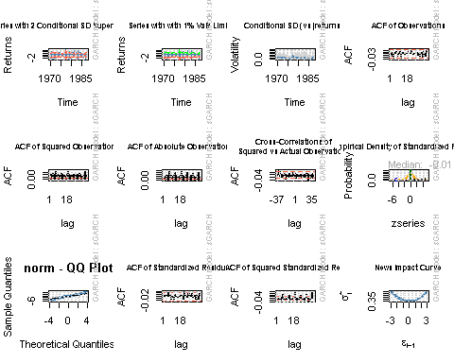

##Model Diagnostics

EURUSDgarchMODEL1.1

##   
## *---------------------------------*  
## * GARCH Model Fit *  
## *---------------------------------*  
##   
## Conditional Variance Dynamics   
## -----------------------------------  
## GARCH Model : sGARCH(1,1)  
## Mean Model : ARFIMA(5,0,6)  
## Distribution : norm   
##   
## Optimal Parameters  
## ------------------------------------  
## Estimate Std. Error t value Pr(>|t|)  
## mu 0.005205 0.006058 8.5917e-01 0.390244  
## ar1 0.670821 0.009399 7.1372e+01 0.000000  
## ar2 0.043750 0.011547 3.7889e+00 0.000151  
## ar3 0.529323 0.009267 5.7122e+01 0.000000  
## ar4 0.407685 0.011822 3.4485e+01 0.000000  
## ar5 -0.670440 0.009205 -7.2836e+01 0.000000  
## ma1 -0.692520 0.000038 -1.8437e+04 0.000000  
## ma2 -0.013650 0.003467 -3.9373e+00 0.000082  
## ma3 -0.559306 0.000030 -1.8592e+04 0.000000  
## ma4 -0.391693 0.000018 -2.2345e+04 0.000000  
## ma5 0.670544 0.000040 1.6612e+04 0.000000  
## ma6 0.005863 0.003589 1.6339e+00 0.102273  
## omega 0.000803 0.000186 4.3104e+00 0.000016  
## alpha1 0.028952 0.001178 2.4587e+01 0.000000  
## beta1 0.968714 0.000749 1.2931e+03 0.000000  
##   
## Robust Standard Errors:  
## Estimate Std. Error t value Pr(>|t|)  
## mu 0.005205 0.006251 8.3275e-01 0.404988  
## ar1 0.670821 0.009841 6.8166e+01 0.000000  
## ar2 0.043750 0.010589 4.1315e+00 0.000036  
## ar3 0.529323 0.008485 6.2383e+01 0.000000  
## ar4 0.407685 0.011063 3.6850e+01 0.000000  
## ar5 -0.670440 0.008411 -7.9709e+01 0.000000  
## ma1 -0.692520 0.000006 -1.0928e+05 0.000000  
## ma2 -0.013650 0.001864 -7.3241e+00 0.000000  
## ma3 -0.559306 0.000013 -4.2427e+04 0.000000  
## ma4 -0.391693 0.000020 -1.9763e+04 0.000000  
## ma5 0.670544 0.000008 8.0111e+04 0.000000  
## ma6 0.005863 0.001940 3.0217e+00 0.002514  
## omega 0.000803 0.000351 2.2875e+00 0.022168  
## alpha1 0.028952 0.001549 1.8693e+01 0.000000  
## beta1 0.968714 0.000328 2.9502e+03 0.000000  
##   
## LogLikelihood : -4861.779   
##   
## Information Criteria  
## ------------------------------------  
##   
## Akaike 1.5482  
## Bayes 1.5643  
## Shibata 1.5482  
## Hannan-Quinn 1.5537  
##   
## Weighted Ljung-Box Test on Standardized Residuals  
## ------------------------------------  
## statistic p-value  
## Lag[1] 0.363 0.5468  
## Lag[2*(p+q)+(p+q)-1][32] 11.086 1.0000  
## Lag[4*(p+q)+(p+q)-1][54] 21.030 0.9620  
## d.o.f=11  
## H0 : No serial correlation  
##   
## Weighted Ljung-Box Test on Standardized Squared Residuals  
## ------------------------------------  
## statistic p-value  
## Lag[1] 0.509 0.475560  
## Lag[2*(p+q)+(p+q)-1][5] 5.420 0.122754  
## Lag[4*(p+q)+(p+q)-1][9] 14.609 0.004445  
## d.o.f=2  
##   
## Weighted ARCH LM Tests  
## ------------------------------------  
## Statistic Shape Scale P-Value  
## ARCH Lag[3] 0.5826 0.500 2.000 0.445286  
## ARCH Lag[5] 2.9915 1.440 1.667 0.291018  
## ARCH Lag[7] 12.7046 2.315 1.543 0.004201  
##   
## Nyblom stability test  
## ------------------------------------  
## Joint Statistic: 2.8126  
## Individual Statistics:   
## mu 0.25390  
## ar1 0.03996  
## ar2 0.04905  
## ar3 0.05012  
## ar4 0.04546  
## ar5 0.02373  
## ma1 0.03700  
## ma2 0.07893  
## ma3 0.06531  
## ma4 0.03535  
## ma5 0.02948  
## ma6 0.06502  
## omega 0.09434  
## alpha1 0.14927  
## beta1 0.17793  
##   
## Asymptotic Critical Values (10% 5% 1%)  
## Joint Statistic: 3.26 3.54 4.07  
## Individual Statistic: 0.35 0.47 0.75  
##   
## Sign Bias Test  
## ------------------------------------  
## t-value prob sig  
## Sign Bias 0.9273 0.3538   
## Negative Sign Bias 0.1113 0.9114   
## Positive Sign Bias 0.8253 0.4092   
## Joint Effect 4.7340 0.1923   
##   
##   
## Adjusted Pearson Goodness-of-Fit Test:  
## ------------------------------------  
## group statistic p-value(g-1)  
## 1 20 333.8 2.218e-59  
## 2 30 356.9 3.756e-58  
## 3 40 359.6 1.670e-53  
## 4 50 379.4 1.295e-52  
##   
##   
## Elapsed time : 2.859749

## Forecasting

forcgarchEURUSD= ugarchforecast(EURUSDgarchMODEL1.1, data = DiffEURUSDLogTran, n.ahead = 100)  
print(forcgarchEURUSD)

##   
## *------------------------------------*  
## * GARCH Model Forecast *  
## *------------------------------------*  
## Model: sGARCH  
## Horizon: 100  
## Roll Steps: 0  
## Out of Sample: 100  
##   
## 0-roll forecast [T0=1987-04-02 03:00:00]:  
## Series Sigma  
## T+1 -0.0275978 0.4187  
## T+2 0.0361291 0.4192  
## T+3 0.0437004 0.4196  
## T+4 -0.0135389 0.4201  
## T+5 -0.0097401 0.4206  
## T+6 0.0491042 0.4210  
## T+7 0.0190393 0.4215  
## T+8 -0.0249553 0.4219  
## T+9 0.0152887 0.4224  
## T+10 0.0458895 0.4229  
## T+11 -0.0068181 0.4233  
## T+12 -0.0173138 0.4238  
## T+13 0.0354398 0.4242  
## T+14 0.0279638 0.4247  
## T+15 -0.0223030 0.4251  
## T+16 0.0026319 0.4256  
## T+17 0.0417460 0.4260  
## T+18 0.0040521 0.4265  
## T+19 -0.0218048 0.4269  
## T+20 0.0237713 0.4273  
## T+21 0.0324900 0.4278  
## T+22 -0.0149448 0.4282  
## T+23 -0.0075291 0.4287  
## T+24 0.0359013 0.4291  
## T+25 0.0132500 0.4295  
## T+26 -0.0213035 0.4300  
## T+27 0.0123405 0.4304  
## T+28 0.0341422 0.4308  
## T+29 -0.0064029 0.4313  
## T+30 -0.0137396 0.4317  
## T+31 0.0279872 0.4321  
## T+32 0.0205280 0.4325  
## T+33 -0.0176802 0.4330  
## T+34 0.0026417 0.4334  
## T+35 0.0325842 0.4338  
## T+36 0.0023186 0.4342  
## T+37 -0.0164933 0.4346  
## T+38 0.0193136 0.4351  
## T+39 0.0250729 0.4355  
## T+40 -0.0118682 0.4359  
## T+41 -0.0048218 0.4363  
## T+42 0.0285477 0.4367  
## T+43 0.0100287 0.4371  
## T+44 -0.0161260 0.4375  
## T+45 0.0108214 0.4379  
## T+46 0.0268314 0.4383  
## T+47 -0.0050161 0.4387  
## T+48 -0.0096628 0.4391  
## T+49 0.0228224 0.4395  
## T+50 0.0160137 0.4399  
## T+51 -0.0133096 0.4403  
## T+52 0.0033744 0.4407  
## T+53 0.0260387 0.4411  
## T+54 0.0018955 0.4415  
## T+55 -0.0118673 0.4419  
## T+56 0.0163022 0.4423  
## T+57 0.0198713 0.4427  
## T+58 -0.0088247 0.4431  
## T+59 -0.0024321 0.4435  
## T+60 0.0232014 0.4439  
## T+61 0.0080563 0.4443  
## T+62 -0.0116901 0.4446  
## T+63 0.0098147 0.4450  
## T+64 0.0215244 0.4454  
## T+65 -0.0034920 0.4458  
## T+66 -0.0062746 0.4462  
## T+67 0.0189684 0.4466  
## T+68 0.0128947 0.4469  
## T+69 -0.0095976 0.4473  
## T+70 0.0040475 0.4477  
## T+71 0.0211588 0.4481  
## T+72 0.0019286 0.4484  
## T+73 -0.0080979 0.4488  
## T+74 0.0140349 0.4492  
## T+75 0.0160921 0.4495  
## T+76 -0.0061787 0.4499  
## T+77 -0.0005080 0.4503  
## T+78 0.0191560 0.4506  
## T+79 0.0068066 0.4510  
## T+80 -0.0080744 0.4514  
## T+81 0.0090546 0.4517  
## T+82 0.0175720 0.4521  
## T+83 -0.0020600 0.4525  
## T+84 -0.0035774 0.4528  
## T+85 0.0160143 0.4532  
## T+86 0.0106873 0.4535  
## T+87 -0.0065463 0.4539  
## T+88 0.0045738 0.4542  
## T+89 0.0174642 0.4546  
## T+90 0.0021690 0.4549  
## T+91 -0.0050958 0.4553  
## T+92 0.0122724 0.4557  
## T+93 0.0133094 0.4560  
## T+94 -0.0039585 0.4563  
## T+95 0.0009895 0.4567  
## T+96 0.0160534 0.4570  
## T+97 0.0060132 0.4574  
## T+98 -0.0051789 0.4577  
## T+99 0.0084419 0.4581  
## T+100 0.0145989 0.4584

## Forecasting the rate

p.t_1 = 1.22141  
 R_t <- c( -0.0275978, 0.0361291, 0.0437004, -0.0135389, -0.0097401, 0.0491042, 0.0190393, -0.0249553, 0.0152887,  
0.0458895, -0.0068181, -0.0173138, 0.0354398, 0.0279638, -0.0223030, 0.0026319, 0.0417460, 0.0040521, -0.0218048 ,   
0.0237713, 0.0324900, -0.0149448, -0.0075291, 0.0359013, 0.0132500, -0.0213035, 0.0123405, 0.0341422, -0.0064029, -0.0137396, 0.0279872, 0.0205280, -0.0176802, 0.0026417, 0.0325842, 0.0023186, -0.0164933, 0.0193136, 0.0250729, -0.0118682, -0.0048218, 0.0285477, 0.0100287, -0.0161260, 0.0108214, 0.0268314, -0.0050161, -0.0096628, 0.0228224,   
0.0160137, -0.0133096, 0.0033744, 0.0260387, 0.0018955, -0.0118673, 0.0163022, 0.0198713, -0.0088247, -0.0024321,   
0.0232014, 0.0080563, -0.0116901, 0.0098147, 0.0215244, -0.0034920, -0.0062746, 0.0189684, 0.0128947, -0.0095976,  
0.0040475, 0.0211588, 0.0019286, -0.0080979, 0.0140349, 0.0160921, -0.0061787, -0.0005080, 0.0191560, 0.0068066 ,   
-0.0080744, 0.0090546, 0.0175720, -0.0020600, -0.0035774, 0.0160143, 0.0106873, -0.0065463, 0.0045738, 0.0174642,  
0.0021690, -0.0050958, 0.0122724, 0.0133094, -0.0039585, 0.0009895, 0.0160534, 0.0060132, -0.0051789,   
0.0084419, 0.0145989   
  
  
  
  
  
  
  
)  
 p_t= 0  
 for (i in 1:100){  
 p_t = p.t_1 *((2.71828)^(R_t[i]/100))  
 print(p_t)  
 p.t_1=p_t  
 }

## [1] 1.221073  
## [1] 1.221514  
## [1] 1.222048  
## [1] 1.221883  
## [1] 1.221764  
## [1] 1.222364  
## [1] 1.222597  
## [1] 1.222291  
## [1] 1.222478  
## [1] 1.223039  
## [1] 1.222956  
## [1] 1.222744  
## [1] 1.223178  
## [1] 1.22352  
## [1] 1.223247  
## [1] 1.223279  
## [1] 1.22379  
## [1] 1.22384  
## [1] 1.223573  
## [1] 1.223864  
## [1] 1.224261  
## [1] 1.224078  
## [1] 1.223986  
## [1] 1.224426  
## [1] 1.224588  
## [1] 1.224327  
## [1] 1.224478  
## [1] 1.224896  
## [1] 1.224818  
## [1] 1.22465  
## [1] 1.224992  
## [1] 1.225244  
## [1] 1.225027  
## [1] 1.22506  
## [1] 1.225459  
## [1] 1.225487  
## [1] 1.225285  
## [1] 1.225522  
## [1] 1.225829  
## [1] 1.225684  
## [1] 1.225625  
## [1] 1.225975  
## [1] 1.226098  
## [1] 1.2259  
## [1] 1.226033  
## [1] 1.226362  
## [1] 1.2263  
## [1] 1.226182  
## [1] 1.226461  
## [1] 1.226658  
## [1] 1.226495  
## [1] 1.226536  
## [1] 1.226855  
## [1] 1.226879  
## [1] 1.226733  
## [1] 1.226933  
## [1] 1.227177  
## [1] 1.227069  
## [1] 1.227039  
## [1] 1.227323  
## [1] 1.227422  
## [1] 1.227279  
## [1] 1.227399  
## [1] 1.227664  
## [1] 1.227621  
## [1] 1.227544  
## [1] 1.227776  
## [1] 1.227935  
## [1] 1.227817  
## [1] 1.227867  
## [1] 1.228127  
## [1] 1.22815  
## [1] 1.228051  
## [1] 1.228223  
## [1] 1.228421  
## [1] 1.228345  
## [1] 1.228339  
## [1] 1.228574  
## [1] 1.228658  
## [1] 1.228558  
## [1] 1.22867  
## [1] 1.228886  
## [1] 1.22886  
## [1] 1.228816  
## [1] 1.229013  
## [1] 1.229144  
## [1] 1.229064  
## [1] 1.22912  
## [1] 1.229335  
## [1] 1.229362  
## [1] 1.229299  
## [1] 1.22945  
## [1] 1.229613  
## [1] 1.229565  
## [1] 1.229577  
## [1] 1.229774  
## [1] 1.229848  
## [1] 1.229785  
## [1] 1.229888  
## [1] 1.230068