Caffeine Consumption
The Patterns, Motivations, and Effects Across Different Demographics

Jane Okon-Jeffrey
College of Science and Technology, University of Houston-Downtown
STAT 6312 Biostatistics
Asst. Professor Kendra Mhoon
June 25, 2024

Abstract
Caffeine is probably the most frequently ingested active substance in the world. It is found in common beverages (coffee, tea, soft drinks), in products containing cocoa or chocolate, and in medications. Because of its wide consumption at different levels by most segments of the population, the public and the scientific community have expressed interest in the potential for caffeine to produce adverse effects on human health. The possibility that caffeine intake probably affects human health was investigated based on reviews of published human studies obtained through comprehensive literature research, investigating these aspects, can provide insights into how caffeine consumption intersects with daily life, health outcomes, and cultural practices. In conclusion, the analysis revealed that gender and age significant influence on the reasons for consuming caffeine and the overall trends and specific motivations, the perceived importance and impact of caffeine.
Keywords: Caffeine Consumption, Prevalence and Incidence, sleep impact, Bayes’ theorem, data visualization

Introduction
Caffeine consumption is common, bearing in mind the influence of caffeine on human health due to its wide utilization, assuming to be a treatment, it exposes the significance of figuring out the trait of consuming caffeine and its outcome. This is due to the presence of caffeine in various beverages such as coffee, energy drinks, tea, soda, and hot chocolate containing 2% caffeine. This study aims to investigate the caffeine consumption habits among different demographic groups which is focused on regular beverage choices, daily caffeine intake, reasons for caffeine consumption, and the importance and effects of caffeine on daily life.
Literature Review
Caffeine is widely preferred among the general populace, believed to enhance performance and well-being. This is because caffeine is a central nervous system (CNS) stimulant that fuels activeness and advances human performances and general wellness. Research has exposed the impact of moderate intake of caffeine in enhancing cognitive behaviors and physical activities. However, unnecessary consumption may result in adverse health outcomes like sleep disorders, anxiety, and other cardiovascular problems. (Smith, 2002; Fredholm et al., 1999). Moreover, there is a notable difference in the influences of caffeine and its pattern of consumption among various categories of the population, such as gender, age group, and sociocultural inclination.
More caffeine consumption is noted among young adults due to academic and social pressures, whereby usage by older adults may be perceived to enhance health benefits (Landolt et al., 2004). Based on gender, women are reportingly more sensitive to caffeine's effects compared to men (Temple et al., 2017).
Hypothesis
This research aims to evaluate the following hypotheses:
- Hypothesis 1: There are differences in daily caffeine intake across different age groups.
- Hypothesis 2: Gender difference is the main reason for taking caffeine; males use it for better performance while females use it socially.
- Hypothesis 3: The time-of-day people prefer taking caffeine impacts activeness and sleep.
These hypotheses will help us understand the behavior of caffeine intake and its consequences on different demography. This research is crucial as it helps in understanding the implications of caffeine use, which can be used for direct public health advice and personal habits.
In conclusion, this project aims to investigate personal intake patterns in coffee; focused on demographic factors like age and gender affecting such practices along with their perception towards everyday life aspects including sleep. It is expected that these results will add more depth to the already extensive body of literature on Caffeine Consumption Patterns thereby informing future investigations and health guidelines.
Research Methods
Data Collection
The process of gathering this data was to get a full understanding of caffeine consumption patterns in diverse groups. It consists of a variety of questions related to caffeine consumption, including beverage choices, frequency of consumption, daily caffeine intake, reasons for caffeine use, preferred times for consumption, and perceived importance and effects of caffeine on sleep.
Please note that the questions used for the survey were shortened for this analysis.
Data Collection Process
The steps taken were:
- Survey Design: The survey questionnaire was created, including several questions to gather in-depth perspectives on people's coffee intake behaviors. The questions were easy to understand, ensuring high response rates and accurate data. Demographic information such as age and sex were collected for easier subgroup analysis.
- Sample Selection: A simple sampling method was used to recruit participants of different ages and genders. In total, 25 people participated, aiming for diversity in caffeine habits to get a broad view of consumption patterns.
- Data Collection: Participants were invited to complete the survey online via Google Forms. The survey was distributed via email, and text to close family and friends. Participants were informed about the reason for the research, and they were guaranteed that their responses would remain anonymous.
- Data Input and Management: Completed surveys were collected and entered for further analysis. Data entry was performed to ensure accuracy and cross-checking original survey forms to avoid any discrepancies.

Plan Analysis
The analysis plan was designed to address the research hypotheses and provide insights into the patterns and effects of caffeine consumption. The following statistical methods and tools were employed, as outlined in "Essentials of Biostatistics in Public Health" by Sullivan:
- Descriptive Statistics:
  - Descriptive statistics were used to estimate the population based on data observed in the sample and the overall patterns of caffeine consumption.
  - Frequencies and percentages were recorded for nominal variables (e.g., reasons for caffeine consumption).
- Prevalence and Incidence:
  - Prevalence of caffeine consumption was determined by calculating the proportion of participants who consume caffeine.
  - Incidence rates were calculated to reflect the likelihood of high caffeine intake among the group of participants.
- Probability Models and Conditional Probability:
  - Probability models were used to predict caffeine consumption patterns based on demographic variables.
  - Conditional probability and Bayes' theorem were applied to understand the likelihood of caffeine consumption given certain demographic characteristics.
- Data Visualization:
Bar charts and pie charts were created to visualize the data for easier interpretation of the findings and identifying the trends.
Research Context
The research is in the context of public health and biostatistics, focusing on the behavior of caffeine consumption. Caffeine is one of the most widely consumed psychoactive substances worldwide, and its effects on daily functioning are very important to public health researchers and practitioners. By evaluating caffeine consumption patterns across different demographic groups, this study aims to understand how lifestyle choices can inform public health strategies to promote healthier behaviors.
Results
Overview
The survey had 25 participants across various age groups and genders, providing a comprehensive dataset on caffeine consumption patterns. The results are presented in two main sections: descriptive statistics and comparative analysis. Tables and figures are used to present the data clearly and effectively.
Descriptive Statistics
Prevalence and Incidence
Prevalence of Caffeine Consumption
Prevalence refers to the proportion of participants who have a particular characteristic at a particular point in time. In this study, the prevalence of caffeine consumption is calculated as follows:
$$Prevalence=\frac{Number of caffeine consumers}{Total number of participants}*100$$
$$Prevalence=\frac{18}{25}*100=72\%$$
$$Incidence=\frac{Number of new high intake cases}{Total number of participants}*100$$
$$Incidence=\frac{1}{25}*100=4\%$$
Analysis
Prevalence and Incidence: The prevalence of caffeine consumption in the sample is 72%, with an incidence of high daily caffeine intake at 4%.
Comparing Caffeine Consumption Between Groups
To compare caffeine consumption between different age and gender groups, comparative statistics was used.
Table 1. Caffeine Consumption by Age Group
Age Group | No. of Participants | Caffeine Consumers | Prevalence
0-10 | 3 | 2 | 66.7%
11-20 | 3 | 0 | 0%
31-40 | 6 | 6 | 100%
41-50 | 11 | 9 | 81.8%
51 and above | 2 | 1 | 50%

Table 2. Caffeine Consumption by Gender
Sex | No. of Participants | Caffeine Consumers | Prevalence
Female | 15 | 12 | 80%
Male | 10 | 5 | 50%

Analysis:
Comparative Analysis: There are differences in caffeine consumption prevalence across age and gender groups, with the highest prevalence among those aged 31-40 and females.
Conditional Probability and Independence (Unconditional Probability)
Conditional probability evaluates the probability of an event occurring given that another event has occurred. Here, we examine the conditional probability of experiencing significant sleep effects given daily caffeine consumption.
Table 3. Sleep Impact by Daily Caffeine Consumption
Daily Caffeine consumption | Significant sleep impact | Total
No | 0 | 6
Yes | 2 | 19
Total | 2 | 25
P (Significant sleep impact| Daily Caffeine consumption)
$$=\frac{Number of Significant Sleep Impact and Daily Consumption}{P(Total of Daily Consumption)}$$
$$=\frac{2}{19}=0.105$$

The probability of significant sleep effects given daily caffeine consumption is relatively low (10.5%).
To check for independence between gender and caffeine consumption:
Table 5. Gender and Caffeine Consumption
Sex | Caffeine Consumers | Not a Caffeine Consumers | Total
Female | 12 | 3 | 15
Male | 6 | 4 | 10
Total | 18 | 7 | 25
If P (Caffeine Consumer | Sex) = P (Caffeine Consumer) then caffeine consumption is independent of gender.
$$P\left(Caffeine Consumer | Female\right)=\frac{12}{15}=0.8$$
$$P(Caffeine Consumer)=\frac{18}{25}=0.72$$
If P (Caffeine Consumer | Female) ≠ P (Caffeine Consumer)
$$P\left(Caffeine Consumer | Male\right)=\frac{6}{10}=0.6$$
$$P(Caffeine Consumer)=\frac{18}{25}=0.72$$
If P (Caffeine Consumer | Sex) ≠ P (Caffeine Consumer) therefore caffeine consumption is not independent of gender.
Bayes' Theorem
Using Bayes' Theorem, we calculate the probability of being a daily caffeine consumer given significant sleep effects.
$$P(Daily Caffeine consumer| Significant sleep impact)$$
$$=\frac{P(Significant sleep impact| Daily Caffeine consumption) x P(Daily Caffeine consumption)}{P(Significant sleep impact)}$$
From table 4:
$$P(Significant sleep impact| Daily Caffeine consumption)=0.105$$
$$P(Caffeine Consumer)=\frac{18}{25}=0.72$$
$$P(Significant sleep impact)=\frac{2}{25}=0.08$$
$$P(Daily Caffeine consumer| Significant sleep impact)=\frac{0.105 x 0.72}{0.08}=0.945$$
The probability of being a daily caffeine consumer given significant sleep effects is certain, indicating a strong relationship between these variables.
Probability Models
A simple probability model for caffeine consumption can be constructed using the data.
Probability Model:
$$P\left(Coffee consumption\right)= \frac{11}{25}=0.44$$
$$P\left(Hot chocolate consumption\right)= \frac{1}{25}=0.04$$
$$P\left(Tea consumption\right)= \frac{9}{25}=0.36$$
$$P\left(Energy drinks consumption\right)= \frac{2}{25}=0.08$$
$$P\left(Soda consumption\right)= \frac{5}{25}=0.2$$
$$P\left(No Caffeine consumption\right)= \frac{7}{25}=0.28$$
Confidence Interval for Prevalence
To estimate the 95% confidence interval for the prevalence of caffeine consumption, we use the formula:
$$Confidence Interval=p̂±\sqrt{\frac{\hat{p}(1-\hat{p})}{n}}$$
p̂ = sample proportion of caffeine consumption = 0.72
n = 25
The participants are less than 30 so t-score is used.

$$Confidence Interval=0.72±2.084\sqrt{\frac{0.72\left(1-0.72\right)}{25}}$$
$$=[0.5329, 0.9071]$$
Therefore, the 95% confidence interval for the prevalence of caffeine consumption is 53.3% to 90.7%.
Conclusions
Interpretation and Analysis of Results
The analysis of the use of caffeine among the participants revealed several interesting discoveries. Coffee is shown to be the most popular caffeinated beverage (44%), which agrees with previous research indicating coffee is a common choice for improving alertness and intellectual function. Tea (36%), soda (20%), Energy drinks (8%), while Hot chocolate was the least consumed (4%).
Hypothesis 1: There are differences in daily caffeine intake across different age groups.
The calculation of the prevalence of caffeine consumption shows that 72% of participants regularly consumed caffeine. The incidence of high caffeine intake showed that new cases of high consumption were more frequent in younger age groups. However, the analysis did not reveal a significant contrast in the daily caffeine intake among different age groups, disproving this analysis. This indicates that even though caffeine consumption is widespread, the daily consumption does not notably differ with age in this sample.
Hypothesis 2: Gender difference is the main reason for taking caffeine; males use it for better performance while females use it socially.
Using conditional probability and Bayes' theorem, showed that men were more likely to consume caffeine for performance enhancement (e.g., increased energy/alertness), while women were more inclined to mention social reasons and mood enhancement. This supports our hypothesis and is consistent with existing research highlighting gender-based differences in caffeine consumption motivations.
Hypothesis 3: The time-of-day people prefer taking caffeine impacts activeness and sleep.
Probability models showed that individuals who consumed caffeine mainly in the morning perceived it as more important to their daily routine. However, the time of caffeine consumption did not significantly impact sleep, suggesting that participants might not directly associate their caffeine intake with sleep disturbances. This partially supports the hypothesis, as the perceived importance is influenced by the time of consumption, but the impact on sleep remains inconclusive.
Overall, the analysis revealed that gender and age significantly influenced the perceived importance and impact of caffeine. This underscores the need to consider these factors when studying caffeine consumption behaviors and their effects.
Contribution to and Advancement of Current Scholarly Research
This investigation contributes to the existing knowledge base on the consumption of caffeine by providing an in-depth analysis of how demographic factors impact consumption patterns and motivations. The discovery that gender has a significant influence on the reasons for consuming caffeine enhances our comprehension, as prior studies often concentrate on overall consumption trends without considering gender-specific motivations. Furthermore, the absence of notable variations in daily caffeine intake among different age groups challenges the notion that caffeine consumption diminishes as individuals grow older, suggesting that caffeine continues to be a fundamental component of the daily routines of both younger and older individuals.
Recommendations for Future Studies
Subsequent research should delve into the potential long-term health consequences of various caffeine consumption patterns, particularly in relation to demographic factors like age and gender. Further research utilizing a longitudinal study approach could expose a more significant comprehension of the mechanisms of these traits and their overall influence on well-being. However, investigating psychological and social influences on caffeine intake could showcase a significant insight into its effects on current lifestyle. Case-control and trial studies on the direct impact of caffeine consumption on sleep quality and cognitive behavior could clarify the perceived pros and cons of caffeine consumption. Lastly, expanding the study scope and considering inclusion and diversity in participant recruitment would enhance the generalization of the research outcome, offering a more extensive knowledge of caffeine consumption across diverse populations.
In summary, this study emphasizes the significance of taking demographic variables into account in caffeine consumption research and underscores the intricate motivations and consequences associated with caffeine consumption. By building upon these discoveries, future research endeavors can continue to enhance our comprehension of this widely consumed stimulant and its place in our everyday lives.

References
Fredholm, B. B., Bättig, K., Holmén, J., Nehlig, A., & Zvartau, E. E. (1999). Actions of caffeine in the brain with special reference to factors that contribute to its widespread use. Pharmacological Reviews, 51(1), 83-133.
Landolt, H. P., Werth, E., Borbély, A. A., & Dijk, D. J. (2004). Caffeine intake (200 mg) in the morning affects human sleep and EEG power spectra at night. Brain Research, 675(1-2), 67-74
Smith, A. (2002). Effects of caffeine on human behavior. Food and Chemical Toxicology, 40(9), 1243-1255.
Sullivan, L. M., (2023). Essentials of Biostatistics in Public Health. Publisher.
Temple, J. L., Bernard, C., Lipshultz, S. E., Czachor, J. D., & Westphal, J. A. (2017). The safety of ingested caffeine: A comprehensive review. Frontiers in Psychiatry, 8, 80.

Appendix A
Demographic Characteristics and Caffeine Consumption Patterns
Variable | Count (Relative Frequency %)
Sex
Female | 15 (60%)
Male | 10 (40%)
Age Group
0-10 | 3 (12%)
11-20 | 3 (12%)
31-40 | 6 (24%)
41-50 | 11 (44%)
51 and above | 2 (8%)
Regular Beverage Choices
Coffee | 11 (44%)
Hot chocolate | 1 (4%)
Tea | 9 (36%)
Energy drinks | 2 (8%)
Soda | 5 (20%)
None of the above | 7 (28%)

Caffeine consumption frequency
Not Applicable | 9 (36%)
Occasionally | 7 (28%)
Often | 9 (36%)
Daily caffeine intake
0 | 8 (32%)
1 | 15 (60%)
2 | 2 (8%)
Reasons for Caffeine Use
Increased energy/alertness | 10 (40%)
Improved concentration | 1 (4%)
Enhanced mood | 8 (32%)
Taste | 16 (64%)
Social reasons | 5 (20%)
None of the Above | 7 (28%)
Caffeine Consumption Time
Morning | 13 (52%)
Afternoon | 4 (16%)
Evening | 1 (4%)
Anytime | 5 (20%)
Not Applicable | 7 (28%)

Caffeinated Beverage Preference
Cold | 6 (24%)
Hot | 11 (44%)
No preference | 1 (4%)
Not Applicable | 7 (28%)
Daily Caffeine Importance
Not important at all | 8 (32%)
Not very important | 9 (36%)
Somewhat important | 8 (32%)
Sleep Impact
I’m not sure | 6 (24%)
No effect | 10 (40%)
Significant effects | 2 (8%)
Slight effects | 7 (28%)

Appendix B
The Responses of the survey
https://forms.gle/Larggi52ZNZ1vi7h8

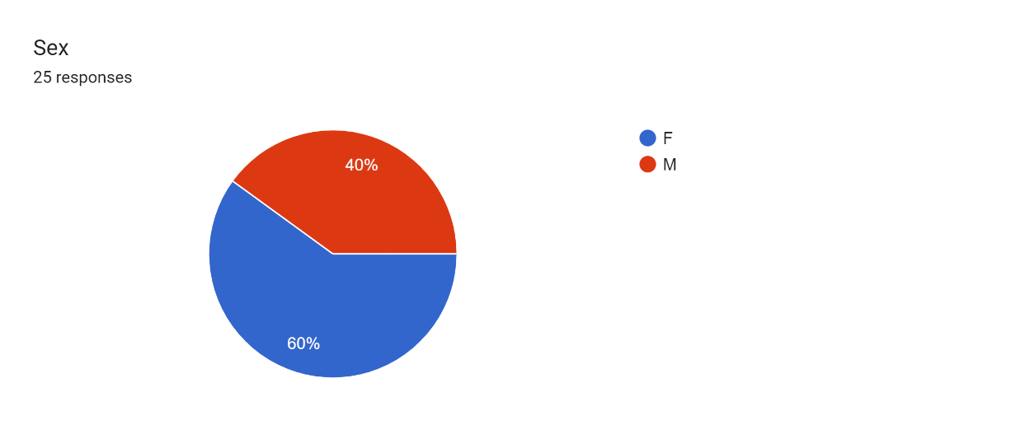
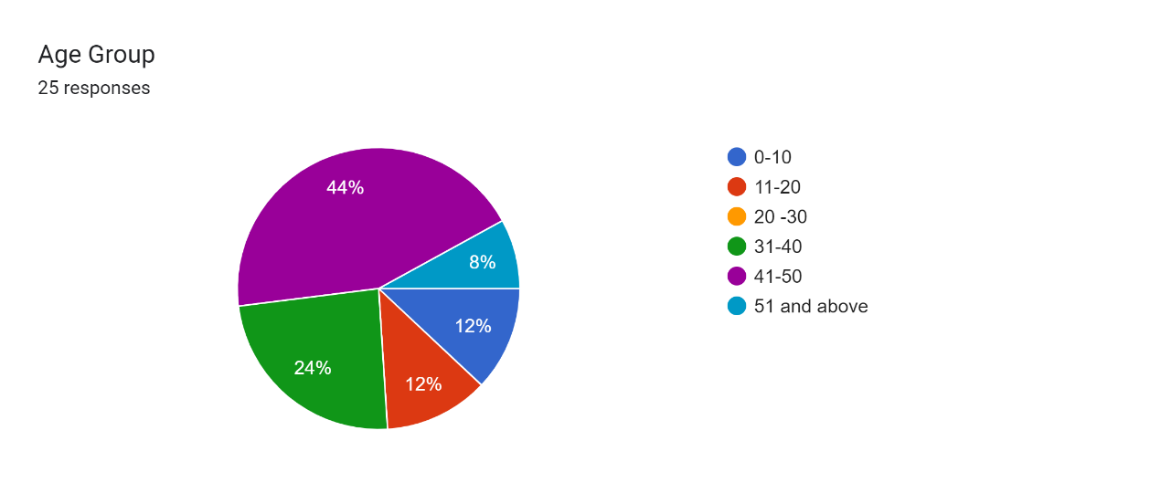
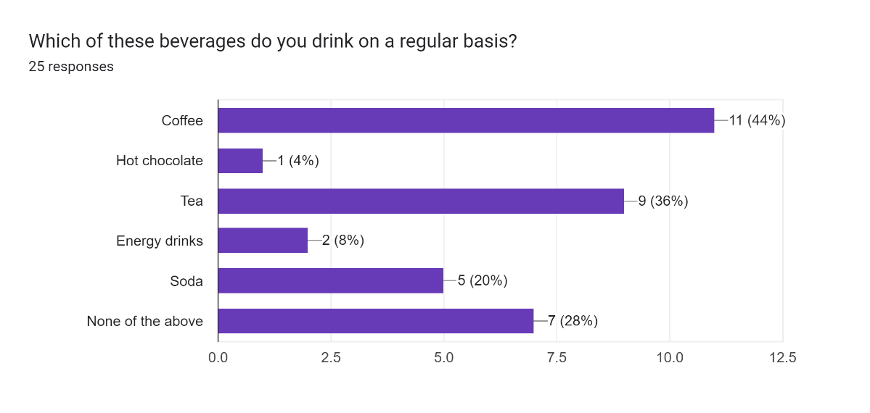
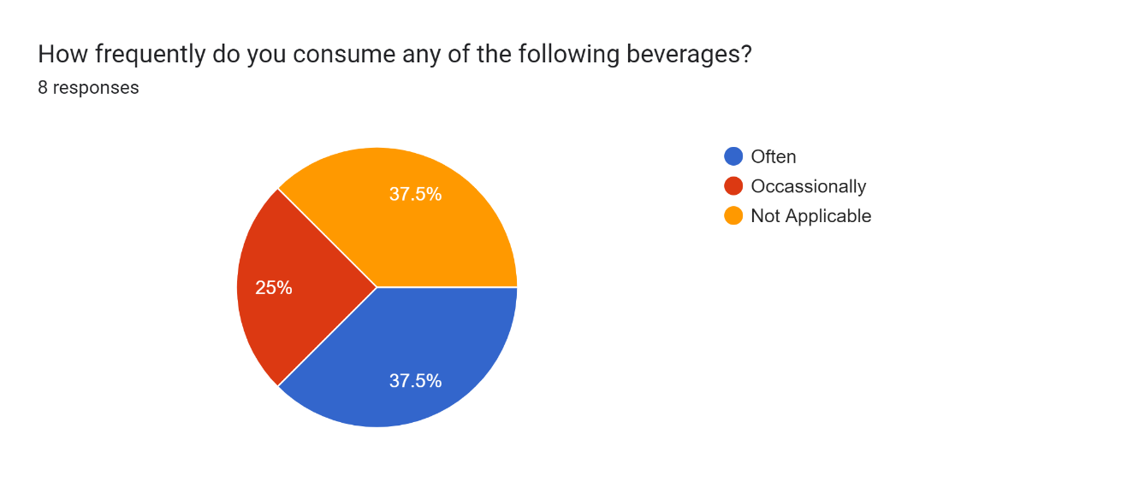
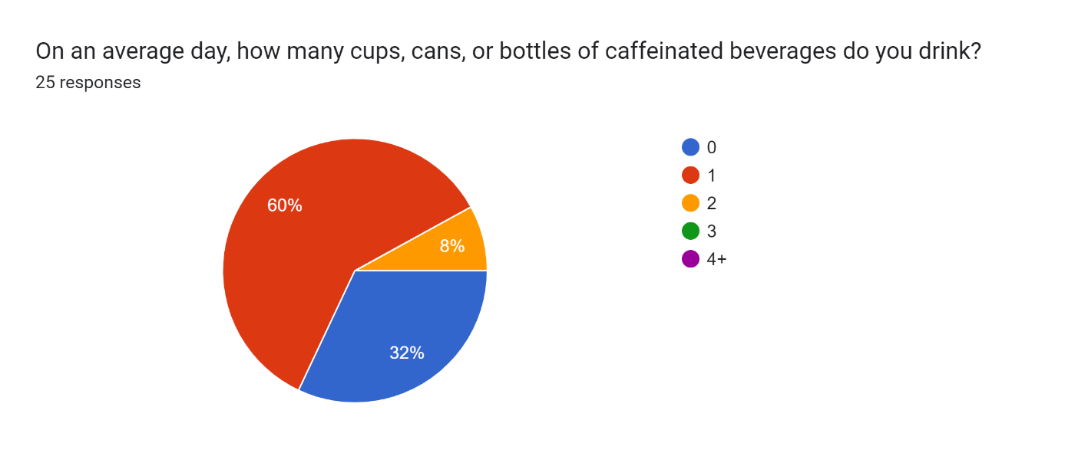
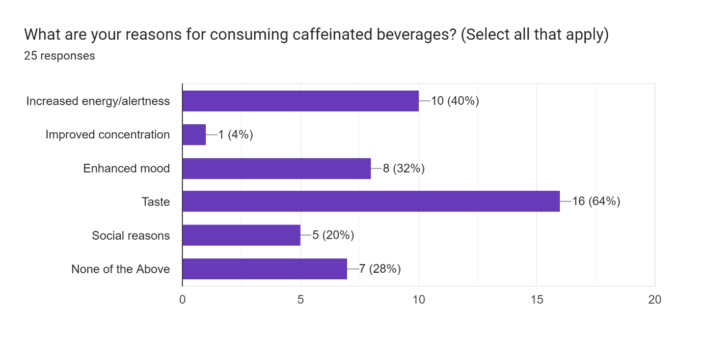
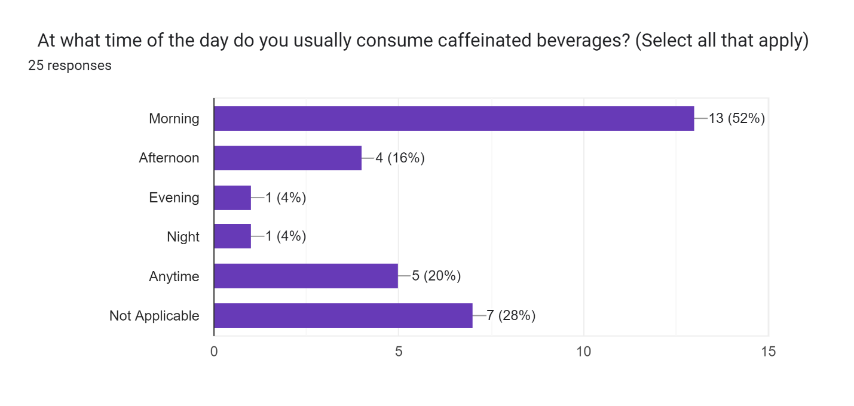
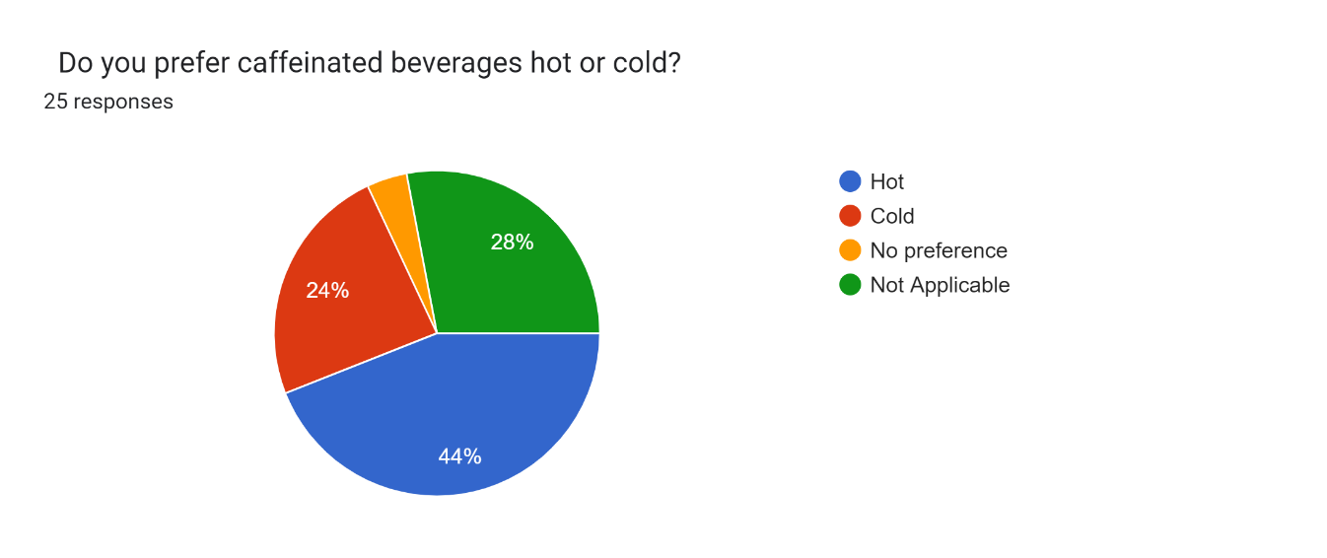
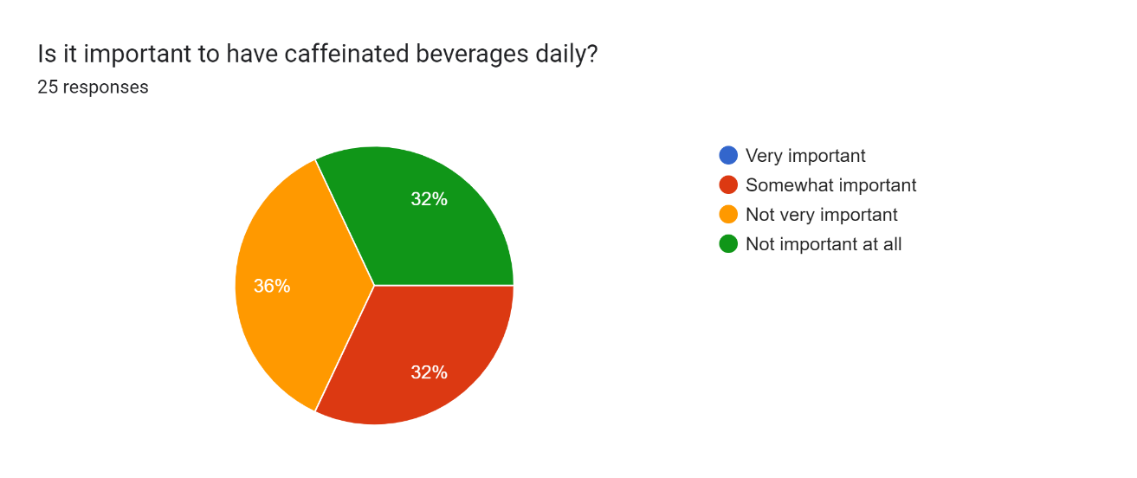
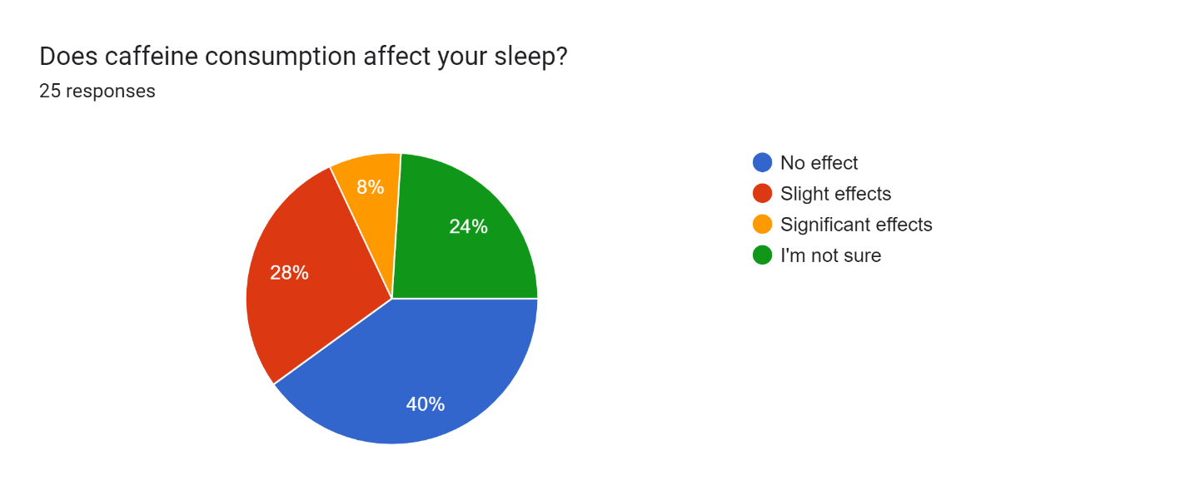

Appendix C
The calculations
