Cw_2_1

Cw_2_2

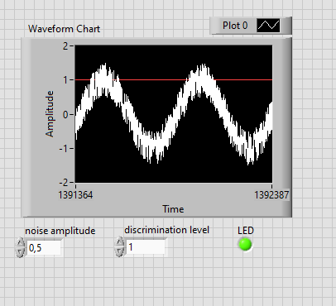

Cw_2_3

Cw_2_4

Cw_2_5

Cw_2_6

Cw_2_7

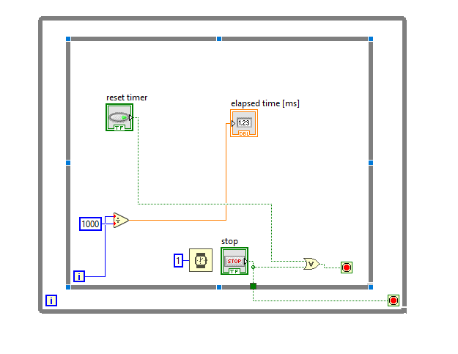

Cw_2_8

