**孤独的阅读者**

**学术英文**

**听力 · 文段逻辑**

**练习册**

Table of Contents

使用说明 3

Level I 4

练习说明 5

I. How to gain control of your free time 7

II. What makes a good life? Lessons from the longest study on happiness 22

III. How language shapes the way we think 33

Level II 51

练习说明 52

I. Why We Have Too Few Women Leaders 53

II. The Power of Introverts 55

III. A Healthy Economy Should Be Designed To Thrive, Not Grow 57

Level III 59

练习说明 60

I. Is The World Getting Better Or Worse? A Look At Numbers 63

II. Why You Should Make Useless Things? 67

III. Connected, But Alone? 71

IV. Is Our Universe The Only Universe? 78

# 使用说明

**组成 | 难度 | 文本 | 音频**

1. 「听力 · 文段训练」由两部分组成：「练习册」和「答案」
2. 「听力 · 文段训练」分三个阶段，难度依次递增：
   * Level I：逐句听记训练
   * Level II：指代性名词辨析训练
   * Level III：听力速记训练
3. 听力文段精选：选自十篇Ted 演讲，内容主题涵盖时间管理、语言习得、良善生活的追求、女性主义、世界经济……
4. 音视频资源链接附于单个练习部分的页首

Level I

**（逐句听记训练）**

## 练习说明

**【练习目的】**

不同于纯粹的辨音训练，逐句听记的目的在于对听力信息输入的处理，将输入的信息处理为自己熟悉的具有画面感的信息并输出记录。以此提高听力输入时信息处理的速度。

**【练习示例】**

* 原文：When people find out I write about time management, they assume two things
* 听记填写 (参考)：当人们发现我写时间管理文章时，they假设 2 (如下图)

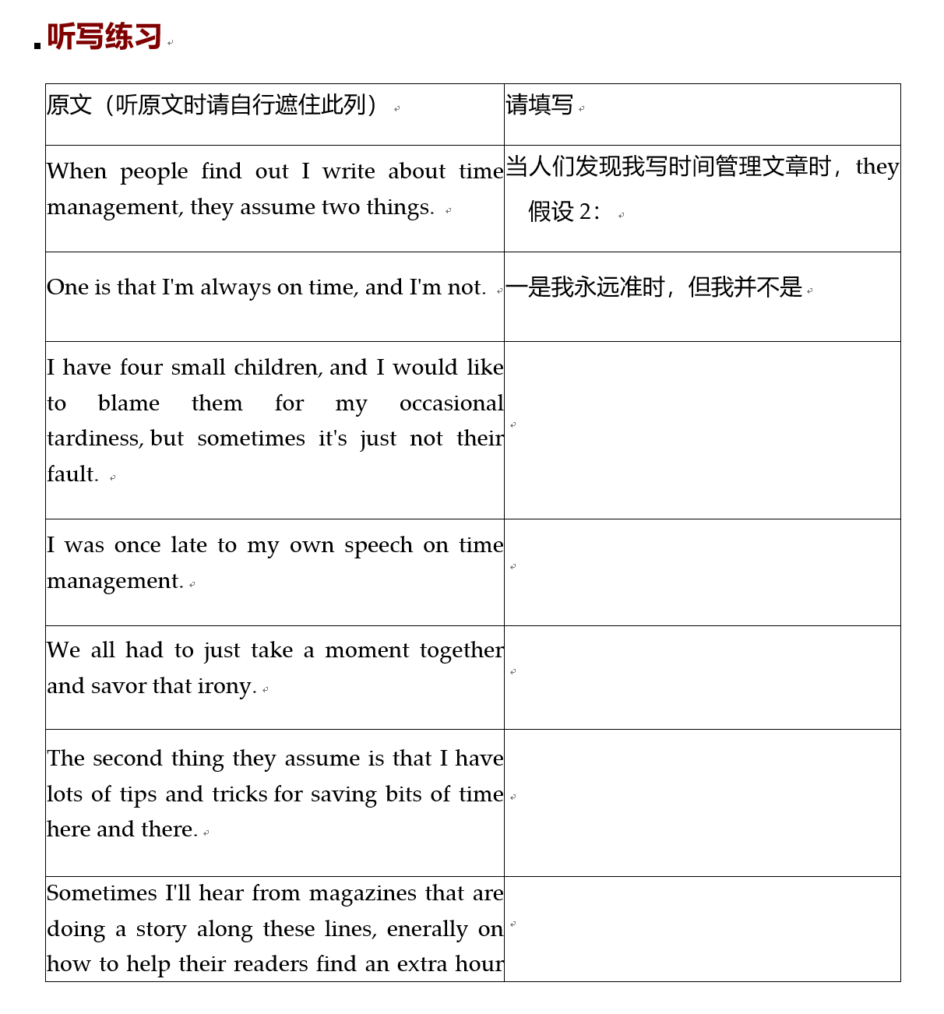

**【注意】**

逐句听记的过程中，需要同学们组织自己的语言记录对当句的理解。你们可以使用英文、中文，甚至交织各种自己习惯书写速记的符号，只需保证自己回溯时能够理解即可。填写时，请先遮住原文列。

## How to gain control of your free time

**视频地址**

<https://www.ted.com/talks/laura_vanderkam_how_to_gain_control_of_your_free_time/transcrip>

**听写练习**

|  |  |
| --- | --- |
| 原文（听记时请自行遮住此列） | 请填写 |
| When people find out I write about time management, they assume two things. | 当人们发现我写时间管理文章时，they假设 2： |
| One is that I'm always on time, and I'm not. | 一是我永远准时，但我并不是 |
| I have four small children, and I would like to blame them for my occasional tardiness, but sometimes it's just not their fault. |  |
| I was once late to my own speech on time management. |  |
| We all had to just take a moment together and savor that irony. |  |
| The second thing they assume is that I have lots of tips and tricks for saving bits of time here and there. |  |
| Sometimes I'll hear from magazines that are doing a story along these lines, generally on how to help their readers find an extra hour in the day. |  |
| And the idea is that we'll shave bits of time off everyday activities, add it up, and we'll have time for the good stuff. |  |
| I question the entire premise of this piece, but I'm always interested in hearing what they've come up with before they call me. |  |
| Some of my favorites: doing errands where you only have to make right-hand turns -- |  |
| Being extremely judicious in microwave usage: it says three to three-and-a-half minutes on the package, we're totally getting in on the bottom side of that. |  |
| And my personal favorite, which makes sense on some level, is to DVR your favorite shows so you can fast-forward through the commercials. |  |
| That way, you save eight minutes every half hour, so in the course of two hours of watching TV, you find 32 minutes to exercise. |  |
| Which is true. |  |
| You know another way to find 32 minutes to exercise? |  |
| Don't watch two hours of TV a day, right? |  |
| Anyway, the idea is we'll save bits of time here and there, add it up, we will finally get to everything we want to do. |  |
| But after studying how successful people spend their time and looking at their schedules hour by hour, I think this idea has it completely backward. |  |
| We don't build the lives we want by saving time. |  |
| We build the lives we want, and then time saves itself. |  |
| Here's what I mean. |  |
| I recently did a time diary project looking at 1,001 days in the lives of extremely busy women. |  |
| They had demanding jobs, sometimes their own businesses, kids to care for, maybe parents to care for, community commitments -- busy, busy people. |  |
| I had them keep track of their time for a week so I could add up how much they worked and slept, and I interviewed them about their strategies, for my book. |  |
| One of the women whose time log I studied goes out on a Wednesday night for something. |  |
| She comes home to find that her water heater has broken, and there is now water all over her basement. |  |
| If you've ever had anything like this happen to you, you know it is a hugely damaging, frightening, sopping mess. |  |
| So she's dealing with the immediate aftermath that night, next day she's got plumbers coming in, day after that, professional cleaning crew dealing with the ruined carpet. |  |
| All this is being recorded on her time log. |  |
| Winds up taking seven hours of her week. |  |
| Seven hours. |  |
| That's like finding an extra hour in the day. |  |
| But I'm sure if you had asked her at the start of the week, "Could you find seven hours to train for a triathlon?" |  |
| "Could you find seven hours to mentor seven worthy people?" |  |
| I'm sure she would've said what most of us would've said, which is, "No -- can't you see how busy I am?" |  |
| Yet when she had to find seven hours because there is water all over her basement, she found seven hours. |  |
| And what this shows us is that time is highly elastic. |  |
| We cannot make more time, but time will stretch to accommodate what we choose to put into it. |  |
| And so the key to time management is treating our priorities as the equivalent of that broken water heater. |  |
| To get at this, I like to use language from one of the busiest people I ever interviewed. |  |
| By busy, I mean she was running a small business with 12 people on the payroll, she had six children in her spare time. |  |
| I was getting in touch with her to set up an interview on how she "had it all" -- that phrase. |  |
| I remember it was a Thursday morning, and she was not available to speak with me. |  |
| Of course, right? |  |
| But the reason she was unavailable to speak with me is that she was out for a hike, because it was a beautiful spring morning, and she wanted to go for a hike. |  |
| So of course this makes me even more intrigued, and when I finally do catch up with her, she explains it like this. |  |
| She says, "Listen Laura, everything I do, every minute I spend, is my choice." |  |
| And rather than say,"I don't have time to do x, y or z," she'd say, "I don't do x, y or z because it's not a priority." |  |
| "I don't have time," often means "It's not a priority." |  |
| If you think about it, that's really more accurate language. |  |
| I could tell you I don't have time to dust my blinds, but that's not true. |  |
| If you offered to pay me $100,000 to dust my blinds, I would get to it pretty quickly. |  |
| Since that is not going to happen, I can acknowledge this is not a matter of lacking time; it's that I don't want to do it. |  |
| Using this language reminds us that time is a choice. |  |
| And granted, there may be horrible consequences for making different choices, I will give you that. |  |
| But we are smart people, and certainly over the long run, we have the power to fill our lives with the things that deserve to be there. |  |
| So how do we do that? |  |
| How do we treat our priorities as the equivalent of that broken water heater? |  |
| Well, first we need to figure out what they are. |  |
| I want to give you two strategies for thinking about this. |  |
| The first, on the professional side: I'm sure many people coming up to the end of the year are giving or getting annual performance reviews. |  |
| You look back over your successes over the year, your "opportunities for growth." |  |
| And this serves its purpose, but I find it's more effective to do this looking forward. |  |
| So I want you to pretend it's the end of next year. |  |
| You're giving yourself a performance review, and it has been an absolutely amazing year for you professionally. |  |
| What three to five things did you do that made it so amazing? |  |
| So you can write next year's performance review now. |  |
| And you can do this for your personal life, too. |  |
| I'm sure many of you, like me, come December, get cards that contain these folded up sheets of colored paper, on which is written what is known as the family holiday letter. |  |
| Bit of a wretched genre of literature, really, going on about how amazing everyone in the household is, or even more scintillating, how busy everyone in the household is. |  |
| But these letters serve a purpose, which is that they tell your friends and family what you did in your personal life that mattered to you over the year. |  |
| So this year's kind of done, but I want you to pretend it's the end of next year, and it has been an absolutely amazing year for you and the people you care about. |  |
| What three to five things did you do that made it so amazing? |  |
| So you can write next year's family holiday letter now. |  |
| Don't send it. |  |
| Please, don't send it. |  |
| But you can write it. |  |
| And now, between the performance review and the family holiday letter, we have a list of six to ten goals we can work on in the next year. |  |
| And now we need to break these down into doable steps. |  |
| So maybe you want to write a family history. |  |
| First, you can read some other family histories, get a sense for the style. |  |
| Then maybe think about the questions you want to ask your relatives, set up appointments to interview them. |  |
| Or maybe you want to run a 5K. |  |
| So you need to find a race and sign up, figure out a training plan, and dig those shoes out of the back of the closet. |  |
| And then -- this is key -- we treat out priorities as the equivalent of that broken water heater, by putting them into our schedules first. |  |
| We do this by thinking through our weeks before we are in them. |  |
| I find a really good time to do this is Friday afternoons. |  |
| Friday afternoon is what an economist might call a "low opportunity cost" time. |  |
| Most of us are not sitting there on Friday afternoons saying, "I am excited to make prgress toward my personal and professional priorities right now." |  |
| But we are willing to think about what those should be. |  |
| So take a little bit of time Friday afternoon, make yourself a three-category priority list: career, relationships, self. |  |
| Making a three-category list reminds us that there should be something in all three categories. |  |
| Career, we think about; relationships, self -- not so much. |  |
| But anyway, just a short list, two to three items in each. |  |
| Then look out over the whole of the next week, and see where you can plan them in. |  |
| Where you plan them in is up to you. |  |
| I know this is going to be more complicated for some people than others. |  |
| I mean, some people's lives are just harder than others. |  |
| It is not going to be easy to find time to take that poetry class if you are caring for multiple children on your own. |  |
| I get that. |  |
| And I don't want to minimize anyone's struggle. |  |
| But I do think that the numbers I am about to tell you are empowering. |  |
| There are 168 hours in a week. |  |
| Twenty-four times seven is 168 hours. |  |
| That is a lot of time. |  |
| If you are working a full-time job, so 40 hours a week, sleeping eight hours a night, so 56 hours a week -- that leaves 72 hours for other things. |  |
| That is a lot of time. |  |
| You say you're working 50 hours a week, maybe a main job and a side hustle. |  |
| Well, that leaves 62 hours for other things. |  |
| You say you're working 60 hours. |  |
| Well, that leaves 52 hours for other things. |  |
| You say you're working more than 60 hours. |  |
| Well, are you sure? |  |
| There was once a study comparing people's estimated work weeks with time diaries. |  |
| They found that people claiming 75-plus-hour work weeks were off by about 25 hours. |  |
| You can guess in which direction, right? |  |
| Anyway, in 168 hours a week, I think we can find time for what matters to you. |  |
| If you want to spend more time with your kids, you want to study more for a test you're taking, you want to exercise for three hours and volunteer for two, you can. |  |
| And that's even if you're working way more than full-time hours. |  |
| So we have plenty of time, which is great, because guess what? |  |
| We don't even need that much time to do amazing things. |  |
| But when most of us have bits of time, what do we do? |  |
| Pull out the phone, right? |  |
| Start deleting emails. |  |
| Otherwise, we're puttering around the house or watching TV. |  |
| But small moments can have great power. |  |
| You can use your bits of time for bits of joy. |  |
| Maybe it's choosing to read something wonderful on the bus on the way to work. |  |
| I know when I had a job that required two bus rides and a subway ride every morning, I used to go to the library on weekends to get stuff to read. |  |
| It made the whole experience almost, almost, enjoyable. |  |
| Breaks at work can be used for mediating or praying. |  |
| If family dinner is out because of your crazy work schedule, maybe family breakfast could be a good sustitute. |  |
| It's about looking at the whole of one's time and seeing where the good stuff can go. |  |
| I truly believe this. |  |
| There is time. |  |
| Even if we are busy, we have time for what matters. |  |
| And when we focus on what matters, we can build the lives we want in the time we've got. |  |
| Thank you. |  |

## What makes a good life? Lessons from the longest study on happiness

**视频地址**：<https://www.ted.com/talks/robert_waldinger_what_makes_a_good_life_lessons_from_the_longest_study_on_happiness?referrer=playlist-the_most_popular_talks_of_all>

**听写练习**

|  |  |
| --- | --- |
| 原文（听句时请遮住此列） | 请填写 |
| What keeps us healthy and happy as we go through life? |  |
| If you were going to invest now in your future best self, where would you put your time and your energy? |  |
| There was a recent survey of millennials asking them what their most important life goals were, and over 80 percent said that a major life goal for them was to get rich. |  |
| And another 50 percent of those same young adults said that another major life goal was to become famous. |  |
| And we're constantly told to lean in to work, to push harder and achieve more. |  |
| We're given the impression that these are the things that we need to go after in order to have a good life. |  |
| Pictures of entire lives, of the choices that people make and how those choices work out for them, those pictures are almost impossible to get. |  |
| Most of what we know about human life we know from asking people to remember the past, and as we know, hindsight is anything but 20/20. |  |
| We forget vast amounts of what happens to us in life, and sometimes memory is downright creative. |  |
| But what if we could watch entire lives as they unfold through time? |  |
| What if we could study people from the time that they were teenagers all the way into old age to see what really keeps people happy and healthy? |  |
| We did that. |  |
| The Harvard Study of Adult Development may be the longest study of adult life that's ever been done. |  |
| For 75 years, we've tracked the lives of 724 men, year after year, asking about their work, their home lives, their health, and of course asking all along the way without knowing how their life stories were going to turn out. |  |
| Studies like this are exceedingly rare. |  |
| Almost all projects of this kind fall apart within a decade because too many people drop out of the study, or funding for the research dries up, or the researchers get distracted, or they die, and nobody moves the ball further down the field. |  |
| But through a combination of luck and the persistence of several generations of researchers, this study has survived. |  |
| About 60 of our original 724 men are still alive, still participating in the study, most of them in their 90s. |  |
| And we are now beginning to study the more than 2,000 children of these men. |  |
| And I'm the fourth director of the study. |  |
| Since 1938, we've tracked the lives of two groups of men. |  |
| The first group started in the study when they were sophomores at Harvard College. |  |
| They all finished college during World War II, and then most went off to serve in the war. |  |
| And the second group that we've followed was a group of boys from Boston's poorest neighborhoods, boys who were chosen for the study specifically because they were from some of the most troubled and disadvantaged families in the Boston of the 1930s. |  |
| Most lived in tenements, many without hot and cold running water. |  |
| When they entered the study, all of these teenagers were interviewed. |  |
| They were given medical exams. |  |
| We went to their homes and we interviewed their parents. |  |
| And then these teenagers grew up into adults who entered all walks of life. |  |
| They became factory workers and lawyers and bricklayers and doctors, one President of the United States. |  |
| Some developed alcoholism. |  |
| A few developed schizophrenia. |  |
| Some climbed the social ladder from the bottom all the way to the very top, and some made that journey in the opposite direction. |  |
| The founders of this study would never in their wildest dreams have imagined that I would be standing here today, 75 years later, telling you that the study still continues. |  |
| Every two years, our patient and dedicated research staff calls up our men and asks them if we can send them yet one more set of questions about their lives. |  |
| Many of the inner city Boston men ask us, "Why do you keep wanting to study me? My life just isn't interesting." The Harvard men never ask that question. |  |
| To get the clearest picture of these lives, we don't just send them questionnaires. |  |
| We interview them in their living rooms. |  |
| We get their medical records from their doctors. |  |
| We draw their blood, we scan their brains, we talk to their children. |  |
| We videotape them talking with their wives about their deepest concerns. |  |
| And when, about a decade ago, we finally asked the wives if they would join us as members of the study, many of the woman said, "You know, it's about time." |  |
| So what have we learned? |  |
| What are the lessons that come from the tens of thousands of pages of information that we've generated on these lives? |  |
| Well, the lessons aren't about wealth or fame or working harder and harder. |  |
| The clearest message that we get from this 75-year study is this: Good relationships keep us happier and healthier. |  |
| We've learned three big lessons about relationships. |  |
| The first is that social connections are really good for us, and that loneliness kills. |  |
| It turns out that people who are more socially connected to family, to friends, to community, are happier, they're physically healthier, and they live longer than people who are less well connected. |  |
| And the experience of loneliness turns out to be toxic. |  |
| People who are more isolated than they want to be from others find that they are less happy, their health declines earlier in midlife, their brain functioning declines sooner and they live shorter lives than people who are not lonely. |  |
| And the sad fact is that at any given time, more than one in five Americans will report that they're lonely. |  |
| And we know that you can be lonely in a crowd and you can be lonely in a marriage, so the second big lesson that we learn is that it's not just the number of friends you have, and it's not whether or not you're in a committed relationship, but it's the quality of your close relationships that matters. |  |
| It turns out that living in the midst of conflict is really bad for our health. |  |
| High-conflict marriages, for example, without much affection, turn out to be very bad for our health, perhaps worse than getting divorced. |  |
| And living in the midst of good, warm relationship is protective. |  |
| Once we had followed our men all the way into their 80s, we wanted to look back at them at midlife and to see if we could predict who was going to grow into a happy, healthy octogenarian and who wasn't. |  |
| And when we gathered together everything we knew about them at age 50, it wasn't their middle age cholesterol levels that predicted how they were going to grow old. |  |
| It was how satisfied they were in their relationships. |  |
| The people who were the most satisfied in their relationships at age 50 were the healthiest at age 80. |  |
| And good, close relationships seem to buffer us from some of the slings and arrows of getting old. |  |
| Our most happily partnered men and women reported, in their 80s, that on the days when they had more physical pain, their mood stayed just as happy. |  |
| But the people who were in unhappy relationships, on the days when they reported more physical pain, it was magnified by more emotional pain. |  |
| And the third big lesson that we learned about relationships and our health is that good relationships don't just protect our bodies, they protect our brains. |  |
| It turns out that being in a securely attached relationships where they really feel they can count on the other person in times of need, those people's memories stay sharper longer. |  |
| And the people in relationships where they feel they really can't count on the other one, those are the people who experience earlier memory decline. |  |
| And those good relationships, they don't have to be smooth all the time. |  |
| Some of our octogenarian couples could bicker with each other day in and day out, but as long as they felt that they could really count on the other when the going got tough, those arguments didn't take a toll on their memories. |  |
| So this message, that good, close relationships are good for our health and well-being, this is wisdom that's as old as the hills. |  |
| Why is this so hard to get and so easy to ignore? |  |
| Well, we're human. |  |
| What we'd really like is a quick fix, something we can get that'll make our lives good and keep them that way. |  |
| Relationships are messy and they're complicated and the hard work of tending to family and friends, it's not sexy or glamorous. |  |
| It's also lifelong. |  |
| It never ends. |  |
| The people in our 75-year study who were the happiest in retirement were the people who had actively worked to replace workmates with new playmates. |  |
| Just like the millennials in that recent survey, many of our men when they were starting out as young adults really believed that fame and wealth and high achievement were what they needed to go after to have a good life. |  |
| But over and over, over these 75 years, our study has shown that the people who fared the best were the people who leaned in to relationships, with family, with friend, with community. |  |
| So what about you? |  |
| Let's say you're 25, or you're 40, or you're 60. |  |
| What might leaning in to relationships even look like? |  |
| Well, the possibilities are practically endless. |  |
| It might be something as simple as replacing screen time with people time or livening up a stale relationship by doing something new together, long walks or date nights, or reaching out to that family member who you haven't spoken to in years, because those all-too-common family feuds take a terrible toll on the people who hold the grudges. |  |
| I'd like to close with a quote from Mark Twain. |  |
| More than a century ago, he was looking back on his life, and he wrote this:"There isn't time, so brief is life, for bickerings, apologies, heartburnings, callings to account. There is only time for loving, and but an instant, so to speak, for that." |  |
| The good life is built with good relationships. |  |
| Thank you. |  |

## How language shapes the way we think

**视频地址**：<https://www.ted.com/talks/lera_boroditsky_how_language_shapes_the_way_we_think>

**听写练习**

|  |  |
| --- | --- |
| **原文（听句时请遮住此列）** | **请填写** |
| So, I'll be speaking to you using language ... because I can. |  |
| This is one these magical abilities that we humans have. |  |
| We can transmit really complicated thoughts to one another. |  |
| So what I'm doing right now is, I'm making sounds with my mouth as I'm exhaling. |  |
| I'm making tones and hisses and puffs, and those are creating air vibrations in the air. |  |
| Those air vibrations are traveling to you, they're hitting your eardrums, and then your brain takes those vibrations from your eardrums and transforms them into thoughts. I hope. |  |
| I hope that's happening. |  |
| So because of this ability, we humans are able to transmit our ideas across vast reaches of space and time. |  |
| We're able to transmit knowledge across minds. |  |
| I can put a bizarre new idea in your mind right now. |  |
| I could say, "Imagine a jellyfish waltzing in a library while thinking about quantum mechanics." |  |
| Now, if everything has gone relatively well in your life so far, you probably haven't had that thought before. |  |
| But now I've just made you think it, through language. |  |
| Now of course, there isn't just one language in the world, there are about 7,000 languages spoken around the world. |  |
| And all the languages differ from one another in all kinds of ways. |  |
| Some languages have different sounds, they have different vocabularies, and they also have different structures -- very importantly, different structures. |  |
| That begs the question: Does the language we speak shape the way we think? |  |
| Now, this is an ancient question. |  |
| People have been speculating about this question forever. |  |
| Charlemagne, Holy Roman emperor, said, "To have a second language is to have a second soul" --strong statement that language crafts reality. |  |
| But on the other hand, Shakespeare has Juliet say,"What's in a name? A rose by any other name would smell as sweet." |  |
| Well, that suggests that maybe language doesn't craft reality. |  |
| These arguments have gone back and forth for thousands of years. |  |
| But until recently, there hasn't been any data to help us decide either way. |  |
| Recently, in my lab and other labs around the world, we've started doing research, and now we have actual scientific data to weigh in on this question. |  |
| So let me tell you about some of my favorite examples. |  |
| I'll start with an example from an Aboriginal community in Australia that I had the chance to work with. |  |
| These are the Kuuk Thaayorre people. |  |
| They live in Pormpuraaw at the very west edge of Cape York. |  |
| What's cool about Kuuk Thaayorre is, in Kuuk Thaayorre, they don't use words like "left" and "right," and instead, everything is in cardinal directions:north, south, east and west. |  |
| And when I say everything, I really mean everything. |  |
| You would say something like, "Oh, there's an ant on your southwest leg." |  |
| Or, "Move your cup to the north-northeast a little bit." |  |
| In fact, the way that you say "hello" in Kuuk Thaayorre is you say, "Which way are you going?" |  |
| And the answer should be, "North-northeast in the far distance. How about you?" |  |
| So imagine as you're walking around your day, every person you greet, you have to report your heading direction. |  |
| But that would actually get you oriented pretty fast, right? |  |
| Because you literally couldn't get past"hello,"if you didn't know which way you were going. |  |
| In fact, people who speak languages like this stay oriented really well. |  |
| They stay oriented better than we used to think humans could. |  |
| We used to think that humans were worse than other creatures because of some biological excuse: "Oh, we don't have magnets in our beaks or in our scales." |  |
| No; if your language and your culture trains you to do it, actually, you can do it. |  |
| There are humans around the world who stay oriented really well. |  |
| And just to get us in agreement about how different this is from the way we do it, I want you all to close your eyes for a second and point southeast. |  |
| Keep your eyes closed. Point. |  |
| OK, so you can open your eyes. |  |
| I see you guys pointing there, there, there, there, there ... I don't know which way it is myself -- |  |
| You have not been a lot of help. |  |
| So let's just say the accuracy in this room was not very high. |  |
| This is a big difference in cognitive ability across languages, right? |  |
| Where one group -- very distinguished group like you guys -- doesn't know which way is which, but in another group, I could ask a five-year-old and they would know. |  |
| There are also really big differences in how people think about time. |  |
| So here I have pictures of my grandfather at different ages. |  |
| And if I ask an English speaker to organize time, they might lay it out this way, from left to right. |  |
| This has to do with writing direction. |  |
| If you were a speaker of Hebrew or Arabic, you might do it going in the opposite direction, from right to left. |  |
| But how would the Kuuk Thaayorre, this Aboriginal group I just told you about, do it? |  |
| They don't use words like "left" and "right." |  |
| Let me give you hint. |  |
| When we sat people facing south, they organized time from left to right. |  |
| When we sat them facing north, they organized time from right to left. |  |
| When we sat them facing east, time came towards the body. |  |
| What's the pattern? |  |
| East to west, right? |  |
| So for them, time doesn't actually get locked on the body at all, it gets locked on the landscape. |  |
| So for me, if I'm facing this way, then time goes this way, and if I'm facing this way, then time goes this way. |  |
| I'm facing this way, time goes this way -- very egocentric of me to have the direction of time chase me around every time I turn my body. |  |
| For the Kuuk Thaayorre, time is locked on the landscape. |  |
| It's a dramatically different way of thinking about time. |  |
| Here's another really smart human trick. |  |
| Suppose I ask you how many penguins are there. |  |
| Well, I bet I know how you'd solve that problem if you solved it. |  |
| You went, "One, two, three, four, five, six, seven, eight." |  |
| You counted them. |  |
| You named each one with a number, and the last number you said was the number of penguins. |  |
| This is a little trick that you're taught to use as kids. |  |
| You learn the number list and you learn how to apply it. |  |
| A little linguistic trick. |  |
| Well, some languages don't do this, because some languages don't have exact number words. |  |
| They're languages that don't have a word like "seven" or a word like "eight." |  |
| In fact, people who speak these languages don't count, and they have trouble keeping track of exact quantities. |  |
| So, for example, if I ask you to match this number of penguins to the same number of ducks, you would be able to do that by counting. |  |
| But folks who don't have that linguistic trick can't do that. |  |
| Languages also differ in how they divide up the color spectrum -- the visual world. |  |
| Some languages have lots of words for colors, some have only a couple words, "light" and "dark." |  |
| And languages differ in where they put boundaries between colors. |  |
| So, for example, in English, there's a word for blue that covers all of the colors that you can see on the screen, but in Russian, there isn't a single word. |  |
| Instead, Russian speakers have to differentiate between light blue, "goluboy," and dark blue, "siniy." |  |
| So Russians have this lifetime of experience of, in language, distinguishing these two colors. |  |
| When we test people's ability to perceptually discriminate these colors, what we find is that Russian speakers are faster across this linguistic boundary. |  |
| They're faster to be able to tell the difference between a light and dark blue. |  |
| And when you look at people's brains as they're looking at colors -- say you have colors shifting slowly from light to dark blue -- the brains of people who use different words for light and dark blue will give a surprised reaction as the colors shift from light to dark. |  |
| As if, "Ooh, something has categorically changed," whereas the brains of English speakers, for example, that don't make this categorical distinction, don't give that surprise, because nothing is categorically changing. |  |
| Languages have all kinds of structural quirks. |  |
| This is one of my favorites. |  |
| Lots of languages have grammatical gender; every noun gets assigned a gender, often masculine or feminine. |  |
| And these genders differ across languages. |  |
| So, for example, the sun is feminine in German but masculine in Spanish, and the moon, the reverse. |  |
| Could this actually have any consequence for how people think? |  |
| Do German speakers think of the sun as somehow more female-like, and the moon somehow more male-like? |  |
| Actually, it turns out that's the case. |  |
| So if you ask German and Spanish speakers to, say, describe a bridge, like the one here -- "bridge" happens to be grammatically feminine in German,grammatically masculine in Spanish -- German speakers are more likely to say bridges are "beautiful," "elegant" and stereotypically feminine words. |  |
| Whereas Spanish speakers will be more likely to say they're "strong" or "long," these masculine words. |  |
| Languages also differ in how they describe events, right? |  |
| You take an event like this, an accident. |  |
| In English, it's fine to say, "He broke the vase." |  |
| In a language like Spanish, you might be more likely to say, "The vase broke," or, "The vase broke itself." |  |
| If it's an accident, you wouldn't say that someone did it. |  |
| In English, quite weirdly, we can even say things like, "I broke my arm." |  |
| Now, in lots of languages, you couldn't use that construction unless you are a lunatic and you went out looking to break your arm -- and you succeeded. |  |
| If it was an accident, you would use a different construction. |  |
| Now, this has consequences. |  |
| So, people who speak different languages will pay attention to different things, depending on what their language usually requires them to do. |  |
| So we show the same accident to English speakers and Spanish speakers. |  |
| English speakers will remember who did it, because English requires you to say, "He did it; he broke the vase." |  |
| Whereas Spanish speakers might be less likely to remember who did it if it's an accident, but they're more likely to remember that it was an accident. |  |
| They're more likely to remember the intention. |  |
| So, two people watch the same event, witness the same crime, but end up remembering different things about that event. |  |
| This has implications, of course, for eyewitness testimony. |  |
| It also has implications for blame and punishment. |  |
| So if you take English speakers and I just show you someone breaking a vase, and I say, "He broke the vase," as opposed to "The vase broke," even though you can witness it yourself, you can watch the video, you can watch the crime against the vase, you will punish someone more, you will blame someone more if I just said, "He broke it," as opposed to, "It broke." |  |
| The language guides our reasoning about events. |  |
| Now, I've given you a few examples of how language can profoundly shape the way we think, and it does so in a variety of ways. |  |
| So language can have big effects, like we saw with space and time, where people can lay out space and time in completely different coordinate frames from each other. |  |
| Language can also have really deep effects -- that's what we saw with the case of number. |  |
| Having count words in your language, having number words, opens up the whole world of mathematics. |  |
| Of course, if you don't count, you can't do algebra, you can't do any of the things that would be required to build a room like this or make this broadcast, right? |  |
| This little trick of number words gives you a stepping stone into a whole cognitive realm. |  |
| Language can also have really early effects, what we saw in the case of color. |  |
| These are really simple, basic, perceptual decisions. |  |
| We make thousands of them all the time, and yet, language is getting in there and fussing even with these tiny little perceptual decisions that we make. |  |
| Language can have really broad effects. |  |
| So the case of grammatical gender may be a little silly, but at the same time, grammatical gender applies to all nouns. |  |
| That means language can shape how you're thinking about anything that can be named by a noun. |  |
| That's a lot of stuff. |  |
| And finally, I gave you an example of how language can shape things that have personal weight to us -- ideas like blame and punishment or eyewitness memory. |  |
| These are important things in our daily lives. |  |
| Now, the beauty of linguistic diversity is that it reveals to us just how ingenious and how flexible the human mind is. |  |
| Human minds have invented not one cognitive universe, but 7,000 -- there are 7,000 languages spoken around the world. |  |
| And we can create many more -- languages, of course, are living things, things that we can hone and change to suit our needs. |  |
| The tragic thing is that we're losing so much of this linguistic diversity all the time. |  |
| We're losing about one language a week, and by some estimates, half of the world's languages will be gone in the next hundred years. |  |
| And the even worse news is that right now, almost everything we know about the human mind and human brain is based on studies of usually American English-speaking undergraduates at universities. |  |
| That excludes almost all humans. Right? |  |
| So what we know about the human mind is actually incredibly narrow and biased, and our science has to do better. |  |
| I want to leave you with this final thought. |  |
| I've told you about how speakers of different languages think differently, but of course, that's not about how people elsewhere think. |  |
| It's about how you think. |  |
| It's how the language that you speak shapes the way that you think. |  |
| And that gives you the opportunity to ask, "Why do I think the way that I do?" |  |
| "How could I think differently?" |  |
| And also, "What thoughts do I wish to create?" |  |
| Thank you very much. |  |

Level II

**（辨析指代性名词）**

## 练习说明

**【练习目的】**

在第二部分的练习中，我们将尝试总结听力文段的部分信息，目的是：理解前文的所指，承接上下文之间的内容与逻辑，最终达到对整篇细致而全面的理解。

**【练习方式】**

1. 先尝试一次性地 (无暂停的方式) 泛听完演讲的全部内容，做到对演讲的主题有一定的理解和掌握
2. 找到习题中该句话出现的时间节点 (具体时间节点已经标注在练习文本中)，通过重新精听前文演讲内容，并尝试**概括**记录练习册文本中划线部分的「指代性名词」的具体含义（中英文皆可）

**【练习示例】**

1. 原文：And I felt kind of guilty about this. (06:20)

Answer: I felt guilty about closing the book and I never read that again. / 我把书收起来没再看。

## Why We Have Too Few Women Leaders

**视频地址：**

<https://www.ted.com/talks/sheryl_sandberg_why_we_have_too_few_women_leaders>

**指代性名词辨析训练**

1. The numbers have not moved since 2002 and are going in the wrong direction.  (01:10)

Answer:

1. So the question is, how are we going to fix this? (02:30)

Answer:

1. I know no women, whether they're at home or whether they're in the workforce, who don't feel that sometimes. (03:55)

Answer:

1. The problem with these stories is that they show what the data shows: women systematically underestimate their own abilities. (06:01)

Answer:

1. I wish I could tell that to my daughter. (07:22)

Answer:

1. There's a really good study that shows this really well. (07:40)

Answer:

1. I said, "You're thinking about this just way too early." (12:57)

Answer:

## The Power of Introverts

**视频地址：**

<https://www.ted.com/talks/susan_cain_the_power_of_introverts/transcript?referrer=playlist-the_most_popular_talks_of_all>

**指代性名词辨析训练**

1. Now, I tell you this story summer camp. I could have told you 50 others just like it. (02:31)

Answer:

1. But for years I denied the intuition, and so I became a Wall Street lawyer. (02:57)

Answer:

1. Now this is what many introverts do, and it's our loss for sure, but it is also our colleagues' loss and our communities' loss. (03:19)

Answer：

1. All of them subject to this bias that is pretty deep and real in our society. (03:57)

Answer:

1. Okay, same thing is true in our workplace. (06:00)

Answer:

1. And I often think that they have best of all worlds. (08:00)

Answer:

1. This is especially important when it comes to creativity and to productivity, because... (08:15)

Answer:

1. It's only recently that we've strangely begun to forget it. (09:45)

Answer:

1. One answer lies deep in our cultural history. (11:19)

Answer:

1. And so these days I try to learn from my grandfather's example in my own way. (15:26)

Answer:

1. And that's a lot harder for me, because as honored as I am to be here with all of you right now, this is not my natural milieu. (15:59)

Answer:

1. And so I am going to leave you now with three calls for action for those who share this vision. (16:38)

Answer:

## A Healthy Economy Should Be Designed To Thrive, Not Grow

**视频地址：**

<https://www.ted.com/talks/kate_raworth_a_healthy_economy_should_be_designed_to_thrive_not_grow/transcript>

**指代性名词辨析训练**

1. We tell it in our story of evolution as well, from our lolloping ancestors to Homo erectus, finally upright, to Homo sapiens, depicted, always a man, always mid-stride. (00:26)

Answer:

1. I believe this is the shift we need to make if we, humanity, are going to thrive here together this century. (01:34)

Answer:

1. So where did this obsession with growth come from? (01:38)

Answer：

1. This was 1960, remember. (03:17)

Answer:

1. Well, you can hear the implicit airplane metaphor in this story, but this plane is like no other, because it can never be allowed to land. (03:20)

Answer:

1. ......a growing GDP seems a sure way to do that. (05:02)

Answer:

1. None of these addictions are insurmountable, but they all deserve far more attention than they currently get, because look where this journey has been taking us. (05:52)

Answer:

1. We, the people of the early 21st century, this is our selfie. (09:33)

Answer:

1. ......so we need to bend those arrows around, create economies that work with and within the cycles of the living world......(10:32)

Answer:

1. And this kind of regenerative design is popping up everywhere. (10:43)

Answer:

1. We've got unprecedented opportunities for making that happen, because...... (11:30)

Answer:

1. So where does this leave Rostow's airplane ride? (12:51)

Answer:

1. So why would we imagine that our economies would be the one system that could buck this trend and succeed by growing forever? (14:31)

Answer:

Level III

(听力速记训练)

## 练习说明

Level I 和 Level II 两部分的训练中，我们从「单句」与「段落」维度进行了听力输入的信息处理训练。第三部分我们将从关键词入手，尝试对一篇演讲在「篇章维度」进行听力速记训练

本部分的练习分为两阶段：篇目 ”*I. Is The World Getting Better Or Worse? A Look At Numbers*” 和 “*II. Why You Should Make Useless Things？”* 为阶段一；篇目 ”*III. Connected, But Alone*” 和 “*IV. Is Our Universe The Only Universe”* 为阶段二。

**【练习示例】**

**阶段一**

阶段一的听力速记训练分两步：

1. Step One：请在纸张上速记听力笔记，可以使用中文、英文甚至自创的符号进行速记，比如关键词、逻辑链条的箭头符号、或者关键性语句等。切记不要听到只言片语就写，理解是笔记的基础。笔记的形式类似“口译笔记”(如下图)，感兴趣的同学可以继续钻研完善自己的速记符号体系。

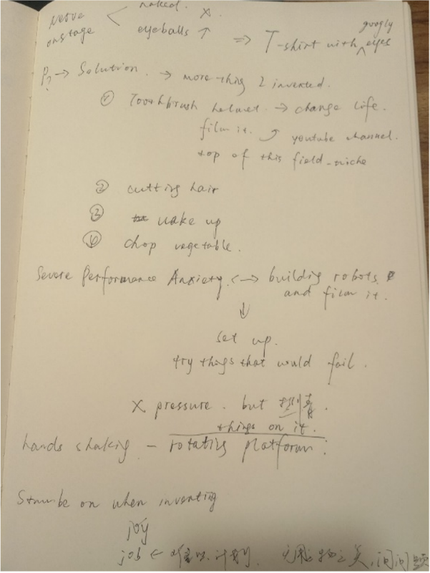

1. Step Two：练习册中给出了两列表格，左列是经过筛选的，具有逻辑性特征的关键信息(Key points)，第二列是你重新精听一遍之后根据左边列表的关键词提示需要完成的细节内容。你也可以在纸上进行训练。

两个步骤之间的关系是，首先是自主练习，属于泛听并进行速记训练；然后是通过我们给出的关键信息作为拐杖，辅助练习，属于精听。二者顺序不可颠倒。

**阶段二**

阶段二的练习篇目在选材上从内容长度和内容本身两个维度提升了训练难度。并在训练的方式上提出了更高的要求。此阶段的训练需要完成两部分内容：

1. 第一部分：通过阶段一的速记练习，已经初步建立听力速记的符号系统。第一遍训练时，在纸上或直接在 word 文档中快速记录演讲的主要内容

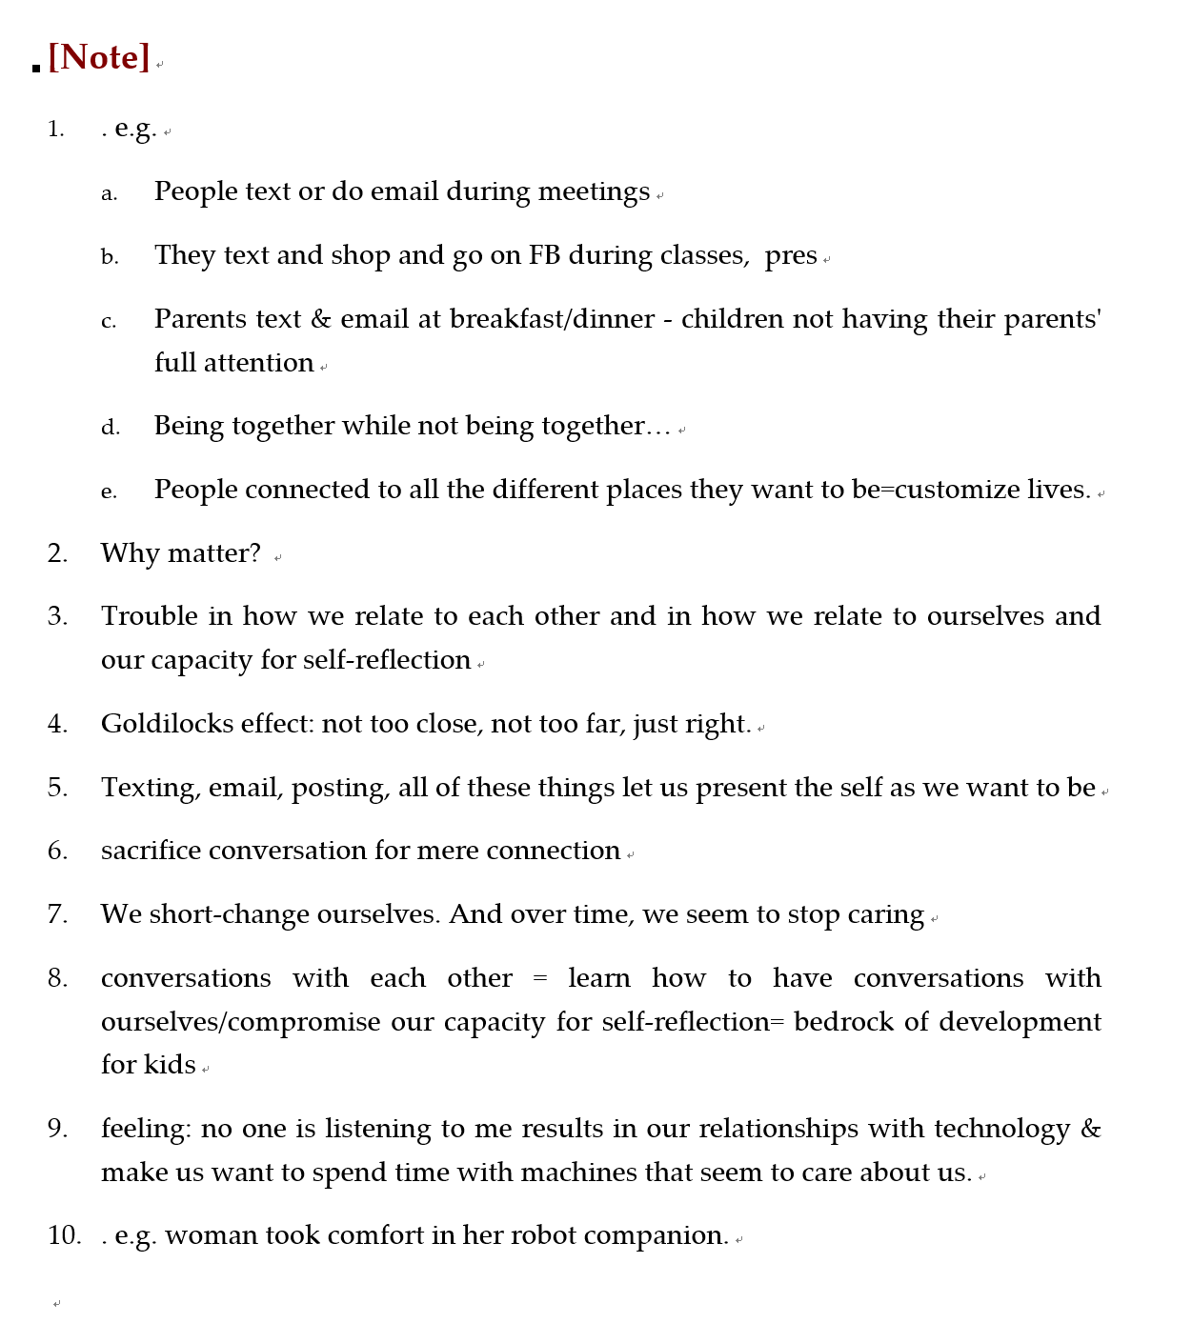

( Word 速记笔记参考)

1. 第二部分：根据第一遍听力输入时所记录的主要信息绘制思维导图 (Mind Map)，描绘关键性概念和概念之间的逻辑关系；然后进行第二遍听力输入，补全思维导图中漏记的部分。

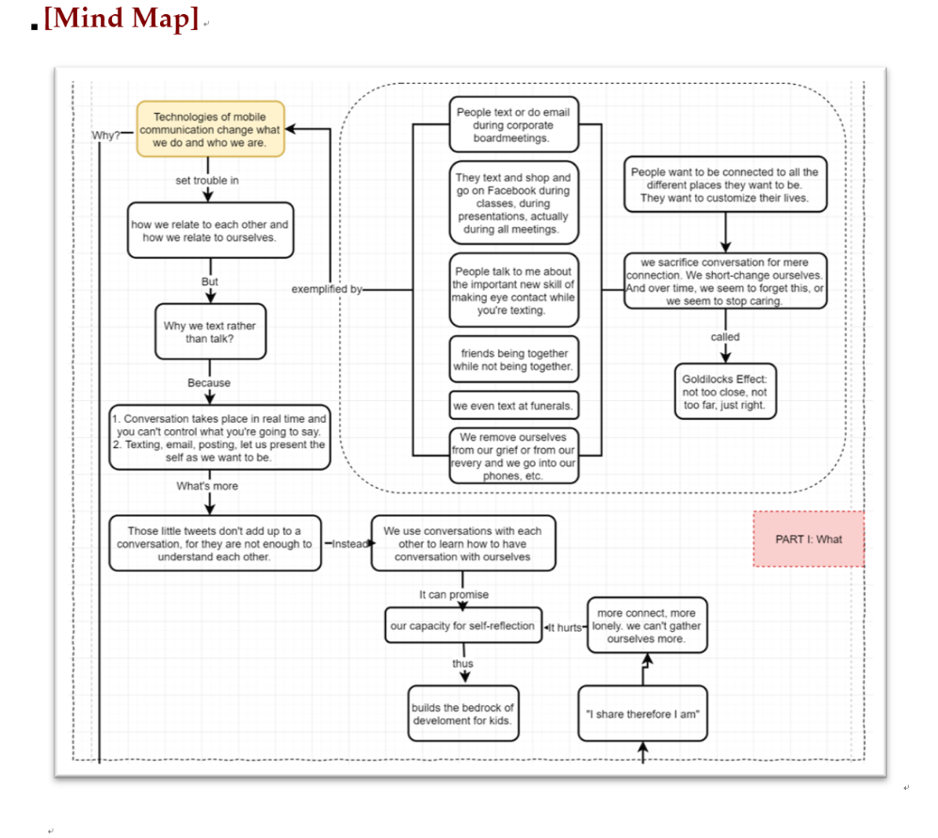

（思维导图样式参考）

## Is The World Getting Better Or Worse? A Look At Numbers

视频地址：

<https://www.ted.com/talks/steven_pinker_is_the_world_getting_better_or_worse_a_look_at_the_numbers>

STEP ONE

(请将手写笔记拍照上传贴于此空白处)

STEP TWO

|  |  |
| --- | --- |
| Points | Details |
| HOOK - we feel that world is getting worse |  |
| bad thing = decline |  |
| faith is irrelevant |  |
| whether progress has taken is not a faith but a fact that can be measured  progress = fact |  |
| Why don't people appreciate progress?  1. "availability heuristic"  2. News |  |
| Be pessimistic is not good  We should be accurate |  |
| What causes progress?  Human efforts governed by an idea of The Enlightenment -- reason + science = enhance human well-being |  |
| Enlightenment against human nature?  Human nature is a problem, but human nature channeled by Enlightenment norms is also the solution. |  |
| We will never have a perfect world, but we can get betterments if we continue to apply knowledge to enhance flourishing. |  |

## Why You Should Make Useless Things?

**视频地址**：

<https://www.ted.com/talks/simone_giertz_why_you_should_make_useless_things/discussion>

STEP ONE

(请将手写笔记拍照贴于此空白处)

STEP TWO

|  |  |
| --- | --- |
| Points | Details |
| HOOK - how to stop nervous when onstage |  |
| The reason for making the T |  |
| The Toothbrush Helmet |  |
| a super ambitious student growing up |  |
| something obviously happened that let me change: one is puberty |  |
| come up with a setup that guarantee100% success |  |
| think as an inventor: identify the problem |  |
| the "head orbit device" |  |
| something bigger than engineering slapstick |  |
| share enthusiasm with people |  |

## Connected, But Alone?

**视频地址**

<https://www.ted.com/talks/sherry_turkle_alone_together>

**HOOK（演讲中用于切入主题的语句）**

I'm a woman who loves getting texts who's going to tell you that too many of them can be a problem.

**[Note]**

Part One: Technologies of mobile communication: they don't only change what we do, they change who we are.

**[Note]**

**[Mind Map]**

Part Two: We turn to technology to help us feel connected in ways we can comfortably control.

**[Note]**

**[Mind Map]**

Part Three: We need to reconsider how we use it, how we build it.

**[Note]**

**[Mind Map]**

## Is Our Universe The Only Universe?

**视频地址：**

<https://www.ted.com/talks/brian_greene_why_is_our_universe_fine_tuned_for_life>

**HOOK**

Although most of us were raised to believe that outr universe is the only universe, the new discovery explained that our universe is part of a vast complex of universes that we call the multiverse.

**[Note]**

Part One: I'm going to describe those Nobel Prize-winning results and to highlight a profound mystery which those results revealed.

**[Note]**

**[Mind Map]**

Part Two: I'll offer a solution to that mystery. It's based on an approach called string theory.

**[Note]**

**[Mind Map]**

Part Three:  I'm going to describe a cosmological theory called inflation, which will pull all the pieces of the story together.

**[Note]**

**[Mind Map]**