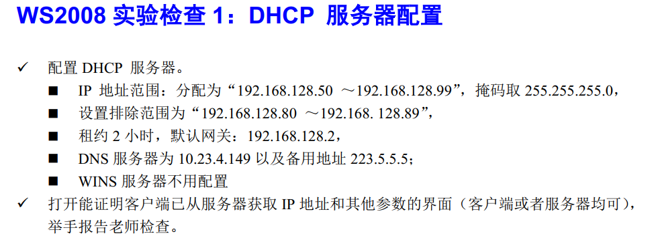

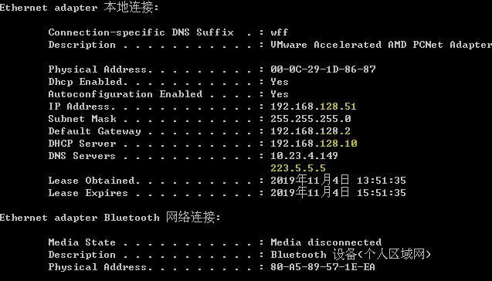

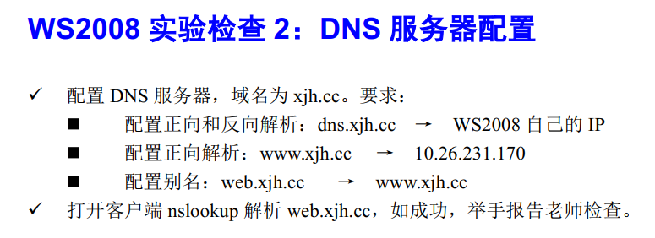

打开GuestOS的WinXP，设置DNS服务器为你配置的WS2008。

P22-30 34-40 50-54

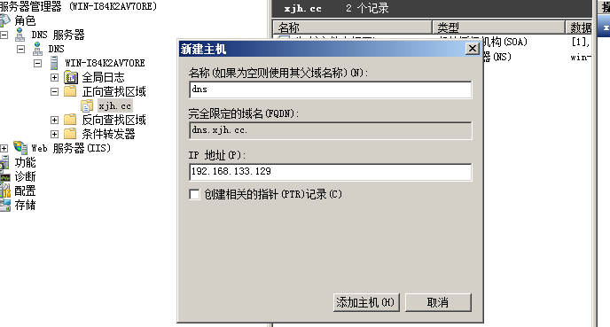

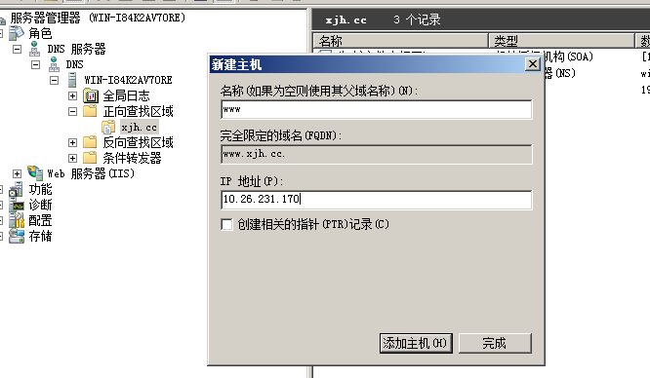

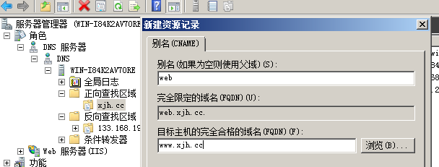

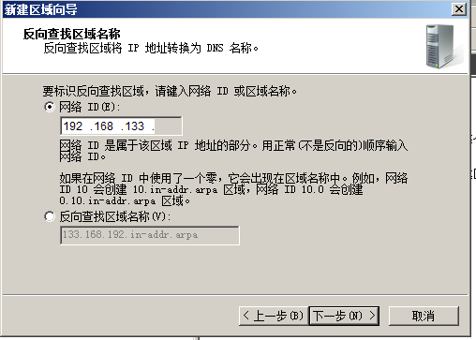

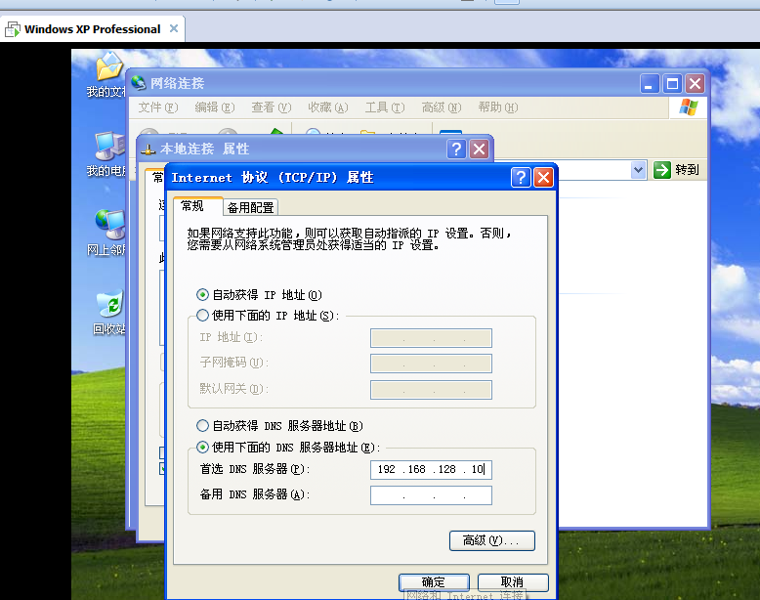

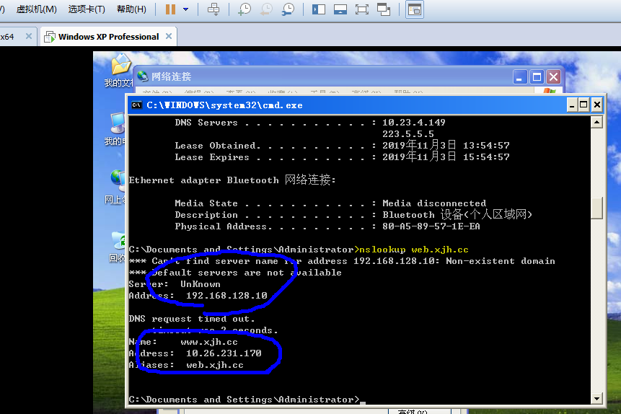

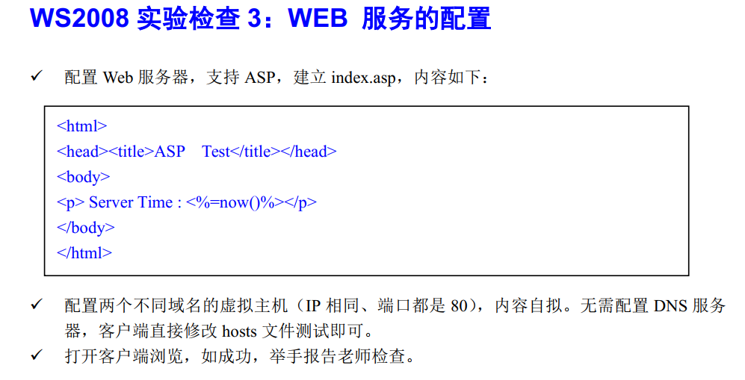

<html>

<head><title>ASP Test</title></head>

<body>

<p> Server Time : <%=now()%></p>

</body>

</html>

<html>

<head><title>Web Server</title></head>

<body>

<h1 align="center">Web Server Test</h1>

</body>

</html>

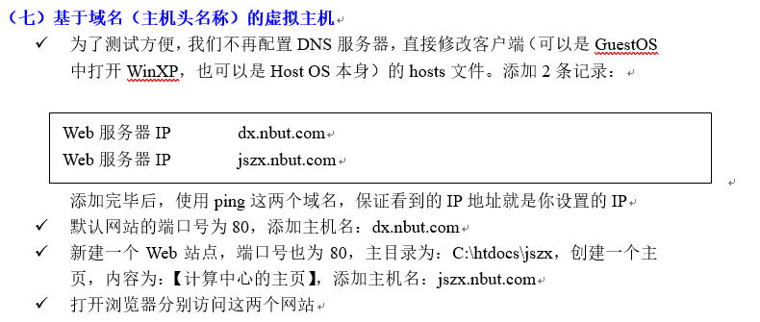

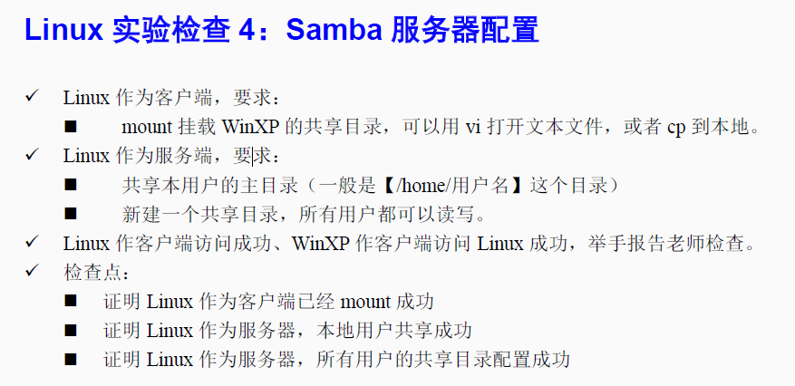

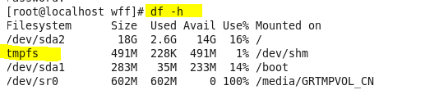

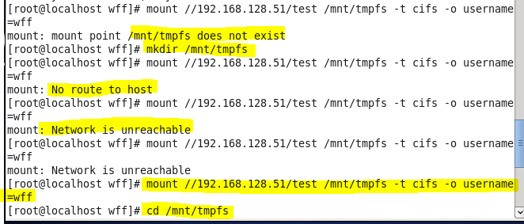

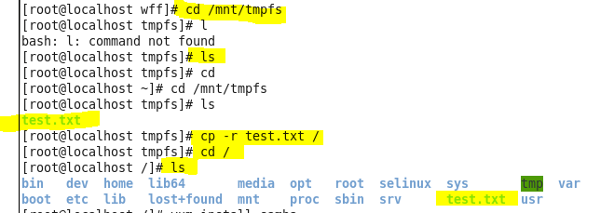

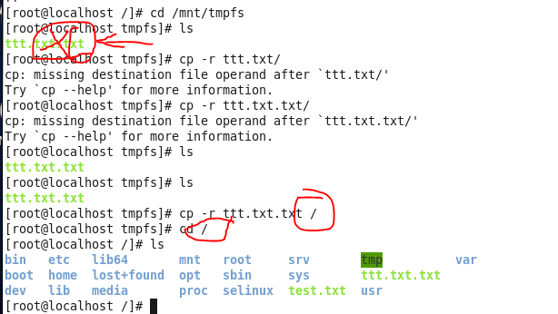

服务端



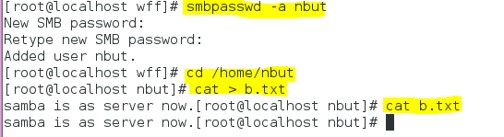

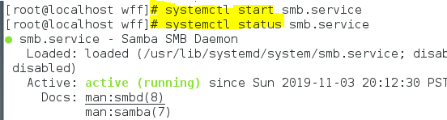

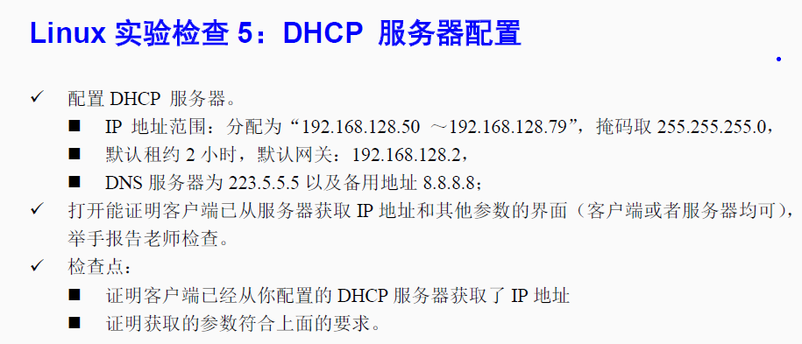



**安装 dhcp:** yum I nstall dhcp

**查看是否安装好dhcp：**rpm -qa|gerp dhcp

**给Linux配置默认地址：**

找端口：#cd /etc/sysconfig/network-scripts/

#ls

修改IP 参数（可以和目标同网段）#vim 端口

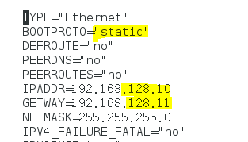

重启网络：#service network restart

查看新配置IP 地址： ifconfig

**修改dhcp 配置文件**：#cd /etc/dhcp

#vi dhcpd.conf

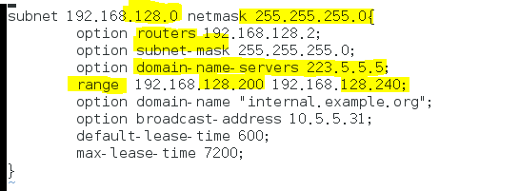

**查看dhcp状态**：#service dhcpd status

**重启/关闭的dhcp:** #systemctl restart dhcpd.service

stop

**客户端测试：yyyyyy**

Ipconfig/renew

Ipconfig/all

**服务端查看:**

#Cd /var/lib/dhcpd

#Ls

#More dhcpd.leases

