**VIRTUAL MOUSE**

Deepika P  
Computer Science and Engineering  
Panimalar Engineering CollegeChennai  
deepika200110@gmail.com

Janani N  
Computer Science and Engineering  
Panimalar Engineering CollegeChennai  
janani19101@gmail.com

Janet Jessica R  
Computer Science and Engineering  
Panimalar Engineering CollegeChennai janetjessica10062000@gmail.com

*Abstract*— Virtual Mouse utilizes various image processing techniques to eliminate the need for a hardware mouse while enabling users to interact with the computer system through webcam. It enhances Human Computer Interaction (HCI) by utilizing a camera and computer vision technology to control numerous mouse events and is capable of performing all functions that a physical computer mouse can accomplish. This type of HCI is referred to as "natural user interface" (NUI). In recent decades, the keyboard and mouse have become progressively important in human-computer interaction. This incorporates the advancement of touch technology over buttons, as well as other gesture control modalities. A conventional camera may be utilized to create a hand tracking- based virtual mouse.

Keywords— Computer vision, Dynamic hand gesture

Introduction

Vision-based hand gesture recognition includes static hand gesture recognition and dynamic hand gesture recognition. Dynamic hand gestures are more reliable and natural in human-robot interaction (HRI) or human-computer interaction (HCI) than static hand gestures (HCI). Dynamic hand gestures, on the other hand, combine both temporal and spatial information, making recognition more difficult. Furthermore, in order to recognize dynamic hand gestures online, each dynamic hand motion must be located and segmented from streaming video. Therefore, developing effective dynamic hand gesture localization methods is an important research challenge. Our study on online detection and recognition of dynamic hand movements, design a new recognition method, and apply it to hand-based HRI in order to address these issues. The principal method of hand gesture recognition uses a feature extractor to extract hand gesture features and then a using classifier to classify the extracted features for the recognition of different hand gestures. Image-based hand gesture detection has made significant progress recently. Furthermore, 3D pose estimation of hand joints can increase the accuracy of dynamic hand gesture recognition. Because the hand often occupies only a small part of a collected image, the accurate detection of dynamic hand gestures is the key to dynamic hand gesture recognition. This device, the webcam, will be constantly used by software that monitors the user’s gestures in order to interpret and translate them into pointes motion, comparable to a physical mouse.

# Literature survey

## Title : **Implementing a Real Time Virtual Mouse System and Fingertip Detection based on Artificial Intelligence**

* Author: **Banda Aneela, Narlanka Vasuki, Rebelli Sai Sahana, Charupalli Sunil Kumar**
* Year: 2021
* It involves the progression of touch technology over buttons and variety of other gesture control modalities. A normal camera can be used to construct a hand tracking- based virtual mouse application. Here they combined camera and computer vision technologies, such as finger- tip identification and gesture recognition, into the proposed system to handle mouse operations (volume control, right click, left click), and show how it can execute all that existing mouse devices can but it does not work on browser.

## Title : Hand Gestures – Virtual Mouse for Human Computer Interaction

## Author: [Sherin Mohammed Sali Shajideen](https://ieeexplore.ieee.org/author/37086874147);

* Year: 2019

## Title : Hand Gestures – Virtual Mouse for Human Computer Interaction

* Author: Mahmoud M. Badr , Wesa Al Amiri , Mostafa M. Fouda, Mohamed Mahmound, Abdulah J. Aljohani and Waleed Alasmary
* Year: 2019
* It focuses on the improvement of human computer interaction systems using hand gesture with 3-D space by using two camera in position. It works on accurate values in finger pointing with 3-D space methodology. It detects complete hand with palm and fingers but the process is too complex.

## Title : Virtual Mouse Control Using hand gloves

* Author: Wenhui Zhang, FanGao, ShuruiSun, QiuyingYu, JinjunTang, BohangLiu
* Year :2019

This paper involves a virtual mouse system using colored hand glove based on HCI using computer vision and hand gestures. Gestures captured with a webcam which processed with color segmentation, detection technique and feature extraction using robotic arm technology.

## Title : Design and Development of Hand Gesture Based Virtual Mouse

* Author : Tiwari, Siddhi Parkar, Shruti Gharat, Kinjal Patel, Prof. Khalil Pinjari
* Year : 2019
* It proposes a virtual mouse system based on HCI using computer vision and hand gestures. Gestures captured with a built-in camera or webcam were processed with color segmentation & detection technique. It works on Histogram analysis of skin pixels methodology.

## Title :Virtual Mouse Implementation using Open CV

* Author: Kollipara Sai Varun, I. Puneeth, Dr. T. Prem Jacob
* Year: 2019
* This This paper focuses on the improvement of human computer interaction systems using hand gesture with 3-D space by using two camera in position. The hand pointing gesture is estimated and mapped to the screen coordinate system. The human-computer interaction (HCI) system proposed consists of hand pointing detection. The overview of the system has three different strategies for hand pointing gesture such as detection of hand region, tracking of hand features, Making 3D pointing towards direction
* F. Title:Hand-Mouse Interface Using Virtual Monitor Concept for Natural Interaction
* Author: Changhyun jeon, oh-jin kwon, dongil shin, and dongkyoo shin
* Year: 2018
* This This paper uses implementation of hand mouse interface that introduces a concept called as “virtual monitor” to extract the user’s physical features through Kinect in real time because recognition algorithms such as NUI/NUX are difficult to train and takes a long time for testing. In this paper, preprocessing, normalization and feature extraction are used. The virtual monitor uses a virtual space to control the hand mouse. The accuracy experiment showed the high accuracy level of the mouse functions [drag (80.9%), click (80%), double-click (76.7%)].
* Title: Measurement of 3D-Velocity by High-Frame-Rate Optical Mouse Sensors to Extrapolate 3D Position Captured
* Author : Itsuo Kumazawa, Toshihiro Kai, Yoshikazu Onuki, and Shunsuke Ono
* Year : 2017
* This paper proposes to use a pair of optical-mouse-sensors as a stereo image sensor to measure 3D velocity and use it to extrapolate 3D position measured by a low frame-rate stereo camera. This paper specifies that it requires a lot of computational costs to find correspondence between stereo images to compute distance. This paper deals with the optical mouse sensor mounted with lenses customized for quick hand motion detection. A quick hand swing is performed within 66ms for the range of 60 degree of angle over the sensor. 30 trials for each of 8 swing directions are conducted under various illumination conditions.
* Title: Virtual Mouse with RGB Colored Tapes
* Author: Upasana, V Monisha Joseph, Kanchana V.p
* Year: 2017
* This paper tries to use a camera and computer vision technologies such as gesture recognition and image segmentation to control tasks with colored tapes and shows how it can perform all the mouse functions a physical mouse can perform. In the first phase, hand gestures are acquired using a camera based on colour detection technique using segmentation and image subtraction algorithm. In the second phase, RGB colored tapes are used to control different functions of the mouse and also the combination of these 3 colors by considering the area of each object/colored tape using the blob analysis and the bounding box algorithm. The user must wear the red, green and blue tapes to the fingers such that it is easy to make the movements for each tape and also the combination of the colored tapes to acquire the desired output of the cursor movement in the system

# proposed methodology

Using the present technology, we could utilise the laptop or webcam to recognise the hand gesture and operate the mouse and execute simple operations like manipulating the mouse pointer, choosing and deselecting using left click. As we progress into the modern world, we are adopting the most advanced Artificial Intelligence technologies. The web camera may be used to control the mouse. Python is a simple language that is platform independent, flexible, and portable, all of which are useful in developing a programme with a specific goal in mind, such as building a virtual mouse.

## Advantages:

* It helps to interact with the computer with non- contact human computer interaction
* Convenient for user who is not comfortable with touch pad
* This framework can also be used in gaming application, independent of gesture control
* Virtual mouse eliminates mechanical wear and tear of physical mouse

# system architecture

# 

# Results and discussions

Performance analysis was performed 10 times to evaluate the accuracy of the detection by performing a range of quick gestures. This information was captured and analysed so that we could show that our approach is better suitable with real-world applications and user-friendly.

We'll assume that X represents the number of fingertips visible on the right hand. Under normal lighting circumstances, each individual participant performs out the gestures. The trails were repeated 10 times with each gesture from 1 to 5, totaling 600 gestures that were manually labelled as ground truth. Mouse movement (X = 1), left-click (X = 2), right-click (X = 3 || X = 4) and no action (X = 5 || X = 0) were among the gestures. Every participant was right-handed since we were focusing on right-hand movement for convenience of detection and accuracy.

**Table 1 Accuracy of virtual mouse**

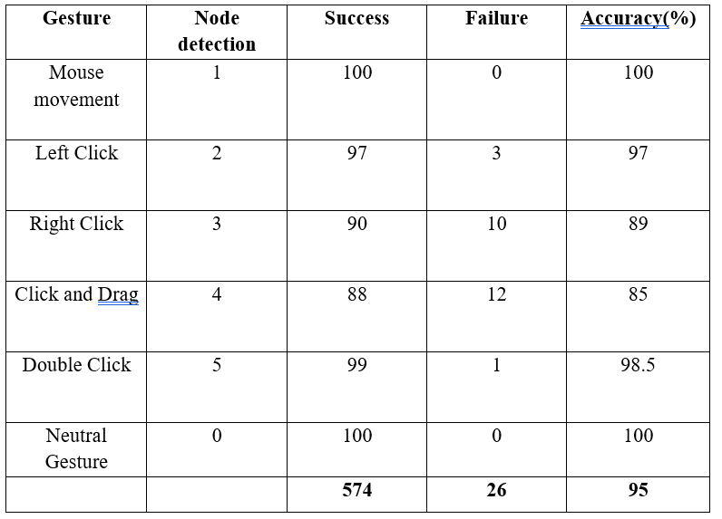

Table 1 shows the results of our experimental testing of our Virtual mouse technology. On average, 96.13 percent of the predictions are accurate. This is a very high level of performance for a gesture-based interface. As expected, the less difficult gesture known as "mouse movement" achieved the best accuracy, while the more difficult gesture known as "right-click" achieved the lowest accuracy. Because quick fingertip tracking occasionally led it to be confused with other gestures, the 'right-click' gesture's precision was reduced. The experiment also shows the results did not change significantly over a spectrum of resolutions.

## Accuracy = DF / TF × 100%

DF- number of successfully recognized operations .

TF -number of total operations.

The accuracy of our system using the above equation is 95%. Since the system uses webcam captured videos, the performance of the system may depend on illumination.

# conclusion

We've developed a technology that, in the not-too-distant future, will allow us to replace the real mouse with our own virtual mouse. A virtual mouse is the most efficient way for humans to interface with computers. The ability to recognise gestures is critical for the development of new forms of human-computer interaction. It makes it possible for humans and robots to connect in a more natural way than before. Our virtual mouse will assist in reducing clutter in the workplace. We believe that the greatest location to start delivering artificial intelligence-based modernity to the rest of the globe is with our virtual mouse.

# References

1. Banda Aneela , Narlanka Vasuki, Rebelli Sai Sahana, Charupalli Sunil Kumar, (2021), ”Implementing a Real Time Virtual Mouse System and Fingertip Detection based on Artificial Intelligence”. Institute of Electrical and Electronics Engineering (IEEE), pp. 6299–6308.
2. [Sherin](https://ieeexplore.ieee.org/author/37086874147) [Mohammed](https://ieeexplore.ieee.org/author/37086874147) [Sali](https://ieeexplore.ieee.org/author/37086874147) [Shajideen](https://ieeexplore.ieee.org/author/37086874147); [VH](https://ieeexplore.ieee.org/author/37086054925) [Preetha](https://ieeexplore.ieee.org/author/37086054925)(2019) “Hand Gestures - Virtual Mouse for Human Computer Interaction” Institute of Electrical and Electronics Engineering(IEEE), pp. 5239–2301.
3. Vantukala Vishnu Teja Reddy, Thumma Dhyanchand , Galla Vamsi Krishna , Satish Maheshwaram (2019), “Virtual Mouse Control Using hand gloves ” Institute of Electrical and Electronics Engineering(IEEE), pp. 1239–5239.
4. Tiwari, Siddhi Parkar, Shruti Gharat, Kinjal Patel, Prof. Khalil Pinjari, (2019) “Design and Development of Hand Gesture Based Virtual Mouse”, Institute of Electrical and Electronis Engineering(IEEE) , pp. 8745–3219.
5. Kollipara Sai Varun, I. Puneeth, Dr. T. Prem Jacob, (2019) “Virtual Mouse Implementation using Open CV”, Institute of Electrical and Electronics Engineering(IEEE), pp. 2341–9834.
6. Swati Tiwari, Siddhi Parkar, Shruti Gharat, Kinjal Patel, Prof. Khalil Pinjari, (2018), “Virtual mouse using sixth sense technology” Institute of Electrical and Electronics Engineering(IEEE), pp. 4312–7865.
7. Sherin Mohammed Sali Shajideen Preetha V H, YEAR: March 2018, “Virtual Mouse for Human Computer Interaction”, Institute of Electrical and Electronis Engineering(IEEE), ISBN : pp. 7891–2308.
8. Changhyun jeon, oh-jin kwon, dongil shin, and dongkyoo shin, (2018), “Hand- Mouse Interface Using Virtual Monitor Concept for Natural Interaction”, Institute of Electrical and Electronics Engineering(IEEE), pp. 6534–2354.
9. Itsuo Kumazawa, Toshihiro Kai, Yoshikazu Onuki, and Shunsuke Ono,(2017) “Measurement of 3D-Velocity by High-Frame-Rate Optical Mouse Sensors to Extrapolate 3D Position Captured”, Institute of Electrical and Electronis Engineering(IEEE), pp. 7634-1254.
10. S. S. Rautaray, A. Agrawal, “Vision based hand gesture recognition for human computer interaction: a survey,” Artificial intelligence review., vol. 43, no. 1, pp. 1–54, 2017.