Assignment1 Jia Yun Xuan 301230410

subsample.m

function [ subimage ] = subsample(image, factor)

% calculate the new dimension, make each new pixel = old pixel * factor

scale = [sqrt(factor) sqrt(factor)];

oldS = size(image);

newS = max(floor(scale.*oldS(1:2)),1);

% Compute the new index

rowInd = min(round((1:newS(1))./scale(1)),oldS(1));

colInd = min(round((1:newS(2))./scale(2)),oldS(2));

% Put new index into new image

subimage = image(rowInd,colInd,:);

return;

end

shrink.m

function [ shrinkIM ] = shrink(image)

% calculate the new dimension, reduce the length of both col and row by 2

factor=0.5;

scale = [factor factor];

oldS = size(image);

newS = max(floor(scale.*oldS(1:2)),1);

% Compute the new index

rowInd = min(round((1:newS(1))./scale(1)),oldS(1));

colInd = min(round((1:newS(2))./scale(2)),oldS(2));

% Put new index into new image

shrinkIM = image(rowInd,colInd,:);

end

zoom.m

function [ zoomIM ] = zoom( image )

% calculate the new dimension, twice the length of both col and row

factor=2;

scale = [factor factor];

oldS = size(image);

newS = max(floor(scale.*oldS(1:2)),1);

% Compute the new index

rowInd = min(round((1:newS(1))./scale(1)),oldS(1));

colInd = min(round((1:newS(2))./scale(2)),oldS(2));

% Put new index into new image

zoomIM = image(rowInd,colInd,:);

end

myrotate.m

function [ myrotateIM ] = myrotate( image )

%rotate 90 degrees clockwise

% reflect image about horizontal axis

I = image(end:-1:1,:,:);

% transpose 3 planes

T1=transpose(I(:, :, 1));

T2=transpose(I(:, :, 2));

T3=transpose(I(:, :, 3));

% combine 3 planes to one image

myrotateIM=cat(3, T1, T2, T3);

end

reflect.m

function [ reflectIM ] = reflect( image )

% reflect image about the vertical axis

reflectIM = image(:,end:-1:1,:);

end

dim.m

function [ dimIM ] = dim( image, fraction )

% scale every pixel in the image by fraction

dimIM=image(:, :, :)*fraction;

end

contrast_compress.m

function [ contrastIM ] = comtrast_compress( image )

% take the square root of all the pixels in every color plane and add them

% to one plane(compress)

adjIM=(sqrt(double(image(:, :, 1))) + sqrt(double(image(:, :, 2))) + sqrt(double(image(:, :, 3))));

% scale every pixel to [0,1] intensity

contrastIM=(double(adjIM(:,:)))/255*4; %/255makes image too dark, *4 to add more contrast

end

assign1.m

%cmpt412-assignment1

%author: Janet Xuan

image=imread('ThreePenniesAreduced.jpg');

% small image:

% image = zeros(6,6,3);

% image(:,:,1)=magic(6);

% image(:,:,2)=magic(6)';

% image(:,:,3)=ones(6)/2;

% image=image/max(image(:));

figure

imshow(image)

title('Original Image')

%%%%%%%%%%%%%%% subimage %%%%%%%%%%%%%%%%

[subimage] = subsample(image, 0.3);

figure

imshow(subimage)

title('subimage IMage')

%%%%%%%%%%%%%%% shrink %%%%%%%%%%%%%%%%%%

[shrinkIM] = shrink(image);

figure

imshow(shrinkIM)

title('shrink IMage')

%%%%%%%%%%%%%%% zoom %%%%%%%%%%%%%%%%%%

[zoomIM] = zoom(image);

figure

imshow(zoomIM)

title('zoom IMage')

%%%%%%%%%%%%%%% rotate %%%%%%%%%%%%%%%%%

[myrotateIM] = myrotate(image);

figure

imshow(myrotateIM)

title('rotate IMage 90 degrees clockwise')

%%%%%%%%%%%%%%% reflect %%%%%%%%%%%%%%%%%

[reflectIM] = reflect(image);

figure

imshow(reflectIM)

title('reflect IMage about the vertical axis')

%%%%%%%%%%%%%%% dim %%%%%%%%%%%%%%%

[dimIM] = dim(image, 0.3);

figure

imshow(dimIM)

title('darker Image by the fraction')

%%%%%%%%%%%%%%% contrast_compress %%%%%%%%%

[ contrastIM ] = comtrast_compress( image );

figure

imshow(contrastIM)

title('comtrast and compress image')

Test results:

subsample:

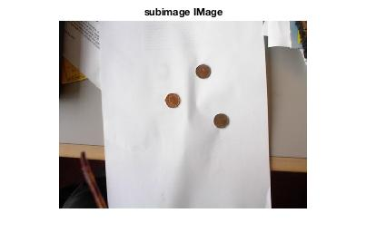

shrink:

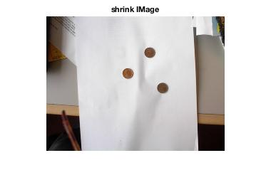

zoom

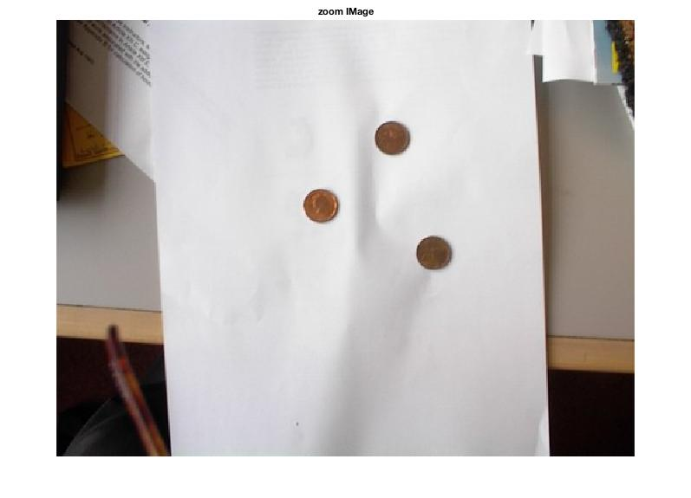

>> assign1

Warning: Image is too big to fit on screen; displaying at 67%

> In images.internal.initSize (line 71)

In imshow (line 328)

In assign1 (line 25)

myrotate

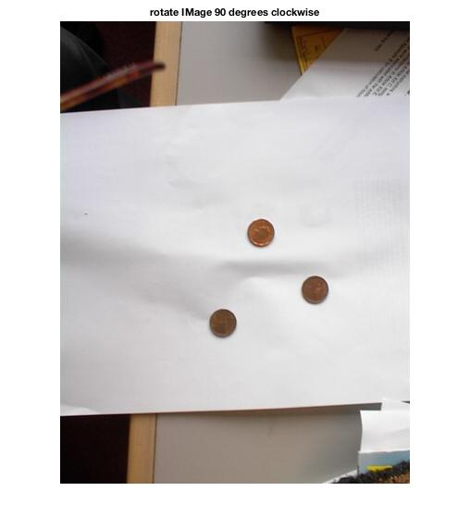

reflect

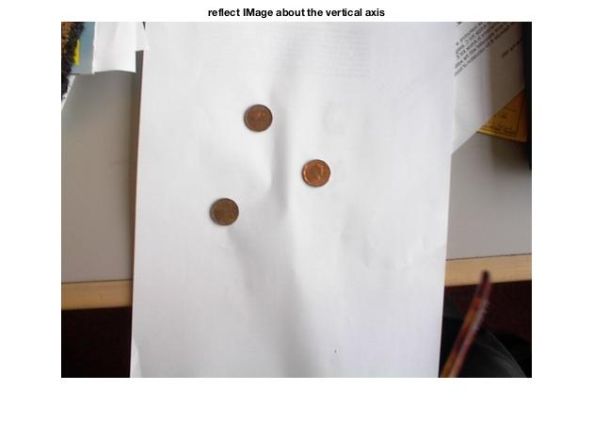

dim

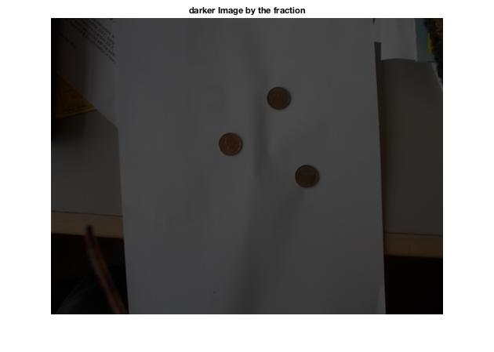

contrast_compress

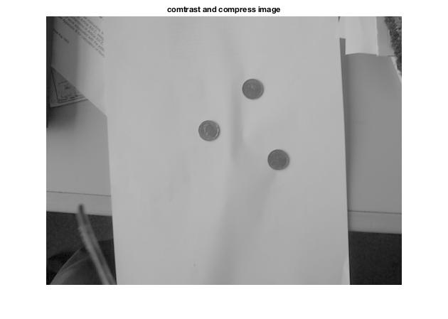

Test results for very small images:

image = zeros(6,6,3);

image(:,:,1)=magic(6);

image(:,:,2)=magic(6)';

image(:,:,3)=ones(6)/2;

image=image/max(image(:));

original image:

val(:,:,1) =

0.9722 0.0278 0.1667 0.7222 0.5278 0.6667

0.0833 0.8889 0.1944 0.5833 0.6389 0.6944

0.8611 0.2500 0.0556 0.6111 0.7500 0.5556

0.2222 0.7778 0.9167 0.4722 0.2778 0.4167

0.8333 0.1389 0.9444 0.3333 0.3889 0.4444

0.1111 1.0000 0.8056 0.3611 0.5000 0.3056

val(:,:,2) =

0.9722 0.0833 0.8611 0.2222 0.8333 0.1111

0.0278 0.8889 0.2500 0.7778 0.1389 1.0000

0.1667 0.1944 0.0556 0.9167 0.9444 0.8056

0.7222 0.5833 0.6111 0.4722 0.3333 0.3611

0.5278 0.6389 0.7500 0.2778 0.3889 0.5000

0.6667 0.6944 0.5556 0.4167 0.4444 0.3056

val(:,:,3) =

0.0139 0.0139 0.0139 0.0139 0.0139 0.0139

0.0139 0.0139 0.0139 0.0139 0.0139 0.0139

0.0139 0.0139 0.0139 0.0139 0.0139 0.0139

0.0139 0.0139 0.0139 0.0139 0.0139 0.0139

0.0139 0.0139 0.0139 0.0139 0.0139 0.0139

0.0139 0.0139 0.0139 0.0139 0.0139 0.0139

subimage:

val(:,:,1) =

0.8889 0.5833 0.6389

0.7778 0.4722 0.2778

0.1389 0.3333 0.3889

val(:,:,2) =

0.8889 0.7778 0.1389

0.5833 0.4722 0.3333

0.6389 0.2778 0.3889

val(:,:,3) =

0.0139 0.0139 0.0139

0.0139 0.0139 0.0139

0.0139 0.0139 0.0139

shrink:

val(:,:,1) =

0.8889 0.5833 0.6944

0.7778 0.4722 0.4167

1.0000 0.3611 0.3056

val(:,:,2) =

0.8889 0.7778 1.0000

0.5833 0.4722 0.3611

0.6944 0.4167 0.3056

val(:,:,3) =

0.0139 0.0139 0.0139

0.0139 0.0139 0.0139

0.0139 0.0139 0.0139

zoom

val(:,:,1) =

Columns 1 through 9

0.9722 0.9722 0.0278 0.0278 0.1667 0.1667 0.7222 0.7222 0.5278

0.9722 0.9722 0.0278 0.0278 0.1667 0.1667 0.7222 0.7222 0.5278

0.0833 0.0833 0.8889 0.8889 0.1944 0.1944 0.5833 0.5833 0.6389

0.0833 0.0833 0.8889 0.8889 0.1944 0.1944 0.5833 0.5833 0.6389

0.8611 0.8611 0.2500 0.2500 0.0556 0.0556 0.6111 0.6111 0.7500

0.8611 0.8611 0.2500 0.2500 0.0556 0.0556 0.6111 0.6111 0.7500

0.2222 0.2222 0.7778 0.7778 0.9167 0.9167 0.4722 0.4722 0.2778

0.2222 0.2222 0.7778 0.7778 0.9167 0.9167 0.4722 0.4722 0.2778

0.8333 0.8333 0.1389 0.1389 0.9444 0.9444 0.3333 0.3333 0.3889

0.8333 0.8333 0.1389 0.1389 0.9444 0.9444 0.3333 0.3333 0.3889

0.1111 0.1111 1.0000 1.0000 0.8056 0.8056 0.3611 0.3611 0.5000

0.1111 0.1111 1.0000 1.0000 0.8056 0.8056 0.3611 0.3611 0.5000

Columns 10 through 12

0.5278 0.6667 0.6667

0.5278 0.6667 0.6667

0.6389 0.6944 0.6944

0.6389 0.6944 0.6944

0.7500 0.5556 0.5556

0.7500 0.5556 0.5556

0.2778 0.4167 0.4167

0.2778 0.4167 0.4167

0.3889 0.4444 0.4444

0.3889 0.4444 0.4444

0.5000 0.3056 0.3056

0.5000 0.3056 0.3056

val(:,:,2) =

Columns 1 through 9

0.9722 0.9722 0.0833 0.0833 0.8611 0.8611 0.2222 0.2222 0.8333

0.9722 0.9722 0.0833 0.0833 0.8611 0.8611 0.2222 0.2222 0.8333

0.0278 0.0278 0.8889 0.8889 0.2500 0.2500 0.7778 0.7778 0.1389

0.0278 0.0278 0.8889 0.8889 0.2500 0.2500 0.7778 0.7778 0.1389

0.1667 0.1667 0.1944 0.1944 0.0556 0.0556 0.9167 0.9167 0.9444

0.1667 0.1667 0.1944 0.1944 0.0556 0.0556 0.9167 0.9167 0.9444

0.7222 0.7222 0.5833 0.5833 0.6111 0.6111 0.4722 0.4722 0.3333

0.7222 0.7222 0.5833 0.5833 0.6111 0.6111 0.4722 0.4722 0.3333

0.5278 0.5278 0.6389 0.6389 0.7500 0.7500 0.2778 0.2778 0.3889

0.5278 0.5278 0.6389 0.6389 0.7500 0.7500 0.2778 0.2778 0.3889

0.6667 0.6667 0.6944 0.6944 0.5556 0.5556 0.4167 0.4167 0.4444

0.6667 0.6667 0.6944 0.6944 0.5556 0.5556 0.4167 0.4167 0.4444

Columns 10 through 12

0.8333 0.1111 0.1111

0.8333 0.1111 0.1111

0.1389 1.0000 1.0000

0.1389 1.0000 1.0000

0.9444 0.8056 0.8056

0.9444 0.8056 0.8056

0.3333 0.3611 0.3611

0.3333 0.3611 0.3611

0.3889 0.5000 0.5000

0.3889 0.5000 0.5000

0.4444 0.3056 0.3056

0.4444 0.3056 0.3056

val(:,:,3) =

Columns 1 through 9

0.0139 0.0139 0.0139 0.0139 0.0139 0.0139 0.0139 0.0139 0.0139

0.0139 0.0139 0.0139 0.0139 0.0139 0.0139 0.0139 0.0139 0.0139

0.0139 0.0139 0.0139 0.0139 0.0139 0.0139 0.0139 0.0139 0.0139

0.0139 0.0139 0.0139 0.0139 0.0139 0.0139 0.0139 0.0139 0.0139

0.0139 0.0139 0.0139 0.0139 0.0139 0.0139 0.0139 0.0139 0.0139

0.0139 0.0139 0.0139 0.0139 0.0139 0.0139 0.0139 0.0139 0.0139

0.0139 0.0139 0.0139 0.0139 0.0139 0.0139 0.0139 0.0139 0.0139

0.0139 0.0139 0.0139 0.0139 0.0139 0.0139 0.0139 0.0139 0.0139

0.0139 0.0139 0.0139 0.0139 0.0139 0.0139 0.0139 0.0139 0.0139

0.0139 0.0139 0.0139 0.0139 0.0139 0.0139 0.0139 0.0139 0.0139

0.0139 0.0139 0.0139 0.0139 0.0139 0.0139 0.0139 0.0139 0.0139

0.0139 0.0139 0.0139 0.0139 0.0139 0.0139 0.0139 0.0139 0.0139

Columns 10 through 12

0.0139 0.0139 0.0139

0.0139 0.0139 0.0139

0.0139 0.0139 0.0139

0.0139 0.0139 0.0139

0.0139 0.0139 0.0139

0.0139 0.0139 0.0139

0.0139 0.0139 0.0139

0.0139 0.0139 0.0139

0.0139 0.0139 0.0139

0.0139 0.0139 0.0139

0.0139 0.0139 0.0139

0.0139 0.0139 0.0139

myrotate:

val(:,:,1) =

0.1111 0.8333 0.2222 0.8611 0.0833 0.9722

1.0000 0.1389 0.7778 0.2500 0.8889 0.0278

0.8056 0.9444 0.9167 0.0556 0.1944 0.1667

0.3611 0.3333 0.4722 0.6111 0.5833 0.7222

0.5000 0.3889 0.2778 0.7500 0.6389 0.5278

0.3056 0.4444 0.4167 0.5556 0.6944 0.6667

val(:,:,2) =

0.6667 0.5278 0.7222 0.1667 0.0278 0.9722

0.6944 0.6389 0.5833 0.1944 0.8889 0.0833

0.5556 0.7500 0.6111 0.0556 0.2500 0.8611

0.4167 0.2778 0.4722 0.9167 0.7778 0.2222

0.4444 0.3889 0.3333 0.9444 0.1389 0.8333

0.3056 0.5000 0.3611 0.8056 1.0000 0.1111

val(:,:,3) =

0.0139 0.0139 0.0139 0.0139 0.0139 0.0139

0.0139 0.0139 0.0139 0.0139 0.0139 0.0139

0.0139 0.0139 0.0139 0.0139 0.0139 0.0139

0.0139 0.0139 0.0139 0.0139 0.0139 0.0139

0.0139 0.0139 0.0139 0.0139 0.0139 0.0139

0.0139 0.0139 0.0139 0.0139 0.0139 0.0139

reflect:

val(:,:,1) =

0.6667 0.5278 0.7222 0.1667 0.0278 0.9722

0.6944 0.6389 0.5833 0.1944 0.8889 0.0833

0.5556 0.7500 0.6111 0.0556 0.2500 0.8611

0.4167 0.2778 0.4722 0.9167 0.7778 0.2222

0.4444 0.3889 0.3333 0.9444 0.1389 0.8333

0.3056 0.5000 0.3611 0.8056 1.0000 0.1111

val(:,:,2) =

0.1111 0.8333 0.2222 0.8611 0.0833 0.9722

1.0000 0.1389 0.7778 0.2500 0.8889 0.0278

0.8056 0.9444 0.9167 0.0556 0.1944 0.1667

0.3611 0.3333 0.4722 0.6111 0.5833 0.7222

0.5000 0.3889 0.2778 0.7500 0.6389 0.5278

0.3056 0.4444 0.4167 0.5556 0.6944 0.6667

val(:,:,3) =

0.0139 0.0139 0.0139 0.0139 0.0139 0.0139

0.0139 0.0139 0.0139 0.0139 0.0139 0.0139

0.0139 0.0139 0.0139 0.0139 0.0139 0.0139

0.0139 0.0139 0.0139 0.0139 0.0139 0.0139

0.0139 0.0139 0.0139 0.0139 0.0139 0.0139

0.0139 0.0139 0.0139 0.0139 0.0139 0.0139

dim

val(:,:,1) =

0.2917 0.0083 0.0500 0.2167 0.1583 0.2000

0.0250 0.2667 0.0583 0.1750 0.1917 0.2083

0.2583 0.0750 0.0167 0.1833 0.2250 0.1667

0.0667 0.2333 0.2750 0.1417 0.0833 0.1250

0.2500 0.0417 0.2833 0.1000 0.1167 0.1333

0.0333 0.3000 0.2417 0.1083 0.1500 0.0917

val(:,:,2) =

0.2917 0.0250 0.2583 0.0667 0.2500 0.0333

0.0083 0.2667 0.0750 0.2333 0.0417 0.3000

0.0500 0.0583 0.0167 0.2750 0.2833 0.2417

0.2167 0.1750 0.1833 0.1417 0.1000 0.1083

0.1583 0.1917 0.2250 0.0833 0.1167 0.1500

0.2000 0.2083 0.1667 0.1250 0.1333 0.0917

val(:,:,3) =

0.0042 0.0042 0.0042 0.0042 0.0042 0.0042

0.0042 0.0042 0.0042 0.0042 0.0042 0.0042

0.0042 0.0042 0.0042 0.0042 0.0042 0.0042

0.0042 0.0042 0.0042 0.0042 0.0042 0.0042

0.0042 0.0042 0.0042 0.0042 0.0042 0.0042

0.0042 0.0042 0.0042 0.0042 0.0042 0.0042

contrast_compress

|  |  |  |  |  |  |
| --- | --- | --- | --- | --- | --- |
| 0.0327823956794400 | 0.00899126166994882 | 0.0228087866321562 | 0.0225739958680406 | 0.0275640033981147 | 0.0198851928542560 |
| 0.00899126166994882 | 0.0314269680527354 | 0.0166087793261468 | 0.0276632290150891 | 0.0202326961620890 | 0.0306068151142132 |
| 0.0228087866321562 | 0.0166087793261468 | 0.00924322589786337 | 0.0291296344772497 | 0.0306776760751333 | 0.0276193661263284 |
| 0.0225739958680406 | 0.0276632290150891 | 0.0291296344772497 | 0.0234073674050245 | 0.0191725125659939 | 0.0214003696806744 |
| 0.0275640033981147 | 0.0202326961620890 | 0.0306776760751333 | 0.0191725125659939 | 0.0214128668097632 | 0.0233980325968780 |
| 0.0198851928542560 | 0.0306068151142132 | 0.0276193661263284 | 0.0214003696806744 | 0.0233980325968780 | 0.0191904741487512 |