TTT G AAATTT GACTG TAA CACAAAG ATAT T A G TAC A AATACG T GACGTAG AAAGTAATAAT TTCTTG GGTAGTTTGCAGT TTTAAAATTATGT TTTAAAAT G AAT G ATTTTT GACTG TAA CACAAAG ATAT T A G TAC A AATACG T GACGTAG AAAGTAATAAT TTCTTG GGTAGTTTGCAGT TTTAAAATTATGT TTTAAAAT G

GACTATCATAT GCT TACCGTAACT TGAAAGTATT TCGATTTC TTG GCTTTATATATC T TG TG GAAAG GACGAAACAC CG GGCATC CTACTTGTCCTAATA GACTATCATAT GCT TACCGTAACT TGAAAGTATT TCGATTTC TTG GCTTTATATATC T TG TG GAAAG GACGAAACAC CG GGCATC CTACTTGTCCTAATA

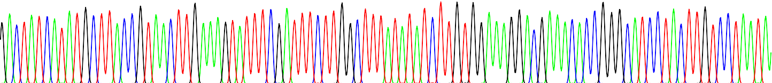

101

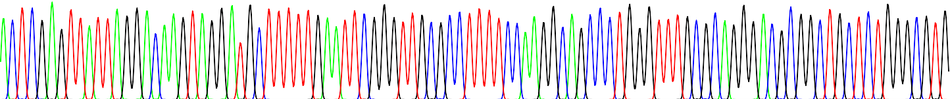

201

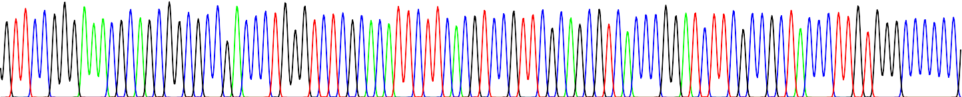

301

G GCGA CGC TTCCTGCTCCGCCCCTAAGT CG GGAAGG TT CCTTGCG GTTCGCGGCGTGCC GGACG TGACAAACG GAAGC CGCACG TCTC ACTAGTACCCTC G GCGA CGC TTCCTGCTCCGCCCCTAAGT CG GGAAGG TT CCTTGCG GTTCGCGGCGTGCC GGACG TGACAAACG GAAGC CGCACG TCTC ACTAGTACCCTC

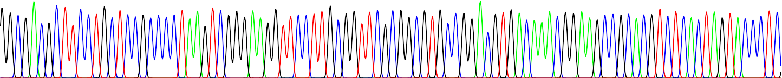

GCAGACGGACAGC GCCAGGG AGCAAT GGCAGC GCGCCG ACC GCGATG GGCT GTG GCCAATA GCGGCTGCT CAGC AG GGCG C GC CGA GA GCAGCG GC CG G GCAGACGGACAGC GCCAGGG AGCAAT GGCAGC GCGCCG ACC GCGATG GGCT GTG GCCAATA GCGGCTGCT CAGC AG GGCG C GC CGA GA GCAGCG GC CG G

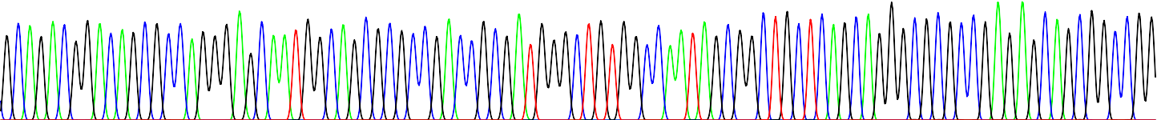

G A AGGGGCG GTGCG GGA GGCG GGGTGTG GGGCG GTAGTGTG GGCC CT G TTCCTGCCC GCGCG GTG TTCCGCATTCTGCAAGCC TCC GG AGC GCACG TCG G A AGGGGCG GTGCG GGA GGCG GGGTGTG GGGCG GTAGTGTG GGCC CT G TTCCTGCCC GCGCG GTG TTCCGCATTCTGCAAGCC TCC GG AGC GCACG TCG

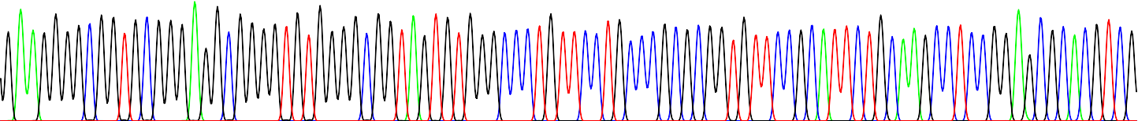

GCAGTCG GC TCCC TCGTTGACCG AATCACCG ACCTC TCTCCCCAGGGG ATCCGCCACCATG GTG AGC AA GG GCG A GG AGCTGTTCACCG GGG TGGTGCCC GCAGTCG GC TCCC TCGTTGACCG AATCACCG ACCTC TCTCCCCAGGGG ATCCGCCACCATG GTG AGC AA GG GCG A GG AGCTGTTCACCG GGG TGGTGCCC



AT CC TGGTCG AGC TGGACGG CG ACGTAAACGGCCAC AA GTTCAGC GTGTCCGGCG A GGGCG A GGG CG ATGCCACC TAC GGCAAGC TG ACCC TGAA GTTCAT AT CC TGGTCG AGC TGGACGG CG ACGTAAACGGCCAC AA GTTCAGC GTGTCCGGCG A GGGCG A GGG CG ATGCCACC TAC GGCAAGC TG ACCC TGAA GTTCAT



CTGCA C ACC GGCAAGCTGCCC GTG CCC TGG CC ACCC TCGTGACACC C TG ACCTACGGCGTGCAGTGCTTCAGCCGCTA C C C GA CCCATG AA GCAG CC GAC T CTGCA C ACC GGCAAGCTGCCC GTG CCC TGG CC CCCC TCGTGACCCC C TG ACCTACGGGGGGCAGGGCTTCAGCCGCTA C C C GA CAAATG AA GCAG AA GAA T

TCTTC A GTCCG C ATGCCCGAA G GTACGT C AGGA TTTTC A GTCCC C ATGCCCGAA G GTAAGT C AGAA

CGCC CATTTTTT T AA GGAG AC GGG ACT C AG GCAA CATCTTCT C AA GGGA AC GGC ACT C AA

1003

902

801

701

602

503

403

1