Modeling, Simulation, and Visualization of a Robotic Manipulator
KUKA KR 6 R900 sixx (AGILUS) 6-DOF

Algebra for the equations is in BLISSjanga_Handwritten. Python code that produced the figures and numerical results is in the Jupyter notebook BLISSjanga_FinalProject.ipynb.

Overview
I decided to pick the KUKA KR 6 R900 sixx from the KR AGILUS family. This robot is a 6-DOF industrial arm with all revolute joints and a true spherical wrist (axes 4, 5 and 6 all meet at one point). The spherical wrists give closed-form inverse kinematics, so Part 6 becomes an algebra problem instead of a numerical one. The PUMA-like shoulder offset ($a_{1}=25$mm) adds shoulder front and shoulder back branches, which made the IK slightly more interesting.
The math in this report uses the DH convention used in class. The derived DH table was cross-checked against the DH figure in Turgut & Kaleli (2022, MDPI Machines).
All code runs in Python 3 inside the conda env rvc (numpy, matplotlib, spatialmath-python, urchin). Running the code regenerates every figure and animation here.

Problem 1 - Robot Identification: KR 6 R900 sixx
I chose the KUKA KR 6 R900 sixx from the KR AGILUS family after seeing KUKA arms building Mercedes cars during a visit to a manufacturing plant in Germany. Watching a factory of these arms weld, handle, and position sheet-metal panels fully coordinated together, quickly and even in a confined space made the precision and compactness of the AGILUS design very interesting. From a project standpoint, the KR 6 R900 sixx is interesting as well because of its true 6R arm with a spherical wrist, which is nice because it gives closed-form inverse kinematics, and because the ROS-Industrial community maintains a well-documented URDF that I can cross-check my DH model against. Its compact size (≈52 kg, 0.9 m reach).
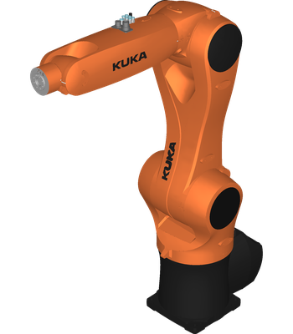

KR 6 R900 sixx Specs.
Source: KUKA OI BA KR AGILUS sixx V12 (2015).
Manufacturer | KUKA Roboter GmbH (Augsburg, Germany)
Family / model | KR AGILUS sixx / KR 6 R900 sixx
Joints | 6 revolute, in-line (spherical) wrist
Reach | $0.901$m to wrist centre ($0.981$m to flange)
Payload | $6$kg max, $3$kg rated
Arm mass | $≈52$kg
Repeatability | $±0.03$mm (ISO 9283)
Working volume | $2.85$m$​^{3}$
Protection | IP54 (WP/HM variants: IP67)
Actuation | brushless AC servo motors with cycloidal (RV-type) reducers on the main axes A1-A3; A4 uses a smaller gear stage, while A5 and A6 are driven via toothed belts that decouple motor placement from the wrist joint axes, reducing distal mass (KUKA OI §3.2, §9.4)
Sensing | per-joint resolvers; motor brakes on every axis
Controller | KR C4 compact
Kinematically, the KR 6 R900 sixx is an anthropomorphic 6R manipulator. Joint A1 allows the robot to have vertical base rotation. Joints A2 (shoulder pitch) and A3 (elbow pitch) form a planar two-link arm in the vertical plane, that have a small 25 mm shoulder offset a₁ which gives the arm a PUMA-like geometry. This offset shifts the shoulder singularity locus from just a line to a thin cylinder around the A1 axis. Joints A4 (wrist roll), A5 (wrist bend), and A6 (tool roll) create aspherical wrist whose three axes all intersect at a single point, the wrist center, that is located 420 mm from the elbow along the forearm. The upper arm length is 455 mm (a₂), and the flange sits 80 mm beyond the wrist centre (d₆). Some typical applications for this robot include high-speed small-part handling, machine tending, assembly, and arc welding in compact, safety-fenced cells. Seeing these applications at the Mercedes plant is what made me so interested.

Joint limits (radians):
$$\begin{matrix}q_{\text{min}} & =[-2.9671, -3.3161, -2.0944, -3.2289, -2.0944, -6.1087]^{​⊤}, \\ q_{\text{max}} & =[+2.9671, +0.7854, +2.7227, +3.2289, +2.0944, +6.1087]^{​⊤},\end{matrix}$$

Problem 2 - DH Frames and DH Table

The Rules for assigning frames (Standard DH)
Frames are assigned following the three rules from the handout:
- $z_{i-1}$ is along the axis of joint $i$.
- $x_{i}$ lies along the common normal from $z_{i-1}$ to $z_{i}$ (pointing from $z_{i-1}$ toward $z_{i}$).
- $y_{i}$ completes a right-handed frame.
Using these conventions, the link parameters $(a_{i},α_{i},d_{i},θ_{i})$ are defined as:
$$\begin{matrix}a_{i} & =\text{distance from }z_{i-1}\text{ to }z_{i}\text{ along }x_{i}, \\ α_{i} & =\text{angle from }z_{i-1}\text{ to }z_{i}\text{ about }x_{i}, \\ d_{i} & =\text{distance from }x_{i-1}\text{ to }x_{i}\text{ along }z_{i-1}, \\ θ_{i} & =\text{angle from }x_{i-1}\text{ to }x_{i}\text{ about }z_{i-1}.\end{matrix}$$
For a revolute joint the variable is $θ_{i}$ ( $θ_{i}=q_{i}$ plus any offset); $a_{i},α_{i},d_{i}$ are constants.

Below on figure 2, it shows the coordinate frames I assigned to the KR 6 R900 sixx by applying the three rules given above to the robot's physical geometry. The assignment applied joint by joint were:
- Frame 0 (base): z₀ points upward along the A1 rotation axis. x₀ is chosen pointing forward (toward the arm's default reach direction). y₀ completes the right-handed frame but is not necessary to draw.
- Frame 1: z₁ points along the A2 axis (horizontal, perpendicular to z₀). x₁ lies along the common normal from z₀ to z₁, offset radially by a₁ = 25 mm(the shoulder offset) which is kept in the same direction for simplicity. The distance from x₀ to x₁ measured along z₀ is d₁ = 400 mm which is the shoulder height. The twist from z₀ to z₁ about x₁ is α₁ = −π/2.
- Frame 2: z₂ is parallel to z₁ (both A2 and A3 are shoulder/elbow pitch axes and are in the same plane), so α₂ = 0. x₂ is along the common normal from z₁ to z₂, spanning the upper arm length a₂ = 455 mm. There is no offset along z₁, so d₂ = 0.
- Frame 3: z₃ points along the A4 axis, which is perpendicular to z₂ (this is the forearm rotates about a different plane than the elbow pitch). x₃ lies along the common normal from z₂ to z₃, covering the 35 mm elbow offset a₃. The twist from z₂ to z₃ about x₃ is α₃ = −π/2. There is a θ offset of −π/2 which is needed so that q₃ = 0 aligns with the URDF software zero (arm extended horizontally) rather than with x₂.
- Frames 4 and 5 (makes a spherical wrist): z₃, z₄, z₅ all intersect at the wrist centre. z₄ is along the A5 axis, perpendicular to z₃, giving α₄ = +π/2. The distance from x₃ to x₄ along z₃ is the forearm length d₄ = 420 mm. z₅ which is along the A6 axis, perpendicular to z₄, giving α₅ = −π/2.
- Frame 6 (flange): z₆ is along the tool axis. a₆ = 0 and α₆ = 0 (there is no twist or offset beyond the wrist). d₆ = 80 mm is the distance from the wrist centre to the flange face.
These assignments make the six rows of the DH table below. The θ-offsets for joints 3, 4, and 6 (−π/2, −π, −π respectively) align the DH software zero with the ROS-Industrial URDF convention where q = 0 corresponds to the arm fully extended horizontally.
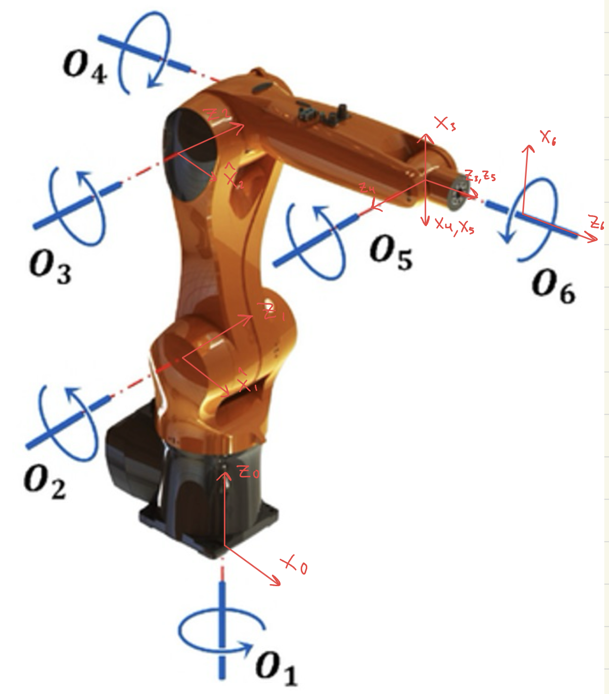
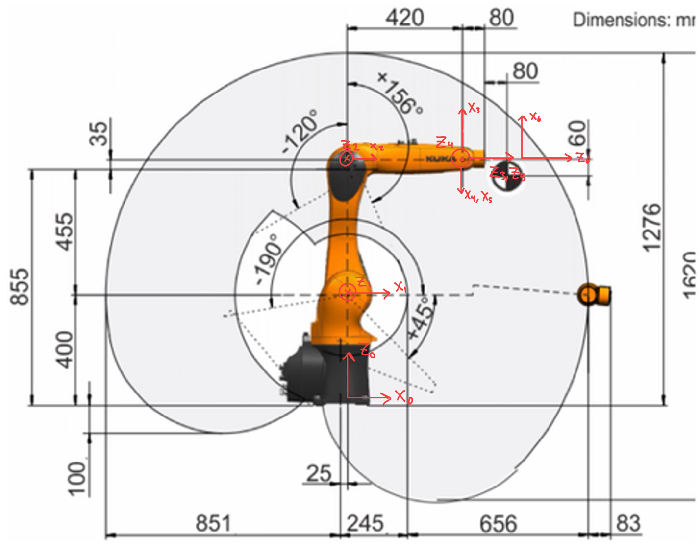
Figure 2-3: DH coordinate frame assignments for the KR 6 R900 sixx at q = 0. (Top) 3D perspective which shows the frame origins at each joint. (Bottom) Side view with dimensions in mm from the KUKA datasheet. Each frame shows xᵢ and zᵢ in red.

The KR 6 Standard-DH table
DH parameters for the KR 6 R900 sixx. Lengths in m, angles in rad. The $θ_{i}$ column is the joint variable $q_{i}$. $q=0$ lines up with the ROS-Industrial URDF software-zero (arm fully extended horizontally).
$$i$$ | $a_{i}$ [m] | $α_{i}$ [rad] | $d_{i}$ [m] | $θ_{i}$ [rad]
1 | $$0.025$$ | $$-π/2$$ | $$0.400$$ | $$θ₁$$
2 | $$0.455$$ | $$0$$ | $$0.000$$ | $$θ₂$$
3 | $$0.035$$ | $$-π/2$$ | $$0.000$$ | $$θ₃$$
4 | $$0.000$$ | $$+π/2$$ | $$0.420$$ | $$θ₄$$
5 | $$0.000$$ | $$-π/2$$ | $$0.000$$ | $$θ₅$$
6 | $$0.000$$ | $$0$$ | $$0.080$$ | $$θ₆$$
Physical meaning of the non-zero parameters:
- $a_{1}=25$mm: shoulder offset (PUMA style).
- $d_{1}=400$mm: shoulder height.
- $a_{2}=455$mm: upper arm length.
- $a_{3}=35$mm: elbow offset between A3 and A4 axes.
- $d_{4}=420$mm: forearm length.
- $d_{6}=80$mm: wrist-centre to flange.

The Standard DH link transform
The transform from frame $i-1$ to frame $i$ is the product of four elementary transforms:
$$T_{i}^{i-1}=R_{z}(θ_{i}) T_{z}(d_{i}) T_{x}(a_{i}) R_{x}(α_{i}).$$
This was derived in class by expanding the four elementary matrices and multiplying them out. The results are:
$$\boxed{ T_{i}^{i-1}(a_{i},α_{i},d_{i},θ_{i}) = \left[\begin{matrix}cθ_{i} & -sθ_{i} cα_{i} & sθ_{i} sα_{i} & a_{i} cθ_{i} \\ sθ_{i} & cθ_{i} cα_{i} & -cθ_{i} sα_{i} & a_{i} sθ_{i} \\ 0 & sα_{i} & cα_{i} & d_{i} \\ 0 & 0 & 0 & 1\end{matrix}\right]. }$$
I’ll check by substituting $q=0$ into and chaining through puts the wrist centre at $(0.900, 0, 0.435)$m. Which is a radial distance from the A1 axis $=0.900$m. KUKA publishes $0.901$m (difference from 4-decimal URDF rounding).
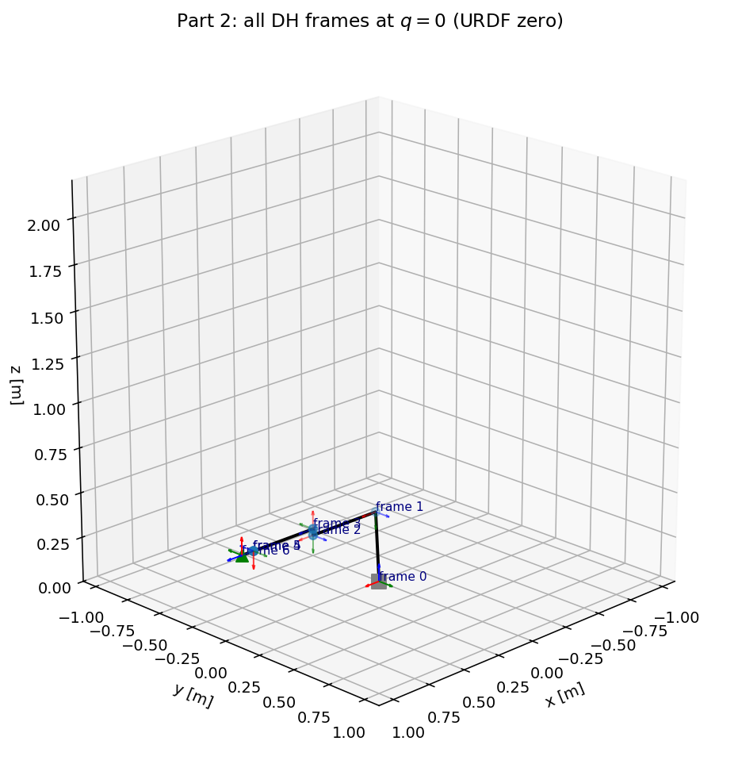
To validate DH frames 0 through 7 computed by the FK code at q = 0 (this is the URDF software zero). Each frame shows xᵢ, yᵢ, zᵢ in the base frame. This plot confirms that the DH table above produces frames that are consistent with the physical joint axes shown in Figure 2-3: each zᵢ lines up with joint i + 1, and the x-axes walk along the common normals between consecutive z-axes.

Problem 3 - Forward Kinematics

Chain product
The forward kinematics is the product of six link transforms from the DH table
$$T_{6}^{0}(q) = T_{1}^{0}(q_{1}) T_{2}^{1}(q_{2}) T_{3}^{2}(q_{3}) T_{4}^{3}(q_{4}) T_{5}^{4}(q_{5}) T_{6}^{5}(q_{6}).$$

Numerical evaluation at the ready pose
The general transformation matrix T⁰₆ was derived by multiplying all six link transforms from the DH table, the derivation for this is worked out in BLISSjanga_Handwritten.pdf. To also check and verify the result numerically, I evaluate at the ready pose (picked to keep $q_{5}≠0$ so the wrist is not singular, and $q_{3}>0$ so that the elbow is bent):
$$q_{\text{ready}} = [0, -π/3, π/3, 0, π/4, 0]^{​⊤}.$$
At $q_{1}=0$:
$$T_{1}^{0}(q_{1}=0)=\left[\begin{matrix}1 & 0 & 0 & 0.025 \\ 0 & 0 & 1 & 0 \\ 0 & -1 & 0 & 0.400 \\ 0 & 0 & 0 & 1\end{matrix}\right]$$
The other five link matrices $T_{2}^{1},…,T_{6}^{5}$ at $q_{\text{ready}}$ are printed by the problem3.py cell on the Jupyter notebook. Multiplying all six link matrices in order produces the pose:
$$\boxed{ T_{6}^{0}​(q_{\text{ready}})=\left[\begin{matrix}-0.7071 & 0 & 0.7071 & 0.7291 \\ 0 & -1 & 0 & 0 \\ 0.7071 & 0 & 0.7071 & 0.8856 \\ 0 & 0 & 0 & 1\end{matrix}\right]. }$$
The flange position $p_{6}=(0.7291, 0, 0.8856)$m, is the tool pointing forward and up at a ${45}^{∘} angle$. This was cross checked with the ROS-Industrial URDF in RViz at the same joint values.

Intermediate link poses $T_{i}^{0}$for $q_{\text{ready}}$:
$$\begin{matrix}T_{2}^{0} & =\left[\begin{matrix}0.5000 & 0.8660 & 0 & 0.2525 \\ 0 & 0 & 1 & 0 \\ 0.8660 & -0.5000 & 0 & 0.7940 \\ 0 & 0 & 0 & 1\end{matrix}\right], & T_{3}^{0} & =\left[\begin{matrix}0 & 0 & 1 & 0.2525 \\ 0 & -1 & 0 & 0 \\ 1 & 0 & 0 & 0.8290 \\ 0 & 0 & 0 & 1\end{matrix}\right], \\ T_{4}^{0} & =\left[\begin{matrix}0 & 1 & 0 & 0.6725 \\ 0 & 0 & -1 & 0 \\ -1 & 0 & 0 & 0.8290 \\ 0 & 0 & 0 & 1\end{matrix}\right], & T_{5}^{0} & =\left[\begin{matrix}0.7071 & 0 & 0.7071 & 0.6725 \\ 0 & 1 & 0 & 0 \\ -0.7071 & 0 & 0.7071 & 0.8290 \\ 0 & 0 & 0 & 1\end{matrix}\right].\end{matrix}$$
These are the matrices printed by problem3.py in the notebook which are rounded to 4 decimals here for the write-up. Some things that help confirm the angles are frame 4 and 5 share the same origin $(0.6725, 0, 0.829)$, which makes sense. Frames 4, 5, 6 meet at the wrist centre.
The wrist centre origin $p_{4}=p_{5}=(0.6725,0,0.829)$ is good to see for Part 6 where it is what the inverse position IK has to target.
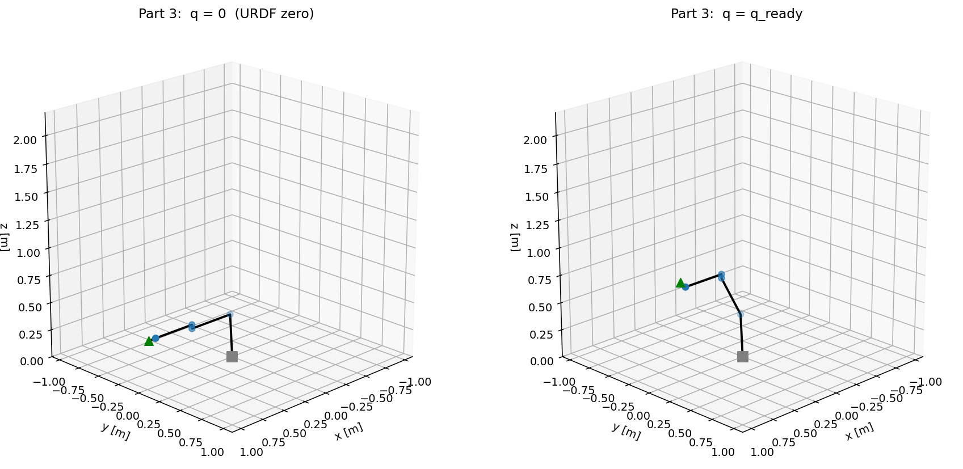
Stick figures from kr6_frames at $q=0$ (left, URDF software zero) and $q_{\text{ready}}$ (right).

Problem 4 - Stick Figure + Joint-Space Quintic Trajectories

The quintic polynomial trajectory
Let
$$q(t) = a_{0}+a_{1}t+a_{2}t^{2}+a_{3}t^{3}+a_{4}t^{4}+a_{5}t^{5}.$$
Six unknowns, six conditions (position, velocity, acceleration at $t_{0}$ and $t_{f}$) give a $6×6$ linear system (in BLISSjanga_Handwritten.pdf). With ${\dot{q}}_{0}={\ddot{q}}_{0}={\dot{q}}_{f}={\ddot{q}}_{f}=0$ and $t_{0}=0$, $t_{f}=T$. We can set the velocity and acceleration to zero at both endpoints which makes the arm start and arrive at rest with no jerk. Solving the system gives:
$$\boxed{ a_{0}=q_{0}, a_{1}=a_{2}=0, a_{3}=\frac{10 Δq}{T^{3}}, a_{4}=-\frac{15 Δq}{T^{4}}, a_{5}=\frac{6 Δq}{T^{5}}, Δq=q_{f}-q_{0}, }$$
trajectories.quintic in the notebook solves the 6$×$6 system numerically.

Numerical example - joint 1, $q_{f}=0.8$ rad.
With $q_{0}=0$, $q_{f}=0.8$, $T=2$s, gives $a_{3}=1.000$, $a_{4}=-0.750$, $a_{5}=0.150$. So $q_{1}(t)=t^{3}-0.75 t^{4}+0.15 t^{5}$ on $[0,2]$. the quintic profile figure plots this polynomial and its first two derivatives below.
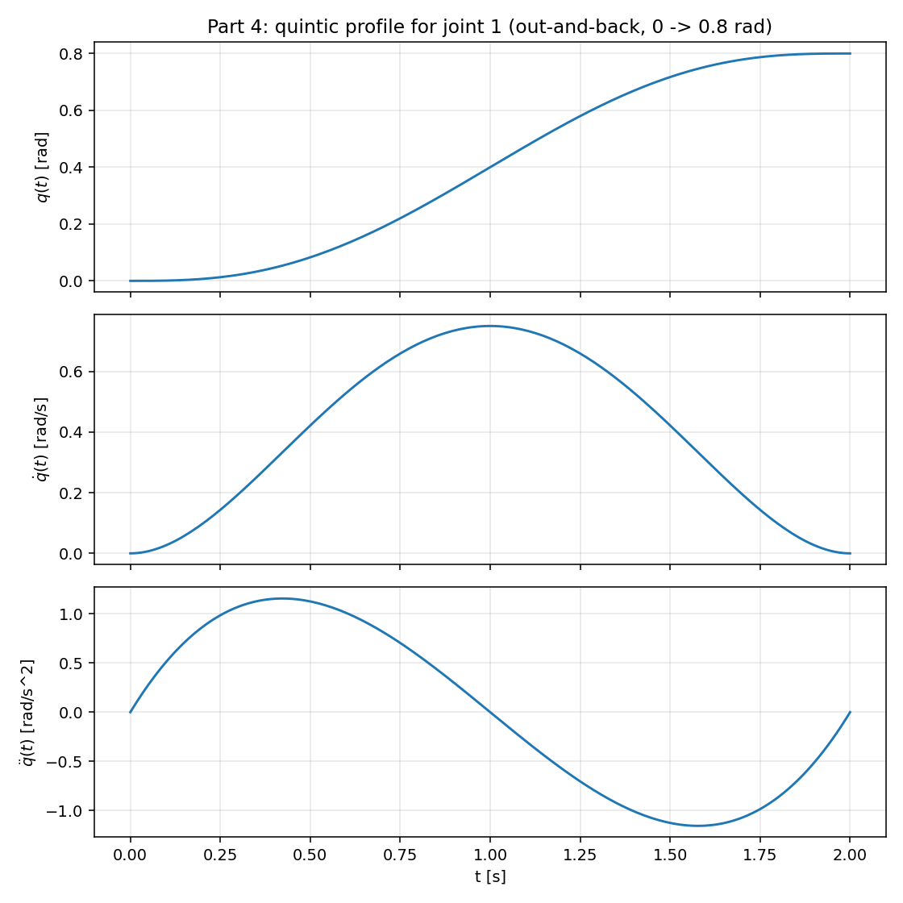
Joint 1 quintic profile $q(t),\dot{q}(t),\ddot{q}(t)$. Zero boundary velocity and acceleration give a nice smooth start and smooth stop.

Stick figure and joint-at-a-time motion
The stick figures at q = 0 and q_ready (Problem 3) shows that the FK gves the expected geometry. The joint at a time sweeps below provides additional verification of each joint’s independent effect on the arm. The stick figure is drawn by reading origins $\{p_{0},p_{1},…,p_{6}\}$ from kr6_frames(q) and connecting consecutive origins with line segments. This was applied in Part 4 GIF
q(t) = q₀ + (10Δq/T³)t³ − (15Δq/T⁴)t⁴ + (6Δq/T⁵)t⁵ to one joint at a time with
$$Δq=[0.8, 0.6, 0.8, 0.6, 0.8, 0.6]\text{ rad},$$
moving out and back .
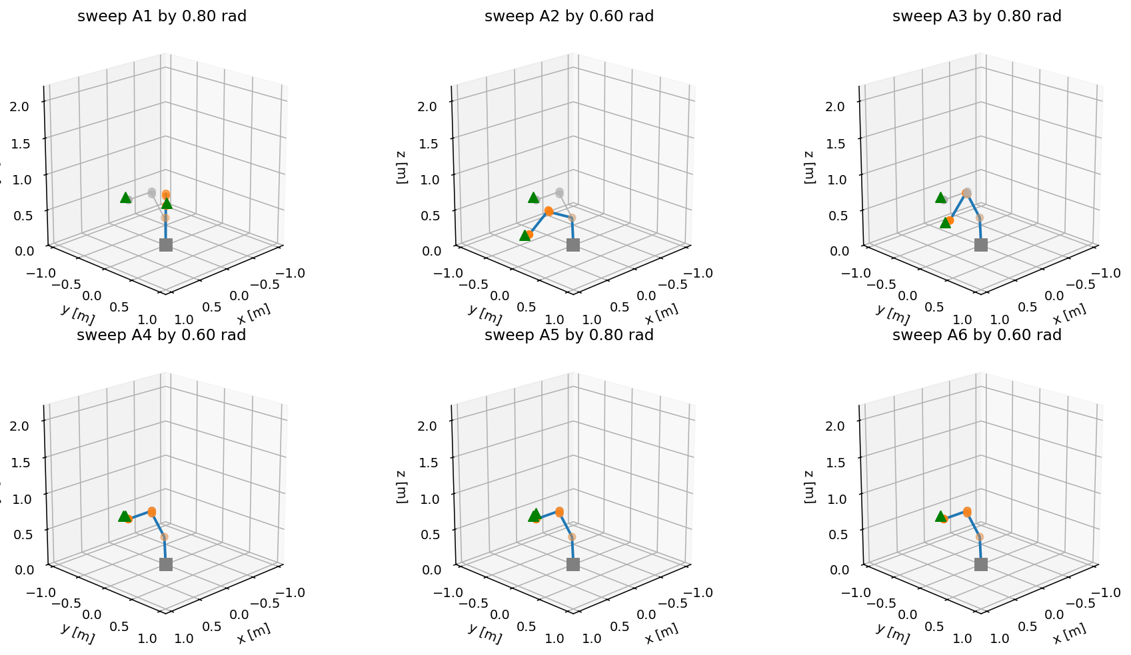
This is each joint swept individually from the ready pose. The grey ghost is the ready pose and colored figure is the ready pose with only joint $j$ shifted by $Δq_{j}$.

Animation:


Problem 5 - Jacobian and Singular Configurations

Direct-method geometric Jacobian
For a configuration $q$, the flange velocity $[v;ω]$ expressed in the base frame is always related to $\dot{q}$ by the $6×6$ geometric Jacobian (square because the KR 6 has $6$ joints):
$$\left[\begin{matrix}v_{0,6}^{ 0} \\ ω_{0,6}^{ 0}\end{matrix}\right]=J(q) \dot{q}.$$
Every joint is revolute, so every column uses the same formula from the JacobianGuide.pdf provided in class:
$$\boxed{ J_{i}(q) = \left[\begin{matrix}z_{i-1}^{ 0}×(t_{0,6}^{ 0}-t_{0,i-1}^{ 0}) \\ z_{i-1}^{ 0}\end{matrix}\right], i=1,…,6. }$$
$z_{i-1}^{ 0}$ is the third column of $R_{i-1}^{ 0}$, and $t_{0,i-1}^{ 0}$ is the origin of frame $i-1$ in base coordinates. Both come directly from $\{T_{i-1}^{0}\}$ returned by kr6_frames.

Derivation
Joint $i$ is spinning at rate ${\dot{q}}_{i}$ about $z_{i-1}^{ 0}$ which contributes $ω_{i}={\dot{q}}_{i}z_{i-1}^{ 0}$ to the flange’s angular velocity. Rigid-body velocity then gives $v_{i}=ω_{i}×(t_{0,6}^{ 0}-t_{0,i-1}^{ 0})={\dot{q}}_{i} z_{i-1}^{ 0}×(t_{0,6}^{ 0}-t_{0,i-1}^{ 0})$ for the upper block.

$$J(q_{\text{ready}})$$
Plugging $q_{\text{ready}}$ into the equation, it gives
$$J(q_{\text{ready}})=\left[\begin{matrix}0 & 0.4856 & 0.0916 & 0 & -0.0566 & 0 \\ 0.7291 & 0 & 0 & -0.0566 & 0 & 0 \\ 0 & -0.7041 & -0.4766 & 0 & 0.0566 & 0 \\ 0 & 0 & 0 & 1 & 0 & 0.7071 \\ 0 & 1 & 1 & 0 & -1 & 0 \\ 1 & 0 & 0 & 0 & 0 & 0.7071\end{matrix}\right].$$
The $\text{det}J(q_{\text{ready}})=-0.0749$.

Singular configurations
$J$ loses rank when the end-effector can no longer move instantaneously in some direction of a task space. For the $6×6$ KR 6 Jacobian this happens when $\text{det}J=0$, which for a 6R arm with spherical wrist happens in three distinct geometric families:
Shoulder singularity
This happens when the wrist centre lies on (or very close to) the A1 axis. Because $a_{1}=0.025$ m is non-zero, the singular set is a cylinder of radius $a_{1}$ around the A1 axis instead of the axis itself.
- Numerical check: at q = [0, −1.760, 0.417, 0, π/4, 0] the wrist centre sits at r_wc ≈ 0 m (directly above A1); det J ≈ 10⁻¹⁰ ≈ 0.
Elbow singularity
This is when the shoulder, elbow and wrist centre line up (the arm is fully extended). In terms of the bend $β_{e}$ in IK, this is $β_{e}→0$.
- Numerical check: at q = [0, 0, 0.0831, 0, π/4, 0] the arm is fully extended (q₃ = β = atan2(a₃, d₄), so β_e = 0); det J ≈ 10⁻¹⁷ ≈ 0.
Wrist singularity.
Happens when axes A4 and A6 become collinear ($q_{5}→0$). It makes the wrist lose one orientation DOF and the Jacobian submatrix for the last three columns drops rank.
The Yoshikawa manipulability measure
$$w(q) = \sqrt{|\text{det}​(J(q)J(q)^{​⊤})|}$$
Which is a scalar that goes away at each of these singular configurations.

Wrist-singularity sweep.
I decided to sow the wrist singularity because it is the one a trajectory planner is most likely to encounter: a tool approaching a surface normally runs $q_{5}$ through zero. Starting from $q_{\text{ready}}$ I swept $q_{5}$ linearly from $+π/4$ down to $0$, holding all other joints fixed, and recorded $σ_{\text{min}}(J)$, $w(q)$ and $|\text{det}J|$ at each step. The singularity sweep figure shows all three signals drop as $q_{5}→0$, a standard wrist-singularity signature.
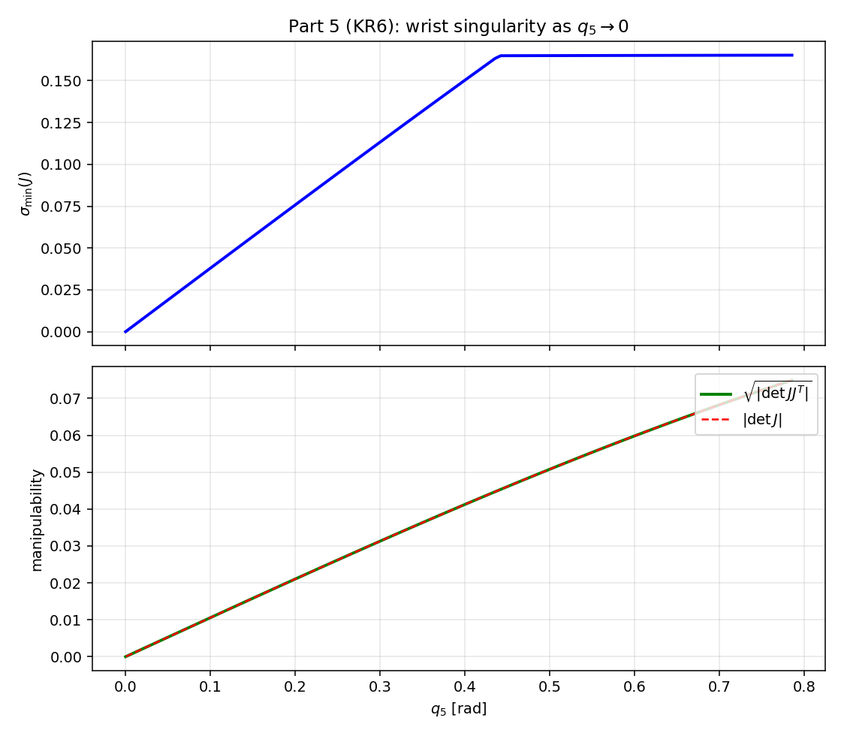
$σ_{\text{min}}(J)$ (top) and $w(q)$ + $|\text{det}J|$ (bottom) along a wrist-straightening sweep $q_{5}:π/4→0$. All three signals drop to zero at $q_{5}=0$ (which is wrist singularity).

Velocity-arrow visualization
Given any $\dot{q}$, the flange twist comes from the Jacobian definition Equation.
Example:
$\dot{q}=(0.6, 0.4, -0.3, 0.5, 0.3, 0)^{​⊤}$rad/s at the ready pose,
$$v=J_{v}(q_{\text{ready}}) \dot{q}=(0.150, 0.409, -0.122)^{​⊤} \text{m/s}, |v|=0.452 \text{m/s},$$
$$ω=J_{ω}(q_{\text{ready}}) \dot{q}=(0.500, -0.200, 0.600)^{​⊤} \text{rad/s}, |ω|=0.806 \text{rad/s}.$$
the velocity-arrows figure draws these as arrows on the stick figure.
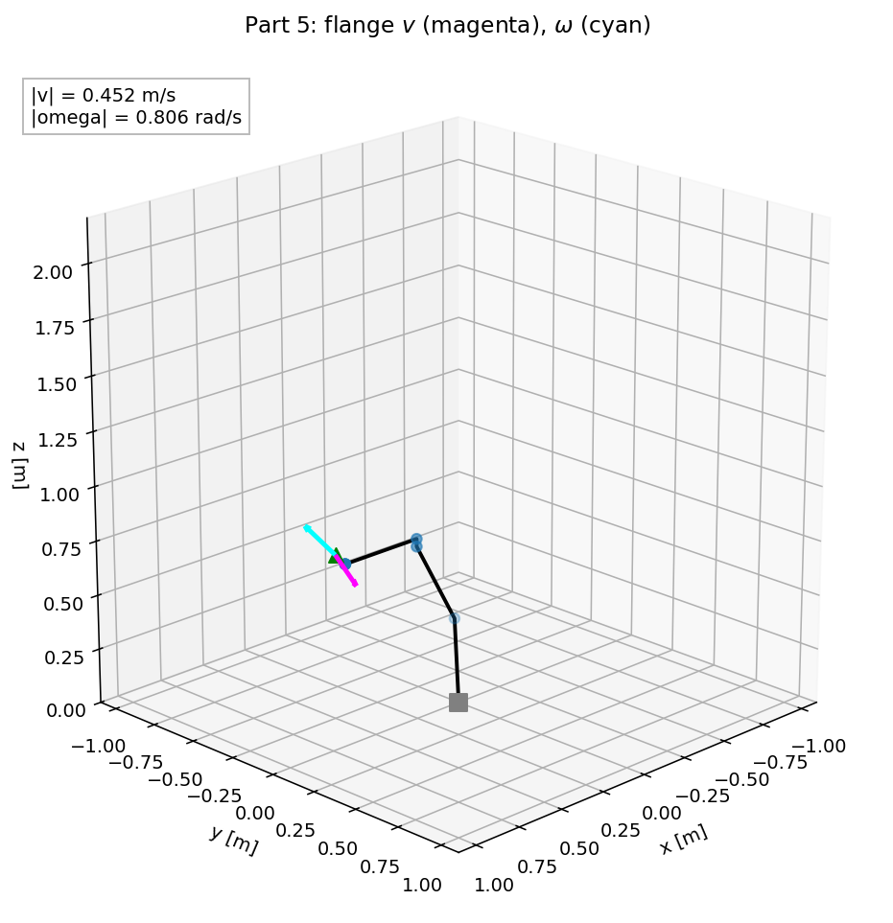
Stick figure at $q_{\text{ready}}$ with the linear velocity arrow $v$ (magenta) and the scaled angular velocity arrow $ω$ (cyan) on the flange.
The animation below draws the linear velocity arrow $v=J_{v}(q)\dot{q}$ (magenta) and angular velocity arrow $ω=J_{ω}(q)\dot{q}$ (cyan) on the flange as the arm moves along a short joint-space quintic.

Animation:


Problem 6 - Inverse Position and Velocity Kinematics
KR 6 has a spherical wrist. The IK is closed-form. This derivation splits into four steps:
- Wrist centre $p_{\text{wc}}$. Point where A4, A5, A6 all intersect. It lies a distance $d_{6}$ behind the flange along the tool axis. Just one vector subtraction.
- $q_{1}$. Azimuth of $p_{\text{wc}}$ in the base frame. My $a_{1}$ is a radial offset along $x_{1}$, so the standard PUMA “lift” term goes away and $q_{1}$ is a single atan2 call.
- $q_{2},q_{3}$. Planar 2R triangle with vertices at shoulder, elbow, wrist centre. The elbow offset $a_{3}$ and the forearm $d_{4}$ fold into a single virtual forearm of length $L=\sqrt{a_{3}^{2}+d_{4}^{2}}$.
- $q_{4},q_{5},q_{6}$. ZYZ Euler decomposition of $R_{3}^{ 6}=R_{0}^{ 3 ⊤}R_{d}$.
Inverse velocity IK follows from the square Jacobian: $\dot{q}=J(q)^{-1}[v_{d};ω_{d}]$. No damping, no pseudoinverse.

Step 1 - The wrist centre
Let the desired flange pose be $T_{​}^{d}=\left[\begin{matrix}R_{d} & p_{d} \\ 0^{​⊤} & 1\end{matrix}\right]∈SE(3)$. The wrist centre $p_{\text{wc}}$ is on the tool axis, offset by $d_{6}$ behind the flange origin:
$$\boxed{ p_{\text{wc}} = p_{d}-d_{6} R_{d} e_{z}, }$$
where $e_{z}=(0,0,1)^{​⊤}$, so $R_{d}e_{z}$ is the third column of $R_{d}$, where $p_{\text{wc}}$ is independent of $q_{4},q_{5},q_{6}$.

Step 2 - $q_{1}$ from the wrist centre’s azimuth
$a_{1}=25$mm in the DH table above is a radial offset along $x_{1}$, so after the $q_{1}$ rotation the shoulder sits on the arm’s radial line from the A1 axis. The wrist centre which means it lies in the same half-plane at azimuth $q_{1}$. With $p_{\text{wc}}=(x_{w},y_{w},z_{w})$:
$$\boxed{ q_{1}=\text{atan2}(y_{w}, x_{w}). }$$
A second branch $q_{1}=\text{atan2}(y_{w},x_{w})+π$, this means shoulder rotated ${180}^{∘}$, arm pointing backward is also reachable. The shoulder-back branch.

Step 3 - $q_{2},q_{3}$ from a planar 2R triangle
With $q_{1}$ fixed, the problem collapses to the arm plane (the plane containing the upper arm and the A2 axis). Using the arm-plane coordinates $(r,z)$ with $r$ the radial distance from A1 and $z$ the world $z$:
$$\begin{matrix}\text{A2 (shoulder) at} & (a_{1}, d_{1})=(0.025, 0.400), \\ \text{wrist centre at} & (±r_{xy}, z_{w}), r_{xy}=\sqrt{x_{w}^{2}+y_{w}^{2}},\end{matrix}$$
with the sign of $r_{xy}$ set by the shoulder branch where $+$ is for front, $-$ is for back.

The virtual-forearm trick
From A3 to the wrist centre is a 35-mm perpendicular elbow offset followed by a 420-mm forearm. Combining them into a single virtual forearm of length
$$L=\sqrt{a_{3}^{2}+d_{4}^{2}}≈0.4215 \text{m}, β=\text{atan2}(a_{3},d_{4})≈0.0832 \text{rad},$$
which turns the three-segment chain of upper arm, elbow offset, and forearm into a 2R planar linkage with legs $a_{2}$ and $L$ offset by $β$.

2R triangle.
With $s_{x}=±r_{xy}-a_{1}$, $s_{z}=z_{w}-d_{1}$, $d_{\text{p}}=\sqrt{s_{x}^{2}+s_{z}^{2}}$, and $β_{e}$ being the “bend” between upper arm and virtual forearm, law of cosines gives
$$\text{cos}β_{e} = \frac{d_{\text{p}}^{2}-a_{2}^{2}-L^{2}}{2 a_{2} L}, β_{e}>0 \text{is }\text{elbow up}, β_{e}<0 \text{is }\text{elbow down}.$$
This means joint variable $q_{3}$ is the bend plus the constant elbow-offset angle $β$ (this is at $q_{3}=0$ the virtual forearm is already tilted above the upper arm by $β$, and not aligned with it):
$$\boxed{ q_{3} = β_{e}+β. }$$
For $q_{2}$, let $ψ=\text{atan2}(s_{z},s_{x})$ be the angle of the shoulder-to-wrist line. The law of sines at the shoulder vertex gives
$$ϕ=\text{atan2}​(L\text{sin}β_{e}, a_{2}+L\text{cos}β_{e}),$$
and flipping the sign from $α_{1}=-π/2$ in the DH table gives
$$\boxed{ q_{2}=-(ψ+ϕ) \text{(}\text{elbow up)}, q_{2}=-(ψ-ϕ)\text{ (elbow down)}. }$$

(from the class derivation.)

Step 4 - $q_{4},q_{5},q_{6}$ from ZYZ Euler
With $q_{1},q_{2},q_{3}$ known, FK gives $R_{0}^{ 3}$ and the wrist must produce $R_{3}^{ 6}=R_{0}^{ 3 ⊤}R_{d}$. Substituting the $α$ and $θ$-offsets from the DH table above into the DH product and also simplifying using the identity R_x(π/2) R_z(q₅) R_x(−π/2) = R_y(−q₅):
$$R_{3}^{ 6} = R_{z}(q_{4}-π) R_{y}(-q_{5}) R_{z}(q_{6}-π).$$
This is a ZYZ Euler decomposition with shifted first and third angles. Taking out Euler angles from $R_{3}^{ 6}$ with the standard formulas, then using the sign ambiguity $(α,β,γ)∼(α+π,-β,γ+π)$ to pick $q_{5}≥0$ (this cancels the two $-π$ offsets from the DH table above) gives the final joint-angle assignments:
$$\boxed{ q_{4}=\text{atan2}​([R_{3}^{ 6}]_{23}, [R_{3}^{ 6}]_{13}), q_{5}=\text{atan2}​(\sqrt{[R_{3}^{ 6}]_{13}^{2}+[R_{3}^{ 6}]_{23}^{2}}, [R_{3}^{ 6}]_{33}), q_{6}=\text{atan2}​([R_{3}^{ 6}]_{32}, -[R_{3}^{ 6}]_{31}). }$$

(following the ZYZ extraction method from class.)

Validation
Equations wrist-centre, q1 azimuth, q3 elbow-bend, q2 shoulder-lift, and ZYZ Euler are what we need to use algebra to map from $T_{​}^{d}$ to $q$, given a choice of elbow-up/down and shoulder-front/back. A way to do a quick check by round-tripping is to pick 500 random $q∼uniform([q_{\text{min}},q_{\text{max}}])$ with $q_{5}>0$ so the wrist is not singular, compute $T_{​}^{d}=T_{6}^{0}(q)$, run IK, then FK applied to the IK solution should reproduce $T_{​}^{d}$. Code (problem6.py::round_trip) reports
$$\begin{matrix}\text{max}∥p_{\text{FK}}-p_{d}∥ & ≈6×{10}^{-16} \text{m}, \\ \text{max}∥R_{\text{FK}}-R_{d}∥_{F} & ≈2×{10}^{-15}.\end{matrix}$$
Both residuals are roundoff-limited (double-precision).
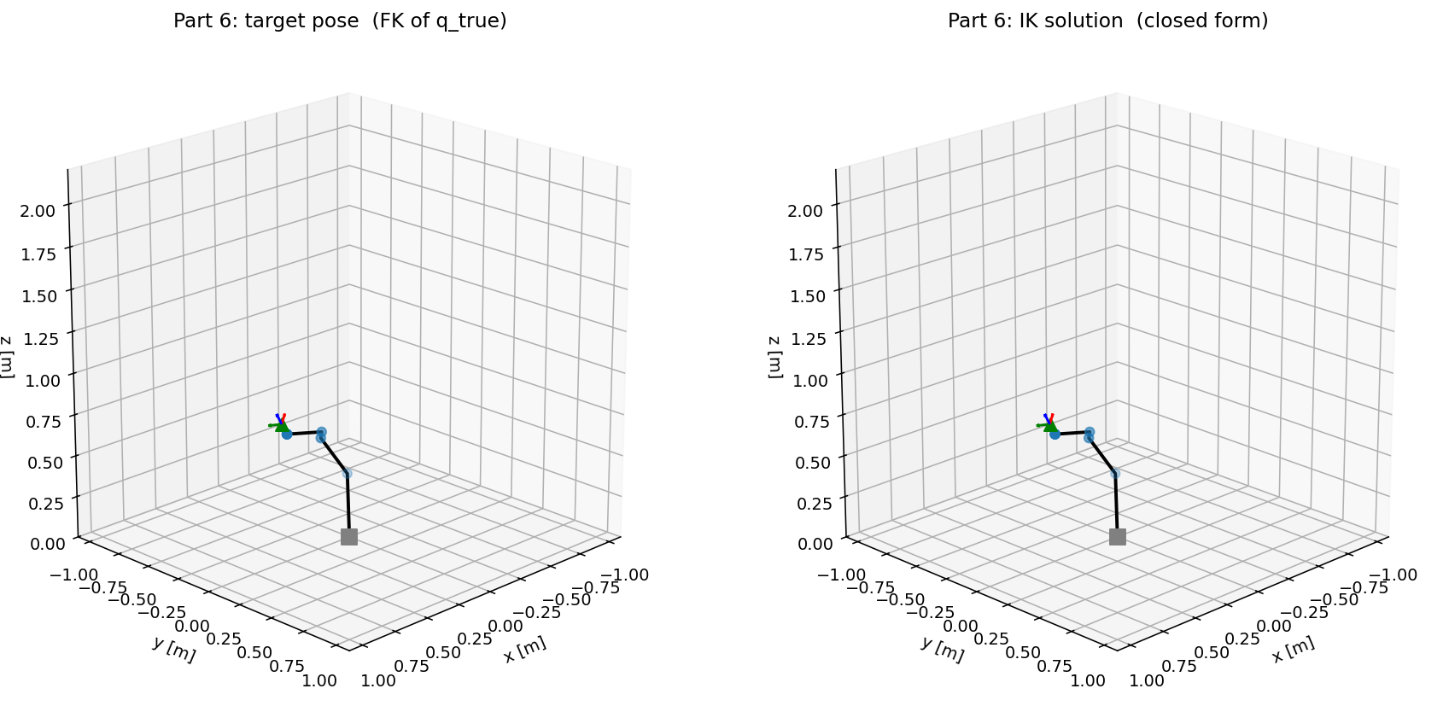
Target pose generated by FK of $q_{\text{true}}$ (left) vs. IK reconstruction returned by the closed form (right). The two stick figures and flange frames match.

Branches
For a reachable target there are up to four position-level branches: (elbow-up or elbow-down) $×$ (shoulder-front or shoulder-back). In the code these are the elbow_up and shoulder_front flags of ik_position. Another ambiguity ($q_{5}>0$ vs. $q_{5}<0$) comes from the wrist, in this case my sign convention from the ZYZ Euler equation always uses the positive branch.
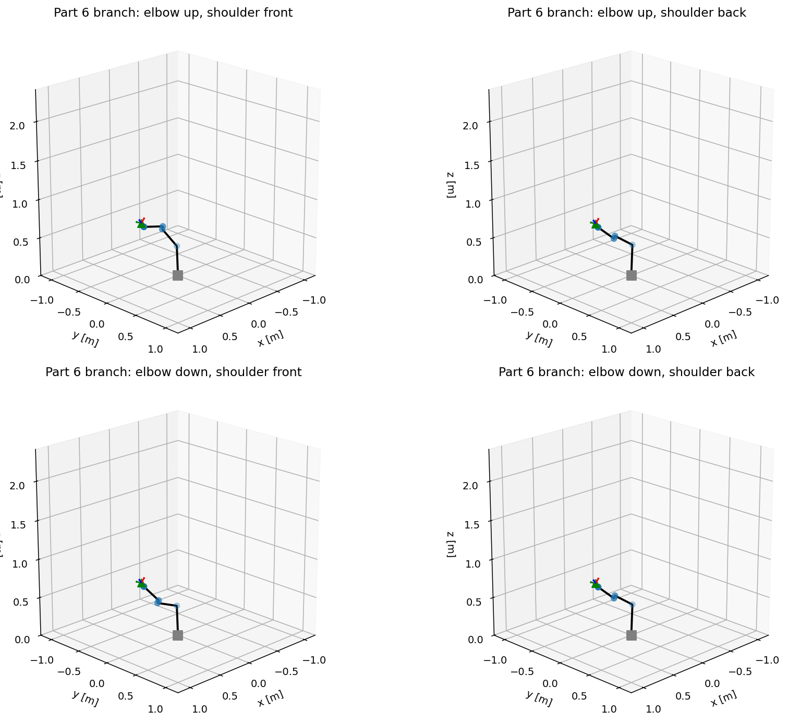
Four position-level IK branches for one flange target: elbow up/down $×$ shoulder front/back. Each $q$ satisfies $T_{6}^{0}(q)=T_{​}^{d}$ where they differ in how the arm is folded.

Inverse velocity kinematics
The $6×6$ Jacobian $J(q)$ in from the Jacobian definition equation is square. It is invertible everywhere except at the three named singularities in problem 5. Inverse velocity IK is then a nice direct solve:
$$\boxed{ \dot{q} = J(q)^{-1}\left[\begin{matrix}v_{d} \\ ω_{d}\end{matrix}\right]. }$$
There is no damping or pseudoinverse. Next we will go to problem 7 where we will put the inverse-velocity equation on a moving reference and compare against $\frac{d}{dt}q(t)$ to check for independent consistency.

Problem 7 - Task-Space Trajectory with Position and Velocity IK

Cartesian quintic trajectory
Two flange poses as small offsets from the original ready position were picked so the path stays inside a folded-elbow region and away from the three singularities we talked about earlier:
$$p_{\text{start}}=p_{\text{ready}}+(-0.15, +0.05, +0.05)^{​⊤}\text{m}, p_{\text{end}}=p_{\text{ready}}+(-0.05, -0.08, -0.05)^{​⊤}\text{m}.$$
Orientation is fixed at $R_{\text{fixed}}=R_{\text{ready}}$ throughout, so $ω_{d}(t)≡0$. Each Cartesian axis $ξ∈\{x,y,z\}$ gets its own quintic with $T=2$s:
$$ξ(t)=ξ_{0}+Δξ (10s^{3}-15s^{4}+6s^{5}), \dot{ξ}(t)=\frac{Δξ}{T}(30s^{2}-60s^{3}+30s^{4}), s=t/T.$$
Stacking them gives the task-space reference $p_{d}(t)$, $v_{d}(t)$. The peak task-space speed along this path is $∥v_{d}∥_{\text{max}}≈0.180 \text{m/s}$.

Inverse position kinematics - $q(t)$
At each of the $N=80$ uniform time samples $t_{k}$ calling the closed-form IK (wrist-centre equation)-(ZYZ Euler equation) against $T_{​}^{d}(t_{k})=(R_{\text{fixed}}, p_{d}(t_{k}))$, while also keeping the same branch (elbow-up and shoulder-front) at every step. This makes each call one pass through the equations, with no iteration.
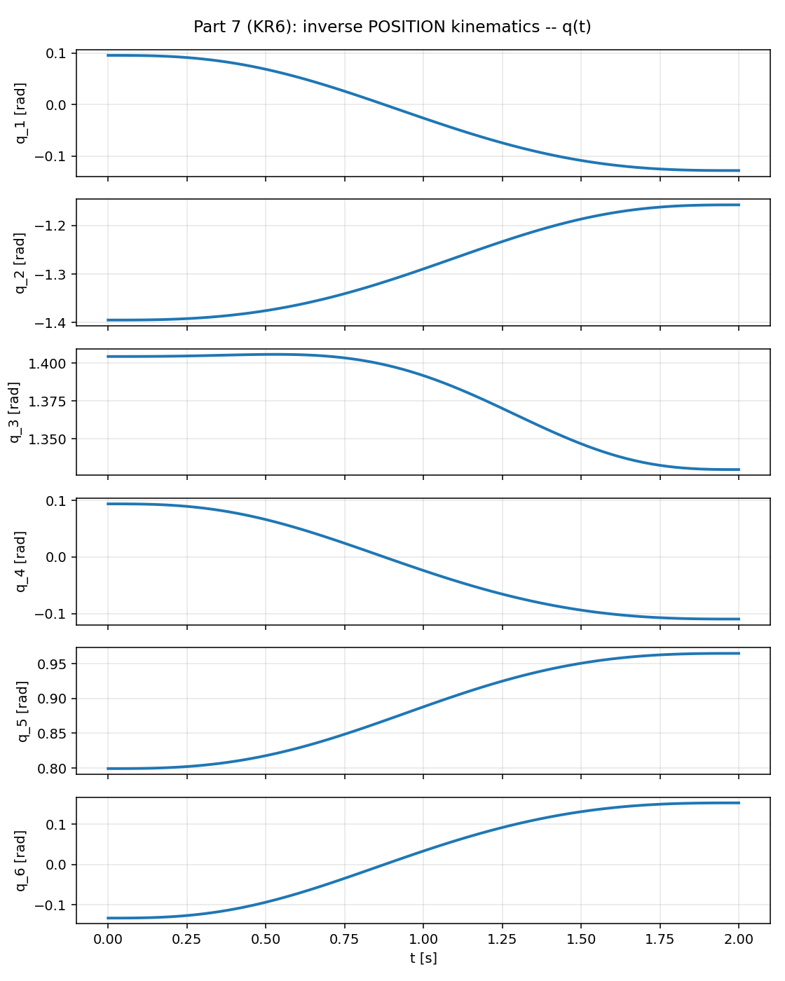
Inverse Position kinematics: $q(t)$ for the six joints over the 2 second Cartesian quintic, which were all produced by the closed-form solver.

Inverse velocity kinematics - $\dot{q}(t)$
At each $q(t_{k})$, we will compute $\dot{q}(t_{k})$ directly from inverse-velocity equation:
$$\dot{q}(t_{k}) = J(q(t_{k}))^{-1} \left[\begin{matrix}v_{d}(t_{k}) \\ 0\end{matrix}\right].$$
Logging $σ_{\text{min}}(J)$ at every sample where the minimum over the whole path is $≈0.1$, so the inverse is numerically safe.

Consistency check
Compute the central-difference derivative of the position-IK trajectory,
${\hat{\dot{q}}}_{j}(t_{k})=(q_{j}(t_{k+1})-q_{j}(t_{k-1}))/(2Δt)$, and compare to the velocity-IK output ${\dot{q}}_{j}(t_{k})$. So since the finite-difference estimate is independent of (inverse-velocity Eq.) but describes the same trajectory, they should match:
$$\underset{j,k}{\text{max}}|{\dot{q}}_{j}(t_{k})-{\hat{\dot{q}}}_{j}(t_{k})|≈3×{10}^{-4} \text{rad/s}, \text{RMS}≈8×{10}^{-5} \text{rad/s},$$
against $∥\dot{q}∥_{∞}≈0.48$rad/s. Roughly 3-4 significant figures of agreement. Position-IK and velocity-IK are consistent.
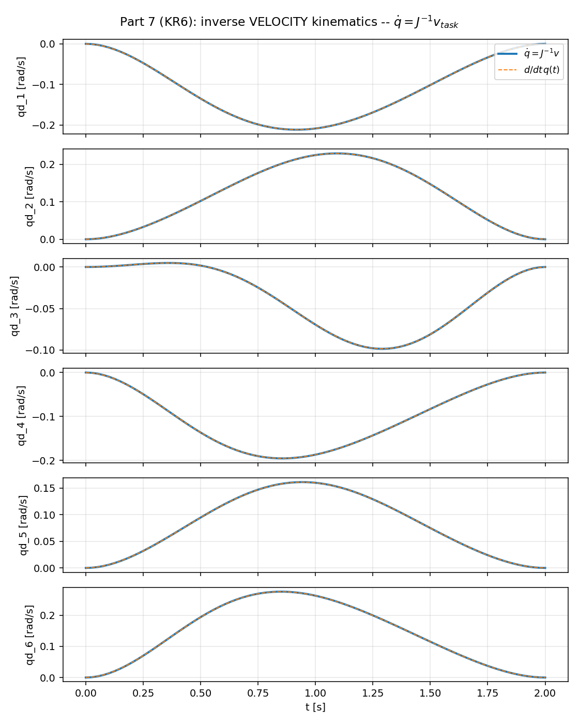
Inverse velocity kinematics: $\dot{q}(t)$ computed directly from $J^{-1}v_{\text{task}}$ (solid line) overlaid with the finite-difference derivative of $q(t)$ (dashed line). The two curves are indistinguishable on every joint.
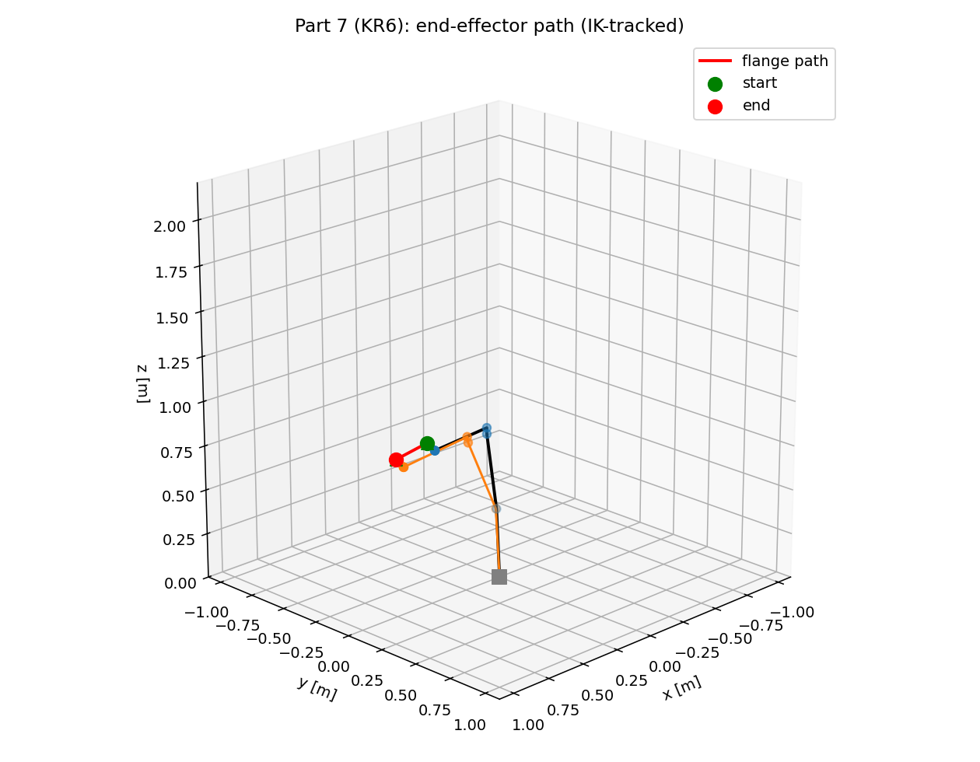
The start stick figure is blue, end stick figure is orange, and the flange path is red which was produced by the closed-form position IK.

Animation:



What happens near a singularity
If a path crossed a wrist singularity ($q_{5}→0$) or an elbow singularity ($β_{e}→0$), $J^{-1}$ would blow up. A good workaround is to damp the least-squares pseudoinverse $J^{​⊤}(JJ^{​⊤}+λ^{2}I)^{-1}$ inside a small neighborhood or inserting a waypoint that avoids the area entirely. We didn’t have to use either of the workarounds for this path.

Problem 8 - URDF Creation and Animation

Goal is to create a URDF whose link frames are the DH frames
So, the issue of URDF is that it is a very broad format, and it does not tailor towards a specific kinematic convention. This causes different URDFs of the same physical robot having their link frames in very different places, depending on who created the file. This causes things like trajectories computed in my DH code to not work, in general. Which causes the transfer to an URDF of the same robot to not work without changing each link.
What is needed to fix this issue is a URDF whose link frames are the same to the frames my DH code uses. This would make it so a $q$ vector that drives the stick figure to also drive the URDF render in the same way without needing additional changes. Doing this would make the wrist centre in this URDF sit at the same world coordinates that Problem 6 targeted, and the task-space trajectory from Problem 7 replays through the URDF without any need for re-mapping.

Why a single URDF revolute joint is not enough
The URDF says that every revolute joint has a fixed origin transform from parent link to joint axis, which then causes the joint variable to rotate about that axis:
ᵖᵃʳᵉⁿᵗT_child = Ξᵢ · R_z(qᵢ)
The full Standard-DH link transform factors as
$$T_{i}^{i-1}(q_{i}) = R_{z}(θ_{\text{off},i}) T_{z}(d_{i}) R_{z}(q_{i}) T_{x}(a_{i}) R_{x}(α_{i}) = \underset{{\text{pre}}_{i}}{\underset{⏟}{R_{z}(θ_{\text{off},i}) T_{z}(d_{i})}} R_{z}(q_{i}) \underset{{\text{post}}_{i}}{\underset{⏟}{T_{x}(a_{i}) R_{x}(α_{i})}},$$
which is because $R_{z}$ and $T_{z}$ move along $z$. A single URDF revolute joint can realise ${\text{pre}}_{i}⋅R_{z}(q_{i})$, but it cannot also do the ${\text{post}}_{i}$ factor that comes after $R_{z}(q_{i})$. If I tried to compress $T_{i}^{i-1}$ into just one revolute joint, URDF link $i$ would land at the pre-rotation point, and not at DH frame $i$, which causes the two descriptions to diverge by up to $​a_{i}$ at every joint.

The fix is to split each DH link into a revolute joint and a fixed joint
I followed what we discussed and added an auxiliary pivot_i and a fixed joint ${FJ}_{i}$ after each revolute joint, so this makes the URDF chain for link $i$ to be
$$link_\{i-1\} → [revolute joint_i, origin = pre_i, axis = e_z] → pivot_i → [fixed FJ_i, origin = post_i] → link_i$$
With this structure, the URDF transform from ${\text{link}}_{i-1}$ to ${\text{link}}_{i}$ is
$$Ξ_{i}^{\text{rev}} R_{z}(q_{i}) Ξ_{i}^{\text{fix}} = {\text{pre}}_{i}⋅R_{z}(q_{i})⋅{\text{post}}_{i} = T_{i}^{i-1}(q_{i}),$$
which is exactly the DH link product from DH pre/post factoring equation that we are looking for. So if URDF link $i$ is the same $SE(3)$ pose as DH frame $i$ for any $q$, the pre_i and post_i factors get to be computed directly from the DH table, where URDF writer in problem8.py(write_urdf) numerically evaluates them and serializes as xyz translations and rpy Euler angles.

Numerical validation across four configurations
Loading urdf/kr6_sdh.urdf with urchin and calling link_fk(cfg=q) returns the URDF’s link origins for any $q$. Using this we can compare those origins to $t_{0,i}^{ 0}$ from kr6_frames(q) at four test configurations
Maximum position and rotation mismatch between URDF link $i$ and DH frame $i$ over $i=0,…,6$, woth the residual floor set by the four-decimal rounding of xyz / rpy in the URDF.
configuration | max position error [mm] | max rotation Frob. error
$$q_{\text{zero}}=0$$ | $$0.003$$ | $$2.7×{10}^{-5}$$
$$q_{\text{ready}}=[0,-π/3,π/3,0,π/4,0]$$ | $$0.002$$ | $$3.1×{10}^{-5}$$
twisted $q=[0.5,-0.6,0.7,0.8,0.5,-0.3]$ | $$0.002$$ | $$2.9×{10}^{-5}$$
folded $q. =[-1.0,-1.2,1.5,0.2,0.8,0.1]$ | $$0.002$$ | $$3.1×{10}^{-5}$$
The per-configuration max error stays at the 3-micrometre rounding floor even when aggressive off-zero configurations are used, which confirms the URDF link frames are the DH frames and not just close or nearly the same for every reachable $q$.

Trajectories transfer directly
Due to the URDF link frames being the DH frames, the outputs I generated in earlier problems transfer directly to the URDF model.
- The stick figure from kr6_frames is drawn by connecting the DH frame origins, and the URDF link origins are the same points, so the two plots would be the same.
- The joint trajectory $q(t)$ saved as figures/problem7_Q.npy from Problem 7 would drive the URDF through the same $SE(3)$ motion as the stick figure at every timestep.
- Waypoint, flange target, or velocity profile built in the DH code would work as a URDF waypoint without additional changes.
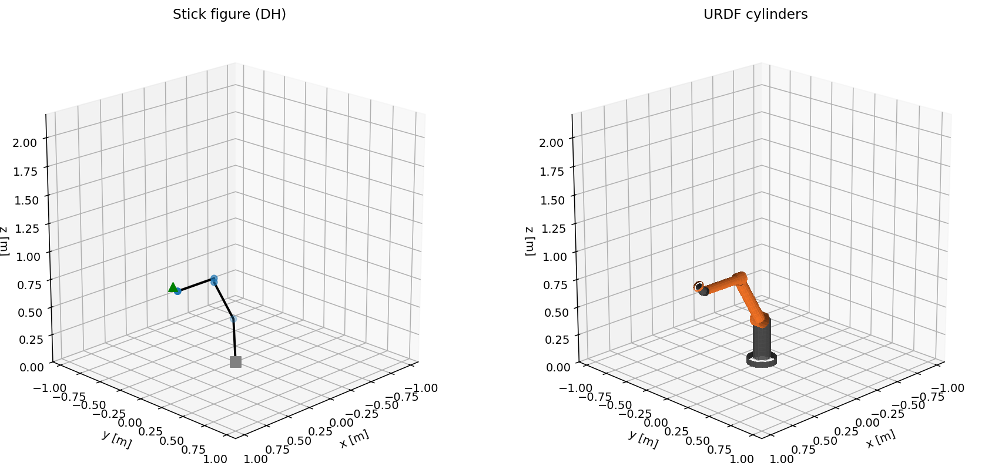
Stick figure (left) vs URDF cylinders (right) at $q_{\text{ready}}$, drawn from using the same $q$ vector as well as using the same link frames. Cylinder lengths and radii are just visual, so they do not represent the AGILUS’s external sheet-metal geometry.
The URDF-vs-stick animation over this box path shows the DH stick figure (left) and the URDF cylinders (right) at the same $q$ at every frame. They are symmetric at every time step because the link frames are the same.

Animation:


Deliverables
- BLISSjangaFinalProject.pdf / .docx — this report and its Word source
- BLISSjanga_FinalProject.ipynb: Jupyter notebook with every line of code that produced the figures and numerical results, organised by Problem
- BLISSjanga_Handwritten.pdf: iPad derivations (DH frame assignment, link-transform matrix expansion, six individual link transforms, general T⁰₆ symbolic multiplication, quintic coefficient solve)
- code/kuka_dh.py - DH table, link transform (link-transform Eq.), FK chain (FK chain Eq.)
- urdf/kr6_sdh.urdf - hand-authored URDF with revolute + fixed-joint pairs so link frames coincide with DH frames
Every numerical value in this report is produced by running the notebook cells in the rvc conda env.

