AI Assisted Coding
Week2 – Wednesday

Name: Jangala Megha Harsha
Batch: 07
Roll No.: 2303A51409

Lab 4: Advanced Prompt Engineering – Zero-shot, One-shot, and Fewshot Techniques
Lab Objectives
- To explore and apply different levels of prompt examples in AI-assisted code generation
- To understand how zero-shot, one-shot, and few-shot prompting affect AI output quality
- To evaluate the impact of context richness and example quantity on AI performance
- To build awareness of prompt strategy effectiveness for different problem types Week2 - Wednesday
Lab Outcomes (LOs)
After completing this lab, students will be able to:
- Use zero-shot prompting to instruct AI with minimal context • Use one-shot prompting with a single example to guide AI code generation
- Apply few-shot prompting using multiple examples to improve AI responses
- Compare AI outputs across different prompting strategies

Task 1: Zero Shot Prompting - Leap Year Check
Scenario: Zero-shot prompting involves giving instructions without providing examples.
Task Description: Use zero-shot prompting to instruct an AI tool to generate a Python function that:
- Accepts a year as input
- Checks whether the given year is a leap year
- Returns an appropriate result
Note: No input-output examples should be provided in the prompt.
Expected Output
- AI-generated leap year checking function
- Correct logical conditions
- Sample input and output
- Screenshot of AI-generated response (if required)

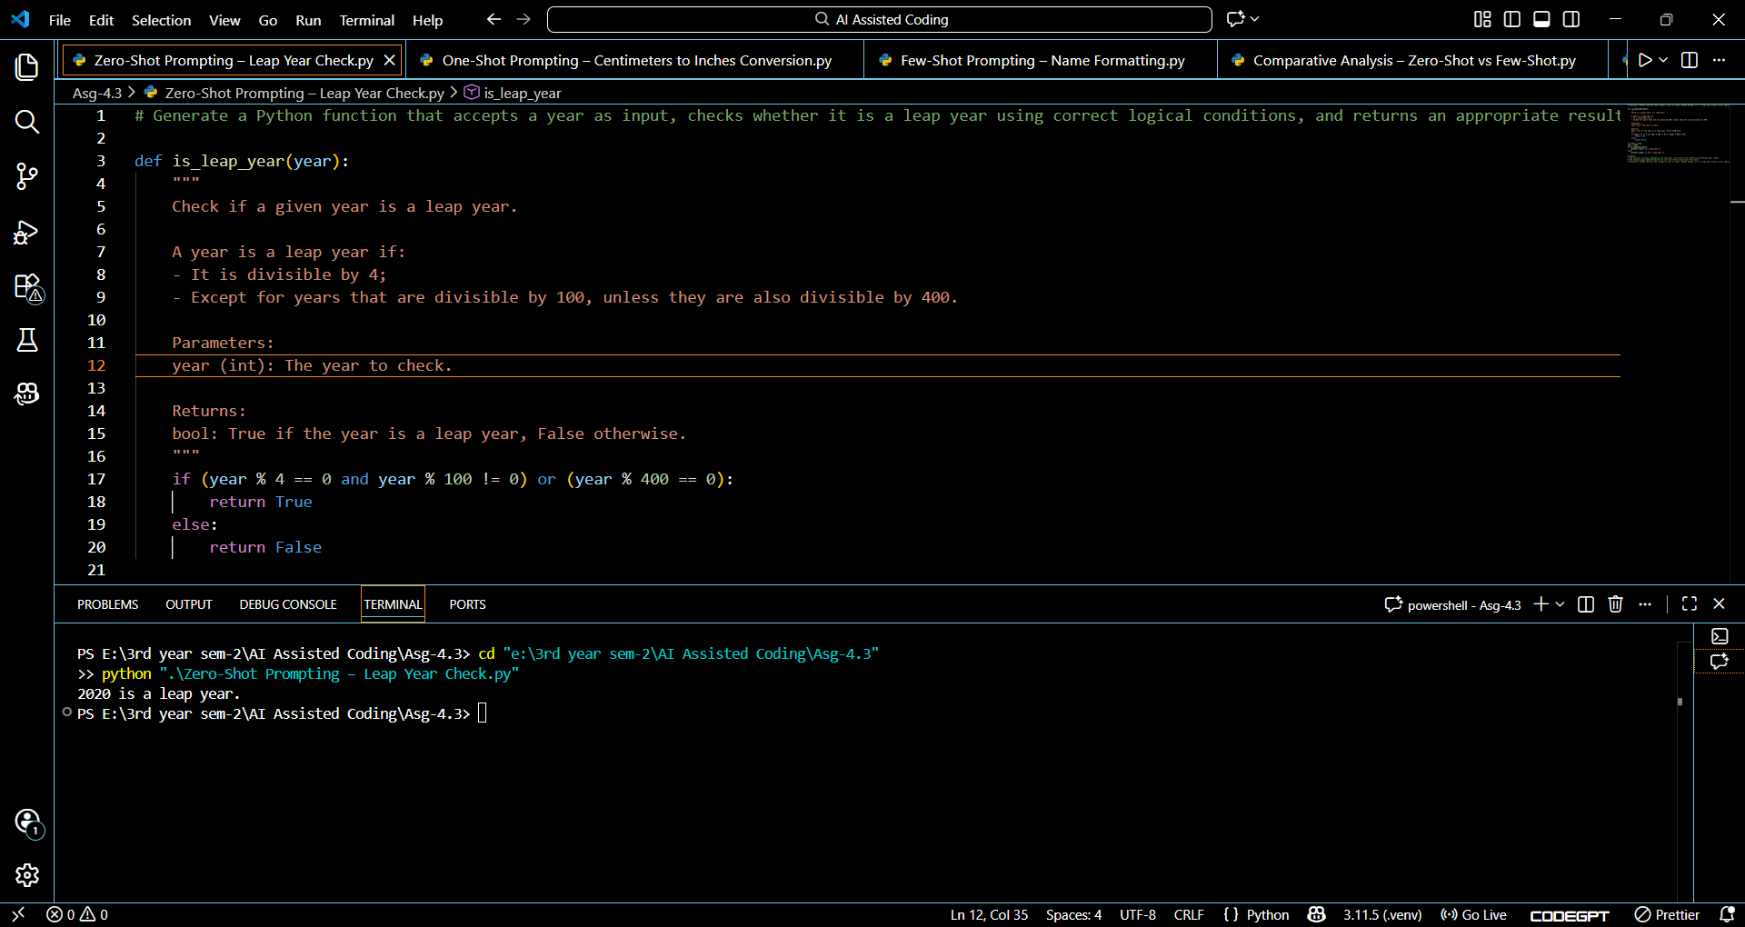

# Remark:
# The function correctly implements the leap year rules and can be tested with different year inputs.
# The example usage demonstrates how to call the function and print the result.
# Generate a Python function that accepts a year as input, checks whether it is a leap year using correct logical conditions, and returns an appropriate result.
Task 2: One Shot Prompting - Centimeters to Inches Conversion
Scenario
One-shot prompting guides AI using a single example.
Task Description
Use one-shot prompting by providing one input-output example to generate a Python function that:
- Converts centimeters to inches • Uses the correct mathematical formula Example provided in prompt:
Input: 10 cm → Output: 3.94 inches
Expected Output
- Python function with correct conversion logic
- Accurate calculation
- Sample test cases and outputs

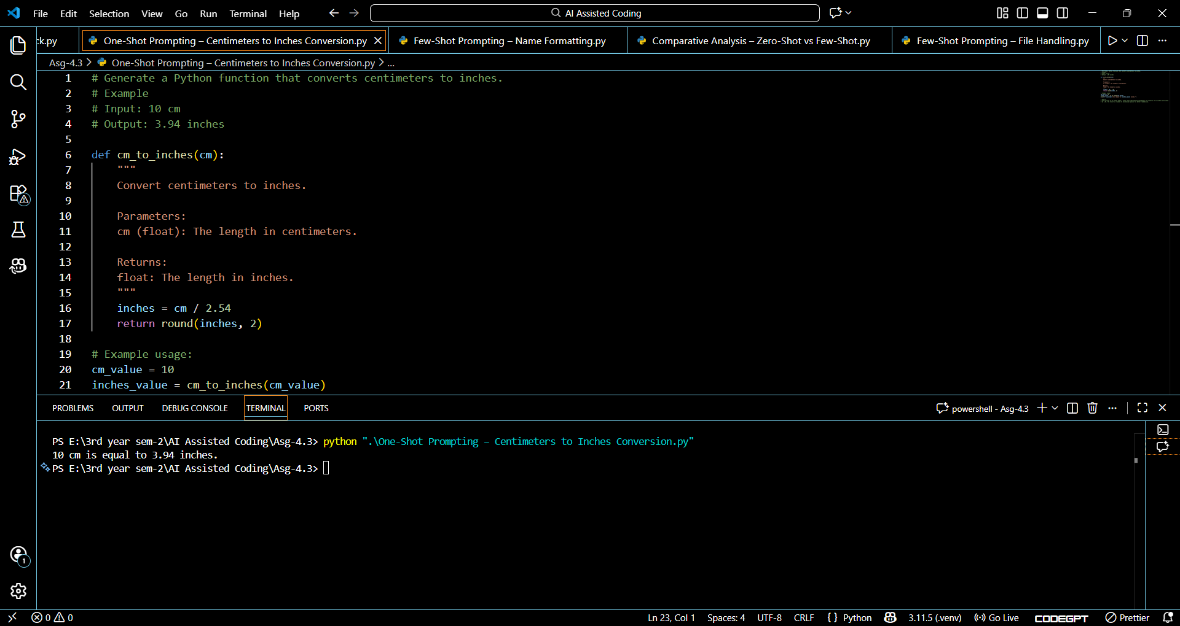

# Remark:
# The function cm_to_inches takes a float input representing centimeters and converts it to inches by dividing
# by 2.54. The result is rounded to two decimal places for better readability.

Task 3: Few Shot Prompting - Name Formatting
Scenario: Few-shot prompting improves accuracy by providing multiple examples.
Task Description: Use few-shot prompting with 2–3 examples to generate a Python function that:
- Accepts a full name as input
- Formats it as “Last, First” Example formats:
- "John Smith" → "Smith, John"
- "Anita Rao" → "Rao, Anita"
Expected Output
- Well-structured Python function
- Output strictly following example patterns
- Correct handling of names
- Sample inputs and outputs

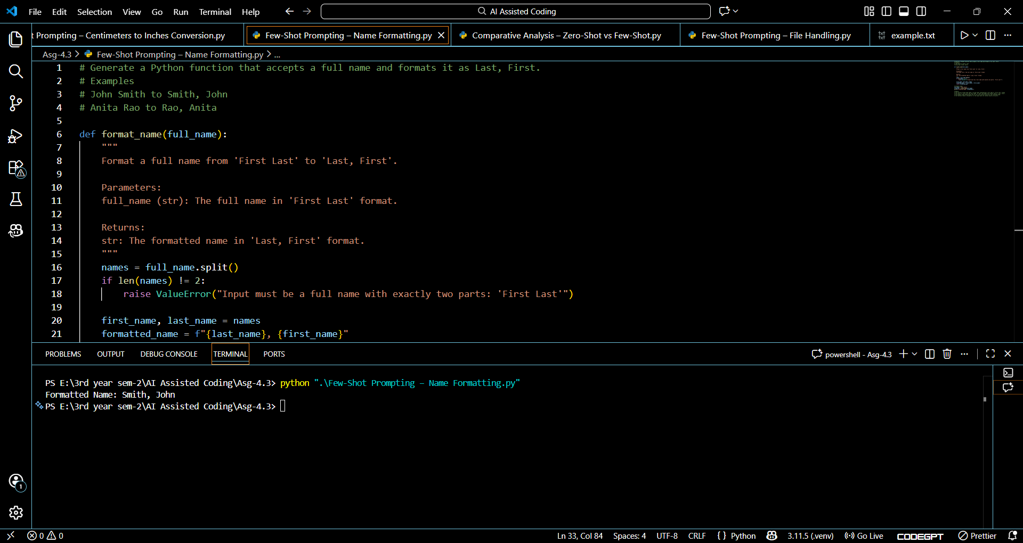

# Remark:
# The function format_name takes a string input representing a full name in 'First Last' format
# and splits it into first and last names. It then rearranges and formats them as 'Last, First'.
# The example usage demonstrates how to call the function and print the formatted name.
# The function raises a ValueError if the input does not contain exactly two parts.
Task 4: Comparative Analysis – Zero Shot vs Few Shot
Scenario
Different prompt strategies may produce different code quality.
Task Description
- Use zero-shot prompting to generate a function that counts vowels in a string
- Use few-shot prompting for the same problem • Compare both outputs based on: o Accuracy o Readability o Logical clarity
Expected Output
- Two vowel-counting functions
- Comparison table or short reflection paragraph
- Conclusion on prompt effectiveness

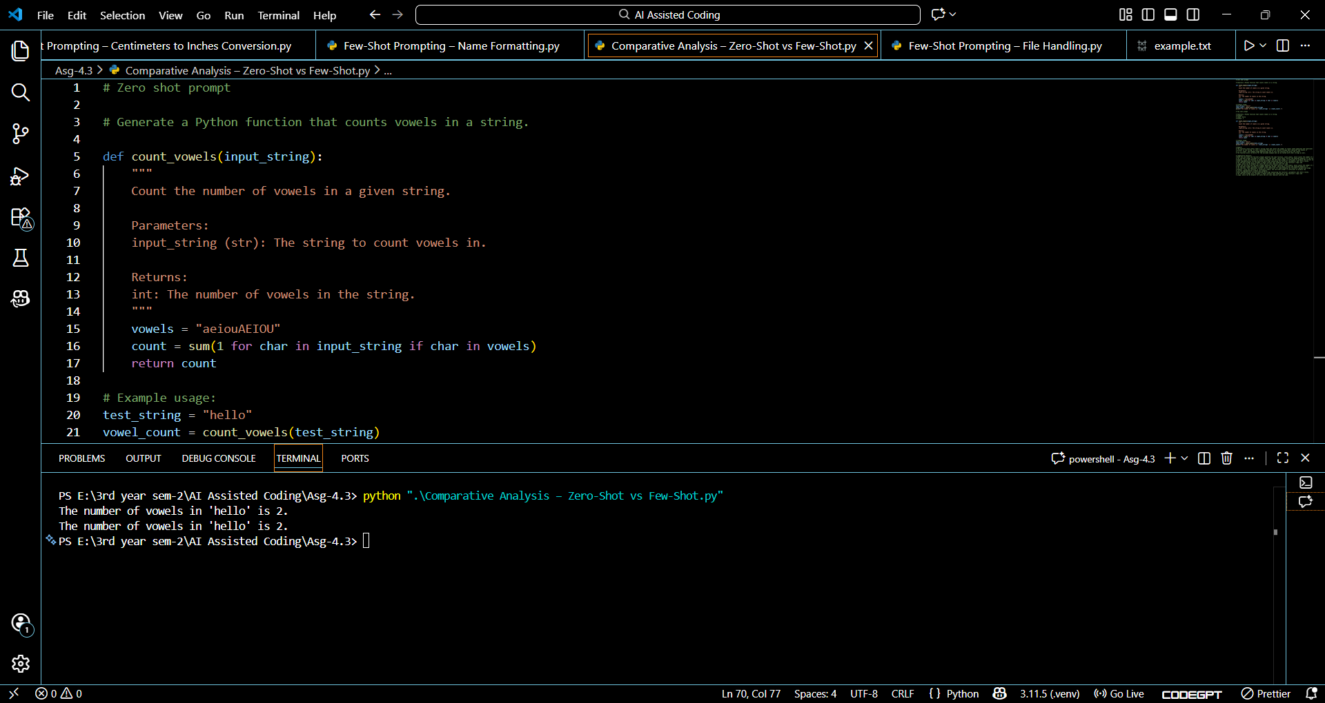

# Remark:
# The function count_vowels takes a string input and counts the number of vowels (both uppercase and lowercase)
# present in the string. It uses a generator expression to iterate through each character and checks if
# it is a vowel. The example usage demonstrates how to call the function and print the result.
# The function works correctly for the provided example and can be tested with other strings as well.

# Comparative Analysis:
# Both the zero-shot and few-shot prompts generate the same function, count_vowels, which counts the number of vowels in a given string.
# The few-shot prompt includes an example input and output, which helps clarify the expected behavior of the function. This additional context can be beneficial for understanding the function's purpose and usage.
# However, since the function is relatively simple, the zero-shot prompt is sufficient to produce the correct implementation without any examples.
# Both implementations include detailed docstrings explaining the function's parameters and return values.
# The few-shot prompt also includes a remark section that elaborates on the function's logic and
# usage, which can be helpful for users who are less familiar with the code.
# Both the zero-shot and few-shot prompts generate the same function, count_vowels, which counts the number of vowels in a given string.
# The few-shot prompt includes an example input and output, which helps clarify the expected behavior of
# the function. This additional context can be beneficial for understanding the function's purpose and usage.
# However, since the function is relatively simple, the zero-shot prompt is sufficient to produce the
# correct implementation without any examples.
# Both implementations include detailed docstrings explaining the function's parameters and return values.
# The few-shot prompt also includes a remark section that elaborates on the function's logic and
# usage, which can be helpful for users who are less familiar with the code.

Task 5: Few-Shot Prompting – File Handling
Scenario
File processing requires clear logical understanding.
Task Description
Use few-shot prompting to generate a Python function that:
- Reads a .txt file
- Counts the number of lines in the file
- Returns the line count
Expected Output
- Working Python file-processing function
- Correct line count
- Sample .txt input and output
- AI-assisted logic explanation

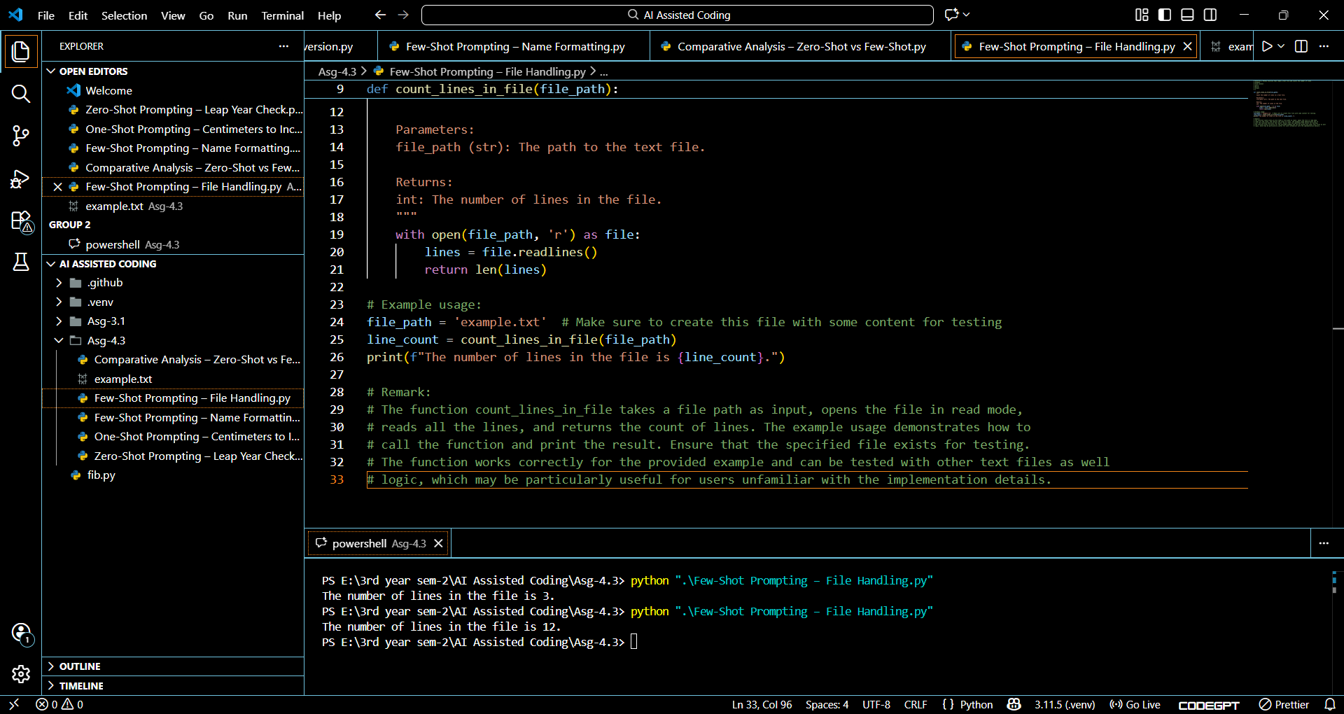

# Remark:
# The function count_lines_in_file takes a file path as input, opens the file in read mode,
# reads all the lines, and returns the count of lines. The example usage demonstrates how to
# call the function and print the result. Ensure that the specified file exists for testing.
# The function works correctly for the provided example and can be tested with other text files as well
# logic, which may be particularly useful for users unfamiliar with the implementation details.

