

Requirement & Design Specification
Diamond Shop System
DAT J
Version: 1.0

– Ho Chi Minh Campus, 2024 –

Record of Changes
Version | Date | A*  M, D | In charge | Change Description
V1.0 | 15/05 | M | DuongVDQ | Comment từng phần nên được làm như thế nào.  Add actor vào mục I.1
V1.0 | 16/05 | A | AnhDL  DuongVDQ | AnhDl: thêm use case vào bảng gần mục II
V1.0 | 16/05 | A | DatNT | Add 2 use cases’ details in Common Function.
V1.1 | 17/05 | A, M | DatNT | Continue to add new use cases in Common Function.  Modify 2 use cases in 16/05
V1.0 | 18/05 | A | DucDT | Add screen flow
V1.0 | 18/05 | A | DatNT | Add 5 use cases’ details in Common Function
v1.0 | 19/05 | A | DucDT | Add screen description, screen authorization, non-UI Function
V1.0 | 19/05 | A | DatNT | Add 5 use cases’ details in Common Function
V1.0 | 20/05 | A | TruongLT | Add database schemas
V1.0 | 27/05 | A | AnhDL  DuongVDQ | Add use case description to I, 1, 1.2 b.
*A - Added M - Modified D - Deleted

Contents
Record of Changes 2
I. Overview 4
1. User Requirements 4
1.1 Actors 4
1.2 Use Cases 4
2. Overall Functionalities 9
2.1 Screens Flow 9
2.2 Screen Descriptions 9
2.3 Screen Authorization 11
2.4 Non-UI Functions 12
3. System High Level Design 12
3.1 Database Design 12
3.2 Code Packages 15
II. Requirement Specifications 16
1. Shopping Function 16
1.1 UC-14_Add to Cart 16
1.2 UC-15_Update Order (For Manager) 18
1.3 UC-15_Update Order Status (For Sale Staff) 19
1.4 UC-16_Update Order Status (For Delivery Staff) 21
1.5 UC-17_ Create Diamond 22
1.6 UC-18_ Update Diamond Price List 23
2. Common Functions 24
2.1 UC-1_Register 24
2.2 UC-2_View Shop Information 26
2.3 UC-3_View policies 27
2.4 UC-4_View Jewelry Blog 27
2.4 UC-5_View measure jewelry size’s blog 28
2.5 UC-6_View diamond prices list 29
2.6 UC-7_Search product 30
2.7 UC-8_View diamond list 30
2.8 UC-9_View detail diamond 31
2.9 UC-10_Login 32
2.10 UC-11_Log out 33
2.11 UC-12_View profile 33
3. Warranty Function 34
3.1 UC-24_Make warranty request 34
III. Design Specifications 36
1. Shopping features 36
1.1 Add to cart 36
2. Order features 42
2.1 Update Order 42
3. Warranty features 43
3.1 Create Warranty Request 43
4. Product features 44
4.1 Create Diamond 44
4.2 Update Diamond 46
5. System feature 47
5.1 Update Diamond Price List 47
IV. Appendix 47
1. Assumptions & Dependencies 47
2. Limitations & Exclusions 47
3. Business Rules 47

I. Overview

1. User Requirements

1.1 Actors
# | Actor | Description
1 | Administrator | System administrator with access to manage the entire system, perform settings, and maintenance.
2 | Guest | Guests are people who have not been authenticated to the  system, who can browse products but cannot make purchases or access restricted functions.
3 | Customer | Shoppers who can view and purchase products, and track their orders.
4 | Sales Staff | Responsible for selling products, assisting customers, and managing orders.
5 | Delivery Staff | Responsible for transporting and delivering products to customers. This actor has high knowledge about diamonds to confirm and give diamonds to customers.
6 | Warranty Staff | Responsible for transporting and warranty requests to customers.
7 | Manager | Oversees store operations, supervises staff, and handles reporting.

1.2 Use Cases

a. Diagram(s)

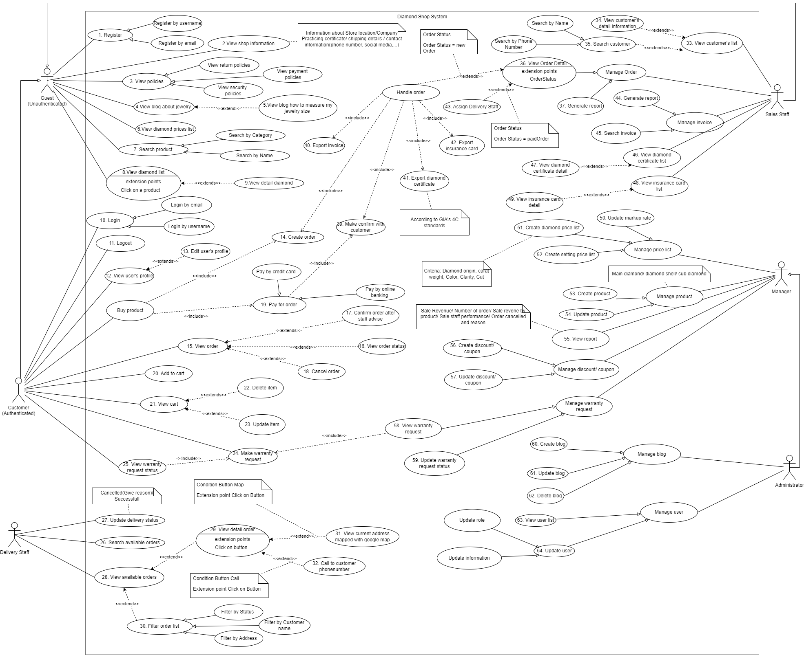

b. Descriptions
ID | Feature | Use Case | Use Case Description
1 | Common function | Register | New customer register for a new account
2 | Common function | View shop information | View shop information: location, phone number, gmail, social account, …
3 | Common function | View policies | View policies of the shop: shopping policy, warranty policy, …
4 | Common function | View blog about jewelry | View blog about jewelry
5 | Common function | View blog how to measure my jewelry size | View blog how to measure my jewelry size
6 | Common function | View diamond prices list | View diamond price list by date
7 | Common function | Search product | Search for a diamond, accessory
8 | Common function | View diamond list | View diamond list to buy
9 | Common function | View detail diamond | View detail about a diamond
10 | Common function | Login | Login by account
11 | Common function | Logout | Logout from system
12 | Common function | View user's profile | View user’s profile, show user information
13 | Common function | Edit user's profile | Edit information
14 | Shopping function | Create order | Create order to buy product
15 | Shopping function | View order | View Order detail
16 | Shopping function | View order status | View order status
17 | Shopping function | Confirm order after staff advise | Confirm order
18 | Shopping function | Cancel order | Cancel order after create but not delivery yet
19 | Shopping function | Pay for order | pay for order
20 | Shopping function | Add to cart | Add product to cart
21 | Shopping function | View cart | View cart
22 | Shopping function | Delete item | Delete cart item
23 | Shopping function | Update item | Update accessory
24 | Warranty function | Make warranty request | Make warranty request with warranty card
25 | Warranty function | View warranty request status | Sale staff view warranty request from customer
26 | Staff function | Search available orders | Delivery staff search for available order
27 | Staff function | Update delivery status | Delivery staff update delivery status
28 | Staff function | View available orders | Delivery staff view available order list
29 | Staff function | View detail order | Delivery staff view order details including customer information : phone number, address, …
30 | Staff function | Filter order list | Delivery staff filter order by address, by product, …
31 | Staff function | View current address mapped with google map | Delivery staff view customer address
32 | Staff function | Call to customer phone number | Delivery staff can get phone number to call customer
33 | Staff function | View customer's list | Sale staff view customer list
34 | Staff function | View customer's detail information | Sale staff view customer details
35 | Staff function | Search customer | Sales staff search for customers: name, phone number,...
36 | Staff function | View Order Detail | Sale staff view order detail
37 | Staff function | Generate report | Manage generate reports about revenue, order, sale staff, delivery staff, …
38 | Staff function | Make confirm with customer | Sale staff make confirm with customer
39 | Staff function | Export invoice | Sale staff export invoice when customer buy a product
40 | Staff function | Export diamond certificate | Export diamond certificates after a successful purchase.
41 | Staff function | Export warranty card | Create and export warranty cards after a successful purchase.
42 | Staff function | Assign Delivery Staff | Assign delivery staff to order.
43 | Staff function | Generate report | Generate reports from sales statistics.
44 | Staff function | Search invoice | Search for an existing invoice by invoice id.
45 | Staff function | View diamond certificate list | View the list of existing diamond certificates.
46 | Staff function | View diamond certificate detail | View the details of a diamond certificate.
47 | Staff function | View warranty card list | View the list of existing warranty cards.
48 | Staff function | View warranty card detail | View the details of a warranty card.
49 | Staff function | Update markup rate | Update the currently applied markup rate.
50 | Staff function | Create diamond price list | Create diamond prices to be applied to the whole system.
51 | Staff function | Create accessory price list | Create accessory prices to be applied to the whole system.
52 | Staff function | Create product | Create diamond, accessories.
53 | Staff function | Update product | Update diamond, accessory details.
54 | Staff function | View report | View report about sales statistics.
55 | Staff function | Create discount/ coupon | Create discount promotion, coupon
56 | Staff function | Update discount/ coupon | Update currently applied discount/coupon
57 | Staff function | View warranty request | View list of currently assigned warranty requests.
58 | Staff function | Update warranty request status | Sale staff update warranty status
59 | Staff function | Create blog | Manage create blogs
60 | Staff function | Update blog | Update existing blog.
61 | Staff function | Delete blog | Deleted created blog.
62 | Admin function | View user list | Admin view all registered user accounts
63 | Admin function | Update user | Admin update user’s account details

2. Overall Functionalities

2.1 Screens Flow
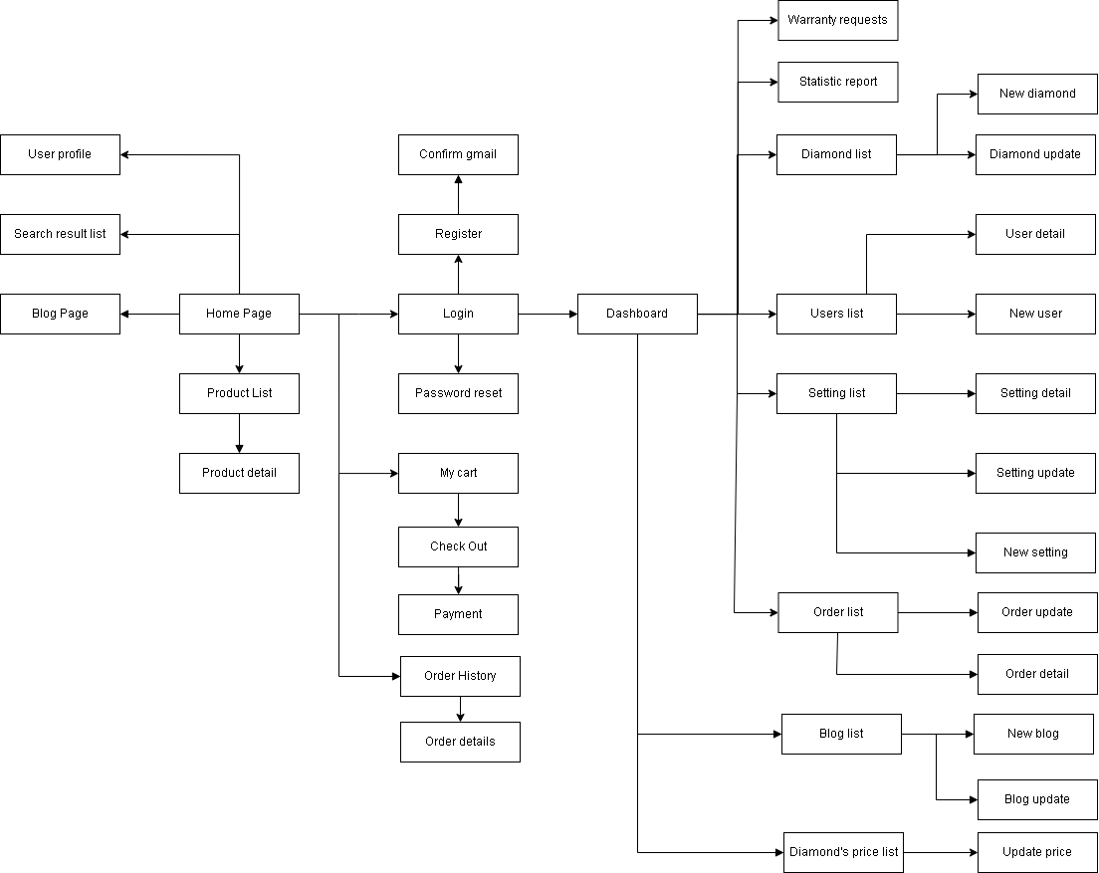

2.2 Screen Descriptions
# | Feature | Screen | Description
1 | User Profile | User Profile | Display user information, and account settings.
2 | Search Bar | Home Page, Product List | Allows users to search for products.
3 | Search Result | Search Result List | Shows a list of items matching the user’s search.
4 | Blog Posts | Blog Page, Blog List | Displays a list of blog posts.
5 | Product Listing | Product List | Shows a list of products available.
6 | Product Details | Product Detail | Provides detailed information about a selected product.
7 | Login Form | Login | Allows users to enter username and password to access their accounts.
8 | Registration Form | Register | Allows new users to create an account.
9 | Email Confirmation | Confirm Gmail | Users confirm their email address after registration.
10 | Password Reset | Password Reset | Allows users to reset their password by entering their email.
11 | Shopping Cart | My Cart | Displays items that the users have added to their shopping cart.
12 | Checkout Process | Check Out
13 | Payment Information | Payment | Payment details from the user to complete a purchase.
14 | Order History | Order History | Lists past orders placed by the user
15 | Order Details | Order Detail | Display detailed information about a specific order.
16 | Dashboard | Dashboard | Overview of statistics.
17 | Warranty Request | Warranty Request | Display all warranty requests made by users.
18 | Statistics Report | Statistic Report | Displays various statistics and analytics related to sales.
19 | Diamond Listing | Diamond List | Shows a list of diamonds contained in the system.
20 | Add New Diamond | New Diamond | Form to add a new diamond to the inventory.
21 | Update Diamond | Diamond Update | Allows editing of existing diamond information.
22 | User List | User List | Display a list of all registered users.
23 | User Detail | User Detail | Provides detailed information about a specific user.
24 | Add New User | New User | Form to add a new user to the system.
25 | Setting Overview | Setting List | Displays a list of available settings in the system.
26 | Setting Details | Setting Detail | Provides detailed information about specific settings.
27 | Update Setting | Setting Update | Allows editing of an existing setting.
28 | Add New Setting | New Setting | Form to add a new setting to the inventory.
29 | Order List | Order List | Displays a list of all orders placed through the system.
30 | Update Order | Order Update | Allows confirm order or cancel order.
31 | Blog List | Blog List | Shows a list of all blog posts.
32 | Add New Blog | New Blog | Form to create a new blog post.
33 | Update Blog Post | Blog Update | Allows editing of an existing blog post.
34 | Diamond Price List | Diamond’s Price List | Display a list of all categories of diamond.
35 | Update Diamond Price | Update Price | Allows updating of diamond prices.

2.3 Screen Authorization
Screen | Guest | Customer | Sale Staff | Delivery Staff | Manager | Administrator
User Profile |  | X | X | X | X | X
View/Edit Profile |  | X | X | X | X | X
Search Result List | X | X | X | X | X | X
View Result | X | X | X | X | X | X
Blog Page | X | X | X | X | X | X
View Blog Page | X | X | X | X | X | X
Home Page | X | X | X | X | X | X
View Home | X | X | X | X | X | X
Product List | X | X | X | X | X | X
View Product | X | X | X | X | X | X
Product Detail | X | X | X | X | X | X
View Product Detail | X | X | X | X | X | X
Login | X | X | X | X | X | X
Log In | X | X | X | X | X | X
Register | X | X
Create Account | X | X
Confirm Gmail | X | X
Password Reset | X | X | X | X | X | X
My Cart |  | X
View/Edit Cart |  | X
Check Out |  | X
Payment |  | X
Order History |  | X | X |  | X | X
View Order History |  | X | X |  | X | X
Dashboard |  | X | X |  | X | X
View Dashboard |  | X | X |  | X | X
Warranty Request |  |  | X
Statistic Report |  |  | X |  | X | X
Diamond List |  | X | X | X | X | X
View Diamond List |  | X | X | X | X | X
New Diamond |  |  |  |  | X | X
Add new Diamond |  |  |  |  | X | X
Diamond Update |  |  |  |  | X | X
Update Diamond |  |  |  |  | X | X
User List |  |  |  |  |  | X
New User |  |  |  |  |  | X
Add New User |  |  |  |  |  | X
Setting List |  |  |  |  |  | X
Setting Detail |  |  |  |  |  | X
Setting Update |  |  |  |  |  | X
New Setting |  |  |  |  |  | X
Order List |  | X | X |  | X | X
Order Update |  |  |  |  | X | X
Blog List |  | X | X |  | X | X
View Blog List |  | X | X |  | X | X
Add New Blog |  |  |  |  |  | X
Update Blog |  |  |  |  |  | X
Diamond’s Price List |  | X | X |  | X | X
View Diamond Prices |  | X | X |  | X | X
Update Diamond Prices |  |  |  |  |  | X

2.4 Non-UI Functions
# | Feature | System Function | Description
1 | Update Order to “Expired” | Confirm Order | Update “Pending” order to “Expired”. This function will run when the order is not paid within 7 days.
2 | Email Verification | Send Confirmation Email | Send an email to users to confirm their email address. This function will run when a new user registers a new account.
3 | Password Management | Password Reset Token | Generates a secure token for password reset requests.

3. System High Level Design

3.1 Database Design

a. Database Schema

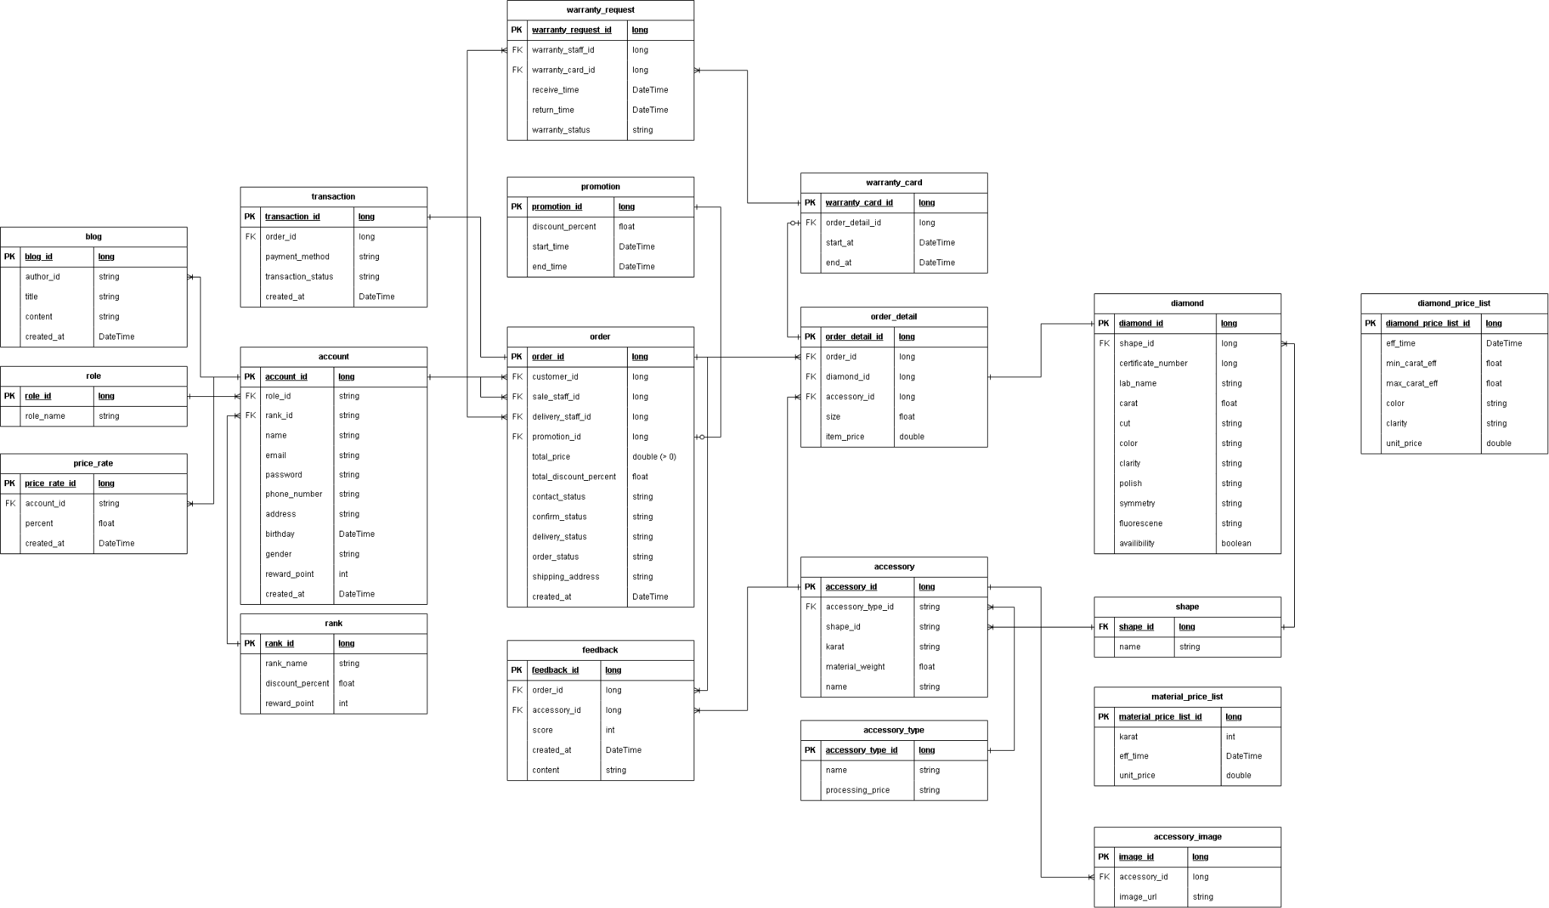

b. Table Descriptions

No | Table | Description
01 | account | - Primary keys: account_id  - Foreign keys: role_id, rank_id  - Attributes: name, email, password, phone_number, address, birthday, gender, reward_point, created_at
02 | role | - Primary keys: role_id  - Foreign keys: account_id  - Attributes: role_name
03 | blog | - Primary keys: blog_id  - Foreign keys: author_id  - Attributes: title, content, created_at
04 | price_rate | - Primary keys: price_rate_id  - Foreign keys: account_id  - Attributes: percent, created_at
05 | rank | - Primary keys: rank_id  - Foreign keys: account_id  - Attributes: rank_name, discount_percent, reward_point
06 | order | - Primary keys: order_id  - Foreign keys: customer_id, sale_staff_id, delivery_staff_id, promotion_id  - Attributes: total_price, total_discount_percent, contact_status, confirm_status, delivery_status, order_status, shipping_address, created_at
07 | order_detail | - Primary keys: order_detail_id  - Foreign keys: order_id, diamond_id, accessory_id  - Attributes: size, item_price
08 | promotion | - Primary keys: promotion_id  - Foreign keys: order_id  - Attributes: discount_percent, start_time, end_time
09 | warranty_card | - Primary keys: warranty_card_id  - Foreign keys: order_detail_id  - Attributes: start_time, end_time
10 | warranty_request | - Primary keys: warranty_request_id  - Foreign keys: warranty_staff_id, warranty_card_id  - Attributes: receive_time, return_time, warranty_status
11 | feedback | - Primary keys: feedback_id  - Foreign keys: order_id, accessory_id  - Attributes: score, created_at, content
12 | accessory | - Primary keys: accessory_id  - Foreign keys: shape_id, accessory_type  - Attributes: karat, material_weight, name
13 | accessory_type | - Primary keys: accessory_type  - Foreign keys: none  - Attributes: name, processing_price
14 | accessory_image | - Primary keys: accessory_image_id  - Foreign keys: accessory_id  - Attributes: image_url
15 | diamond | - Primary keys: diamond_id  - Foreign keys: shape_id  - Attributes: certificate_number, lab_name, color, clarity, cut, carat, polish, symmetry, fluorescence, availability
16 | shape | - Primary keys: shape_id  - Foreign keys: none  - Attributes: name
17 | diamond_price_list | - Primary keys: diamond_price_list_id  - Foreign keys: none  - Attributes: min_carat_eff, max_carat_eff, eff_time, color, clarity, unit_price
18 | material_price_list | - Primary keys: material_price_list  - Foreign keys: none  - Attributes: karat, eff_time, unit_price
19 | transaction | - Primary keys: transaction_id  - Foreign keys: order_id  - Attributes: payment_method, transaction_status, created_at

3.2 Code Packages
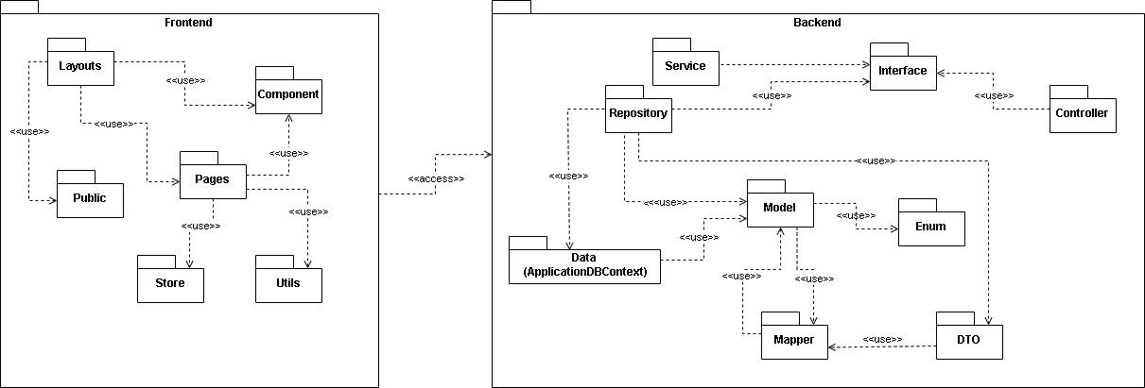
Package descriptions
No | Package | Description
01 | Frontend | Package for frontend development
02 | Layouts | Package contains page’s layout
03 | Pages | Package contains pages
04 | Public | Package contains static resource
05 | Component | Package contains general components
06 | Store | Package for global state handling
07 | Utils | Package for commonly used function
08 | Backend | Package for backend development
09 | Service | Package for service
10 | Repository | Package for interactions with database
11 | Controllers | Package for controlling routing of the server
12 | Models | Package for classes to reflect database’s table
13 | Enum | Package for Enum classes to constraint certain attribute
14 | DTO | Package for classes tobe send to frontend
15 | Mapper | Package for converting Model to DTO and vice versa
16 | Data | Package to connect to database

II. Requirement Specifications

1. Shopping Function

1.1 UC-14_Add to Cart

a. Functionalities

UC ID and Name: | UC-14: Add to Cart
Created By: | Vo Do Quang Duong | Date Created: | 16/05/2024
Primary Actor: | Customer, Guest | Secondary Actors:
Trigger: | The actor wants to add the products.to cart.
Description: | This feature allows actors to add products to cart which have a diamond, and a diamond shell(optional).
Preconditions:
Postconditions: | Add success an diamond and a diamond shell (optional) that can view in the Cart detail page
Normal Flow | Step Actor Action System Response  1 Click on the Diamond tab in the top navigation bar from the homepage. Show the list of diamonds available in the system with some information about each diamond: - Image - Shape - Price - Carat - Color - Clarity - Cut - Lab And a button to go into the diamond detail page to view more information.  2 Choose a diamond in the list from diamond list page Show the detail information about the diamond: - Image - Certificate number - Price - Lab - Carat - Color - Clarity - Polish - Symmetry - Fluorescence and 2 button: - “Choose this diamond” to choose an accessory for this diamond to add to cart - “Buy without accessory” to add to cart without accessory  3 Click “Choose this diamond” [Alternative 1] [Exception 1] Add the diamond to current choosing product phase, and navigate user to the accessory list page which  4 Choose an accessory in the list Show the detail information about the accessory and ask user to choose their size  5 Choose the size and click “Choose this accessory” Add the accessory to current choosing product phase, and navigate user to the complete product page  6 Confirm the information of the complete product and click “Add to cart” Add the product includes a diamond and a accessory to cart and navigate user to their cart page
Alternative Flows: | Step Actor Action System Response  1 Click “Buy without accessory”. [Exception 1] Add the diamond to the current choosing product phase. Add the product to cart and navigate user to their cart page
Exceptions: | No Cause System Response  1 Add an existing diamond to the cart. Popup notification that the diamond already existed in the cart and navigate user to the cart page
Priority: | Must Have
Frequency of Use: | Frequent
Business Rules: | BR-02
Other Information: | None
Assumptions: | - Actor’s internet connection is available

b. Business Rules
None

1.2 UC-15_Update Order (For Manager)

a. Functionalities

UC ID and Name: | UC-14: Add to Cart
Created By: | Vo Do Quang Duong | Date Created: | 17/05/2024
Primary Actor: | Manager | Secondary Actors: | Customer
Trigger: | The actor wants to assign staff responsible to the order or update the order status.
Description: | This feature allows actors to assign sales staff and delivery to an order or update the order status.
Preconditions: | - Actor login as Manager role  - A customer buys a diamond and the system creates an order.
Postconditions: | Assign successful sale staff and delivery staff for an order
Normal Flow | Step Actor Action System Response  1 Click on the Order tab in the sidebar from the Dashboard. Show the list of orders currently in process. Each order have information: - OrderID - Created At - Customer - Shipping Address - Phone number - Sale staff - Delivery staff - Order Price - Order status Sale staff and delivery staff column is drop down to assign them for the order  2 In the sale staff column, the manager clicks the drop down button of an order. Manager chooses a sale staff in the drop down menu to assign this order to. [Alternative 1] [Alternative 2] Navigate to Order list page with updated assigned staff
Alternative Flows: | Alternative 1  Step Actor Action System Response  1 In the delivery staff column, the manager clicks the drop down button of an order. Manager chooses a delivery staff in the drop down menu to assign this order to. Navigate to Order list page with updated delivery staff  Alternative 2  Step Actor Action System Response  1 In the order status column, the manager clicks the drop down button of an order. Manager chooses a suitable status for this order. Navigate to Order list page with updated order status
Exceptions: | None
Priority: | Must Have
Frequency of Use: | Frequent
Business Rules: | BR-01, FR1
Other Information: | None
Assumptions: | - Actor’s internet connection is available

b. Business Rules

ID | Business Rule | Business Rule Description
FR1 | Flow assign | Delivery Staff only be assign after sale staff be assigned and turn this order status to “Confirm”

1.3 UC-15_Update Order Status (For Sale Staff)

a. Functionalities

UC ID and Name: | UC-15: Update Order Status (For Sale Staff)
Created By: | Vo Do Quang Duong | Date Created: | 17/05/2024
Primary Actor: | Sale Staff | Secondary Actors: | Manager
Trigger: | The actor wants to update the order status as a sale staff
Description: | This feature allows actors to update the order status as a sale staff
Preconditions: | - Actor login as Sale Staff role  - A customer buys a diamond and the system creates an order.  - Manager assigned an order for this actor.
Postconditions: | Update status of order from “Processing” to “Confirmed” success.
Normal Flow | Step Actor Action System Response  1 Click on the Sale Staffs tab in the sidebar from the Dashboard. Show the list of orders currently in process. Each order have information: - OrderID - Created At - Customer - Shipping Address - Phone number - Order detail - Order Price - Order status Order status column is a button to update status from “Processing” to “Confirmed”.  2 Click on the “Processing” button. Update the status of the order to “Confirmed”.
Alternative Flows: | N/A
Exceptions:
Priority: | Must Have
Frequency of Use: | Frequent
Business Rules: | BR-01
Other Information: | None
Assumptions: | - Actor’s internet connection is available

b. Business Rules
None

1.4 UC-16_Update Order Status (For Delivery Staff)

a. Functionalities

UC ID and Name: | UC-16: Update Order (For Delivery Staff)
Created By: | Vo Do Quang Duong | Date Created: | 17/05/2024
Primary Actor: | Delivery Staff | Secondary Actors: | Manager
Trigger: | The actor wants to update the order status as a delivery staff.
Description: | This feature allows actors to update the order status as a delivery staff.
Preconditions: | - Actor login as Delivery Staff role  - A customer buys a diamond and the system creates an order.  - Manager assigned an order for this actor after Sale staff changed this order status to “Confirm”.
Postconditions: | Update status of order from “Confirm” to “Delivery”, “Success” or “Fail” success.
Normal Flow | Step Actor Action System Response  1 Click on the Delivery Staffs tab in the sidebar from the Dashboard. Show the list of orders currently in process. Each order have information: - OrderID - Created At - Customer - Shipping Address - Phone number - Order detail - Order Price - Order status Order status column is a button to update status from “Processing” to “Confirmed”.  2 Click on the Order Status Select on the right of the order in the admin screen. Show the list of status in the order. Each order have status: - Delivering - Completed - Failed And click select on “Delivering”, system update the order status to “Delivering”  3 Click on the Order Status select on the right of the order in the admin screen. [Alternative 1] Show the list of status in the order. Each order have status: - Delivering - Completed - Failed And click select on “Completed”, system update the order status to “Completed”
Alternative Flows: | Alternative 1  Step Actor System Response  1 Click on the Order Status select on the right of the order in the admin screen. Show the list of status in the order. Each order have status: - Delivering - Completed - Failed And click select on “Failed”, system update the order status to “Failed”
Exceptions: | None
Priority: | Must Have
Frequency of Use: | Frequent
Business Rules: | BR-02
Other Information: | None
Assumptions: | - Actor’s internet connection is available

b. Business Rules

1.5 UC-17_ Create Diamond

a. Functionalities

UC ID and Name: | UC-17: Create Diamond
Created By: | Vo Do Quang Duong | Date Created: | 16/05/2024
Primary Actor: | Administrator, Manager | Secondary Actors:
Trigger: | The actor wants to add the diamond to the system’s database.
Description: | This feature allows actors to add the diamond to the system’s database.
Preconditions: | Actor login as Administrator or Manager role
Postconditions: | Add success an diamond to the system’s database
Normal Flow | Step Actor Action System Response  1 Click on the “Diamonds” tab on the dashboard sidebar Navigate user to the diamond list page  2 Click on the “New Diamond” button Navigate to create diamond form with these information: - Clarity - Image - Certificate number - Lab - Shape - Carat - Color - Clarity - Cut - Polish - Symmetry - Fluorescence  3 Fill in the form and click “Create” [Exception 1] Add the diamond to the system’s database and navigate user to the diamond detail page
Alternative Flows: | N/A
Exceptions: | No Cause System Response  1 Add an existing diamond to the system. Popup notification that the diamond already existed in the database
Priority: | Must Have
Frequency of Use: | Frequent
Business Rules: | BR-02
Other Information: | None
Assumptions: | - Actor’s internet connection is available

1.6 UC-18_ Update Diamond Price List

a. Functionalities

UC ID and Name: | UC-17: Update Diamond Price List
Created By: | Vo Do Quang Duong | Date Created: | 16/05/2024
Primary Actor: | Administrator | Secondary Actors:
Trigger: | The actor wants to update the diamond price of the system
Description: | This feature allows actors to update the diamond price of the system
Preconditions: | Actor login as Administrator role
Postconditions: | Update success diamond price of the system
Normal Flow | Step Actor Action System Response  1 Click on the “Diamond Price” tab on the dashboard sidebar Navigate user to the diamond price list page  2 Click on the diamond price box that the actor want to update Display a dialogue to get the input from the user  3 Fill in the dialogue and click “OK” Update the diamond price to the system’s database
Alternative Flows: | None
Exceptions: | None
Priority: | Must Have
Frequency of Use: | Frequent
Business Rules: | BR-02
Other Information: | None
Assumptions: | - Actor’s internet connection is available

2. Common Functions

2.1 UC-1_Register

a. Functional Description
UC ID and Name: | UC-1_Register
Created By: | DatNT | Date Created: | May 17th 2024
Primary Actor: | Guest | Secondary Actors: | None
Trigger: | Actor wants to sign up an account and clicks “Register” label from the page header
Description: | As a guest, I want to be able to have an account so that I can log into the system.
Preconditions: | None
Postconditions: | - User creates an account successfully.  - The system tracked successful registers into the Activity Log.
Normal Flow | Step Actor Action System Response  1 Actor clicks the Register link in Home Page screen [Alternative 1] System redirects to Register screen  2 Actor types in the register details System validates the register details [Exception 1]  3 Actor clicks Register button System shows successful message System allows user to use account System tracks user’s success register to the Activity Log System redirects to Home Page
Alternative Flows: | Alternative 1  Step Actor Action System Response  1 Actor clicks “Login with Google” button System redirects to Register with email screen if they haven’t  2 Actor types in the register details. Actor clicks submit System sends an OTP to the mail that you have registered  3 Actor enters that OTP System shows successful message System allows user to use account System tracks user’s success register to the Activity Log System redirects to Home Page
Exceptions: | None
Priority: | Must Have
Frequency of Use: | Frequent
Business Rules: | None
Other Information: | None
Assumptions: | None

b. Business Rules
ID | Business Rule | Business Rule Description
FR1 | Password Encoding | User’s password must be encoded with MD5 hashing
FR2 | Invalid Registering | User can’t be authenticated to register the account if below cases  - His/her register’s details are incorrect  - His/her username or email has already existed
FE3 | Age range | Users must be at least 13 years old to register

2.2 UC-2_View Shop Information

a. Functional Description
UC ID and Name: | UC-2_View Shop Information
Created By: | DatNT | Date Created: | May 18th 2024
Primary Actor: | Guest | Secondary Actors: | Customer, Staff
Trigger: | Actor wants to view the information (address, certificate, contact) and click “About us” label
Description: | As a guest, I want to be able to view the shop’s information to check the legitimacy of the shop.
Preconditions: | None
Postconditions: | - Users can see all the information about the shop.
Normal Flow | Step Actor Action System Response  1 Actor clicks the “About us” label in Home Page screen System redirects to “About us” screen
Alternative Flows: | None
Exceptions: | None
Priority: | Must have
Frequency of Use: | None
Business Rules: | FR1, FR2, FR3
Other Information: | None
Assumptions: | None

b. Business Rules: None

2.3 UC-3_View policies

a. Functional Description
UC ID and Name: | UC-3_View policies
Created By: | DatNT | Date Created: | May 18th 2024
Primary Actor: | Guest | Secondary Actors: | Customer, Staff
Trigger: | Actor wants to see the policies and clicks on “Our policies”
Description: | As a guest, I want to read the policy of the shop, so that I can know how Dat J sells products to me.
Preconditions: | None
Postconditions: | - Users see all policies displayed on the screen.
Normal Flow | Step Actor Action System Response  1 Actor clicks the “About us” label in Home Page screen System redirects to “About us” screen
Alternative Flows: | None
Exceptions: | None
Priority: | Must Have
Frequency of Use: | Frequent
Business Rules: | FR1, FR2
Other Information: | None
Assumptions: | None

b. Business Rules
None

2.4 UC-4_View Jewelry Blog

a. Functional Description
UC ID and Name: | UC-4_View Jewelry Blog
Created By: | DatNT | Date Created: | May 18th 2024
Primary Actor: | Guest | Secondary Actors: | Customer, Staff
Trigger: | Actor wants to view the blog that the shop posts on the website.
Description: | As a guest, I want to see the shop’s blogs so that I can know the shop’s recent information.
Preconditions: | None
Postconditions: | - User views a blog successfully
Normal Flow | Step Actor Action System Response  1 Actor clicks the “Blog” link in Home Page screen System redirects to Blog screen System shows list of blogs  2 Actor clicks on a blog System redirect to that blog.
Alternative Flows: | None
Exceptions: | None
Priority: | Should have
Frequency of Use:
Business Rules: | FR1, FR2, FR3
Other Information: | None
Assumptions: | None

b. Business Rules
ID | Business Rule | Business Rule Description
FR1 | Password Encoding | User’s password must be encoded with MD5 hashing
FR2 | Invalid Registering | User can’t be authenticated to register the account if below cases  - His/her register’s details are incorrect  - His/her username or email has already existed

2.4 UC-5_View measure jewelry size’s blog

a. Functional Description
UC ID and Name: | UC-5_View measure jewelry size’s blog
Created By: | DatNT | Date Created: | May 18th 2024
Primary Actor: | Guest | Secondary Actors: | Customer, Staff
Trigger: | Actor wants to view how to measure ring size
Description: | As a guest, I want to see the shop’s blogs so that I can know how to measure my size.
Preconditions: | None
Postconditions: | - Users view a blog successfully.
Normal Flow | Step Actor Action System Response  1 Actor clicks the “About us” link in Home Page screen System redirects to the blog's screen.  2 Actor clicks the header “How to measure my size” in System redirects to the measure guide screen.
Alternative Flows: | None
Exceptions: | None
Priority: | Should Have
Frequency of Use: | Frequent
Business Rules: | FR1, FR2, FR3
Other Information: | None
Assumptions: | None

b. Business Rules
ID | Business Rule | Business Rule Description
FR1 | Password Encoding | User’s password must be encoded with MD5 hashing
FR2 | Invalid Registering | User can’t be authenticated to register the account if below cases  - His/her register’s details are incorrect  - His/her username or email has already existed

2.5 UC-6_View diamond prices list

a. Functional Description
UC ID and Name: | UC-6_View diamond prices list
Created By: | DatNT | Date Created: | May 19th 2024
Primary Actor: | Guest | Secondary Actors: | Customer, Staff
Trigger: | Actor wants to view the diamond price on the website.
Description: | As a guest, I want to see the diamond price so that I can know the shop’s recent
Preconditions: | None
Postconditions: | - Actor views blogs successfully.
Normal Flow | Step Actor Action System Response  1 Actor clicks the “Diamond Price” link in Home Page screen System redirects to “Diamond Price” screen
Alternative Flows: | None
Exceptions: | None
Priority: | Must Have
Frequency of Use: | Frequent
Business Rules: | FR1, FR2, FR3
Other Information: | None
Assumptions: | None

b. Business Rules
None

2.6 UC-7_Search product

a. Functional Description
UC ID and Name: | UC-7_Search product
Created By: | DatNT | Date Created: | May 18th 2024
Primary Actor: | Guest | Secondary Actors: | Customer, Staff
Trigger: | Actor wants to search product of the shop
Description: | As a guest, I want to search the product of the shop
Preconditions: | None
Postconditions: | - User views search result successfully
Normal Flow | Step Actor Action System Response  1 Actor clicks the “Search” icon , type the keyword and press Enter System redirects to search result screen
Alternative Flows: | None
Exceptions: | None
Priority: | Must Have
Frequency of Use: | Frequent
Business Rules: | FR1, FR2, FR3
Other Information: | None
Assumptions: | None

b. Business Rules
None

2.7 UC-8_View diamond list

a. Functional Description
UC ID and Name: | UC-8_View diamond list
Created By: | DatNT | Date Created: | May 18th 2024
Primary Actor: | Guest | Secondary Actors: | Customer, Staff
Trigger: | Actor wants to view the diamond list of the shop posts on the website.
Description: | As a guest, I want to see the shop’s blogs so that I can know the shop’s recent information.
Preconditions: | None
Postconditions: | - User views diamond list successfully
Normal Flow | Step Actor Action System Response  1 Actor clicks the “Diamond” link in Home Page screen System redirects to Diamond list screen
Alternative Flows: | None
Exceptions: | None
Priority: | Must Have
Frequency of Use: | Frequent
Business Rules: | FR1, FR2, FR3
Other Information: | None
Assumptions: | None

b. Business Rules
ID | Business Rule | Business Rule Description
FR1 | Password Encoding | User’s password must be encoded with MD5 hashing
FR2 | Invalid Registering | User can’t be authenticated to register the account if below cases  - His/her register’s details are incorrect  - His/her username or email has already existed

2.8 UC-9_View detail diamond

a. Functional Description
UC ID and Name: | UC-9_View detail diamond
Created By: | DatNT | Date Created: | May 18th 2024
Primary Actor: | Guest | Secondary Actors: | Customer, Staff
Trigger: | Actor wants to view the diamond detail that the shop posts on the website.
Description: | As a guest, I want to see the diamond detail of the shop
Preconditions: | None
Postconditions: | - User views diamond detail successfully
Normal Flow | Step Actor Action System Response  1 Actor clicks the “Detail” button in diamond list screen System redirects to Diamond detail screen
Alternative Flows: | None
Exceptions: | None
Priority: | Must Have
Frequency of Use: | Frequent
Business Rules: | FR1, FR2, FR3
Other Information: | None
Assumptions: | None

b. Business Rules
None

2.9 UC-10_Login

a. Functional Description
UC ID and Name: | UC-10_Login
Created By: | DatNT | Date Created: | May 18th 2024
Primary Actor: | Guest | Secondary Actors: | Customer, Staff
Trigger: | Actor wants to view the blog that the shop posts on the website.
Description: | As a guest, I want to see the shop’s blogs so that I can know the shop’s recent information.
Preconditions: | None
Postconditions: | - User views the blog successfully
Normal Flow | Step Actor Action System Response  1 Actor clicks the “Blog” link in Home Page screen System redirects to Blog screen System shows list of blogs  2 Actor clicks on a blog System redirect to that blog.
Alternative Flows: | None
Exceptions: | None
Priority: | Must Have
Frequency of Use: | Frequent
Business Rules: | FR1, FR2, FR3
Other Information: | None
Assumptions: | None

b. Business Rules
None

2.10 UC-11_Log out

a. Functional Description
UC ID and Name: | UC-11_Log out
Created By: | DatNT | Date Created: | May 18th 2024
Primary Actor: | Guest | Secondary Actors: | Customer, Staff
Trigger: | Actor wants to log out from the shop
Description: | As a authenticated user, I want to log out from the shop
Preconditions: | None
Postconditions: | - User views a blog successfully
Normal Flow | Step Actor Action System Response  1 Actor clicks the “Account” icon in Home Page screen System log the user out and redirect to the login page
Alternative Flows: | None
Exceptions: | None
Priority: | Must Have
Frequency of Use: | Frequent
Business Rules: | FR1, FR2, FR3
Other Information: | None
Assumptions: | None

b. Business Rules
None

2.11 UC-12_View profile

a. Functional Description
UC ID and Name: | UC-12_View profile
Created By: | DatNT | Date Created: | May 18th 2024
Primary Actor: | Customer | Secondary Actors: | Staff
Trigger: | Actor wants to view the profile and click on the avatar.
Description: | As a customer, I want to see my profile, so that I can check the information that I provided to the system.
Preconditions: | None
Postconditions: | - User views view profile successfully.
Normal Flow | Step Actor Action System Response  1 Actor clicks the “Account” icon in Home Page screen System redirects to “Account detail” screen
Alternative Flows: | None
Exceptions: | 2.0.E1 System can’t authenticate the user  1. The Error Message screen is shown to the user  2. User cancels the logging in => UC stops, change to UC-1_View Home Page  3. User clicks “Forgot Password?” link => change to UC-3_Reset Password  4. User clicks “Register” link => change to UC-4_Register User Account
Priority: | Must Have
Frequency of Use: | Frequent
Business Rules: | FR1, FR2, FR3
Other Information: | None
Assumptions: | None

b. Business Rules
ID | Business Rule | Business Rule Description
FR1 | Password Encoding | User’s password must be encoded with MD5 hashing
FR2 | Invalid Registering | User can’t be authenticated to register the account if below cases  - His/her register’s details are incorrect  - His/her username or email has already existed

3. Warranty Function

3.1 UC-24_Make warranty request

a. Functional Description
ID and Name: | UC-24 Make warranty request
Created By: | DucDT | Date Created: | 5/20/24
Primary Actor: | Customer | Secondary Actors: | WarrantyStaff
Description: | This use case allows a customer to submit a warranty request for a product they have purchased.
Trigger: | Customer decides to make a warranty request for a purchased product
Preconditions: | PRE-1: Customer must have an active account  PRE-2: Warranty period for the product must be valid
Postconditions: | Add success a warranty request to the system that can view in the Warranty request detail page
Normal Flow: | Step Actor Action System Response  1 Actor clicks the “User” icon in the top navigation bar System redirects to Account page  2 Choose “Make a warranty request” in the sidebar System redirect to “Create warranty request” page and show the form of informations needed to fill: - Warranty card of the product that need to fix - Phone number - Shipping address - Reason - Receive time  3 Fill in the form and click “Send” System add the warranty request to the database and redirect user to the “Warranty request list” page
Alternative Flows: | N/A
Exceptions: | None
Priority: | High
Frequency of Use: | Frequent
Business Rules: | None
Other Information: | None
Assumptions: | None

b. Business Rules
None

III. Design Specifications

1. Shopping features

1.1 Add to cart

a. View Available Diamond List

UI Design
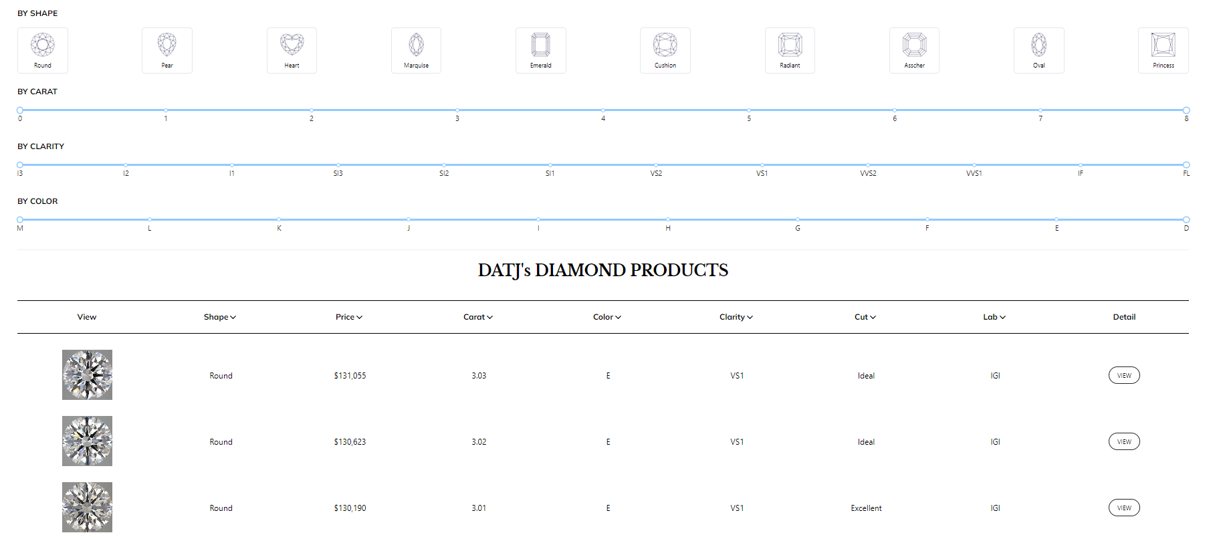

Field Name | Field Type | Description
Shape | Select | This is for user to input the shape of the diamonds they want to search
Carat | Range | This is for user to input the range of the carat they want to search
Clarity | Range | This is for user to input the range of the clarity they want to search
Color | Range | This is for user to input the range of the color they want to search
View | Button | User click to view detail of the diamond

Database Access
Table | CRUD | Description
diamonds | R | Get all available diamond
diamond price | R | Get latest diamond price

b. View Diamond Details

UI Design
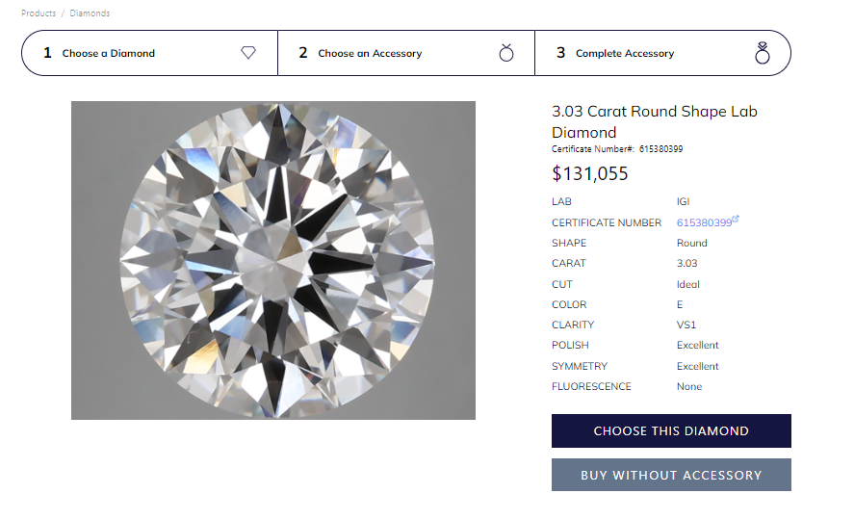

Field Name | Field Type | Description
Choose this diamond | Button | User clicks to choose this diamond for their accessory
Buy without accessory | Button | User clicks to choose this diamond to buy without accessory

Database Access

Table | CRUD | Description
diamonds | R | Get all diamond filed
diamond price | R | Get latest diamond price

c. View Available Accessory List

UI Design
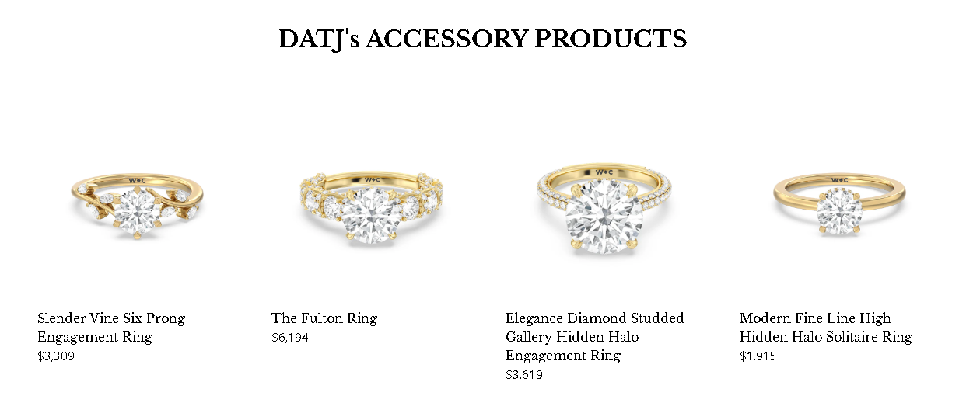

Field Name | Field Type | Description
View | Card | User click to view detail of the accessory

Database Access
Table | CRUD | Description
accessory | R | Query the list of current settings from the database  Update status of a specific setting
material-  price | R | Query the latest material price

d. View Accessory Details

UI Design
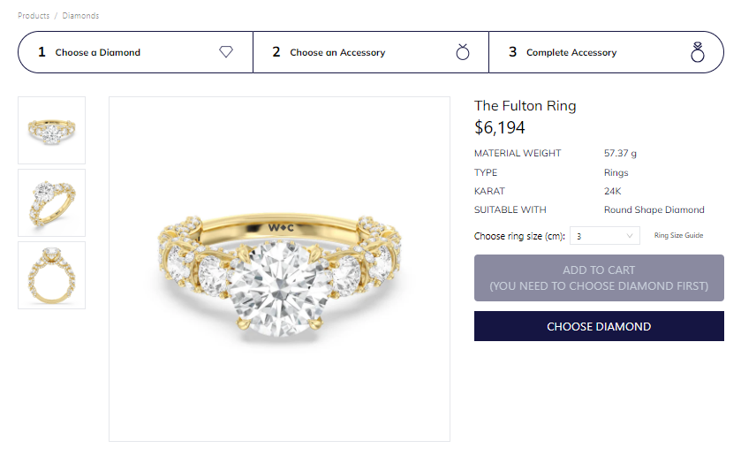

Field Name | Field Type | Description
Size | Select | Choose the size of the accessory
Choose this accessory | Button | Click to choose this accessory for the product

Database Access

Table | CRUD | Description
accessory | R | Query the list of current settings from the database  Update status of a specific setting
material-  price | R | Query the latest material price

e. View Complete Product

UI Design
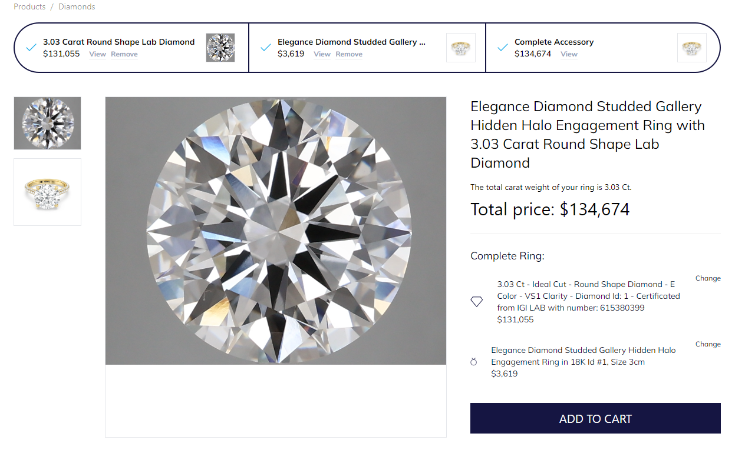

Field Name | Field Type | Description
Add to cart | Button | Click to add the product to cart

Database Access

Table | CRUD | Description
accessory | R | Query the list of current settings from the database  Update status of a specific setting
material-  price | R | Query the latest material price
diamonds | R | Get all diamond filed
diamond price | R | Get latest diamond price

f. View Cart

UI Design
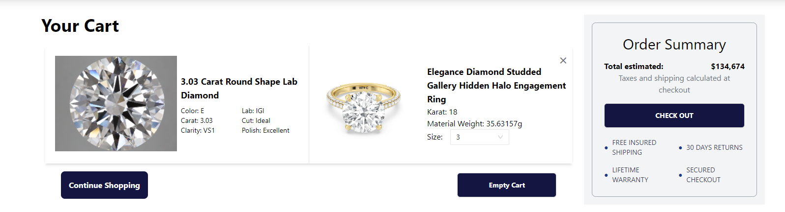

Field Name | Field Type | Description
Check Out | Button | Click to pay for the product
Continue shopping | Button | Click to back to the diamond list to continue shopping other diamonds
Empty Cart | Button | Click to clear the cart items

Database Access

Table | CRUD | Description
accessory | R | Query the list of current settings from the database  Update status of a specific setting
material-  price | R | Query the latest material price
diamonds | R | Get all diamond filed
diamond price | R | Get latest diamond price

2. Order features

2.1 Update Order

a. View Order List & Update Order Status

UI Design
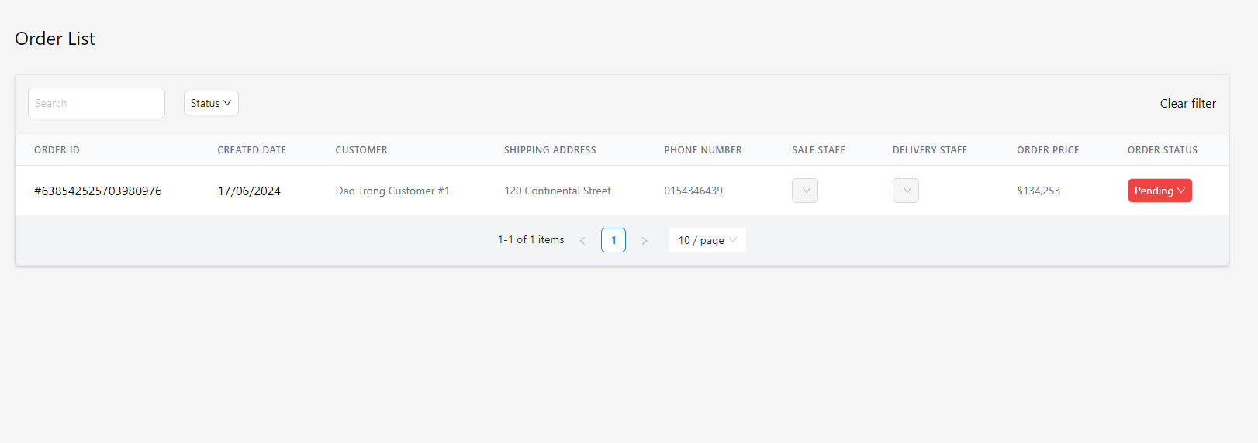

Field Name | Field Type | Description
Search | Text Box | Enter customer name to search the orders of the customer
Order Status | Select | Select status to update the status of the order
Sale Staff | Select | Select sale staff to assign them to contact the customer of the order
Deliver Staff | Select | Select delivery staff to assign them to delivery the customer of the order

Database Access

Table | CRUD | Description
order | RU | Query the list of current settings from the database  Update status of a specific setting
account | R | Get customer detail

3. Warranty features

3.1 Create Warranty Request

a. Create Warranty Request

UI Design
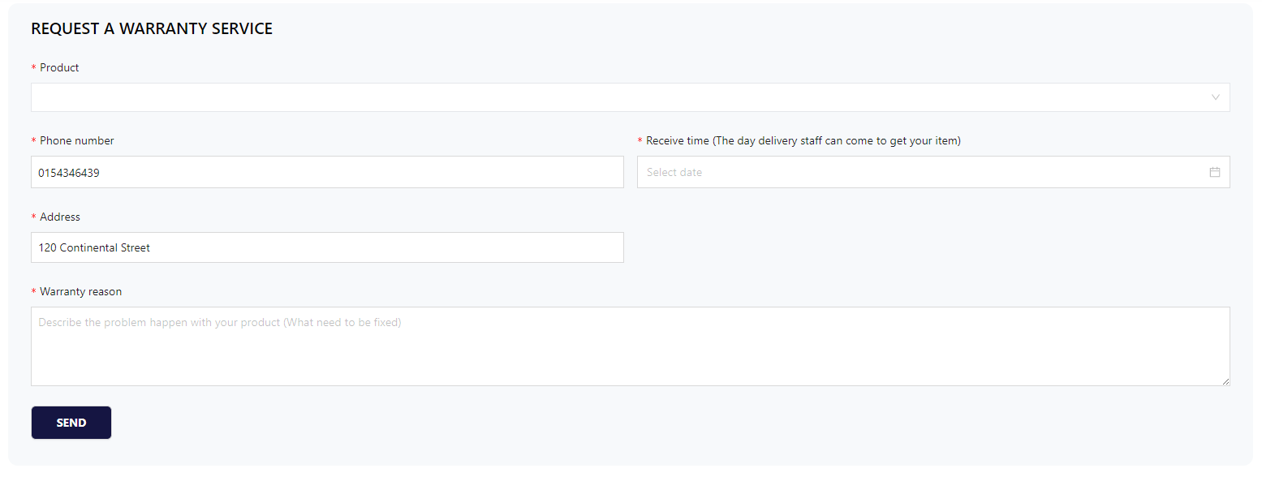
Field Name | Field Type | Description
Product | Select | Choose the product to make a warranty request
Phone Number | Text Box | Enter customer phone number for staff can call
Receive time | Date time picker | Select the time that delivery staff can come to get the customer’s item for warranty.
Address | Text Box | Enter customer address for delivering.
Warranty reason | Text Box | Enter the reason to make a warranty request for staff can fix the product

Database Access

Table | CRUD | Description
warranty_card | R | Query the list of available warranty card
account | R | Get customer detail
warranty_request | C | Insert new warranty request to database

4. Product features

4.1 Create Diamond

a. View Diamond List

UI Design
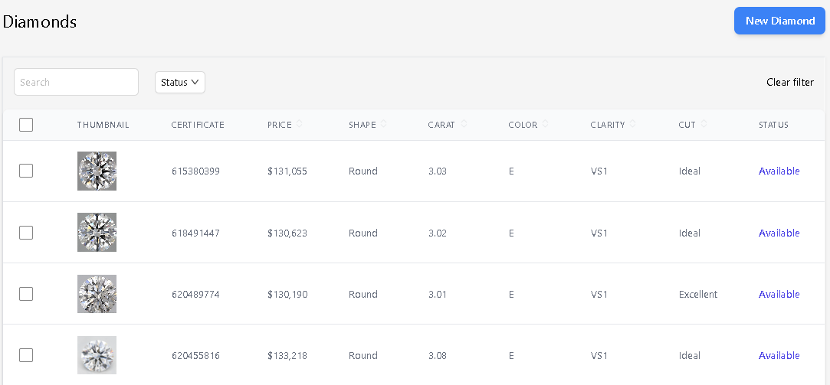

Field Name | Field Type | Description
View detail | Button | Click to view detail information of the diamond
New Diamond | Button | Click to navigate to the input form page to add a new diamond to the system.

Database Access

Table | CRUD | Description
diamond | R | Query the list of diamond

b. Create Diamond

UI Design
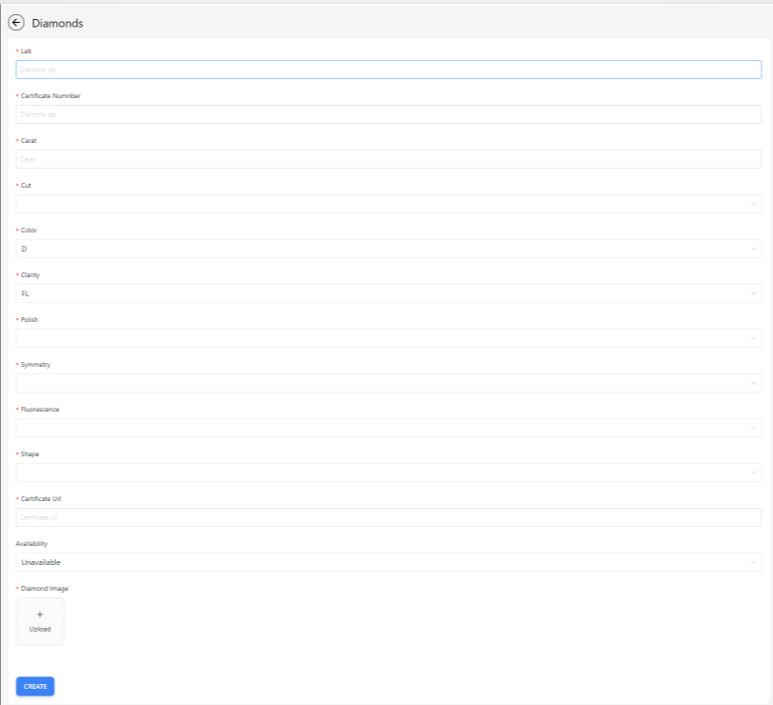

Field Name | Field Type | Description
Lab | Text Box | Choose the product to make a warranty request
Certificate Number | Text Box | Enter customer phone number for staff can call
Carat | Text Box | Select the time that delivery staff can come to get the customer’s item for warranty
Cut | Select | Enter customer address for delivering
Color | Select | Enter the reason to make a warranty request for staff can fix the product
Clarity | Select | Select the clarity of the diamond
Polish | Select | Select the polish of the diamond
Symmetry | Select | Select the symmetry of the diamond
Fluorescence | Select | Select the fluorescence of the diamond
Shape | Select | Select the shape of the diamond
Certificate Url | Text Box | Enter the certificate url of the diamond
Availability | Select | Select status of diamond to create
Diamond Image | Image Upload | Upload a file to create a diamond
Create | Button | Click to add diamond to system

Database Access

Table | CRUD | Description
diamond | C | Create to the diamond table

4.2 Update Diamond

a. Update Diamond Price

UI Design
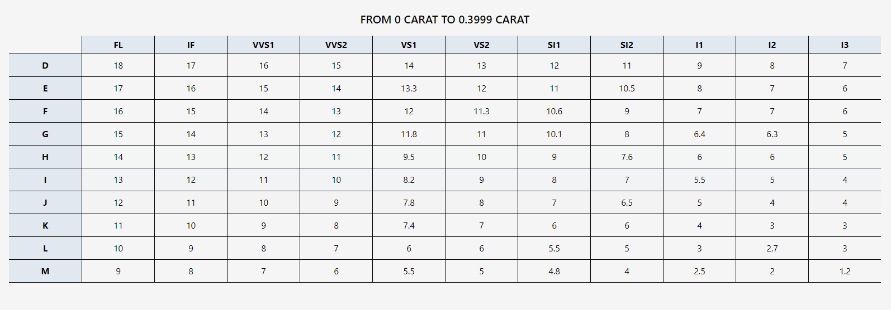

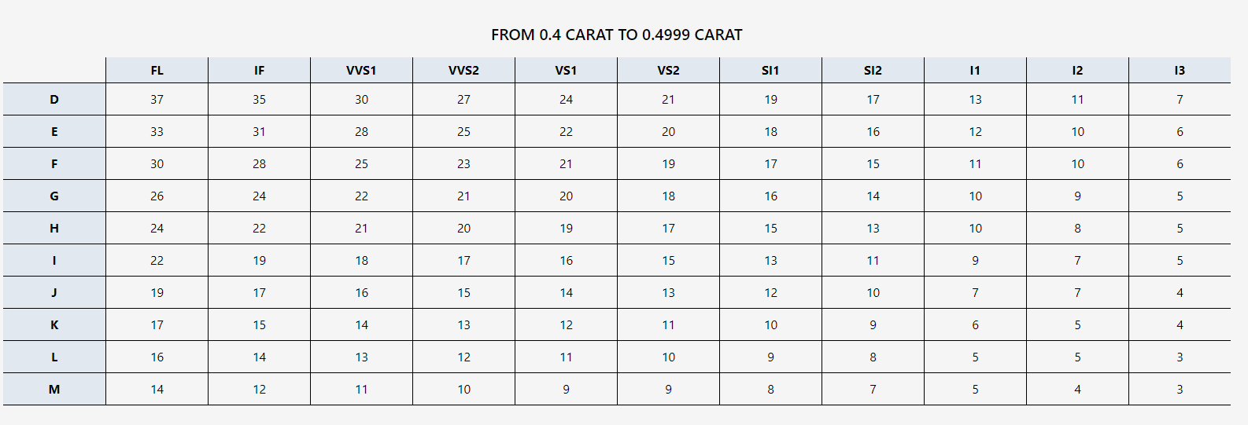

Field Name | Field Type | Description
Update price | Button | Click to view and update information of the price

Database Access

Table | CRUD | Description
diamond_price | RU | Retrieve and Update new diamond price to the diamond_price table

b. Update Diamond Detail

5. System feature

5.1 Update Diamond Price List

UI Design

Database Access

IV. Appendix

1. Assumptions & Dependencies

AS-1: Reliable suppliers will provide a consistent inventory of diamonds and precious metals.
AS-2: The system will have real-time access to global diamond market prices for accurate valuation.
AS-3: Customers will have access to secure internet connections for online transactions.
DE-1: The system must integrate securely with payment gateways for transaction processing.

2. Limitations & Exclusions

LE-1: The system will not appraise diamonds not purchased within our network.
LE-2: Delivery is limited to regions where our courier partners operate.
LE-3: Custom jewelry design services are excluded from the standard purchase process.

3. Business Rules

ID | Category | Rule Definition
BR-01 | Constraints | One staff can’t handle more than 5 tasks at the same time.
BR-02 | Facts | Can not add to cart a diamond that is already bought.
BR-03 | Constraints | All diamonds must be authenticated and certified by recognized authorities before being added to inventory.
BR-04 | Constraints | Each diamond must have a unique identification number for tracking purposes.
BR-05 | Facts | All diamonds in a single purchase must be billed on a single invoice.
BR-06 | Facts | Each diamond must have a unique certificate.
BR-07 | Constraints | All employees must undergo a background check before hiring.
BR-08 | Computations | Loyalty points are calculated as 1 point per $1 spent.
BR-09 | Constraints | Deliveries of diamond products must be insured and require a signature upon receipt.
BR-10 | Constraints | Inventory system must be updated in real-time with each sale or new stock addition.
BR-11 | Constraints | Order status must be updated in real-time, while staff change status, the customer can keep track.
BR-12 | Constraints | Products’ price has already included sales tax.
BR-13 | Constraints | If an order is not purchased after 3 days, Manager will change this status to fail.
BR-14 | Constraints | Refunds will take place at the store. Only refund 70% of total transactions.
BR-15 | Constrains | Delivery staff have the ability to verify diamonds when receiving diamonds from the customer for warranty.
BR-16 | Constrains | For each warranty request, only one delivery staff handles both collecting and returning.
BR-17 | Constrains | When managers create a promotion, they need to write a blog with a special name to announce the customer for this promotion.
BR-18 | Constrains | Price rate, formula to calculate diamond price, and accessory price is defined by the shop.
BR-19 | Constrains | If the customer fails to meet up and get an order from delivery staff for more than 3 times. That order will be changed to fail.
BR-20

