

DAT J
Software Design Specification

– Ho Chi Minh Campus, 2024 –

Record of changeS
Date | A*  M, D | In charge | Change Description
*A - Added M - Modified D - Deleted

Table of Contents
I. Overview 4
1. Code Packages 4
2. Database Design 5
a. Database Schema 5
b. Table Description 5
II. Code Designs 7
1. Create Order 7
a. Class Diagram 7
b. Class Specifications 7
c. Sequence Diagram(s) 8
2. Update Order Status 8
a. Class Diagram 8
b. Class Specifications 8
c. Sequence Diagram(s) 9
3. Create Warranty Request 9
a. Class Diagram 9
b. Class Specifications 9
c. Sequence Diagram(s) 10
4. Create Diamond 10
a. Class Diagram 10
b. Class Specifications 10
c. Sequence Diagram(s) 11
5. Update Diamond Price 11
a. Class Diagram 11
b. Class Specifications 11
c. Sequence Diagram(s) 12

I. Overview

1. Code Packages
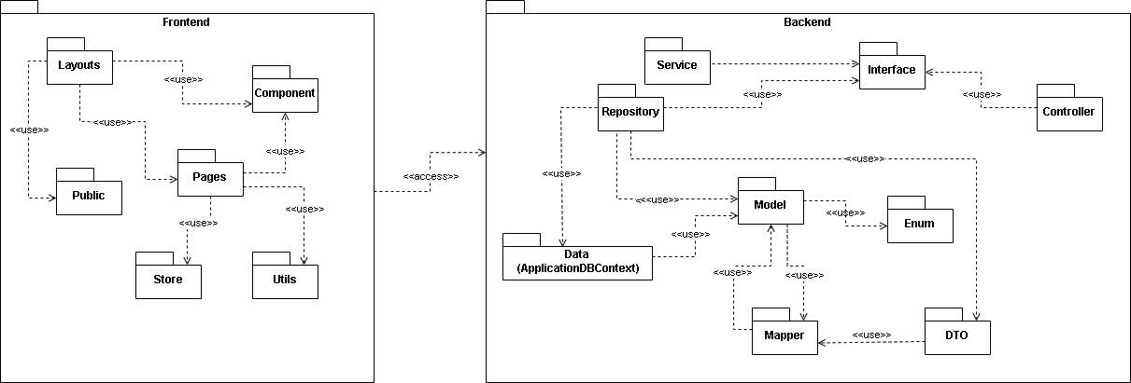
Package descriptions
No | Package | Description
01 | Frontend | Package for frontend development
02 | Layouts | Package contains page’s layout
03 | Pages | Package contains pages
04 | Public | Package contains static resource
05 | Component | Package contains general components
06 | Store | Package for global state handling
07 | Utils | Package for commonly used function
08 | Backend | Package for backend development
09 | Service | Package for service
10 | Repository | Package for interactions with database
11 | Controllers | Package for controlling routing of the server
12 | Models | Package for classes to reflect database’s table
13 | Enum | Package for Enum classes to constraint certain attribute
14 | DTO | Package for classes tobe send to frontend
15 | Mapper | Package for converting Model to DTO and vice versa
16 | Data | Package to connect to database

2. Database Design

a. Database Schema
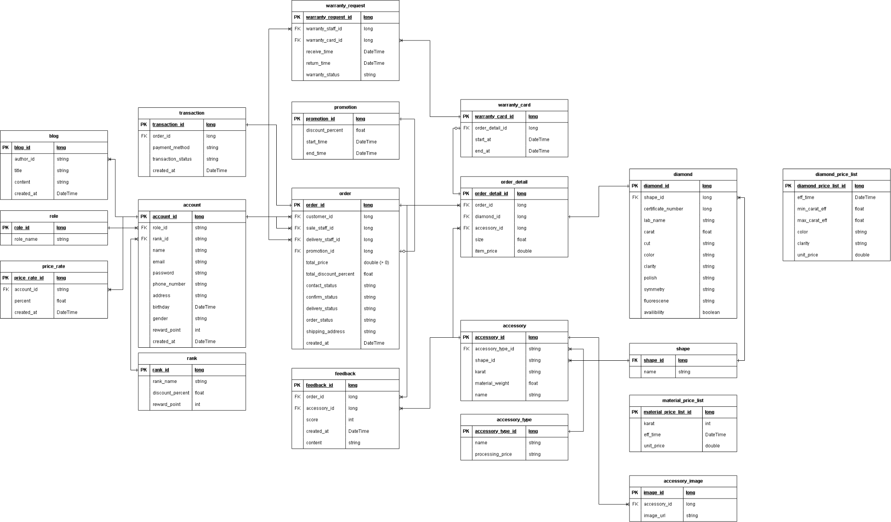

b. Table Description

No | Table | Description
01 | account | - Primary keys: account_id  - Foreign keys: role_id, rank_id  - Attributes: name, email, password, phone_number, address, birthday, gender, reward_point, created_at
02 | role | - Primary keys: role_id  - Foreign keys: account_id  - Attributes: role_name
03 | blog | - Primary keys: blog_id  - Foreign keys: author_id  - Attributes: title, content, created_at
04 | price_rate | - Primary keys: price_rate_id  - Foreign keys: account_id  - Attributes: percent, created_at
05 | rank | - Primary keys: rank_id  - Foreign keys: account_id  - Attributes: rank_name, discount_percent, reward_point
06 | order | - Primary keys: order_id  - Foreign keys: customer_id, sale_staff_id, delivery_staff_id, promotion_id  - Attributes: total_price, total_discount_percent, contact_status, confirm_status, delivery_status, order_status, shipping_address, created_at
07 | order_detail | - Primary keys: order_detail_id  - Foreign keys: order_id, diamond_id, accessory_id  - Attributes: size, item_price
08 | promotion | - Primary keys: promotion_id  - Foreign keys: order_id  - Attributes: discount_percent, start_time, end_time
09 | warranty_card | - Primary keys: warranty_card_id  - Foreign keys: order_detail_id  - Attributes: start_time, end_time
10 | warranty_request | - Primary keys: warranty_request_id  - Foreign keys: warranty_staff_id, warranty_card_id  - Attributes: receive_time, return_time, warranty_status
11 | feedback | - Primary keys: feedback_id  - Foreign keys: order_id, accessory_id  - Attributes: score, created_at, content
12 | accessory | - Primary keys: accessory_id  - Foreign keys: shape_id, accessory_type  - Attributes: karat, material_weight, name
13 | accessory_type | - Primary keys: accessory_type  - Foreign keys: none  - Attributes: name, processing_price
14 | accessory_image | - Primary keys: accessory_image_id  - Foreign keys: accessory_id  - Attributes: image_url
15 | diamond | - Primary keys: diamond_id  - Foreign keys: shape_id  - Attributes: certificate_number, lab_name, color, clarity, cut, carat, polish, symmetry, fluorescence, availability
16 | shape | - Primary keys: shape_id  - Foreign keys: none  - Attributes: name
17 | diamond_price_list | - Primary keys: diamond_price_list_id  - Foreign keys: none  - Attributes: min_carat_eff, max_carat_eff, eff_time, color, clarity, unit_price
18 | material_price_list | - Primary keys: material_price_list  - Foreign keys: none  - Attributes: karat, eff_time, unit_price
19 | transaction | - Primary keys: transaction_id  - Foreign keys: order_id  - Attributes: payment_method, transaction_status, created_at

II. Code Designs

1. Create Order

a. Class Diagram
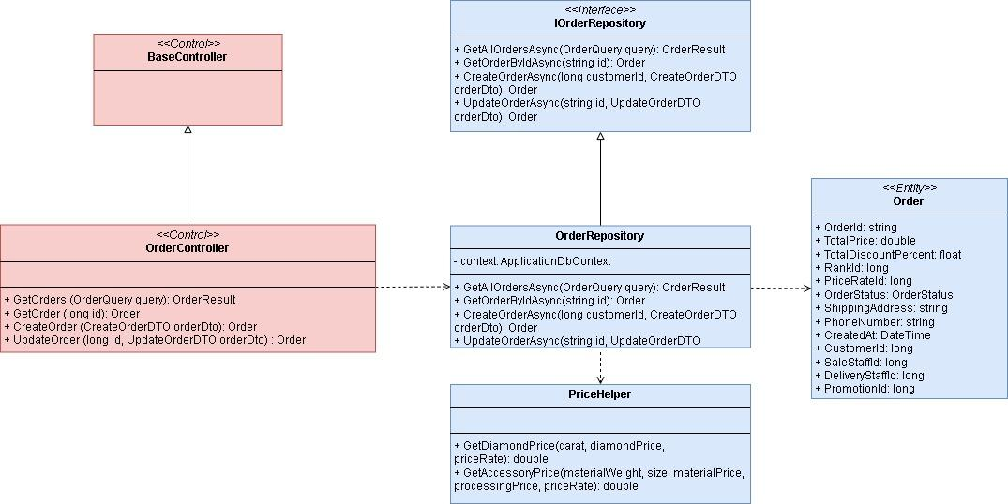

b. Class Specifications

OrderController
No | Method | Description
1 | GetOrders | - GetOrders (OrderQuery query): OrderResult  - Get all the order with the filter and pagination
2 | GetOrder | - GetOrder (long id): Order  - Get the order with the specific id
3 | CreateOrder | - CreateOrder (CreateOrderDTO orderDto): Order  - Create new order
4 | UpdateOrder | - UpdateOrder (long id, UpdateOrderDTO orderDto) : Order  - Update the order

OrderRepository
No | Method | Description
1 | GetAllOrdersAsync | - GetAllOrdersAsync(OrderQuery query): OrderResult  - Get all the order with the filter and pagination
2 | GetOrder | - GetOrderByIdAsync(string id): Order  - Get the order with the specific id
3 | CreateOrderAsync | - CreateOrderAsync(long customerId, CreateOrderDTO orderDto): Order  - Create new order
4 | UpdateOrderAsync | - UpdateOrderAsync(string id, UpdateOrderDTO orderDto): Order  - Update the order

PriceHelper
No | Method | Description
1 | GetDiamondPrice | - GetDiamondPrice(carat, diamondPrice, priceRate): double  - Get price of the diamond
2 | GetAccessoryPrice | - GetAccessoryPrice(materialWeight, size, materialPrice, processingPrice, priceRate): double  - Get the price of the accessory

c. Sequence Diagram(s)

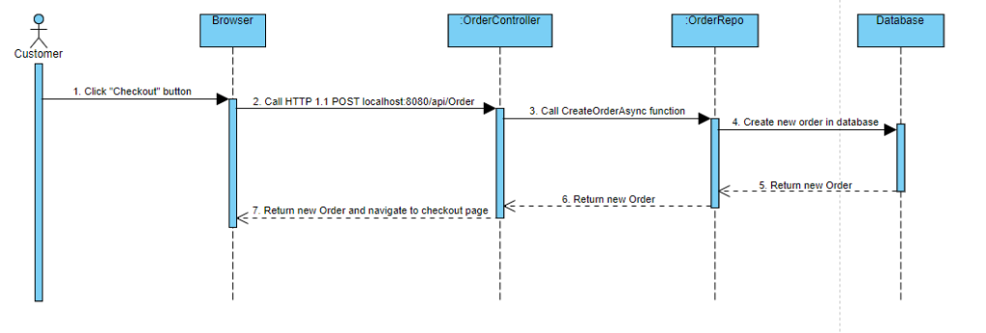

2. Update Order Status

a. Class Diagram
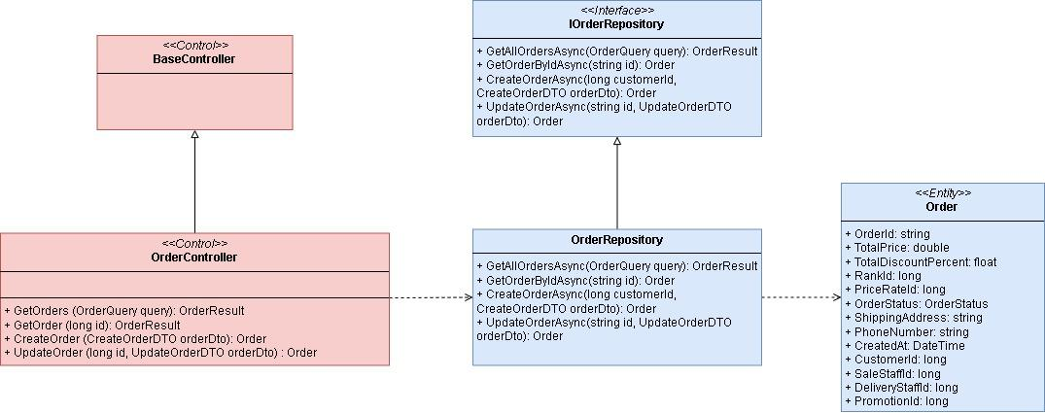

b. Class Specifications

OrderController
No | Method | Description
1 | GetOrders | - GetOrders (OrderQuery query): OrderResult  - Get all the order with the filter and pagination
2 | GetOrder | - GetOrder (long id): Order  - Get the order with the specific id
3 | CreateOrder | - CreateOrder (CreateOrderDTO orderDto): Order  - Create new order
4 | UpdateOrder | - UpdateOrder (long id, UpdateOrderDTO orderDto) : Order  - Update the order

OrderRepository
No | Method | Description
1 | GetAllOrdersAsync | - GetAllOrdersAsync(OrderQuery query): OrderResult  - Get all the order with the filter and pagination
2 | GetOrder | - GetOrderByIdAsync(string id): Order  - Get the order with the specific id
3 | CreateOrderAsync | - CreateOrderAsync(long customerId, CreateOrderDTO orderDto): Order  - Create new order
4 | UpdateOrderAsync | - UpdateOrderAsync(string id, UpdateOrderDTO orderDto): Order  - Update the order

c. Sequence Diagram(s)

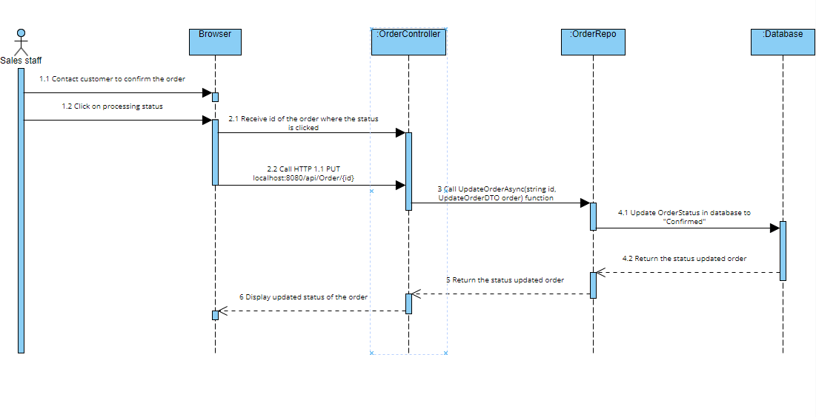

3. Create Warranty Request

a. Class Diagram
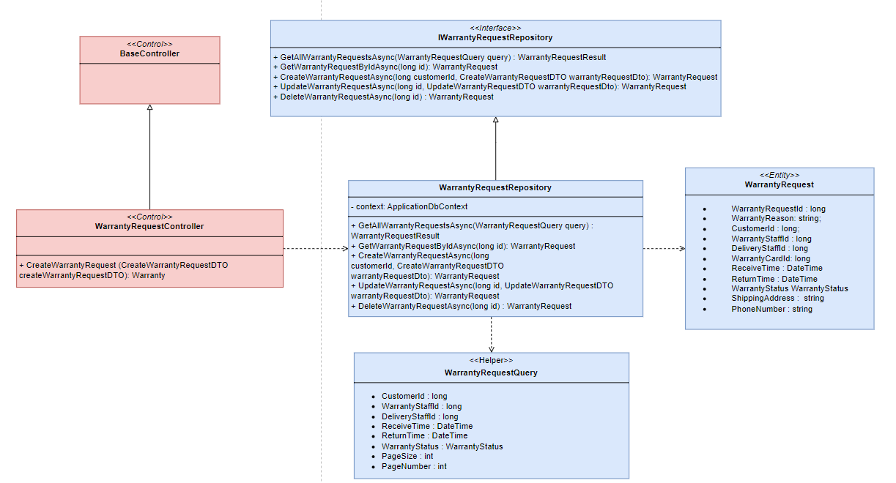

b. Class Specifications

WarrantyRequestsController
No | Method | Description
1 | CreateWarrantyRequest | - CreateWarrantyRequest (CreateWarrantyRequestDTO createWarrantyRequestDTO): Warranty  - Create new warranty request

WarrantyRequestRepository
No | Method | Description
1 | GetAllWarrantyRequestAsync | - GetWarrantyRequestsAsync (WarrantyRequestQuery query) : WarrantyRequestResult  - Get all the order with the filter and pagination
2 | GetWarrantyRequest | - GetWarrantyRequestByIdAsync(long id): WarrantyRequest  - Get the order with the specific id
3 | CreateWarrantyRequestrAsync | - CreateWarrantyRequestAsync(long customerId, CreateWarrantyRequestDTO warrantyRequestDto): WarrantyRequest  - Create new order
4 | UpdateWarrantyRequestAsync | - UpdateWarrantyRequestAsync(long id, UpdateWarrantyRequestDTO warrantyRequestDto): WarrantyRequest  - Update the warranty request
5 | DeleteWarrantyRequestAsync | - DeleteWarrantyRequestAsync(long id) : WarrantyRequest  - Delete the warranty request

c. Sequence Diagram(s)
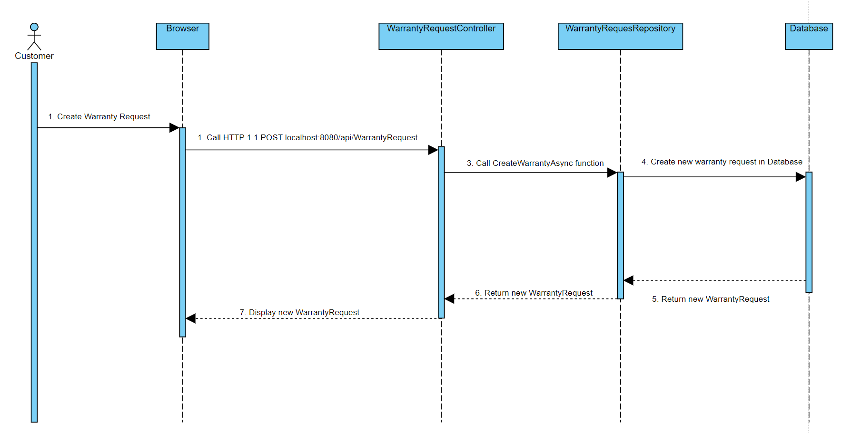

4. Create Diamond

a. Class Diagram
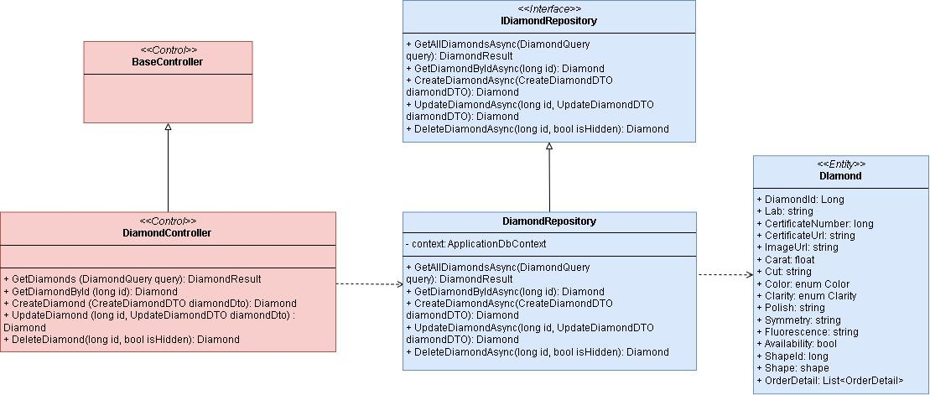

b. Class Specifications

DiamondsController
No | Method | Description
1 | GetDiamonds | - GetDiamonds (DiamondQuery query): DiamondResult  - Get all the diamond with the filter and pagination
2 | GetDiamondById | - GetDiamondById (long id): Diamond  - Get the diamond with the specific id
3 | CreateDiamond | - CreateDiamond (CreateDiamondDTO diamondDto): Diamond  - Create new diamond
4 | UpdateDiamond | - UpdateDiamond (long id, UpdateDiamondDTO diamondDto) : Diamond  - Update the diamond
5 | DeleteDiamond | - DeleteDiamond(long id, bool isHidden): Diamond  - Delete the diamond

DiamondRepository
No | Method | Description
1 | GetAllOrdersAsync | - GetAllOrdersAsync(OrderQuery query): OrderResult  - Get all the order with the filter and pagination
2 | GetOrder | - GetOrderByIdAsync(string id): Order  - Get the order with the specific id
3 | CreateOrderAsync | - CreateOrderAsync(long customerId, CreateOrderDTO orderDto): Order  - Create new order
4 | UpdateOrderAsync | - UpdateOrderAsync(string id, UpdateOrderDTO orderDto): Order  - Update the order
5 | DeleteDiamondAsync | - DeleteDiamondAsync(long id, bool isHidden): Diamond  - Delete the diamond

c. Sequence Diagram(s)
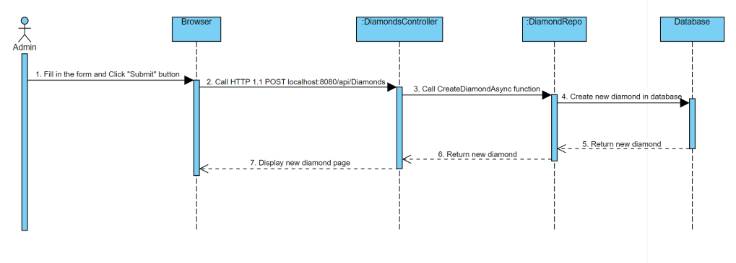

5. Update Diamond Price

a. Class Diagram
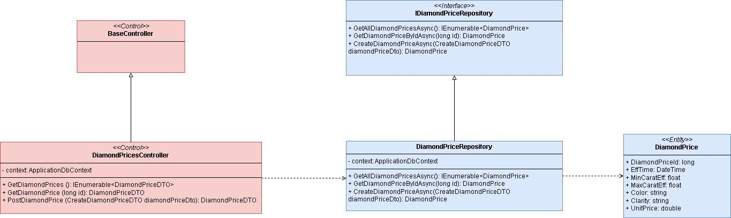

b. Class Specifications

DiamondPricesController
No | Method | Description
1 | GetDiamondPrices | - GetDiamondPrices (): IEnumerable<DiamondPriceDTO>  - Get all the diamond price
2 | GetDiamondPrice | - GetDiamondPrice (long id): DiamondPriceDTO  - Get the diamond price with the specific id
3 | PostDiamondPrice | - PostDiamondPrice (CreateDiamondPriceDTO diamondPriceDto): DiamondPriceDTO  - Create new diamond price

DiamondPriceRepository
No | Method | Description
1 | GetDiamondPricesAsync | - GetDiamondPricesAsync (): IEnumerable<DiamondPrice>  - Get all the diamond price
2 | GetDiamondPriceByIdAsync | - GetDiamondPriceByIdAsync(long id): DiamondPrice  - Get the diamond price with the specific id
3 | CreateDiamondPriceAsync | - CreateDiamondPriceAsync(CreateDiamondPriceDTO diamondPriceDto): DiamondPrice  - Create new diamond price

c. Sequence Diagram(s)
