Customer:
_ As a customer, I want to see through the available diamond products, So that I can see the variety of options available
_ As a customer, I want to view detailed information about a specific diamond product, So that I can make a purchase decision
_ As a customer, I want to add a diamond product to my shopping cart, So that I can purchase it later
_ As a customer, I want to checkout my shopping cart, So that I can complete my purchase
_ As a customer, I want to track the status of my order, So that I can know when to expect my purchase
_ As a customer, I want to add diamond products to my wishlist, So that I can save them for future consideration
_ As a customer, I want to manage my account details, So that I can change my information
_ As a customer, I want to be able to contact customer support so that I can get help with any issues or questions I have
_ As a customer, I want to be able to return products and get a refund so that I can be assured of my purchase.
_ As a customer, I want to be part of a loyalty program so that I can earn points and get rewards on my purchases.
_ As a customer, I want to locate physical stores on a map so that I can visit if I prefer to shop in person.
_ As a customer, I want to specify the size of the ring for the diamond I’ve chosen so that the ring fits perfectly and comfortably.
_ As a customer, I want to compare different diamond products so that I can make the best choice for my needs.

Sales Staff
- As a sales staff, I want to view the product's detailed information, so that I can provide accurate information for customers’ demands.
- As a sales staff, I want to view the customers’ detailed information, so that I can use that information to communicate with customers effectively.
- As a sales staff, I want to view the customers’ order details, so that I can know exactly what kind of jewelry they want to order.
- As a sales staff, I want to record customer preferences, so that I can provide personalized service and recommendations to customers in the future.
- As a sales staff, I want to export the invoice for successful purchase, so that I can confirm with the customer and the owner that the product is sold successfully.
- As a sales staff, I want to generate a daily report, so that I can notify the manager of the tracking of the work.
- As a sales staff, I want to record special demands from customers, so that I can report to the manager if it is necessary to update the options for customers.
- As a sales staff, I want to set reminders for important tasks, so that I can keep track and not miss those crucial ones.
- As a sales staff, I want to view all the purchases made by customers I assisted, so that I can accurately calculate my total earnings.
- As a sales staff, I want to search any purchase made by customers I assisted, so that I can check if there was any confusion with customers.
- As a sales staff, I want to search for any customers by a factor such as name, phone number, email, so that I can find the customer that I need to check.
- As a sales staff, I want customers to follow my guidelines through phone calls or through messages, so that they can measure correctly.
- As a sales staff, I want to export the insurance card for customers, so that they can exchange other jewelry if there is any fault itself.
Delivery Staff
- As a delivery staff, i want to view the delivery orders assigned to me
- As a delivery staff, i want to search for the delivery order
- As a delivery staff, i want to filter the delivery orders by criteria (Status, Address, Product name, Order ID, Customer name,)
- As a delivery staff, i want to update the status of the order to Cancelled, Successfully or Refund once i have delivered the product to the customer (If cancelled or refund, shipper must provide a reason for the cancellation or refund)
- As a delivery staff, i want to see the name, gender and phone number òf the customer to contact and confirm that ís the right customer
- As a delivery staff, I want to navigate to customers' locations using GPS or mapping tools integrated into the delivery app, to reach destinations efficiently.
- As a delivery staff, I want to see the statistic about the number of delivery orders i have delivered, and salary of each month
Guest
- As a guest, I want to register to become a Customer.
- As a guest, I want to view the products based on category (ring, chain, earring, pendance, etc…).
- As a guest, I want to view individual product details.
- As a guest, I want to search for products based on names.
- As a guest, I want to search for products based on brand.
- As a guest, I want to search for a store location, store details (address, contact, operating time)
- As a guest, I want to view the current special offer/discount.
- As a guest, I want to view the company practicing certificate. (chứng chỉ hành nghề)
- As a guest, I want to view the payment policies.
- As a guest, I want to view the return policies.
- As a guest, I want to view the shipping details.
- As a guest, I want to view the security policy.
- As a guest, I want to view the information security policy.
- As a guest, I want to view blogs to learn more about the shop/jewelry.
- As a guest, I want to contact the shop through social media.
- As a guest, I want to contact the shop through direct calling.
- As a guest, I want to view how to measure my jewelry size.
- As a guest, I want to share the product by a link.
As a guest, I want to buy a product then have it shipped to me.
- As a guest, I want to buy a product then I can pick it up at a store..
Manager
- As a Manager, I want to see an overview of my store's sales performance, including sales revenue, number of orders, ... to inform strategic performance management.
- As a Manager, I want to view reports on sales by product over a specific time period to analyze the performance of each item.
- As a Manager, I want to view reports on the inventory status of diamond products to ensure that the store is not experiencing shortages or overstocking.
- As a Manager, I want to approve important changes in the system such as adding new employees, changing product prices and changing promotions to ensure data integrity.
- As a Manager, I want to see a list of loyal customers and potential customers, so I can make more customer-oriented decisions.
- As a Manager, I want to view reports on sales staff performance to evaluate and recommend measures to improve performance.
- As a Manager, I want to create new special promotions such as holiday discounts and gift programs for loyal customers to attract and retain customers.
- As a Manager, I want to create and manage delivery schedules to ensure on-time deliveries and enhance the customer shopping experience.
- As a Manager, I want to see reports on order cancellation rates and reasons for cancellations to come up with measures to improve and reduce the order cancellation rate.
- As a Manager, I want to manage warranty claims from customers by recording, tracking and processing requests in a timely and professional manner.
Administrator
- As an Administrator, I want to create, manage, and delete salesperson, delivery person
accounts to control access to the system.

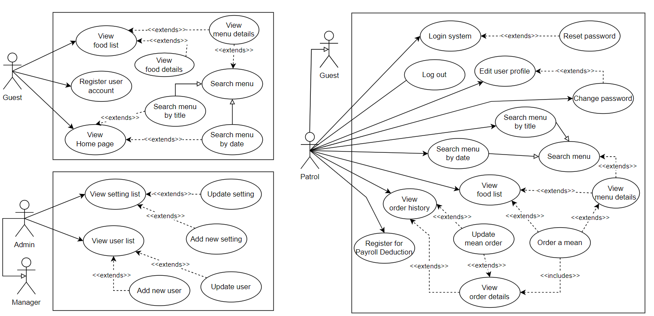

1. đăng ký tài khoản --> Xác nhận --> Login --> Hiển thị danh sách sản phẩm --> Tìm kiếm→ add to cart —>

