|  |  |  |  |
| --- | --- | --- | --- |
|  | **Course Name: Design Patterns/Thinking LAB** | **EXPERIMENT NO. 7** | |
| **Course Code: 20CP210P**  **Faculty: Dr. Ketan Sabale** | **Branch: CSE** | **Semester: IV** |
| **Submitted by: Jangle Parth**  **Roll no: 22BCP083** | | | |

Objective: To familiarize students with standard Structural design patterns.

Experiment: Explain the prototype design pattern and write a program using any object-oriented programming language to demonstrate the working of Adapter design pattern.

Theory: When you have a object of a class which can’t be joined directly to other class object we use a adapter class whose job is to join or connect object of other two classes. Adapter design pattern is a [structural pattern](https://www.geeksforgeeks.org/structural-design-patterns/) that allows the interface of an existing class to be used as another interface. It acts as a bridge between two incompatible interfaces, making them work together. This pattern involves a single class, known as the adapter, which is responsible for joining functionalities of independent or incompatible interfaces.

**Problem Statement Explanation: I**magine a Scenario when you have a Tank and a Manhole now Tank and Manhole both are Different Products and Can’t Be joined Directly it requires something which can join both of them. And that is done through welding hence the welding is an adapter for this problem.

**Flowchart Explanation:**

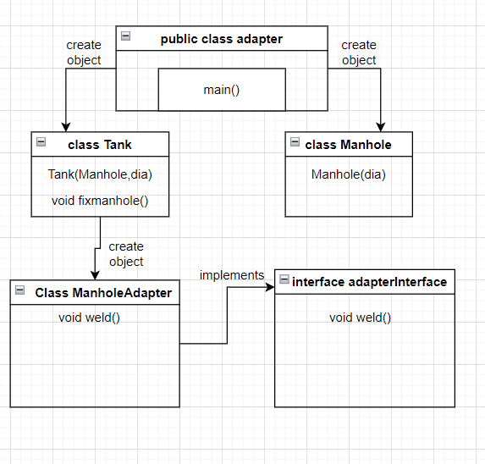

**Code:**

interface adapterInterface {

    void weld();

}

class Tank {

    int dia;

    Manhole mh;

    Tank(int dia, Manhole m) {

        this.dia = dia;

        this.mh = m;

        fixManhole();

    }

    public void fixManhole() {

        ManholeAdapter mAdapter = new ManholeAdapter(mh, this);

        mAdapter.weld();

    }

}

class Manhole {

    int dia;

    Manhole(int dia) {

        this.dia = dia;

    }

}

class ManholeAdapter implements adapterInterface {

    Manhole mh;

    Tank t;

    ManholeAdapter(Manhole m, Tank t) {

        this.mh = m;

        this.t = t;

    }

    public void weld() {

        System.out.println();

        System.out.println("Doing Welding");

        System.out.println("Welding Done");

    }

}

public class adapter {

    public static void main(String[] args) {

        Manhole nestleManhole = new Manhole(320);

        Manhole amulManhole = new Manhole(280);

        Tank nestleTank = new Tank(2500, nestleManhole);

        Tank amulTank = new Tank(3000, amulManhole);

    }

}

**Output:**

