Chinese Character Recognization
Image Recognization with Convolution Neural Networks

Jangmin Son / KHU Univ.
Department of Computer Engineering
Suwon, Korea
Contact : djkaiden@naver.com

This document is about how to recognize Chinese Character Image with Convolution Neural Networks(CNNs) using Tensorflow, openCV. It shows how to make CNNs, how to train Model Using CNN, how to test the Model and preprocessing Image Datasets.
Keywords—CNNs; Tensorflow, OpenCV, Chinese Character, Image Recognize, Image Processing, ocropus-linegen

Introduction (Heading 1)
Convolution Neural Networks(CNNs) are similar to ordinary Neural Networks. They are made up of neurons that have learnable weights and biases. But it is differ from ordinary Neural Networks in that it can receive image file for output. As its inputs are images, it allows us to encode certain image properties into the architecture. These then make the forward function more efficient to implement and vastly reduce the amount of parameters in network which can improve performance of image processing. So I use this method to recognize Chinese Characters. CNNs get image inputs and build models which has proper weights and biases for recognize characters. With trained CNNs model, you can convert Chinese characters images into text. It would be very useful to whom doesn’t know Chinese character because they can’t find what the letter is unless they knew the meaning. In that Chinese letters are hard to write and read, CNNs Model will be a solution for finding Chinese letters.

Related Works

Deep Learning
It was received attention by solving object recognition problem successfully. From the perspective of machine learning, object recognition is like classification problem. To solve the classification problem, we should make feature vector that shows feature of the input image and support vector that support feature vector. Those two kind of vectors is used in classifier and then shows result. When the vectors are became other classifier’s output, it’s called Deep Learning. In other words,it has feature vectors that connected to other features in another classifier. Multi layer neural network is used to create Deep learning and CNNs are kind of Multi layer neural networks for processing Images.For example, if you find bicycle in the scene, layer finds the parts of Bicycle like handle, wheels, frame or something and make sure that parts are in a proper positions. Then they make those data into map type which points the position of bicycle(feature map). After combine those feature map, we can get the percentage of existence. You can get more information in [1].

Method
The process can be split into 4 steps.
- Prepare Dataset
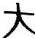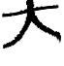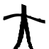
[asd
[Pic-1]
You should have a training dataset if you want to create your trained-model. In my case, I created Chinese Character image datasets by myself using library “ocropus-linegen”. The library provide us to make indivisual character images from True Type Fonts(TTF) that contains Chinese Character. It provides distorted images like stretched, cropped and etc[Pic-1]. You should resize images because Linegen doesn’t equalize image size. Various kind of images that stands for one character makes model more accuracy because those distorted images provide blurred feature which prevent model from overfitting. If you want to predict your model, you should split dataset into 2 groups so that one is for training and the other can be used for validation. Because of those images are made from Online Letter, model may not predict hand-writed characters precisely. If you want to make model for accurate, you should add some hand-writed images.

- Create CNNs
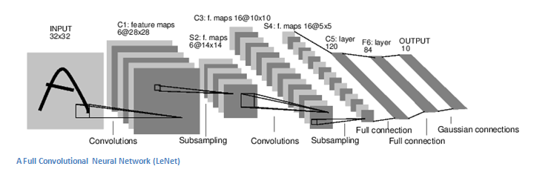
[Pic-2]
Input data’s (image) shape is like (width, heigh, RGB(3)). Channel of image can be changed if you need to use one or two channels. In my case, I used one channel because we don’t need another channels to classify letters. Convolutions arrange neurons in 3-dimensions as it’s inputs are images. Each layers are connected like chains. Imagine layer A and B, layer A’s inputs are coming from front layer’s output which is connected with layer A and it’s output goes to layer B’s input and so on. At first, you should initialize weight and bias. In my case I use random_normal and truncated_normal. I used various initializer and found that it’s the best way to enhance performance. I used max_pooling to get samples more approximately where the features are and Relu for activation function to reduce process time and Gradient Vanishing problem. Next, connect each layers like I said above. It is important to make sure you got the right shape for input otherwise it occurs errors. I used 3 kinds of convolution layers , 1flatten layer and 2 fully connected layers. Flatten layer is for reshaping convolution layer’s output which is 3-dimension to 1dimension. You should use flatten layer if you want to add fully connected layers because fully connected layer doesn’t support 3-dimension data.
- Train CNNs
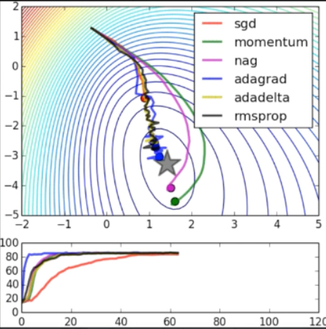
[Pic-3]
This work defines cost function and optimize the cost to find the minimal cost using AdamOptimizer. This function gets the cost gain from train dataset and edit bias or weight to make cost lower every steps. If cost function is activate all of training steps, it would slow down the speed of training. So I spit data into batches and apply above steps. Training model needs few parameters.
Variables | Values
batch_size | 50
validation_size | 0.1
Img_size | 32
Num_channels | 1
Filter_size_conv | 1
Learning_rate | 1e-4
[Table-1]
Cost uses Cross-entropy that makes values always positive number. Each step gets accuracy which shows us how many prediction was correct during training model. Its data are from training data set so if you want to see you’re doing right, you need to use test data which is not used to train model.

Equations

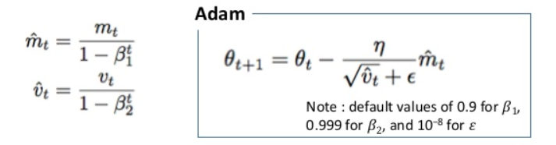
[Pic-4]
Equations for Adam
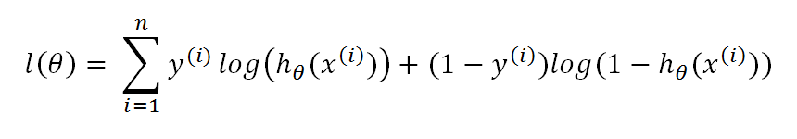
[Pic-5]
Equations for Cross Entropy
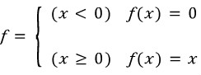
[Pic-6]
Euqations for ReLU

Some Common Mistakes
- Do not validate model with dataset that was used to training model.
- Images should be resized same as inputs for model
- Flatten layer should be in the right place. Between Convolutional layers and Fully Connected layers.

Experimenttal Results
Steps | Training Accuracy | Test Accuracy | Cost | Steps | Training Accuracy | Test Accuracy | Cost
1 | 12% | 4% | 0.038066576 | 10 | 94% | 96% | 0.002522476
2 | 42.0 | 22% | 0.037216056 | 11 | 94% | 98% | 0.002368571
3 | 74% | 62% | 0.027232438 | 12 | 94% | 90% | 0.0022130650
4 | 94% | 96% | 0.005771360 | 13 | 94% | 96% | 0.002031058
5 | 92% | 88% | 0.003919326 | 14 | 94% | 90% | 0.001956754
6 | 94% | 90% | 0.003062358 | 15 | 94% | 92% | 0.001804167
7 | 94% | 90% | 0.003062358 | 16 | 94% | 90% | 0.001659458
8 | 94% | 88% | 0.002851396 | 17 | 94% | 90% | 0.001320584
9 | 94% | 92% | 0.002675146 | 18 | 98% | 96% | 0.001193265
[Table-2]
Above table is Result from each steps. After each steps, Accuracy is getting high, cost is getting low. When the step reached 18, changing rate of cost was very low so I quit training.
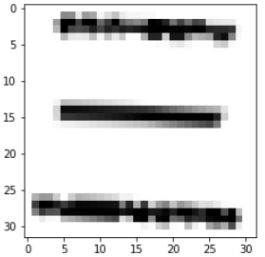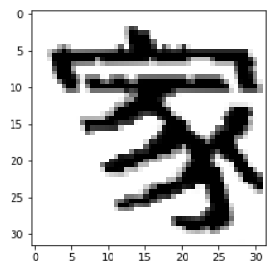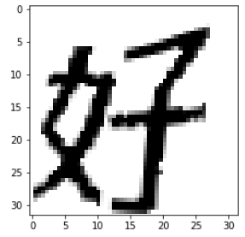
[Pic-6]
The test image above representing ‘three’,’home’, ‘love’ was predicted as ‘sam’ .’ga’,’ho’and the label was ‘sam’,’ga’,’ho’. Because model has obtained the data of image’s feature by training image set, they can detect characters precisly even if the characters are distorted.

Conclusion
The method that shown above improve the recognization of Chinese character. By using CNNs, models can get feature of images and make activation map to detect feature quickly. It can be used to make text file from images like receipt natural images with OpenCV’s TextDetecting algorithm. Further more, if we can get text area from video, we can translate Chinese letters into Korean language. This work opens great potential to the translation area.
Proposed method needs to be fixed in several area. First, It trains only distorted images written by computer so it’s accuracy about recognize hand writed characters are inferior to the former. So I’m planning to add Hand writing dataset, layers and functions to train model more exact. Second, It cannot read two characters at once. Images should be separated individually to be used. If two characters are connected with some kind of lines or point, it is hard to separate and can’t be processed. To solve this problem, I’m trying to modifying MSER Algorithm’s function that draw boxes over letters. Third, I didn’t have used this functions in real life. There is so many variables that I need to concern like noise, brightness, shadows, etc. I’m trying to apply this functions in real life to get problems and going to correct bugs and needs.

References

- Y. LeCun, Y. Bengion and G. Hinton, "Deep learning," Nature, Vol. 521, pp. 436-444, May. 2015.
- Alec Radford's animations for optimization algorithms, MARCH 06, 2015
- Seung-Cheol Baek, Fast and All-Purpose Area-Based Imagery Registration Using ConvNets, Journal of KIISE, Vol. 43, No. 9, pp. 1034-1042, 2016. 9
- Huizhong Chen ; Sam S. Tsai ; Georg Schroth ; David M. Chen ; Radek Grzeszczuk ; Bernd Girod, Robust text detection in natural images with edge-enhanced Maximally Stable Extremal Regions, 11-14 Sept. 2011
- Rian Adam Rajagede ; Chandra Kusuma Dewa ; Afiahayati, Recognizing Arabic letter utterance using convolutional neural network, 31 August 2017

