THE SCORES OF FIRST YEAR BACHELOR OF SCIENCE IN HOSPITALITY MANAGEMENT STUDENTS IN THEIR PRELIM EXAMINATIONS IN UNDERSTANDING THE SELF AT BESTLINK COLLEGE OF THE PHILIPPINES

SUBMITTED BY:
HISTORICO, KEZHIEMICA HASHREE
AMABA, ALDRIN MARK LAPAD
CARIDO, VHERLY GERAMAE
CORTEZ, LANDRY JOHN
ALCANTARA, REYCAN
LUMANOG, HAROLD
LlABRES, SHERELYN
ADOPTANTE, VINCE
FANION, RICHARD
DAVID, CHRISTINE
FRANCISCO, LOU
PERAS, CHARLINE
ROJAS, GABRIEL

SUBMITTED TO:
MS. DEANIELLE MANGAHAS

INTRODUCTION

This study focuses on the midterm examination results of selected first-year Bachelor of Science in Hospitality Management (BSHM) students in the subject Macro Perspective of Tourism and Hospitality, conducted in September. The study aims to determine the distribution of scores, highlighting how many students achieved high marks and how many got a low mark. It also seeks to assess whether the exam was generally easy or difficult for the students, based on their performance. Furthermore, the results will provide insights into the overall percentage of students who performed well, thereby reflecting their understanding of the subject and readiness for future academic challenges.

FORMULAS

1. Frequency and Percentage Table
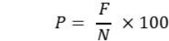

P – Percentage
F – Frequency of responses
N – Number of respondents

2. Mean
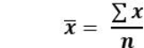
X – Sample Mean
– Summation of each data point n – number of respondents

3. Median

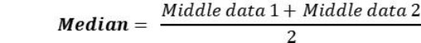

4. Mode. The mode is the value(s) that occur most frequently in a dataset. It is a measure of central tendency that identifies the most common observation

5. Range

6. Interquartile range

IQR – Interquartile Range

Q3 – 75th percentile

Q1 – 21st percentile

GATHERED DATA
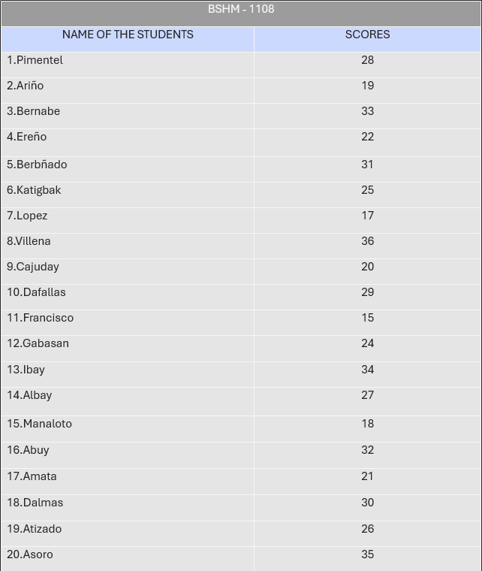

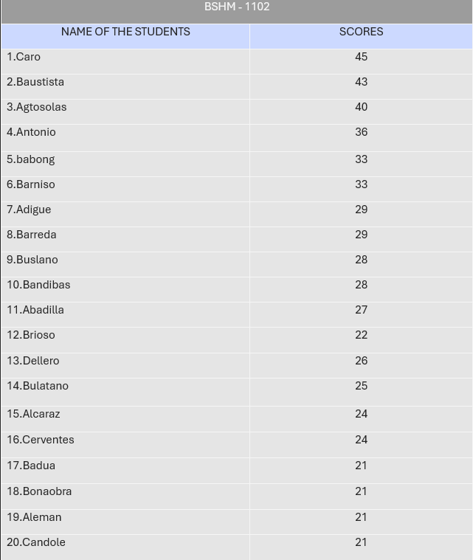

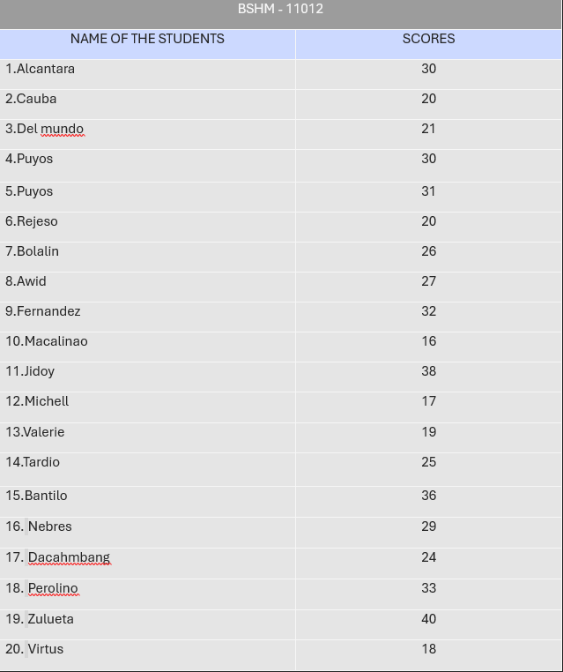

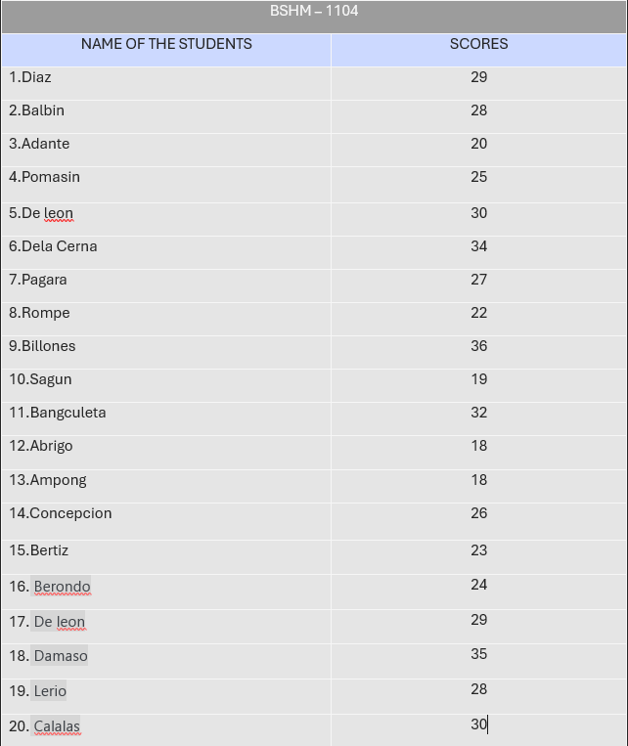

FREQUENCY, PERCENTAGE, AND RANK DISTRIBUTION

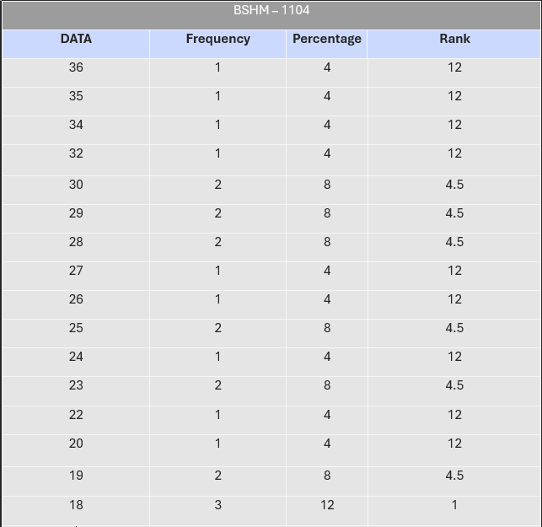

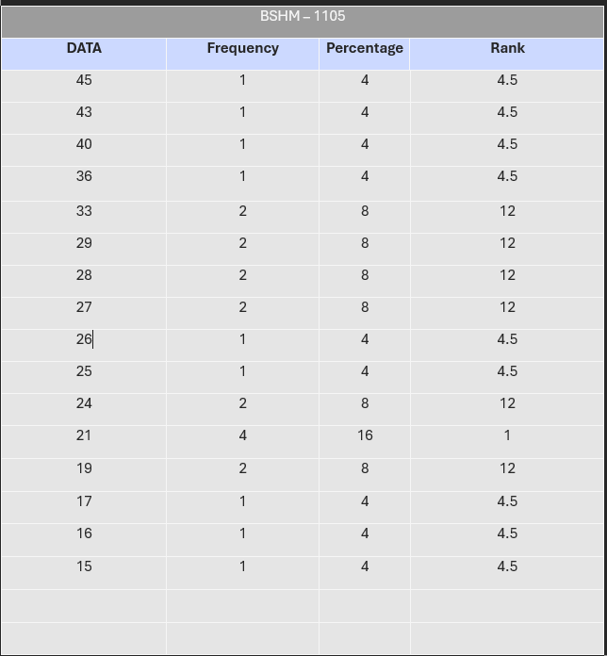

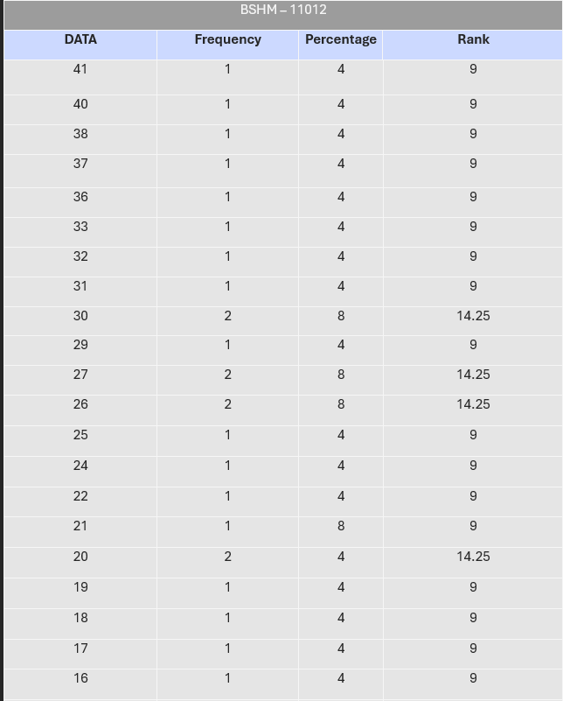

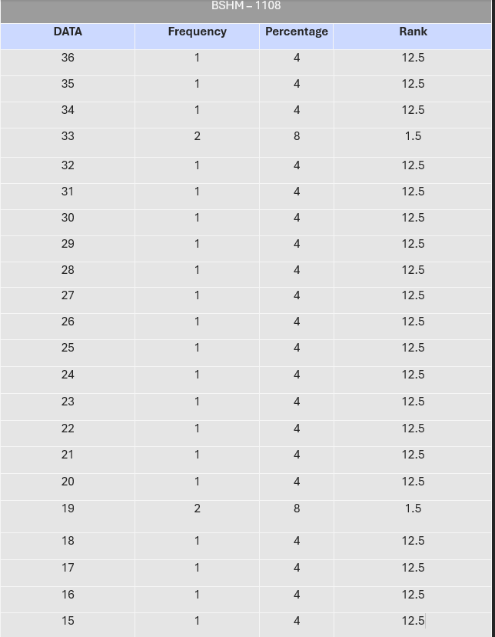

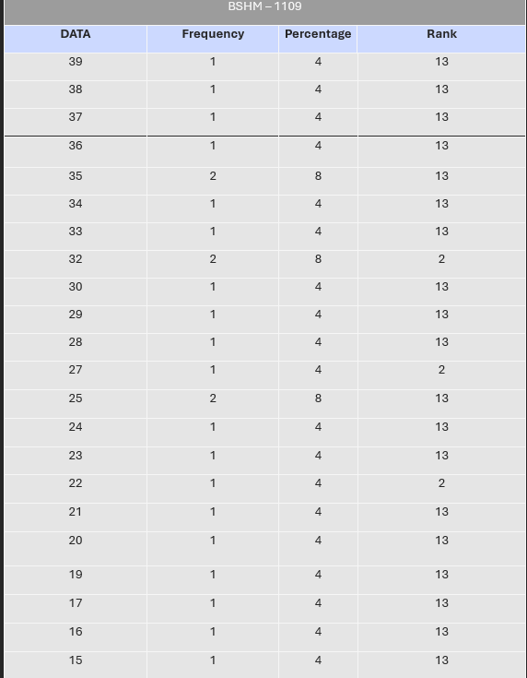

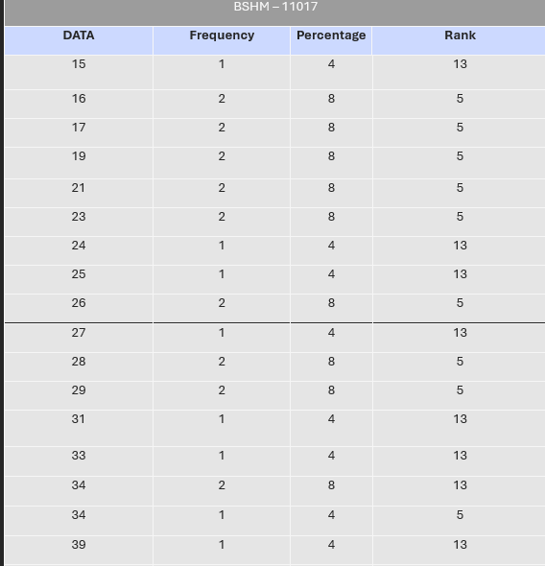

MEAN, MEDIAN, AND MODE

SECTION: BSHM - 1102
Mean = 34.48
Median = 33
Mode = 40, 39, 30

SECTION: BSHM - 1104
Mean = 39.08
Median = 39
Mode = 39

SECTION: BSHM - 1105
Mean = 38.12
Median = 40
Mode = 44

SECTION: BSHM - 1108
Mean = 33.2
Median = 34
Mode = 30

SECTION: BSHM - 1109
Mean = 35.04
Median = 35
Mode = 30, 25

SECTION: BSHM - 1112
Mean = 36.4 Median = 38
Mode = 45, 32

SECTION: BSHM - 1119
Mean = 38.2 Median = 39
Mode = 40, 37

RANGE, Q1, Q3, AND 1QR

SECTION: BSHM - 1102
R = 21
QI = 6.5
Q3 = 19.5
1QR = 13

SECTION: BSHM - 1104
R = 20
QI = 6.5
Q3 = 19.5
1QR = 13

SECTION: BSHM - 1105
R = 28
QI = 6.5
Q3 = 19.5
1QR = 13

SECTION: BSHM - 1108
R = 32
QI = 6.5
Q3 = 19.5
1QR = 13

SECTION: BSHM - 1109
R = 23
QI = 6.5
Q3 = 19.5
1QR = 13

SECTION: BSHM - 1112
R = 38
QI = 6.5
Q3 = 19.5
1QR = 13

SECTION: BSHM - 1119
R = 27
QI = 6.5
Q3 = 19.5

1QR = 13 DOCUMENTATION

