Task 5: Insights & Summary
The objective of this project was to analyze house characteristics and build a machine learning model capable of predicting house prices. Through correlation analysis and feature importance evaluation, it was observed that area is the most significant factor influencing house prices. Other important features include the number of bathrooms, air conditioning availability, parking spaces, number of stories, and bedrooms. Generally, houses with larger areas and better amenities tend to have higher market values.
To evaluate the predictive performance of the models, both Linear Regression and Random Forest Regression were trained and tested. The Linear Regression model performed better, achieving an R² score of approximately 0.65, which means the model was able to explain around 65% of the variation in house prices. The obtained MAE and RMSE values indicate that the model provides reasonably accurate estimates and can be used as a useful tool for price prediction, although it may not perfectly capture all real-world market factors.
One interesting observation from the dataset was that some features that are often assumed to be highly influential, such as main road access, guest rooms, and hot water heating, had a relatively low impact on house prices compared to features like area and bathrooms. This suggests that buyers tend to prioritize the overall size and functionality of a property more than certain additional amenities.
Based on these findings, a recommendation for a real estate business would be to focus on properties with larger living areas, adequate bathrooms, parking facilities, and modern amenities such as air conditioning, as these factors contribute most significantly to property value. Understanding these key price drivers can help real estate companies make better investment decisions, improve property valuation strategies, and target customer preferences more effectively.

1. Project Workflow

The project began with loading and exploring the house price dataset. Data cleaning was performed by checking for missing values, duplicate records, and converting categorical attributes into numerical form using one-hot encoding. The dataset was then split into training and testing sets. Two machine learning models, Linear Regression and Random Forest Regression, were trained and evaluated using MAE, RMSE, and R² Score. Finally, visualizations were created to understand feature relationships and derive meaningful business insights.

2. Dataset Description
The dataset contains information about residential properties and their selling prices. The target variable is price, while the remaining columns represent property characteristics that may influence the price.
Feature | Description
price | House Price (Target Variable)
area | Area of the House
bedrooms | Number of Bedrooms
bathrooms | Number of Bathrooms
stories | Number of Floors
parking | Number of Parking Spaces
mainroad_yes | Main Road Access
guestroom_yes | Guest Room Availability
basement_yes | Basement Availability
hotwaterheating_yes | Hot Water Heating
airconditioning_yes | Air Conditioning Availability
prefarea_yes | Preferred Area
furnishingstatus_* | Furnishing Status

3. Data Preprocessing & Feature Engineering
3.1 Data Preprocessing
Before training the machine learning models, several preprocessing steps were performed to improve data quality and prepare the dataset for analysis.
3.2 Missing Value Analysis
The dataset was examined for missing values using Pandas functions. No significant missing values were found; therefore, no imputation techniques were required.
3.4 Duplicate Record Check
The dataset was checked for duplicate records to avoid biased learning and repeated information. Duplicate entries were removed if present.
3.5 One-Hot Encoding
Several categorical attributes contained textual values such as "yes/no" and furnishing status. Since machine learning models require numerical inputs, one-hot encoding was applied to convert these categorical features into binary numerical columns.
The following attributes were encoded:
- mainroad
- guestroom
- basement
- hotwaterheating
- airconditioning
- prefarea
- furnishingstatus

For example:
Original Value | Encoded Value
Yes | 1
No | 0
For furnishing status:
Original Value | Encoded Columns
Furnished | 0,0
Semi-Furnished | 1,0
Unfurnished | 0,1
This transformation enabled the machine learning models to process categorical information effectively.
3.6 Feature Selection
Feature selection was performed to identify attributes that contribute to house price prediction.
A correlation analysis and Random Forest feature importance analysis were carried out to evaluate the influence of each feature on house price.
The analysis revealed that the most important features were:
- Area
- Bathrooms
- Air Conditioning
- Parking
- Stories
- Bedrooms
Although some features such as main road access, guest room, and hot water heating showed relatively lower importance scores, they were retained in the final dataset because they still represent meaningful property characteristics and may contribute to prediction accuracy.
Therefore, no feature columns were removed from the final model.

4. Model Development Process
The processed dataset was divided into training and testing sets using an 80:20 split ratio.
Two machine learning models were developed:

4.1 Linear Regression
Linear Regression was used as the baseline model because it provides a simple and interpretable relationship between house features and price.
4.2 Random Forest Regression
Random Forest Regression was used as an ensemble learning model capable of capturing complex non-linear relationships between house attributes and price.
The performance of both models was evaluated using:
- Mean Absolute Error (MAE)
- Root Mean Squared Error (RMSE)
- R² Score
The model with the better evaluation metrics was selected as the final prediction model.

5. Data Visualization and Analysis
Data visualization was performed to better understand the relationships between different house attributes and house prices. The generated charts helped identify important features, understand price distribution, and evaluate the performance of the machine learning models.
5.1 Correlation Heatmap
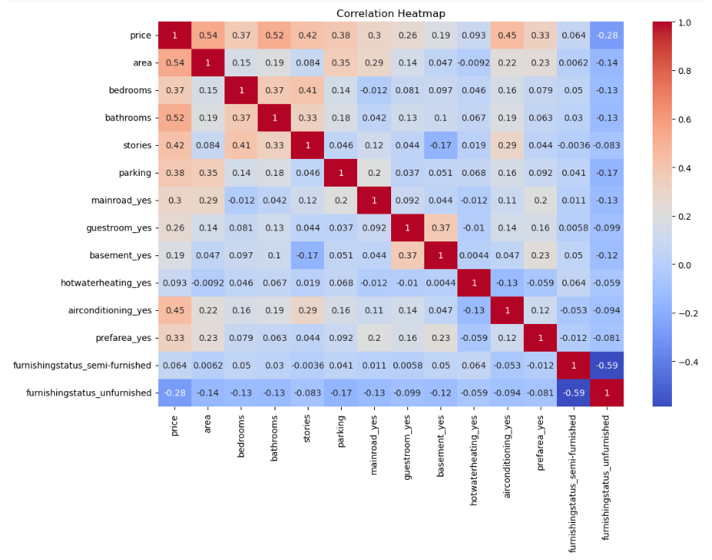
Description
The correlation heatmap shows the relationship between all features present in the dataset. Correlation values range from -1 to +1, where values closer to +1 indicate a strong positive relationship and values closer to 0 indicate a weak relationship.
Interpretation
The heatmap reveals that area has the strongest positive correlation with house price. Other features such as bathrooms, air conditioning, stories, and parking spaces also show positive relationships with price. Features like guest room availability and hot water heating exhibit relatively weaker correlations.
Conclusion
The heatmap confirms that larger houses with better amenities generally have higher market values.
5.2 Area vs Price Scatter Plot
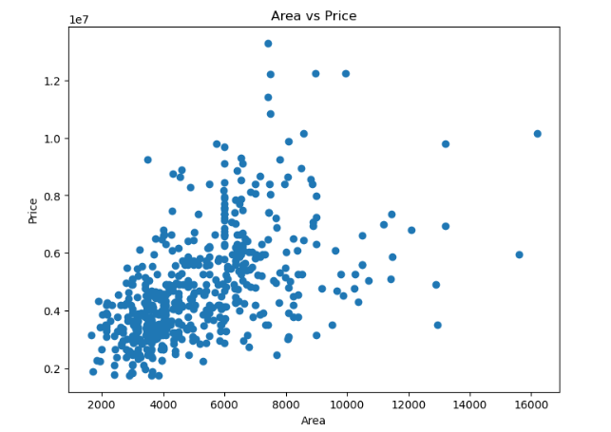
Description
A scatter plot was created to visualize the relationship between house area and selling price. Each point represents an individual house in the dataset.
Interpretation
The plot shows a clear upward trend, indicating that house prices generally increase as the area increases. Although some variation exists due to additional factors such as furnishing status and amenities, area remains one of the strongest determinants of price.
Conclusion
Area is a highly influential feature and plays a major role in house price prediction.
5.3 Average Price by Bedrooms
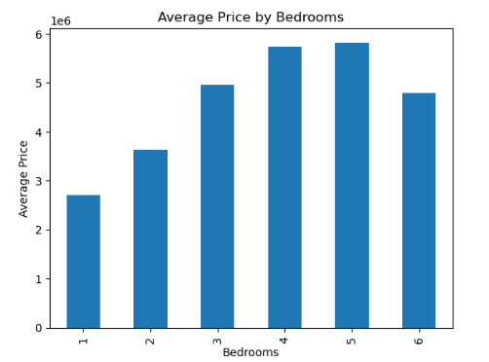
Description
This bar chart presents the average selling price of houses based on the number of bedrooms available in the property.
Interpretation
The chart indicates that houses with a greater number of bedrooms generally have higher average prices. However, the increase is not perfectly proportional because other factors such as house area, bathrooms, and location-related features also contribute to pricing.
Conclusion
The number of bedrooms positively influences house prices, but it should be considered along with other structural features.
5.4 Feature Importance Analysis
Description
Feature importance analysis was performed using the Random Forest Regression model to determine which features contribute most significantly to house price prediction.
Interpretation
The analysis identified area as the most important feature by a large margin. Features such as bathrooms, air conditioning, parking, stories, and bedrooms also contributed to the prediction process. Features such as main road access, guest room availability, and hot water heating had relatively low importance scores.

Conclusion
Area is the most influential factor affecting house prices, while several amenities provide additional but comparatively smaller contributions.
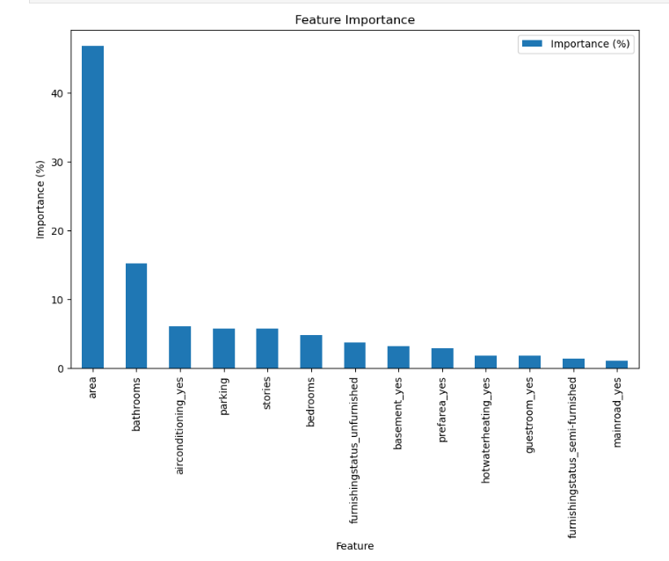
5.5 Actual vs Predicted Prices
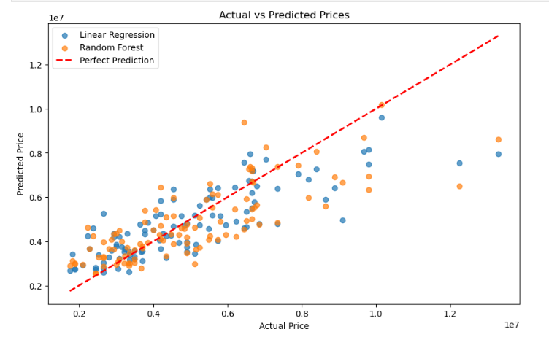
Description
This graph compares actual house prices with the prices predicted by the machine learning models. The red diagonal line represents perfect predictions where actual and predicted values are equal.
Interpretation
Most data points are located reasonably close to the reference line, indicating that the models are able to capture the overall pricing trends. Some deviations are observed for expensive properties, which contribute to prediction errors measured by MAE and RMSE.
Conclusion
The developed machine learning models provide reasonably accurate price estimates and successfully identify overall pricing patterns within the dataset.
5.6 Distribution of House Prices (Histogram)
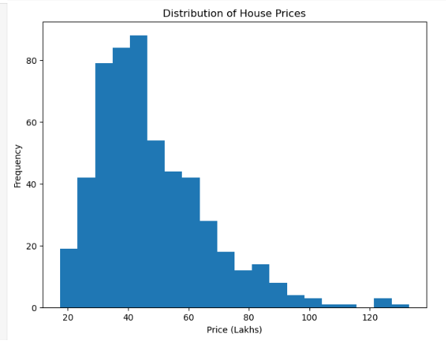
Description
A histogram was generated to examine the distribution of house prices within the dataset.
Interpretation
The majority of houses are concentrated in the mid-price range, while high-priced houses occur less frequently. The distribution is slightly right-skewed, indicating the presence of a limited number of premium properties with significantly higher prices.
Conclusion
Most properties belong to the middle-price segment, while luxury houses represent a smaller portion of the dataset.

- Insights and Recommendations
6.1 Key Insights
- Area was identified as the most influential factor affecting house prices, followed by bathrooms, air conditioning, parking facilities, and number of stories.
- Houses with larger living spaces generally command higher prices, as observed from both the correlation analysis and scatter plot visualization.
- The distribution of house prices showed that most properties belong to the middle-price segment, while luxury properties represent a smaller portion of the dataset.
- Feature importance analysis revealed that structural characteristics contribute more significantly to house prices than certain amenities such as guest rooms and hot water heating.
- The Linear Regression model outperformed the Random Forest model on this dataset and achieved the highest predictive performance.
6.2 Recommendation
Based on the analysis, real estate businesses should prioritize properties with larger areas, adequate bathrooms, parking facilities, and modern amenities such as air conditioning, as these features contribute most significantly to property value and customer demand.

- Conclusion
In this project, a House Price Prediction System was developed using Machine Learning techniques. The dataset was explored, cleaned, and preprocessed through duplicate checking and one-hot encoding of categorical variables. Exploratory Data Analysis and visualization techniques were applied to understand relationships between house features and price.
Two machine learning models, namely Linear Regression and Random Forest Regression, were trained and evaluated using MAE, RMSE, and R² Score metrics. The Linear Regression model achieved the best overall performance with an R² score of approximately 0.65, indicating a reasonable ability to predict house prices based on available property characteristics.
The analysis demonstrated that area, bathrooms, parking facilities, stories, and air conditioning are among the most important factors influencing house prices. The developed model can be used as a decision-support tool for estimating property values and understanding the key drivers of housing prices.
Overall, the project successfully combined data preprocessing, visualization, machine learning, and model evaluation techniques to build an effective house price prediction solution.

