PROJECT REPORT
ATMOSYNC: MICRO-CLIMATE
ARBITRAGE ANALYTICS
Data Analytics Project
Submitted to
INFOTACT SOLUTIONS
Project Period: 5 September 2026 – 5 October 2026
SUBMITTED BY
Janhavi Raut — Team Leader
Ravinder Singh
Soumik Singha Mahapatra
S. Priyanka
Tools: Python • Pandas • Matplotlib • Jupyter Notebook • Power BI • GitHub

1. Introduction
AtmoSync: Micro-Climate Arbitrage Analytics is a data analytics project focused on studying temperature and humidity variations across geographical locations. Python is used for data preparation and analysis, while Microsoft Power BI presents the findings through an interactive dashboard. The current implementation focuses on micro-climate analytics; actual economic arbitrage is not calculated because the available dataset does not include verified market prices, transport costs, demand, or revenue.

2. Problem Statement
Temperature and humidity vary across geographical locations. This project organizes and analyzes weather data, identifies patterns, compares locations, and presents results through a dashboard.

3. Project Objectives
- Prepare and organize weather data.
- Check for missing values and duplicate records.
- Analyze temperature and humidity distributions.
- Compare conditions across containers.
- Classify containers into four climate categories.
- Study the temperature-humidity relationship.
- Visualize geographical coordinates.
- Develop an interactive Power BI dashboard.

4. Dataset Description
The source dataset is GlobalWeatherRepository.csv. The final analytical dataset, AtmoSync_Final_Data.csv, contains 5,000 records representing 100 containers, with 50 records per container.
Column | Description
Container_ID | Identifier assigned to each container.
Timestamp | Timestamp associated with an analytical record.
Temperature_C | Temperature in degrees Celsius.
Humidity_Percent | Humidity percentage.
Latitude | Latitude coordinate.
Longitude | Longitude coordinate.

The final dataset was checked for missing values and duplicate rows. No missing values or duplicate rows were identified in the final dataset.
Data limitation: timestamps in the final analytical dataset were generated as sequential minute-based timestamps. They do not represent actual live sensor readings or necessarily reflect original observation times.

5. Tools and Technologies
- Python: data preparation, calculations, and analysis.
- Pandas: data manipulation, grouping, and descriptive statistics.
- Matplotlib: visualizations for exploratory analysis.
- Jupyter Notebook: writing and executing Python code.
- Microsoft Power BI: interactive dashboard development.
- GitHub: project source-code and file management.

6. Project Methodology

6.1 Data Preparation
Relevant weather fields were selected and organized into a structured dataset containing identifiers, timestamps, temperature, humidity, latitude, and longitude.

6.2 Data Generation
A dataset of 5,000 records across 100 containers was prepared, with 50 records per container. Sequential minute-based timestamps were generated for organizing analytical records.

6.3 Data Quality Checks
The dataset was checked for missing values, duplicate rows, record counts, and observations per container.

6.4 Exploratory Data Analysis
Descriptive statistics and container-wise comparisons were used to understand temperature and humidity patterns. Correlation analysis examined their relationship.

6.5 Climate Classification
Containers were classified using average temperature and average humidity, with overall averages of 26.37°C and 55.01% used as thresholds.

6.6 Dashboard Development
Power BI visuals present key metrics, container comparisons, temperature versus humidity, climate distribution, coordinates, and filters.

7. Exploratory Data Analysis and Key Findings
Metric | Result
Total records | 5,000
Total containers | 100
Average temperature | 26.37°C
Minimum temperature | -3.7°C
Maximum temperature | 49.1°C
Average humidity | 55.01%
Minimum humidity | 3%
Maximum humidity | 100%
Temperature-humidity correlation | -0.47

7.1 Temperature Analysis
Average temperature was 26.37°C, with a minimum of -3.7°C and a maximum of 49.1°C, indicating variation across analyzed observations.

7.2 Humidity Analysis
Average humidity was 55.01%, with values ranging from 3% to 100%.

7.3 Temperature and Humidity Relationship
The correlation was approximately -0.47, indicating a moderate negative linear relationship in this dataset. Correlation alone does not establish causation.

7.4 Climate Category Distribution
The four climate categories and their counts are listed below.
Climate Category | Containers | Percentage
Hot and Dry | 27 | 27%
Hot and Humid | 23 | 23%
Cool and Dry | 24 | 24%
Cool and Humid | 26 | 26%
Total | 100 | 100%

8. Power BI Dashboard
The Power BI dashboard presents the analysis in a visual and interactive format.
- KPI cards: average temperature, average humidity, total containers, and total records.
- Container-wise average temperature chart.
- Container-wise average humidity chart.
- Temperature-versus-humidity scatter plot.
- Climate type distribution donut chart.
- Latitude-versus-longitude scatter plot showing geographic coordinates.
- Container_ID and Climate_Type filters, where configured.
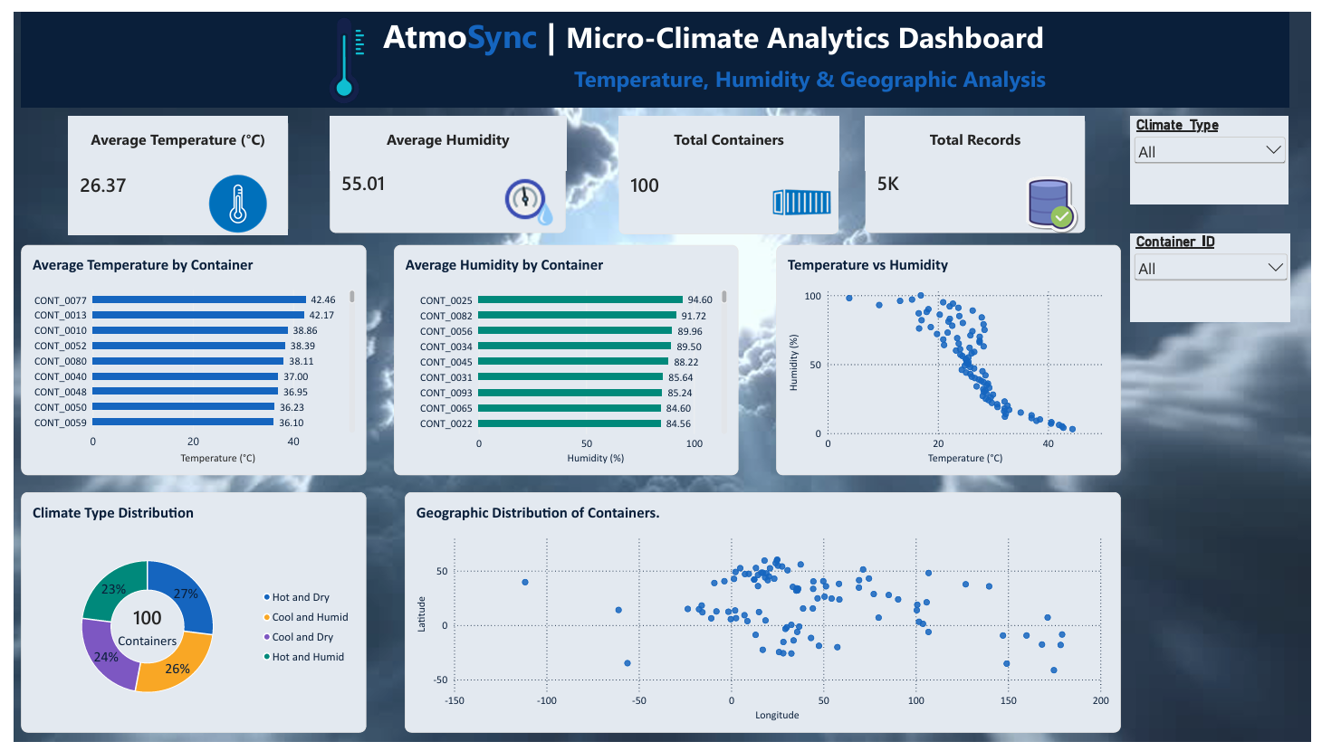
sNote: the latitude-versus-longitude visual is a coordinate scatter plot, not a map with geographic boundaries.

9. Project Outcomes
- Prepared a structured dataset containing 5,000 records.
- Performed data quality checks.
- Analyzed temperature and humidity distributions.
- Calculated temperature-humidity correlation.
- Classified 100 containers into four climate categories.
- Created visualizations and a Power BI dashboard.
- Organized notebooks and supporting files.

10. Conclusion
AtmoSync demonstrates how Python and Power BI can be combined to analyze weather data and communicate environmental patterns. The project involved data preparation, validation, exploratory analysis, climate classification, and dashboard development. It provided practical experience in data analytics, Python programming, visualization, and dashboard development.
The current implementation uses historical weather data and generated analytical timestamps. It does not implement live sensor monitoring or calculate actual economic arbitrage opportunities.

11. Limitations and Future Scope

11.1 Limitations
The project uses a prepared dataset rather than a live sensor feed. Generated timestamps do not represent real-time sensor measurements. The analysis focuses mainly on temperature, humidity, and coordinates. Verified prices, transport costs, demand, and revenue are not included for calculating arbitrage. The geographic visualization displays coordinates rather than a detailed map.

11.2 Future Scope
Future improvements could include live weather APIs or IoT sensors, actual timestamps for time-series monitoring, additional environmental variables, a geographic map, verified price and demand data, automated dashboard refreshes, and alerts for unusual temperature or humidity conditions.

12. References
- GlobalWeatherRepository.csv — source weather dataset.
- Python documentation: https://docs.python.org/
- Pandas documentation: https://pandas.pydata.org/docs/
- Matplotlib documentation: https://matplotlib.org/stable/
- Microsoft Power BI documentation: https://learn.microsoft.com/power-bi/
- GitHub documentation: https://docs.github.com/

Project Team
Name | Role
Janhavi Raut | Team Leader
Ravinder Singh | Team Member
Soumik Singha Mahapatra | Team Member
S. Priyanka | Team Member

Infotact Solutions

