Assignment

Name = Rushikesh Prasad Inamdar

Q1)

package PracticeQuestion;

import java.io.*;

public class New {

public static void main(String[] args) {

{

try

{

int i,num=0;

String s;

BufferedReader br=new BufferedReader(new InputStreamReader(System.in));

System.out.println("Give the no. of manager:\n");

s=br.readLine();

num=Integer.parseInt(s);

Manager[] man=new Manager[num];

for(i=0;i<num;i++)

{

man[i]=new Manager();

man[i].entM();

}

System.out.println("Give the no. of Typist :");

s=br.readLine();

num=Integer.parseInt(s);

Typist[] typ=new Typist[num];

for(i=0;i<num;i++)

{

typ[i]=new Typist();

typ[i].entT();

}

System.out.println("Give the no. of Officer:\n");

s=br.readLine();

num=Integer.parseInt(s);

Officer[] off=new Officer[num];

for(i=0;i<num;i++)

{

off[i]=new Officer();

off[i].entO();

}

System.out.println("Manager details\n");

for(i=0;i<num;i++)

{

man[i].show();

}

System.out.println("Typist Details\n");

for(i=0;i<num;i++)

{

typ[i].show();

}

System.out.println("officer Details\n");

for(i=0;i<num;i++)

{

off[i].show();

}

}

catch(Exception e){

}

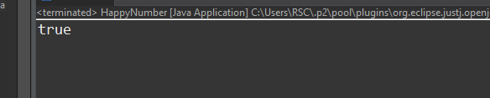

Q2)

package PracticeQuestion;

public class RunningSum {

public static int[] runningSum(int[] nums) {

int[] runningSum = new int[nums.length];

int sum = 0;

for (int i = 0; i < nums.length; i++) {

sum += nums[i];

runningSum[i] = sum;

}

return runningSum;

}

public static void main(String[] args) {

int[] nums = {1, 2, 3, 4};

int[] runningSum = *runningSum*(nums);

for (int i = 0; i < runningSum.length; i++) {

System.***out***.print(runningSum[i] + " ");

}

}

}

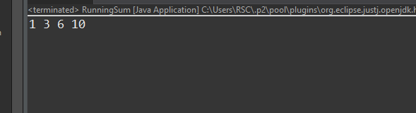

Q3)

package PracticeQuestion;

import java.util.*;

public class BinarySearch {

public static void main(String[] args) {

Scanner sc = new Scanner(System.***in***);

System.***out***.print("Enter the size of the array: ");

int N = sc.nextInt();

int[] arr = new int[N];

System.***out***.print("Enter the elements of the array in sorted order: ");

for (int i = 0; i < N; i++) {

arr[i] = sc.nextInt();

}

System.***out***.print("Enter the integer to search for: ");

int K = sc.nextInt();

int position = *binarySearch*(arr, K);

if (position == -1) {

System.***out***.println(K + " is not present in the array.");

} else {

System.***out***.println(K + " is present at position " + (position + 1) + ".");

}

}

public static int binarySearch(int[] arr, int K) {

int left = 0;

int right = arr.length - 1;

while (left <= right) {

int mid = (left + right) / 2;

if (arr[mid] == K) {

return mid;

} else if (arr[mid] < K) {

left = mid + 1;

} else {

right = mid - 1;

}

}

return -1;

}

}

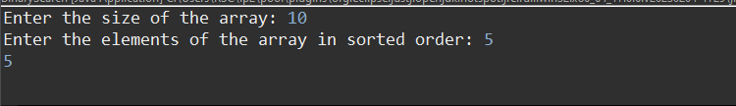

Q4)

package PracticeQuestion;

public class Question4 {

public static void main(String[] args) {

int[] arr = {4, 7, 1, 0};

int n = arr.length;

int max = arr[n-1];

System.***out***.print("Leaders: " + max);

for (int i = n-2; i >= 0; i--) {

if (arr[i] > max) {

max = arr[i];

System.***out***.print(" " + max);

}

}

}

}

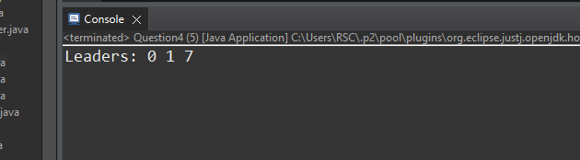

Q5)

package PracticeQuestion;

public class Question5 {

public static void main(String[] args) {

int[] numbers = new int[args.length];

for (int i = 0; i < args.length; i++) {

numbers[i] = Integer.*parseInt*(args[i]);

}

boolean swapped = true;

while (swapped) {

swapped = false;

for (int i = 0; i < numbers.length - 1; i++) {

if (numbers[i] > numbers[i+1]) {

int temp = numbers[i];

numbers[i] = numbers[i+1];

numbers[i+1] = temp;

swapped = true;

}

}

}

System.***out***.println("Sorted numbers in ascending order:");

for (int i = 0; i < numbers.length; i++) {

System.***out***.print(numbers[i] + " ");

}

}

}

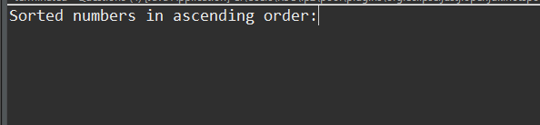

Q6)

package PracticeQuestion;

import java.io.*;

public class New {

public static void main(String[] args) {

try {

int i, num = 0;

String s;

BufferedReader br = new BufferedReader(new InputStreamReader(System.***in***));

System.***out***.println("Give the no. of manager:");

s = br.readLine();

num = Integer.*parseInt*(s);

Manager[] man = new Manager[num];

for (i = 0; i < num; i++) {

man[i] = new Manager();

man[i].entM();

}

System.***out***.println("Give the no. of Typist:");

s = br.readLine();

num = Integer.*parseInt*(s);

Typist[] typ = new Typist[num];

for (i = 0; i < num; i++) {

typ[i] = new Typist();

typ[i].entT();

}

System.***out***.println("Give the no. of Officer:");

s = br.readLine();

num = Integer.*parseInt*(s);

Officer[] off = new Officer[num];

for (i = 0; i < num; i++) {

off[i] = new Officer();

off[i].entO();

}

System.***out***.println("Manager details:");

for (i = 0; i < num; i++) {

man[i].show();

}

System.***out***.println("Typist Details:");

for (i = 0; i < num; i++) {

typ[i].show();

}

System.***out***.println("Officer Details:");

for (i = 0; i < num; i++) {

off[i].show();

}

} catch (Exception e) {

e.printStackTrace();

}

}

}

class Manager {

void entM() {

//code to enter Manager details

}

void show() {

//code to display Manager details

}

}

class Typist {

void entT() {

//code to enter Typist details

}

void show() {

//code to display Typist details

}

}

class Officer {

void entO() {

//code to enter Officer details

}

void show() {

//code to display Officer details

}

