INDEX

Sr.  No. | Contents | Page No.
1. | Introduction | 2
1.1 | Abstract | 2
1.2 | Existing System and Need for System | 2
1.3 | Scope of System | 3
1.4 | Objective | 3
2. | Technology Description | 4
2.1 | Operating Environment (Hardware/Software) | 4
2.3 | Brief Description of Technology (Used Technology) | 4
3. | System Features | 6
3.1 | Module wise Functional Requirement | 6
3.2 | Non-functional Requirement | 7
4. | System Design Details | 8
4.1 | Use case Diagram | 8
4.2 | Activity Diagram | 9
4.3 | Class Diagram | 10
4.4 | ER Diagram | 11
4.5 | Sequence Diagram | 12
4.6 | Deployment Diagram | 13
5. | Implementation Detail | 14
5.1 | Source Code | 14
5.2 | Table Specification | 19
5.3 | User Interface Design and Report | 19
5.4 | Website map Diagram | 23
5.5 | Test Plan & Test Cases | 24
6. | Drawbacks and Limitations | 27
7. | Proposed Enhancements | 28
8. | Conclusion | 29
9. | Bibliography | 30

Introduction

  - Abstract

This The Smart Crop Advisory System is a web-based application designed to assist farmers in selecting the most suitable crops for cultivation based on environmental and soil conditions. The system utilizes machine learning algorithms to analyse key factors such as soil nutrients (NPK values), weather conditions, and crop characteristics to generate accurate crop recommendations. By enabling data-driven decision-making, the system aims to improve agricultural productivity, minimize crop losses, and support sustainable farming practices. The proposed solution provides farmers with an accessible and reliable tool for informed crop planning.

  - Existing System and Need of System

The Existing System:
In In the existing system, farmers largely rely on traditional farming practices, personal experience, and general advice from local experts to decide which crops to cultivate. Crop selection is often based on intuition rather than scientific analysis of soil nutrients and environmental conditions. Information related to soil health, weather patterns, and suitable crops is usually obtained from scattered sources, which may be outdated or inaccurate. There is no integrated system to analyse multiple factors such as soil nutrients (NPK values), climate conditions, and crop requirements simultaneously. As a result, farmers may select unsuitable crops, leading to reduced yield, increased risk of crop failure, and economic losses. The lack of data-driven decision support limits agricultural productivity and efficient resource utilization.

The Need of the System:
- To provide farmers with a centralized digital platform for crop advisory and decision support.
- To analyze soil nutrients (NPK values) and environmental conditions accurately using machine learning techniques.
- To reduce crop losses caused by improper crop selection and lack of scientific guidance.
- To assist farmers in choosing suitable crops based on real-time and historical data.
- To improve agricultural productivity through data-driven and informed decision-making.
- To minimize dependency on traditional guesswork and inconsistent advisory sources.
- To promote sustainable farming practices by optimizing resource utilization.

  - Scope of the System

- Development of a web-based Smart Crop Advisory System.
- User registration and authentication for secure access.
- Collection and analysis of soil nutrient data (NPK values).
- Integration of weather and environmental data for accurate crop recommendations.
- Application of machine learning algorithms to predict suitable crops.
- Generation of crop recommendations based on analyzed data.
- User-friendly interface to allow easy interaction and understanding of results.

  - Objective

- To design and develop a web-based Smart Crop Advisory System.
- To analyze soil nutrients and environmental factors using machine learning techniques.
- To provide accurate crop recommendations based on soil and weather conditions.
- To assist farmers in selecting suitable crops for improved yield and productivity.
- To reduce crop losses caused by improper crop selection.
- To support data-driven agricultural decision-making.
- To promote sustainable and efficient farming practices.
- To enhance accessibility to intelligent crop advisory services through a web platform.

Technology Description
  - Operating Environment (Hardware/Software)

Hardware Requirements:
- Processor: Intel i3 / above
- RAM: 8 GB
- OS: Windows 10 / 11
- Internet Connection

Software Requirements:
- Python 3.10+, Django 5.x
- SQLite Database
- HTML5, CSS3, React Js

  - Brief Description of Technology (Used Technology)
- Python:
Python is used as the primary programming language for developing the backend of the application. It helps in implementing business logic, note verification processes, and server-side functionalities efficiently.

- Django:
Django is a high-level web framework used to build the web application.
It provides built-in features such as authentication and database
management, and security, which help in rapid and secure development.

- SQLite:
SQLite is used as the database to store user details, soil data, and crop-related information. It provides a lightweight, efficient, and reliable data storage solution with fast data retrieval and easy integration for web applications.

- HTML5 (Hyper Text Markup Language):
HTML5 is used to design the basic structure and layout of the web application. It helps in creating web pages with elements such as forms, buttons, links, tables, and input fields required for user registration, note uploading, downloading, and searching.

- CSS3 (Cascading Style Sheets):
CSS3 is used to control the presentation and visual design of the website. It helps in defining colors, fonts, spacing, layouts, and responsiveness of the web pages. By using CSS3, the application achieves a consistent and attractive user interface, improves readability, and enhances overall user experience across different devices and screen sizes.

- ReactJS:
ReactJS is used as the frontend framework to develop an interactive and user-friendly interface for the Smart Crop Advisory System. It enables efficient rendering of components, smooth user interaction, and responsive design, allowing users to easily input data and view crop recommendations.

System Features
  - Module wise Functional Requirement
- User Registration & Login Users:
  - Users (Farmer, Expert, Admin) can register and log in securely.
  - Expert accounts become active only after admin approval.
- Farmer Features:
  - Enter soil nutrient values (NPK) and environmental details.
  - View recommended crops based on analyzed data.
  - Access previous crop recommendations.
- Expert Features:
  - Review crop recommendations and system predictions.
  - Provide feedback or suggestions to improve accuracy.
  - Cannot modify system data directly.
- Admin Features:
  - Manage user and expert accounts.
  - Approve or reject expert registrations.
  - Manage crop and dataset information.
  - Monitor system performance and usage.
- Crop Recommendation Module:
  - Analyze soil and weather data using machine learning algorithms.
  - Generate suitable crop recommendations.
  - Display results in a clear and understandable format.
- Data Management:
  - Store user inputs, soil data, and recommendations securely.
  - Maintain a centralized database for efficient retrieval.

  - Non-functional Requirements:
- Usability: The system should be simple and easy to use for farmers with minimal technical knowledge.
- Performance: The system should process data and generate crop recommendations quickly.
3.Security: User data should be securely stored, and access should be restricted based on user roles.
4.Reliability: The system should provide consistent and accurate recommendations without failure.
5.Scalability: The system should support future expansion, including more users, crops, and datasets.

System Design Details
  - Use Case Diagram

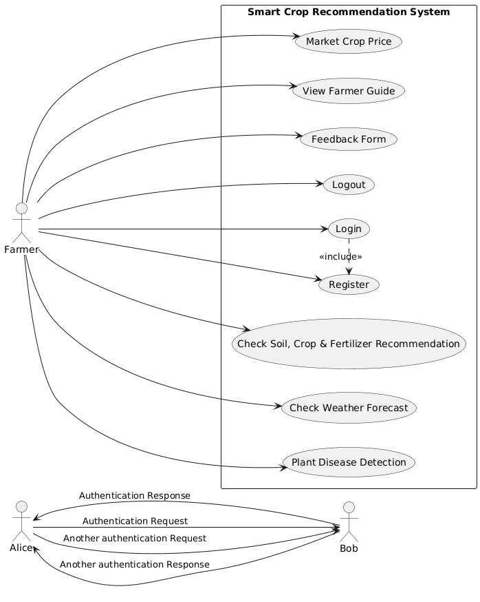

  - Activity Diagram

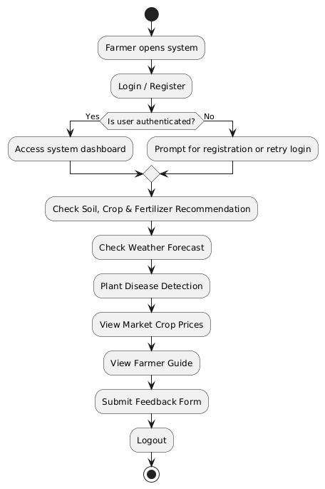

  - Class Diagram

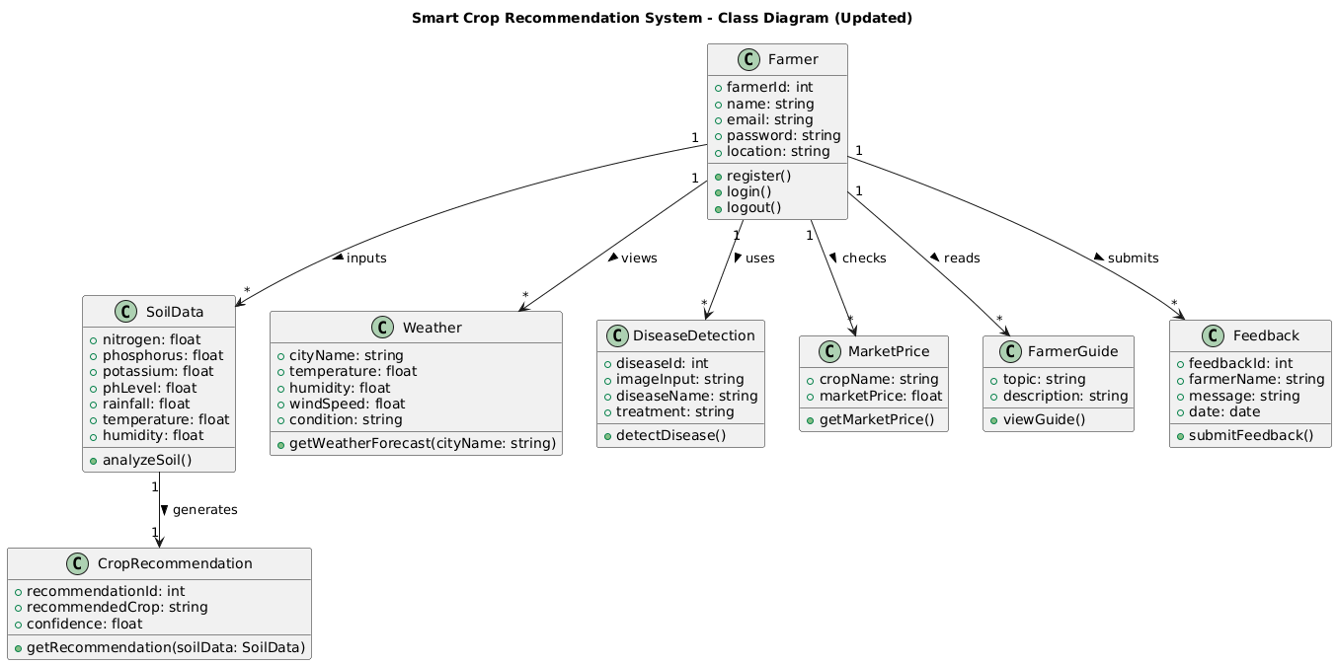

  - ER Diagram

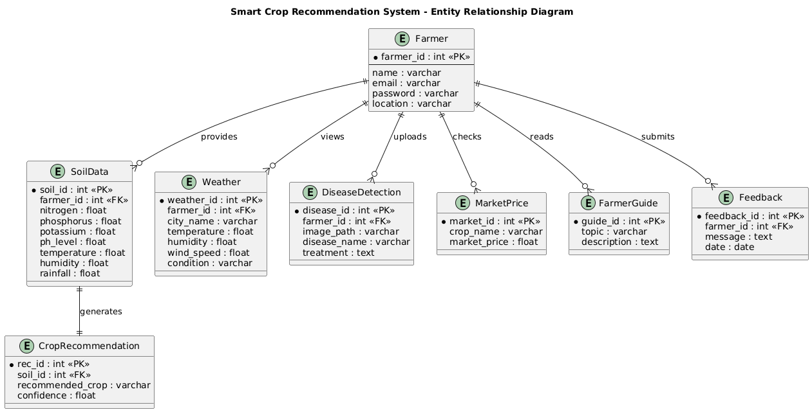

  - Sequence Diagram

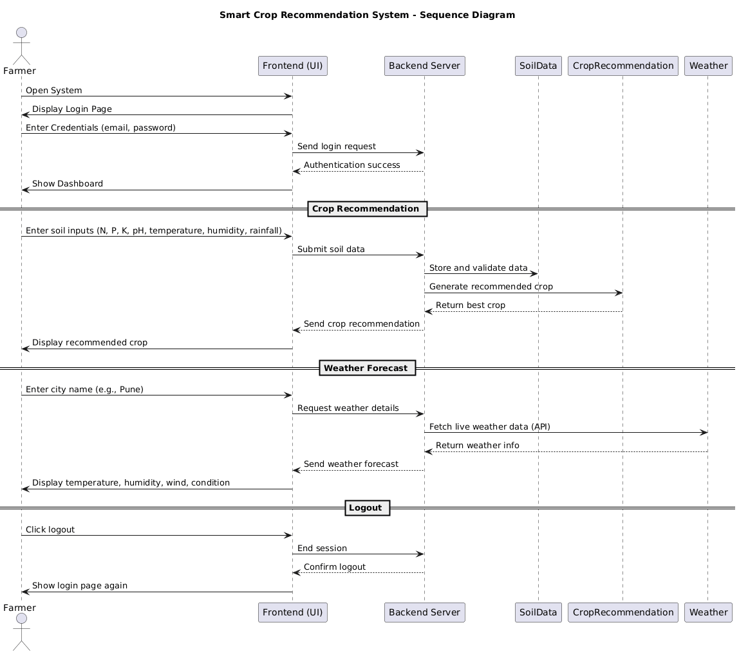

  - Deployment Diagram

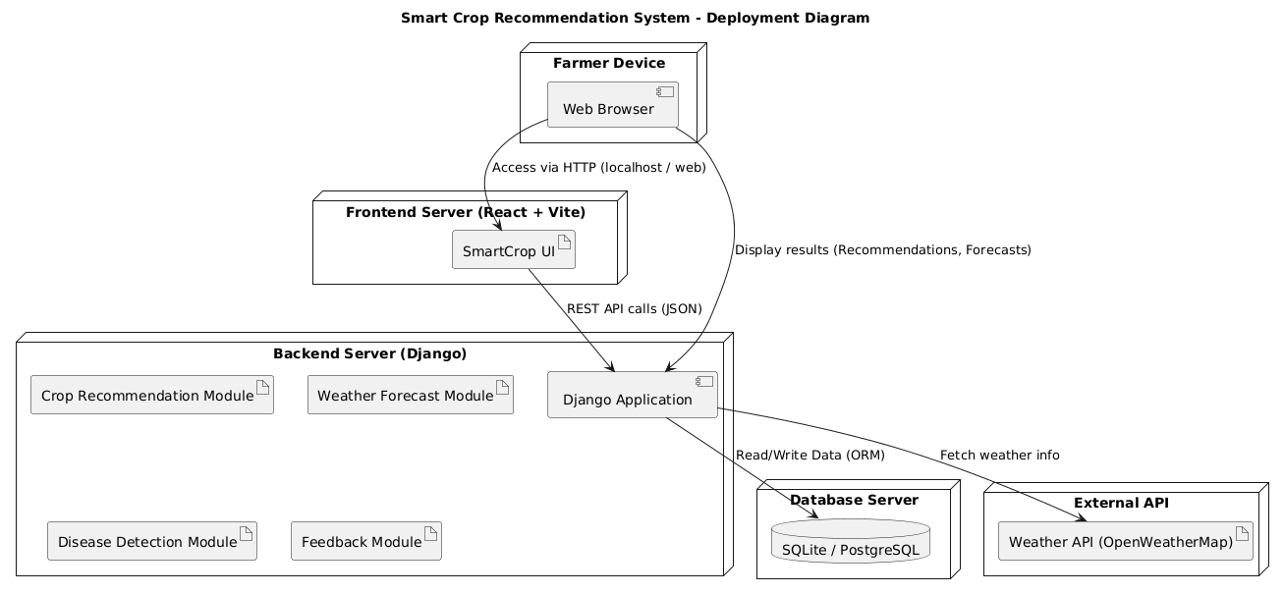

Implementation Detail
  - Source Code
    - App.jsx
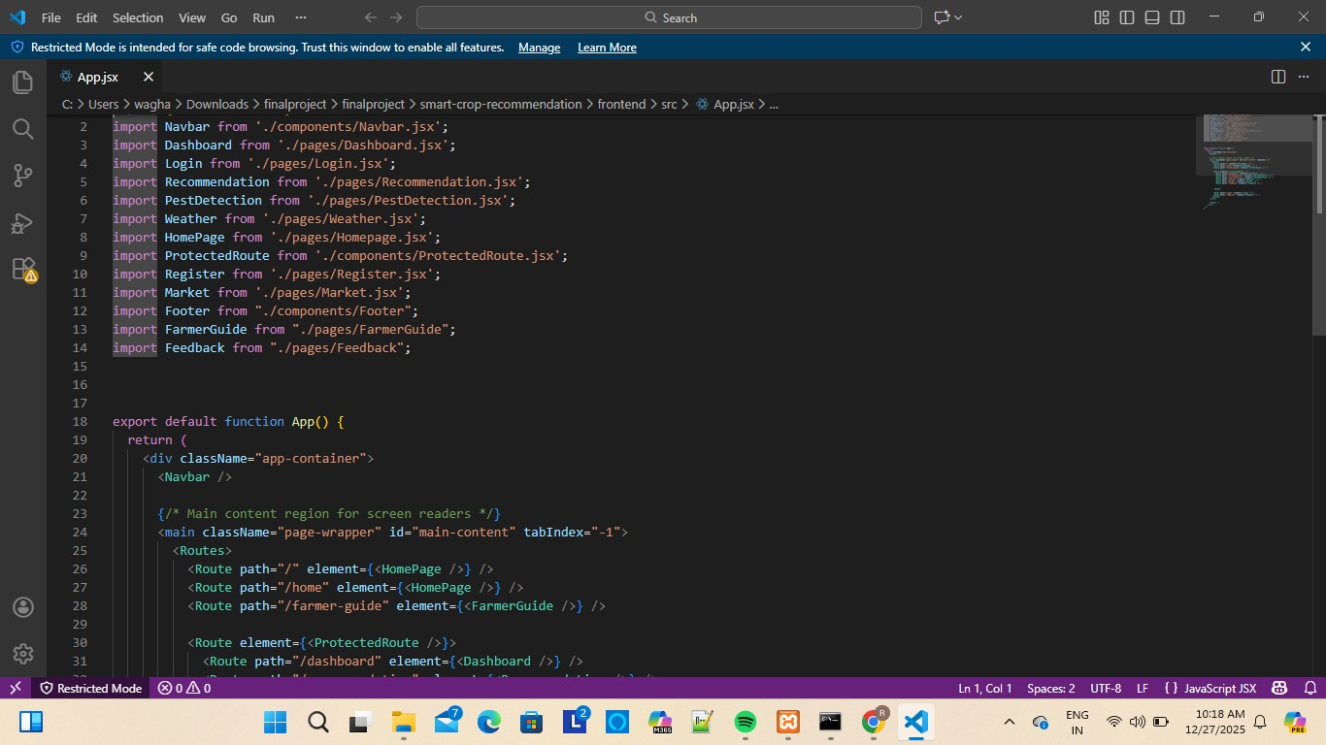

    - Settings.py
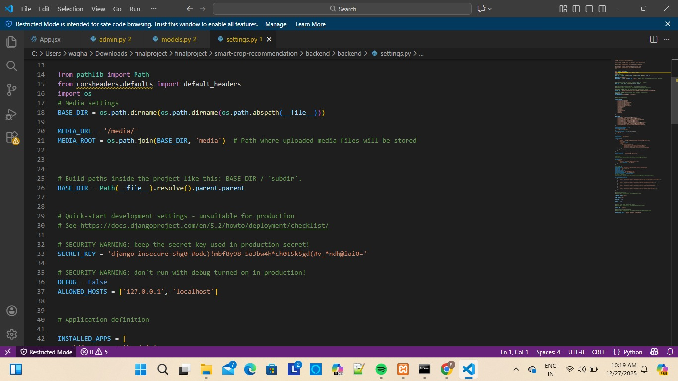

  - Table Specification
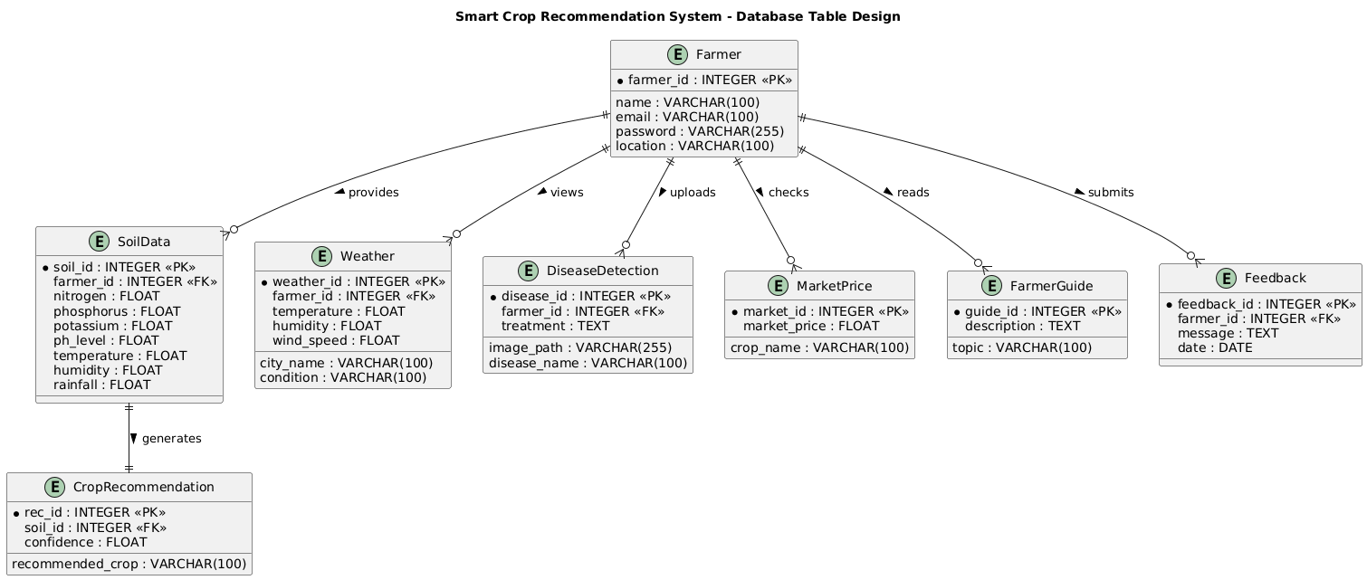

  - User Interface Design and Report
    - User Interface
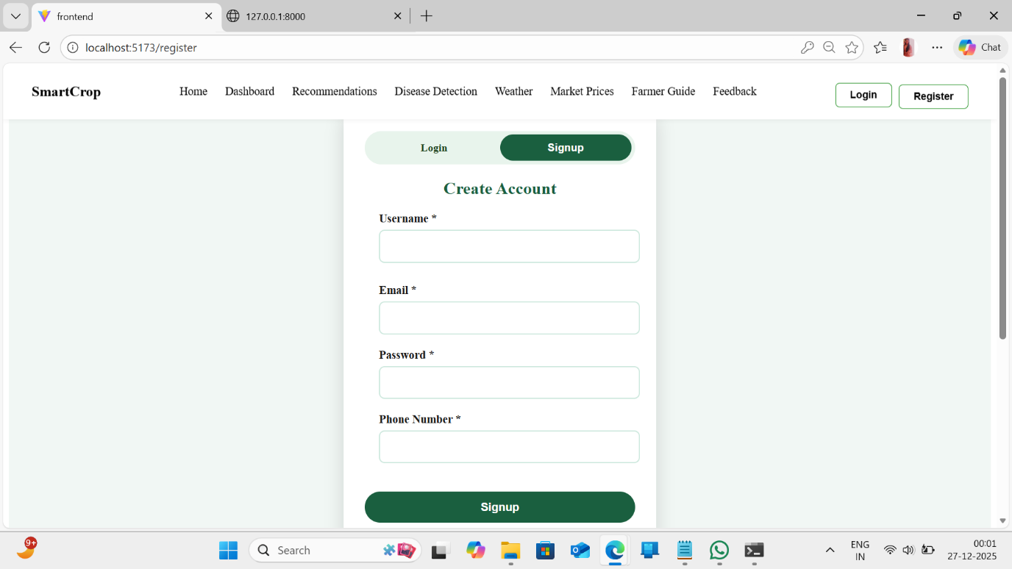

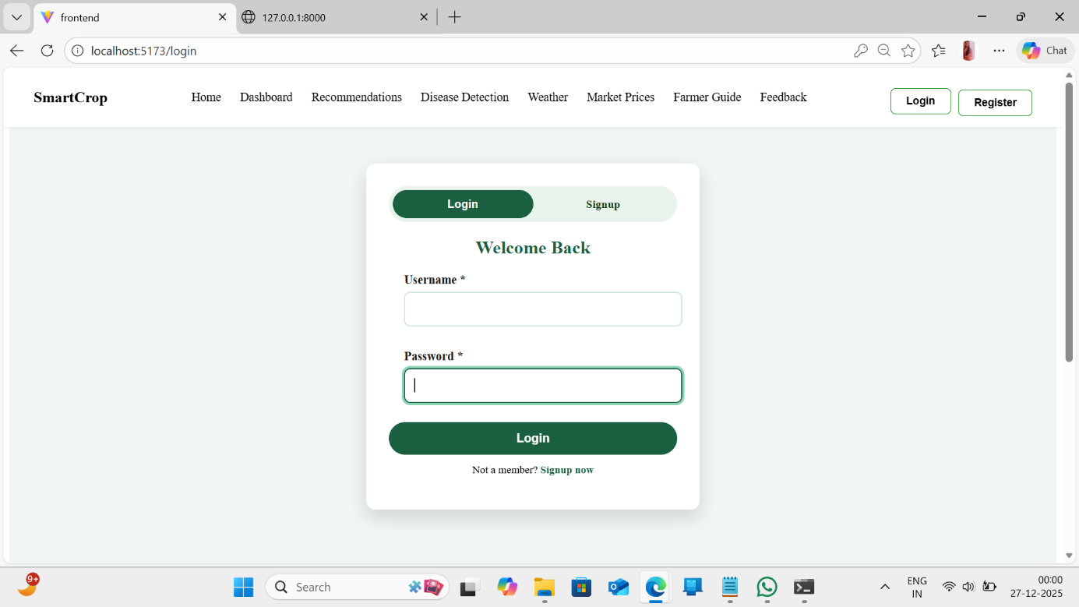

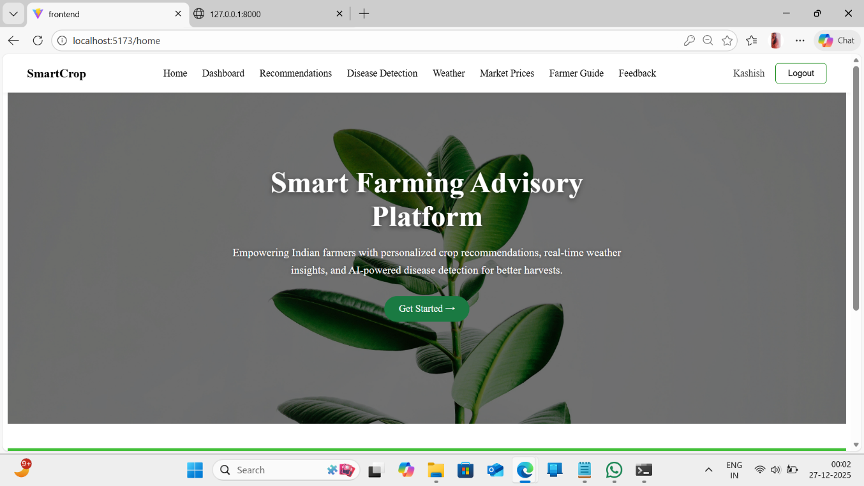

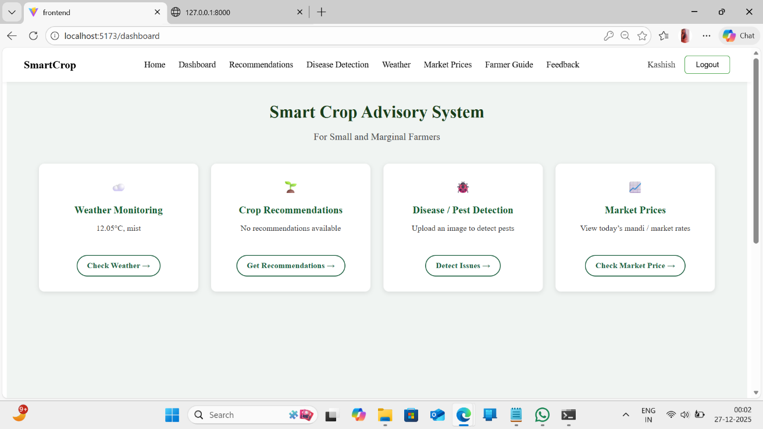

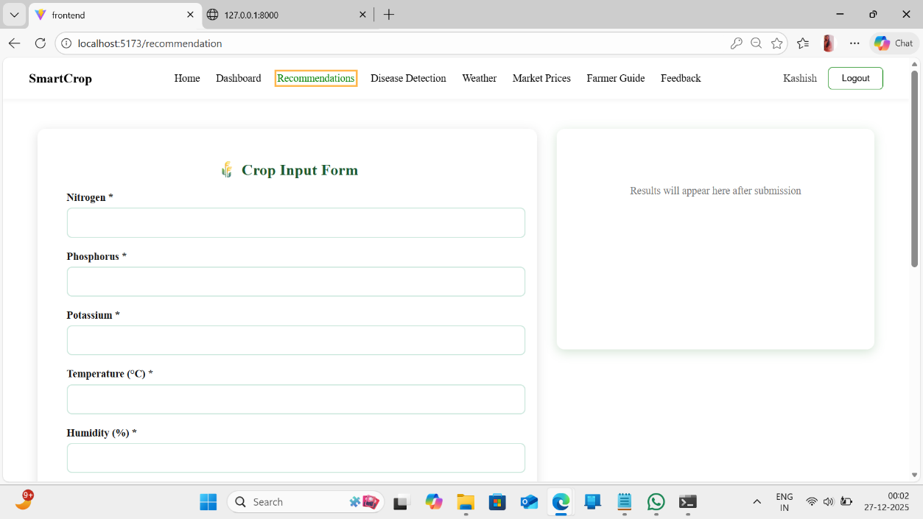

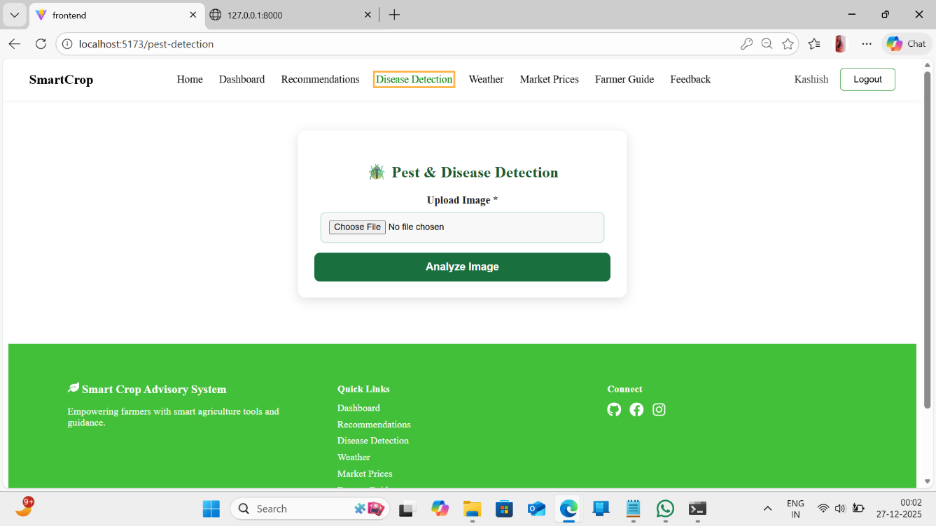

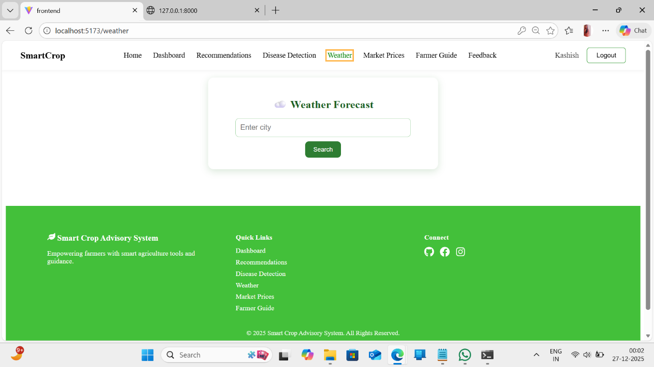

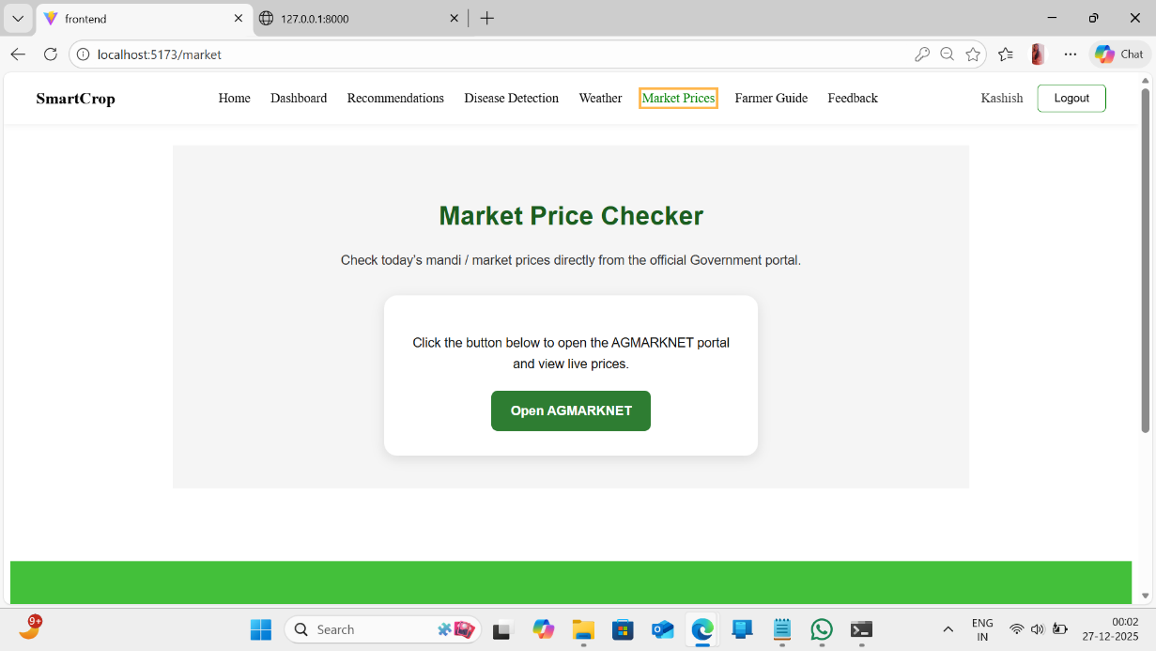

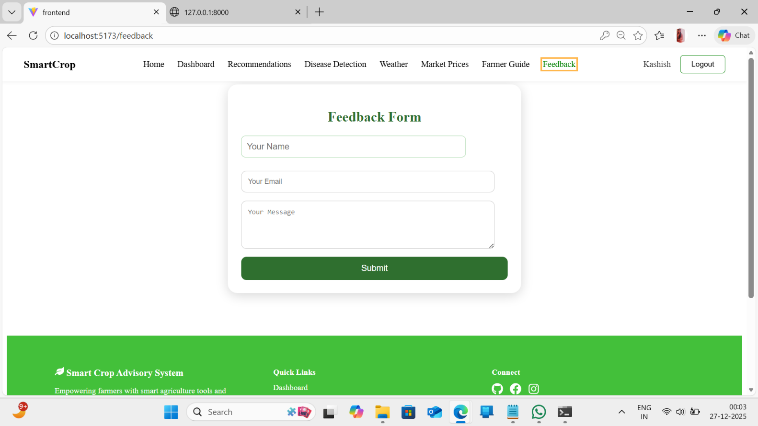
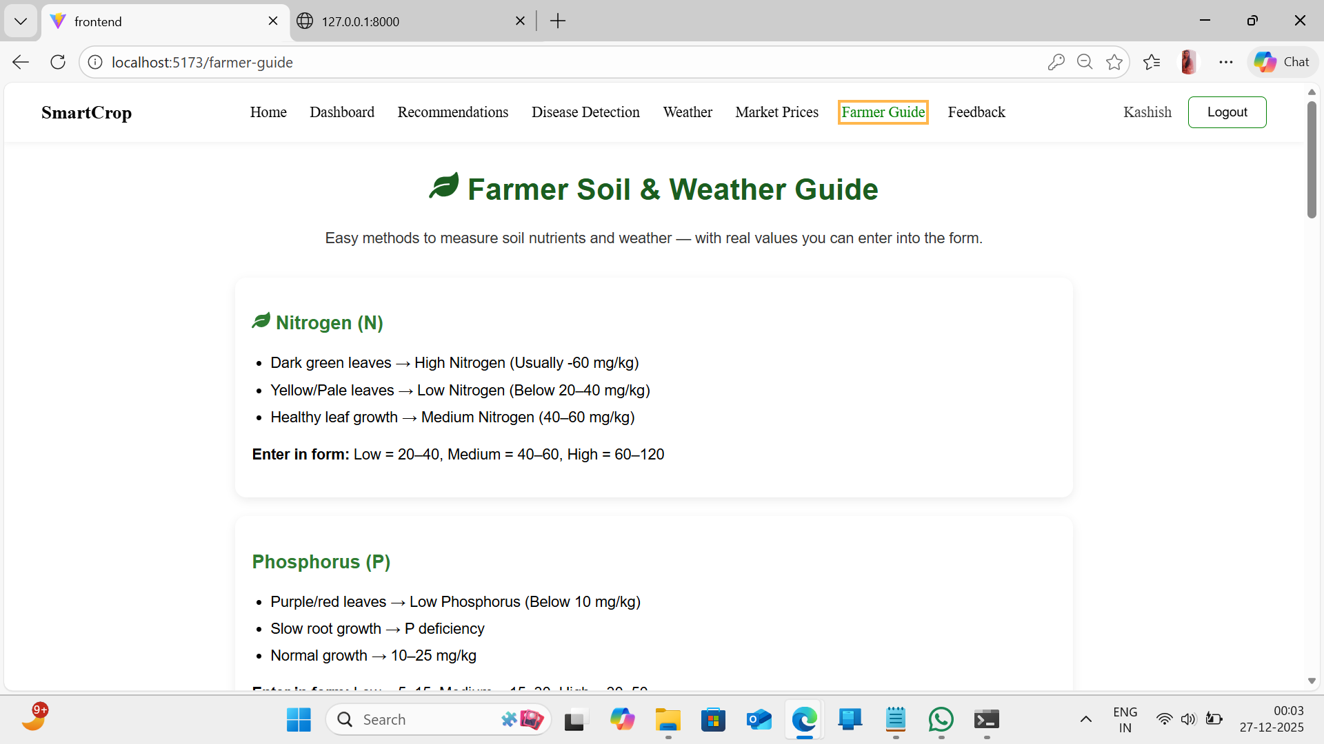

  - Website Map Diagram
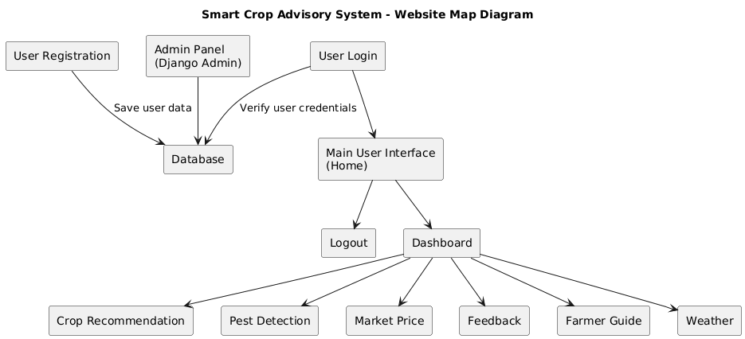

  - Test Plan and Test Cases

Test Case ID | Module Name | Description | Expected Result
TC001 | Authentication | Verify user login with valid credentials | User should be redirected to the dashboard
TC002 | Authentication | Verify login with invalid credentials | System should show 'Invalid credentials' message
TC003 | Registration | Verify new farmer registration | Accounts should be created and confirmation displayed
TC004 | Crop Recommendation | Verify crop recommendation generation | System should accept and store soil data and display recommended crop
TC005 | Weather Forecast | Verify weather data fetching | System should display live weather details
TC006 | Disease Detection | Verify plant disease detection with image upload | System should display detected disease name
TC007 | Market Price | Verify market price display for crops | System should show current market price
TC008 | Feedback | Verify feedback submission functionality | System should show success message
TC009 | Logout | Verify logout functionality | User should be redirected to login page

Drawbacks and Limitations

  - Drawbacks
- The system relies heavily on stable internet connectivity, which may not always be available in rural areas.
- Initial setup, maintenance, and calibration require technical expertise.
- Machine learning model accuracy depends on the quality and amount of available data.
- Limited support for certain complex soil or environmental parameters in the basic version.
- Scalability challenges may arise when handling large datasets or many users simultaneously.
- Expert review may require additional human effort for validation.
- System performance depends on server capacity and database efficiency.

  - Limitations

- Continuous internet access is required for real-time recommendations.
- Crop recommendation and expert feedback processes may not be fully automated.
- Currently supports limited environmental and soil parameters for analysis.
- Performance may degrade with a rapid increase in users or data volume.
- Depends on server uptime and database reliability.
- Basic security features may not cover all potential vulnerabilities.
- Requires periodic updates and system maintenance.

Proposed Enhancements

- Implement more advanced AI and machine learning techniques for automated expert-level recommendations.
- Include support for additional environmental factors and sensor data integration.
- Add advanced filtering and search options based on crop type, soil condition, and region.
- Introduce role-based access control for farmers, experts, and admins.
- Move to cloud-based storage and processing for better scalability and reliability.
- Develop a mobile-friendly interface or a dedicated mobile app for easier farmer access.
- Add user feedback and rating system for recommendations and advisory quality.

Conclusion

- The Smart Crop Advisory System offers an intelligent solution to improve crop selection and farming decisions based on data analysis.
- By leveraging soil nutrients, weather data, and machine learning, the system provides accurate and reliable crop recommendations.
- The web-based platform ensures easy accessibility for farmers to input data and receive advice anytime, anywhere.
- This helps reduce crop losses, increase productivity, and supports sustainable agricultural practices.
- Overall, the system promotes efficient resource use, data-driven farming, and better knowledge sharing within the agricultural community.

Bibliography
- Sommerville, I., Software Engineering, Pearson Education.
- Django Software Foundation, Django Documentation.
- Python Software Foundation, Python Documentation.
- Silberschatz, A., Korth, H. F., and Sudarshan, S., Database System Concepts, McGraw-Hill.
- SQLite Documentation.
- W3Schools, HTML5 and CSS3 Tutorials.
- Pressman, R. S., Software Engineering: A Practitioner’s Approach, McGraw- Hill.
- ChatGPT, Gemini.
- Connect Django Backend to React.js Frontend - Full Stack App Development Tutorial

