**Bank CRM Analysis**

**Objective Questions:**

1. **What is the distribution of account balances across different regions?**

**Power bi :**

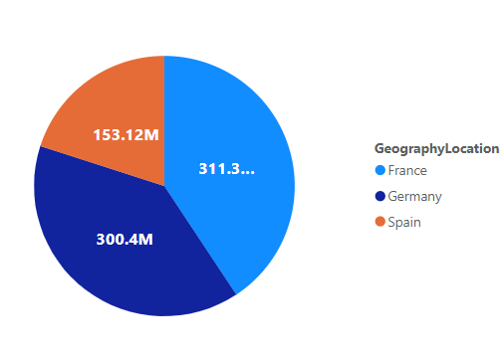

There are currently three regions in the dataset: France, Germany, and Spain. To determine the distribution of account balances, we calculate the total balances and group them by the regions (Geography).

From this pie chart that we used to visualize the distribution of balances across different regions, we draw an insight that **France** has highest account balance.

1. **Identify the top 5 customers with the highest Estimated Salary in the last quarter of the year. (SQL)**

This query can be used for identifying the customer id and salary of the top 5 customers with the highest estimated salary in the last quarter of the year.

**SQL Query :**

SELECT

CustomerId,

Surname,

EstimatedSalary,

BankDOJ

FROM customerinfo

WHERE QUARTER(STR_TO_DATE(BankDOJ, '%Y-%m-%d')) = 4

ORDER BY EstimatedSalary DESC

LIMIT 5;

**Output:**

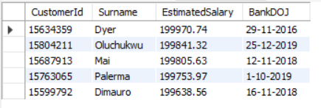

1. **Calculate the average number of products used by customers who have a credit card. (SQL)**

**SQL Query:**

SELECT avg(NumOfProducts) as avg_products_used_by_creditcard_holder

FROM bank_churn

WHERE HasCrCard = 1;

**Output:**

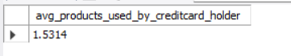

1. **Determine the churn rate by gender for the most recent year in the dataset.**

**Power bi:**

(ChurnRate = DIVIDE([LostCustomers],[TotalCustomers])*100) -- determines the churn rate.

For females : For males:

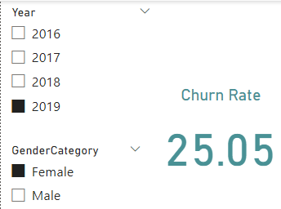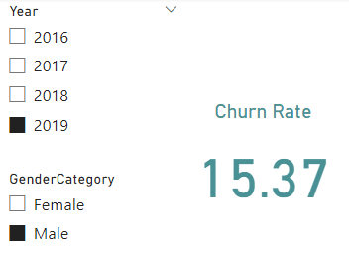

**Conclusion:**

Churn rate for Males in 2019 is 15.37.

Churn rate for Females in 2019 is 25.05.

1. **Compare the average credit score of customers who have exited and those who remain. (SQL)**

**SQL Query :**

SELECT Exited, AVG(CreditScore) AS CreditScoreAverage

FROM bank_churn

GROUP BY Exited;

**Output:**

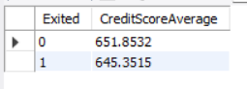

1. **Which gender has a higher average estimated salary, and how does it relate to the number of active accounts? (SQL)**

The query first finds the number of active accounts among the customers and then segregates it into Gender category. Now we find the total number of active accounts and average estimated salary for each Gender category.

**SQL Query:**

WITH ActiveAccounts AS (

SELECT CustomerId, COUNT(*) AS ActiveAccounts

FROM bank_churn

WHERE IsActiveMember = 1

GROUP BY CustomerId

)

SELECT

CASE WHEN ci.GenderID = 1 THEN 'Male' ELSE 'Female' END AS Gender,

COUNT(aa.CustomerId) AS ActiveAccounts, AVG(EstimatedSalary) AS AverageSalary

FROM customerinfo ci LEFT JOIN ActiveAccounts aa ON ci.CustomerId = aa.CustomerId

GROUP BY Gender

ORDER BY AverageSalary DESC;

**Output:**

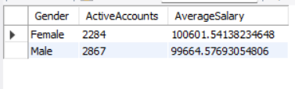

**Conclusion:** Male have higher active accounts and the average salary of the females who have active accounts is slightly higher than the males.

1. **Segment the customers based on their credit score and identify the segment with the highest exit rate. (SQL)**

**SQL Query:**

SELECT

Credit_segment,

round(avg(Exited)*100,2) as rate_of_exited

from (

select bc.CustomerId,

case

when bc.CreditScore <500 then "Poor Credit"

when bc.CreditScore between 500 and 600 then "Good Credit"

when bc.CreditScore between 600 and 700 then "Very Good Credit"

when bc.CreditScore between 700 and 800 then "Excellent Credit"

else "Super Credit"

end as Credit_segment, bc.Exited

From bank_churn bc

inner join customerinfo cf

on bc.CustomerId = cf.CustomerId) as segments

group by Credit_segment

order by rate_of_exited desc;

**Output:**

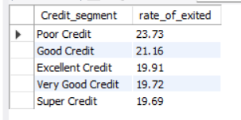

Segment customers by credit score ranges using SQL, compute average exit rates for each segment, and identify the segment with the highest exit rate by ordering results in descending order.

1. **Find out which geographic region has the highest number of active customers with a tenure greater than 5 years. (SQL)**

**SQL Query:**

SELECT g.GeographyLocation, COUNT(b.CustomerId) AS active_customers

FROM geography g

INNER JOIN customerinfo c ON g.GeographyID = c.GeographyID

INNER JOIN bank_churn b ON c.CustomerId = b.CustomerId

WHERE b.Tenure > 5

and isactivemember =1

GROUP BY g.GeographyLocation

ORDER BY active_customers DESC

LIMIT 1;

**Output:**

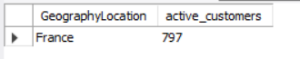

1. **What is the impact of having a credit card on customer churn, based on the available data?**

The provided graph compares customer churn (exit) rates between customers who do not have a credit card (HasCrCard = 0) and those who have a credit card (HasCrCard = 1).

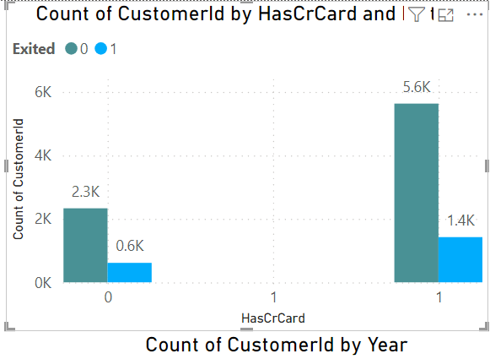

* It appears that more customers with a credit card (HasCrCard = 1) have churned compared to those without a credit card.
* In comparison less people who don’t have a credit card have churned in comparison to the people who have a credit card.

**Conclusion:**

**Yes**, having a credit card seems to have a noticeable impact on customer churn. Customers with a credit card are more likely to churn.

1. **For customers who have exited, what is the most common number of products they have used?**

The below chart provides the comparison between the number of products and the customers who have exited.

**Insights:**

* Product 1: The number of customers who have exited that use product 1 are 1409.
* Product 2: The number of customers who have exited that use product 2 are 348.
* Product 1: The number of customers who have exited that use product 3 are 220.
* Product 1: The number of customers who have exited that use product 4 are 60.

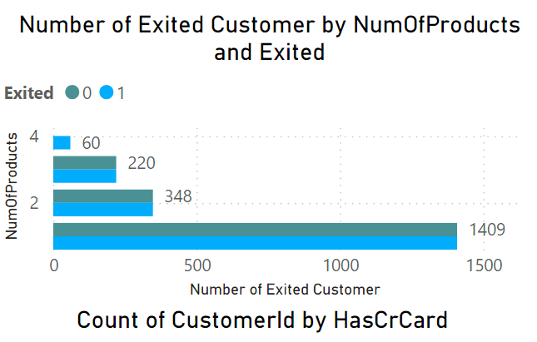

**Conclusion:** The customers who use 3 or 4 products are less likely to churn.

The customer who uses just 1 product are the customers who have churned the most. So, focusing on those customer base can help to decrease the churn rate.

1. **Examine the trend of customers joining over time and identify any seasonal patterns (yearly or monthly). Prepare the data through SQL and then visualize it.**

**SQL Query:**

select year(bankDOJ) as year, count(c.CustomerId) as Exited_cust_count

from bank_churn bc

inner join customerinfo c ON bc.CustomerId= c.CustomerId

where exited =1

group by year;

**Output:**

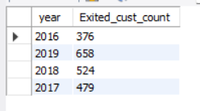

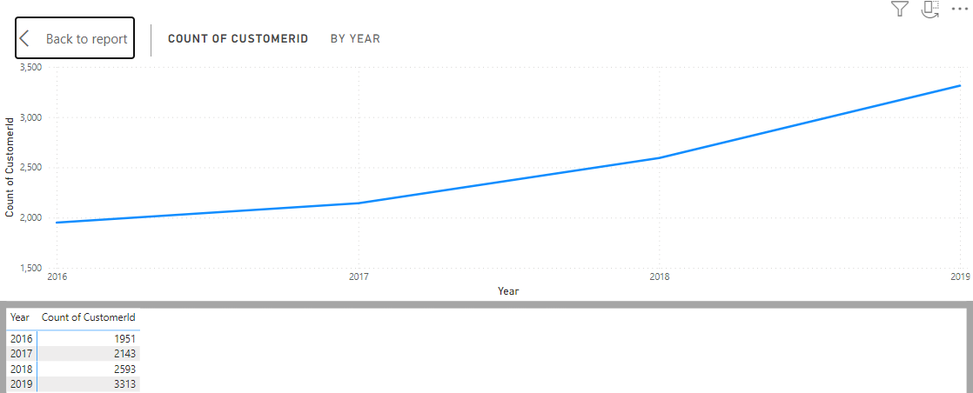

The number of customers has increased per year in the bank, that is a good sign. It is showing that customers getting satisfaction with the bank services and products.

From the data above, we could say that it is almost double in the 4 years of span.

1. **Analyze the relationship between the number of products and the account balance for customers who have exited.**

The chart describes the distribution of the number of products used by customers who have exited. The x-axis represents the number of products used, and the y-axis represents the count of customers who used that many products.

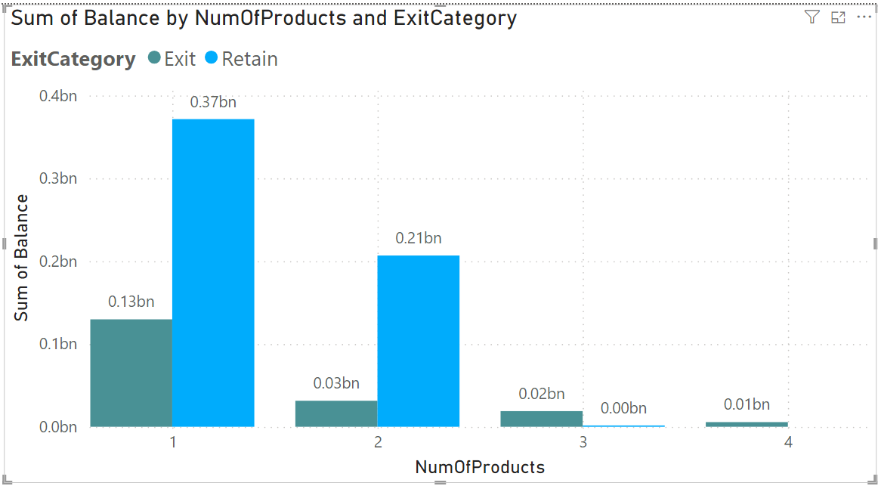

**Conclusion:**

* The most common number of products used by exiting customers is 1. This suggests that the customers who use least number of products are more likely to churn.
* As the number of products used increases. This suggests that customers who churned tend to have fewer products compared to active customers.

The customers who have used 4 products have less balance

1. **Identify any potential outliers in terms of balance among customers who have remained with the bank**.

We can use Box plots or scatter plots are both useful tools for detecting outliers, but they offer different perspectives.

A **box plot** highlights outliers by visualizing the spread of data through quartiles. The whiskers represent data points within 1.5 times the interquartile range (IQR), and any points beyond them are considered potential outliers. This allows you to quickly identify customers with unusually high or low balances. The box itself shows the middle 50% of the data, with the line inside it indicating the median.

Outliers beyond the whiskers often represent customers who deviate significantly from the majority, either with very high or low balances, which could pose a risk to the bank.

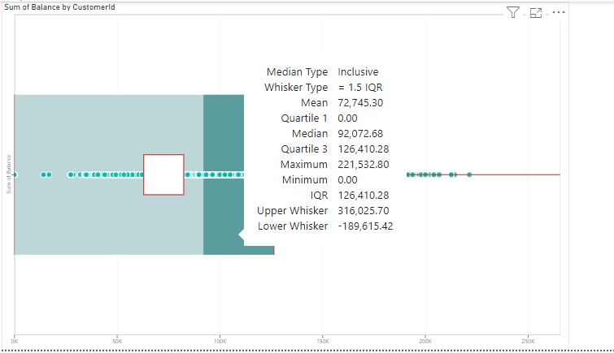

**Detecting Outliers:**

The data points which are beyond the whiskers represent the outliers.

As per the dataset, The customers which have a balance greater than 316,025 or lower than -189,615 could act as outliers.

They could affect the data of the bank.

**Zero outliers** detected as all the data points are within the whiskers.

**Scatter plot** provides a more visual approach by displaying individual data points and their relationships. Outliers appear as points far removed from the main cluster of data, making it easy to spot customers with extreme values, such as balances that don’t align with expected trends.

Example, a customer with a low salary but a high balance might be flagged as an outlier in a scatter plot of balance vs. salary. Scatter plots can also reveal clusters and trends, helping to detect deviations from expected patterns. When combined with a trendline, outliers become even more apparent as points that stray far from the general trend. This helps in identifying customers whose behavior differs from the norm, possibly indicating financial risk.

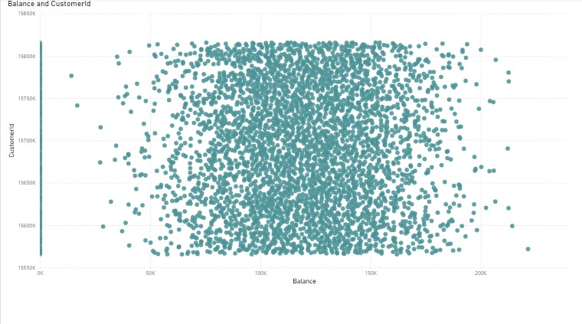

**Conclusion:** No outliers have been found in the data.

1. **How many different tables are given in the dataset, out of these tables which table only consists of categorical variables?**

The dataset has seven different tables they are, Active Customer, Bank Churn, Credit Card, Customer Info, Exit Customer, Gender, Geography.

**Tables with Categorical Variables:**

* Customer Info: Contains categorical variables like Surname.
* Exit Customer: Contains categorical variables like Exit Category.
* Gender: Contains categorical variables like Gender Category.
* Geography: Contains categorical variables like Geography Location.
* Active Customer: Contains categorical variables like Active Category.
* Credit Card: Contains categorical variables like Category.

**Conclusion:** There is no such table which contains only categorical variables.

1. **Using SQL, write a query to find out the gender-wise average income of males and females in each geography id. Also, rank the gender according to the average value. (SQL)**

This SQL query calculates the average income for males and females within each geographic location and assigns rank based on the average salary.

**SQL Query:**

WITH AverageGeographySalary AS (

SELECT

g.GeographyLocation,

CASE

WHEN c.GenderID = 1 THEN 'Male'

ELSE 'Female'

END AS Gender,

AVG(c.EstimatedSalary) AS avg_salary

FROM customerinfo c

INNER JOIN geography g ON c.GeographyID = g.GeographyID

GROUP BY g.GeographyLocation, c.GenderID

ORDER BY g.GeographyLocation

)

SELECT *,

RANK() OVER (PARTITION BY GeographyLocation ORDER BY avg_salary DESC) AS 'rank'

FROM AverageGeographySalary;

**Output:**

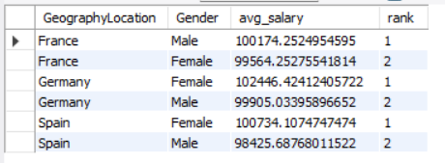

France male customer has highest average income among all countries and Germany male customers has lowest average income among all countries.

1. **Using SQL, write a query to find out the average tenure of the people who have exited in each age bracket (18-30, 30-50, 50+).**

To find the average tenure for each age bracket we first segregate the user base into three segments.

* People with age from 18-30 as adults.
* People with age from 31-50 as Middle Aged.
* People with age above 50 as Old Aged.

**SQL Query:**

SELECT

CASE

WHEN age BETWEEN 18 AND 30 THEN 'Adult'

WHEN age BETWEEN 31 AND 50 THEN 'Middle-Aged'

ELSE 'Old-Aged'

END AS AgeBrackets,

AVG(b.tenure) AS avg_tenure

FROM customerinfo c

JOIN bank_churn b ON c.CustomerId = b.CustomerId

WHERE b.exited = 1

GROUP BY AgeBrackets

ORDER BY AgeBrackets;

**Output:**

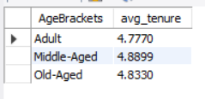

1. **Is there any direct correlation between salary and the balance of the customers? And is it different for people who have exited or not?**

In this analysis, we are examining the correlation between Balance and Estimated Salary. From the scatter plot, there does not appear to be a strong or clear relationship between these two variables. The data points are spread relatively uniformly across various salary and balance ranges, indicating that higher or lower salaries do not consistently correspond to higher or lower balances. Additionally, the two categories for Exited (represented by different shades on the plot) are evenly distributed throughout the chart. This suggests that customer churn (exiting behaviour) does not seem to be directly influenced by either salary or balance based solely on this visual representation.

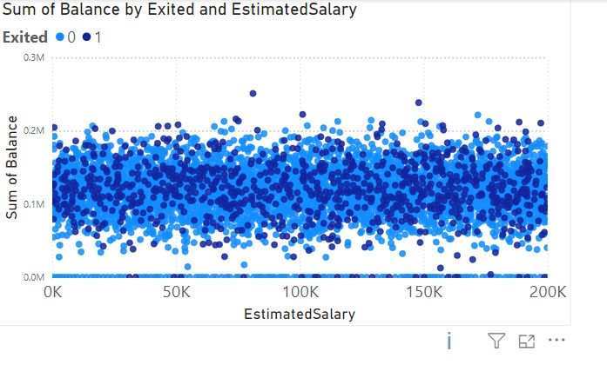

1. **Is there any correlation between the salary and the Credit score of customers?**

There does not appear to be a strong or clear correlation between Credit Score and Estimated Salary. The data points are widely and evenly spread across all ranges of both variables, indicating no evident linear relationship. Additionally, the exit status (Exited 0 or 1) is uniformly distributed across different credit scores and salary ranges. This suggests that neither credit score nor estimated salary alone significantly predicts customer exit behaviour. Despite some variation, the graph does not visually present any clear pattern or correlation between these two variables and customer churn.

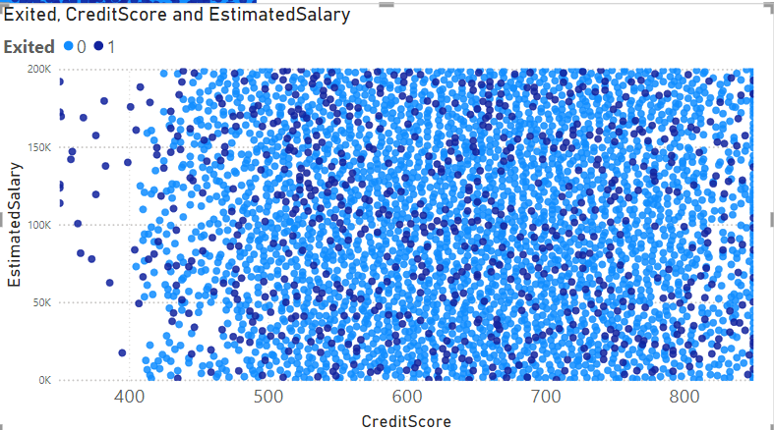

1. **Rank each bucket of credit score as per the number of customers who have churned the bank.**

The below chart provides the distribution of the customer base across different credit score segments.

Insights: On the basis of the graph the credit score segments are ranked by the count of customers as follows:

1. Good (6.8k customers)
2. Poor (1.4k customers)
3. Very Good (1.2k customers)
4. Excellent (0.7k customers)

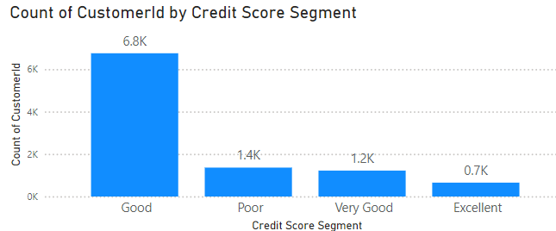

**Conclusion:** the majority of customers fall into the "Good" credit score segment, followed by "Poor," "Very Good," and then "Excellent." This chart represents churned customers, the ranking indicates the distribution of churn across these segments.

1. **According to the age buckets find the number of customers who have a credit card. Also retrieve those buckets that have lesser than average number of credit cards per bucket.**

The below query provides the numbers of customers who have a credit card based on the credit card. We first segregate the customers based on the age into age brackets and then find those buckets that have lesser than average number of credit cards per bucket.

**SQL Query:**

WITH creditinfo AS (

SELECT

CASE

WHEN age BETWEEN 18 AND 30 THEN 'Adult'

WHEN age BETWEEN 31 AND 50 THEN 'Middle-Aged'

ELSE 'Old-Aged'

END AS AgeBrackets,

COUNT(c.CustomerId) AS HasCrCard

FROM customerinfo c

JOIN bank_churn b ON c.CustomerId = b.CustomerId

WHERE b.HasCrcard = 1 -- Ensures filtering is done before counting

GROUP BY AgeBrackets

)

SELECT *

FROM creditinfo

WHERE HasCrCard < (

SELECT AVG(HasCrCard)

FROM creditinfo

);

**Output:**

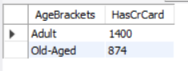

1. **Rank the Locations as per the number of people who have churned the bank and average balance of the customers.**

**SQL Query:**

SELECT

g.GeographyLocation,

COUNT(b.CustomerId) AS TotalExited,

round(AVG(b.Balance),2) AS avg_bal

FROM bank_churn b

JOIN customerinfo c ON b.CustomerId = c.CustomerId

JOIN geography g ON c.GeographyID = g.GeographyID

WHERE b.Exited = 1

GROUP BY g.GeographyLocation

ORDER BY COUNT(b.CustomerId) DESC;

**Output:**

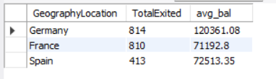

**Conclusion:**

* **Germany**: 814 customers exited, with an average balance of approximately 15,687,083.
* **France**: 810 customers exited, with an average balance of approximately 15,692,615.
* **Spain**: 413 customers exited, with an average balance of approximately 15,687,680.

1. **As we can see that the “CustomerInfo” table has the CustomerID and Surname, now if we have to join it with a table where the primary key is also a combination of CustomerID and Surname, come up with a column where the format is “CustomerID_Surname”.**

The column where the format is “CustomerID_Surname” can be created in POWER BI using the formula:

CustomerID_Surname = CustomerInfo[CustomerId]&” “&CustomerInfo[Surname]

Steps: In Table View -> Click on New Column -> Use the Formula.

By following the above steps you can create a new column in the prescribed fomat.

**Output:**

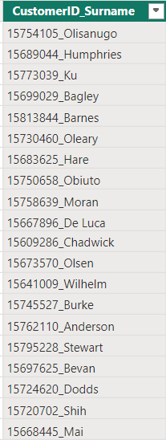

1. **Without using “Join”, can we get the “ExitCategory” from ExitCustomers table to Bank_Churn table? If yes do this using SQL.**

This code retrieves customer data from the Bank_Churn table and adds a new column named "ExitCategory" to classify customers as 'Retain' (not churned) or 'Exit' (churned) based on the value in the Exited column (likely 0 for non-churned, non-zero for churned).

**SQL Query:**

SELECT

CustomerId,

CreditScore,

Tenure,

Balance,

NumOfProducts,

HasCrCard,

IsActiveMember,

CASE

WHEN Exited = 0 THEN 'Retain'

ELSE 'Exit'

END AS ExitCategory

FROM bank_churn;

**Output:**

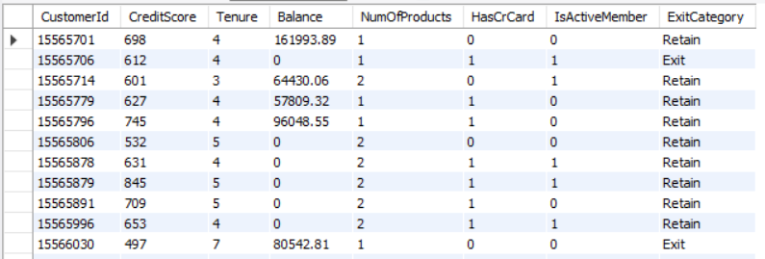

1. **Were there any missing values in the data, using which tool did you replace them and what are the ways to handle them?**

**No,** there weren’t any missing values in the data. This eliminates the need for imputation techniques that might introduce assumptions or biases.

If there were missing values in the data, I would use these techniques to handle them:

* **Deletion**: This involves removing rows or columns with missing values.
* **Imputing missing values**: Fill missing values using statistical methods like mean, median, or values from other related columns.
* **Replace Missing Values with a Default Value**

1. **Write the query to get the customer IDs, their last name, and whether they are active or not for the customers whose surname ends with “on”.**

**SQL Query:**

SELECT

c.CustomerId,

c.Surname,

CASE

WHEN b.IsActiveMember = 1 THEN 'Active'

ELSE 'Inactive'

END AS ActivityStatus

FROM customerinfo c

JOIN bank_churn b ON c.CustomerId = b.CustomerId

WHERE c.Surname LIKE '%on'

ORDER BY c.Surname;

**Output:**

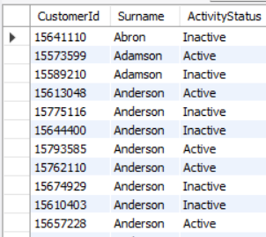

1. **Can you observe any data disrupency in the Customer’s data? As a hint it’s present in the IsActiveMember and Exited columns. One more point to consider is that the data in the Exited Column is absolutely correct and accurate.**

**SQL Query:**

SELECT *

FROM bank_churn b join customerinfo c on b.CustomerId = c.CustomerId

WHERE b.Exited =1 and b.IsActiveMember =1;

Yes, there are data discrepancy in the Customer’s data. When the customer is Active which mean the customer is still in the bank and hence the data in IsActiveMember column is 1. When the customer exits the bank, the Exited column is 1. But here there is data which represents both the customer Exited and also an active member at the same time. This is due to data discrepancy.

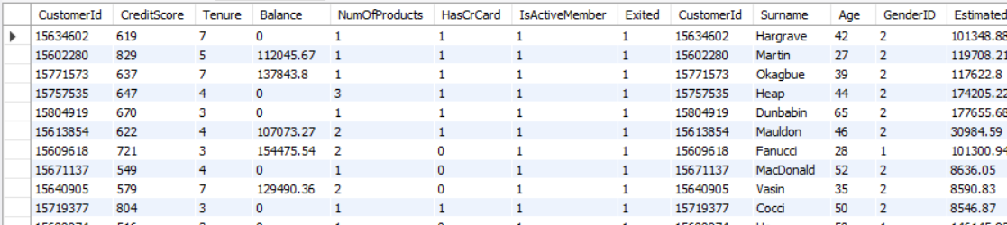

**Subjective Question:**

1. **Customer Behavior Analysis: What patterns can be observed in the spending habits of long-term customers compared to new customers, and what might these patterns suggest about customer loyalty?**

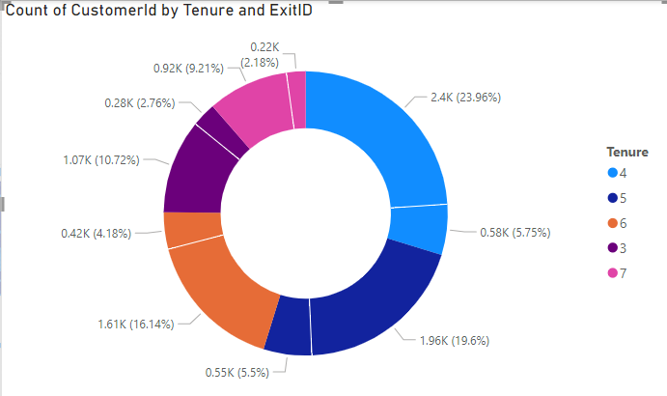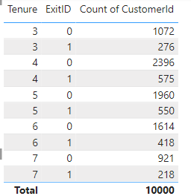

* The 4 years tenure customers have 5.75% of exit rate.
* The 5 years tenure customers have 5.5% of exit rate.
* The 6 years tenure customers have 4.18% of exit rate.
* The 3 years tenure customers have 2.76% of exit rate.
* The 7 years tenure customers have 2.18% of exit rate.

Means the oldest customers has more belief on bank.

1. **Product Affinity Study: Which bank products or services are most commonly used together, and how might this influence cross-selling strategies?**

**Answer:**

The data shows that customers with fewer products tend to have a lower churn rate compared to those who have purchased more products.

**Approach:**

Identify commonly paired products and services to uncover usage patterns, noting that fewer product holdings correlate with lower churn rates. Use these insights to refine cross-selling strategies to enhance customer retention.

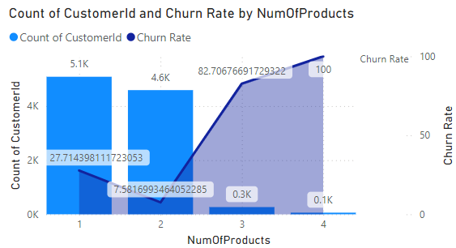

1. **Geographic Market Trends: How do economic indicators in different geographic regions correlate with the number of active accounts and customer churn rates?**

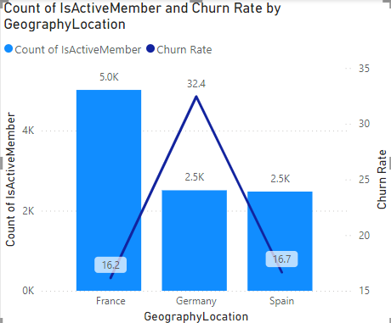

**Answer:**

From the above visual we can easily get to know that the France has high number of active members as compare to other two location but churn rate of Germany is high.

**Approach:**

Analyze economic indicators by region to correlate with active account numbers and churn rates, highlighting France's high membership and Germany's high churn. Utilize these findings to tailor regional strategies for retention and growth.

1. **Risk Management Assessment: Based on customer profiles, which demographic segments appear to pose the highest financial risk to the bank, and why?**

Firstly, the customer profiles can be divided into four different segments based on the salary they are Lower Middle Class, Poor, Rich and Upper Middle Class.

The charts provide the insights on the demographic segments with the most customers are those with lower credit scores.

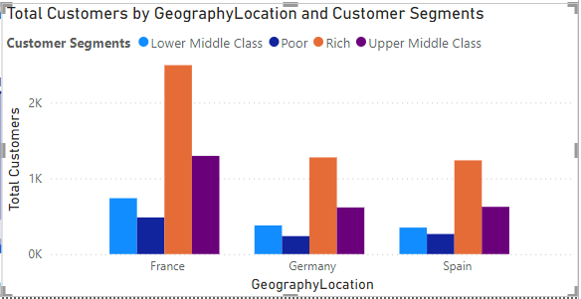

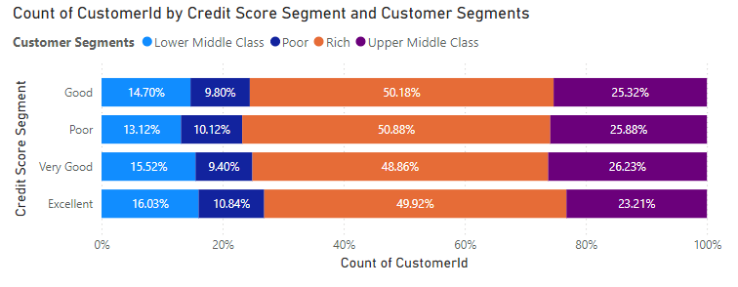

**Insights:**

* + France has the greatest number of Poor and Lower Middle-Class people followed by Germany and Spain.
  + These demographic segments also represent the largest portion of the bank's customer base. Based on the data in the chart, it's clear that these groups (“lower middle class” and “poor”) not only have the most customers but also present the highest potential financial risk to the bank.

**Conclusion:**

* + While creditworthiness is a key factor in assessing customer risk, other elements such as income and employment history should also be considered.
  + That said, creditworthiness remains a strong predictor of a customer's ability to repay loans.
  + Customers with lower credit scores are statistically more likely to default on loans compared to those with higher credit scores.
  + This suggests that the bank faces a greater financial risk when lending to customers in the "Lower Middle Class" and "Poor" segments, as these groups are more likely to result in loan defaults than customers in other segments.

1. **Customer Tenure Value Forecast: How would you use the available data to model and predict the lifetime (tenure) value in the bank of different customer segments?**

The charts provide the insights on the demographic segments with the most customers are those with lower credit scores.

**Insights:**

Balance Segments: Customers with higher average balances tend to have a longer tenure with the bank. This may be due to their higher level of investment in the bank’s products and services or the bank’s efforts to offer better benefits to retain them.

* + High Salary & Balance Greater than 2 Lakh: This segment has the longest average tenure, at approximately 5.4 years.
  + Zero Balance: Customers with zero balance have the shortest average tenure, around 4.2 years across all salary segments.

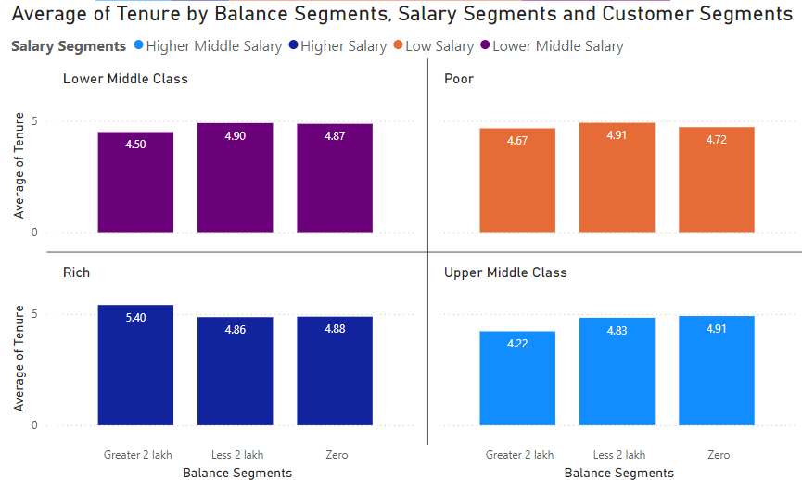

Salary Segments:There is a weak correlation between salary and tenure. On average, customers in higher salary segments have slightly longer tenures, but the difference is not significant across most segments.

* + High Salary: Customers in this segment are likely to have an average tenure of 4.8 to 5.4 years.
  + Low Salary & Lower Middle Class: Expected tenure for this segment is around 4.5 to 4.9 years.
  + Upper Middle Class & Rich: Average tenure in this segment is likely to be between 4.8 and 4.9 years.

**Conclusion:**

* + Balance segments play a more critical role in predicting customer tenure than salary segments.
  + Banks can use this insight to focus retention strategies on customers in higher balance segments, while also working to enhance customer satisfaction and product adoption across all segments to improve. overall tenure.

1. **Marketing Campaign Effectiveness: How could you assess the impact of marketing campaigns on customer retention and acquisition within the dataset? What extra information would you need to solve this?**

To evaluate how marketing campaigns affect customer retention and acquisition, we need to consider several key strategies and additional data points:

**Enhanced Customer Service:** Improve customer service by offering personalized assistance, resolving issues quickly, and addressing customer feedback efficiently.

**Targeted Offers:** The marketing team should create special offers and provide additional security features for customers over the age of 50, as well as offer incentives to customers who purchase multiple products. Special promotions for credit card holders should also be considered.

### Key Strategies:

**Customer Segmentation:** Group customers by age, location, and the number of products they use. This segmentation allows for a more focused analysis of how different campaigns perform within specific groups.

**Trend Analysis:** Study changes in active customer numbers, exit rates, and product usage over time. This helps identify trends that might be influenced by marketing efforts.

**Control Groups:** If possible, establish control groups that haven't been exposed to certain campaigns. Comparing these groups to those that have been exposed can help determine the true impact of the campaigns.

**Campaign Details & Timing:** Detailed information about campaign content, channels used (e.g., online, offline), and launch dates. This data is essential for linking campaign exposure to changes in customer behavior.

**Customer Acquisition Channel:** Information on how customers were originally acquired (e.g., referral, online advertisement). This helps assess whether campaigns are effective in retaining customers acquired through different channels.

**Customer Lifetime Value (CLV):** Calculate the CLV to understand the long-term impact of marketing campaigns on customer retention and revenue.

1. **Customer Exit Reasons Exploration: Can you identify common characteristics or trends among customers who have exited that could explain their reasons for leaving?**

To find the common characteristics or trends among customers who have exited that could explain their reasons for leaving we can use the below chart analysis.

**Insights:**

* Credit card ownership: The idea here is that customers who have credit cards are more likely to churn than those who don't.
* Number of products purchased: Customers who buy fewer products from the bank are more likely to churn than those who buy more products.

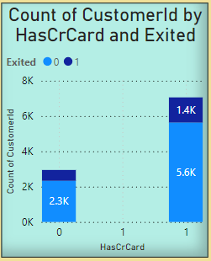

**Conclusion:**

**The main reasons for exit are:**

* Credit Card Ownership: The chart displays the number of customers who exited the bank (churned) categorized by whether they own a credit card (HasCrCard) or not. According to the chart, a significantly higher number of customers with credit cards exited (around 1,200) compared to those without credit cards (around 300).
* Less Products Purchased: The number of customers who exited the bank is highest for those who purchased no products (around 800), and the number of exits decreases as the number of products purchased increases. Customers who purchased four or more products have the lowest exit rate (approximately 60). This suggests that customers who engage more with the bank by purchasing multiple products are less likely to churn.

1. **Are 'Tenure', 'NumOfProducts', 'IsActiveMember', and 'EstimatedSalary' important for predicting if a customer will leave the bank?**

Analysis of Factors for Predicting Customer Churn:

The aim is to determine whether tenure, number of products held, active membership status, and estimated salary can predict whether a customer will leave the bank. The analysis is based on four charts that visualize these factors for both customers who exited and those who remained.

Insights on NumOfProducts:

* The chart compares the number of products customers hold (NumOfProducts) with the likelihood of exiting or staying, represented by the count of customer IDs.

Observations:

* There is no consistent pattern between the number of products a customer holds and their likelihood of exiting.
* In some ranges, such as 1 product or 3 products, more customers exited than stayed.
* Conversely, for 2 products and 4 or more products, more customers stayed with the bank than those who exited.

Importance of NumOfProducts for Prediction:

* Based on this chart alone, it's hard to conclude that the number of products is a strong predictor of customer churn, as the trend fluctuates across product ranges.
* However, NumOfProducts could still play a role in conjunction with other factors:
  + Customer Needs: Customers who hold more products might have their needs more fully met, increasing satisfaction and reducing the likelihood of leaving.
  + Account Management: On the other hand, customers managing multiple products might feel overwhelmed, potentially leading to frustration and churn in some cases.

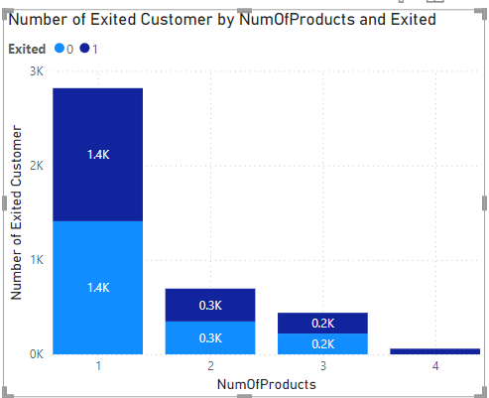 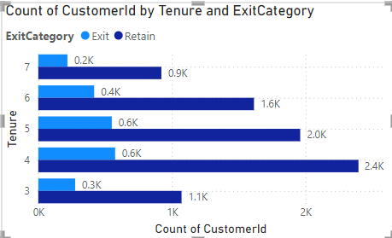

Comparison with Tenure:

While comparing the relationship with tenure of the customers and the exit rate of the customers we can find a key relationship that the customers who have a tenure of greater than or equal to four years are more likely to retain than others.

**Conclusion:**

While NumOfProducts by itself does not show a clear predictive trend for churn, it might be valuable when combined with other factors like tenure, IsActiveMember, and estimated salary. The interplay of these attributes could provide a more accurate prediction model for customer churn.

1. **Utilize SQL queries to segment customers based on demographics and account details.**

The customers are segmented mainly into three categories based on their estimated salary. They are Low, Medium and High segments. These segments are further divided in female and male customers based on their Geography.

**Query:**

SELECT

g.GeographyLocation,

CASE

WHEN EstimatedSalary < 50000 THEN 'Low'

WHEN EstimatedSalary < 100000 THEN 'Medium'

ELSE 'High'

END AS IncomeSegment,

CASE

WHEN c.GenderID = 1 THEN 'Male'

ELSE 'Female'

END AS Gender,

Age,

COUNT(c.CustomerId) AS NumberOfCustomers

FROM customerinfo c

JOIN geography g ON c.GeographyID = g.GeographyID

GROUP BY IncomeSegment, g.GeographyLocation, Gender, Age

ORDER BY g.GeographyLocation, Age;

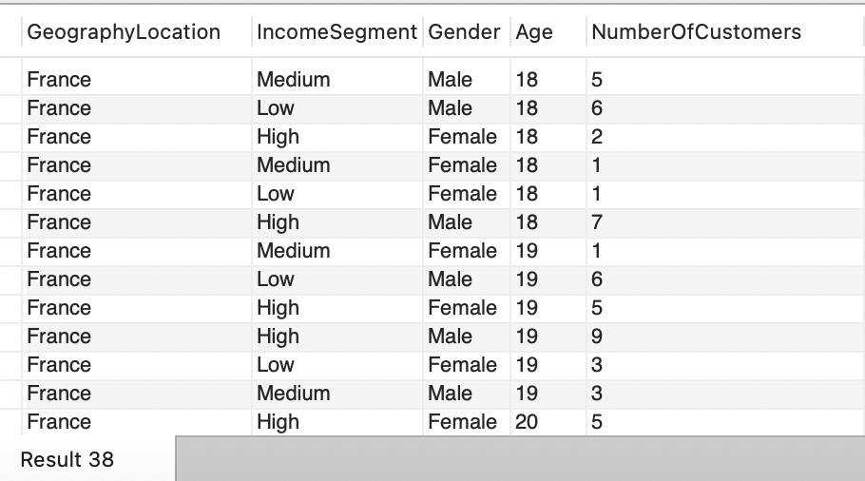

1. **How can we create a conditional formatting setup to visually highlight customers at risk of churn and to evaluate the impact of credit card rewards on customer retention?**

The chart, which appears to be filter window, we can create a conditional formatting setup to visually highlight customers at risk of churn and to evaluate the impact of credit card rewards on customer retention by following these steps:

1. Identify the churn criteria: Define the criteria to identify customers at risk of churn. This could be based on a combination of factors, such as:
   * Customers with a low number of products purchased (NumOfProducts)
   * Customer id
   * Customers Salary segments
   * Customer Segments
2. Conditional formatting based on churn criteria: Apply a conditional formatting rule to highlight cells that meet the churn criteria. You can format the cells with a different background color or font to make them visually distinct.
3. Filter by Credit Card ownership: Create a filter for the "HasCrCard" field. This will allow you to segment customers by whether they have a credit card or not.
4. Evaluate churn rate by Credit Card ownership: Analyze the churn rate (percentage of customers who exited) for customers with and without credit cards. You can calculate this by comparing the number of exited customers (where Exited = 1) to the total number of customers in each segment (HasCrCard = Yes or No).

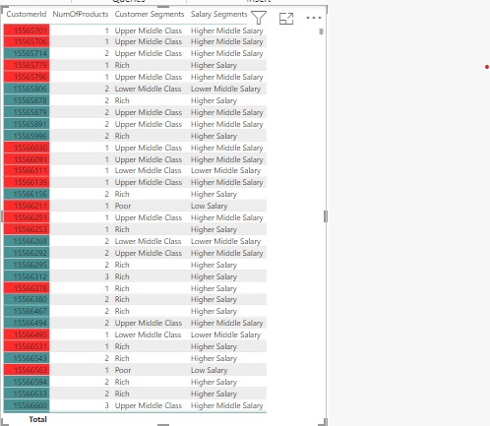

1. **What is the current churn rate per year and overall as well in the bank? Can you suggest some insights to the bank about which kind of customers are more likely to churn and what different strategies can be used to decrease the churn rate?**

**Customer Churn Analysis and Retention Strategies:**

**Churn Rate Overview:**

* The bank’s overall churn rate is **20.37%**, with year-on-year fluctuations:
  + **2016**: 19.27%
  + **2017**: 22.35% (highest)
  + **2018**: 20.21%
  + **2019**: 19.86% (lowest)
  + 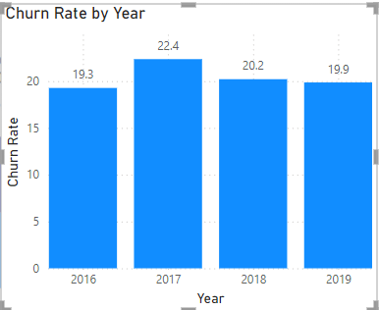

**Customer Segments Prone to Churn:**

Analysis reveals several customer segments with higher likelihoods of churn:

* **Single Product Users**: Customers using only one product may not see enough value in the bank's offerings, particularly when competitors provide broader or more integrated services.
* **Credit Card Holders**: Potential factors for credit card holders churning include:
  + Insufficient credit limits.
  + Lack of appealing rewards programs.
  + High fees associated with the card.
* **Tenure of 4-5 Years**: These customers might be coming off promotional offers or discounts, making them susceptible to competitors offering more attractive rates or features.
* **High Salary Customers**: High earners may have more financial options and are more likely to switch banks for slightly better benefits or interest rates elsewhere.

**Recommendations to Reduce Churn:**

* **Targeted Product Bundles**:
  + Develop tailored product bundles to address the specific needs of customers who use only one product. Highlight the added value and potential cost savings of using multiple services.
* **Enhanced Credit Card Rewards**:
  + Improve the credit card offering by:
    - Increasing credit limits based on customer behavior and creditworthiness.
    - Aligning rewards programs with customer preferences (e.g., travel, cashback for certain categories).
    - Reducing or eliminating annual fees, especially for high-value customers.
* **Retention Offers for Existing Customers**:
  + For customers nearing the end of their introductory offers, proactively offer personalized retention deals, such as:
    - Extending the promotional rates.
    - Providing discounts on other products or services.
* **Customer Satisfaction Surveys**:
  + Regularly survey customers to gather insights into why they leave. Use this feedback to fine-tune retention strategies and address customer pain points.
* **Relationship Management for High-Value Customers**:
  + Assign dedicated relationship managers to high-value customers, offering them personalized services and exclusive benefits to strengthen loyalty and meet their individual needs.

By focusing on these strategies, the bank can reduce churn, retain high-value customers, and increase overall customer satisfaction.

1. **Create a dashboard incorporating all the KPIs and visualization-related metrics. Use a slicer in order to assist in selection in the dashboard.**

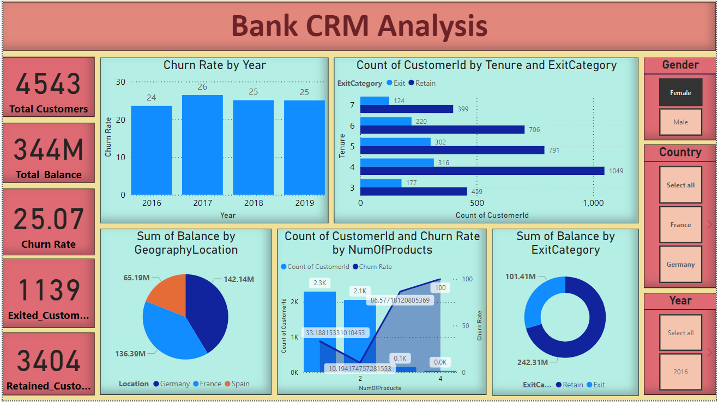

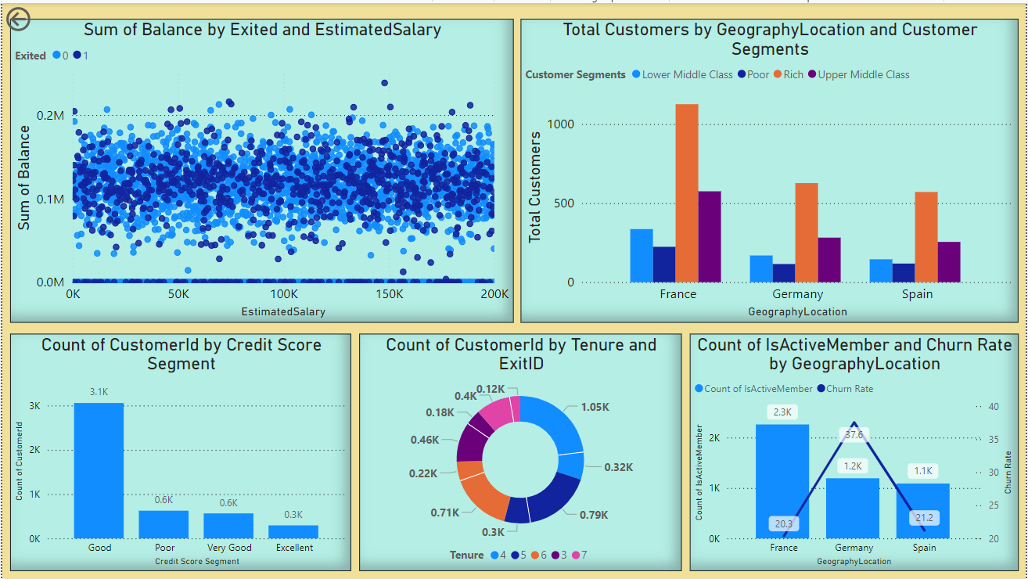

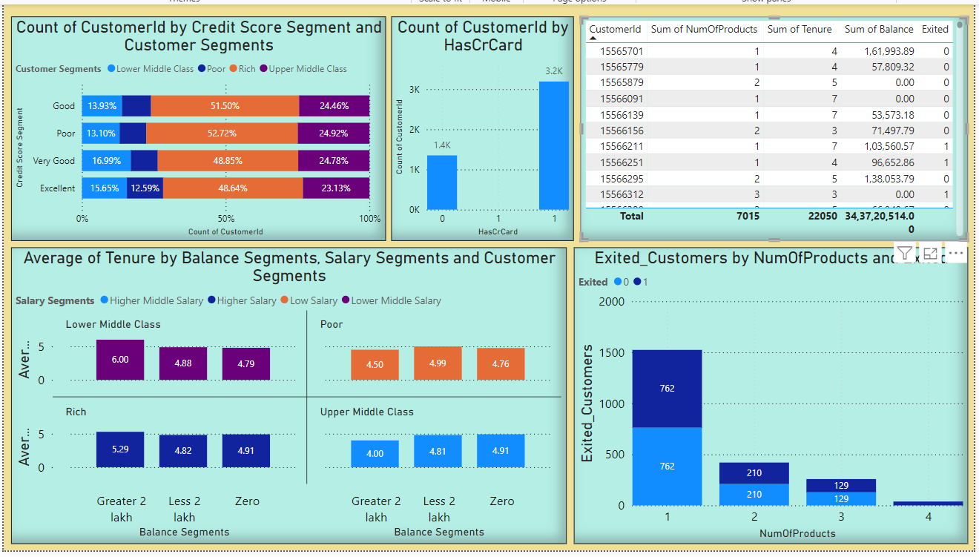

1. **How would you approach this problem, if the objective and subjective questions weren't given?**

Contextual Understanding: Start by thoroughly comprehending the context and aim of the data analysis. Engage with stakeholders or review project materials to uncover any implicit goals or expectations.

Data Exploration: Perform exploratory data analysis to become familiar with the dataset. Analyze its structure, distributions, and variable relationships, noting any patterns, anomalies, or trends.

Insight Identification: Brainstorm potential insights or hypotheses based on your initial data exploration. Consider both quantitative trends and qualitative factors relevant to the problem domain.

Hypothesis Generation: Develop hypotheses or conjectures from your preliminary observations. Use these as guiding principles for further analysis and testing.

Iterative Analysis Process: Apply a variety of analytical methods iteratively to test and refine your hypotheses. This may involve statistical analysis, machine learning, or qualitative techniques, as well as experimenting with data using tools like Excel, PowerBI, and SQL.

Visualization and Communication: Use data visualization techniques to effectively present your findings. Visuals can reveal patterns, relationships, and insights to stakeholders in an understandable way.

Synthesis of Findings: Integrate your findings into coherent narratives or themes, providing a comprehensive understanding of the data. Identify overarching patterns or trends that span different aspects of the analysis.

Feedback and Validation: Validate your results through peer reviews, expert opinions, or external comparisons if feasible. Seek stakeholder feedback to ensure your analysis aligns with their expectations and enhances their understanding of the problem.

1. **In the “Bank_Churn” table how can you modify the name of the “HasCrCard” column to “Has_creditcard”?**

This SQL query changes the name of the “HasCrCard” column to “Has_creditcard” in the Bank_churn table. It is a more descriptive name which provides more clarity.

ALTER TABLE bank_churns

RENAME COLUMN HasCrCards TO Has_creditcard;

SELECT * FROM bank_churn

**Output:** The output shows that the column name “HasCrCard” had been change to “Has_creditcard**”.**

