**Zomato Data Analysis For Global Restaurant Expansion**



**Objective Questions :**

1. What is the total no. of tables present in the data?
   * Our dataset comprises two main tables: the "Raw Data" table, which contains detailed information about each restaurant, and the "Country Description" table, which provides a brief overview of the countries listed in our dataset.
2. What is the total no. of attributes present in the data?
   * In total, there are 20 attributes or columns in the "Raw Data" table and 2 in the "Country Description" table. These attributes provide a range of information, from restaurant names and locations to pricing and customer feedback.
   * **Approach :**I have used excel formula =COUNTA and selected the range of header cells of the table to get the number.
3. How many categorical columns are there in the data? [Search about categorical and continuous data, and try to answer this question]

* There are 11 categorical columns in the table which is in the raw data.

**Approach :**I counted categorical columns manually.

1. The data consists of some inconsistent and missing values so ensure that the data used for further analysis is cleaned.

* It is vital to ensure that our data is clean before conducting any analysis. I checked for duplicate entries in the "Raw Data" using the “Remove Duplicates” feature in Excel and found none, ensuring all data points are unique. However, there were 9 missing values in the dataset. There are some fields in “average cost of two cuisines” column are 0.

**Approach :** Using Excel's special blank selection feature (Ctrl+G -> Special -> Blanks), I filled in missing entries with "North Indian" in the "Cuisine" column to maintain consistency. For fields with 0 value I replace those fields with 500 which is mode of that column. Then I sort the data by Restaurant ID with Smallest to largest. I apply filter to all the data for further processing.

1. Using the LookUp functions, fill up the countries in the original data using the country code.

* Created new column “country” to fill the countries from “country description” sheet.

**Approach :** I used the **Vlookup** function to extract the country =**VLOOKUP(C4,'countrydescription'!$A$2:$B$16,2,0)**

1. Create a table to represent the number of restaurants opened in each country.

**Approach :** We have created a new sheet named pivot table and then added a pivot table to it. We have given the whole raw data as its range and added the Country column as its rows and selected Count of Restaurants ID as its values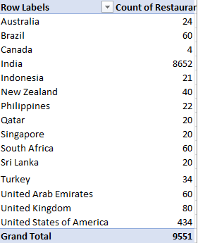

1. Also, the management wants to look at the number of restaurants opened each year, so provide them with something here.

* In the raw data sheet, date is not present in proper format so I have to first convert that date in proper format.

**Approah :** For this first to separate Year from “Datekey_Opening “ column, I click on text to column🡪 select delimiter as _ then it will saperate date month and year to different column . Then I created pivot table in which year drag in row label and restaurant Id in value field.

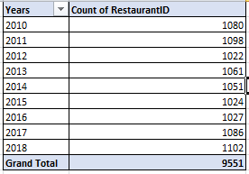

1. What is the total number of restaurants in India in the price range of 4?

* There are total **388** restaurant in India in the price range of 4.

**Approach :** I have used conditional filtering where in rating column I select 4 and in country column I select India.

1. What is the average number of voters for the restaurants in each country according to the data?

**Approach :**For this I have used the pivot table in that I include Countries in rows and votes in values and I select average to calculate the the average of voters in value field.

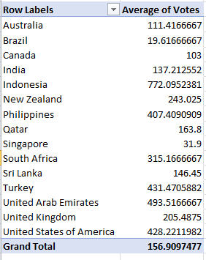

1. Calculate the average rating for all the restaurants that have price_range < 4 and provide online delivery. Use only the “IF” function, Logical Operators, and Aggregation functions to solve this problem. **[Note: Don’t use Conditional aggregation in this question.]**

* I got average rating as **2.89126**,

**Approach :** I have used the formula:

**=AVERAGE(IF(('RawData'!R2:R9552<4)*('RawData'!O2:O9552="Yes"),'Raw Data'!U2:U9552))**

1. Using Conditional formatting highlight the rows of restaurants that are located in the countries or cities that you’ve suggested to the management for opening new restaurants.

**Approach :** I have analysed the and taken insight from the pivot table sheet where I found countries which are Canada, Qatar, Singapore, Sri lanka are having least no. of restaurants and their currency exchange value is also decent which was analysed by currency exchange sheet.

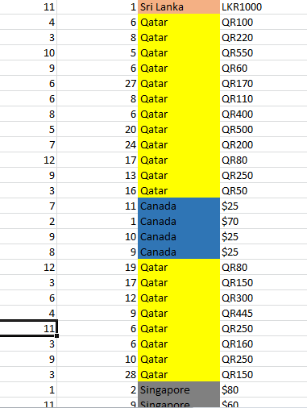

1. Create a new customized price column that consists of the abbreviation/symbol of the currency along with the Average_cost_for_two value. [Use string operations to do this task].

**Approach :** I use TRIM function along with MID and FIND function in the new column created named as customized price.

**Formula=TRIM(MID(K2,FIND("(",K2)+1,FIND(")",K2) - FIND("(",K2)-1))& R2**

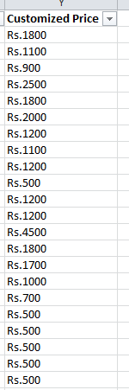

1. How can you create an array formula in Excel or Google Sheets to count the number of restaurants listed that do not offer online delivery, are in the lowest price range, and have an average cost for two people less than or equal to 250 Indian Rupees?

**Approach :** After using the array formula with a combination of SUM and IF conditions we got **1676** numbers of restaurants which has average cost for 2 people less than or equal to Rs.250 and didn’t offers online delivery and has lowest price range.

**=SUMPRODUCT(('Raw Data'!M2:M9552="No")*('Raw Data'!P2:P9552=1)*('Raw Data'!Z2:Z9552<=250))**

**Subjective Question:**

1. Suggest a few countries where the team can open newer restaurants with lesser competition. Which visualization/technique will you use here to justify the suggestions?

**Approach : Most suitable countries (cities) for opening new restaurants** based on criteria where total number of restaurants are less than 200, average ratings are higher than or equals to 3, with less than Rs 1600 average expenditure for two person to have a meal and number of voters higher than 150, are :

* Canada, Quatar, Sigapore, Shri Lanka, Indonesia, So management can open new restaurant in those countries.
* I used Chart visualization technique to justify the suggetions.

**Insights :** These countries are characterized by moderate competition and a positive customer satisfaction landscape. They provide Zomato with the potential to enter and quickly establish a presence, leveraging local preferences and trends. By focusing on these countries, Zomato can balance risk and reward.

**Recommendation :** Detailed market research is necessary to understand local dining trends, customer behavior, and potential challenges.

1. Come up with the names of States and cities in the suggested countries suitable for opening restaurants.

**Approach :** For this I create the pivot table in which I Include Country and cities in rows and restaurant Id and rating in values field. On the basis of no of restaurant id and average of rating I have come with some state where management can open new restaurant which are :

* Canada – Vineland Station, Chatham-kent
* Quatar – Doha
* Singapore – Bandung, Tangeranga
* Shri-Lanka
* Indonedia

**Insights:** The chosen locations generally have fewer restaurants, suggesting less market saturation. This presents a significant opportunity for Zomato to enter these markets with less competition, high average ratings indicate satisfied customers who are likely to appreciate new dining options.

**Recommendation :** While the pivot table analysis provides a good starting point, further research into local consumer behavior, competitive landscape is recommended to fine-tune the restaurant offerings and marketing strategies for each location.

* Pivot table for this is given in next answer.

1. According to the countries you suggested, what is the current quality regarding ratings for restaurants that are open there?

**Approach :** For this I have insert the pivot table In which add average of rating in value fields

* Countries that I suggested for opening new restaurant have the average rating of :

Canada – 3.5

Quatar – 4.06

Singapore – 3.5

Shri-Lanka – 3.8

Indonedia – 4.2

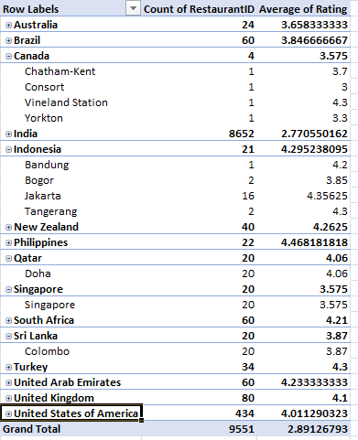

**Insights:**

**Growth Potential in developing markets:**

**Canada (3.5) and Singapore (3.5) and SriLanka(3.8)** : With an average rating of 3.5, 3.8, Canada, Singapore and Sri Lanka shows a good level of customer satisfaction. This suggests that while the market is developing, there is a positive perception of dining experiences among customers. Zomato could leverage this by opening restaurants that enhance the dining experience further, focusing on both local tastes and innovative concepts to appeal to both locals and tourists.

**Qatar (4.06) and Indonesia (4.2):** The high average ratings in Qatar and Indonesia indicate that customers in these markets are generally very satisfied with their dining experiences. Zomato, this suggests an opportunity to introduce high-quality or niche restaurants that meet the current standards.

**Recommendation :** Focus on Differentiation and Quality Improvement, Introduce Value-Added Dining Experiences, Develop targeted marketing campaigns that highlight the unique aspects of Zomato’s new restaurants, emphasizing quality, experience, and differentiation to attract a broad customer base.

1. Also, what is the current expenditure on food in the suggested countries, so we can keep our financial expenditure in control?

**Approach :** I have added new column to the raw data which cost in indian currency, in which I have converted all different countries currency into indian currecy. The calculation of expenditures in Indian Rupees helps in standardizing costs across different countries, making it easier to compare. However, it’s important to monitor currency fluctuations, as they can impact profitability and cost management in international operations.

* I Used pivot table in which insert countries in row field and sum of cost in Indian currency in value field.
* Canada = 8861

Indonesia = 30942

Quatar = 103150

Singapore = 197053

Sri Lanka = 13199

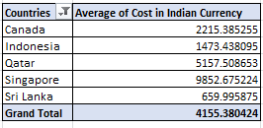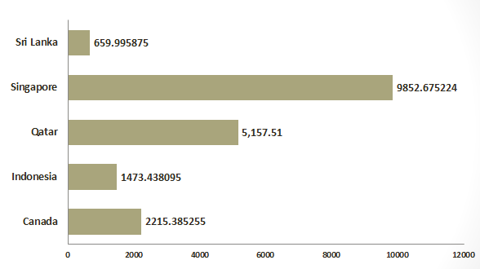

* **Insights :** • **High Expenditure Markets (Singapore and Qatar):** These markets may cater to a more affluent customer base or have a stronger demand for luxury dining. Restaurants in these locations may need to maintain high standards of quality and service to meet customer expectations.
* **Moderate to Low Expenditure Markets (Indonesia, Sri Lanka, and Canada):** These markets might be more suitable for mid-range or budget-friendly dining options, appealing to a broader customer base that seeks value for money.

**Recommendation:**

• **High-Cost Markets:** In countries like Singapore and Qatar, consider offering a mix of premium and mid-tier restaurant options. This approach allows to cater to different customer segment revenue while keeping costs manageable. Focus on high-margin items or experiences that justify higher price points.

• **Moderate to Low-Cost Markets:** In countries like Indonesia, Sri Lanka, and Canada, focus on optimizing menu offerings to ensure they provide value for money. Consider introducing budget-friendly or casual dining options that attract a larger volume of customers.

1. Come up with the names of restaurants from the recommended states that are our biggest competitors and also those that are rated in the lower brackets, i.e. 1-2 or 2-3.

**Approach:** For this I have used pivot table and in which I insert countries and restaurant name in row labe and average of rating & sum of votes in value field. I apply this criteria to find out the biggest competitor :

* + - 1. Restaurant rating>=4
      2. Number of Voters >150
* This are biggest competitor restaurant having rating greater than 4 and votes greater than 150 :

**Insight:**

|  |  |  |  |
| --- | --- | --- | --- |
| Country | Restaurant Name | Average of Rating | Sum of Votes |
| Canada | Lake House Restaurant | 4.3 | 204 |
| Indonesia | Talaga Sampireun  Toodz House  Lemongrass  Skye | 4.9  4.6  4  4.1 | 5514  1476  1498  1159 |
| Singapore | Fratini La Trattoria  Cut By Wolfgana Puck | 4.1  4 | 35  33 |
| Sri Lanka | Ministry of Crab  Arabian Knights  The Commons  The Sizzle | 4.9  4.2  4  4.2 | 203  158  209  286 |
| Quatar | Mainland China Restaurant  Zaffran Dining Experinece  Gokul Gujrati Restaurant  Zaoq | 4.9  4.6  4.3  4.2 | 182  348  211  189 |

**Recommendation:**  Implement successful strategies observed in top competitors, such as high-quality ingredients, exceptional service, or unique dining experiences. Focus on Customer Feedback, Enhance Marketing and Visibility.

**Approach:** For this I have used pivot table in which data source is all raw data , in row field inserted Country and restaurant name, and in value field inserted rating and applied value filter to country column and select less than or equal to 3. And also selected country which I suggested for opening new restaurant such as Canada, quatar, Indonesia, sri Lanka, Singapore

**Insights:** For restaurant which have ratings in lower brackets.

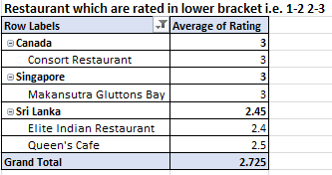

The analysis shows that in the recommended countries for expansion (Canada, Singapore, and Sri Lanka), there are already existing restaurants rated in the lower brackets (1-2 or 2-3 stars). For example:

* **Canada** has the restaurant *Consort Restaurant* with a rating of 3.
* **Singapore** has *Makansutra Gluttons Bay* rated 3.
* **Sri Lanka** has two restaurants with lower ratings:
  + *Elite Indian Restaurant* (2.4)
  + *Queen's Cafe* (2.5).

These low ratings indicate that certain restaurants in these regions struggle to meet customer expectations, which could be due to a variety of factors such as menu options, service, or price-value perception.

**Recommendations :**

• **Conduct Market Research**: Investigate the reasons behind the lower ratings in these regions, focusing on factors like service quality, customer preferences, and menu offerings to avoid repeating similar mistakes in new ventures.

• **Focus on Quality Improvement**: In the new restaurants, prioritize high-quality customer experiences by ensuring better service, menu variety, and price-value balance. Learn from competitors' weak points to improve.

1. Which cuisines should we focus on in the newer restaurants to get better feedback? Does the choice of cuisines affect the restaurant ratings?

**Approach:** I have used Pivot table in which I added cuisines in row label and rating in value field and then by right clicking on cuisines added filter to cuisines that “Top 10”

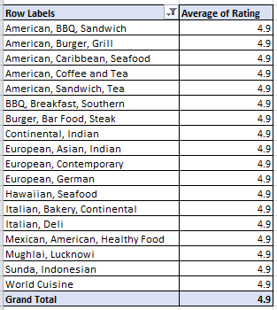

The analysis shows a strong correlation between certain popular cuisines and higher restaurant ratings. Focusing on these top-rated cuisines in new restaurants is likely to enhance customer satisfaction and overall feedback. The top cuisines, including Brazilian, Turkish, Filipino, and American, consistently receive higher ratings, indicating that customers in various regions highly appreciate these offerings. Additionally, cuisines like Café, European, and Continental also perform well across multiple countries, suggesting a broad appeal that can attract diverse customer bases.

By prioritizing these popular and highly-rated cuisines, Zomato can increase the likelihood of positive customer experiences, leading to better ratings and stronger brand loyalty in new markets. Balancing local favorites with globally popular dishes will be key to maximizing customer satisfaction and success in these new ventures.

**Recommendation:**

**Introduce Diverse Offerings**: In countries with moderate ratings, offer a mix of popular and high-quality cuisines to cater to diverse tastes and improve overall ratings.

**Adapt to Local Preferences**: Tailor restaurant concepts to local tastes and preferences, combining popular dishes with high ratings to maximize customer satisfaction and positive feedback.

1. According to our current data, should we go for online delivery and table booking? Does that affect the customer’s ratings?
   * + As per the data, the restaurants which provides online food delivery seems to have higher rating than table booking sevice.
     + Therefore, we can say that online delivery and table booking does affects the customer’s ratings.

**Approach:** I used pivot to analyse this, in pivot I insert has table booling in column field, has online delivery in row field and average of rating in value field. Further for visualisation I used chart visualisation technique.

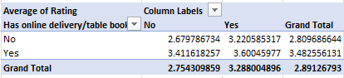

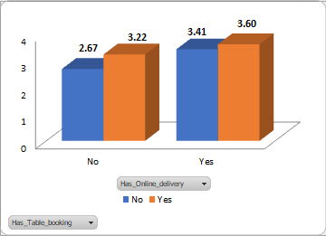

**Insights:** As per the above graph we can see the ratings that we are getting in the online food delivery service is higher than the rating in the table booking service. This suggests that these services positively influence customer satisfaction and contribute to better ratings.

**Recommendation:** Restaurants offering both online delivery and table booking generally show higher average ratings. This suggests that these services positively influence customer satisfaction and contribute to better ratings. Highlight the availability of online delivery in marketing efforts to attract more customers and drive sales.

1. Should the team keep the rate of cuisines higher? Will that affect the feedback? According to our data are the rates of cuisines and ratings, correlated?

**Approach:** I have used pivot table to show the relation if rate of cuisines and ratings are correlated or not.

* As shown in below chart rate of cuisines are increases as the ratings are increases so rating and rates are correlated with each other.

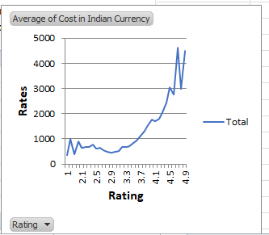

**Correlation :**

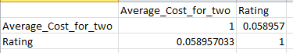

**Insights:** Higher rates might indicate a higher perceived value or better quality, which can positively affect ratings if customers feel they are getting good value for their money.

**Customer Expectations:** Pricing can also influence customer expectations. Higher prices may lead to higher expectations, and if those expectations are met or exceeded, it can result in better ratings.

**Recommendation:** Review feedback to see if higher prices are justified by the quality of food and service. If higher-priced cuisines receive better ratings, it may be beneficial to maintain or slightly increase prices to reflect the quality. Test different pricing strategies to see how changes impact customer ratings and feedback.

1. What is the distribution of the number of restaurants of different price ranges in all the countries?

**Approach:** For price distribution I created the pivot table wherein I drag countries in row, price range in columns field and restaurant id in value field.

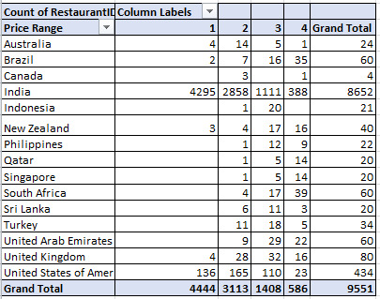

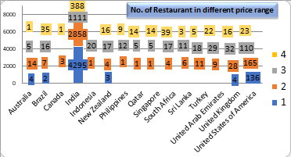

**Insights:**

• **India Dominates in Low-Price Range:** The vast majority of restaurants in the lowest price range (Price Range 1) are located in India, with 4,295 out of 4,444 restaurants. This suggests a strong market preference for budget-friendly dining options in India.

• **Mid-Range Popularity in Several Countries:** Countries like the United States, New Zealand, United Kingdom, and Turkey have a significant number of restaurants in mid-price ranges (Price Range 2 and 3), indicating a balanced demand for moderate-priced dining experiences.

• **High-End Dining Concentrated in Specific Countries:** High-price range restaurants (Price Range 4) are more concentrated in countries like Brazil, Qatar, Singapore, and the United Arab Emirates, reflecting a market that supports luxury dining experiences.

**Recommendation:**

Focus on countries with fewer restaurants in specific price ranges. For instance, in Canada and Sri Lanka, introducing mid to high-priced restaurants could tap into a less saturated market segment.

iven the dominance of low-price range restaurants in India, there could be opportunities to introduce more mid-range and premium options to cater to a wider audience, particularly in metropolitan areas.

1. Explain your approach in brief for suggesting countries/cities in order to open new restaurants.

**Approaches:**

**1. Market Research:**

- Analyze Zomato ratings, reviews, and popularity of restaurants in target countries.

- Identify top-performing cuisines, dishes, and price ranges.

**2. Competitor Analysis:**

- Study successful restaurants' menus, pricing, and marketing strategies.

- Identify gaps in the market and opportunities for differentiation.

**3. Customer Segmentation:**

- Analyze Zomato user demographics, preferences, and behavior.

- Identify target audience segments and tailor restaurant concepts accordingly.

**4. Location Analysis:**

- Evaluate city-wise demand, competition, and footfall using Zomato data.

- Identify prime locations for the new restaurant.

**Suggestions:**

**1. Cuisine:**

- Offer a unique fusion of local and international flavors.

- Cater to vegan, gluten-free, and other dietary preferences.

**2. Menu Engineering:**

- Optimize menu items, pricing, and portion sizes based on Zomato data.

- Offer signature dishes and limited-time offers to drive sales.

**3. Marketing Strategies:**

- Leverage social media, influencer partnerships, and loyalty programs.

- Offer online ordering, delivery, and takeaway options.

**4. Location-Specific:**

- Adapt restaurant concepts to suit local tastes, preferences, and regulations.

**Dashboard**

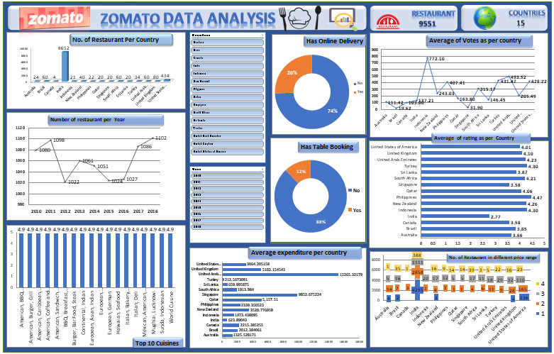

**Thank You**

**-Janhavi Santosh Devare**