**LINUX LAB 10**

1. Jahnavi vardhan

17MIS1061

# SL:

code:

sudo apt-get install sl sl

EXPLANATION:

sl is just a fun command when you install the package and execute sl in terminal a train like structure will move in your terminal.

OUTPUT:

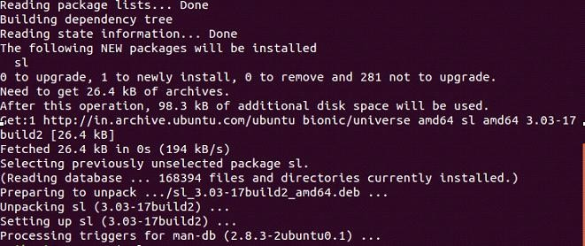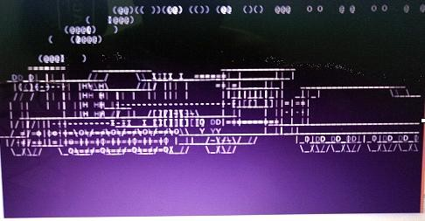

# SCRIPT1.SH

CODE:

rev

EXPLANATION:

the command “rev” is used to reverse the lines. Once it is executed it will prompt for you to enter any word and when you press enter the word will be reversed and displayed.

output:

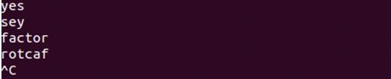

# Write a bash script to monitor health of the system.

Health.sh:

vmstat 1200 > vmstat1.data

filename= "/home/srihari/vmstat1.data" tail -f $filename |

while read $line do

if [ (cat vmstat1.data | grep "swap")>0 ] then

echo "some rogue process has consumed massive amounts of memory"> swap.txt fi

if [ (cat vmstat1.data | grep "r")>1 ] then

echo "some process are waiting to execute"> runqueue.txt fi

if [ (cat vmstat1.data | grep "cpu")>1000 ] then

echo "cpu usage is more"> cpu.txt fi

End EXPLANATION:

the vmstat 1200 – monitors every 24 hours and puts the data into the vmstat1.data

grep “swap”- the swap should always be zero if its not then some process has consumed massive memory. That will be monitored in this line

grep “r”- the running queue is constantly above process 1 it indicates the system is slow and some process is waiting to be executed. That will be monitored here.

Grep “cpu”- it indicates the cpu usage of the system. If the cpu usage is more it will be monitored and will alert in this line.

GITHUB LINK:

<https://github.com/Janhavivardhan/linuxlab>