AgroBot – Universal AI-Based Agricultural Assistant

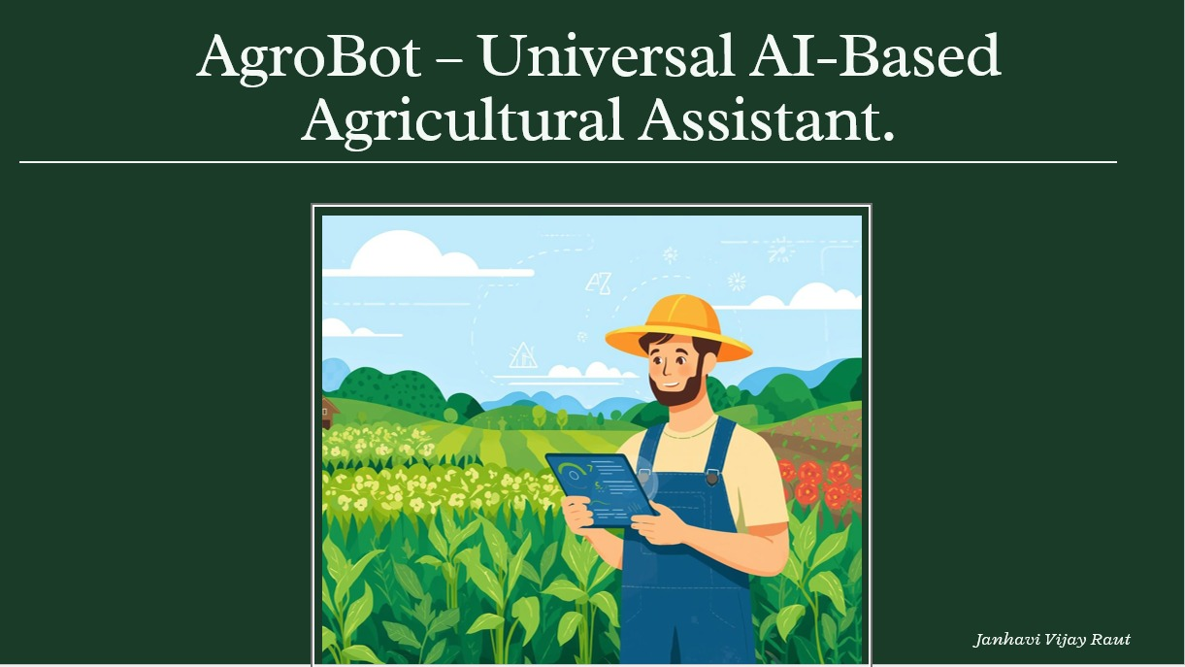

1.Project Statement
Farmers around the world face many challenges in accessing accurate and timely agricultural information. They often need guidance about crop diseases, pest control, fertilizers, irrigation methods, and modern farming techniques. However, most available solutions require digital literacy or are limited to a single language.
This project aims to develop AgroBot, an AI-based agricultural chatbot that provides instant and reliable farming advice. The chatbot uses Natural Language Processing (NLP) to understand farmers' questions and provide relevant responses.
The system supports multiple languages, making it easier for farmers to interact with the chatbot. By providing accurate agricultural guidance, the system helps farmers improve crop productivity, reduce costs, and adopt better farming practices.

2. Outcomes
The expected outcomes of the AgroBot system include:
- Providing easy access to agricultural knowledge through a chatbot interface.
- Supporting multiple languages such as English and Hindi for better accessibility.
- Helping farmers get information about:
    - Crop diseases
    - Pest management
    - Fertilizer usage
    - Farming techniques
- Reducing the information gap between farmers and agricultural experts.
- Improving decision-making and crop productivity.
- Creating a scalable knowledge base that can be expanded with more crops and regions in the future.
- Enabling secure user accounts for personalized interaction with the chatbot.

- Technologies Used
Frontend
- HTML
- CSS
- JavaScript
- Streamlit / Web Interface

Backend
- Python
- Flask Framework

Artificial Intelligence / NLP
- Natural Language Processing (NLP)
- Hugging Face Transformers
- Rasa NLU (for intent recognition)

Database
- SQLite / JSON based knowledge base
Tools & Platforms
- GitHub (Version Control)
- Docker (Containerization)
- Cloud Deployment Platforms
4. Modules to be Implemented
4.1 User Authentication and Profile Management
This module allows users to securely access the system.
Features:
- User registration using email and password.
- Secure login authentication using JWT tokens.
- Role-based access control (Farmer / Admin).
- User profile management.
- Farmers can store information such as:
- Preferred language
- Crops grown
- Location.
This information helps the chatbot provide personalized agricultural recommendations.

4.2 Conversational AI Core (Chatbot Engine)
This is the main component of the system that enables interaction between the farmer and the chatbot.
Features:
- Natural Language Understanding (NLU) to interpret farmer queries.
- Intent recognition to understand the user’s question.
- Dialogue management to maintain conversation flow.
- Natural Language Generation (NLG) to produce meaningful responses.
- Multi-language input and output support.
- The chatbot processes user queries and retrieves relevant information from the knowledge base.

4.3 Agricultural Knowledge Base
This module stores agricultural information used by the chatbot.
The database contains:
- Crop information
- Pest details
- Disease symptoms
- Treatment solutions
- Fertilizer recommendations
The chatbot retrieves data from this knowledge base to answer user queries. The knowledge base can be expanded with additional agricultural data in the future.

4.4 Admin Dashboard & Content Management
The admin dashboard allows administrators to manage and update the system.
Features:
- Add, update, or delete crop information.
- Manage pest and disease data.
- Monitor chatbot interactions.
- Manage user accounts.
- Analyze feedback provided by users.
This helps improve the chatbot's accuracy and performance over time.

5. Architecture Diagram (Explanation)
The AgroBot system follows a client-server architecture.
Components:
- User Interface
- Farmers interact with the chatbot through a web interface.
- Backend Server
- Handles user authentication.
- Processes chatbot requests.
- NLP Engine
- Interprets user queries.
- Detects intent and extracts entities.
- Knowledge Base
- Stores agricultural information.
- Admin Dashboard
- Allows administrators to update data and monitor system usage.

The user sends a query → chatbot processes it → NLP engine understands it → system retrieves data → response is sent back to the user

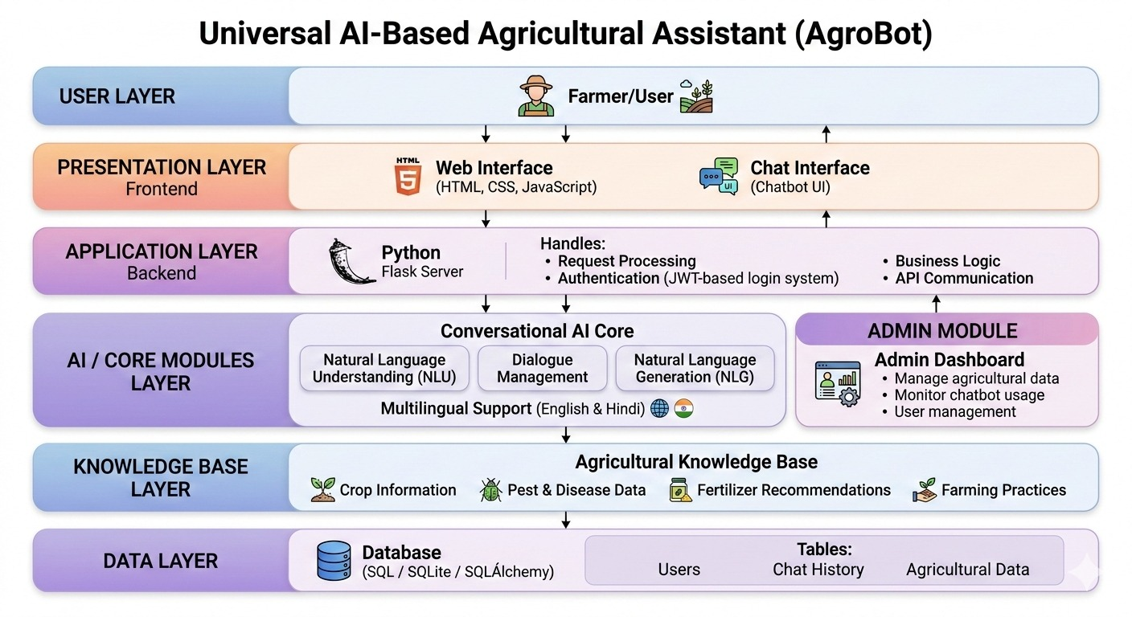
Architecture Diagram

6. Database Schema
The database stores information related to users, crops, diseases, and chatbot interactions.
Main Tables
1. Users
- user_id
- name
- email
- password
- role
- preferred_language
2. Crops
- crop_id
- crop_name
- description
3. Diseases
- disease_id
- disease_name
- symptoms
4. Chat History
- chat_id
- user_id
- user_query
- bot_response
- timestamp
This schema helps store agricultural data and user interactions efficiently.

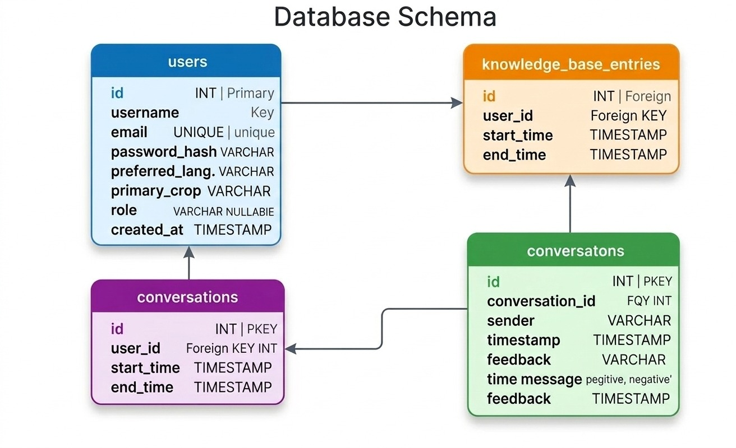
Database Schema

7.Future Enhancement
Although the AgroBot – Universal AI-Based Agricultural Assistant provides several useful features to assist farmers, there are many opportunities to further enhance the system. Future improvements can make the platform more powerful, accurate, and accessible to a larger number of users. Some of the potential future enhancements are described below.
Integration with Real-Time Weather APIs
Weather conditions play a crucial role in agricultural decision-making. In the current system, weather advice is provided based on stored agricultural data. In future versions, the system can be integrated with real-time weather APIs to provide accurate and up-to-date weather information.
Development of a Mobile Application
Currently, AgroBot is implemented as a web-based platform. In the future, a dedicated mobile application can be developed for Android and iOS devices.
Since many farmers rely on smartphones for digital services, a mobile application would significantly improve the accessibility and usability of the system.
Multi-Language Support
Agricultural users often come from diverse linguistic backgrounds. The current system primarily supports a single language interface. In future versions, the system can support multiple regional languages to make the platform accessible to a wider range of farmers.
Possible language support may include:
- Hindi
- Marathi
- Telugu
- Tamil
- Kannada
- Bengali
Multi-language support will ensure that farmers can easily interact with the system in their preferred language, improving usability and adoption.
Advanced AI Models for Crop Disease Detection
The image recognition module currently detects crop diseases based on an AI model. Future versions of AgroBot can incorporate more advanced machine learning and deep learning models to improve detection accuracy.
Integration with IoT-Based Smart Farming Systems
Another possible enhancement is the integration of Internet of Things (IoT) sensors with the AgroBot system.
IoT devices can collect real-time data from agricultural fields such as:
• Soil moisture levels
• Soil nutrients
• Temperature
• Humidity

Government Scheme Integration
Future versions of the system may also include information about government agricultural schemes and subsidies. This will allow farmers to easily access information related to financial support programs, crop insurance schemes, and agricultural subsidies provided by the government.

Conclusion
The AgroBot – Universal AI-Based Agricultural Assistant system provides an intelligent platform that helps farmers access agricultural information and expert guidance. The system integrates AI chatbot technology, image recognition, and a community platform to support farmers in solving agricultural problems.
By using modern web technologies and artificial intelligence, the system makes it easier for farmers to obtain information about crops, pests, fertilizers, and weather conditions. The community feature also encourages knowledge sharing among farmers.
Overall, AgroBot can significantly contribute to improving agricultural productivity and helping farmers make informed decisions. With further enhancements and real-world deployment, the system has the potential to become a powerful digital assistant for modern agriculture.

Sample Output
The AgroBot system was successfully implemented and tested. The system provides multiple functionalities that help farmers access agricultural information easily.
The main outputs of the system include:

- User Registration Page – Allows new users to create an account

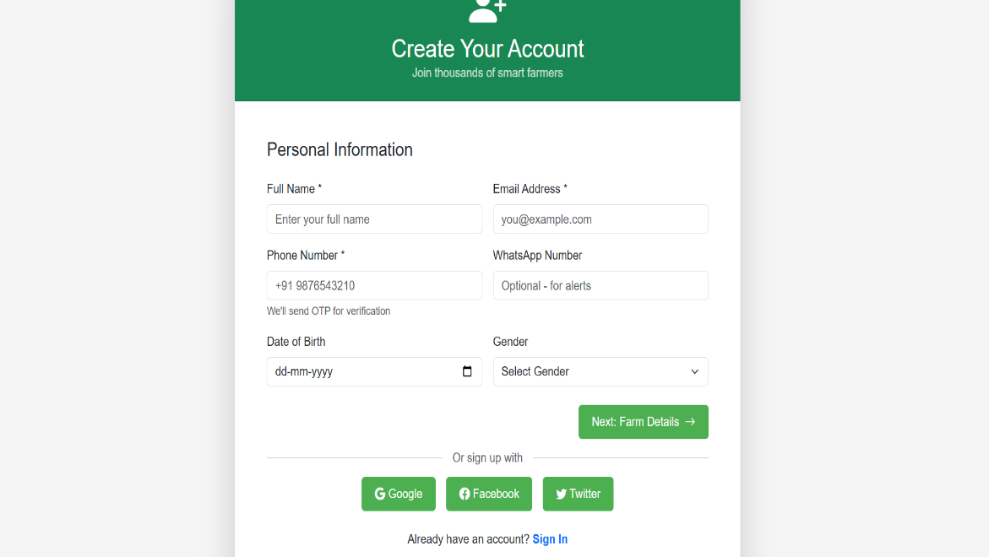

- Login Page – Enables users to securely log into the system.
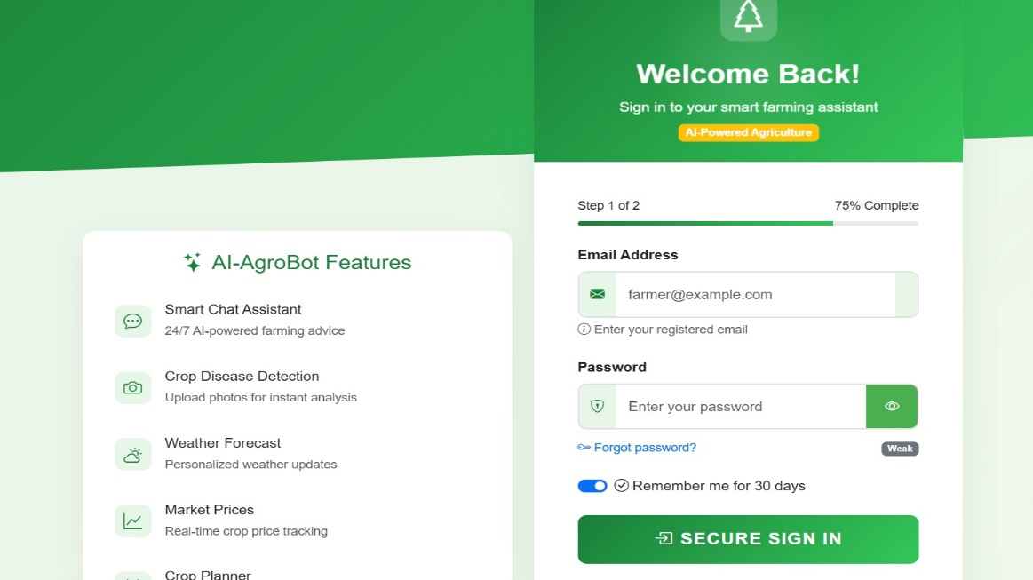

- Dashboard – Displays various features available in the system.
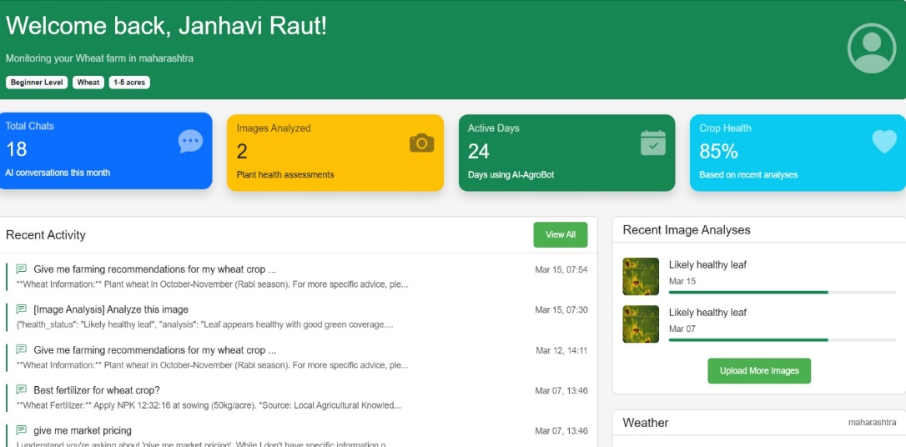

- AI Chatbot Interface – Allows users to ask agricultural questions.
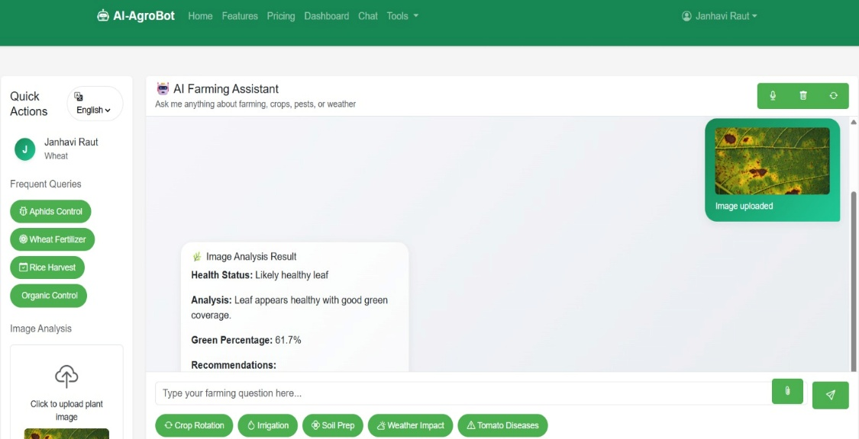

- Community Page – Enables farmers to share posts and interact with other users.
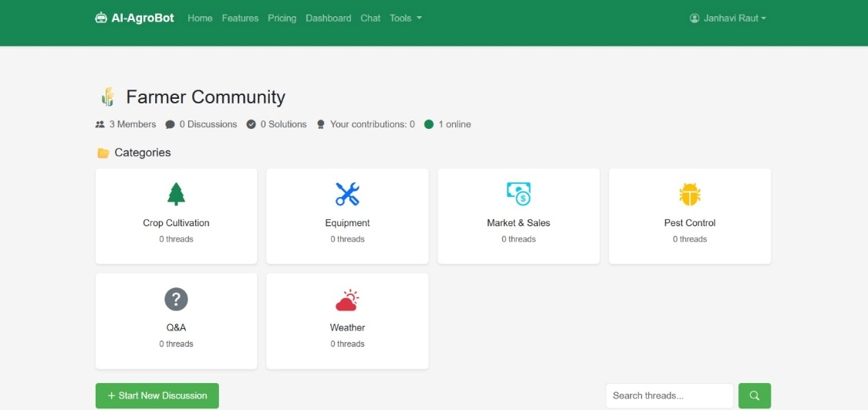

- Admin Dashboard – Allows administrators to monitor and manage the system.

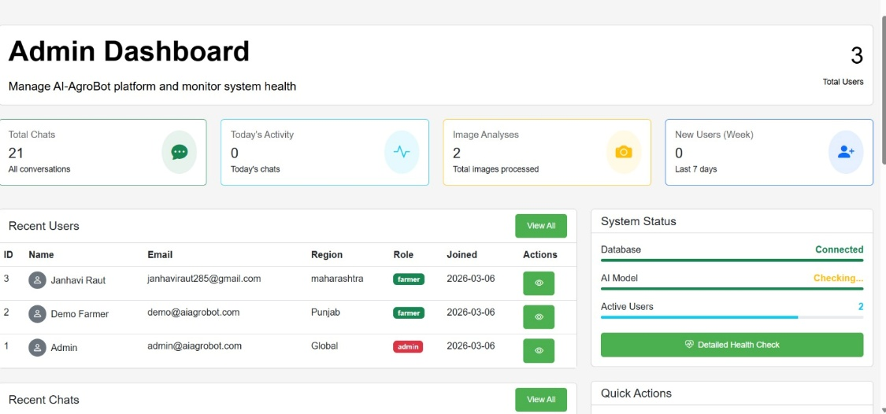
Screenshots of these pages are included in the documentation to demonstrate the functionality of the system.

