**PROJECT UNITY GAME**

PROJECT CLOSING REPORT VERSION 1.0

THE VERSION HISTORY OF THE DOCUMENT

|  |  |  |  |
| --- | --- | --- | --- |
| VERSION No. | DATE | REASON FOR CHANGE | AUTHOR/ACCEPTOR |
|  |  |  |  |
| 1.0 | 22.12.2018 | Finished | Aalto |
| 0.1 | 28.5.2015 | Initial version | MEST |

LIST OF CONTENTS

1 THE DESCRIPTION OF THE PROJECT 4

2 RESULTS OF THE PROJECT 4

3 GENERAL EVALUATION OF THE PROGRESSION OF THE PROJECT 5

4 THE EXPERIENCES OF THE USED TOOLS AND METHODS 5

5 PERSONAL EXPERIENCES AND LEARNING 6

6 SELF-EVALUATION OF THE STUDY MODULE 6

# THE DESCRIPTION OF THE PROJECT

The aim of this project was to produce a PC game with the Unity game development software, and to create a playable WebGL build.

Descriptions of the project phases and tasks can be found in the project plan (1) and on the project’s Trello page (2) respectively.

The main goals of the project were completed in the planned amount of time, although the game was left somewhat unfinished.

# RESULTS OF THE PROJECT

The finished game is a hybrid turn-based/real-time strategy game. It consists of a main menu with an options page and a level select view, and of the first level. The game’s WebGL build runs in a browser window.



The player’s objective is to place down military units in ambush locations along a road. When the game begins, an enemy column moves along the road towards a goal on the other side of the map. The player can order their units to open fire, at which point the enemies try to fight back and flee. The player is scored by how many enemy units they destroyed or let escape.

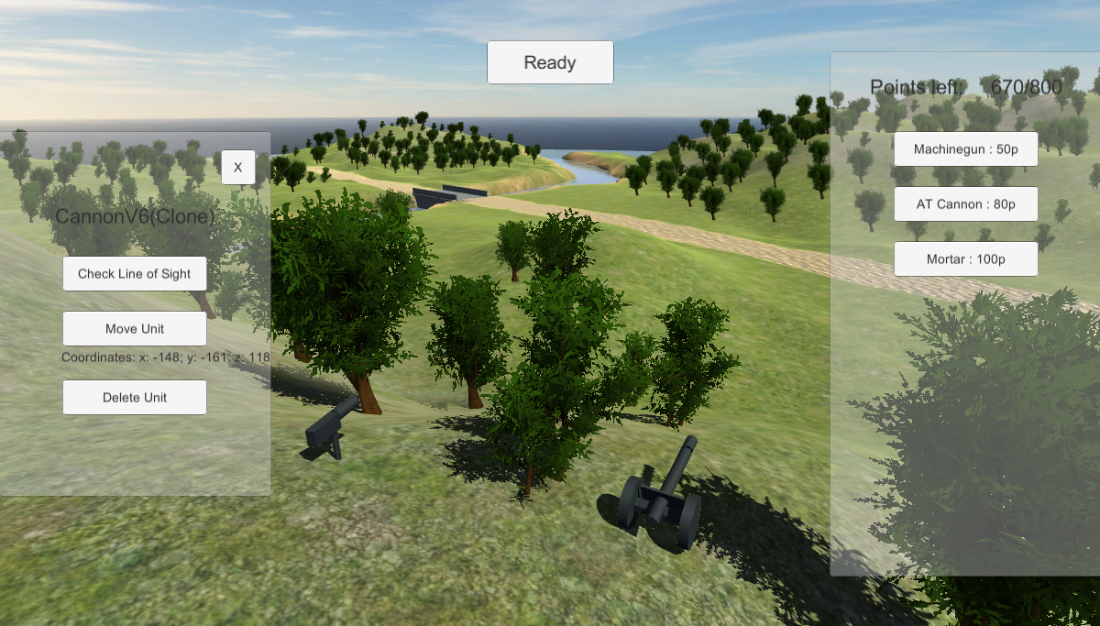

FIGURE 1. A view of the game’s first level

# GENERAL EVALUATION OF THE PROGRESSION OF THE PROJECT

A detailed description of the completed game features is on the project’s Trello page (2). The project progressed smoothly, although working from home I didn’t follow a specific daily schedule.

# THE EXPERIENCES OF THE USED TOOLS AND METHODS

The use of Unity was rather unproblematic, thanks to the very extensive online documentation and other help found online. The software is quite robust and complex and some time was spent learning its use, but my previous experience with it meant I didn’t really struggle with the software at any point and could mostly focus on developing game features. I used Unity’s proprietary MonoDevelop for writing the code, and it worked flawlessly even though some time ago I had had issues with it.

# PERSONAL EXPERIENCES AND LEARNING

I enjoyed the project and learned a considerable deal about game development, although I discovered my initial choice of game idea was slightly too technically complex and creatively bland, so I had to scale down some features in complexity and had weak motivation at times to work on the project. I now have a better understanding of the kinds of games I’d like to make and how much time game development takes.

# SELF-EVALUATION OF THE STUDY MODULE

All of the game’s main features were successfully completed on time, and the final project output includes all the necessary files and documents (this closing report being one day late). I’m not perfectly satisfied with the finished state of the game, but seeing how I completed the planned tasks successfully and overcame the difficulties encountered, the project was a success and I believe it deserves a grade of 4 or 5.

REFERENCES

1. Peliprojektisuunnitelma. 2018. Mallidokumentti. OAMK Informaatioteknologian osasto.
2. The project’s Trello page. https://trello.com/b/b4fIIkIL/unity-strategiapeliprojekti