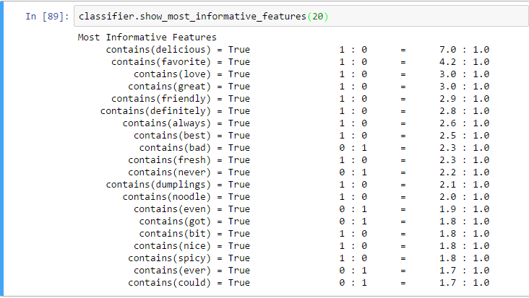



classifier.show_most_informative_features(20)

Most Informative Features

contains(delicious) = True 1 : 0 = 7.0 : 1.0

contains(favorite) = True 1 : 0 = 4.2 : 1.0

contains(love) = True 1 : 0 = 3.0 : 1.0

contains(great) = True 1 : 0 = 3.0 : 1.0

contains(friendly) = True 1 : 0 = 2.9 : 1.0

contains(definitely) = True 1 : 0 = 2.8 : 1.0

contains(always) = True 1 : 0 = 2.6 : 1.0

contains(best) = True 1 : 0 = 2.5 : 1.0

contains(bad) = True 0 : 1 = 2.3 : 1.0

contains(fresh) = True 1 : 0 = 2.3 : 1.0

contains(never) = True 0 : 1 = 2.2 : 1.0

contains(dumplings) = True 1 : 0 = 2.1 : 1.0

contains(noodle) = True 1 : 0 = 2.0 : 1.0

contains(even) = True 0 : 1 = 1.9 : 1.0

contains(got) = True 0 : 1 = 1.8 : 1.0

contains(bit) = True 1 : 0 = 1.8 : 1.0

contains(nice) = True 1 : 0 = 1.8 : 1.0

contains(spicy) = True 1 : 0 = 1.8 : 1.0

contains(ever) = True 0 : 1 = 1.7 : 1.0

contains(could) = True 0 : 1 = 1.7 : 1.0