ProjectDescription:

# Wireframe for static:

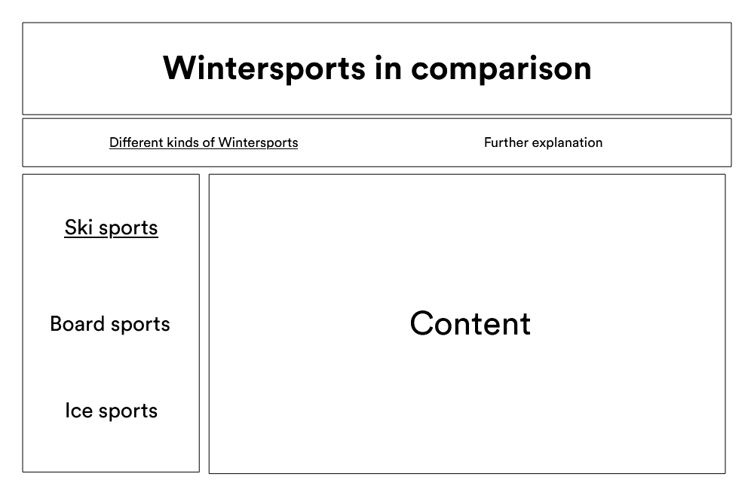

# Wireframe for webapplication:

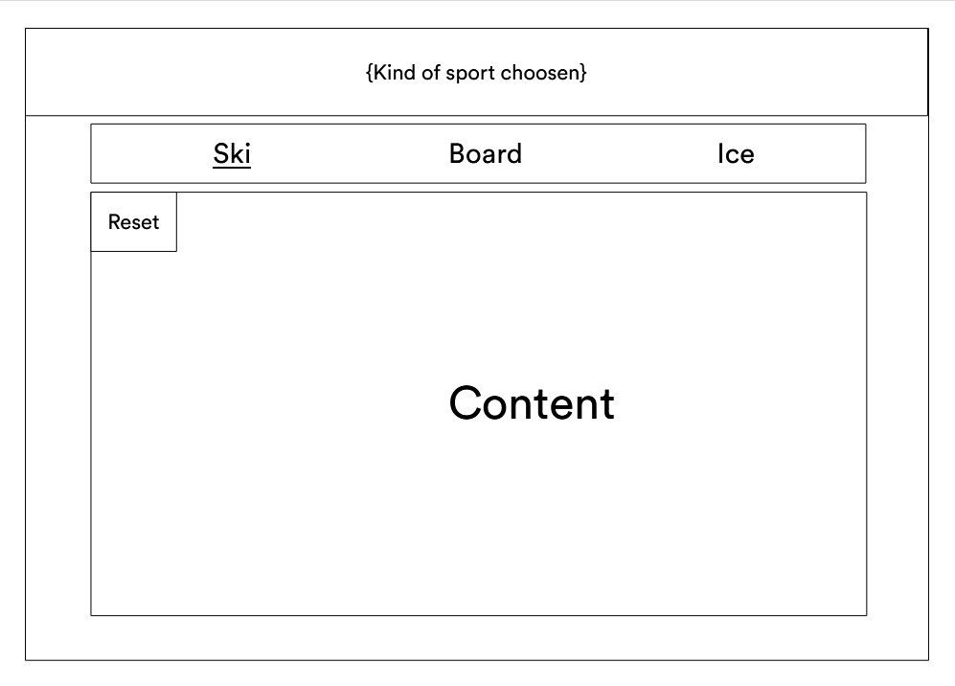

## Usage of webapplication:

In the web application part the user will be able to get their information in other ways than reading it. This could be minigames or a video player depending on the assessment of the developers.

# Timeline:

|  |  |
| --- | --- |
| 22.01.2021  Find a good template and edit it to our needs  (Machowetz&Gergar) | In time: true  Delayed: false  Not done: false |
| 04.02.2021  Find all needed information  (Gergar) | In time: false  Delayed: false  Not done: true |
| 07.02.2021  Implement all given information  (Machowetz) | In time: false  Delayed: false  Not done: true |
| 20.02.2021  Work on Webapplication  (Machowetz&Gergar) | In time: false  Delayed: false  Not done: true |