**Robotics project work**

2018 University of Eastern Finland

**Jani Heikkinen 266905**

**Juuso Hämäläinen 258961**

**Tomi Asikainen**

**Aleksanteri Kuitu 266936**

**Juho Rönkkö 259480**

**Lasse Soininen 269458**

**Juha Voutilainen 259035**

**Jyri Mäntylä**

**Miika Mäkinen 255263**

Sisältö

1 Introduction 3

2 Hardware components 3

2.1 Raspberry Pi 3

2.2 Arduino Uno 3

2.2.1 Arduino Uno components 3

3 Software components 5

3.1 Neural network 5

3.2 Main program 5

3.3 Arduino program 5

4 Conclusion/review tms. 5

5 References 6

Attachments

Attachment 1. XXXX

Attachment 2. XXXXX

# Introduction

The problem to solve is to build a robot that moves and scans surroundings autonomously so it can move around without hitting obstacles or walls. It also learns by using sensor data and neural network to optimize route choice and move around more smoothly. All of these functions must work without any user inputs or directions.

# Hardware components

## Raspberry Pi

The implemented neural network that gives the robot self-learning capabilities is too demanding for the Arduino Uno microcontroller so a Raspberry Pi 3 single-board computer is used to increase the computing capabilities of the robot. The Raspberry Pi 3 is connected to the Arduino Uno via bluetooth and that link is used for all of the communication between them.

## Arduino Uno

Arduino Uno microcontroller was used for the robot to act as the central hub for the connections between the required components and it also handles the basic functionalities of the robot (i.e. driving motors, sensing via ultrasonic sensors).

### Arduino Uno components

List of components:

* 2 x DC Motors
* Adafruit Motorshield v2.3
* HC-05 Bluetooth module
* 3 x HC-SR4 Ultrasonic sensors
* Breadboard
* Jumper cables
* Plastic building materials
* Battery pack containing 4xAAA batteries

All of the connections and signal processing are made via the Arduino Uno microcontroller. The Adafruit Motorshield is attached directly on top of the Arduino Uno and acts as an extension for the microcontroller. The robots two DC motors are connected to the motorshield ports M1 and M2 and the whole system is powered by a battery pack that is connected to the motorshield’s Vin and GND ports. The bluetooth module is connected to the motorshield/Uno digital ports 0 and 1 which represent the RX and TX pins. All of the ultrasonic sensors are connected to the remaining digital pins ranging from 2 to 7. The connections are handled through a small breadboard that is placed on top of the motorshield. More detailed description of the connections can be seen from the wiring diagram (Image 1) and images of the robot (Image 2 & 3).

The readings from the ultrasonic sensors are transmitted to a RaspberryPi computer via bluetooth. After the computer has accomplished the required calculations on what action to take it will send the instructions to the Arduino using the same bluetooth link.

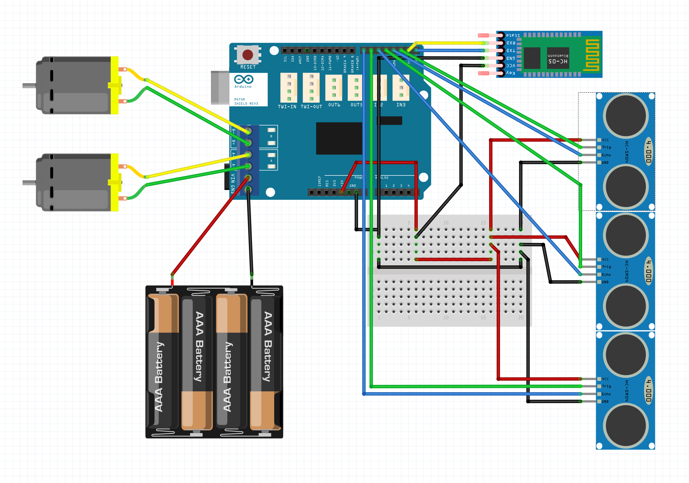

*Image 1: Wiring diagram*

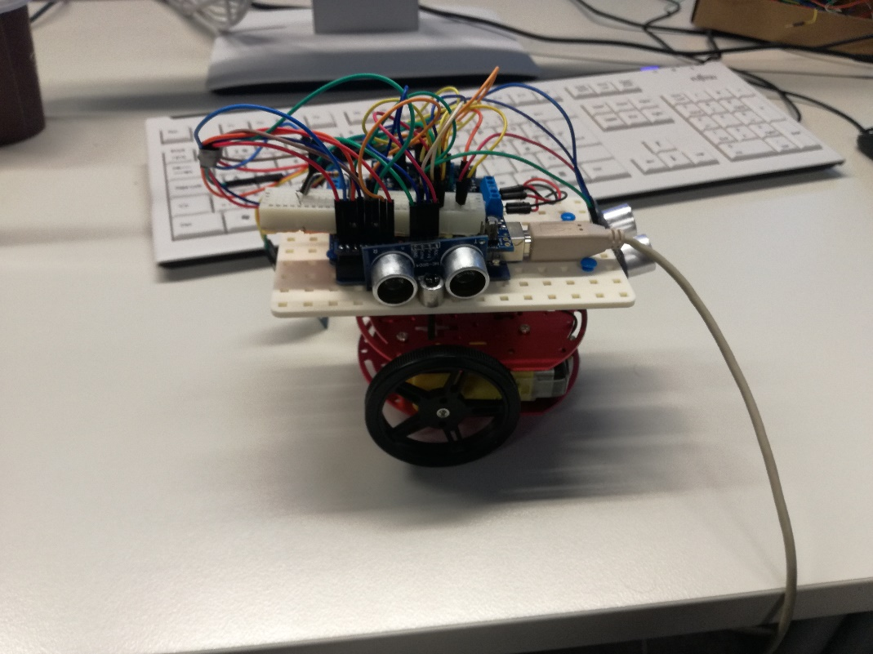

*Image 2: Side view*

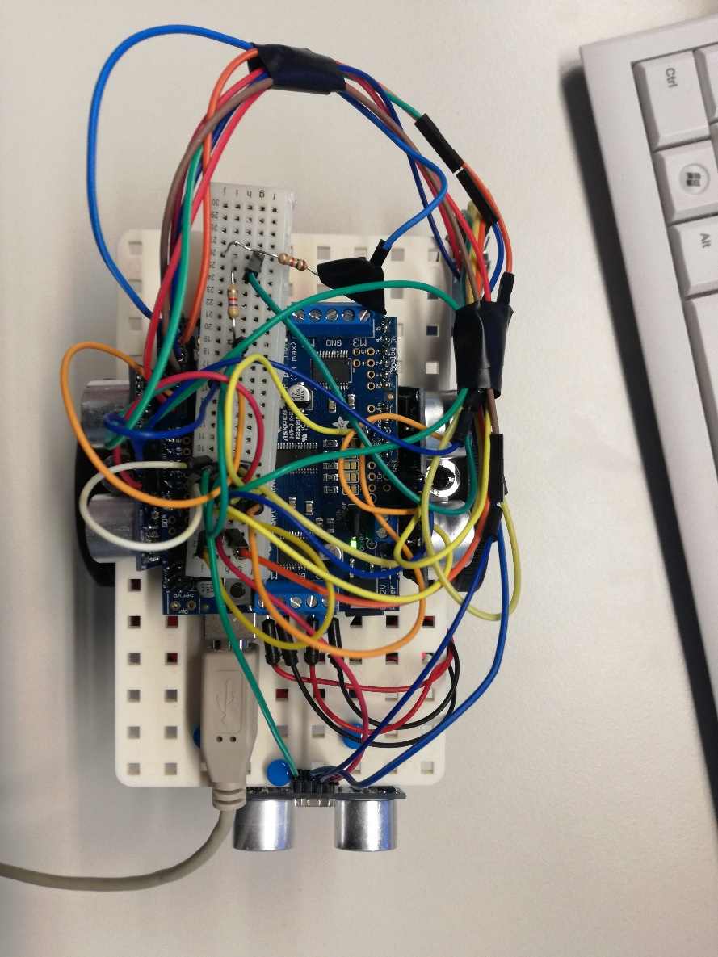

*Image 3: Top view*

# Software components

## Neural network

## Main program

## Arduino program

The Arduino program consists of the following functions:

* Movement (separate for each direction)
* Reading ultrasonic sensor values
* Bluetooth connection (receive and transmit)

The purpose of the Arduino code is to read, transmit, receive and act. It reads the values from the three ultrasonic sensors and records them as a “state”. It then transmits that information to the neural network code running in the Raspberry Pi 3 and receives instructions on how to act to that given state. That action consists of the available movement options (front, left, right, back).

# Conclusion and reflections

The project proceeded somewhat smoothly from beginning to end as we figured out our team composition and project goal. At first there were some complications as to the size of the group as initially we thought it would be groups of 4 but in reality, the final group size were all the master course enrollers which was 9. The work division was also efficient and the size of the team proved to be an advantage in a project of this scope.

# References