Eigenfaces – Paper Turk and Pentland, 1991

* Assume that most face images will lie on a low-dimensional subspace determined by the frist k (k<<<d0) directions of maximum variance
* Use PCA to determine the vectors or “Eigenfaces” u1,..,uk that span that subspace
* Represent all face images in the dataset as linear combinations of eigenfaces 🡪 This means it is a tremendous data reduction

Try do face recognition only on the cropped faces. They result in an Average Face / Mean Face.

* Interesting note: Average faces appear to be more beautiful then normal faces
* The Mean Face will be subtracted from all the faces and results into a set of “Eigenvectors”. They are tenthousnal vectors
* Overlay a real picture and sum them up with the Eigenface vectors by a dot product. So the higher the number, the

Reconstruction:

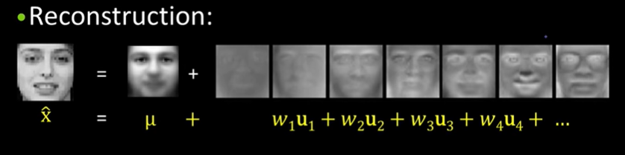

* If the average face is taken and add three times the Standard Deviation or subtract it kind changes the lighting direction from left to right. When a component is added the results look more feminine, when reduced it looks more male.