

INFORMATICS INSTITUTE OF TECHNOLOGY

In Collaboration with

UNIVERSITY OF WESTMINSTER

**Formal Methods – Coursework (2023/24)**

**Module leader Klaus Draeger**

|  |  |  |
| --- | --- | --- |
| Name | : | Janindu Chamodya Vitharana Pathirana |
| IIT ID | : | 2019592 |
| UOW ID | : | w1809774 |
| Date | : | 2023/12/25 |

# Structure Diagram of your Spaceship & Asteroids System B machine.

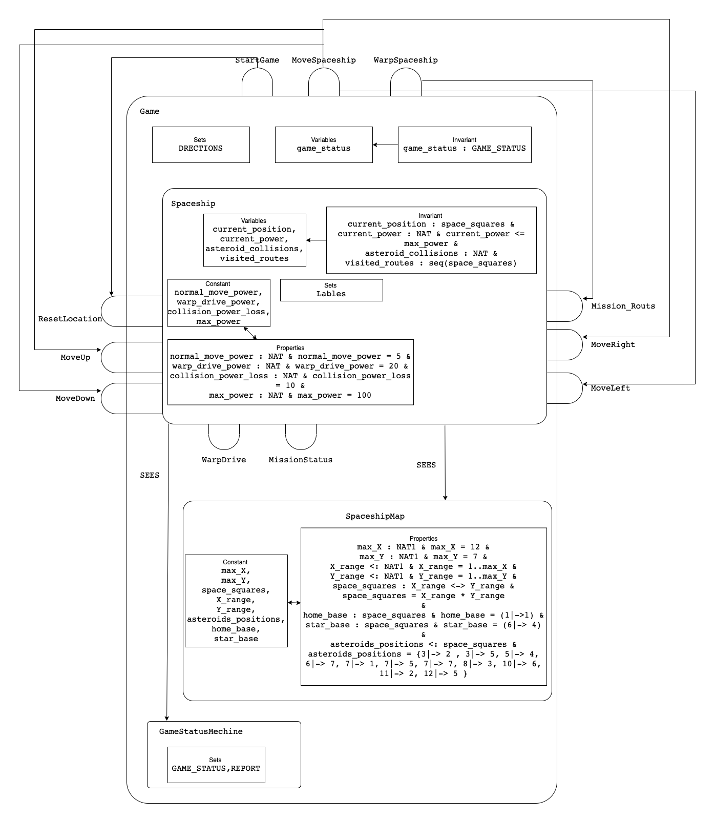

# State invariants description.

## Game Machine

* 1. **game_status : GAME_STATUS**: The variable **game_status** must always have a value from the set **GAME_STATUS**, which includes {WON, LOST, NOT_OVER}.

## Spaceship Machine

* 1. **current_position : space_squares**: The current position of the spaceship must always be within the set of **space_squares**.
  2. **current_power : NAT & current_power <= max_power**: The current power level of the spaceship must be a natural number (non-negative integer) and should not exceed the maximum power defined by **max_power**.
  3. **asteroid_collisions : NAT**: The number of asteroid collisions must be a natural number.
  4. **visited_routes : seq(space_squares)**: The sequence of visited routes must consist of elements from the set **space_squares**.

## SpaceshipMap Machine

* 1. **max_X : NAT1 & max_X = 12**: The maximum value for the X-coordinate must be a natural number greater than zero and equal to 12.
  2. **max_Y : NAT1 & max_Y = 7**: The maximum value for the Y-coordinate must be a natural number greater than zero and equal to 7.
  3. **X_range <: NAT1 & X_range = 1..max_X**: The X-coordinate range must be a subset of natural numbers up to **max_X** and is defined as 1 through **max_X**.
  4. **Y_range <: NAT1 & Y_range = 1..max_Y**: The Y-coordinate range must be a subset of natural numbers up to **max_Y** and is defined as 1 through **max_Y**.
  5. **space_squares : X_range <-> Y_range**: The set of **space_squares** must be a bijective relation between the X and Y coordinates within their respective ranges.
  6. **home_base : space_squares & home_base = (1|->1)**: The home base must be a valid element of **space_squares** and is specifically located at coordinates (1, 1).
  7. **star_base : space_squares & star_base = (6|-> 4)**: The star base must be a valid element of **space_squares** and is specifically located at coordinates (6, 4).
  8. **asteroids_positions <: space_squares**: The set of asteroid positions must be a subset of **space_squares**.