

[Berberi@email.cz](mailto:Berberi@email.cz)

<https://www.linkedin.com/in/janis-erion-berberi-128759b0/>

­­

Experienced Real Estate Expansion & Construction Senior with a demonstrated history of over 22 years in the retail industry in the CEE region. I have managed CE business and negotiation, opening or refit of over 150 retail stores in the CE region (CZ, SK, HU, RO, HR, BG, DE).

From January 2024 Area Expansion Manager CZ & SK Takko fashion, dealing with new expansion locations and extension of existing store contracts.

From February 2021, Retail Expansion & Construction Director at Sportisimo, leading sporting goods retailer in the CEE region. Managing the expansion strategy in the CEE region and the construction of all the stores opened and refitted.

Until 2020, General Manager of 18 NEXT PLC stores and business in the CE with around 250 staff members and annual revenues of over 25 Mio €.

Great advantage is my detailed knowledge of retail business, expansion and operation in the CEE region with individual countries specifics, mentality and culture in line with some very good personal relationship with the main landlords, of shopping centres and retail parks, in the CZ, SK and CEE region.

* Retail Real Estate Management
* Lease Contract Negotiations
* Team management
* Project management
* Retail Management
* Project Planning and Execution
* CAPEX & OPEX Management



* CZECH C2
* ENGLISH C1
* GERMAN B2
* GREEK B2
* ALBANIAN C1



**Area Expansion Manager CZ, SK, PL, LT, EE |** TAKKO | Prague

* Negotiation
* Leadership
* Communication
* Decision making
* Flexibility
* Time management
* Problem solving
* MS Office
* European driving licence

Jan. 2024– current

Reporting to Group Expansion Director, Direct Reports : 2

**Key responsibilities:**

* Dealing with LL on new retails spaces in CZ/SK/PL/LT/EE
* New location evaluation, negotiation, arrangements
* Managing the current store portfolio (225 stores)
* Contract negotiations, extensions, amendments, construction
* Expansion map, target locations, lease benchmarks



* Sports
* Football
* Skiiing
* Biking
* Mountain Hiking
* Reading
* Mediterranian Cuisine

**Retail Expansion & Construction Director | Sportisimo** | Prague

Reporting to CEO, Direct Reports : 4, Team of 20 (CZ, SK, RO, HU, HR)



* Creating store expansion strategy, model, target locations, country evaluations, expansion effectiveness plan

**Key responsibilities:**

Managing the retail store expansion & construction for the Area of Central Europe (CZ, SK, RO, HU, HR, BG).

Jan. 2021– Sep. 2023

+420 774 442 457

Berberi@email.cz



**Pavel Vajskebr**

**Co-Owner Former CEO**

**Sportisimo**

e-mail: [vajskebr@sportisimo.cz](mailto:vajskebr@sportisimo.cz)

**Tomáš Borek**

**CCO**

**Sportisimo**

e-mail: [tomas.borek@sportisimo.cz](mailto:tomas.borek@sportisimo.cz)

**Mila Hájek**

**Former Retail Director**

**Sportisimo**

e-mail: [mila.hajek@email.cz](mailto:mila.hajek@email.cz)

**Lukáš Jagnešak**

**Head of Category & Space Mngmt.**

**Sportisimo**

e-mail: [jagnesak@sportisimo.cz](mailto:jagnesak@sportisimo.cz)

@

* Entering new countries (HU, CR) while actively co-managing the
* timeline and processes
* Managing the expansion in the whole area CEE
* Contract negotiation, extension, renegotiations, databasing
* Portfolio Management
* Store construction planning, tendering, site management, design
* Documentation, permits, processes, timelines
* Technical design studies, layouts, logo signages
* Store equipment, security, timeline coordination among

departments

* Facility and energy management
* CAPEX and OPEX Budgeting, 20 Mio €

**Key Achievements:**

* Setting up Store expansion Model
* Setting up processes for new and extend lease contracts
* Store expansion strategy for whole area
* Setup of Location Scoring process
* Create Expansion target location
* Setup of expansion benchmarks per country
* Improving store open CAPEX by 20%
* Negotiating Opening of 50 new retail stores (lower rent or
* Contribution)
* designing, planning, tendering and construction of 150 stores
* reconstruction of 100 retail stores CZ, SK
* setting up international expansion and construction team
* entering new markets (HU, CRO, BG)
* tendering of main commodities (Lights, Flooring, HVAC, Contractors)
* saving over 30% of construction costs
* new store design layout - 10% space saving
* new facility strategy / 15% cost saving

­­



**MASTER OF BUSINESS ADMINISTRATION**

**UNIVERSITY OF TIRANA**

Faculty of Economics

Sep 1995 – Jun 1999

**GYMNASIUM GENERAL DEGREE**

**M. Collaku Gymnasium**

Pogradec, Albania

Sep 1990 – Jun 1995

-

Jan. 2017– Dec. 2020

Reporting to NEXT PLC, Direct Reports : 12, Team of 30 (CZ, SK, HU, DK, SE)

**CEE Area General Manager |** NEXT PLC, NEXT CZ **|** Prague

**Key responsibilities:**

* managing the 18 stores portfolio with annual turnover of 25 Mio € (day2day)
* direct managing a team of 30 people (18 store managers a 12 HO Prague)
* total employees, 250 in 5 countries
* P&L, NBC, Capex and KPI Management
* Store visits store standards management (weekly basis)
* overseeing all departments (Operations, Accounting, IT, Telco,
* Shopfitting, Security, local authorities)
* Expansion in the region, dealing with LL, Assets & facility
* management, contracting, communication with HO in UK

**Key Achievements:**

* Increasing local sales by 18%
* Lowering fluctuation rate by 25%
* Implementing new staff bonus scheme
* Lowering OPEX costs by 10%
* Set up of trial e-shop returns in store
* Improving inventory results by -1%
* Set up of new stock delivery system to improve efficacity
* Set up of store local hotline support
* Set up of new stock return policy



**LEADERSHIP MANAGEMENT**

**Sportisimo – 02.02.2023**

**Team management**

**Next CZ – 31.05.2018**

**FCMG Retail Management**

**Next PLC – 10.05.2017**

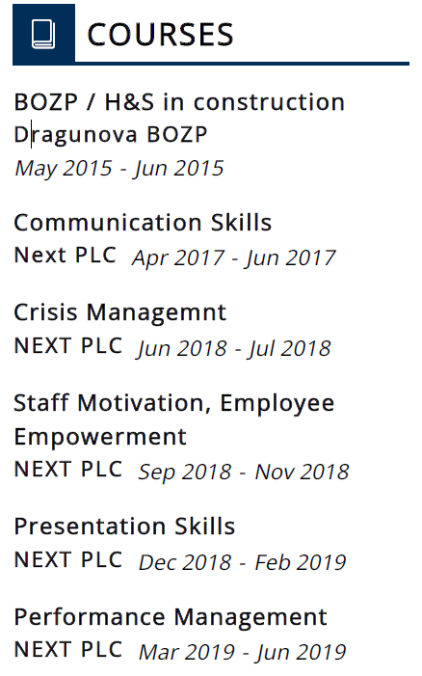

Reporting to NEXT PLC, Team of 3-5 (CZ, SK, HU, DK, SE)

Jun. 2001– Dec. 2016

**Expansion & Shopfitting Manager |** NEXT CZ **|** Prague

**Key responsibilities:**

* Expansion, Construction and / or refits of new and existing retail stores of NEXT, Mothercare, Accessorize
* Full Expansion of Next stores in the area of CEE, Entry to SK 2004, Entry to HU 2005, DE 2006, DK 2007 SE 2008
* Creating expansion model for next business outside UK
* Full project preparation and coordination with LLs
* Projects design with local architects and tenders
* Complete documentation for authorities approvals
* Managing the construction from H/O to opening
* Coordination local suppliers, equipment deliveries and installation,
* Low voltage and security installations, Signages
* CAPEX and OPEX budgeting

**Technical management and facility management for all stores and HO**

* Technical monitoring and facility reaction for all stores in the region including H & S, Security and operation 24/7
* ensuring periodical checks and revisions (electrics equipment, fire security
* technical prevention and trainings
* dealing with LL

**Assets management and inventorying**

* tendering on store equipment & fit-out components
* planning and coordination of new supplies and supplements
* regular inventorying and audit of equipment (local regulations)
* evidence & completion of documentation

**Other duties covered and coordinated in the region CEE**

**Security**

* tendering and installation of antitheft and alarm systems
* Loss prevention
* mandatory trainings / dealing with local authorities

**Health & Safety**

* prevention and checks on H & S regulations
* dealing with City Hall (local authorities)
* trainings & support

­­

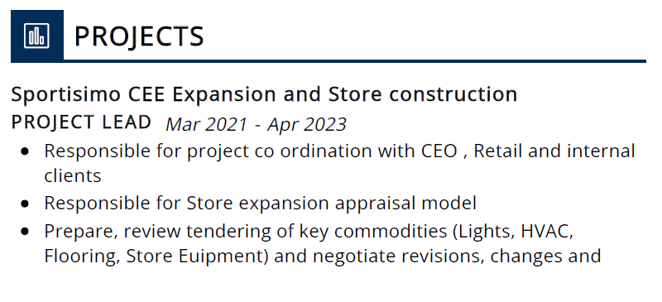

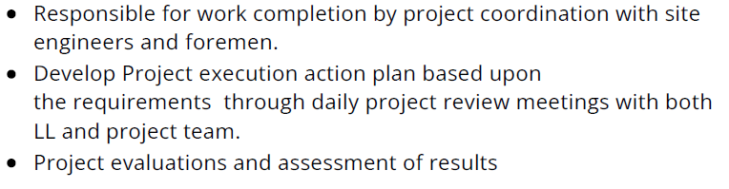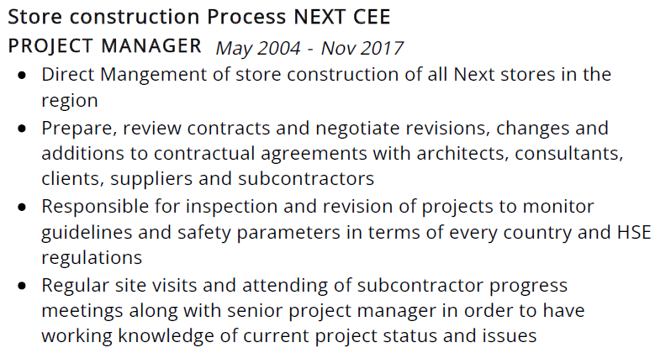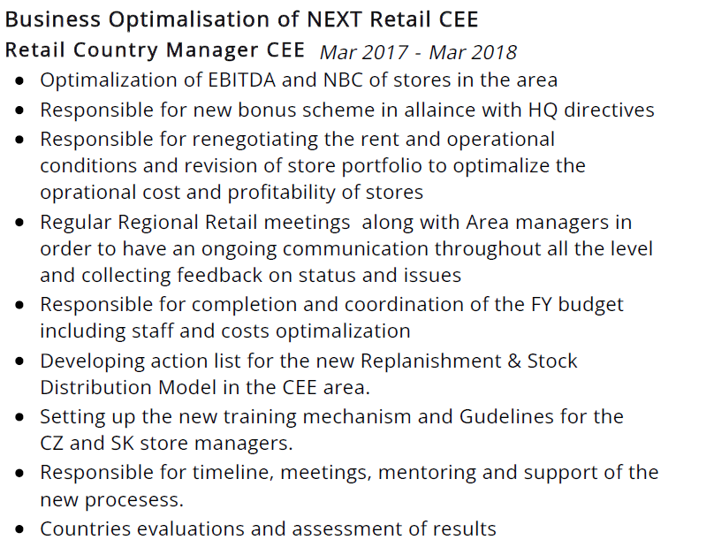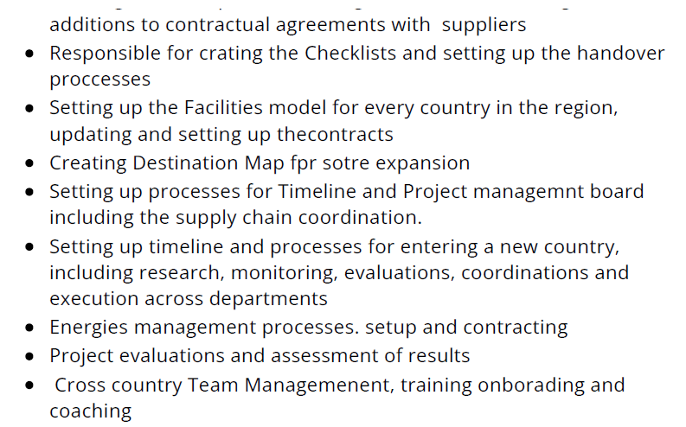

+420 774 442 457