Q_01

Code

package Q_01;  
import javax.swing.*;  
  
public class Question_01 {  
 public static void main(String[] args) {  
 JFrame frame = new JFrame();  
 frame.setTitle("Welcome to JAVA");  
 frame.setSize(800, 600);  
 frame.setVisible(true);  
 }  
}

Output

Q_02

Code

package Q_02;  
import javax.swing.*;  
  
public class Question_02 {  
 public static void main(String[] args) {  
  
 String Firstname=JOptionPane.*showInputDialog*("Enter your First Name");  
 String Lastname=JOptionPane.*showInputDialog*("Enter your Last Name");  
 String fullname=Firstname+" "+Lastname;  
 JFrame frame=new JFrame();  
 frame.setTitle(fullname);  
 frame.setSize(400,300);  
 frame.setVisible(true);  
 }  
}

Output

Q_03

Code

package Q_03;  
import java.util.Scanner;  
  
public class Question_03 {  
 public static void main(String[] args) {  
 Scanner input = new Scanner(System.*in*);  
  
 System.*out*.print("Enter your first name: ");  
 String firstName = input.nextLine();  
  
 System.*out*.print("Enter your middle name: ");  
 String middleName = input.nextLine();  
  
 System.*out*.print("Enter your last name: ");  
 String lastName = input.nextLine();  
  
 String middleInitial = middleName.isEmpty() ? "" : middleName.substring(0, 1).toUpperCase() + ".";  
  
 System.*out*.println(firstName + " " + middleInitial + " " + lastName);  
  
 input.close();  
 }  
}

Output

Q_04

Code

package Q_04;  
import java.time.LocalDate;  
import java.time.format.DateTimeFormatter;  
  
public class Question_o4 {  
 public static void main(String[] args) {  
 LocalDate today = LocalDate.*now*();  
 DateTimeFormatter formatter = DateTimeFormatter.*ofPattern*("dd MMMM yyyy");  
 String formattedDate = today.format(formatter);  
 System.*out*.println(formattedDate);  
 }  
}

Output

Q_05

Code

package Q_05;  
import java.time.LocalDate;  
import java.time.format.DateTimeFormatter;  
import java.util.Locale;  
  
public class Question_05 {  
 public static void main(String[] args) {  
 LocalDate today = LocalDate.*now*();  
 DateTimeFormatter formatter = DateTimeFormatter.*ofPattern*("EEEE, MMMM dd, yyyy", Locale.*US*);  
 String formattedDate = today.format(formatter);  
 System.*out*.println(formattedDate);  
 }  
}

Output

Q_06

Code

package Q_06;  
import javax.swing.*;  
  
public class Question_06 {  
 public static void main(String[] args) {  
 int Width = Integer.*parseInt*(JOptionPane.*showInputDialog*("Enter Width"));  
 int Height = Integer.*parseInt*(JOptionPane.*showInputDialog*("Enter Height"));  
 String Title = JOptionPane.*showInputDialog*("Enter a Title");  
  
 JFrame frame = new JFrame();  
 frame.setTitle(Title);  
 frame.setSize(Width, Height);  
 frame.setVisible(true);  
  
 }  
}

Output

Q_07

Code

package Q_07;  
import javax.swing.*;  
import java.time.LocalTime;  
import java.time.format.DateTimeFormatter;  
  
  
public class Question_07 {  
 public static void main(String[] args) {  
 LocalTime currentTime = LocalTime.*now*();  
 DateTimeFormatter formatter = DateTimeFormatter.*ofPattern*("hh:mm:ss a");  
 String formattedTime = currentTime.format(formatter).toLowerCase();  
 JFrame frame = new JFrame();  
 frame.setTitle(formattedTime);  
 frame.setSize(500,500);  
 frame.setVisible(true);  
 frame.setDefaultCloseOperation(WindowConstants.*EXIT_ON_CLOSE*);  
 }  
}

Output

Q_08

Code

package Q_08;  
import java.util.Scanner;  
  
public class Question_08 {  
 public static void main(String[] args) {  
 Scanner scanner = new Scanner(System.*in*);  
 System.*out*.println("Enter a string that contains a single exclamation mark:");  
 String input = scanner.nextLine();  
  
 int exclamationIndex = input.indexOf('!');  
 if (exclamationIndex != -1) {  
 String beforeExclamation = input.substring(0, exclamationIndex).trim();  
 String afterExclamation = input.substring(exclamationIndex + 1).trim();  
 System.*out*.println(beforeExclamation);  
 System.*out*.println(afterExclamation);  
 } else {  
 System.*out*.println("The input string does not contain an exclamation mark.");  
 }  
 }  
}

Output

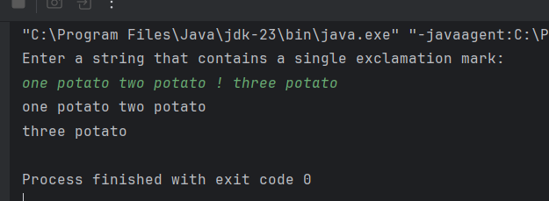

Q_09

Code

package Q_09;  
import java.util.Scanner;  
  
public class Question_09 {  
 public static void main(String[] args) {  
 Scanner scanner = new Scanner(System.*in*);  
 System.*out*.println("Enter a string:");  
 String input = scanner.nextLine();  
  
 int length = input.length();  
 char firstChar = input.charAt(0);  
 char lastChar = input.charAt(length - 1);  
  
 System.*out*.println(length);  
 System.*out*.println(firstChar);  
 System.*out*.println(lastChar);  
 }  
}

Output

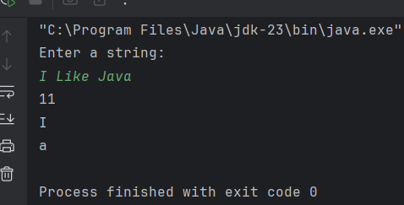

Q_10

Code

package Q_10;  
import java.util.Scanner;  
  
public class Question_10 {  
 public static void main(String[] args) {  
 Scanner scanner = new Scanner(System.*in*);  
 System.*out*.println("Enter an odd-length word:");  
 String input = scanner.nextLine();  
  
 if (input.length() % 2 == 1) {  
 int middleIndex = input.length() / 2;  
 char middleChar = input.charAt(middleIndex);  
 System.*out*.println(middleChar);  
 } else {  
 System.*out*.println("The input word does not have an odd length.");  
 }  
 }  
}

Output

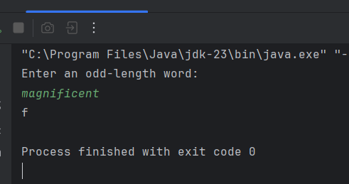

Q_11

Code

package Q_11;  
import java.util.Scanner;  
  
public class Question_11 {  
 public static void main(String[] args) {  
 Scanner scanner = new Scanner(System.*in*);  
 System.*out*.println("Enter your full name (first middle last):");  
 String input = scanner.nextLine();  
  
 String[] nameParts = input.split(" ");  
 if (nameParts.length == 3) {  
 String firstName = nameParts[0];  
 String middleName = nameParts[1];  
 String lastName = nameParts[2];  
 String middleInitial = middleName.substring(0, 1);  
  
 System.*out*.printf("%s, %s %s.%n", lastName, firstName, middleInitial);  
 } else {  
 System.*out*.println("Please enter your full name in the format first middle last.");  
 }  
 }  
}

Output

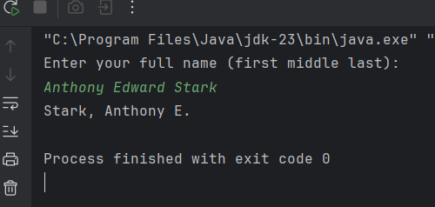

Q_12

Code

package Q_12;  
import javax.swing.*;  
  
public class Question_12 {  
 public static void main(String[] args) {  
 JFrame frame = new JFrame();  
 frame.setTitle("My First Frame");  
 frame.setSize(300, 200);  
 frame.setLocation(100, 50);  
 frame.setDefaultCloseOperation(JFrame.*EXIT_ON_CLOSE*);  
 frame.setVisible(true);  
 }  
}

Output

