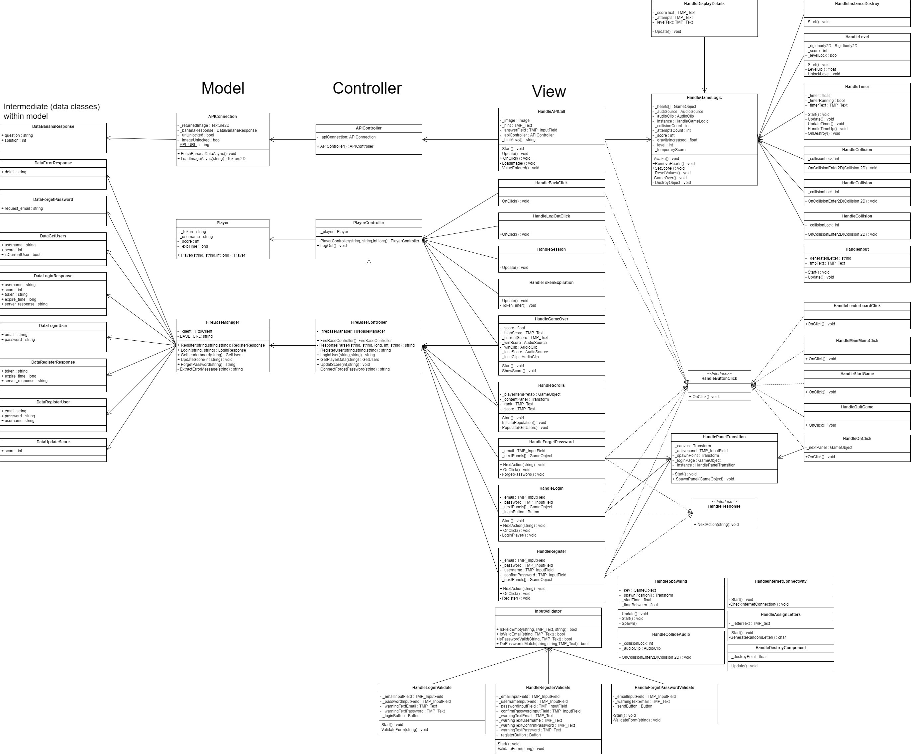**FallingLetters – Class Diagram**